
ENROLLMENT SPRING 2013
FACT SHEET 2012-2013 Academic Year, Issue 2
Office of Institutional Research http://irweb.erau.edu Daytona Beach, FL 32114-3900 (386) 226-6225

Overall figures for unduplicated headcount are presented in this fact sheet. Each student is counted only once, even if concurrently enrolled in both an undergraduate and graduate program. Since last spring, Daytona Beach’s new undergraduate enrollment has increased by 7.5% (from 187 to 201), while overall undergraduates increased .8% (from 4210 to 4245). Prescott’s new undergraduate enrollment has increased by 3.8% (from 53 to 55), while overall undergraduates increased 2.8% (from 1535 to 1578). The graduate enrollment at Daytona Beach has decreased by 1.8% (from 606 to 595), while Prescott’s graduate enrollment shows a decrease of 4% (from 50 to 48).

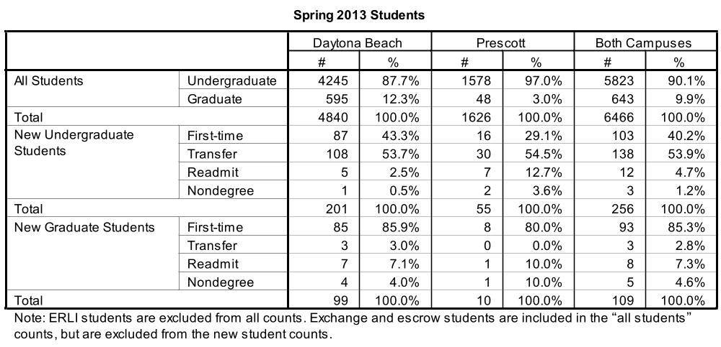

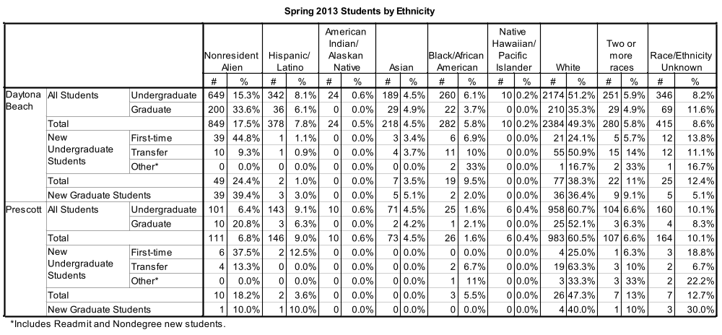

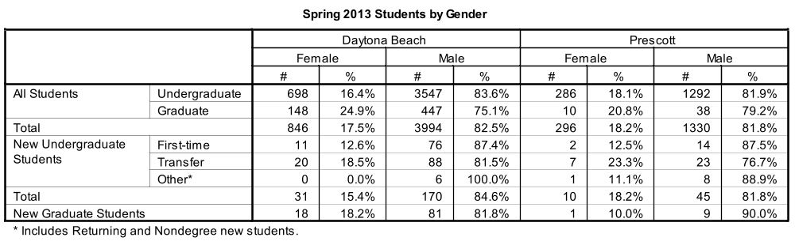

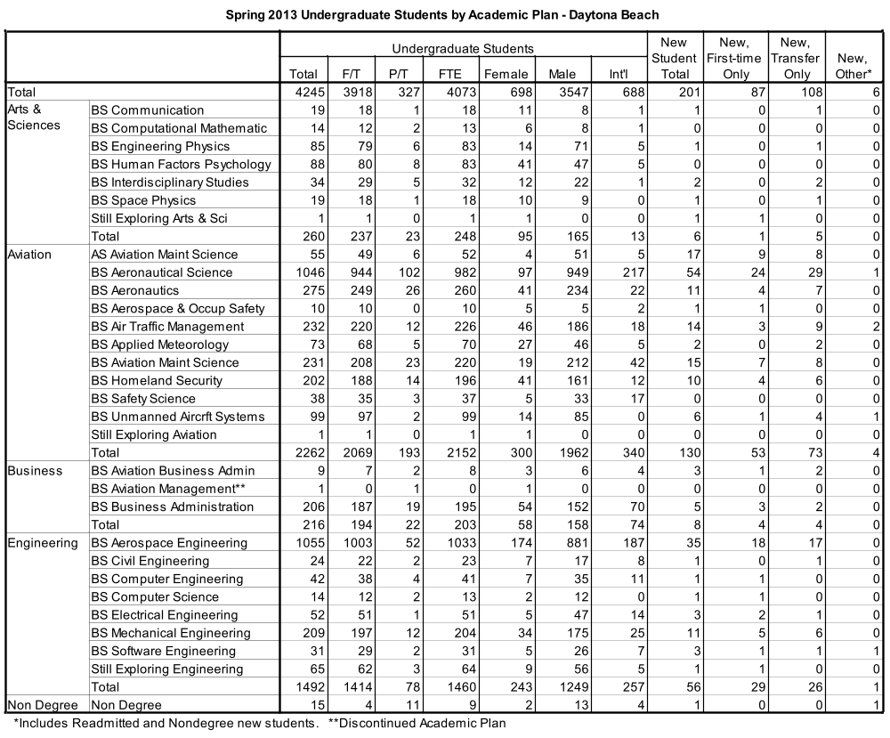

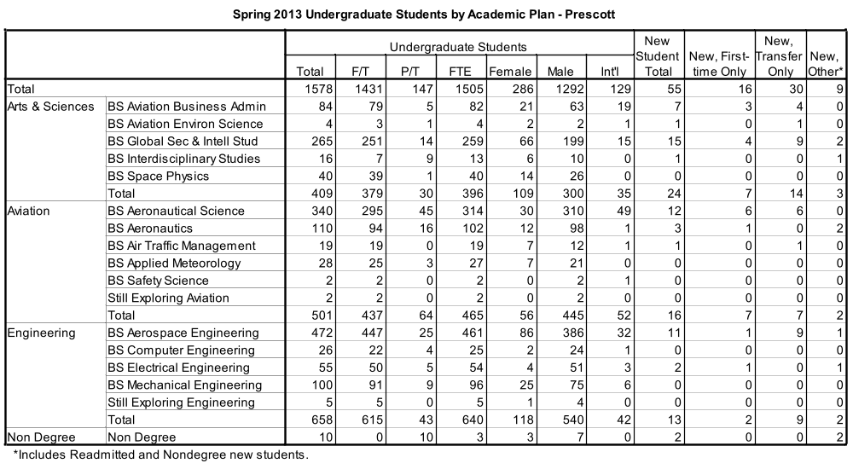

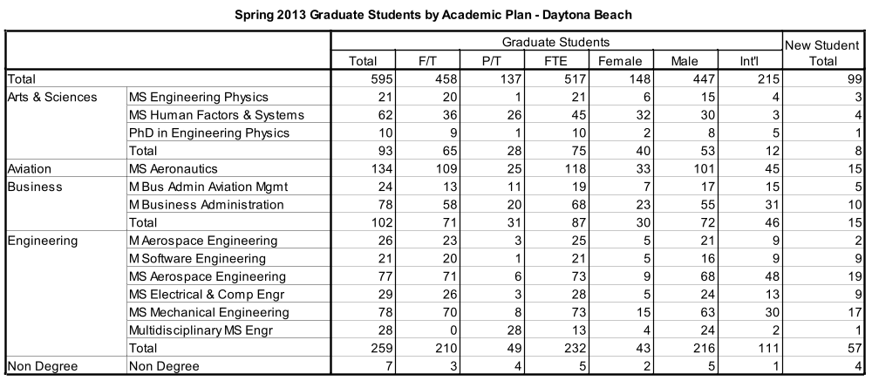

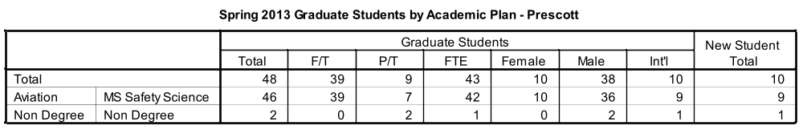

The remaining tables describe first-time college students only.

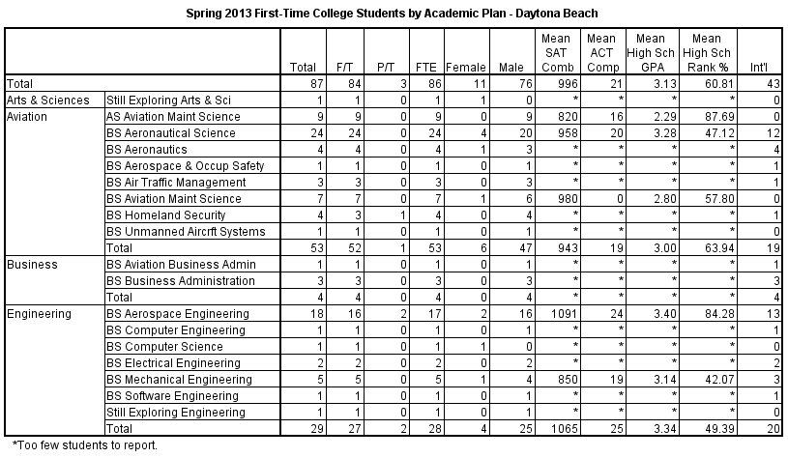

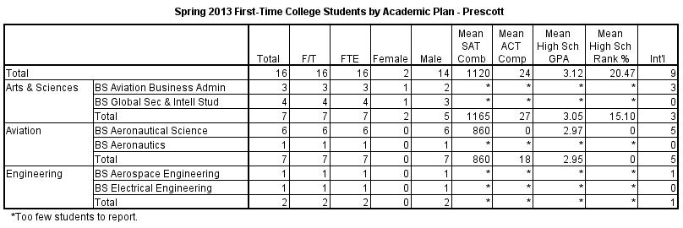

(Published 4/3/13)

