
ENROLLMENT SPRING 2012
FACT SHEET 2011-2012 Academic Year, Issue 2
Office of Institutional Research http://irweb.erau.edu Daytona Beach, FL 32114-3900 (386) 226-6225

Overall figures for unduplicated headcount are presented in this fact sheet. Each student is counted only once, even if concurrently enrolled in both an undergraduate and graduate program. Since Spring 2011, Daytona Beach’s new undergraduate enrollment has decreased by 11.4% (from 211 to 187), while overall undergraduates increased 1.5% (from 4149 to 4210). Prescott’s new undergraduate enrollment has decreased by 8.6% (from 58 to 53), while overall undergraduates increased .3% (from 1530 to 1535). The graduate enrollment at Daytona Beach has increased by 3.8% (from 584 to 606), while Prescott’s graduate enrollment shows an increase of 2% (from 49 to 50).

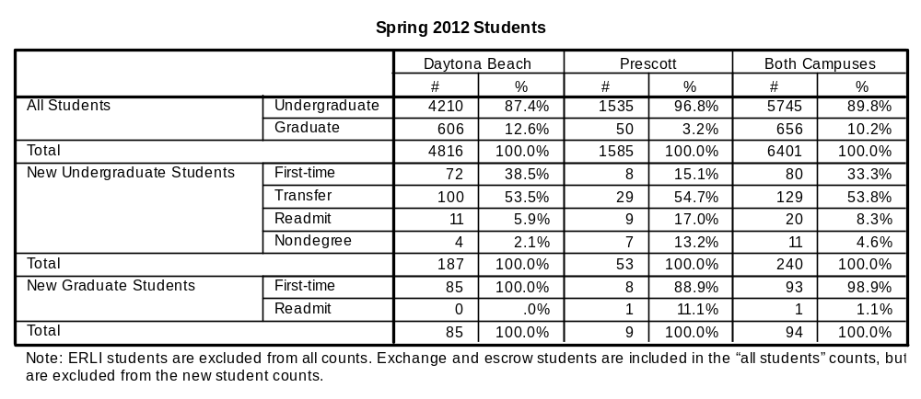

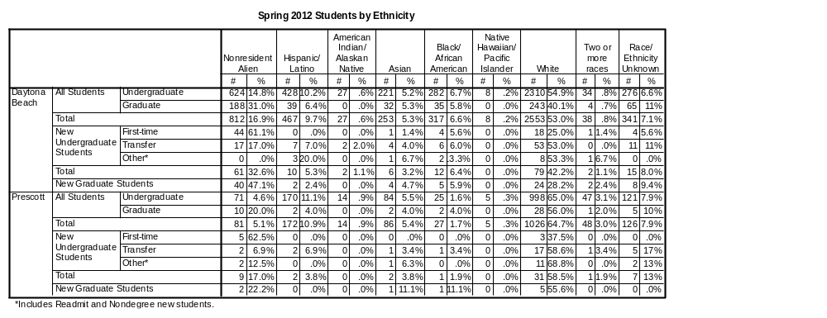

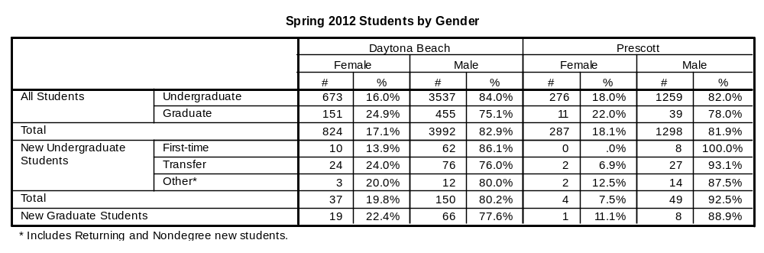

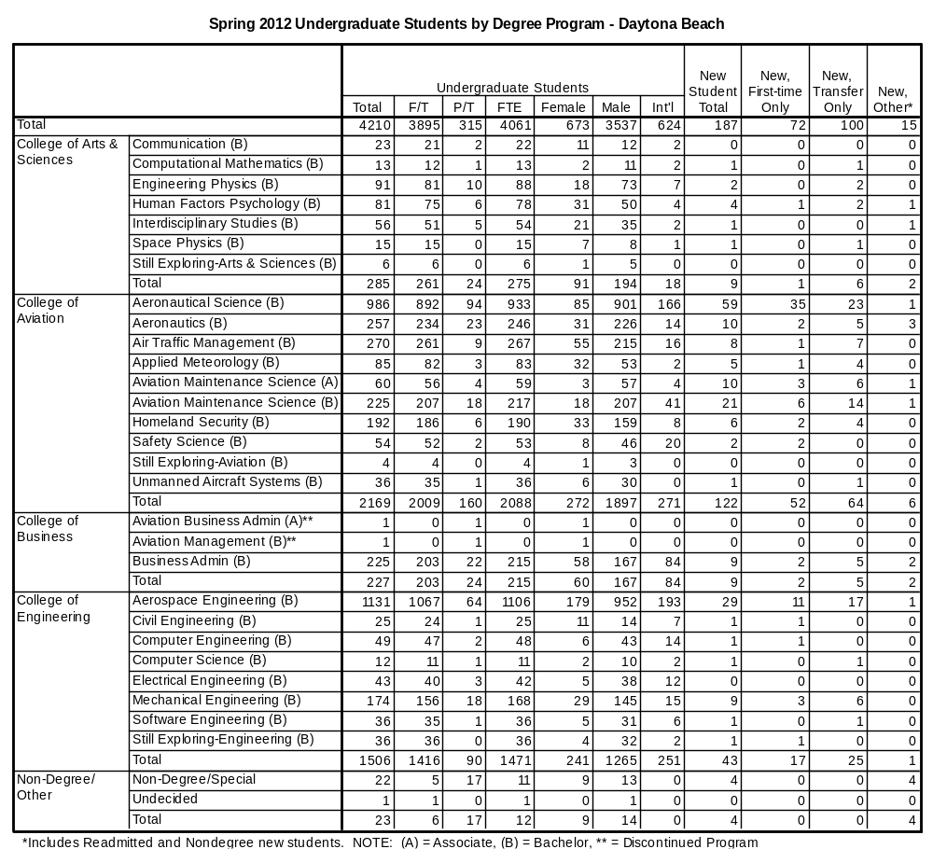

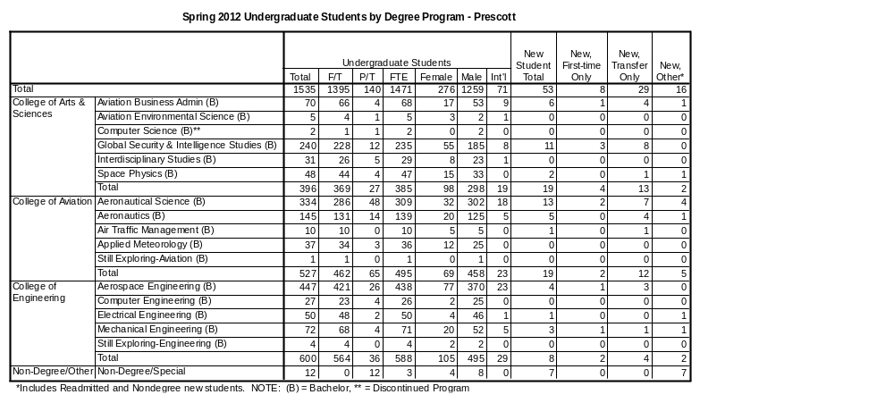

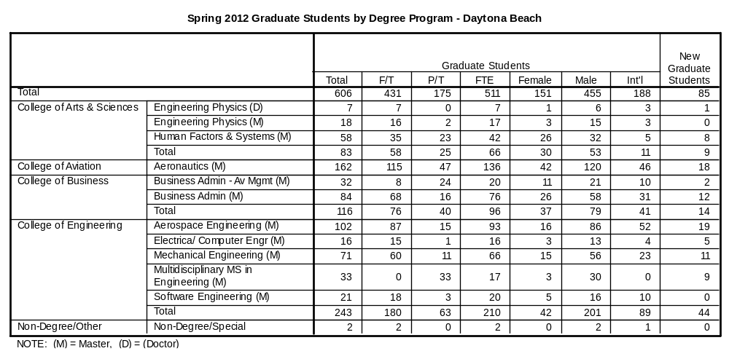

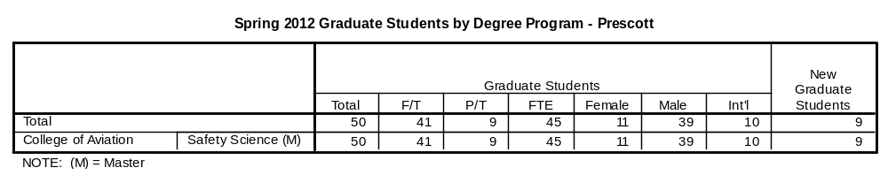

The remaining tables describe first-time college students only.

