GeoTag WIDGET

**-Manual-**

Index

Index 1

How does it work 2

GeoTag 3

GeoTagExpress 4

Setting up the widget 4

Using the widget 6

Home 6

See GeoTagged Files 7

By Coordinate 8

By Field 9

Personalized 9

Extra options 10

GeoTag File 11

By Coordinate 11

By Field 12

Personalized 13

Extra options 13

# **How it work**

**GeoTag**

This is a custom widget for ArcGIS Experience Builder, this is the graphical part of the widget, known as “front end,” it has different codes written in Typescript with React, each one has a different functionality:

* WidgetUI:

Here is the implementation of the container, which has a “go back” button, a left bar where there are some buttons that you can click, and you will move to a different view. Also, there is the body where the user needs to enter the credentials, and then be able to add, check and delete tags from files.

* Widget:

Here there is an implementation to query data from a feature layer and display the results of the user selection. This is important when adding or deleting a tag, because there is an option to select a tag to a field from a popup using a dropdown menu.

* SiteNameView:

Here there is an implementation to send the entered name of a SharePoint site, after clicking “add” to a node express server.

* SeeTaggedFilesView:

Here there is an implementation to delete a tag from a file, it contains the logic to send it to a node express server.

* SeeFilesView:

Here there is an implementation to check if a file contains a specific tag, there are three options to check, one is by coordinate, then by field, where you can select a field from a pop up of the layer, and then, by name.

* HomeView:

Here there is an implementation of the graphic interface to add the credentials of the user, as well as the name of the SharePoint site.

* GeoTagView:

Here there is an implementation to GeoTag files, it contains a breadcrumb to navigate through folders and files.

* AppCredentialsView:

Here there is an implementation to send the entered user credentials, after clicking “add” to a node express server.

* AddTagView:

Here there is an implementation to check add GeoTag a file, there are three options to add it, one is by coordinate, then by field, where you can select a field from a pop up of the layer, and then, by name.

## GeoTagExpress

This file is a node express server, that works as a back-end server that communicates through Microsoft Graph API for SharePoint. It connects using diverse kinds of methods, such as “POST” and “PATCH” here there is a single file.

* Server:

Here there is an implementation to send the entered user credentials to get an API token, which has a lifespan of an hour, as this token has a very short duration, if you have a valid token, manages to get another one before the old one expires, also, it sends the SharePoint site name. Finally, it contains the logic to add and delete a tag to a file.

# Setting up the widget

After placing the widget on the map, you need to connect it to data by clicking the switch button, and after that, you need to connect it to the map, by clicking “None” and then to "Map”.

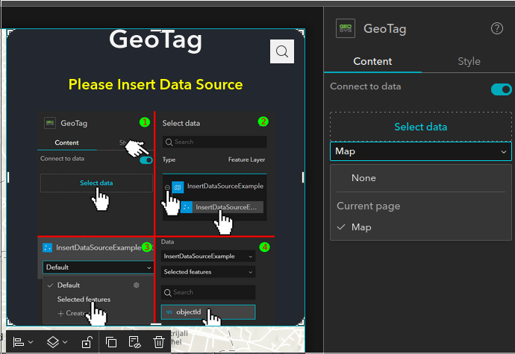

Following that, you need to select the feature layer, to do it you need to click “Add new data”, which can be found on the bottom of the new page that appears.

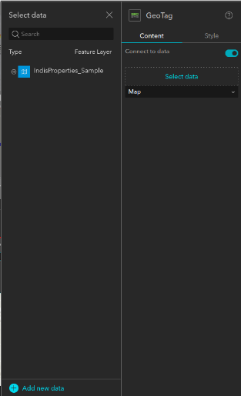

To continue, you must select one of the available Web Maps, these ones can be yours, from your groups, organization, ArcGIS Online or Living Atlas, and then, you have to click “Done.”

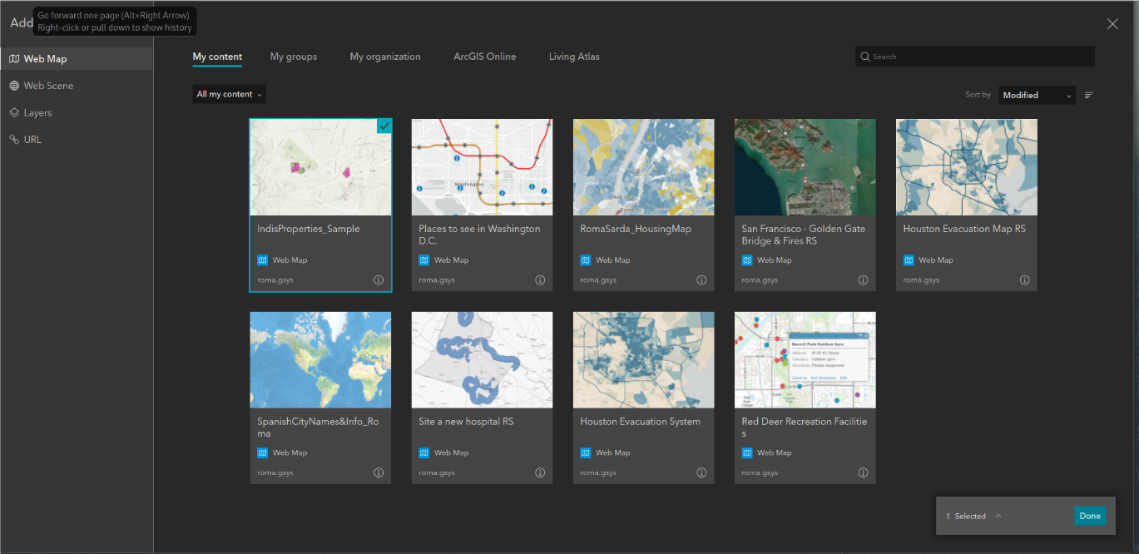

After that, you should select “Selected Features”, by clicking on the button that appears on the bottom of the name of the Web Map. Then you need to select a property that the web map has.

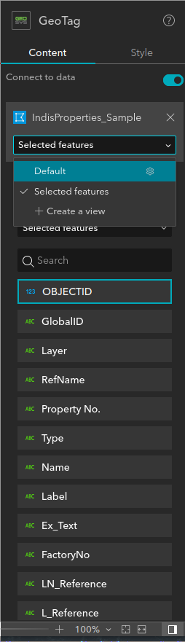

After doing these simple steps, the appearance of the widget will swap from the previous state to being functional, it ought to be like this, and now you can use it.

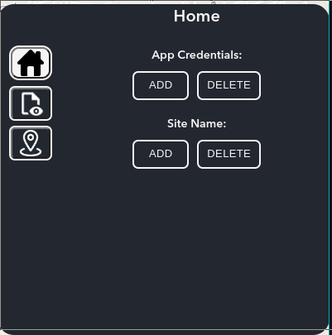

# **Using the widget**

## **Home**

After setting up the widget, you have to click on the first icon of the left bar, one that has a house, and add the SharePoint credentials, which is “App Credentials”, to add them, you need to click “Add”, and the appearance of the widget will change to this:

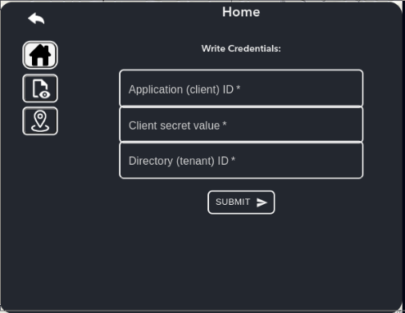

If you already have your Client ID, Client Secret and Tenant ID, you can enter it and click “Submit” button, and you will be redirected to the home again, if you do not have them, you can check the other manual that we have that is called GeoTagInstallation-Manual.

After this, you need to add the site name, which is the name of your SharePoint site, to do it, you have to click on “Add”, and the appearance of the widget will change to this:

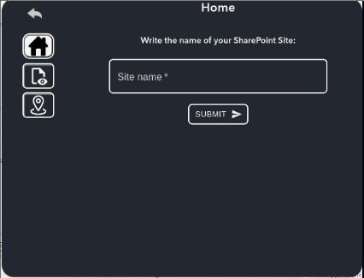

To get the name of the SharePoint site, you need to go to SharePoint, and finally to the site you want to use, and then, you will find the name of the SharePoint site, in this case is “Esri with SharePoint”.

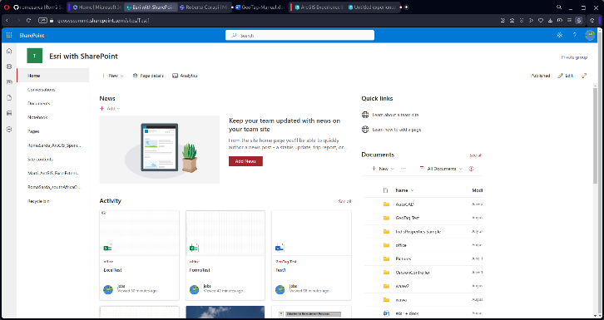

## **See GeoTagged Files**

After clicking on the second icon, it should redirect you to this other view, here you will be able to search files by tags, as you can see, there are different options, one is called “By Coordinate”, “By Field”, or “Personalized”.

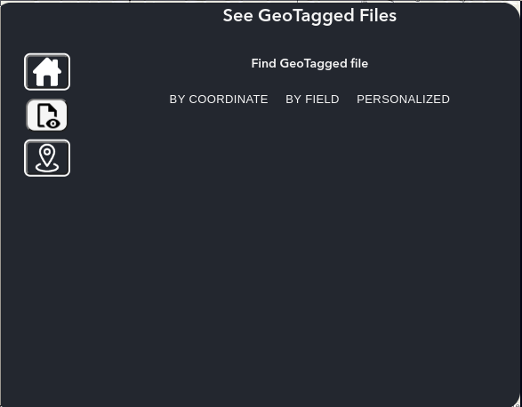

### **By Coordinate**

If you click on “By Coordinate”, you will be redirected to this window:

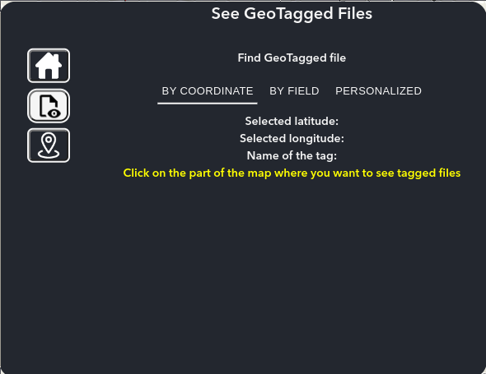

Now if you click on the map, you will see that the coordinates of the map will appear, and then you will be able to search if a file has this tag.

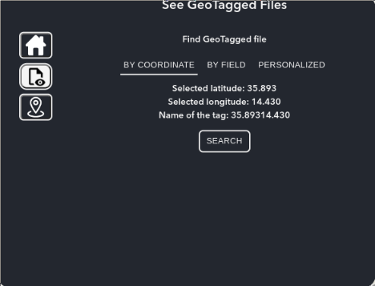

If you click on search, you will see the files that have this specific coordinate, if it does not exist, you will get the following message:

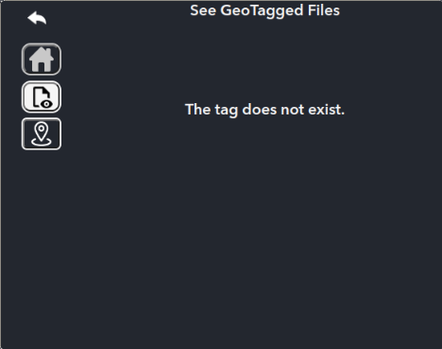

### **By Field**

Following that, you can see files that are tagged by fields, to do it, you need to click on “By Field”, and the following screen will appear:

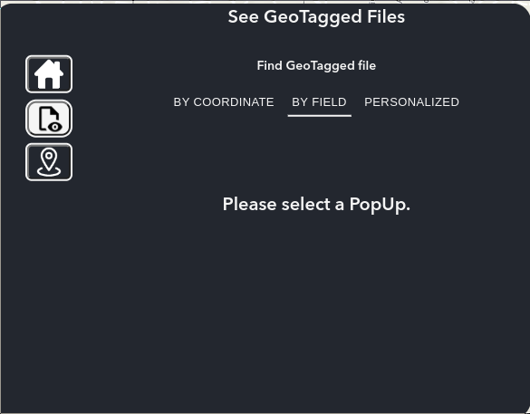

Then, you must select a pop up from the map, in this case, I select this one:

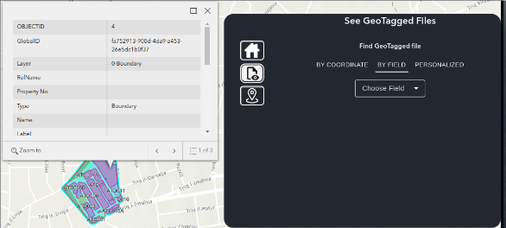

Then, you should select the field, which are the ones that appear on the pop up and are not null, for instance now I will select GlobalID, and the value that will be searched will be “fa752913-900d-4da9-a453-26e5dc1b0f37”, because is the value of the GlobalID, as I have a file that has this tag, the file will appear.

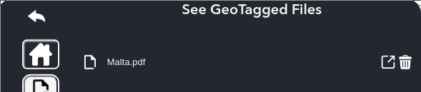

### **Personalized**

Finally, you can search files that contain a personalized tag, to do it, you need to click on “Personalized”, and the widget screen will change to:

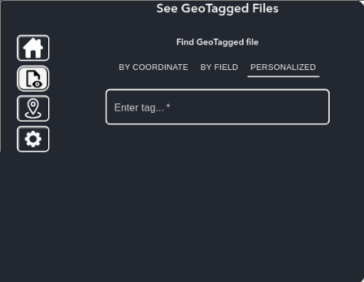

Then, you can enter the custom tag, and click on “Search”, the files that contain this tag will appear, in this case I search for a tag that does not exist, and I got:



### **Extra options**

Finally, you can preview a file, or delete a tag from a file.

To preview, you just need to hover the name of the file, and click on it, a new page on the browser will open.

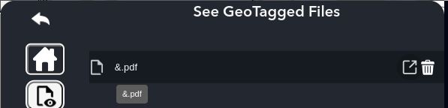

Then, you can open this file to a new window, to do it, you need to click on the following icon, and a new webpage will open.

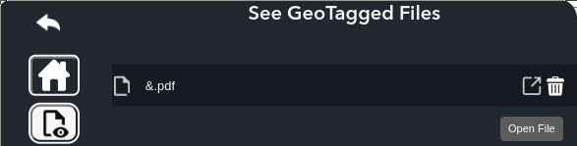

To end, you can delete a tag from a file by clicking on the bin icon, when you hover it, the color will change to red.

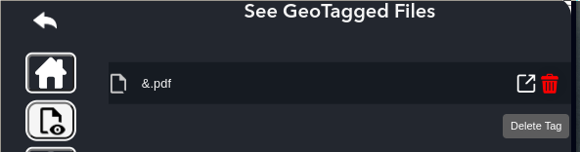

If you click on the bin, a pop-up in the center of the screen will appear to confirm if you want to delete the tag.

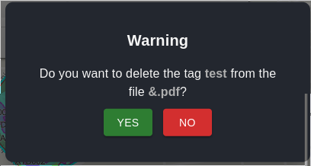

## **GeoTag File**

After clicking on the third icon, it should redirect you to this other view, which is for adding tags to files:

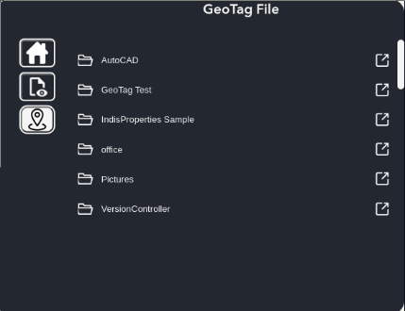

Here will appear all the files and folders that are in your SharePoint site, in my case, is “Esri with SharePoint”. There is a scrollbar that you can use to move around, also, a breadcrumb is present, to be able to move between folders easily and have the full path.

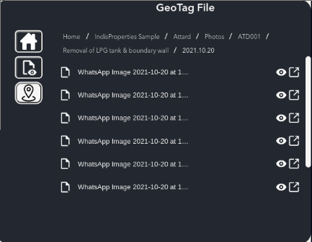

To input a tag, you simply need to click on the file you enter the tag to, and the following screen will appear, here you have three different options “By Coordinate”, “By Field” or “Personalized”.

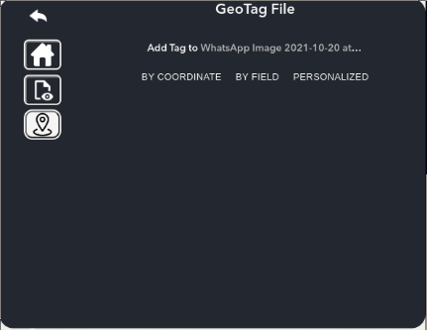

### **By Coordinate**

If you click on “By Coordinate”, you will be redirected to this window:

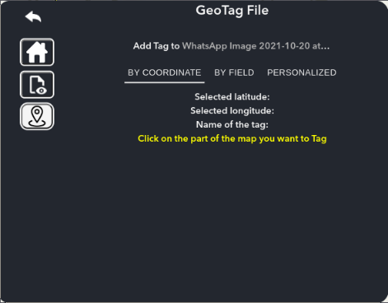

Now, if you click on the map, you will see that its coordinates will appear, and then you can add this tag to the file.

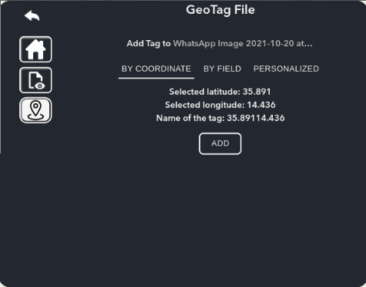

If you click on "Add”, a pop up will appear to confirm if you want to add the tag.

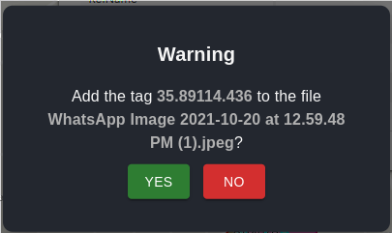

### **By Field**

If you click on “By Field”, the following screen will appear:

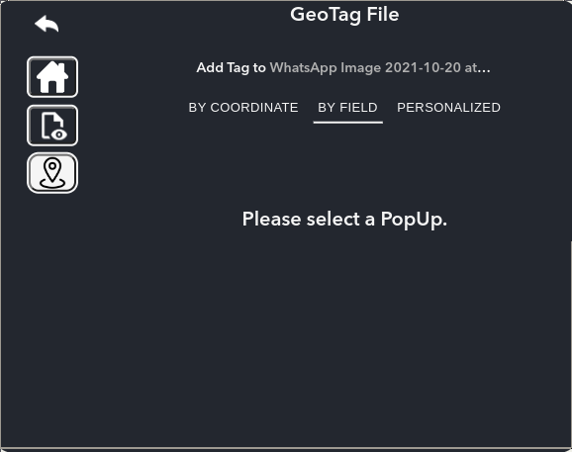

Then, you must select a pop up from the map, in this case, I select this one:

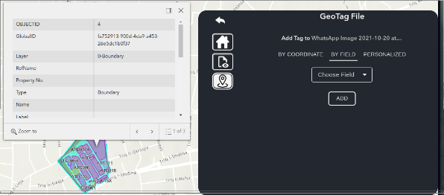

Then, you should select the field, which are the ones that appear on the pop up and are not null, for instance now I will select GlobalID, and the added tag will be “fa752913-900d-4da9-a453-26e5dc1b0f37”, because is the value of the GlobalID, after clicking add, a popup will appear.

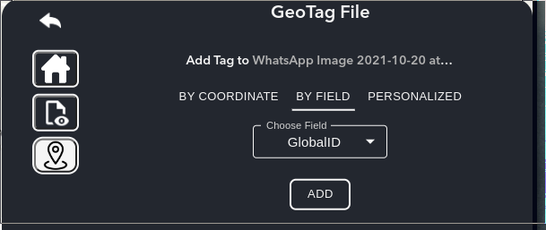 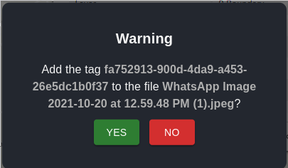

### **Personalized**

Finally, you can add a personalized tag, to do it, you need to click on “Personalized”, and the widget screen will change to:

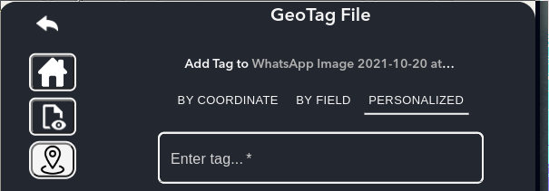

After this, you need to type the tag that you want to use.

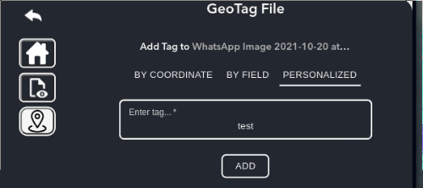

Finally, you need to click “Add”, and a popup will appear to confirm that you want to add the tag to the file.

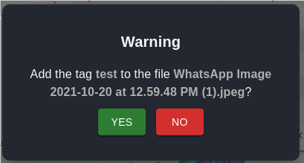

### **Extra options**

Finally, you can preview a file or open it in a new window or open a folder in a new window.

To preview, you just need to click on the eye that is on the right side, and a new page on the browser will open.

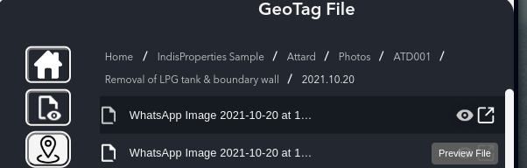

Then, you can open this file to a new window, to do it, you need to click on the following icon, and a new webpage will open.

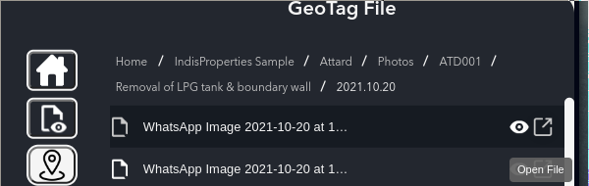

To end, you can open a folder to a new window, to do it, you need to click on the following icon, and a new webpage will open.

