**Instructions for manufacturing the Minsight Sensor-Shell**

1. Preparation of the mold:
   1. Connect the two halves of the outer mold tightly, but using two elastic rings. When coming fresh out of the printer, use a product like Inhibit-X to prevent problems with curing.
   2. Ein Bild, das Handtuch, Text, Im Haus, Blau enthält.

      Automatisch generierte BeschreibungScrew the skeleton on the insert part of the mold in the following orientation:

Do not over tighten the screws and make sure that the skeleton is centered.

* 1. Grease the outer mold with a thin layer of mold release. Do not put mold release on the insert, as it changes the reflective properties of the Minsight shell!

1. Production of the silicone mixture:
   1. Prepare a plastic vessel and a wooden spatula to stir the elastomer components.
   2. Shake the two different silicones well and stir them.
   3. Fill 15g Smooth-On EcoFlex part A into the vessel.

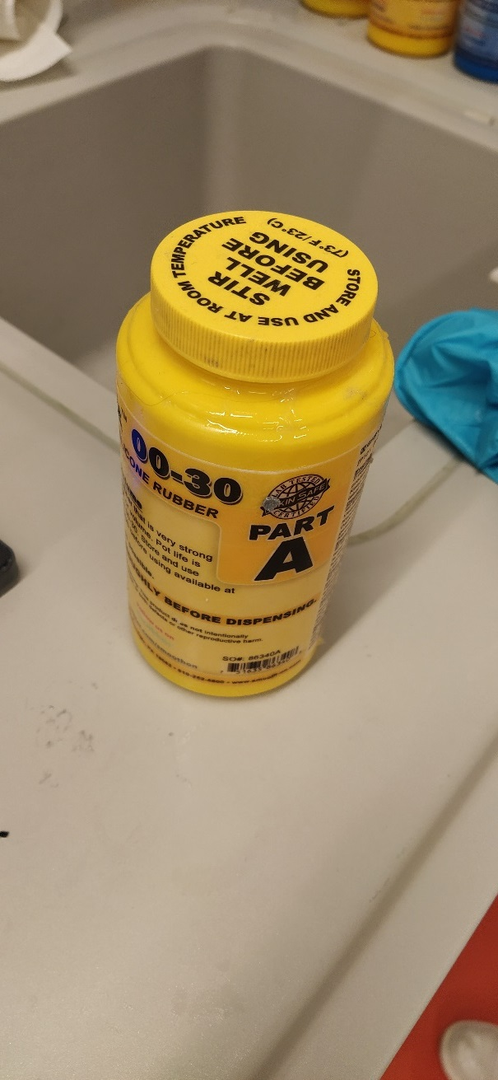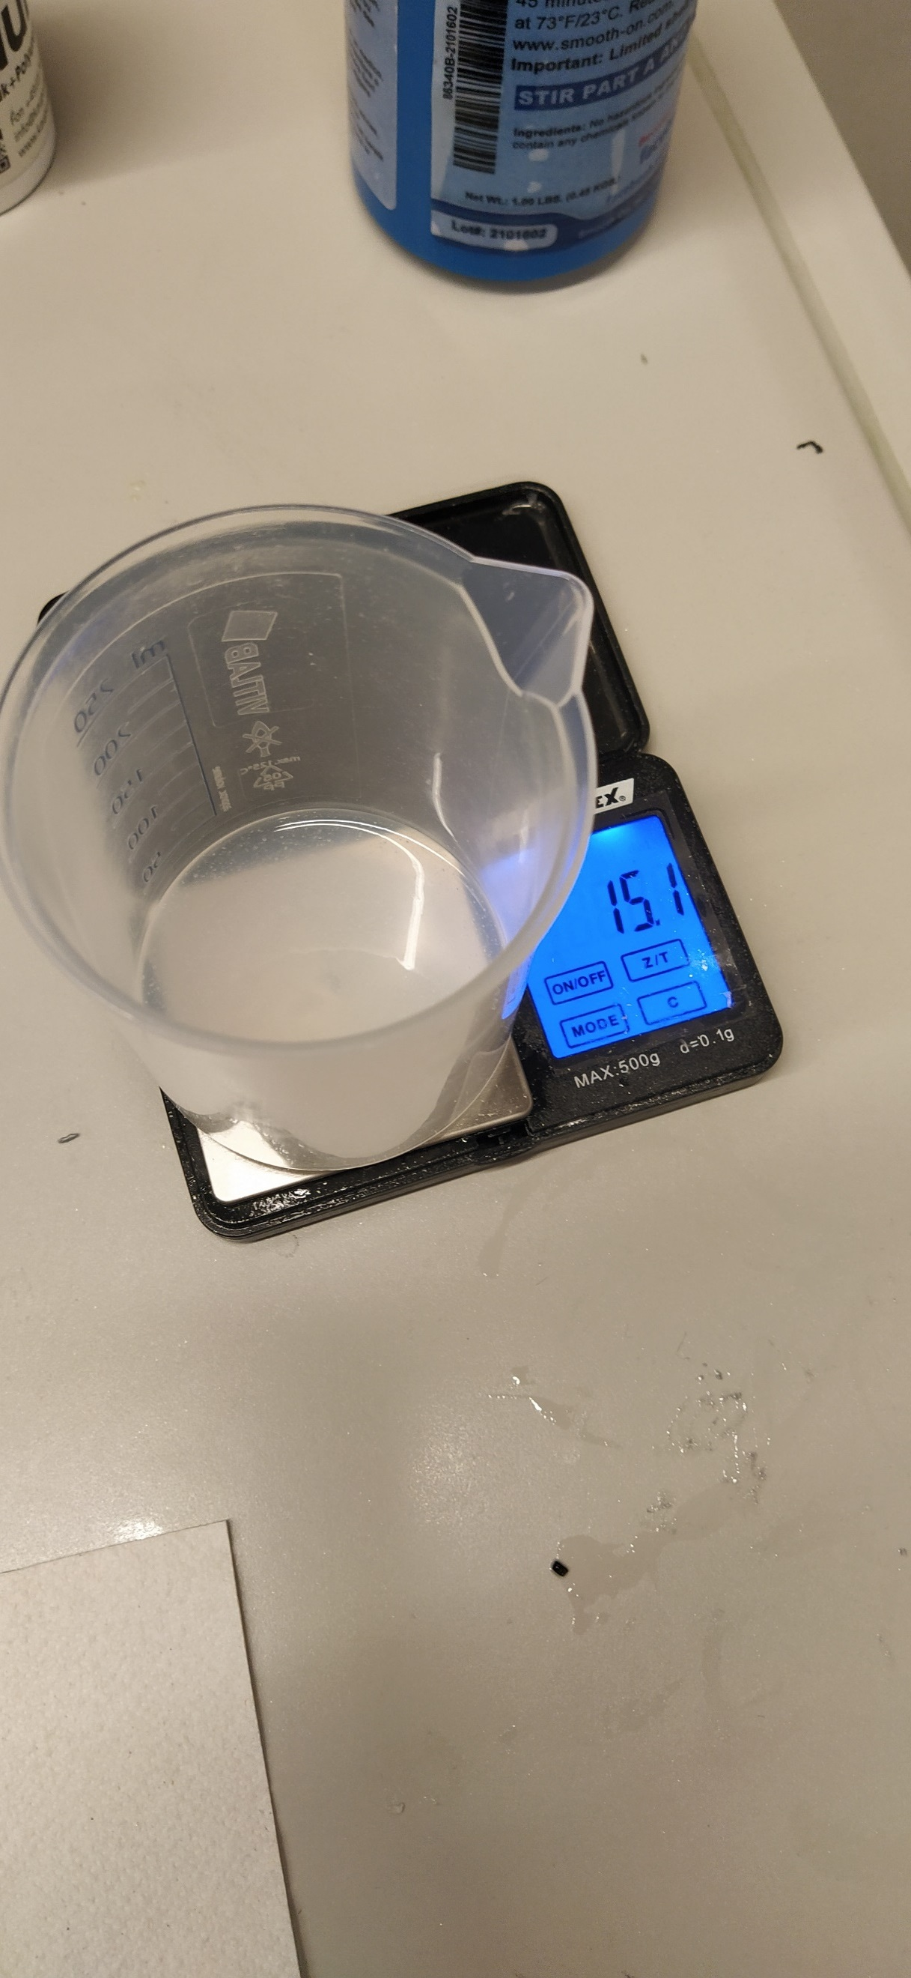

* 1. Put on a mask and safety glasses before proceeding. Now add 3g of aluminium powder as well as 0.1 g aluminium flakes with a teaspoon and stir it well with the wooden spatula.

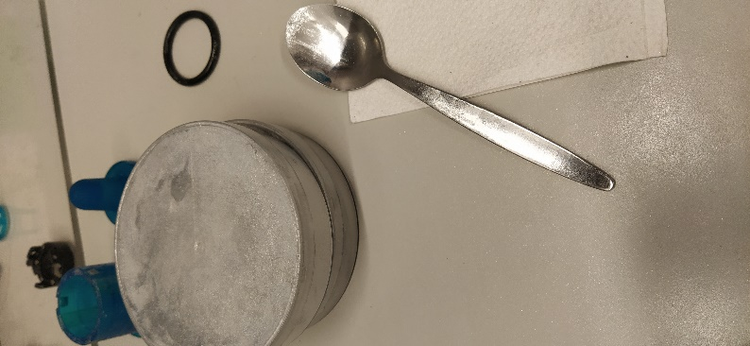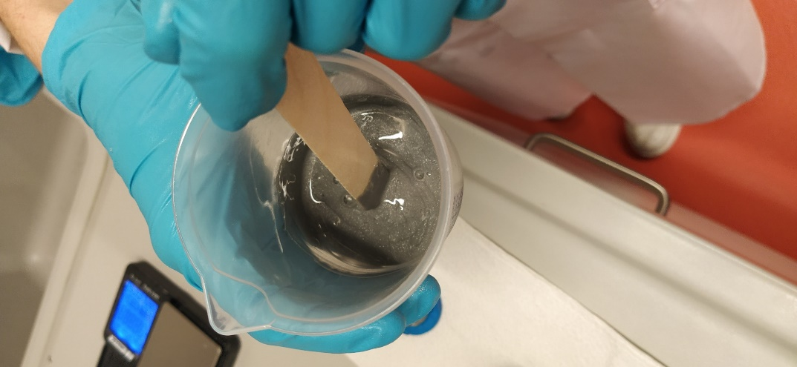

* 1. Then add 15g Smooth-On EcoFlex part B and stir again.
  2. To ensure homogeneity of the material, degas the silicone mixture for 5 minutes at 5 Pa. Afterwards, make sure to open the valve slowly and release the pressure.

1. Fill the mixture carefully (like pouring a beer) into the mold and degas again for 5 minutes.

Ein Bild, das Sicherheitshandschuh, medizinische Handschuhe, Plastik, medizinische Ausrüstung enthält.

1. Now carefully place the upper part of the mold with the skeleton onto the lower part filled with the silicone mixture. Make sure that the two parts of the mold fit together correctly but do not press too much on it.
2. Let the whole shell cure for a minimum of 4 hours.
3. After curing, use a spatula to open the mold and unscrew the skeleton. Disconnecting the molded shell from the insert is tricky, Therefore insert the a thin spatula between the silicone and the mold, and lever the sensor shell upwards so that air can enter. Repeat this in several places to release the shell from the mold. The edge of the shell can then be trimmed with scissors.

**3D printing the the base of the sensor**

Use an SLA 3D printing method available to you for the sensor base, camera holder and collimator. Before curing the parts, insert nuts into the cutouts in the sensor base.

Ein Bild, das Autoteile, Kreis, Rotor enthält.
Ein Bild, das Autoteile, Kreis, Zahnrad enthält.
**Assembling the sensor**

Screw the skeleton and shell combination to sensor base and

insert the collimator in the correct orientation.

Remove the built-in white LED ring on top of the camera lens, but keep the thin power cables intact. They will later power the custom LED ring.

Open the connector of the camera USB cable and thread it through the

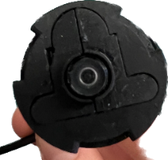Ein Bild, das Kreis, Metall, Schloss enthält.
camera holder. The camera should have a certain

orientation to optimize the viewing angle (see picture).

Then place the two small camera holder parts around the lens

of the camera and insert it into the camera holder.

Carefully close the camera cable connector again.

Now place the LED ring on the collimator in the correct orientation and solder the power cables to the camera power supply. Screw the lower and upper parts of the mount together with the three screws.

