CPE301 – SPRING 2019

MIDTERM 2

Student Name: Victor Martinez

Student #: 5003131674

Student Email: [martiv6@unlv.nevada.edu](mailto:martiv6@unlv.nevada.edu)

Primary Github address: <https://github.com/martiv6/>

Directory: <https://github.com/martiv6/>midterms/Midterm_2

Submit the following for all Labs:

1. In the document, for each task submit the modified or included code (only) with highlights and justifications of the modifications. Also, include the comments.
2. Use the previously create a Github repository with a random name (no CPE/301, Lastname, Firstname). Place all labs under the root folder ESD301/Midterm, sub-folder named LABXX, with one document and one video link file for each lab, place modified asm/c files named as LabXX-TYY.asm/c.
3. If multiple asm/c files or other libraries are used, create a folder LabXX-TYY and place these files inside the folder.
4. The folder should have a) Word document (see template), b) source code file(s) and other include files, c) text file with youtube video links (see template).

1. **COMPONENTS LIST AND CONNECTION BLOCK DIAGRAM w/ PINS**

ESP-01

APDS

9960

BREAD

BOARD

328P

Mini

POWERSUPPLY

1. **INITIAL/MODIFIED/DEVELOPED CODE OF TASK 1/A**

/*

* MIDTERM_2.c

*

* Created: 5/01/2019 10:06:39 PM

* Author : victor

*/

#define *F_CPU* 16000000UL

#define BAUD 9600

#define MYUBRR *F_CPU*/16/BAUD-1

#include <avr/io.h>

#include <util/delay.h>

#include <stdio.h>

#include <avr/interrupt.h>

#include <stdlib.h>

#include "I2C_MASTER_C.h"

#include "APDS_9960_LIB.h"

void USART_tx_string(char *data); // where it prints string USART

void USART_init( unsigned int ubrr ); // where USART initializes

void RGB_dect(); // used to read the colors and put their values

void APDS_9960_init(); // begins to use APDS sensor

*uint16_t* baud_rate = MYUBRR; // Int declaration

*uint8_t* red_low, red_high; //

*uint8_t* blue_low, blue_high; //

*uint8_t* green_low, green_high; //

*uint8_t* config; //

char outs[256]; // room we have to print

int main(void)

{

*uint16_t* red = 0; // Declare red

*uint16_t* green = 0; // Declare green

*uint16_t* blue = 0; // Declare blue

i2c_init(); // i2C function call

USART_init(MYUBRR); // uart initialization function call

APDS_9960_init(); // initialize 9960 sensor function call

unsigned char AT_CHECK[] = "AT\r\n"; // AT Commands

unsigned char CWMODE_SET[] = "AT+CWMODE=1\r\n"; // Set MODE

unsigned char CWJAP_LOGIN[] = "AT+CWJAP=\"iPXSMax\",\"12345678\"\r\n"; // MUST CHANGE WIFI AND PASSWORD

unsigned char CIPMUX_SET[] = "AT+CIPMUX=0\r\n";

unsigned char CIPSTART_SEND[] = "AT+CIPSTART=\"TCP\",\"api.thingspeak.com\",80\r\n";

unsigned char CIPSEND_FINISH[] = "AT+CIPSEND=100\r\n";

*_delay_ms*(2500);

USART_tx_string(AT_CHECK); //send commands

*_delay_ms*(6000);

USART_tx_string(CWMODE_SET); //set mode

*_delay_ms*(6000);

USART_tx_string(CWJAP_LOGIN); //connect to Wifi

*_delay_ms*(16000);

while (1)

{

///////////////////////// SENDING RED, GREEN, BLUE READINGS/////////////////////////

USART_tx_string(CIPMUX_SET); //select MUX

*_delay_ms*(10000);

USART_tx_string(CIPSTART_SEND); //connect TCP

*_delay_ms*(10000);

USART_tx_string(CIPSEND_FINISH); //send size

*_delay_ms*(6000);

RGB_dect(&red, &blue, &green); // Call colors function

*snprintf*(outs,sizeof(outs),"GET https://api.thingspeak.com/update?api_key=5HICIFGYJQ1XUU90&field1=0%05u&field2=%05u&field3=%05u\r\n", red,green,blue); // print it

USART_tx_string(outs); //send data

*_delay_ms*(10000);

}

}

/* INIT USART (RS-232) */

void USART_init( unsigned int ubrr ) {

UBRR0H = (unsigned char)(ubrr>>8);

UBRR0L = (unsigned char)ubrr;

UCSR0B |= (1 << TXEN0) | (1 << RXEN0)| ( 1 << RXCIE0); // Enable receiver, transmitter & RX interrupt

UCSR0C |= (1<<UCSZ01) | (1 << UCSZ00);

}

void USART_tx_string( char *data ) // used to print on to the screen

{

while ((*data != '\0')) {

while (!(UCSR0A & (1 <<UDRE0)));

UDR0 = *data;

data++;

}

}

void RGB_dect(*uint16_t* *red, *uint16_t* *blue, *uint16_t* *green) // Function used to read the colors for sensor (red, blue and green)

{

i2c_readReg(APDS_WRITE, APDS9960_RDATAL, &red_low, 1);

i2c_readReg(APDS_WRITE, APDS9960_RDATAH, &red_high, 1);

i2c_readReg(APDS_WRITE, APDS9960_GDATAL, &green_low, 1);

i2c_readReg(APDS_WRITE, APDS9960_GDATAH, &green_high, 1);

i2c_readReg(APDS_WRITE, APDS9960_BDATAL, &blue_low, 1);

i2c_readReg(APDS_WRITE, APDS9960_BDATAH, &blue_high, 1);

*red = red_high << 8 | red_low;

*blue = blue_high << 8 | blue_low;

*green = green_high << 8 | green_low;

}

void APDS_9960_init() // Function used to initialize the Sensor only for the RGB, no gesture or proximity used

{

i2c_readReg(APDS_WRITE, APDS9960_ID, &config,1);

if(config != APDS9960_ID_1)

while(1)

{

config = 1 << 1 | 1 << 0 | 1 << 3 | 1 << 4;

}

i2c_writeReg(APDS_WRITE, APDS9960_ENABLE, &config, 1);

config = DEFAULT_ATIME;

i2c_writeReg(APDS_WRITE, APDS9960_ATIME, &config, 1);

config = DEFAULT_WTIME;

i2c_writeReg(APDS_WRITE, APDS9960_WTIME, &config, 1);

config = DEFAULT_PROX_PPULSE;

i2c_writeReg(APDS_WRITE, APDS9960_PPULSE, &config, 1);

config = DEFAULT_POFFSET_UR;

i2c_writeReg(APDS_WRITE, APDS9960_POFFSET_UR, &config, 1);

config = DEFAULT_POFFSET_DL;

i2c_writeReg(APDS_WRITE, APDS9960_POFFSET_DL, &config, 1);

config = DEFAULT_CONFIG1;

i2c_writeReg(APDS_WRITE, APDS9960_CONFIG1, &config, 1);

config = DEFAULT_PERS;

i2c_writeReg(APDS_WRITE, APDS9960_PERS, &config, 1);

config = DEFAULT_CONFIG2;

i2c_writeReg(APDS_WRITE, APDS9960_CONFIG2, &config, 1);

config = DEFAULT_CONFIG3;

i2c_writeReg(APDS_WRITE, APDS9960_CONFIG3, &config, 1);

}

1. **SCHEMATICS**

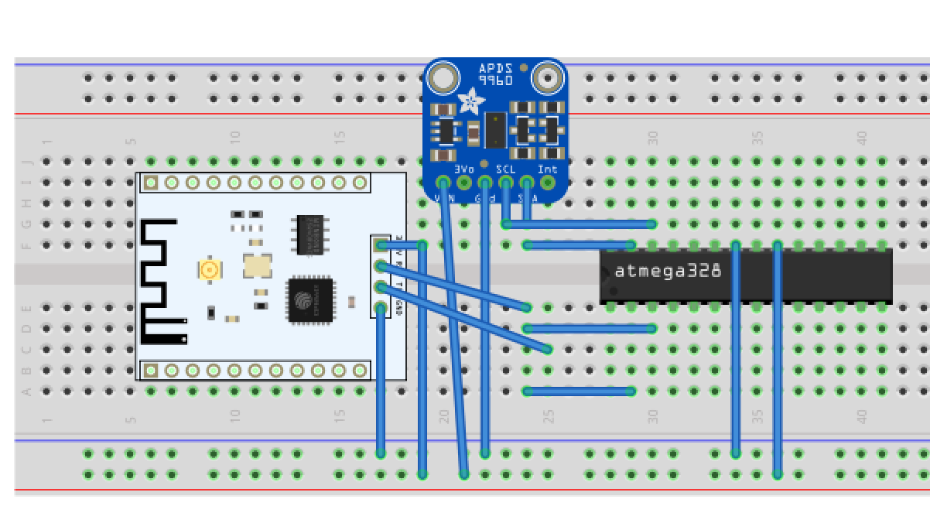

1. **SCREENSHOTS OF EACH TASK OUTPUT (ATMEL STUDIO OUTPUT)**

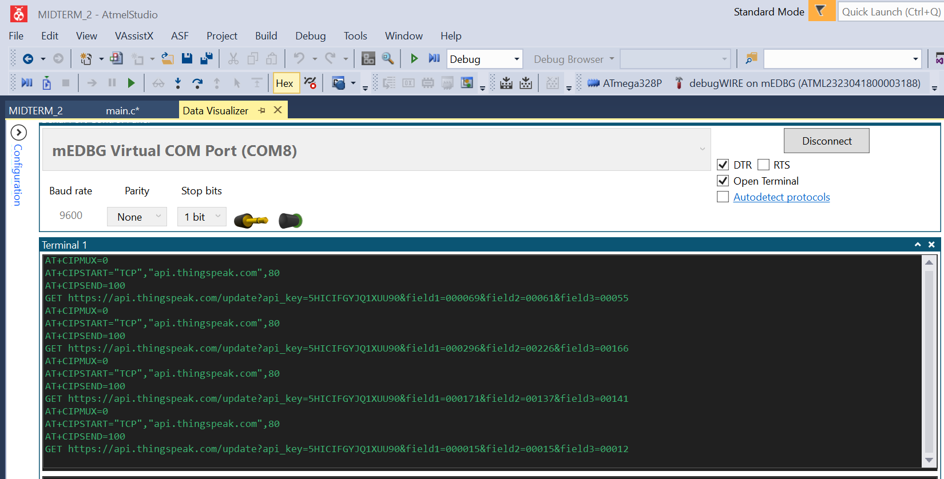

1. **SCREENSHOT OF EACH DEMO (BOARD SETUP)**

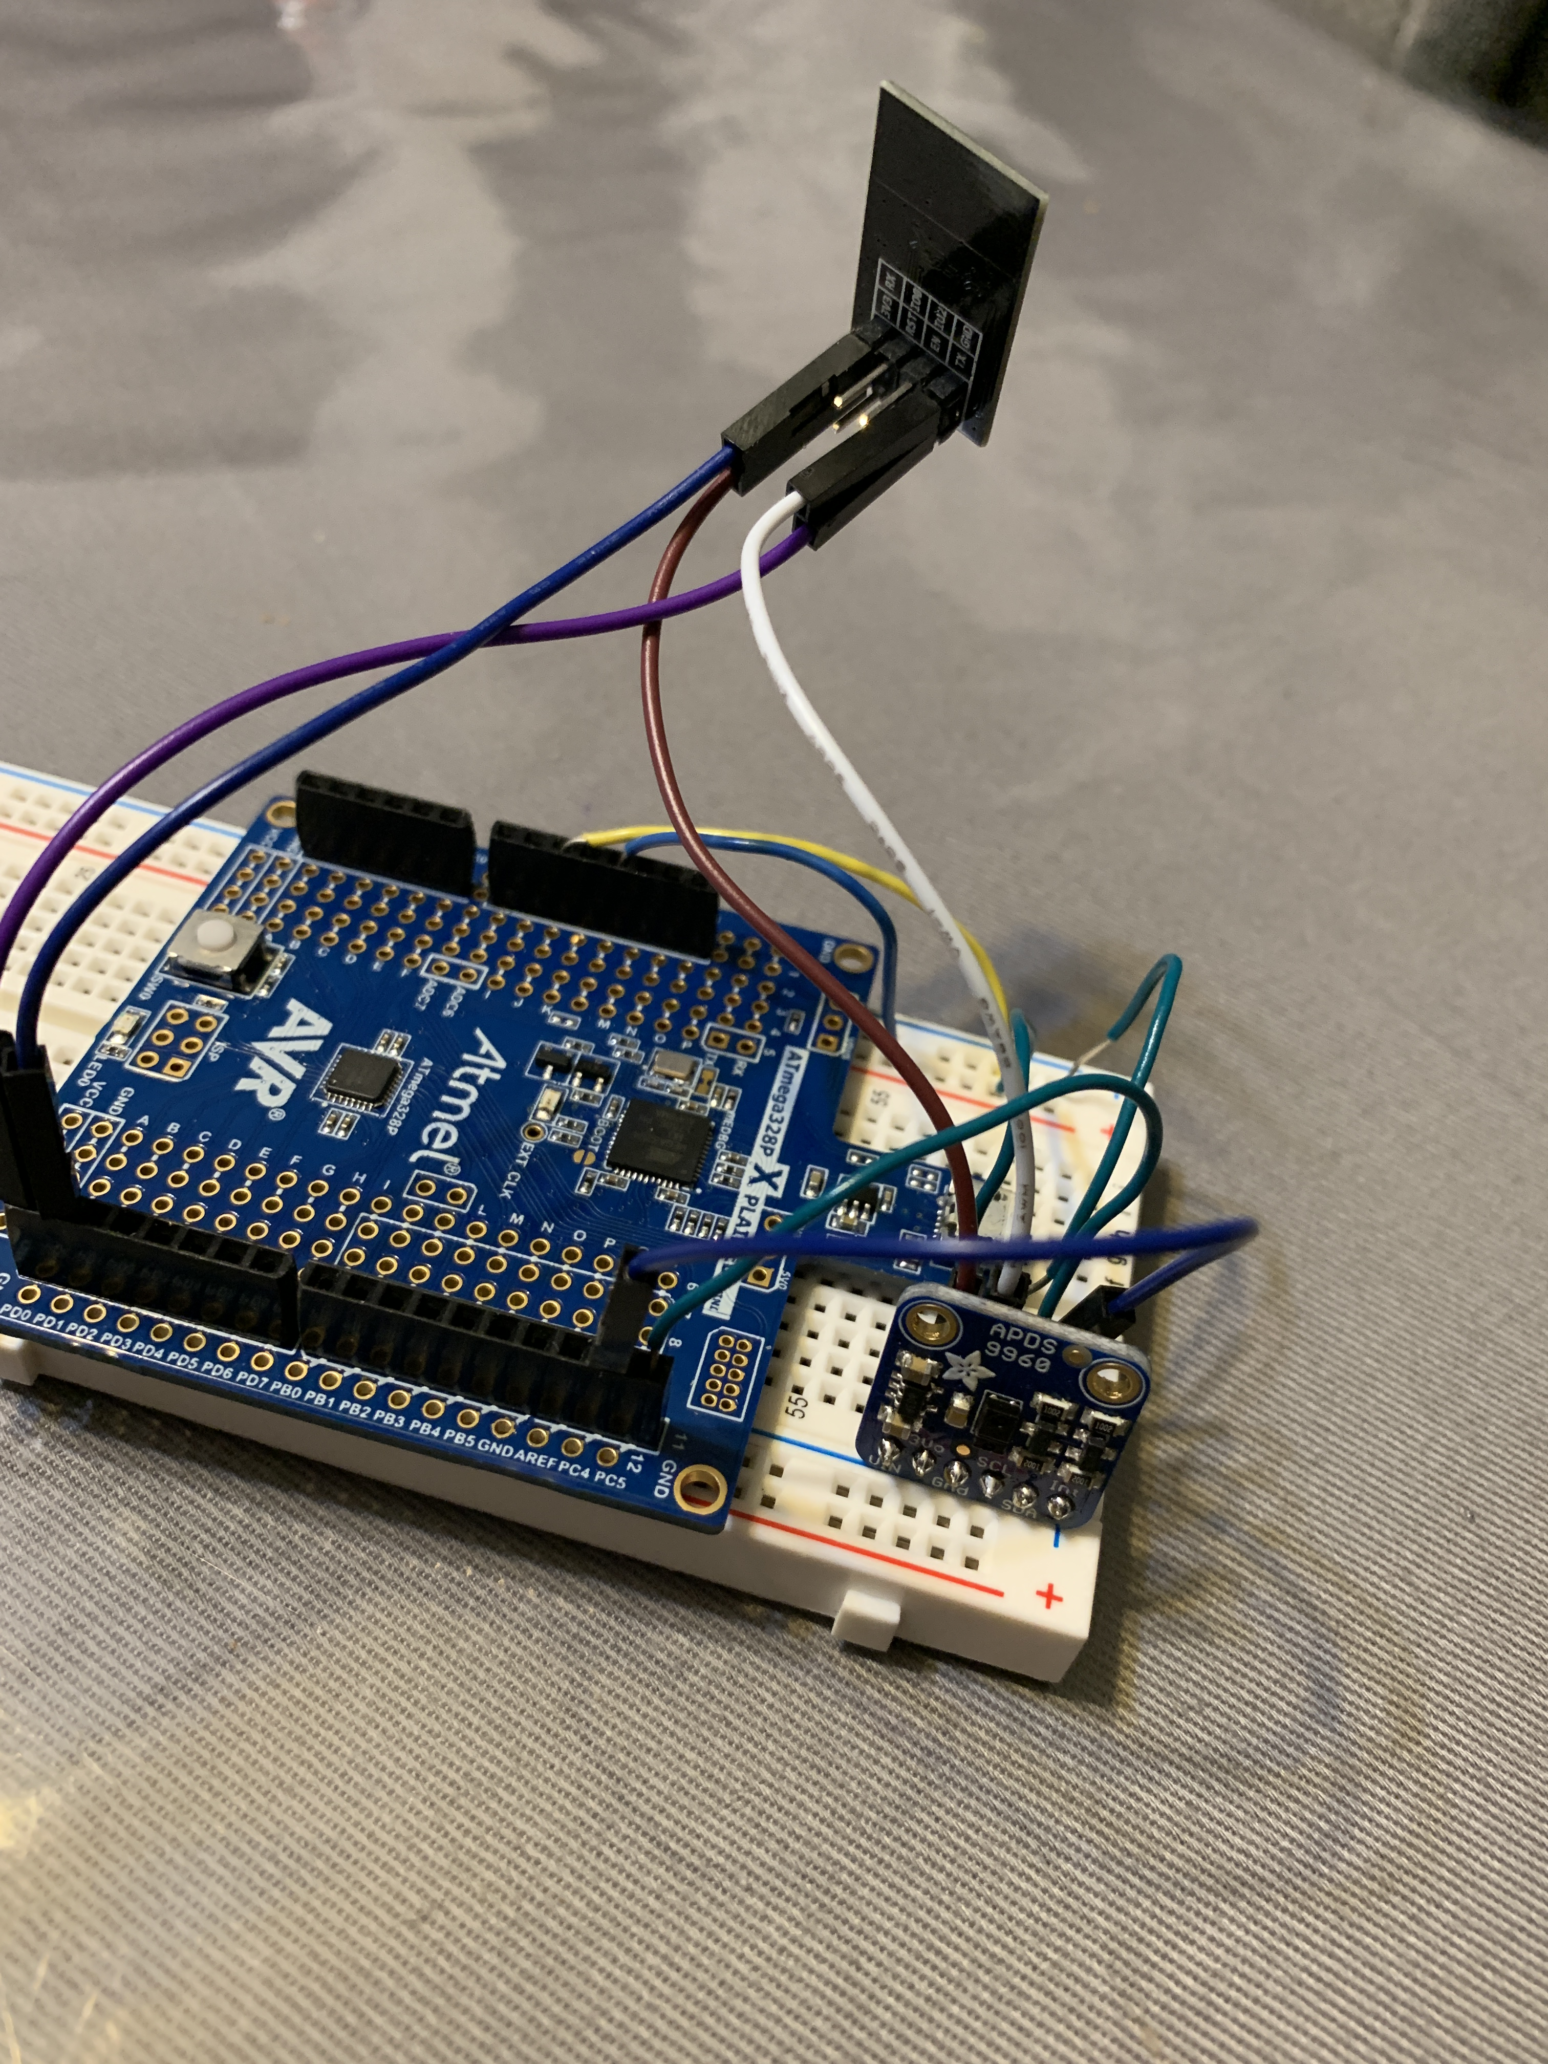

1. **VIDEO LINKS OF EACH DEMO**

<https://youtu.be/Fwgln-hfr2Q>

1. **GITHUB LINK OF THIS DA**

<https://github.com/martiv6/>midterms/Midterm_2

**Student Academic Misconduct Policy**

<http://studentconduct.unlv.edu/misconduct/policy.html>

“This assignment submission is my own, original work”.

Victor Martinez