CPE301 – SPRING 2019

Design Assignment 1

Student Name: Victor Martinez

Student #:5003131674

Student Email: martiv6@unlv.nevada.edu

Primary Github address: https://github.com/martiv6/submissions_da

Directory: DA1A

1. **COMPONENTS LIST AND CONNECTION BLOCK DIAGRAM w/ PINS**

NA

1. **INITIAL/MODIFIED/DEVELOPED CODE OF TASK 1/A**

LDI R17, 0 //used if there is carry

LDI R18, 0 //where the MSB will be stored

LDI R19, 0 //where the middle values will be stored if more than 8 bits

LDI R20, 0 //where the LSB will be stored

LDI R22, 0x45 // the value of the 8 bit multiplier (69)

LDI R24, 0x1D // the first 8 bits of the 16 bit multiplicand

LDI R25, 0x35 // the last 8 bits of the 16 bit multiplicand(7477)

// this is were it will loop adding the values until R22 is equal to 0

pizza: ADC R20, R25 // puts the LSB in R20

ADC R19, R24 // puts the next values in R19

ADC R18, R17 // adds zero and any carry from the additions

DEC R22 // subtracts one from R22 until it hits 0

BRNE pizza // ends loop when equal to zero

end: BREAK // if loops doesnt stop this will make sure it does

1. **DEVELOPED MODIFIED CODE OF TASK 2/A from TASK 1/A**
2. **SCHEMATICS**

NA

1. **SCREENSHOTS OF EACH TASK OUTPUT (ATMEL STUDIO OUTPUT)**

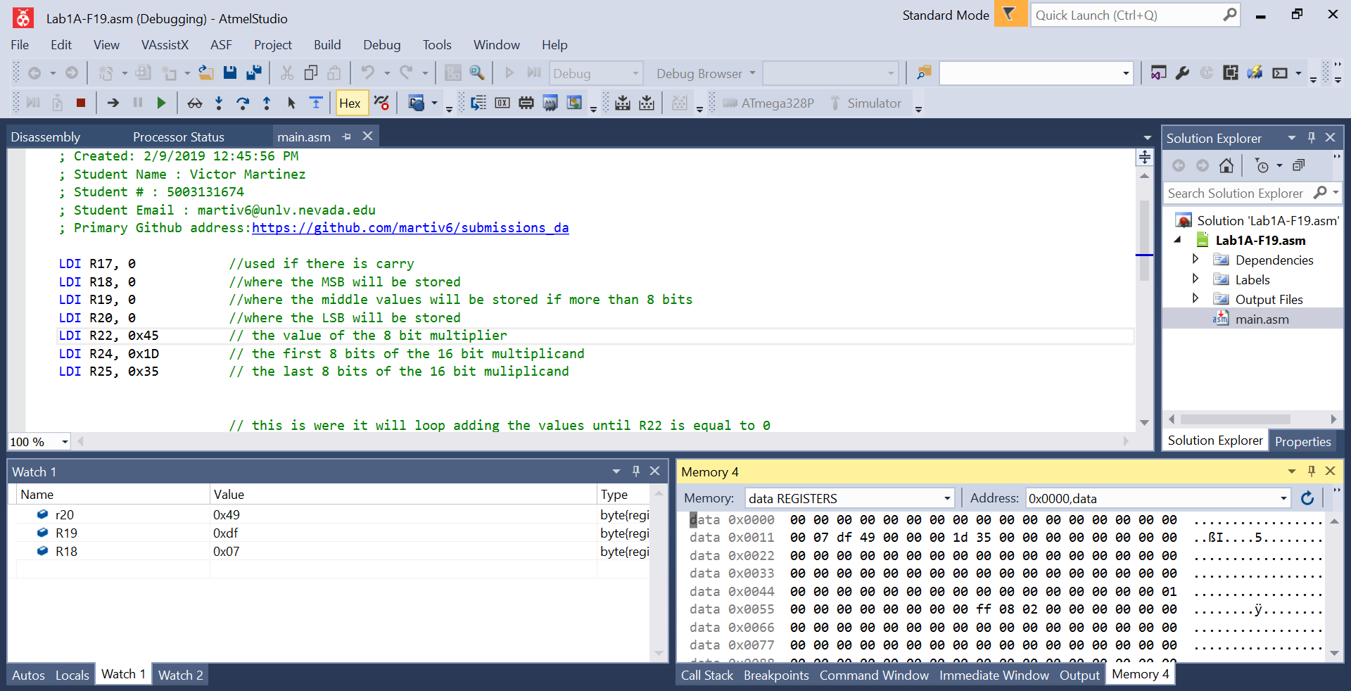



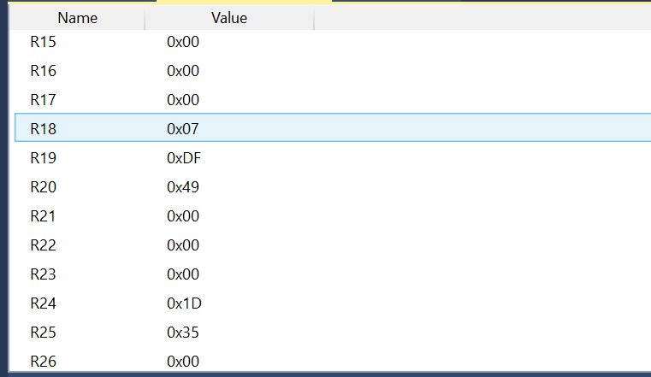07DF49=515913 checks ou



Verification with MUL

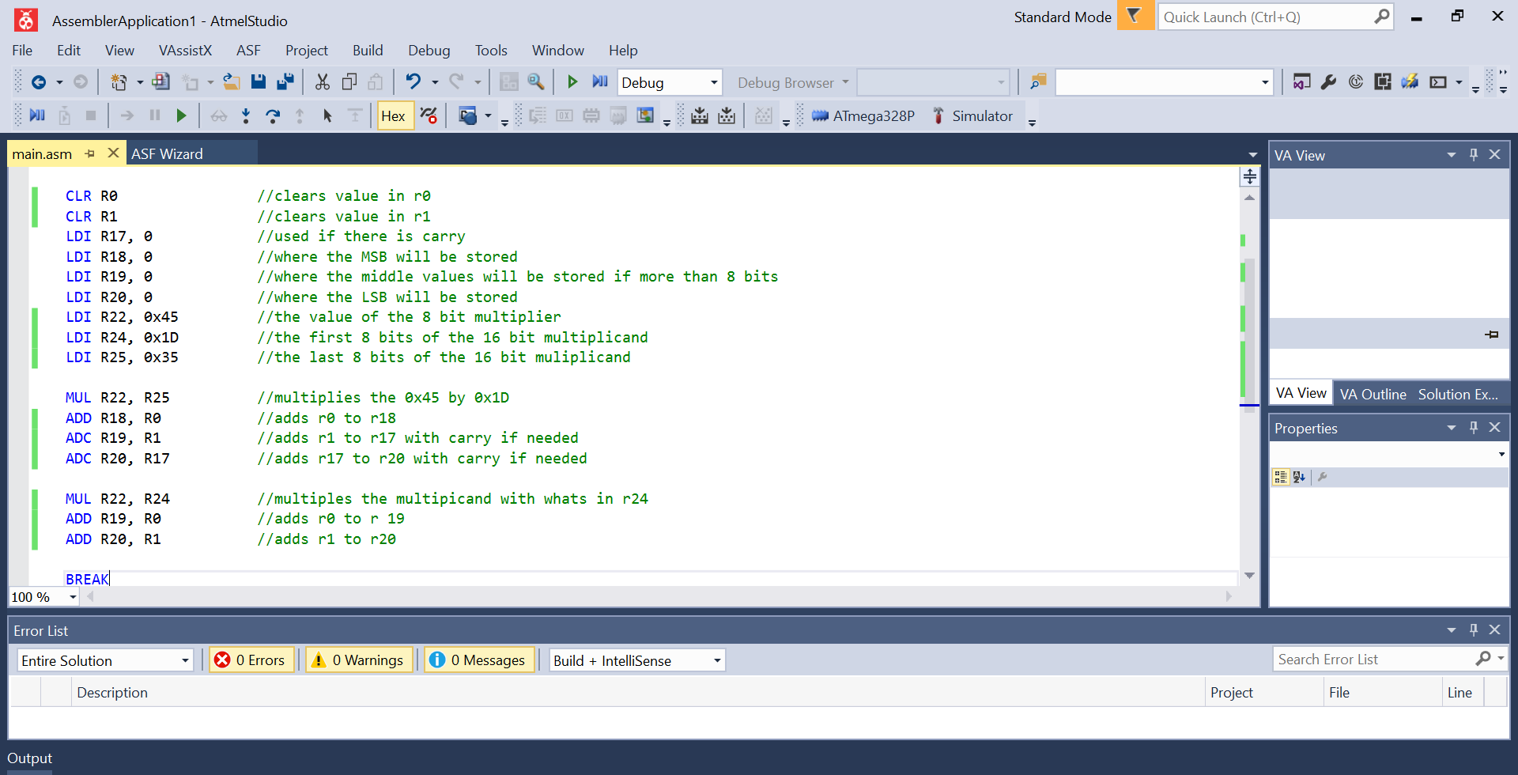

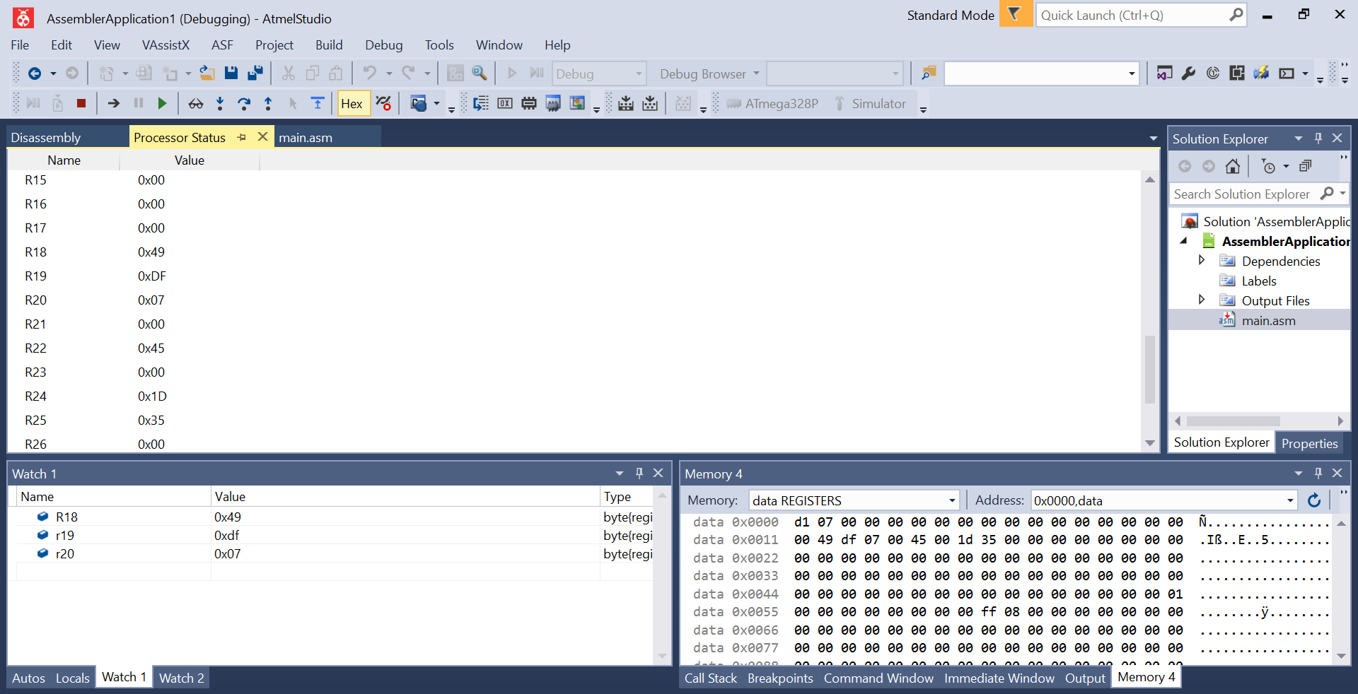



With this we see that my code does multiply without needing the mul function. I did the register backwards.

1. **SCREENSHOT OF EACH DEMO (BOARD SETUP)**

NA

1. **VIDEO LINKS OF EACH DEMO**

NA

1. **GITHUB LINK OF THIS DA**

https://github.com/martiv6/submissions_da/tree/master/DesignAssignment/DA1A

**Student Academic Misconduct Policy**

<http://studentconduct.unlv.edu/misconduct/policy.html>

“This assignment submission is my own, original work”.

Victor Martinez