CPE301 – SPRING 2019

Design Assignment 3

Student Name: Victor Martinez

Student #: 5003131674

Student Email: [martiv6@unlv.nevada.edu](mailto:martiv6@unlv.nevada.edu)

Primary Github address: https://github.com/martiv6

Directory: https://github.com/martiv6/submissions_da/tree/master/DesignAssignment/DA3

Submit the following for all Labs:

1. In the document, for each task submit the modified or included code (only) with highlights and justifications of the modifications. Also, include the comments.
2. Use the previously create a Github repository with a random name (no CPE/301, Lastname, Firstname). Place all labs under the root folder ESD301/DA, sub-folder named LABXX, with one document and one video link file for each lab, place modified asm/c files named as LabXX-TYY.asm/c.
3. If multiple asm/c files or other libraries are used, create a folder LabXX-TYY and place these files inside the folder.
4. The folder should have a) Word document (see template), b) source code file(s) and other include files, c) text file with youtube video links (see template).

1. **COMPONENTS LIST AND CONNECTION BLOCK DIAGRAM w/ PINS**

PC

FDTI

BREAD

BOARD

328P

Mini

POWERSUPPLY

1. **INITIAL/MODIFIED/DEVELOPED CODE OF TASK 1/A**

/*

* DA3A.c

*

* Created: 3/25/2019 6:14:06 PM

* Author : martiv6

*/

#define *F_CPU* 16000000UL

#include <avr/io.h>

#include <util/delay.h>

#include <stdio.h>

#include <avr/interrupt.h>

#define BAUDRATE 9600

#define BAUD_PRESCALLER ( (*F_CPU* /BAUDRATE/16UL) - 1)

// Function that need to be declared

char luke[] = " "; // declares the amount of spaces between words and numbers

char outs[30]; // the amount of spaces thats displayed

char str[] = "YOUR FATHER"; // declare the string and hold value for 'your father'

float pizza=3.14666; // declare the floating point and assign the value

int darth; // the variable that holds the random integer

volatile int counter; // counter to use when using timer0 and calculate when to make 1 second delay

void USART_init( unsigned int ubrr ); // calls integer

void USART_tx_string( char *data ); // calls string

int main(void)

{

counter=0; // sets counter to zero to begin counting

TIMSK0 |= (1<<TOIE0); // sets timer0

sei();

TCCR0A = 0b0000; // sets to normal mode

TCCR0B |= (0b0001<<CS02)|(0b0001<<CS00); // sets prescaler to 1024

USART_init(BAUD_PRESCALLER); // Initialize the USART

USART_tx_string("Connected!\r\n"); // shows that it is ready to display

USART_tx_string(luke); // puts space to seprate

while(1);

}

ISR(TIMER0_OVF_vect)

{

while(counter < 61) // counts and keeps counting until gets over amount to then display

if((TIFR0 & 0b0001)==1)

{

TIFR0=0b0001;

counter++;

}

if (counter>60)

{

USART_tx_string(str); // displays the string value

USART_tx_string(luke); // puts space between number and words

darth= rand(); // gets value for random number

pizza= 3.14666; // value of float

*snprintf*(outs, sizeof(outs), "%3d\r\n", darth); // prints out the random number

USART_tx_string(outs); // makes room for things to be printed

USART_tx_string(luke); // displays the space between values

dtostrf(pizza, 1, 4, outs); // prints out 1 number before decimal and prints 4 after the decimal

USART_tx_string(outs); // makes room for things to be printed

USART_tx_string(luke); // displays the space between values

counter=0; // restarts counter

}

}

/* INIT USART (RS-232) */

void USART_init( unsigned int ubrr )

{

UBRR0H = (unsigned char)(ubrr>>8);

UBRR0L = (unsigned char)ubrr;

/* Enable UART receiver and transmitter */

UCSR0B = ((1<<RXEN0) | (1<<TXEN0) | (1<<RXCIE0));

UCSR0C = (1<<UCSZ01)|(1<<UCSZ00); //asynchronous 8 N 1

}

/* SEND A STRING TO THE RS-232 */

void USART_tx_string( char *data )

{

while ((*data != '\0'))

{

while (!(UCSR0A & (1 <<UDRE0)));

UDR0 = *data;

data++;

}

}

1. **DEVELOPED MODIFIED CODE OF TASK 2/A from TASK 1/A**

**n/a**

1. **SCHEMATICS**

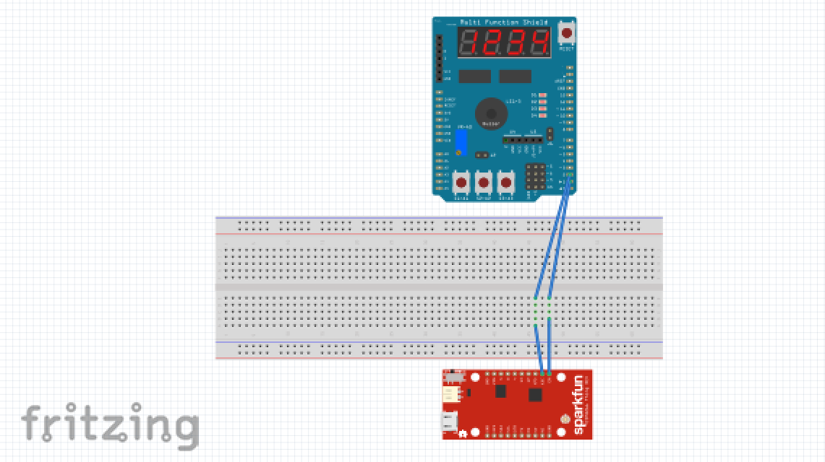

1. **SCREENSHOTS OF EACH TASK OUTPUT (ATMEL STUDIO OUTPUT)**

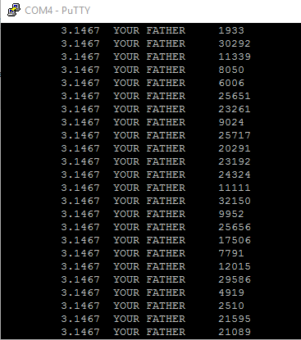

1. **SCREENSHOT OF EACH DEMO (BOARD SETUP)**

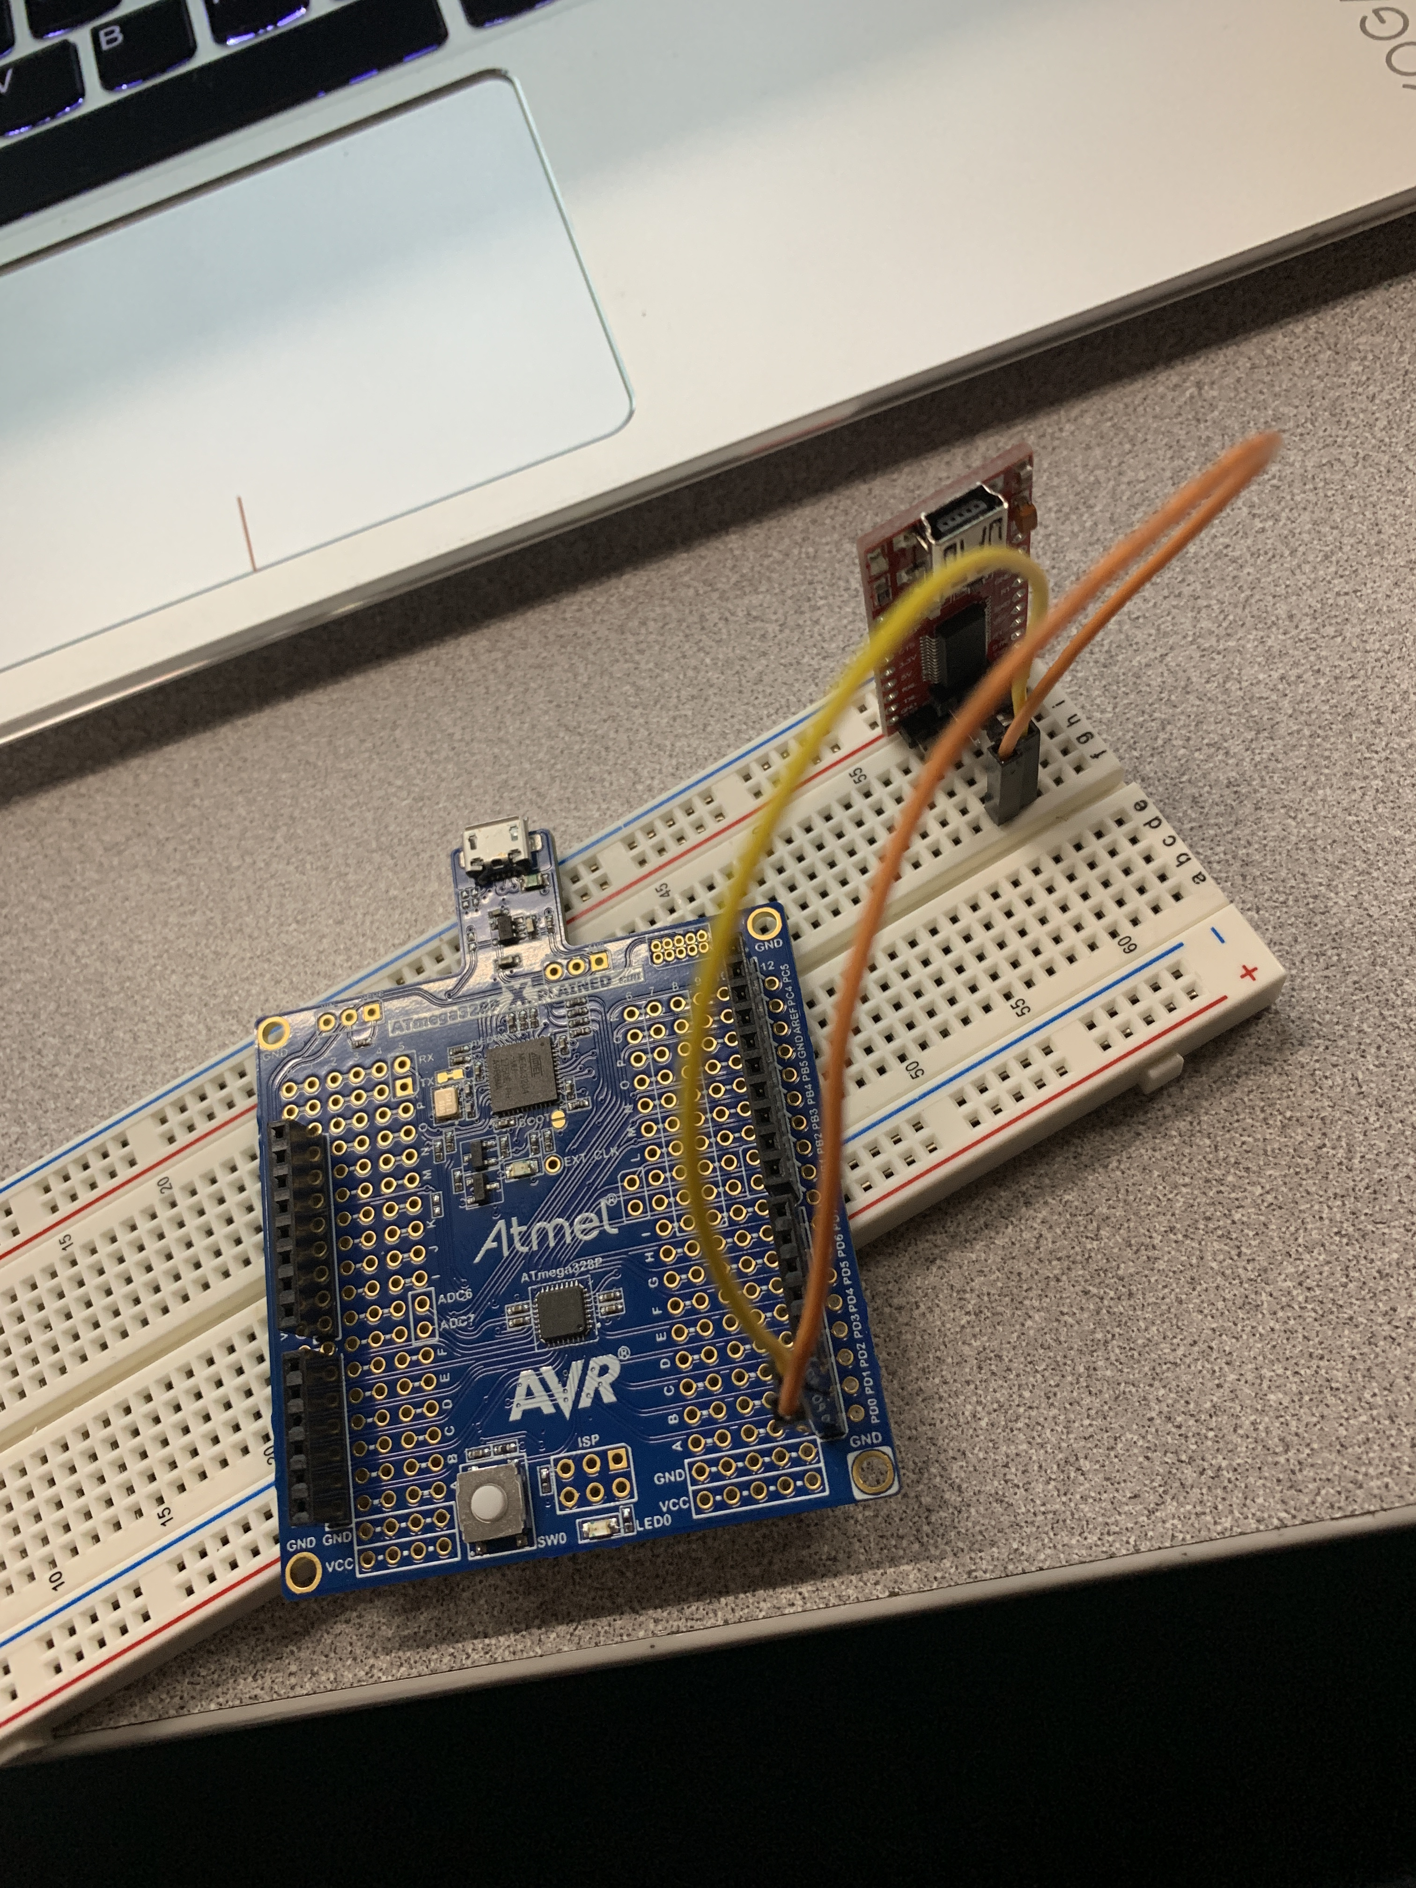

1. **VIDEO LINKS OF EACH DEMO**

<https://youtu.be/J2IrEKffPNU>

1. **GITHUB LINK OF THIS DA**

<https://github.com/martiv6/submissions_da/tree/master/DesignAssignment/DA3>

**Student Academic Misconduct Policy**

<http://studentconduct.unlv.edu/misconduct/policy.html>

“This assignment submission is my own, original work”.

VICTOR MARTINEZ