**Myanmar – PiN snapshot**

## **Children in Need (5-17 y.o.)**

|  |  |
| --- | --- |
| **37.1% amounts to 1.1M children in Need** |  |

## Population groups

* ocap: 33.5% are in need, which amounts to 827K children.
* idp: 63.2% are in need, which amounts to 143K children.
* ret: 57.8% are in need, which amounts to 66K children.
* ndsp: 68.0% are in need, which amounts to 15K children.

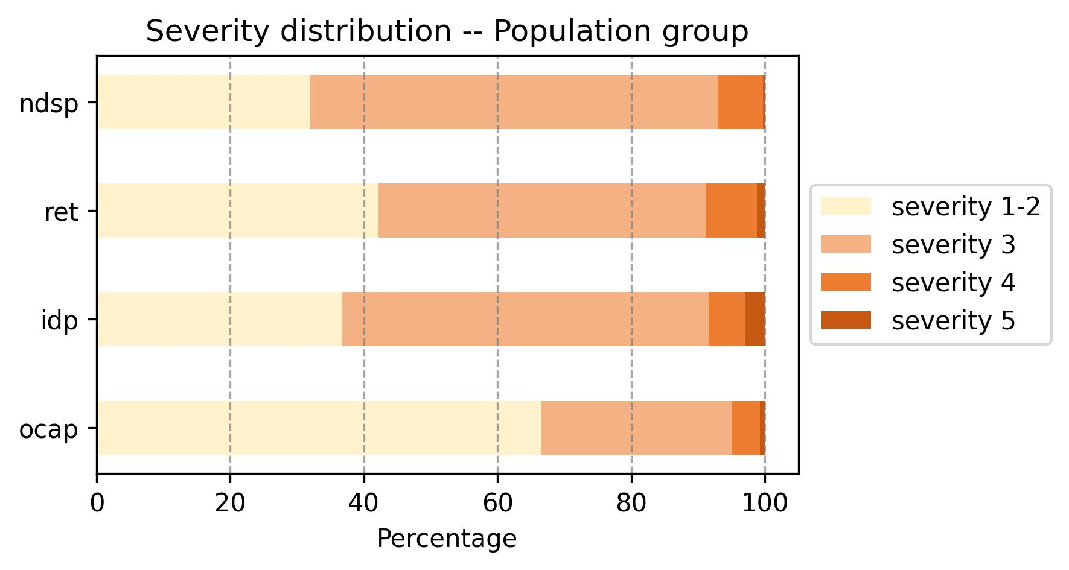

## Profile of children in need

This section provides an overview of different age groups and specific vulnerable groups of children in need.

|  |  |
| --- | --- |
|  |  |

The numbers below reflect the estimated total number of children in need in each category.

5 y.o. children in need: 108K  
Primary school-aged children in need: 404K  
Upper Primary school-aged children in need: 323K  
Secondary school-aged children in need: 243K  
Children with disability in need: 105K

## **Profile of Needs in Myanmar**

By examining the four main dimensions of need—Access, Learning Conditions, Protected Environment, and Aggravating Circumstances—we can identify the most common needs and better understand the support required for children in need. Among children aged 5 to 17 years:  
27.7% lack access to school  
4.0% are affected by aggravating circumstances  
3.9% experience poor learning conditions  
1.4% attend school in unsafe environments.

The variation in needs across different population groups is noteworthy:

* ocap: 24.4% lack access to school, 24.4% face aggravating circumstances, 4.0% experience poor learning conditions, and 1.0% attend school in unsafe environments.
* idp: 51.4% lack access to school, 51.4% face aggravating circumstances, 3.4% experience poor learning conditions, and 5.2% attend school in unsafe environments.
* ret: 45.8% lack access to school, 45.8% face aggravating circumstances, 3.1% experience poor learning conditions, and 1.8% attend school in unsafe environments.
* ndsp: 60.0% lack access to school, 60.0% face aggravating circumstances, 0.9% experience poor learning conditions, and 5.2% attend school in unsafe environments.

This data highlights the differing educational needs among these vulnerable groups.