Terms of Reference
Integrated Public Health Rapid Assessment (IPHRA)
20688

Table of Contents
Right-click and update field to generate table of contents.
List of Figures
Right-click and update field to generate table of figures.
List of Tables
Right-click and update field to generate table of tables.

1. Executive Summary
Country of intervention | Type of Emergency | Type of Crisis | Mandating Body/ Agency | IMPACT Project Code
 |  |  | Example Agency
Geographic Coverage | Population(s) | Stratification
 |  | [Specify stratification, e.g. by geographic area, population group, etc.]
Rationale

1.1 Tools and Methods
Tool | Sampling.Method | Sample.Size
 |  | 0

1.2 Research Timeline
No timeline milestones available.

1.3 Dissemination
Audience Type | Expected Output Type | Dissemination Strategy | Access | Visibility
Cluster(s)
Donor(s)
Operational Actor(s)
Other(s)

2. Rationale
 Note
Reviewer Note: Please take time to complete sections 2.1 and 2.2 to clearly explain the context in which the assessment would be conducted, key information needs, and the intended impact of the assessment.

2.1 Background
- Briefly describe the context, i.e. the crisis within which the IPHRA is planned.
- Information gap and needs i.e. what is known so far about the severity of the public health situaiton and coverage of core public health interventions, what remains to be known and why

2.2 Intended Impact
- Who are the key actors/ what are the key decision-making processes and milestones this research aims to inform?
- What would be the impact of this research be on at least one of the following: (1) Bringing about positive change in the day-to-day lives of the population of interest (2) Improving understanding of the current situation to inform ongoing or planned humanitarian interventions (3) Improving understanding of the current situation to inform strategic decision-making processes, including funding allocations (4) Contributing towards system-wide change

3. Goals and Objectives
Goal: To assess the severity of the public health outcomes and identify initial public health priorities for response to mitigate excess morbidity, malnutrition, and mortality.

3.1 Specific Objectives and Research Questions
Table 1: Specific objectives and research questions
Pillar | Sub.Pillar | Objective | Research.Question

4. Methodology
The general research design for the Integrated Public Health Rapid Assessment (IPHRA) (1) will consist of a mixed-methods approach constituting three main methods: household surveys; Key Informant Interviews (KIIs); and observation checklists, each of these methods having core and supplemental specialized tools and information that can be collected.

4.1 Methodology Overview
PLEASE SPECIFY METHODOLOGY HERE.

4.2 Population of Interest
The geographic coverage of the assessment includes: [Specify geographic coverage]. The total population consists of [Specify total population size] people with approximately [Specify total population size included in the survey if different from total population size] people included in the survey and approximately [Specify total population size excluded from the survey if different from total population size] people excluded from the survey.

4.3 Secondary Data Review
The main assessment design is based off guidance documents and tools for Integrated Public Health Rapid Assessment (IPHRA), available on the IMPACT Intranet (soon, link to intranet). Secondly, the IPHRA toolkit is designed to align with the Acute Needs Framework (ANF) utilized by IMPACT Initiatives in their Acute Needs Analysis workstreams (2). The intention of the Secondary Data Review step is to identify existing data sources for various ANF Pillars and Sub-Pillars, and to identify data gaps which will inform the design of the primary data collection component of the IPHRA. The below figure illustrates the ANF framework and how it maps against the planned primary data collection, as well as secondary data sources planned to be utilized for this assessment.
Figure: Acute Needs Framework (ANF) and Data Collection Mapping
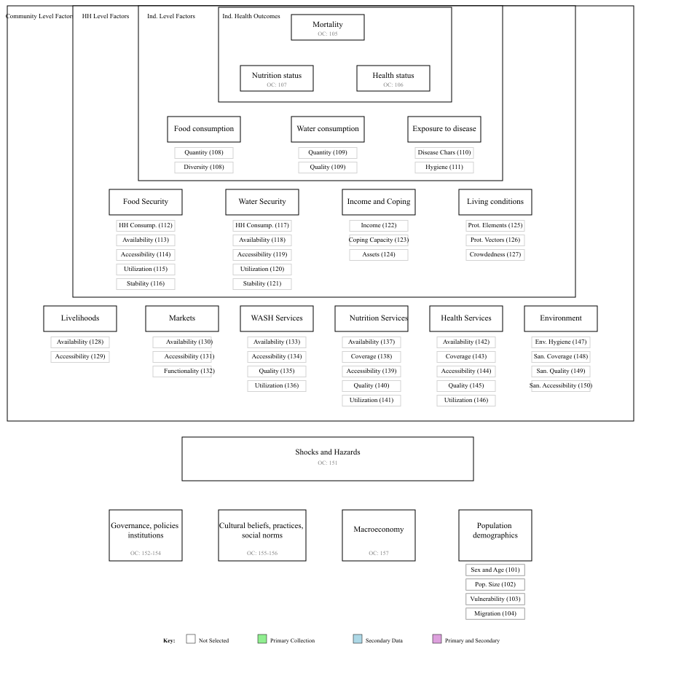
Acute Needs Framework (ANF) and Data Collection Mapping
The below table cites relevant secondary data sources for each of the ANF Pillars and Sub-Pillars, as well as the purpose for which each data source will be utilized in the assessment.
Table 1. Secondary Data Sources
Objective | Source | Purpose

4.4 Key Definitions
Within this population, specific indicators will target sub-populations. All eligible sub-populations within sampled households will be included in the survey. Sub-populations for indicators include:
- Household Definition: A group of people who ate from the same cooking and slept under the same roof the previous night

4.5 Primary Data Collection

4.5.1 Household Surveys
There are several core and supplemental indicators within the household tool of the IPHRA toolkit. For the objectives of thisthis assessment the following are planned:
Pillar | Sub.Pillar | Indicator

4.5.1.1 Sample Size Calculations
Household sample size calculations were done in R version 4.5.1 (2025-06-13 ucrt) and made using a 95% confidence level and the following sampling parameters summarized in the table below, resulting in a final target sample size of 400 households.
The sample size for the general household survey was calculated using the parameters in the table below:
Note
Reviewer Note: Please add justifications to the sample size tables to explain why each parameter was selected for sampling.

Table 2. General sample size calculation parameters
Parameter | Value | Justification
Indicator Name
Sampling Design
Estimated Prevalence (%)
Desired Precision
Estimated population size
Design Effect
Finite Population Correction (FPC) used?
Non-Response Rate
Households to be Included

4.5.1.2 Site Selection Methods

4.5.1.3 Household Selection Methods

4.5.1.4 Team Composition, Training and Planning
The exact composition of teams will depend on the number of tools being implemented. For household surveys, teams will consist of one field supervisor and 3 enumerators. Where possible, teams should incorporate a mix of male and female enumerators. For key informant and observational tools, dedicated enumerators separate from the household survey enumerators will be selected and trained to implement them. One enumerator should not implement more than one or two specific tools to ensure adequate time for use in the field and data quality.
Teams will receive a base three-day training prior to data collection covering purpose of the survey, good interview practices and ethical conduct during public health assessment, field sampling procedures, and review of the survey, key informant and observational tools, and a one-day for pilot and planning activities. It is recommended to divide the team for separate tool review sessions to efficiently make use of training time.
Field supervisors will have a key role in ensuring research quality during data collection. Key responsibilities will include:
- Providing daily feedback sessions to the data collection team
- Monitoring completion of assessment against planned targets
- Completing cluster control forms
- Ensuring proper household sampling techniques are applied
- Providing supportive supervision to enumerators

4.6 Data Processing and Analysis
Template data collection tools with Kobo have been adapted for this assessment. Both quantitative and qualitative data will be collected using KoboCollect on Android devices and uploaded to a Kobo server.

4.6.1 Household Survey Data
Household data will be collected using a contextualized IPHRA KoboCollect tool. Cleaning, indicator calculations, and analysis will be done using a pre-prepared IPHRA application using R version 4.5.1 (2025-06-13 ucrt).
PLEASE SPECIFY ANALYSIS METHODS HERE.
Table 3. Example Integrated Analysis Table
Category | Pillar | Sub-Pillar | Group 1 | Group 2 | Group 3
Health Outcomes  (Individual Level) | Population Mortality | NA | High | Medium | Low
Health Outcomes  (Individual Level) | Nutritional Status | NA | Medium | High | Medium
Health Outcomes  (Individual Level) | Health Needs | NA | Low | Medium | High
Immediate Drivers  (Individual Level) | Food Consumption | Quantity | Medium | High | Medium
Immediate Drivers  (Individual Level) | Food Consumption | Quality | High | Medium | Low
Immediate Drivers  (Individual Level) | Water Consumption | Quantity | Medium | Low | High
Immediate Drivers  (Individual Level) | Water Consumption | Quality | Low | Medium | Medium
Immediate Drivers  (Individual Level) | Exposure to Disease | Reproductive Numbers | High | Medium | Low
Immediate Drivers  (Individual Level) | Exposure to Disease | Hygiene | Not assessed | Not assessed | Not assessed
Direct Contributing Factors  (Household Level) | Household Food Security | HH Food Consumption | Medium | High | Low
Direct Contributing Factors  (Household Level) | Household Food Security | Availability | High | Medium | Medium
Direct Contributing Factors  (Household Level) | Household Food Security | Accessibility | High | Low | High
Direct Contributing Factors  (Household Level) | Household Food Security | Utilization | Medium | Medium | High
Direct Contributing Factors  (Household Level) | Household Food Security | Stability | Low | High | Medium
Direct Contributing Factors  (Household Level) | Household Water Security | HH Water Consumption | Medium | High | Low
Direct Contributing Factors  (Household Level) | Household Water Security | Availability | High | Medium | Medium
Direct Contributing Factors  (Household Level) | Household Water Security | Accessibility | Medium | Low | High
Direct Contributing Factors  (Household Level) | Household Water Security | Utilization | Low | Medium | Medium
Direct Contributing Factors  (Household Level) | Household Water Security | Stability | Not assessed | High | Low
Direct Contributing Factors  (Household Level) | HH Income and Coping | Income | Not assessed | Not assessed | Not assessed
Direct Contributing Factors  (Household Level) | HH Income and Coping | Coping Capacity | Medium | Low | High
Direct Contributing Factors  (Household Level) | HH Income and Coping | Assets | Low | Medium | Medium
Direct Contributing Factors  (Household Level) | Living Conditions | Protection from Elements | Medium | High | Low
Indirect Contributing Factors  (Community Level) | Living Conditions | Protection from Vectors | High | Medium | Medium
Indirect Contributing Factors  (Community Level) | Living Conditions | Crowdedness | Medium | Low | High
Indirect Contributing Factors  (Community Level) | Livelihoods | Availability | Low | Medium | High
Indirect Contributing Factors  (Community Level) | Livelihoods | Accessibility | Medium | High | Medium
Indirect Contributing Factors  (Community Level) | Markets | Availability | High | Medium | Low
Indirect Contributing Factors  (Community Level) | Markets | Accessibility | Medium | High | Medium
Indirect Contributing Factors  (Community Level) | Markets | Functionality | Low | Medium | High
Indirect Contributing Factors  (Community Level) | WASH Services | Availability | Medium | Low | High
Indirect Contributing Factors  (Community Level) | WASH Services | Accessibility | High | Medium | Medium
Indirect Contributing Factors  (Community Level) | WASH Services | Quality | Medium | High | Low
Indirect Contributing Factors  (Community Level) | WASH Services | Utilization | Low | Medium | Medium
Indirect Contributing Factors  (Community Level) | Nutrition Services | Coverage | Not assessed | High | Low
Indirect Contributing Factors  (Community Level) | Nutrition Services | Availability | Medium | Low | High
Indirect Contributing Factors  (Community Level) | Nutrition Services | Accessibility | High | Medium | Medium
Indirect Contributing Factors  (Community Level) | Nutrition Services | Quality | Medium | High | Low
Indirect Contributing Factors  (Community Level) | Nutrition Services | Utilization | Low | Medium | Medium
Indirect Contributing Factors  (Community Level) | Health Services | Coverage | High | Not assessed | Medium
Indirect Contributing Factors  (Community Level) | Health Services | Availability | Medium | High | Low
Indirect Contributing Factors  (Community Level) | Health Services | Accessibility | Low | Medium | High

4.7 Limitations
The IPHRA methodology is intended to be a rapid assessment toolkit to provide an indication of the most key public health outcomes and service coverage indicators compared to other more robust methods. Given the suggested IPHRA methods, there are a few limitations to keep in mind:
- Not a Causal Analysis – The intent of the IPHRA methods is to understand the severity of public health needs and service gaps, however given this focus it may not fully explain the reasons or causes of the results. Some analysis and triangulation with qualitative components may given an indication, but it will likely be limited.
- Likely Not Reaching Saturation – For the qualitative components, sample sizes are likely not adequate to reach a full saturation of responses in the population. The intent of these is to provide some light-touch information to triangulate with household survey results.
- Accessibility – IPHRA is not a hard-to-reach methodology, and should only be applied to populations which the assessment team can physically access.
- The sampling approach is not a cluster design and is intended for a more localized population, therefore the results may not be generalizable and representative of the wider population.

5. Key Ethical Considerations and Related Risks
Note
Reviewer Note: For any ethical consideration that is not met below, please specify any mitigation strategies and liaise with the Research Quality Unit (RQA).

The proposed research design meets / does not meet the following criteria:
Table 4. Ethical Considerations and Risks
The proposed research design... | Yes/No | Details if no (including mitigation)
... Has been coordinated with relevant stakeholders to avoid unnecessary duplication of data collection efforts?
... Respects respondents, their rights and dignity (specifically by: seeking informed consent, designing length of survey/discussion while being considerate of participants’ time, ensuring accurate reporting of information provided)?
... Does not expose data collectors to any risks as a direct result of participation in data collection?
... Does not expose respondents / their communities to any risks as a direct result of participation in data collection?
... Does not involve data collection with minors i.e. anyone less than 18 years old?
... Does not involve data collection with other vulnerable groups e.g. persons with disabilities, victims/survivors of protection incidents, etc.?
... Follows IMPACT SOPs for management of personally identifiable information?
... will assessment teams be aware of basic complaints and referral mechanisms in case needed during the course of the assessment?

6. Roles and Responsibilities
Table 5. RACI Matrix
Task Description | Responsible | Accountable | Consulted | Informed
Research design | Assessment Officer | Research Manager | IMPACT STU | IMPACT RQA
Supervising data collection | Field Officer | Assessment Officer | Research Manager | Country Representative
Data processing (checking, cleaning) | Data Officer | Assessment Officer | IMPACT STU | IMPACT RQA
Data analysis | Data Officer | IMPACT RQA | IMPACT STU | Assessment Officer
Output production | Assessment Officer | IMPACT RQA | IMPACT STU | Assessment Officer
Dissemination | Assessment Officer | Research Manager | IMPACT Comms | IMPACT STU
Monitoring & Evaluation | Assessment Officer | Research Manager | Country Representative | IMPACT MEL
Lessons learned | Assessment Officer | IMPACT STU | Research Manager | IMPACT MEL

7. Data Analysis Plans (DAPs)

7.1 Household Tool DAP
Table 6. Household Tool DAP
Research Question | Indicator Name | Disaggregation | Question | Responses | Data Collection Level

8. References
1. IMPACT Initiatives. Integrated public health rapid assessment (IPHRA) guidelines. Geneva, Switzerland: IMPACT Initiatives; 2026.
2. IMPACT Initiatives. The acute needs framework. Geneva, Switzerland: IMPACT Initiatives; 2026.

