HomeOffice_Main_Analysis

Marton Kovacs

08 August, 2020

# Install packages

library(tidyverse)

# Source R scripts

r_scripts <- list.files("R/", full.names = TRUE)  
walk(r_scripts, source)

# Importing data

processed <- read_tsv("Data/Main/Processed/HomeOffice_Main_Processed_data.tsv")

# Descriptives

## Number of respondents

There are 704 individual responses used for the analysis.

## Median time of responding to the survey

processed %>%   
 mutate(duration_in_seconds = as.integer(duration_in_seconds)) %>%   
 summarise(median_resp = median(duration_in_seconds) / 60)

## # A tibble: 1 x 1  
## median_resp  
## <dbl>  
## 1 5.09

# Background information

## Data preprocessing

Variables that we will use to create the subgroups for the background information.

subvars <- c("position", "area_of_research", "wokrplace_type", "data_coll_remote", "gender", "age", "edu_duties", "team_work", "partner_work", "living_sit", "homeschool", "childcare_help", "work_home_dist", "office_setup", "number_of_children")

We transform all the background information questions to character and replace NAs with “not applicable”. We will use these as subgroup labels only in the following.

processed <-  
 processed %>%   
 mutate_at(all_of(subvars),  
 as.character) %>%   
 mutate_at(all_of(subvars),  
 replace_na, "not applicable")

Calculating the counts and proportions of each subgroup. *note: There is a position NA subgroup which was not an answer option in the survey but based on one respondents comment we dropped his answer to this question.*

background_inf <-  
 tibble(subvars = subvars) %>%   
 mutate(subgroup_desc = purrr::map(subvars, subgroup_count)) %>%   
 select(subvars, subgroup_desc) %>%   
 unnest(subgroup_desc) %>%   
 select(-N) %>%   
 mutate(subvars = case_when(subvars == "position" ~ "Academic position",  
 subvars == "area_of_research" ~ "Area of research",  
 subvars == "wokrplace_type" ~ "Workplace type",  
 subvars == "data_coll_remote" ~ "Data collection remotely",  
 subvars == "gender" ~ "Gender",  
 subvars == "age" ~ "Age",  
 subvars == "edu_duties" ~ "Educational duties",  
 subvars == "team_work" ~ "Team work",  
 subvars == "partner_work" ~ "Partner working",  
 subvars == "living_sit" ~ "Living situation",  
 subvars == "homeschool" ~ "Homeschooling",  
 subvars == "childcare_help" ~ "Help with childcare",  
 subvars == "work_home_dist" ~ "Work-home distance",  
 subvars == "office_setup" ~ "Home office setup",  
 subvars == "number_of_children" ~ "Number of children")) %>%   
 rename(`Background information question` = subvars,  
 Subgroups = levels,  
 `Number of respondents in the subgroup` = n,  
 Proportion = prop)

papaja::apa_table(  
 background_inf,  
 caption = "A Full Summary of All Background Information",  
 escape = TRUE  
)

(#tab:unnamed-chunk-8)

*A Full Summary of All Background Information*

|  |  |  |  |
| --- | --- | --- | --- |
| Background information question | Subgroups | Number of respondents in the subgroup | Proportion |
| Academic position | not applicable | 1 | 0.14 |
| Academic position | research assistant | 14 | 1.99 |
| Academic position | non-academic researcher | 38 | 5.40 |
| Academic position | PhD student | 72 | 10.23 |
| Academic position | postdoc | 72 | 10.23 |
| Academic position | assistant professor | 126 | 17.90 |
| Academic position | associate professor | 172 | 24.43 |
| Academic position | full professor | 209 | 29.69 |
| Area of research | Earth & Space Sciences | 2 | 0.28 |
| Area of research | Formal Sciences | 5 | 0.71 |
| Area of research | Physical Sciences | 5 | 0.71 |
| Area of research | Other | 63 | 8.95 |
| Area of research | Life Sciences | 98 | 13.92 |
| Area of research | Social Sciences | 531 | 75.43 |
| Workplace type | Purely educational institute | 14 | 1.99 |
| Workplace type | None of them | 21 | 2.98 |
| Workplace type | Purely research institute | 57 | 8.10 |
| Workplace type | Research and educational institute | 612 | 86.93 |
| Data collection remotely | not applicable | 21 | 2.98 |
| Data collection remotely | No | 170 | 24.15 |
| Data collection remotely | Yes (including if someone else does it for me) | 513 | 72.87 |
| Gender | Other | 1 | 0.14 |
| Gender | Prefer not to say | 9 | 1.28 |
| Gender | Male | 338 | 48.01 |
| Gender | Female | 356 | 50.57 |
| Age | 75 - 84 | 6 | 0.85 |
| Age | Under 24 | 7 | 0.99 |
| Age | 65 - 74 | 48 | 6.82 |
| Age | 55 - 64 | 93 | 13.21 |
| Age | 25 - 34 | 150 | 21.31 |
| Age | 45 - 54 | 169 | 24.01 |
| Age | 35 - 44 | 231 | 32.81 |
| Educational duties | No | 138 | 19.60 |
| Educational duties | Yes | 566 | 80.40 |
| Team work | No | 331 | 47.02 |
| Team work | Yes | 373 | 52.98 |
| Partner working | No | 121 | 17.19 |
| Partner working | not applicable | 137 | 19.46 |
| Partner working | Yes | 446 | 63.35 |
| Living situation | Living with non-family others | 8 | 1.14 |
| Living situation | Single-parent with non-adult child(ren) | 23 | 3.27 |
| Living situation | Living with parents or other adult family members | 25 | 3.55 |
| Living situation | Other | 33 | 4.69 |
| Living situation | Living alone | 92 | 13.07 |
| Living situation | Living only with partner | 242 | 34.38 |
| Living situation | Living with partner and non-adult child(ren) | 281 | 39.91 |
| Homeschooling | Yes | 239 | 33.95 |
| Homeschooling | No | 465 | 66.05 |
| Help with childcare | Yes | 124 | 17.61 |
| Help with childcare | No | 227 | 32.24 |
| Help with childcare | not applicable | 353 | 50.14 |
| Work-home distance | >60 min | 89 | 12.64 |
| Work-home distance | 30-60 min | 196 | 27.84 |
| Work-home distance | <30 min | 419 | 59.52 |
| Home office setup | Underequipped | 260 | 36.93 |
| Home office setup | Fully equipped | 444 | 63.07 |
| Number of children | 12 | 1 | 0.14 |
| Number of children | 22 | 1 | 0.14 |
| Number of children | 7 | 1 | 0.14 |
| Number of children | 8 | 1 | 0.14 |
| Number of children | 5 | 3 | 0.43 |
| Number of children | 4 | 7 | 0.99 |
| Number of children | 3 | 41 | 5.82 |
| Number of children | 1 | 128 | 18.18 |
| Number of children | 2 | 163 | 23.15 |
| Number of children | 0 | 358 | 50.85 |

map(subvars, ~ apa_barplot(processed, .x))

## [[1]]

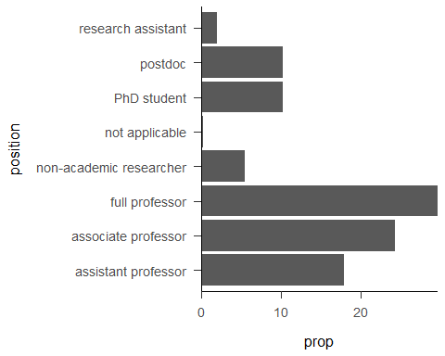

##   
## [[2]]

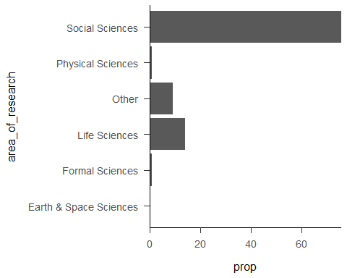

##   
## [[3]]

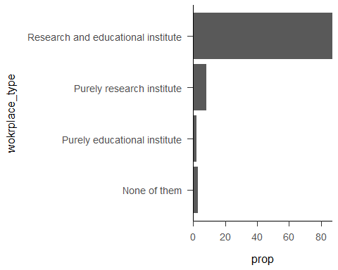

##   
## [[4]]

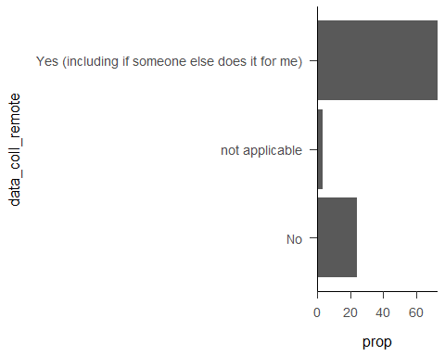

##   
## [[5]]

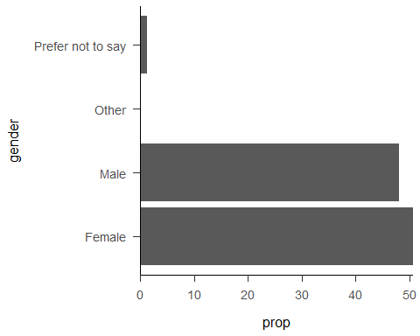

##   
## [[6]]

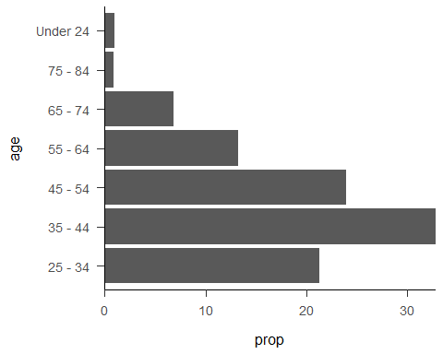

##   
## [[7]]

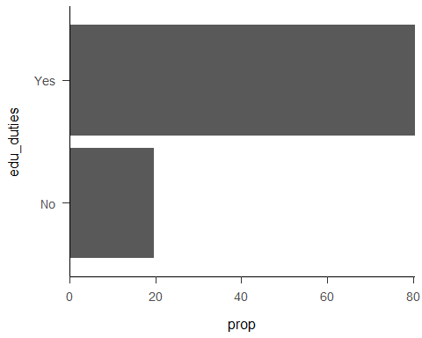

##   
## [[8]]

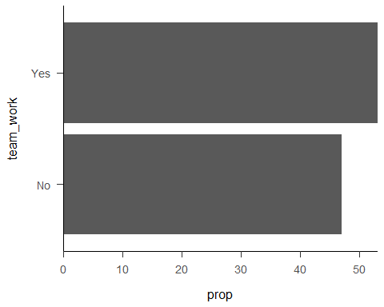

##   
## [[9]]

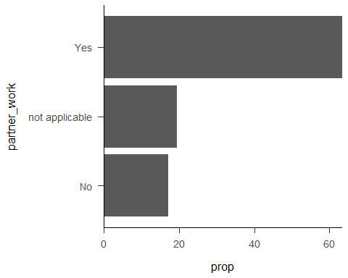

##   
## [[10]]

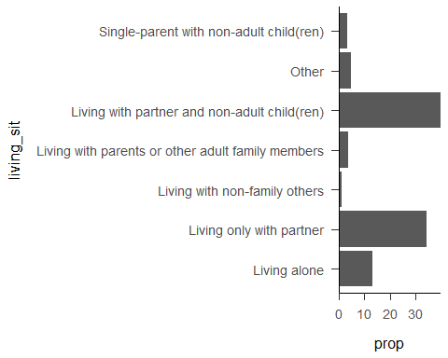

##   
## [[11]]

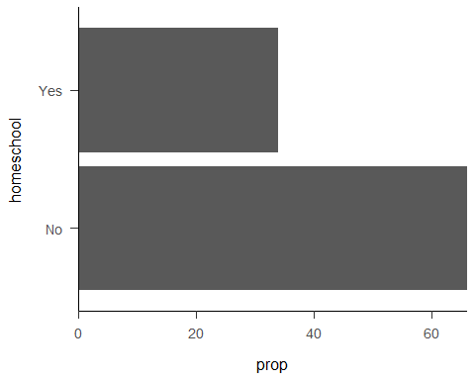

##   
## [[12]]

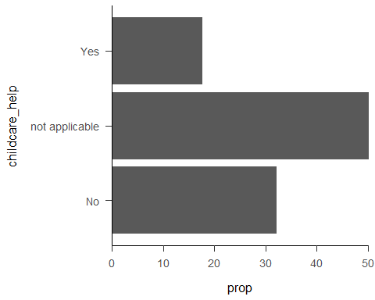

##   
## [[13]]

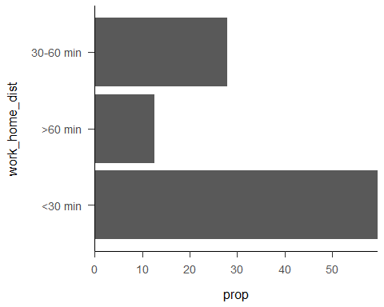

##   
## [[14]]

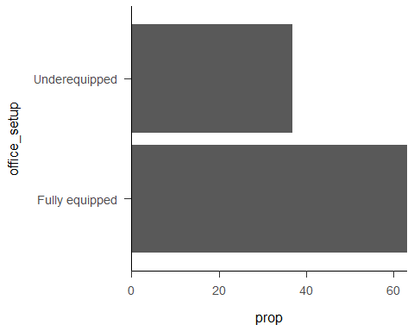

##   
## [[15]]

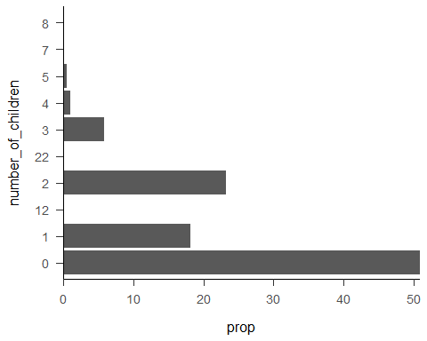

# Percentage of working more from home during the pandemic

percent_by_group(processed, working_home_time)

## # A tibble: 2 x 4  
## working_home_time n N prop  
## <chr> <int> <int> <dbl>  
## 1 No 42 704 5.97  
## 2 Yes 662 704 94.0

662% of the surveyed researchers worked more from home during the pandemic lockdown.

# Efficiency of remote working

## During the lockdown

processed %>%   
 distinct(now_before_eff)

## # A tibble: 4 x 1  
## now_before_eff   
## <chr>   
## 1 less efficient   
## 2 more efficient   
## 3 similarly efficient  
## 4 <NA>

now_before_eff_data <-  
 processed %>%   
 filter(working_home_time == "Yes",  
 !is.na(now_before_eff))  
  
now_before_eff_desc <-  
 now_before_eff_data %>%   
 percent_by_group(now_before_eff)  
  
now_before_eff_desc

## # A tibble: 3 x 4  
## now_before_eff n N prop  
## <chr> <int> <int> <dbl>  
## 1 less efficient 308 661 46.6  
## 2 similarly efficient 199 661 30.1  
## 3 more efficient 154 661 23.3

The number of trials where the efficiency rating is missing is 43. It is because this question was not shown to those who said that they are not working more from home. This number also includes a case, where the response was dropped because the respondent stated in the comment that he did not understand the question.

46.6% of the surveyed scientists who worked more from home during the coronavirus lockdown found that due to working more from home their research became, in general, less efficient, 23.3% found it more efficient, and 30.11% found no difference compared to working before the lockdown. (only from those working from home).

eff_during_plot_data <-  
 now_before_eff_data %>%   
 mutate(now_before_eff = forcats::fct_relevel(now_before_eff, c("less efficient", "similarly efficient", "more efficient"))) %>%  
 percent_by_group(now_before_eff)  
  
y_max_during <- round_any(max(eff_during_plot_data$prop), 0.1, f = ceiling)  
  
eff_during_plot_data %>%  
 ggplot() +  
 aes(x = now_before_eff,  
 y = prop) +  
 geom_bar(stat = "identity") +  
 scale_y_continuous(expand = c(0, 0),  
 limits = c(0, y_max_during)) +  
 labs(x = "Change in the efficiency of the research work",  
 y = "Percentage of responses") +  
 papaja::theme_apa()

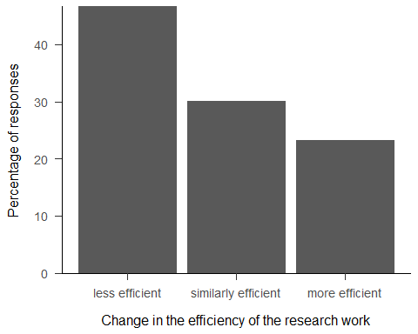

## After the lockdown

processed %>%   
 distinct(now_later_eff)

## # A tibble: 4 x 1  
## now_later_eff   
## <chr>   
## 1 similarly efficient  
## 2 more efficient   
## 3 less efficient   
## 4 <NA>

now_later_eff_data <-  
 processed %>%   
 filter(prior_home_prop_1 != 100)  
  
now_later_eff_desc <-  
 now_later_eff_data %>%  
 percent_by_group(now_later_eff)  
  
now_later_eff_desc

## # A tibble: 3 x 4  
## now_later_eff n N prop  
## <chr> <int> <int> <dbl>  
## 1 less efficient 201 684 29.4  
## 2 similarly efficient 282 684 41.2  
## 3 more efficient 201 684 29.4

The number of trials where the efficiency rating is missing is 1. It is because the respondent did not understand the question as she stated in the comments. However, she said that she used to work 100% before the lockdown from home, therefore her rating will not be included in the analysis anyway.

The number of respondents whose response was excluded because they used to work 100% from home before the lockdown: 20

29.39% of the surveyed scientists assume that working more from home after the coronavirus lockdown could make their research, in general, less efficient, 29.39% found it more efficient, and 41.23% found no difference compared to the time before the lockdown. (excluding 100% home workers).

eff_after_plot_data <-  
 now_later_eff_data %>%   
 mutate(now_later_eff = forcats::fct_relevel(now_later_eff, c("less efficient", "similarly efficient", "more efficient"))) %>%  
 percent_by_group(now_later_eff)  
  
y_max_during <- round_any(max(eff_after_plot_data$prop), 0.1, f = ceiling)  
  
eff_after_plot_data %>%  
 ggplot() +  
 aes(x = now_later_eff,  
 y = prop) +  
 geom_bar(stat = "identity") +  
 scale_y_continuous(expand = c(0, 0),  
 limits = c(0, y_max_during)) +  
 labs(x = "Change in the efficiency of the research work",  
 y = "Percentage of responses") +  
 papaja::theme_apa()

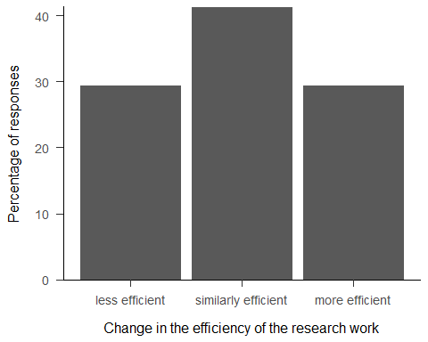

## Investigating aspects of research

We calculate the means and SDs of each aspects ratings. Aspects with higher rating than 4 indicates that it is better to do the task from the lab. Ratings with lower mean rating than 4 means that it is better to do the given action from home.

*note: Based on one comment we dropped the aspect ratings of one respondent during data processing.*

aspects <-   
 processed %>%  
 filter_at(  
 vars(contains("home_office_aspect")),  
 all_vars(!is.na(.))) %>%   
 select(participant_id, contains("home_office_aspect")) %>%  
 gather(key = "aspect", value = "rating", -participant_id) %>%   
 mutate(aspect = case_when(aspect == "home_office_aspect_1" ~ "Optimally organizing my time",  
 aspect == "home_office_aspect_2" ~ "Optimally organizing my tasks",  
 aspect == "home_office_aspect_3" ~ "Keeping focused on my tasks",  
 aspect == "home_office_aspect_4" ~ "Keeping in touch with my team",  
 aspect == "home_office_aspect_5" ~ "Sharing thoughts with colleagues",  
 aspect == "home_office_aspect_6" ~ "Getting support from colleagues",  
 aspect == "home_office_aspect_7" ~ "Working on my manuscript",  
 aspect == "home_office_aspect_8" ~ "Analyzing my data",  
 aspect == "home_office_aspect_9" ~ "Reading the literature",  
 aspect == "home_office_aspect_10" ~ "Collecting data",  
 aspect == "home_office_aspect_11" ~ "Having the infrastructure\n(IT, books, instruments)",  
 aspect == "home_office_aspect_12" ~ "Maintaining emotional balance",  
 aspect == "home_office_aspect_13" ~ "Maintaining work-life balance",  
 aspect == "home_office_aspect_14" ~ "Keeping good relationship\nwith colleagues",  
 aspect == "home_office_aspect_15" ~ "Developing new skills")) %>%   
 group_by(aspect) %>%   
 summarise(mean = mean(rating, na.rm = TRUE),  
 sd = sd(rating, na.rm = TRUE)) %>%   
 mutate(better_home = case_when(mean > 4 ~ 0L,  
 mean < 4 ~ 1L,  
 mean == 4 ~ NA_integer_)) %>%   
 arrange(better_home, mean)

aspects %>%  
 ggplot() +  
 aes(x = fct_reorder(aspect, mean),  
 y = mean) +  
 geom_bar(stat = "identity") +  
 scale_y_continuous(  
 expand = c(0, 0.4),  
 breaks = c(1, 2, 3, 4, 5, 6, 7),  
 labels = c("1\nAt home", "2", "3", "4", "5", "6", "7\nIn the office")) +  
 coord_flip(ylim = c(1, 7)) +  
 geom_hline(yintercept = 4, linetype = "dashed", color = "#828282", size = 1) +  
 labs(x = "Aspects",  
 y = "Mean rating") +  
 papaja::theme_apa()

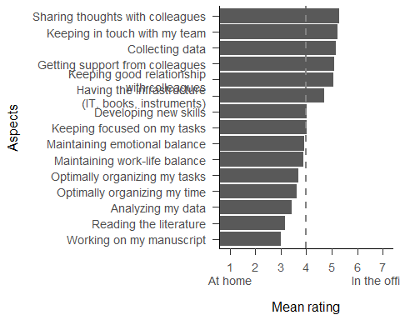

### Main advantages of working from home

The three lowest-rated advantages of working from home

aspects %>%   
 filter(better_home == 1L) %>%   
 slice_min(mean, n = 3)

## # A tibble: 3 x 4  
## aspect mean sd better_home  
## <chr> <dbl> <dbl> <int>  
## 1 Working on my manuscript 3.00 1.89 1  
## 2 Reading the literature 3.15 1.85 1  
## 3 Analyzing my data 3.42 1.94 1

### Main advantages of working in the lab

The three highest-rated advantages of working from the lab

aspects %>%   
 filter(better_home == 0L) %>%   
 slice_max(mean, n = 3)

## # A tibble: 3 x 4  
## aspect mean sd better_home  
## <chr> <dbl> <dbl> <int>  
## 1 Sharing thoughts with colleagues 5.28 1.44 0  
## 2 Keeping in touch with my team 5.21 1.42 0  
## 3 Collecting data 5.16 1.69 0

## How much did researchers work from home before the pandemic?

The distribution of percentages of working from your home time before the pandemic.

percentage_plot_data <-  
 processed %>%  
 select(participant_id,  
 prior_home_prop_1,  
 future_home_prop_1) %>%  
 gather(key = "time", value = "percent", -participant_id) %>%  
 mutate(time = case_when(time == "prior_home_prop_1" ~ "Prior to pandemic",  
 time == "future_home_prop_1" ~ "Ideal"),  
 time = factor(time, c("Prior to pandemic", "Ideal")))  
  
percentage_plot_data %>%  
 filter(time == "Prior to pandemic") %>%   
 ggplot() +  
 aes(x = percent) +  
 geom_density(alpha = 0.6, size = 0.8) +  
 scale_y_continuous(expand = c(0.01, 0),  
 breaks = scales::pretty_breaks()) +  
 scale_x_continuous(expand = c(0, 0),  
 breaks = seq(0, 100, 10),  
 labels = seq(0, 100, 10)) +  
 labs(x = "Percentage of worktime working from home prior to pandemic",  
 y = "Density") +  
 papaja::theme_apa()

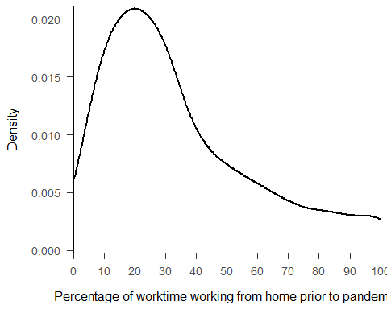

## How much would researchers work from home after the pandemic?

The distribution of percentages of ideal working from home time after the pandemic.

percentage_plot_data %>%  
 filter(time == "Ideal") %>%   
 ggplot() +  
 aes(x = percent) +  
 geom_density(alpha = 0.6, size = 0.8) +  
 scale_y_continuous(expand = c(0.01, 0),  
 breaks = scales::pretty_breaks()) +  
 scale_x_continuous(expand = c(0, 0),  
 breaks = seq(0, 100, 10),  
 labels = seq(0, 100, 10)) +  
 labs(x = "Percentage of worktime working from home",  
 y = "Density") +  
 papaja::theme_apa()

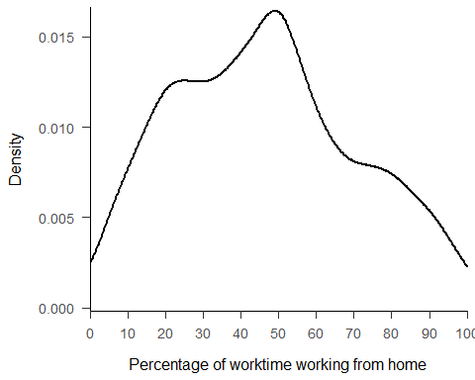

Prior and ideal percentages of working from home on the smae figure.

percentage_plot_data %>%  
 ggplot() +  
 aes(x = percent,  
 color = time) +  
 geom_density(alpha = 0.6, size = 0.8) +  
 scale_y_continuous(expand = c(0.01, 0),  
 breaks = scales::pretty_breaks()) +  
 scale_x_continuous(expand = c(0, 0),  
 breaks = seq(0, 100, 10),  
 labels = seq(0, 100, 10)) +  
 scale_fill_manual(values = c('#000000', '#D3D3D3')) +  
 scale_color_manual(values=c('#000000', '#D3D3D3'))+  
 labs(x = "Percentage of worktime working from home",  
 y = "Density",  
 color = "Time") +  
 papaja::theme_apa()

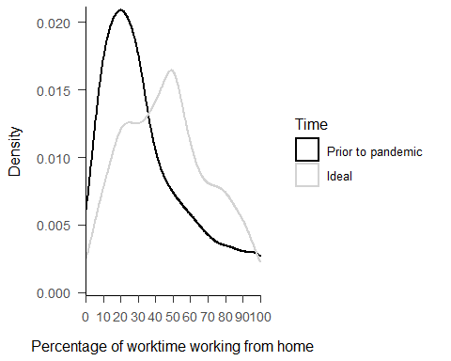

## Would it be possible to work more from home in the future?

See the distinct values of the difference between the ideal percentage of working more from the future and the prior percentage. If the difference is negative the respondent wants to work less from home in the future, if it is positive the respondents wants to work more from home in the future.

processed %>%   
 distinct(future_prior_diff) %>%   
 arrange(future_prior_diff) %>%   
 knitr::kable()

Showing a descriptive comparison.

processed %>%   
 mutate(more_from_home = case_when(future_prior_diff > 0 ~ "Respondent wants to work more from home",  
 future_prior_diff < 0 ~ "Respondent wants to work less from home",  
 future_prior_diff == 0 ~ "Respondent working the ideal amount of time from home")) %>%   
 count(more_from_home) %>%  
 mutate(N = sum(n),  
 prop = n / N * 100) %>%   
 arrange(n)

## # A tibble: 3 x 4  
## more_from_home n N prop  
## <chr> <int> <int> <dbl>  
## 1 Respondent wants to work less from home 114 704 16.2  
## 2 Respondent working the ideal amount of time from home 129 704 18.3  
## 3 Respondent wants to work more from home 461 704 65.5

Number of respondents who worked 100% from home before the pandemic.

processed %>%   
 filter(prior_home_prop_1 == 100) %>%   
 count()

## # A tibble: 1 x 1  
## n  
## <int>  
## 1 20

Taken all their other duties (education, administration, etc.) and provided circumstances at home (infrastructure, level of disturbance) of researchers think that it would be possible to work more from home in the future. (excluding 100% home workers, including only wishing to work more from home, OF those who find working from home more efficient)

processed %>%   
 filter(prior_home_prop_1 != 100,  
 future_prior_diff > 0,  
 now_later_eff == "more efficient") %>%   
 count(feasible) %>%   
 mutate(N = sum(n),  
 prop = n / N * 100)

## # A tibble: 2 x 4  
## feasible n N prop  
## <chr> <int> <int> <dbl>  
## 1 No 15 172 8.72  
## 2 Yes 157 172 91.3

## Additional analyses

Additional descriptive results will be provided for the interested subgroups.

### Are people living with children more or less efficient when working from home?

processed %>% distinct(living_sit)

## # A tibble: 7 x 1  
## living_sit   
## <chr>   
## 1 Living only with partner   
## 2 Living with partner and non-adult child(ren)   
## 3 Living alone   
## 4 Other   
## 5 Living with parents or other adult family members  
## 6 Single-parent with non-adult child(ren)   
## 7 Living with non-family others

living_sit_include <- c("Living with partner and non-adult child(ren)", "Single-parent with non-adult child(ren)")

Number of kids in this subsample.

now_before_eff_data %>%   
 filter(living_sit %in% living_sit_include) %>%   
 count(number_of_children)

## # A tibble: 7 x 2  
## number_of_children n  
## <chr> <int>  
## 1 0 1  
## 2 1 106  
## 3 12 1  
## 4 2 137  
## 5 3 37  
## 6 4 5  
## 7 5 2

Efficiency ratings during the pandemic.

now_before_eff_data %>%   
 filter(living_sit %in% living_sit_include) %>%   
 percent_by_group(now_before_eff)

## # A tibble: 3 x 4  
## now_before_eff n N prop  
## <chr> <int> <int> <dbl>  
## 1 less efficient 168 289 58.1  
## 2 similarly efficient 65 289 22.5  
## 3 more efficient 56 289 19.4

Efficiency ratings after the pandemic.

now_later_eff_data %>%   
 filter(living_sit %in% living_sit_include) %>%   
 percent_by_group(now_later_eff)

## # A tibble: 3 x 4  
## now_later_eff n N prop  
## <chr> <int> <int> <dbl>  
## 1 less efficient 95 295 32.2  
## 2 similarly efficient 113 295 38.3  
## 3 more efficient 87 295 29.5

### What circumstances make a researcher with children more or less efficient in working from home AFTER the lockdown?

#### With partner

now_later_eff_data %>%   
 filter(living_sit == "Living with partner and non-adult child(ren)") %>%   
 percent_by_group(now_later_eff)

## # A tibble: 3 x 4  
## now_later_eff n N prop  
## <chr> <int> <int> <dbl>  
## 1 less efficient 82 272 30.2  
## 2 similarly efficient 105 272 38.6  
## 3 more efficient 85 272 31.2

#### Single

now_later_eff_data %>%   
 filter(living_sit == "Single-parent with non-adult child(ren)") %>%   
 percent_by_group(now_later_eff)

## # A tibble: 3 x 4  
## now_later_eff n N prop  
## <chr> <int> <int> <dbl>  
## 1 less efficient 13 23 56.5  
## 2 similarly efficient 8 23 34.8  
## 3 more efficient 2 23 8.7

### What circumstances make a researcher with children more or less efficient in working from home DURING the lockdown?

#### With partner

now_before_eff_data %>%   
 filter(living_sit == "Living with partner and non-adult child(ren)") %>%   
 percent_by_group(now_before_eff)

## # A tibble: 3 x 4  
## now_before_eff n N prop  
## <chr> <int> <int> <dbl>  
## 1 less efficient 153 268 57.1  
## 2 similarly efficient 61 268 22.8  
## 3 more efficient 54 268 20.2

#### Single

now_before_eff_data %>%   
 filter(living_sit == "Single-parent with non-adult child(ren)") %>%   
 percent_by_group(now_before_eff)

## # A tibble: 3 x 4  
## now_before_eff n N prop  
## <chr> <int> <int> <dbl>  
## 1 less efficient 15 21 71.4   
## 2 similarly efficient 4 21 19.0   
## 3 more efficient 2 21 9.52

### Which subgroup would benefit the most/less from working more from home?

#### During

Using only the filtered dataset for the efficiency rating calculations.

subgroup_eff_during <-  
 tibble(subvars = subvars) %>%   
 mutate(levels = purrr::map(subvars,  
 ~ get_levels(  
 df = now_before_eff_data,  
 var = .x)),  
 levels_eff = purrr::map2(subvars, levels,  
 ~ efficiency_subgroups_levels(  
 df = now_before_eff_data,  
 subvar_name = .x,  
 subgroup_name = .y,  
 efficiency_var = now_before_eff)),  
 levels_eff = set_names(levels_eff, map(subvars, ~rlang::as_name(.x)))) %>%  
 select(subvars, levels_eff) %>%   
 unnest_longer(levels_eff) %>%   
 unnest(levels_eff) %>%   
 mutate(subvars = case_when(subvars == "position" ~ "Academic position",  
 subvars == "area_of_research" ~ "Area of research",  
 subvars == "wokrplace_type" ~ "Workplace type",  
 subvars == "data_coll_remote" ~ "Data collection remotely",  
 subvars == "gender" ~ "Gender",  
 subvars == "age" ~ "Age",  
 subvars == "edu_duties" ~ "Educational duties",  
 subvars == "team_work" ~ "Team work",  
 subvars == "partner_work" ~ "Partner working",  
 subvars == "living_sit" ~ "Living situation",  
 subvars == "homeschool" ~ "Homeschooling",  
 subvars == "childcare_help" ~ "Help with childcare",  
 subvars == "work_home_dist" ~ "Work-home distance",  
 subvars == "office_setup" ~ "Home office setup",  
 subvars == "number_of_children" ~ "Number of children")) %>%   
 select(subvars, levels_eff_id, now_before_eff, n, N, prop) %>%  
 rename(`Background information question` = subvars,  
 Subgroups = levels_eff_id,  
 `Efficiency ratings` = now_before_eff,  
 `Number of responses to the efficiency ratings` = n,  
 `Number of respondents in the subgroup` = N,  
 Proportion = prop)

papaja::apa_table(  
 subgroup_eff_during,  
 caption = "Efficiency Ratings by Each Subgroup Comparing Efficiency Before and During the Lockdown",  
 escape = TRUE  
)

(#tab:unnamed-chunk-35)

*Efficiency Ratings by Each Subgroup Comparing Efficiency Before and During the Lockdown*

|  |  |  |  |  |  |
| --- | --- | --- | --- | --- | --- |
| Background information question | Subgroups | Efficiency ratings | Number of responses to the efficiency ratings | Number of respondents in the subgroup | Proportion |
| Academic position | postdoc | less efficient | 31 | 72 | 43.06 |
| Academic position | postdoc | similarly efficient | 28 | 72 | 38.89 |
| Academic position | postdoc | more efficient | 13 | 72 | 18.06 |
| Academic position | associate professor | less efficient | 87 | 164 | 53.05 |
| Academic position | associate professor | similarly efficient | 34 | 164 | 20.73 |
| Academic position | associate professor | more efficient | 43 | 164 | 26.22 |
| Academic position | assistant professor | less efficient | 71 | 117 | 60.68 |
| Academic position | assistant professor | similarly efficient | 23 | 117 | 19.66 |
| Academic position | assistant professor | more efficient | 23 | 117 | 19.66 |
| Academic position | full professor | less efficient | 79 | 195 | 40.51 |
| Academic position | full professor | similarly efficient | 79 | 195 | 40.51 |
| Academic position | full professor | more efficient | 37 | 195 | 18.97 |
| Academic position | non-academic researcher | less efficient | 11 | 33 | 33.33 |
| Academic position | non-academic researcher | similarly efficient | 8 | 33 | 24.24 |
| Academic position | non-academic researcher | more efficient | 14 | 33 | 42.42 |
| Academic position | not applicable | similarly efficient | 1 | 1 | 100.00 |
| Academic position | PhD student | less efficient | 25 | 67 | 37.31 |
| Academic position | PhD student | similarly efficient | 25 | 67 | 37.31 |
| Academic position | PhD student | more efficient | 17 | 67 | 25.37 |
| Academic position | research assistant | less efficient | 4 | 12 | 33.33 |
| Academic position | research assistant | similarly efficient | 1 | 12 | 8.33 |
| Academic position | research assistant | more efficient | 7 | 12 | 58.33 |
| Area of research | Social Sciences | less efficient | 231 | 501 | 46.11 |
| Area of research | Social Sciences | similarly efficient | 147 | 501 | 29.34 |
| Area of research | Social Sciences | more efficient | 123 | 501 | 24.55 |
| Area of research | Earth & Space Sciences | more efficient | 2 | 2 | 100.00 |
| Area of research | Life Sciences | less efficient | 45 | 89 | 50.56 |
| Area of research | Life Sciences | similarly efficient | 28 | 89 | 31.46 |
| Area of research | Life Sciences | more efficient | 16 | 89 | 17.98 |
| Area of research | Other | less efficient | 28 | 59 | 47.46 |
| Area of research | Other | similarly efficient | 21 | 59 | 35.59 |
| Area of research | Other | more efficient | 10 | 59 | 16.95 |
| Area of research | Physical Sciences | less efficient | 3 | 5 | 60.00 |
| Area of research | Physical Sciences | similarly efficient | 2 | 5 | 40.00 |
| Area of research | Formal Sciences | less efficient | 1 | 5 | 20.00 |
| Area of research | Formal Sciences | similarly efficient | 1 | 5 | 20.00 |
| Area of research | Formal Sciences | more efficient | 3 | 5 | 60.00 |
| Workplace type | Research and educational institute | less efficient | 268 | 573 | 46.77 |
| Workplace type | Research and educational institute | similarly efficient | 178 | 573 | 31.06 |
| Workplace type | Research and educational institute | more efficient | 127 | 573 | 22.16 |
| Workplace type | Purely research institute | less efficient | 27 | 55 | 49.09 |
| Workplace type | Purely research institute | similarly efficient | 13 | 55 | 23.64 |
| Workplace type | Purely research institute | more efficient | 15 | 55 | 27.27 |
| Workplace type | None of them | less efficient | 4 | 19 | 21.05 |
| Workplace type | None of them | similarly efficient | 5 | 19 | 26.32 |
| Workplace type | None of them | more efficient | 10 | 19 | 52.63 |
| Workplace type | Purely educational institute | less efficient | 9 | 14 | 64.29 |
| Workplace type | Purely educational institute | similarly efficient | 3 | 14 | 21.43 |
| Workplace type | Purely educational institute | more efficient | 2 | 14 | 14.29 |
| Data collection remotely | No | less efficient | 86 | 158 | 54.43 |
| Data collection remotely | No | similarly efficient | 46 | 158 | 29.11 |
| Data collection remotely | No | more efficient | 26 | 158 | 16.46 |
| Data collection remotely | Yes (including if someone else does it for me) | less efficient | 218 | 484 | 45.04 |
| Data collection remotely | Yes (including if someone else does it for me) | similarly efficient | 144 | 484 | 29.75 |
| Data collection remotely | Yes (including if someone else does it for me) | more efficient | 122 | 484 | 25.21 |
| Data collection remotely | not applicable | less efficient | 4 | 19 | 21.05 |
| Data collection remotely | not applicable | similarly efficient | 9 | 19 | 47.37 |
| Data collection remotely | not applicable | more efficient | 6 | 19 | 31.58 |
| Gender | Male | less efficient | 153 | 317 | 48.26 |
| Gender | Male | similarly efficient | 97 | 317 | 30.60 |
| Gender | Male | more efficient | 67 | 317 | 21.14 |
| Gender | Female | less efficient | 150 | 336 | 44.64 |
| Gender | Female | similarly efficient | 101 | 336 | 30.06 |
| Gender | Female | more efficient | 85 | 336 | 25.30 |
| Gender | Prefer not to say | less efficient | 5 | 7 | 71.43 |
| Gender | Prefer not to say | similarly efficient | 1 | 7 | 14.29 |
| Gender | Prefer not to say | more efficient | 1 | 7 | 14.29 |
| Gender | Other | more efficient | 1 | 1 | 100.00 |
| Age | 25 - 34 | less efficient | 58 | 144 | 40.28 |
| Age | 25 - 34 | similarly efficient | 44 | 144 | 30.56 |
| Age | 25 - 34 | more efficient | 42 | 144 | 29.17 |
| Age | Under 24 | less efficient | 2 | 7 | 28.57 |
| Age | Under 24 | similarly efficient | 3 | 7 | 42.86 |
| Age | Under 24 | more efficient | 2 | 7 | 28.57 |
| Age | 35 - 44 | less efficient | 118 | 215 | 54.88 |
| Age | 35 - 44 | similarly efficient | 56 | 215 | 26.05 |
| Age | 35 - 44 | more efficient | 41 | 215 | 19.07 |
| Age | 55 - 64 | less efficient | 42 | 90 | 46.67 |
| Age | 55 - 64 | similarly efficient | 31 | 90 | 34.44 |
| Age | 55 - 64 | more efficient | 17 | 90 | 18.89 |
| Age | 45 - 54 | less efficient | 77 | 162 | 47.53 |
| Age | 45 - 54 | similarly efficient | 45 | 162 | 27.78 |
| Age | 45 - 54 | more efficient | 40 | 162 | 24.69 |
| Age | 65 - 74 | less efficient | 10 | 38 | 26.32 |
| Age | 65 - 74 | similarly efficient | 19 | 38 | 50.00 |
| Age | 65 - 74 | more efficient | 9 | 38 | 23.68 |
| Age | 75 - 84 | less efficient | 1 | 5 | 20.00 |
| Age | 75 - 84 | similarly efficient | 1 | 5 | 20.00 |
| Age | 75 - 84 | more efficient | 3 | 5 | 60.00 |
| Educational duties | No | less efficient | 44 | 121 | 36.36 |
| Educational duties | No | similarly efficient | 40 | 121 | 33.06 |
| Educational duties | No | more efficient | 37 | 121 | 30.58 |
| Educational duties | Yes | less efficient | 264 | 540 | 48.89 |
| Educational duties | Yes | similarly efficient | 159 | 540 | 29.44 |
| Educational duties | Yes | more efficient | 117 | 540 | 21.67 |
| Team work | Yes | less efficient | 157 | 354 | 44.35 |
| Team work | Yes | similarly efficient | 111 | 354 | 31.36 |
| Team work | Yes | more efficient | 86 | 354 | 24.29 |
| Team work | No | less efficient | 151 | 307 | 49.19 |
| Team work | No | similarly efficient | 88 | 307 | 28.66 |
| Team work | No | more efficient | 68 | 307 | 22.15 |
| Partner working | Yes | less efficient | 188 | 417 | 45.08 |
| Partner working | Yes | similarly efficient | 128 | 417 | 30.70 |
| Partner working | Yes | more efficient | 101 | 417 | 24.22 |
| Partner working | No | less efficient | 56 | 114 | 49.12 |
| Partner working | No | similarly efficient | 31 | 114 | 27.19 |
| Partner working | No | more efficient | 27 | 114 | 23.68 |
| Partner working | not applicable | less efficient | 64 | 130 | 49.23 |
| Partner working | not applicable | similarly efficient | 40 | 130 | 30.77 |
| Partner working | not applicable | more efficient | 26 | 130 | 20.00 |
| Living situation | Living only with partner | less efficient | 82 | 223 | 36.77 |
| Living situation | Living only with partner | similarly efficient | 85 | 223 | 38.12 |
| Living situation | Living only with partner | more efficient | 56 | 223 | 25.11 |
| Living situation | Living with partner and non-adult child(ren) | less efficient | 153 | 268 | 57.09 |
| Living situation | Living with partner and non-adult child(ren) | similarly efficient | 61 | 268 | 22.76 |
| Living situation | Living with partner and non-adult child(ren) | more efficient | 54 | 268 | 20.15 |
| Living situation | Living alone | less efficient | 33 | 87 | 37.93 |
| Living situation | Living alone | similarly efficient | 28 | 87 | 32.18 |
| Living situation | Living alone | more efficient | 26 | 87 | 29.89 |
| Living situation | Other | less efficient | 12 | 30 | 40.00 |
| Living situation | Other | similarly efficient | 11 | 30 | 36.67 |
| Living situation | Other | more efficient | 7 | 30 | 23.33 |
| Living situation | Living with parents or other adult family members | less efficient | 10 | 25 | 40.00 |
| Living situation | Living with parents or other adult family members | similarly efficient | 8 | 25 | 32.00 |
| Living situation | Living with parents or other adult family members | more efficient | 7 | 25 | 28.00 |
| Living situation | Single-parent with non-adult child(ren) | less efficient | 15 | 21 | 71.43 |
| Living situation | Single-parent with non-adult child(ren) | similarly efficient | 4 | 21 | 19.05 |
| Living situation | Single-parent with non-adult child(ren) | more efficient | 2 | 21 | 9.52 |
| Living situation | Living with non-family others | less efficient | 3 | 7 | 42.86 |
| Living situation | Living with non-family others | similarly efficient | 2 | 7 | 28.57 |
| Living situation | Living with non-family others | more efficient | 2 | 7 | 28.57 |
| Homeschooling | No | less efficient | 173 | 436 | 39.68 |
| Homeschooling | No | similarly efficient | 147 | 436 | 33.72 |
| Homeschooling | No | more efficient | 116 | 436 | 26.61 |
| Homeschooling | Yes | less efficient | 135 | 225 | 60.00 |
| Homeschooling | Yes | similarly efficient | 52 | 225 | 23.11 |
| Homeschooling | Yes | more efficient | 38 | 225 | 16.89 |
| Help with childcare | not applicable | less efficient | 123 | 329 | 37.39 |
| Help with childcare | not applicable | similarly efficient | 114 | 329 | 34.65 |
| Help with childcare | not applicable | more efficient | 92 | 329 | 27.96 |
| Help with childcare | No | less efficient | 120 | 213 | 56.34 |
| Help with childcare | No | similarly efficient | 57 | 213 | 26.76 |
| Help with childcare | No | more efficient | 36 | 213 | 16.90 |
| Help with childcare | Yes | less efficient | 65 | 119 | 54.62 |
| Help with childcare | Yes | similarly efficient | 28 | 119 | 23.53 |
| Help with childcare | Yes | more efficient | 26 | 119 | 21.85 |
| Work-home distance | 30-60 min | less efficient | 75 | 187 | 40.11 |
| Work-home distance | 30-60 min | similarly efficient | 58 | 187 | 31.02 |
| Work-home distance | 30-60 min | more efficient | 54 | 187 | 28.88 |
| Work-home distance | >60 min | less efficient | 26 | 80 | 32.50 |
| Work-home distance | >60 min | similarly efficient | 29 | 80 | 36.25 |
| Work-home distance | >60 min | more efficient | 25 | 80 | 31.25 |
| Work-home distance | <30 min | less efficient | 207 | 394 | 52.54 |
| Work-home distance | <30 min | similarly efficient | 112 | 394 | 28.43 |
| Work-home distance | <30 min | more efficient | 75 | 394 | 19.04 |
| Home office setup | Fully equipped | less efficient | 175 | 416 | 42.07 |
| Home office setup | Fully equipped | similarly efficient | 130 | 416 | 31.25 |
| Home office setup | Fully equipped | more efficient | 111 | 416 | 26.68 |
| Home office setup | Underequipped | less efficient | 133 | 245 | 54.29 |
| Home office setup | Underequipped | similarly efficient | 69 | 245 | 28.16 |
| Home office setup | Underequipped | more efficient | 43 | 245 | 17.55 |
| Number of children | 0 | less efficient | 122 | 331 | 36.86 |
| Number of children | 0 | similarly efficient | 120 | 331 | 36.25 |
| Number of children | 0 | more efficient | 89 | 331 | 26.89 |
| Number of children | 7 | more efficient | 1 | 1 | 100.00 |
| Number of children | 2 | less efficient | 91 | 151 | 60.26 |
| Number of children | 2 | similarly efficient | 34 | 151 | 22.52 |
| Number of children | 2 | more efficient | 26 | 151 | 17.22 |
| Number of children | 1 | less efficient | 63 | 126 | 50.00 |
| Number of children | 1 | similarly efficient | 38 | 126 | 30.16 |
| Number of children | 1 | more efficient | 25 | 126 | 19.84 |
| Number of children | 4 | less efficient | 5 | 7 | 71.43 |
| Number of children | 4 | more efficient | 2 | 7 | 28.57 |
| Number of children | 3 | less efficient | 23 | 40 | 57.50 |
| Number of children | 3 | similarly efficient | 7 | 40 | 17.50 |
| Number of children | 3 | more efficient | 10 | 40 | 25.00 |
| Number of children | 12 | more efficient | 1 | 1 | 100.00 |
| Number of children | 22 | less efficient | 1 | 1 | 100.00 |
| Number of children | 8 | less efficient | 1 | 1 | 100.00 |
| Number of children | 5 | less efficient | 2 | 2 | 100.00 |

#### After

subgroup_eff_later <-  
 tibble(subvars = subvars) %>%   
 mutate(levels = purrr::map(subvars,  
 ~ get_levels(  
 df = now_later_eff_data,  
 var = .x)),  
 levels_eff = purrr::map2(subvars, levels,  
 ~ efficiency_subgroups_levels(  
 df = now_later_eff_data,  
 subvar_name = .x,  
 subgroup_name = .y,  
 efficiency_var = now_later_eff)),  
 levels_eff = set_names(levels_eff, map(subvars, ~rlang::as_name(.x)))) %>%  
 select(subvars, levels_eff) %>%   
 unnest_longer(levels_eff) %>%   
 unnest(levels_eff) %>%   
 mutate(subvars = case_when(subvars == "position" ~ "Academic position",  
 subvars == "area_of_research" ~ "Area of research",  
 subvars == "wokrplace_type" ~ "Workplace type",  
 subvars == "data_coll_remote" ~ "Data collection remotely",  
 subvars == "gender" ~ "Gender",  
 subvars == "age" ~ "Age",  
 subvars == "edu_duties" ~ "Educational duties",  
 subvars == "team_work" ~ "Team work",  
 subvars == "partner_work" ~ "Partner working",  
 subvars == "living_sit" ~ "Living situation",  
 subvars == "homeschool" ~ "Homeschooling",  
 subvars == "childcare_help" ~ "Help with childcare",  
 subvars == "work_home_dist" ~ "Work-home distance",  
 subvars == "office_setup" ~ "Home office setup",  
 subvars == "number_of_children" ~ "Number of children")) %>%   
 select(subvars, levels_eff_id, now_later_eff, n, N, prop) %>%  
 rename(`Background information question` = subvars,  
 Subgroups = levels_eff_id,  
 `Efficiency ratings` = now_later_eff,  
 `Number of responses to the efficiency ratings` = n,  
 `Number of respondents in the subgroup` = N,  
 Proportion = prop)

papaja::apa_table(  
 subgroup_eff_later,  
 caption = "Efficiency Ratings by Each Subgroup Comparing Efficiency During and After the Lockdown",  
 escape = TRUE  
)

(#tab:unnamed-chunk-37)

*Efficiency Ratings by Each Subgroup Comparing Efficiency During and After the Lockdown*

|  |  |  |  |  |  |
| --- | --- | --- | --- | --- | --- |
| Background information question | Subgroups | Efficiency ratings | Number of responses to the efficiency ratings | Number of respondents in the subgroup | Proportion |
| Academic position | postdoc | less efficient | 23 | 72 | 31.94 |
| Academic position | postdoc | similarly efficient | 27 | 72 | 37.50 |
| Academic position | postdoc | more efficient | 22 | 72 | 30.56 |
| Academic position | associate professor | less efficient | 52 | 168 | 30.95 |
| Academic position | associate professor | similarly efficient | 64 | 168 | 38.10 |
| Academic position | associate professor | more efficient | 52 | 168 | 30.95 |
| Academic position | assistant professor | less efficient | 40 | 124 | 32.26 |
| Academic position | assistant professor | similarly efficient | 48 | 124 | 38.71 |
| Academic position | assistant professor | more efficient | 36 | 124 | 29.03 |
| Academic position | full professor | less efficient | 60 | 202 | 29.70 |
| Academic position | full professor | similarly efficient | 97 | 202 | 48.02 |
| Academic position | full professor | more efficient | 45 | 202 | 22.28 |
| Academic position | non-academic researcher | less efficient | 5 | 34 | 14.71 |
| Academic position | non-academic researcher | similarly efficient | 12 | 34 | 35.29 |
| Academic position | non-academic researcher | more efficient | 17 | 34 | 50.00 |
| Academic position | not applicable | more efficient | 1 | 1 | 100.00 |
| Academic position | PhD student | less efficient | 18 | 69 | 26.09 |
| Academic position | PhD student | similarly efficient | 31 | 69 | 44.93 |
| Academic position | PhD student | more efficient | 20 | 69 | 28.99 |
| Academic position | research assistant | less efficient | 3 | 14 | 21.43 |
| Academic position | research assistant | similarly efficient | 3 | 14 | 21.43 |
| Academic position | research assistant | more efficient | 8 | 14 | 57.14 |
| Area of research | Social Sciences | less efficient | 149 | 514 | 28.99 |
| Area of research | Social Sciences | similarly efficient | 212 | 514 | 41.25 |
| Area of research | Social Sciences | more efficient | 153 | 514 | 29.77 |
| Area of research | Earth & Space Sciences | similarly efficient | 1 | 2 | 50.00 |
| Area of research | Earth & Space Sciences | more efficient | 1 | 2 | 50.00 |
| Area of research | Life Sciences | less efficient | 29 | 96 | 30.21 |
| Area of research | Life Sciences | similarly efficient | 41 | 96 | 42.71 |
| Area of research | Life Sciences | more efficient | 26 | 96 | 27.08 |
| Area of research | Other | less efficient | 20 | 62 | 32.26 |
| Area of research | Other | similarly efficient | 25 | 62 | 40.32 |
| Area of research | Other | more efficient | 17 | 62 | 27.42 |
| Area of research | Physical Sciences | less efficient | 2 | 5 | 40.00 |
| Area of research | Physical Sciences | similarly efficient | 2 | 5 | 40.00 |
| Area of research | Physical Sciences | more efficient | 1 | 5 | 20.00 |
| Area of research | Formal Sciences | less efficient | 1 | 5 | 20.00 |
| Area of research | Formal Sciences | similarly efficient | 1 | 5 | 20.00 |
| Area of research | Formal Sciences | more efficient | 3 | 5 | 60.00 |
| Workplace type | Research and educational institute | less efficient | 182 | 594 | 30.64 |
| Workplace type | Research and educational institute | similarly efficient | 247 | 594 | 41.58 |
| Workplace type | Research and educational institute | more efficient | 165 | 594 | 27.78 |
| Workplace type | Purely research institute | less efficient | 14 | 56 | 25.00 |
| Workplace type | Purely research institute | similarly efficient | 24 | 56 | 42.86 |
| Workplace type | Purely research institute | more efficient | 18 | 56 | 32.14 |
| Workplace type | None of them | less efficient | 2 | 20 | 10.00 |
| Workplace type | None of them | similarly efficient | 5 | 20 | 25.00 |
| Workplace type | None of them | more efficient | 13 | 20 | 65.00 |
| Workplace type | Purely educational institute | less efficient | 3 | 14 | 21.43 |
| Workplace type | Purely educational institute | similarly efficient | 6 | 14 | 42.86 |
| Workplace type | Purely educational institute | more efficient | 5 | 14 | 35.71 |
| Data collection remotely | No | less efficient | 62 | 168 | 36.90 |
| Data collection remotely | No | similarly efficient | 72 | 168 | 42.86 |
| Data collection remotely | No | more efficient | 34 | 168 | 20.24 |
| Data collection remotely | Yes (including if someone else does it for me) | less efficient | 136 | 495 | 27.47 |
| Data collection remotely | Yes (including if someone else does it for me) | similarly efficient | 200 | 495 | 40.40 |
| Data collection remotely | Yes (including if someone else does it for me) | more efficient | 159 | 495 | 32.12 |
| Data collection remotely | not applicable | less efficient | 3 | 21 | 14.29 |
| Data collection remotely | not applicable | similarly efficient | 10 | 21 | 47.62 |
| Data collection remotely | not applicable | more efficient | 8 | 21 | 38.10 |
| Gender | Male | less efficient | 106 | 331 | 32.02 |
| Gender | Male | similarly efficient | 137 | 331 | 41.39 |
| Gender | Male | more efficient | 88 | 331 | 26.59 |
| Gender | Female | less efficient | 90 | 344 | 26.16 |
| Gender | Female | similarly efficient | 142 | 344 | 41.28 |
| Gender | Female | more efficient | 112 | 344 | 32.56 |
| Gender | Prefer not to say | less efficient | 5 | 8 | 62.50 |
| Gender | Prefer not to say | similarly efficient | 3 | 8 | 37.50 |
| Gender | Other | more efficient | 1 | 1 | 100.00 |
| Age | 25 - 34 | less efficient | 43 | 149 | 28.86 |
| Age | 25 - 34 | similarly efficient | 54 | 149 | 36.24 |
| Age | 25 - 34 | more efficient | 52 | 149 | 34.90 |
| Age | Under 24 | less efficient | 1 | 7 | 14.29 |
| Age | Under 24 | similarly efficient | 3 | 7 | 42.86 |
| Age | Under 24 | more efficient | 3 | 7 | 42.86 |
| Age | 35 - 44 | less efficient | 71 | 226 | 31.42 |
| Age | 35 - 44 | similarly efficient | 99 | 226 | 43.81 |
| Age | 35 - 44 | more efficient | 56 | 226 | 24.78 |
| Age | 55 - 64 | less efficient | 25 | 90 | 27.78 |
| Age | 55 - 64 | similarly efficient | 42 | 90 | 46.67 |
| Age | 55 - 64 | more efficient | 23 | 90 | 25.56 |
| Age | 45 - 54 | less efficient | 49 | 163 | 30.06 |
| Age | 45 - 54 | similarly efficient | 60 | 163 | 36.81 |
| Age | 45 - 54 | more efficient | 54 | 163 | 33.13 |
| Age | 65 - 74 | less efficient | 10 | 44 | 22.73 |
| Age | 65 - 74 | similarly efficient | 23 | 44 | 52.27 |
| Age | 65 - 74 | more efficient | 11 | 44 | 25.00 |
| Age | 75 - 84 | less efficient | 2 | 5 | 40.00 |
| Age | 75 - 84 | similarly efficient | 1 | 5 | 20.00 |
| Age | 75 - 84 | more efficient | 2 | 5 | 40.00 |
| Educational duties | No | less efficient | 33 | 132 | 25.00 |
| Educational duties | No | similarly efficient | 51 | 132 | 38.64 |
| Educational duties | No | more efficient | 48 | 132 | 36.36 |
| Educational duties | Yes | less efficient | 168 | 552 | 30.43 |
| Educational duties | Yes | similarly efficient | 231 | 552 | 41.85 |
| Educational duties | Yes | more efficient | 153 | 552 | 27.72 |
| Team work | Yes | less efficient | 107 | 362 | 29.56 |
| Team work | Yes | similarly efficient | 151 | 362 | 41.71 |
| Team work | Yes | more efficient | 104 | 362 | 28.73 |
| Team work | No | less efficient | 94 | 322 | 29.19 |
| Team work | No | similarly efficient | 131 | 322 | 40.68 |
| Team work | No | more efficient | 97 | 322 | 30.12 |
| Partner working | Yes | less efficient | 111 | 431 | 25.75 |
| Partner working | Yes | similarly efficient | 184 | 431 | 42.69 |
| Partner working | Yes | more efficient | 136 | 431 | 31.55 |
| Partner working | No | less efficient | 38 | 116 | 32.76 |
| Partner working | No | similarly efficient | 47 | 116 | 40.52 |
| Partner working | No | more efficient | 31 | 116 | 26.72 |
| Partner working | not applicable | less efficient | 52 | 137 | 37.96 |
| Partner working | not applicable | similarly efficient | 51 | 137 | 37.23 |
| Partner working | not applicable | more efficient | 34 | 137 | 24.82 |
| Living situation | Living only with partner | less efficient | 52 | 231 | 22.51 |
| Living situation | Living only with partner | similarly efficient | 111 | 231 | 48.05 |
| Living situation | Living only with partner | more efficient | 68 | 231 | 29.44 |
| Living situation | Living with partner and non-adult child(ren) | less efficient | 82 | 272 | 30.15 |
| Living situation | Living with partner and non-adult child(ren) | similarly efficient | 105 | 272 | 38.60 |
| Living situation | Living with partner and non-adult child(ren) | more efficient | 85 | 272 | 31.25 |
| Living situation | Living alone | less efficient | 29 | 92 | 31.52 |
| Living situation | Living alone | similarly efficient | 36 | 92 | 39.13 |
| Living situation | Living alone | more efficient | 27 | 92 | 29.35 |
| Living situation | Other | less efficient | 11 | 33 | 33.33 |
| Living situation | Other | similarly efficient | 13 | 33 | 39.39 |
| Living situation | Other | more efficient | 9 | 33 | 27.27 |
| Living situation | Living with parents or other adult family members | less efficient | 10 | 25 | 40.00 |
| Living situation | Living with parents or other adult family members | similarly efficient | 7 | 25 | 28.00 |
| Living situation | Living with parents or other adult family members | more efficient | 8 | 25 | 32.00 |
| Living situation | Single-parent with non-adult child(ren) | less efficient | 13 | 23 | 56.52 |
| Living situation | Single-parent with non-adult child(ren) | similarly efficient | 8 | 23 | 34.78 |
| Living situation | Single-parent with non-adult child(ren) | more efficient | 2 | 23 | 8.70 |
| Living situation | Living with non-family others | less efficient | 4 | 8 | 50.00 |
| Living situation | Living with non-family others | similarly efficient | 2 | 8 | 25.00 |
| Living situation | Living with non-family others | more efficient | 2 | 8 | 25.00 |
| Homeschooling | No | less efficient | 128 | 454 | 28.19 |
| Homeschooling | No | similarly efficient | 187 | 454 | 41.19 |
| Homeschooling | No | more efficient | 139 | 454 | 30.62 |
| Homeschooling | Yes | less efficient | 73 | 230 | 31.74 |
| Homeschooling | Yes | similarly efficient | 95 | 230 | 41.30 |
| Homeschooling | Yes | more efficient | 62 | 230 | 26.96 |
| Help with childcare | not applicable | less efficient | 91 | 344 | 26.45 |
| Help with childcare | not applicable | similarly efficient | 151 | 344 | 43.90 |
| Help with childcare | not applicable | more efficient | 102 | 344 | 29.65 |
| Help with childcare | No | less efficient | 72 | 217 | 33.18 |
| Help with childcare | No | similarly efficient | 84 | 217 | 38.71 |
| Help with childcare | No | more efficient | 61 | 217 | 28.11 |
| Help with childcare | Yes | less efficient | 38 | 123 | 30.89 |
| Help with childcare | Yes | similarly efficient | 47 | 123 | 38.21 |
| Help with childcare | Yes | more efficient | 38 | 123 | 30.89 |
| Work-home distance | 30-60 min | less efficient | 38 | 189 | 20.11 |
| Work-home distance | 30-60 min | similarly efficient | 83 | 189 | 43.92 |
| Work-home distance | 30-60 min | more efficient | 68 | 189 | 35.98 |
| Work-home distance | >60 min | less efficient | 15 | 85 | 17.65 |
| Work-home distance | >60 min | similarly efficient | 39 | 85 | 45.88 |
| Work-home distance | >60 min | more efficient | 31 | 85 | 36.47 |
| Work-home distance | <30 min | less efficient | 148 | 410 | 36.10 |
| Work-home distance | <30 min | similarly efficient | 160 | 410 | 39.02 |
| Work-home distance | <30 min | more efficient | 102 | 410 | 24.88 |
| Home office setup | Fully equipped | less efficient | 100 | 432 | 23.15 |
| Home office setup | Fully equipped | similarly efficient | 185 | 432 | 42.82 |
| Home office setup | Fully equipped | more efficient | 147 | 432 | 34.03 |
| Home office setup | Underequipped | less efficient | 101 | 252 | 40.08 |
| Home office setup | Underequipped | similarly efficient | 97 | 252 | 38.49 |
| Home office setup | Underequipped | more efficient | 54 | 252 | 21.43 |
| Number of children | 0 | less efficient | 91 | 347 | 26.22 |
| Number of children | 0 | similarly efficient | 154 | 347 | 44.38 |
| Number of children | 0 | more efficient | 102 | 347 | 29.39 |
| Number of children | 7 | more efficient | 1 | 1 | 100.00 |
| Number of children | 3 | less efficient | 11 | 37 | 29.73 |
| Number of children | 3 | similarly efficient | 16 | 37 | 43.24 |
| Number of children | 3 | more efficient | 10 | 37 | 27.03 |
| Number of children | 1 | less efficient | 43 | 127 | 33.86 |
| Number of children | 1 | similarly efficient | 49 | 127 | 38.58 |
| Number of children | 1 | more efficient | 35 | 127 | 27.56 |
| Number of children | 2 | less efficient | 53 | 160 | 33.12 |
| Number of children | 2 | similarly efficient | 58 | 160 | 36.25 |
| Number of children | 2 | more efficient | 49 | 160 | 30.63 |
| Number of children | 4 | similarly efficient | 3 | 6 | 50.00 |
| Number of children | 4 | more efficient | 3 | 6 | 50.00 |
| Number of children | 12 | more efficient | 1 | 1 | 100.00 |
| Number of children | 22 | similarly efficient | 1 | 1 | 100.00 |
| Number of children | 5 | less efficient | 2 | 3 | 66.67 |
| Number of children | 5 | similarly efficient | 1 | 3 | 33.33 |
| Number of children | 8 | less efficient | 1 | 1 | 100.00 |

### Would it be ideal and possible for those with teaching duties to work proportionally more from home in the future than before the pandemic?

Would it be possible?

processed %>%   
 filter(edu_duties == "Yes") %>%   
 count(feasible) %>%   
 mutate(N = sum(n),  
 prop = round(n / N * 100, 2))

## # A tibble: 2 x 4  
## feasible n N prop  
## <chr> <int> <int> <dbl>  
## 1 No 131 566 23.1  
## 2 Yes 435 566 76.9

Would it be ideal?

processed %>%   
 filter(edu_duties == "Yes") %>%   
 mutate(more_from_home = case_when(future_prior_diff > 0 ~ "Respondent wants to work more from home",  
 future_prior_diff < 0 ~ "Respondent wants to work less from home",  
 future_prior_diff == 0 ~ "Respondent working the ideal amount of time from home")) %>%   
 count(more_from_home) %>%  
 mutate(N = sum(n),  
 prop = round(n / N * 100, 2))

## # A tibble: 3 x 4  
## more_from_home n N prop  
## <chr> <int> <int> <dbl>  
## 1 Respondent wants to work less from home 84 566 14.8  
## 2 Respondent wants to work more from home 376 566 66.4  
## 3 Respondent working the ideal amount of time from home 106 566 18.7