PreregistrationEvaluation_Main_Analysis

Marton Kovacs

30 November, 2021

# Install packages

library(tidyverse)  
library(ragg)

# Source R scripts

r_scripts <- list.files(here::here("R/"), full.names = TRUE)  
walk(r_scripts, source)

# Importing data

processed <- read_tsv(here::here("data/main/processed/PreregistrationEvaluation_Main_Processed.tsv"))

# Descriptives

## Number of respondents

There are 355 individual responses used for the analysis.

## Median time of responding to the survey

processed %>%   
 mutate(duration_in_seconds = as.integer(duration_in_seconds)) %>%   
 summarise(median_resp = median(duration_in_seconds) / 60)

## # A tibble: 1 x 1  
## median_resp  
## <dbl>  
## 1 3.18

# Responses by control or prereg group for all survey questions

## Data preprocessing

Variables that store the responses to the survey questions.

vars <- c("planning", "recommend", "hypothesis", "design", "analysis", "rdm", "workflow", "collab", "preparatory", "duration", "stress", "qrp")  
  
groups <- c("control", "prereg")

Calculating the counts and proportions of each subgroup. *note: There is an NA subgroup for the “position” question which was not an answer option in the survey but based on one respondents comment we dropped his answer to this question.*

List all the questions for each group.

survey_questions <-  
 expand_grid(groups = groups,  
 vars = vars) %>%   
 mutate(type = add_question_type(vars))

Get the levels of each question per group. Some questions has different labels depending on which group the respondents belongs to as questions were worded differently for the preregistration and the control group. See the survey materials for more detail.

The level_present function shows which response levels appeared in the data and which response levels were not chosen by any of the participants.

The get_levels function extracts all the response levels into a character vector.

survey_questions <-  
 survey_questions %>%   
 mutate(var_level_present = purrr::map2(groups, vars,  
 ~ level_present(  
 df = processed,  
 group_name = .x,  
 var_name = .y,  
 factor_group = .x,  
 group_var = group)),  
 var_level_labels = purrr::map2(groups, vars,  
 ~ get_levels(  
 df = processed,  
 group_name = .x,  
 var_name = .y,  
 factor_group = .x,  
 group_var = group)))

Calculate the count for all the levels of all the questions per group. Levels with no responses are also included with 0 for the count. For each question per group these summarized information will be nested in one list type column.

survey_questions <-  
 survey_questions %>%   
 mutate(var_desc = purrr::map2(groups, vars,  
 ~ level_count(  
 df = processed,  
 group_name = .x,  
 var_name = .y,  
 group_var = group,  
 factor_group = .x)))

Create one table out of nested information with more descriptive variable and question names. We will create this table only for the Likert-type questions.

survey_questions_table <-   
 survey_questions %>%   
 filter(type == "likert") %>%  
 select(groups, vars, var_desc) %>%   
 unnest(var_desc) %>%   
 dplyr::group_by(groups, vars) %>%   
 dplyr::mutate(N = sum(n),  
 prop = round(n / N * 100, 2)) %>%   
 select(-N, -levels_int) %>%   
 mutate(vars = vars_rename(vars),  
 groups = groups_rename(groups)) %>%   
 arrange(vars, groups) %>%   
 rename(`Survey question` = vars,  
 Group = groups,  
 Levels = levels,  
 `Number of responses` = n,  
 `Proportion of the level` = prop)

Create an APA formatted table for the paper.

papaja::apa_table(  
 survey_questions_table,  
 caption = "A Full Summary of the Likert-type Survey Questions Per Group",  
 escape = TRUE  
)

(#tab:unnamed-chunk-10)

*A Full Summary of the Likert-type Survey Questions Per Group*

|  |  |  |  |  |
| --- | --- | --- | --- | --- |
| Group | Survey question | Levels | Number of responses | Proportion of the level |
| Control | Consider Preregistration in Future Work | Never | 5.00 | 8.93 |
| Control | Consider Preregistration in Future Work | Rarely | 12.00 | 21.43 |
| Control | Consider Preregistration in Future Work | Occasionally | 12.00 | 21.43 |
| Control | Consider Preregistration in Future Work | Sometimes | 23.00 | 41.07 |
| Control | Consider Preregistration in Future Work | Frequently | 2.00 | 3.57 |
| Control | Consider Preregistration in Future Work | Usually | 2.00 | 3.57 |
| Control | Consider Preregistration in Future Work | Always | 0.00 | 0.00 |
| Preregistration | Consider Preregistration in Future Work | Never | 2.00 | 0.67 |
| Preregistration | Consider Preregistration in Future Work | Rarely | 4.00 | 1.34 |
| Preregistration | Consider Preregistration in Future Work | Occasionally | 7.00 | 2.34 |
| Preregistration | Consider Preregistration in Future Work | Sometimes | 38.00 | 12.71 |
| Preregistration | Consider Preregistration in Future Work | Frequently | 49.00 | 16.39 |
| Preregistration | Consider Preregistration in Future Work | Usually | 129.00 | 43.14 |
| Preregistration | Consider Preregistration in Future Work | Always | 70.00 | 23.41 |
| Control | Preregistration Prevents Questionable Research Practices | Very Strongly Disagree | 3.00 | 5.36 |
| Control | Preregistration Prevents Questionable Research Practices | Strongly Disagree | 0.00 | 0.00 |
| Control | Preregistration Prevents Questionable Research Practices | Disagree | 7.00 | 12.50 |
| Control | Preregistration Prevents Questionable Research Practices | Neither Agree or Disagree | 7.00 | 12.50 |
| Control | Preregistration Prevents Questionable Research Practices | Agree | 24.00 | 42.86 |
| Control | Preregistration Prevents Questionable Research Practices | Strongly Agree | 10.00 | 17.86 |
| Control | Preregistration Prevents Questionable Research Practices | Very Strongly Agree | 5.00 | 8.93 |
| Control | Preregistration Prevents Questionable Research Practices | I do not know | 0.00 | 0.00 |
| Control | Preregistration Prevents Questionable Research Practices | Not applicable | 0.00 | 0.00 |
| Preregistration | Preregistration Prevents Questionable Research Practices | Very Strongly Disagree | 5.00 | 1.67 |
| Preregistration | Preregistration Prevents Questionable Research Practices | Strongly Disagree | 4.00 | 1.34 |
| Preregistration | Preregistration Prevents Questionable Research Practices | Disagree | 12.00 | 4.01 |
| Preregistration | Preregistration Prevents Questionable Research Practices | Neither Agree or Disagree | 34.00 | 11.37 |
| Preregistration | Preregistration Prevents Questionable Research Practices | Agree | 94.00 | 31.44 |
| Preregistration | Preregistration Prevents Questionable Research Practices | Strongly Agree | 79.00 | 26.42 |
| Preregistration | Preregistration Prevents Questionable Research Practices | Very Strongly Agree | 70.00 | 23.41 |
| Preregistration | Preregistration Prevents Questionable Research Practices | I do not know | 1.00 | 0.33 |
| Preregistration | Preregistration Prevents Questionable Research Practices | Not applicable | 0.00 | 0.00 |
| Control | Recommend Preregistration To Colleagues | Very Strongly Disagree | 4.00 | 7.14 |
| Control | Recommend Preregistration To Colleagues | Strongly Disagree | 1.00 | 1.79 |
| Control | Recommend Preregistration To Colleagues | Disagree | 2.00 | 3.57 |
| Control | Recommend Preregistration To Colleagues | Neither Agree or Disagree | 24.00 | 42.86 |
| Control | Recommend Preregistration To Colleagues | Agree | 20.00 | 35.71 |
| Control | Recommend Preregistration To Colleagues | Strongly Agree | 5.00 | 8.93 |
| Control | Recommend Preregistration To Colleagues | Very Strongly Agree | 0.00 | 0.00 |
| Control | Recommend Preregistration To Colleagues | I do not know | 0.00 | 0.00 |
| Control | Recommend Preregistration To Colleagues | Not applicable | 0.00 | 0.00 |
| Preregistration | Recommend Preregistration To Colleagues | Very Strongly Disagree | 12.00 | 4.01 |
| Preregistration | Recommend Preregistration To Colleagues | Strongly Disagree | 1.00 | 0.33 |
| Preregistration | Recommend Preregistration To Colleagues | Disagree | 4.00 | 1.34 |
| Preregistration | Recommend Preregistration To Colleagues | Neither Agree or Disagree | 17.00 | 5.69 |
| Preregistration | Recommend Preregistration To Colleagues | Agree | 82.00 | 27.42 |
| Preregistration | Recommend Preregistration To Colleagues | Strongly Agree | 100.00 | 33.44 |
| Preregistration | Recommend Preregistration To Colleagues | Very Strongly Agree | 83.00 | 27.76 |
| Preregistration | Recommend Preregistration To Colleagues | I do not know | 0.00 | 0.00 |
| Preregistration | Recommend Preregistration To Colleagues | Not applicable | 0.00 | 0.00 |

For the interval type questions we will calculate the mean and confidence intervals for each question per group. We will also present the results in a table.

# Get the id of the questions  
interval_vars <- c("hypothesis", "design", "analysis", "rdm", "workflow", "collab", "preparatory", "duration", "stress")  
  
interval_survey_questions_table <-   
 processed %>%  
 select(response_id, group, all_of(interval_vars)) %>%  
 pivot_longer(  
 all_of(interval_vars),  
 names_to = "vars",  
 values_to = "values") %>%   
 filter(values != "I do not know",  
 values != "Not applicable") %>%   
 mutate(values = as.integer(str_extract(values, "[0-9]{1,2}")),   
 vars = vars_rename(vars)) %>%   
 group_by(group, vars) %>%   
 summarise(Mean = round(mean(values, na.rm = TRUE), 2),  
 SD = round(sd(values, na.rm = TRUE), 2),  
 N = n(),  
 SE = SD / sqrt(N),  
 ub = round(Mean + 1.96 * SE, 2),  
 lb = round(Mean - 1.96 * SE, 2),  
 `Confidence interval` = paste0("[", lb, ", ", ub, "]")) %>%   
 mutate(group = groups_rename(group)) %>%   
 arrange(vars, group) %>%   
 rename(`Survey question` = vars,  
 Group = group)

## `summarise()` regrouping output by 'group' (override with `.groups` argument)

papaja::apa_table(  
 interval_survey_questions_table,  
 caption = "A Full Summary of the Interval Survey Questions Per Group",  
 escape = TRUE  
)

(#tab:unnamed-chunk-11)

*A Full Summary of the Interval Survey Questions Per Group*

|  |  |  |  |  |  |  |  |  |
| --- | --- | --- | --- | --- | --- | --- | --- | --- |
| Group | Survey question | Mean | SD | N | SE | ub | lb | Confidence interval |
| Control | Analysis Plan | 4.98 | 1.67 | 55 | 0.23 | 5.42 | 4.54 | [4.54, 5.42] |
| Preregistration | Analysis Plan | 6.01 | 1.14 | 299 | 0.07 | 6.14 | 5.88 | [5.88, 6.14] |
| Control | Collaboration in the Team | 3.84 | 0.96 | 49 | 0.14 | 4.11 | 3.57 | [3.57, 4.11] |
| Preregistration | Collaboration in the Team | 4.57 | 1.05 | 290 | 0.06 | 4.69 | 4.45 | [4.45, 4.69] |
| Control | Experimental Design | 4.76 | 1.48 | 54 | 0.20 | 5.15 | 4.37 | [4.37, 5.15] |
| Preregistration | Experimental Design | 5.34 | 1.23 | 295 | 0.07 | 5.48 | 5.20 | [5.2, 5.48] |
| Control | Preparatory Work | 4.55 | 1.57 | 55 | 0.21 | 4.96 | 4.14 | [4.14, 4.96] |
| Preregistration | Preparatory Work | 5.37 | 1.22 | 293 | 0.07 | 5.51 | 5.23 | [5.23, 5.51] |
| Control | Project Workflow | 4.31 | 1.21 | 51 | 0.17 | 4.64 | 3.98 | [3.98, 4.64] |
| Preregistration | Project Workflow | 4.98 | 1.10 | 292 | 0.06 | 5.11 | 4.85 | [4.85, 5.11] |
| Control | Research Data Management | 4.31 | 1.20 | 55 | 0.16 | 4.63 | 3.99 | [3.99, 4.63] |
| Preregistration | Research Data Management | 5.02 | 1.14 | 293 | 0.07 | 5.15 | 4.89 | [4.89, 5.15] |
| Control | Research Hypothesis | 5.06 | 1.60 | 54 | 0.22 | 5.49 | 4.63 | [4.63, 5.49] |
| Preregistration | Research Hypothesis | 5.63 | 1.20 | 297 | 0.07 | 5.77 | 5.49 | [5.49, 5.77] |
| Control | Total Project Duration | 2.96 | 1.29 | 50 | 0.18 | 3.32 | 2.60 | [2.6, 3.32] |
| Preregistration | Total Project Duration | 3.07 | 1.17 | 287 | 0.07 | 3.21 | 2.93 | [2.93, 3.21] |
| Control | Work-related Stress | 3.14 | 1.55 | 50 | 0.22 | 3.57 | 2.71 | [2.71, 3.57] |
| Preregistration | Work-related Stress | 3.73 | 1.18 | 293 | 0.07 | 3.87 | 3.59 | [3.59, 3.87] |

We visualize the content of the table as barcharts for each question per group. These plot will not be necessarily included in the paper, but they can aid further investigation of the data.

# survey_questions <-  
# survey_questions %>%  
# mutate(plot = map2(groups, vars,  
# ~ apa_barplot(  
# df = processed,  
# group_name = .x,  
# var_name = .y,  
# group_var = group,  
# factor_group = .x)))  
  
# survey_questions$plot

Three of the questions were using a Likert-scale. We show the proportion of the response levels as horizontal barcharts. Two of them using the same scale, therefore we show them together for practical reasons.

# Get the id of the questions  
likert_plot_data_recommend <- prepare_likert_plot_data(survey_questions, "recommend")  
# Change labels  
likert_plot_data_recommend$groups[likert_plot_data_recommend$groups == 'Control'] <- 'Non-Preregistration'  
  
# Create the plot  
likert_plot_recommend <-   
 likert_plot_odd(  
 data = likert_plot_data_recommend,  
 title = "Recommend Preregistration To Colleagues",  
 levels = levels,  
 levels_to_drop = c("I do not know", "Not applicable"),  
 questions = groups,  
 n = n,  
 positive_side = "upper",  
 limits = c(-1, 1),  
 text_push = 0.01) +   
 theme(  
 legend.margin = margin(l = 0, b = 0, r = 100),  
 legend.key.size = unit(0.8, 'cm'),  
 legend.text = element_text(size = 19),  
 plot.margin = margin(t = 10, r = 40, b = 10, l = 0))

## `summarise()` regrouping output by 'groups' (override with `.groups` argument)

likert_plot_recommend

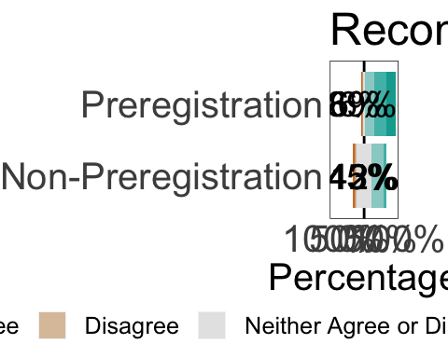

# Save for the paper  
ggsave(here::here("figures/likert_plot_recommend.eps"), device = "eps", plot = likert_plot_recommend, dpi = 300, width = 50, height = 15, units = "cm")  
  
# Save for the manuscript  
ggsave(here::here("figures/likert_plot_recommend.png"), device = "png", plot = likert_plot_recommend, dpi = 300, width = 50, height = 15, units = "cm")

# Get the id of the questions  
likert_plot_data_qrp <- prepare_likert_plot_data(survey_questions, "qrp")  
likert_plot_data_qrp$groups[likert_plot_data_qrp$groups == 'Control'] <- 'Non-Preregistration'  
  
# Create the plot  
likert_plot_qrp <-   
 likert_plot_odd(  
 data = likert_plot_data_qrp,  
 title = "Preregistration Prevents Questionable Research Practices",  
 levels = levels,  
 levels_to_drop = c("I do not know", "Not applicable"),  
 questions = groups,  
 n = n,  
 positive_side = "upper",  
 limits = c(-1, 1),  
 text_push = 0.01) +   
 theme(  
 legend.margin = margin(l = 0, b = 0, r = 100),  
 legend.key.size = unit(0.8, 'cm'),  
 legend.text = element_text(size = 19),  
 plot.margin = margin(t = 10, r = 40, b = 10, l = 0))

## `summarise()` regrouping output by 'groups' (override with `.groups` argument)

likert_plot_qrp

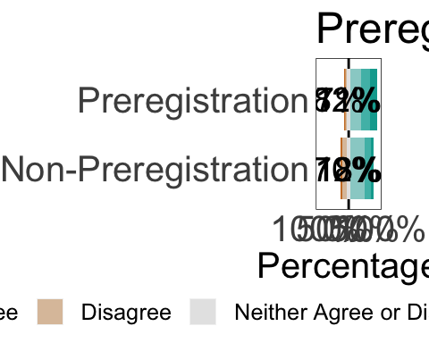

# Save for the paper  
ggsave(here::here("figures/likert_plot_qrp.eps"), device = "eps", plot = likert_plot_qrp, dpi = 300, width = 50, height = 15, units = "cm")  
  
# Save for the manuscript  
ggsave(here::here("figures/likert_plot_qrp.png"), device = "png", plot = likert_plot_qrp, dpi = 300, width = 50, height = 15, units = "cm")

# Get the id of the questions  
likert_plot_data_planning <- prepare_likert_plot_data(survey_questions, "planning")  
likert_plot_data_planning$groups[likert_plot_data_planning$groups == 'Control'] <- 'Non-Preregistration'  
  
  
# Create the plot  
likert_plot_planning <-  
 likert_plot_odd(  
 data = likert_plot_data_planning,  
 title = "Consider Preregistration in Future Work",  
 levels = levels,  
 levels_to_drop = c("I do not know", "Not applicable"),  
 questions = groups,  
 n = n,  
 positive_side = "upper",  
 limits = c(-1, 1),  
 text_push = 0.01) +   
 theme(  
 legend.margin = margin(l = 0, b = 0, r = 0),  
 legend.key.size = unit(0.8, 'cm'),  
 legend.text = element_text(size = 19),  
 plot.margin = margin(t = 10, r = 40, b = 10, l = 0))

## `summarise()` regrouping output by 'groups' (override with `.groups` argument)

likert_plot_planning

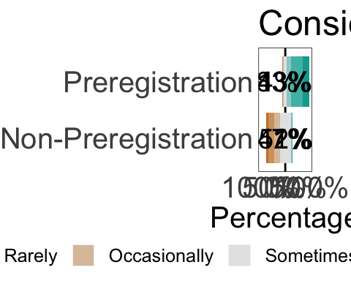

# Save for the paper  
ggsave(here::here("figures/likert_plot_planning.eps"), device = "eps", plot = likert_plot_planning, dpi = 300, width = 50, height = 15, units = "cm")  
  
# Save for the manuscript  
ggsave(here::here("figures/likert_plot_planning.png"), device = "png", plot = likert_plot_planning, dpi = 300, width = 50, height = 15, units = "cm")

The other questions were using a 7 point scale that we will treat as an interval scale. This plot presents the mean rating per question per group with the 95% CI as the errorbar.

## Version order based on the mean rating of the groups  
# Modify the data for plotting  
interval_plot_data <-   
 processed %>%  
 select(response_id, group, all_of(interval_vars)) %>%  
 pivot_longer(  
 all_of(interval_vars),  
 names_to = "vars",  
 values_to = "values") %>%   
 filter(values != "I do not know",  
 values != "Not applicable") %>%   
 mutate(values = as.integer(str_extract(values, "[0-9]{1,2}")),   
 vars = vars_rename(vars)) %>%   
 group_by(group, vars) %>%   
 summarise(mean = mean(values, na.rm = TRUE),  
 sd = sd(values, na.rm = TRUE),  
 n = n()) %>%   
 group_by(vars) %>%   
 mutate(mean_avg = mean(mean)) %>%   
 ungroup() %>%   
 pivot_wider(names_from = group, values_from = c(mean, sd, n)) %>%  
 mutate(mean_difference = mean_prereg - mean_control) %>%   
 pivot_longer(  
 union(contains("prereg"), contains("control")),  
 names_to = c("variables", "groups"),  
 values_to = "values",  
 names_sep = "_") %>%   
 pivot_wider(  
 names_from = variables,  
 values_from = values) %>%   
 mutate(se = sd / sqrt(n),  
 ub = mean + 1.96 * se,  
 lb = mean - 1.96 * se,  
 groups = case_when(groups == "control" ~ "No",  
 groups == "prereg" ~ "Yes"),  
 vars = as.factor(vars),  
 vars = fct_reorder(vars, mean_avg)) %>%   
 arrange(desc(mean_avg))  
  
# Create the plot  
interval_plot <-  
 interval_plot_data %>%  
 ggplot() +  
 aes(x = as.integer(vars),  
 y = mean,  
 fill = groups,  
 group = groups) +  
 # Set error bars  
 ## Error bar for prereg group with nudged position  
 geom_errorbar(  
 data = pick(groups == "Yes"),  
 aes(  
 ymin = mean - (se * 1.96),  
 ymax = mean + (se * 1.96)),  
 width = .3,  
 size = 0.8,  
 position = position_nudge(x = -0.3, y = 0)) +  
 ## Error bar for control group without nudged position  
 geom_errorbar(  
 data = pick(groups == "No"),  
 aes(  
 ymin = mean - (se * 1.96),  
 ymax = mean + (se * 1.96)),  
 width = .3,  
 size = 0.8) +  
 # Set points  
 ## Points of prereg group with nudged position  
 geom_point(  
 data = pick(groups == "Yes"),  
 size = 7,  
 shape = 21,  
 position = position_nudge(x = -0.3, y = 0)) +  
 ## Points of control group without nudged position  
 geom_point(  
 data = pick(groups == "No"),  
 size = 7,  
 shape = 21) +  
 geom_text(  
 aes(  
 x = as.integer(vars),  
 y = 7,  
 label = round(mean_difference, 2)),  
 inherit.aes = FALSE,  
 size = 7,  
 # Text horizontal adjusment  
 hjust = 0.7) +  
 # Color of the fill  
 scale_fill_manual(values = c("white", "grey")) +  
 scale_x_continuous(  
 breaks = as.integer(unique(interval_plot_data$vars)),  
 labels = unique(interval_plot_data$vars),  
 sec.axis = sec_axis(~ ., name = "Mean Difference Between Groups")) +  
 scale_y_continuous(  
 expand = c(0, 0.4),  
 breaks = c(1, 2, 3, 4, 5, 6, 7),  
 labels = c("1\nDisadvantage", "2", "3", "4", "5", "6", "7\nAdvantage")) +  
 # Redrawing the axes  
 geom_segment(  
 aes(x = 1, xend = 9, y = -Inf, yend = -Inf)) +  
 geom_segment(  
 aes(y = 1, yend = 7, x = -Inf, xend = -Inf)) +  
 # Flip the axis  
 coord_flip(ylim = c(1, 7)) +  
 # Add labels  
 labs(x = "Aspect of Research",  
 y = "Mean Rating",  
 fill = "Experience with\nPreregistration") +  
 # Change legend text order  
 guides(fill = guide_legend(reverse = TRUE)) +  
 # Theme options  
 papaja::theme_apa() +  
 theme(axis.title = element_text(size = 22),  
 axis.title.y.right = element_text(margin = margin(l = -15, b = 10)),  
 axis.text.y.right = element_blank(),  
 axis.ticks.y.right = element_blank(),  
 axis.line.y.right = element_blank(),  
 axis.text = element_text(size = 20),  
 axis.line = element_blank(),  
 legend.text = element_text(size = 20),  
 legend.title = element_text(size = 22),  
 legend.position = c(.2, .8)  
 )  
  
# Print plot   
interval_plot

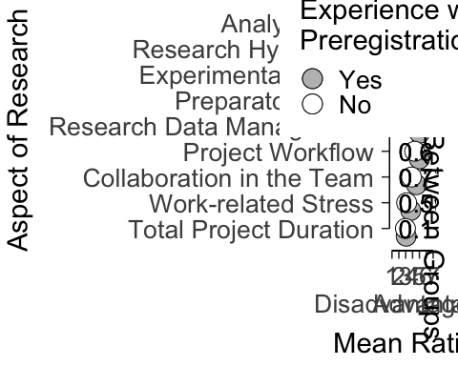

# Save for the paper  
ggsave(here::here("figures/interval_plot.eps"), device = "eps", plot = interval_plot, dpi = 300, width = 50, height = 25, units = "cm")  
  
# Save for the manuscript  
ggsave(here::here("figures/interval_plot.png"), device = "png", plot = interval_plot, dpi = 300, width = 50, height = 25, units = "cm")

# Responses by research type group for all survey questions

## Data preprocessing

Participants indicated their main research type. According to the preregistration we group their responses to compare the results of researchers who primarily do testing and researchers who primarily do another kind of research.

distinct(processed, research_type)

## # A tibble: 6 x 1  
## research_type   
## <chr>   
## 1 Hypothesis testing   
## 2 Other   
## 3 Estimation   
## 4 Modeling   
## 5 Qualitative research  
## 6 Simulations

processed <-   
 processed %>%   
 mutate(research_type_group = case_when(research_type == "Hypothesis testing" ~ "testing",  
 research_type %in% c("Other", "Estimation", "Modeling", "Qualitative research", "Simulations") ~ "else"))  
  
processed %>%   
 group_by(group, research_type_group) %>%   
 summarise(n = n())

## `summarise()` regrouping output by 'group' (override with `.groups` argument)

## # A tibble: 4 x 3  
## # Groups: group [2]  
## group research_type_group n  
## <chr> <chr> <int>  
## 1 control else 15  
## 2 control testing 41  
## 3 prereg else 49  
## 4 prereg testing 250

processed %>%   
 group_by(research_type_group) %>%   
 summarise(n = n())

## `summarise()` ungrouping output (override with `.groups` argument)

## # A tibble: 2 x 2  
## research_type_group n  
## <chr> <int>  
## 1 else 64  
## 2 testing 291

There is not enough participant in the “control” group to make the comparison based on the preregistration of our study. At least 30 respondents need to be in a group to make the comparison.

Therefore, we only run the comparison for the “prereg” group. We keep only these responses for this analysis.

research_type_data <-  
 processed %>%   
 filter(group == "prereg")

Save the group names of interest.

research_type_groups <- c("testing", "else")

List all the questions for each group.

research_type_questions <-  
 expand_grid(groups = research_type_groups,  
 vars = vars) %>%   
 mutate(type = add_question_type(vars))

Get the levels of each question per group.

research_type_questions <-  
 research_type_questions %>%   
 mutate(var_level_present = purrr::map2(groups, vars,  
 ~ level_present(  
 df = research_type_data,  
 group_name = .x,  
 var_name = .y,  
 factor_group = "prereg",  
 group_var = research_type_group)),  
 var_level_labels = purrr::map2(groups, vars,  
 ~ get_levels(  
 df = research_type_data,  
 group_name = .x,  
 var_name = .y,  
 factor_group = "prereg",  
 group_var = research_type_group)))

Count the number of responses for each level

research_type_questions <-  
 research_type_questions %>%   
 mutate(var_desc = purrr::map2(groups, vars,  
 ~ level_count(  
 df = research_type_data,  
 group_name = .x,  
 var_name = .y,  
 group_var = research_type_group,  
 factor_group = "prereg")))

Create one table out of nested information with more descriptive variable and question names.

research_type_questions_table <-   
 research_type_questions %>%   
 filter(type == "likert") %>%   
 select(groups, vars, var_desc) %>%   
 unnest(var_desc) %>%   
 dplyr::group_by(groups, vars) %>%   
 dplyr::mutate(N = sum(n),  
 prop = round(n / N * 100, 2)) %>%   
 select(-N, -levels_int) %>%   
 mutate(vars = vars_rename(vars),  
 groups = groups_rename(groups)) %>%   
 arrange(vars, groups) %>%   
 rename(`Survey question` = vars,  
 Group = groups,  
 Levels = levels,  
 `Number of responses` = n,  
 `Proportion of the level` = prop)

Create an APA formatted table for the paper.

papaja::apa_table(  
 research_type_questions_table,  
 caption = "A Full Summary of All Survey Questions Per Research Type for Preregistration Group",  
 escape = TRUE  
)

(#tab:unnamed-chunk-24)

*A Full Summary of All Survey Questions Per Research Type for Preregistration Group*

|  |  |  |  |  |
| --- | --- | --- | --- | --- |
| Group | Survey question | Levels | Number of responses | Proportion of the level |
| Else | Consider Preregistration in Future Work | Never | 1.00 | 2.04 |
| Else | Consider Preregistration in Future Work | Rarely | 1.00 | 2.04 |
| Else | Consider Preregistration in Future Work | Occasionally | 3.00 | 6.12 |
| Else | Consider Preregistration in Future Work | Sometimes | 8.00 | 16.33 |
| Else | Consider Preregistration in Future Work | Frequently | 11.00 | 22.45 |
| Else | Consider Preregistration in Future Work | Usually | 17.00 | 34.69 |
| Else | Consider Preregistration in Future Work | Always | 8.00 | 16.33 |
| Testing | Consider Preregistration in Future Work | Never | 1.00 | 0.40 |
| Testing | Consider Preregistration in Future Work | Rarely | 3.00 | 1.20 |
| Testing | Consider Preregistration in Future Work | Occasionally | 4.00 | 1.60 |
| Testing | Consider Preregistration in Future Work | Sometimes | 30.00 | 12.00 |
| Testing | Consider Preregistration in Future Work | Frequently | 38.00 | 15.20 |
| Testing | Consider Preregistration in Future Work | Usually | 112.00 | 44.80 |
| Testing | Consider Preregistration in Future Work | Always | 62.00 | 24.80 |
| Else | Preregistration Prevents Questionable Research Practices | Very Strongly Disagree | 0.00 | 0.00 |
| Else | Preregistration Prevents Questionable Research Practices | Strongly Disagree | 0.00 | 0.00 |
| Else | Preregistration Prevents Questionable Research Practices | Disagree | 3.00 | 6.12 |
| Else | Preregistration Prevents Questionable Research Practices | Neither Agree or Disagree | 8.00 | 16.33 |
| Else | Preregistration Prevents Questionable Research Practices | Agree | 17.00 | 34.69 |
| Else | Preregistration Prevents Questionable Research Practices | Strongly Agree | 13.00 | 26.53 |
| Else | Preregistration Prevents Questionable Research Practices | Very Strongly Agree | 8.00 | 16.33 |
| Else | Preregistration Prevents Questionable Research Practices | I do not know | 0.00 | 0.00 |
| Else | Preregistration Prevents Questionable Research Practices | Not applicable | 0.00 | 0.00 |
| Testing | Preregistration Prevents Questionable Research Practices | Very Strongly Disagree | 5.00 | 2.00 |
| Testing | Preregistration Prevents Questionable Research Practices | Strongly Disagree | 4.00 | 1.60 |
| Testing | Preregistration Prevents Questionable Research Practices | Disagree | 9.00 | 3.60 |
| Testing | Preregistration Prevents Questionable Research Practices | Neither Agree or Disagree | 26.00 | 10.40 |
| Testing | Preregistration Prevents Questionable Research Practices | Agree | 77.00 | 30.80 |
| Testing | Preregistration Prevents Questionable Research Practices | Strongly Agree | 66.00 | 26.40 |
| Testing | Preregistration Prevents Questionable Research Practices | Very Strongly Agree | 62.00 | 24.80 |
| Testing | Preregistration Prevents Questionable Research Practices | I do not know | 1.00 | 0.40 |
| Testing | Preregistration Prevents Questionable Research Practices | Not applicable | 0.00 | 0.00 |
| Else | Recommend Preregistration To Colleagues | Very Strongly Disagree | 0.00 | 0.00 |
| Else | Recommend Preregistration To Colleagues | Strongly Disagree | 1.00 | 2.04 |
| Else | Recommend Preregistration To Colleagues | Disagree | 1.00 | 2.04 |
| Else | Recommend Preregistration To Colleagues | Neither Agree or Disagree | 5.00 | 10.20 |
| Else | Recommend Preregistration To Colleagues | Agree | 18.00 | 36.73 |
| Else | Recommend Preregistration To Colleagues | Strongly Agree | 9.00 | 18.37 |
| Else | Recommend Preregistration To Colleagues | Very Strongly Agree | 15.00 | 30.61 |
| Else | Recommend Preregistration To Colleagues | I do not know | 0.00 | 0.00 |
| Else | Recommend Preregistration To Colleagues | Not applicable | 0.00 | 0.00 |
| Testing | Recommend Preregistration To Colleagues | Very Strongly Disagree | 12.00 | 4.80 |
| Testing | Recommend Preregistration To Colleagues | Strongly Disagree | 0.00 | 0.00 |
| Testing | Recommend Preregistration To Colleagues | Disagree | 3.00 | 1.20 |
| Testing | Recommend Preregistration To Colleagues | Neither Agree or Disagree | 12.00 | 4.80 |
| Testing | Recommend Preregistration To Colleagues | Agree | 64.00 | 25.60 |
| Testing | Recommend Preregistration To Colleagues | Strongly Agree | 91.00 | 36.40 |
| Testing | Recommend Preregistration To Colleagues | Very Strongly Agree | 68.00 | 27.20 |
| Testing | Recommend Preregistration To Colleagues | I do not know | 0.00 | 0.00 |
| Testing | Recommend Preregistration To Colleagues | Not applicable | 0.00 | 0.00 |

For the interval type questions we calculate the mean and SD and present the same in a table per group.

research_type_interval_survey_questions_table <-   
 research_type_data %>%  
 select(response_id, research_type_group, all_of(interval_vars)) %>%   
 pivot_longer(  
 all_of(interval_vars),  
 names_to = "vars",  
 values_to = "values") %>%   
 filter(values != "I do not know",  
 values != "Not applicable") %>%   
 mutate(values = as.integer(str_extract(values, "[0-9]{1,2}")),   
 vars = vars_rename(vars),  
 research_type_group = groups_rename(research_type_group)) %>%   
 group_by(research_type_group, vars) %>%   
 summarise(Mean = round(mean(values, na.rm = TRUE), 2),  
 SD = round(sd(values, na.rm = TRUE), 2),  
 N = n()) %>%   
 arrange(vars, research_type_group) %>%   
 rename(`Survey question` = vars,  
 Group = research_type_group)

## `summarise()` regrouping output by 'research_type_group' (override with `.groups` argument)

papaja::apa_table(  
 research_type_interval_survey_questions_table,  
 caption = "A Full Summary of the Interval Survey Questions Per Research Type",  
 escape = TRUE  
)

(#tab:unnamed-chunk-25)

*A Full Summary of the Interval Survey Questions Per Research Type*

|  |  |  |  |  |
| --- | --- | --- | --- | --- |
| Group | Survey question | Mean | SD | N |
| Else | Analysis Plan | 6.06 | 1.21 | 49 |
| Testing | Analysis Plan | 6.00 | 1.12 | 250 |
| Else | Collaboration in the Team | 4.70 | 1.11 | 46 |
| Testing | Collaboration in the Team | 4.55 | 1.04 | 244 |
| Else | Experimental Design | 5.33 | 1.33 | 48 |
| Testing | Experimental Design | 5.34 | 1.21 | 247 |
| Else | Preparatory Work | 5.43 | 1.19 | 47 |
| Testing | Preparatory Work | 5.36 | 1.23 | 246 |
| Else | Project Workflow | 5.14 | 1.22 | 49 |
| Testing | Project Workflow | 4.95 | 1.08 | 243 |
| Else | Research Data Management | 4.91 | 1.14 | 47 |
| Testing | Research Data Management | 5.04 | 1.14 | 246 |
| Else | Research Hypothesis | 5.51 | 1.31 | 49 |
| Testing | Research Hypothesis | 5.65 | 1.18 | 248 |
| Else | Total Project Duration | 3.40 | 1.38 | 47 |
| Testing | Total Project Duration | 3.00 | 1.12 | 240 |
| Else | Work-related Stress | 4.08 | 1.11 | 48 |
| Testing | Work-related Stress | 3.67 | 1.18 | 245 |

Visualize the content of the table to aid the creation of the plots for the paper.

# research_type_questions <-  
# research_type_questions %>%   
# mutate(plot = map2(groups, vars,  
# ~ apa_barplot(  
# df = research_type_data,  
# group_name = .x,  
# var_name = .y,  
# group_var = research_type_group,  
# factor_group = "prereg")))  
#   
# research_type_questions$plot

Creating plots for the Likert-type scales.

# Get data for plot  
likert_plot_data_researc_type_recommend <- prepare_likert_plot_data(research_type_questions, "recommend")  
  
# Create the plot  
research_type_likert_plot_recommend <-   
 likert_plot_odd(  
 data = likert_plot_data_researc_type_recommend,  
 title = "Recommend Preregistration To Colleagues",  
 levels = levels,  
 levels_to_drop = c("I do not know", "Not applicable"),  
 questions = groups,  
 n = n,  
 positive_side = "upper",  
 limits = c(-1, 1),  
 text_push = 0.013) +   
 theme(  
 legend.margin = margin(l = 0, b = 0, r = 100),  
 legend.key.size = unit(0.8, 'cm'),  
 legend.text = element_text(size = 19),  
 plot.margin = margin(t = 10, r = 40, b = 10, l = 0))

## `summarise()` regrouping output by 'groups' (override with `.groups` argument)

research_type_likert_plot_recommend

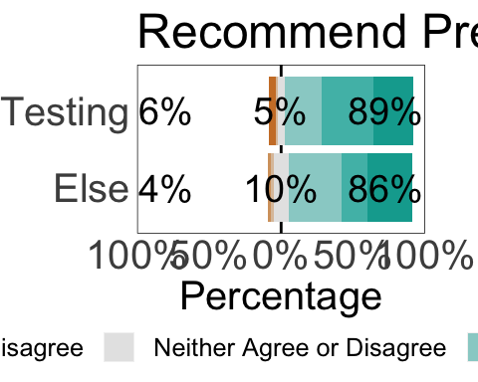

# Save for the paper  
ggsave(here::here("figures/research_type_likert_plot_recommend.eps"), device = "eps", plot = research_type_likert_plot_recommend, dpi = 300, width = 50, height = 15, units = "cm")  
  
# Save for the manuscript  
ggsave(here::here("figures/research_type_likert_plot_recommend.png"), device = "png", plot = research_type_likert_plot_recommend, dpi = 300, width = 50, height = 15, units = "cm")

# Get data for plot  
likert_plot_data_researc_type_qrp <- prepare_likert_plot_data(research_type_questions, "qrp")  
  
# Create the plot  
research_type_likert_plot_qrp <-   
 likert_plot_odd(  
 data = likert_plot_data_researc_type_qrp,  
 title = "Preregistration Prevents Questionable Research Practices",  
 levels = levels,  
 levels_to_drop = c("I do not know", "Not applicable"),  
 questions = groups,  
 n = n,  
 positive_side = "upper",  
 limits = c(-1, 1),  
 text_push = 0.013) +   
 theme(  
 legend.margin = margin(l = 0, b = 0, r = 100),  
 legend.key.size = unit(0.8, 'cm'),  
 legend.text = element_text(size = 19),  
 plot.margin = margin(t = 10, r = 40, b = 10, l = 0))

## `summarise()` regrouping output by 'groups' (override with `.groups` argument)

research_type_likert_plot_qrp

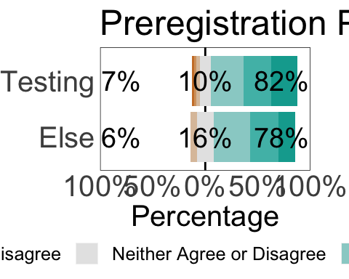

# Save for the paper  
ggsave(here::here("figures/research_type_likert_plot_qrp.eps"), device = "eps", plot = research_type_likert_plot_qrp, dpi = 300, width = 50, height = 15, units = "cm")  
  
# Save for the manuscript  
ggsave(here::here("figures/research_type_likert_plot_qrp.png"), device = "png", plot = research_type_likert_plot_qrp, dpi = 300, width = 50, height = 15, units = "cm")

# Get data for plot  
likert_plot_data_researc_type_planning <- prepare_likert_plot_data(research_type_questions, "planning")  
  
# Create the plot  
research_type_likert_plot_planning <-  
 likert_plot_odd(  
 data = likert_plot_data_researc_type_planning,  
 title = "Consider Preregistration in Future Work",  
 levels = levels,  
 levels_to_drop = c("I do not know", "Not applicable"),  
 questions = groups,  
 n = n,  
 positive_side = "upper",  
 limits = c(-1, 1),  
 text_push = 0.013) +   
 theme(  
 legend.margin = margin(l = 0, b = 0, r = 0),  
 legend.key.size = unit(0.8, 'cm'),  
 legend.text = element_text(size = 19),  
 plot.margin = margin(t = 10, r = 40, b = 10, l = 0))

## `summarise()` regrouping output by 'groups' (override with `.groups` argument)

research_type_likert_plot_planning

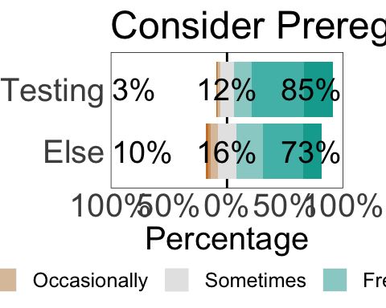

# Save for the paper  
ggsave(here::here("figures/research_type_likert_plot_planning.eps"), device = "eps", plot = research_type_likert_plot_planning, dpi = 300, width = 50, height = 15, units = "cm")  
  
# Save for the manuscript  
ggsave(here::here("figures/research_type_likert_plot_planning.png"), device = "png", plot = research_type_likert_plot_planning, dpi = 300, width = 50, height = 15, units = "cm")

The other questions were using a 7 point scale that we will treat as an interval scale. This plot presents the mean rating per question per group with the 95% CI as the errorbar.

# Modify the data for plotting  
research_type_interval_plot_data <-   
 research_type_data %>%  
 select(response_id, research_type_group, all_of(interval_vars)) %>%  
 pivot_longer(  
 all_of(interval_vars),  
 names_to = "vars",  
 values_to = "values") %>%   
 filter(values != "I do not know",  
 values != "Not applicable") %>%   
 mutate(values = as.integer(str_extract(values, "[0-9]{1,2}")),   
 vars = vars_rename(vars)) %>%   
 group_by(research_type_group, vars) %>%   
 summarise(mean = mean(values, na.rm = TRUE),  
 sd = sd(values, na.rm = TRUE),  
 n = n()) %>%   
 group_by(vars) %>%   
 mutate(mean_avg = mean(mean)) %>%   
 ungroup() %>%   
 pivot_wider(  
 names_from = research_type_group,  
 values_from = c(mean, sd, n)) %>%   
 mutate(mean_difference = mean_testing - mean_else) %>%   
 pivot_longer(  
 union(contains("testing"), contains("else")),  
 names_to = c("variables", "groups"),  
 values_to = "values",  
 names_sep = "_") %>%   
 pivot_wider(  
 names_from = variables,  
 values_from = values) %>%   
 mutate(se = sd / sqrt(n),  
 ub = mean + 1.96 * se,  
 lb = mean - 1.96 * se,  
 groups = case_when(groups == "testing" ~ "Testing",  
 groups == "else" ~ "Else"),  
 vars = as.factor(vars),  
 vars = fct_reorder(vars, mean_avg)) %>%   
 arrange(desc(mean_avg))  
  
# Create the plot  
research_type_interval_plot <-  
 research_type_interval_plot_data %>%  
 ggplot() +  
 aes(x = as.integer(vars),  
 y = mean,  
 fill = groups,  
 group = groups) +  
 # Set error bars  
 ## Error bar for prereg group with nudged position  
 geom_errorbar(  
 data = pick(groups == "Testing"),  
 aes(  
 ymin = mean - (se * 1.96),  
 ymax = mean + (se * 1.96)),  
 width = .3,  
 size = 0.8,  
 position = position_nudge(x = -0.3, y = 0)) +  
 ## Error bar for control group without nudged position  
 geom_errorbar(  
 data = pick(groups == "Else"),  
 aes(  
 ymin = mean - (se * 1.96),  
 ymax = mean + (se * 1.96)),  
 width = .3,  
 size = 0.8) +  
 # Set points  
 ## Points of prereg group with nudged position  
 geom_point(  
 data = pick(groups == "Testing"),  
 size = 8,  
 shape = 21,  
 position = position_nudge(x = -0.3, y = 0)) +  
 ## Points of control group without nudged position  
 geom_point(  
 data = pick(groups == "Else"),  
 size = 8,  
 shape = 21) +  
 geom_text(  
 aes(  
 x = as.integer(vars),  
 y = 7,  
 label = sprintf("%0.2f", round(mean_difference, 2))),  
 inherit.aes = FALSE,  
 size = 7,  
 # Text horizontal adjustment  
 hjust = 0.7) +  
 # Color of the fill  
 scale_fill_manual(values = c("white", "grey")) +  
 scale_x_continuous(  
 breaks = as.integer(unique(research_type_interval_plot_data$vars)),  
 labels = unique(research_type_interval_plot_data$vars),  
 sec.axis = sec_axis(~ ., name = "Mean Difference Between Groups")) +  
 scale_y_continuous(  
 expand = c(0, 0.4),  
 breaks = c(1, 2, 3, 4, 5, 6, 7),  
 labels = c("1\nDisadvantage", "2", "3", "4", "5", "6", "7\nAdvantage")) +  
 # Redrawing the axes  
 geom_segment(  
 aes(x = 1, xend = 9, y = -Inf, yend = -Inf)) +  
 geom_segment(  
 aes(y = 1, yend = 7, x = -Inf, xend = -Inf)) +  
 # Flip the axis  
 coord_flip(ylim = c(1, 7)) +  
 # Add labels  
 labs(x = "Aspect of Research",  
 y = "Mean Rating",  
 fill = "Groups") +  
 # Change legend text order  
 guides(fill = guide_legend(reverse = TRUE)) +  
 # Theme options  
 papaja::theme_apa() +  
 theme(axis.title = element_text(size = 22),  
 axis.title.y.right = element_text(margin = margin(l = -15, b = 10)),  
 axis.text.y.right = element_blank(),  
 axis.ticks.y.right = element_blank(),  
 axis.line.y.right = element_blank(),  
 axis.text = element_text(size = 20),  
 axis.line = element_blank(),  
 legend.text = element_text(size = 20),  
 legend.title = element_text(size = 22),  
 legend.position = c(.2, .8)  
 )  
  
research_type_interval_plot

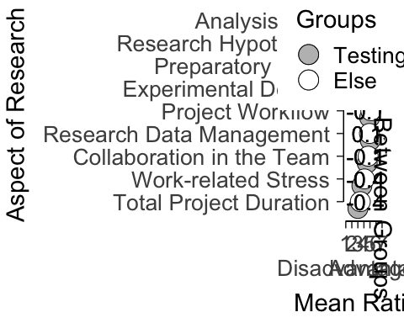

# Save for the paper  
ggsave(here::here("figures/research_type_interval_plot.eps"), device = "eps", plot = research_type_interval_plot, dpi = 300, width = 50, height = 25, units = "cm")  
  
# Save for the manuscript  
ggsave(here::here("figures/research_type_interval_plot.png"), device = "png", plot = research_type_interval_plot, dpi = 300, width = 50, height = 25, units = "cm")

# Background information

Plot showing the distribution of reported research fields by the respondents. As some respondents reported more than one research field the number of all the research fields are not matching the number of individual respondents.

# Importing data  
fields <- read_tsv(here::here("data/main/processed/PreregistrationEvaluation_Fields.tsv"))

##   
## ── Column specification ────────────────────────────────────────────────────────  
## cols(  
## response_id = col_character(),  
## field = col_character(),  
## final_field_1 = col_character(),  
## final_field_2 = col_character(),  
## final_field_3 = col_character()  
## )

# Creating bar plot showing the number of participants in each field, containing duplicates due to participants who are active in more than one field  
fields_gathered <-   
 fields %>%   
 gather(key = "final_field_key", value = "final_field_value", -response_id, -field, na.rm = TRUE) %>%   
 mutate(final_field_value = case_when(final_field_value == "Neurophysiology and Physiological Psychology" ~ "Neurophysiology and\nPhysiological Psychology",  
 final_field_value == "Experimental and Cognitive Psychology" ~ "Experimental and\nCognitive Psychology",  
 final_field_value == "Developmental and Educational Psychology" ~ "Developmental and\nEducational Psychology",  
 TRUE ~ final_field_value))  
  
fields_gathered %>%   
 count(final_field_value) %>%   
 arrange(desc(n)) %>%   
 mutate(N = sum(n))

## # A tibble: 9 x 3  
## final_field_value n N  
## <chr> <int> <int>  
## 1 "Social Psychology" 112 389  
## 2 "Experimental and\nCognitive Psychology" 104 389  
## 3 "Other" 57 389  
## 4 "Developmental and\nEducational Psychology" 36 389  
## 5 "Personality Psychology" 32 389  
## 6 "Neurophysiology and\nPhysiological Psychology" 17 389  
## 7 "Applied Psychology" 15 389  
## 8 "Clinical Psychology" 12 389  
## 9 "Methodology and Statistics" 4 389

fields_plot <-  
 fields_gathered %>%   
 count(final_field_value) %>%  
 mutate(  
 final_field_value = forcats::fct_reorder(final_field_value, n, .desc = FALSE),  
 final_field_value = forcats::fct_relevel(final_field_value, "Other", after = 0)) %>%   
 ggplot() +  
 aes(y = n,  
 x = final_field_value) +  
 geom_bar(stat = "identity") +  
 scale_y_continuous(  
 expand = c(0, 0),  
 limits = c(0, 130)) +  
 labs(x = "Research Background",  
 y = "Number of Respondents") +  
 coord_flip() +  
 papaja::theme_apa() +  
 theme(  
 title = element_text(size = 20),  
 axis.title = element_text(size = 30),  
 panel.background = element_blank(),  
 panel.grid = element_blank(),  
 axis.text = element_text(size = 20),  
 axis.ticks = element_blank(),  
 strip.background = element_blank(),  
 strip.text = element_text(hjust = 0, face = 'bold', size = 25),  
 panel.border = element_rect(color = 'gray90', linetype = "dashed", fill = NA),  
 legend.key.size = unit(1, 'cm'),  
 legend.text = element_text(size = 15))  
  
fields_plot

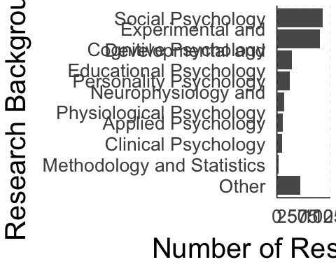

# Save gathered plot for the paper  
ggsave(here::here("figures/Fields.eps"), device = "eps", plot = fields_plot, dpi = 300, width = 45, height = 25, units = "cm")  
  
# Save gathered plot for the manuscript  
ggsave(here::here("figures/Fields.png"), device = "png", plot = fields_plot, dpi = 300, width = 45, height = 25, units = "cm")