**Document for Orientated Phase of Martin Petkov**

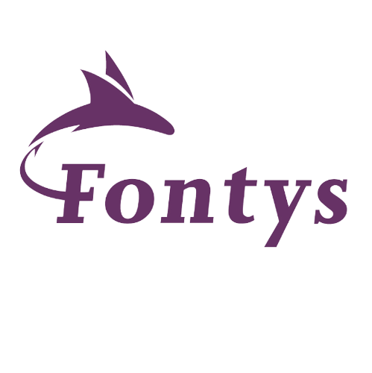

EINDHOVEN 2024, R 10

P-CB-M-CMK, Semester 1 Media Phase

**Fontys University of Applied Sciences, Eindhoven R10**

This document is meant to document my journey through the orientation phase and will be adjusted according to feedback. The **document is structured in () parts including: Website Section, Group Section, Professional and Technical skills.**

Add the content table

# *Introduction: A short interview feat. Myself:*

**About you:** - My name’s Martin 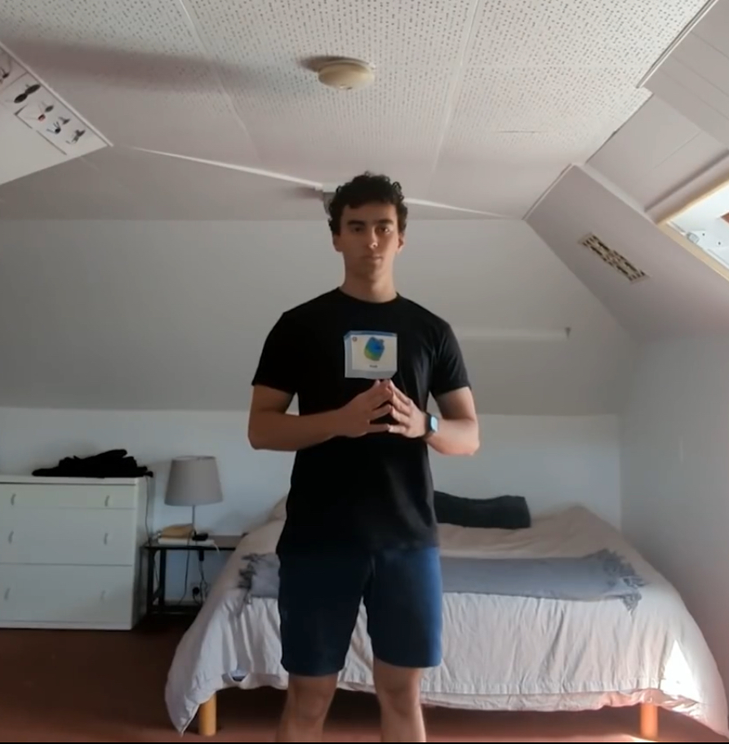as you already know I’m a Fontys ICT student. I’m 19 years old, hailing from Eastern Europe, Sofia, Bulgaria. My hobbies are art, photography, music overall visually and early pleasing stuff.

**Why did you choose Media:** - I chose media because I find the mixture of creativity and technology essential for me to succeed in the direction I’m aiming. I find technology to be an integral part of Media Design and an interesting proposition to today’s art landscape and so even if I’m not the biggest fan of coding I’m interested to learn web development and continue improving myself in both directions so I can realize my ideas.

**Any future plans:** - Something I love to do, something that I can sprout in, creatively, not certain of it, and that’s why I like Media so much, because of the proposition that I can pick up anything in this sphere.

# **Personal Website – Wireframes, Development, Feedback, Reflection, Decisions**

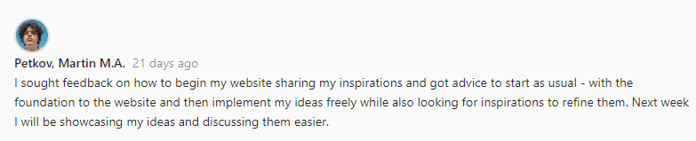

Wireframes

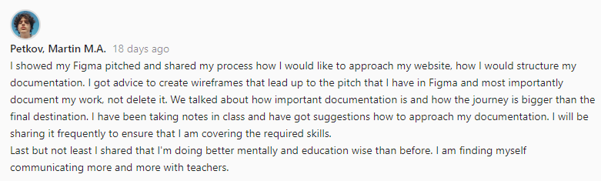

Pitches

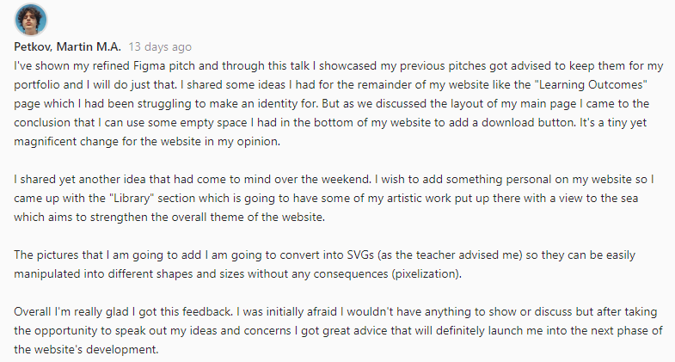

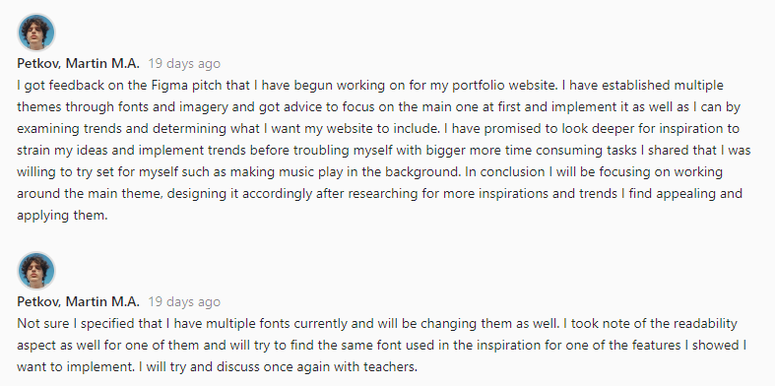

Feedback

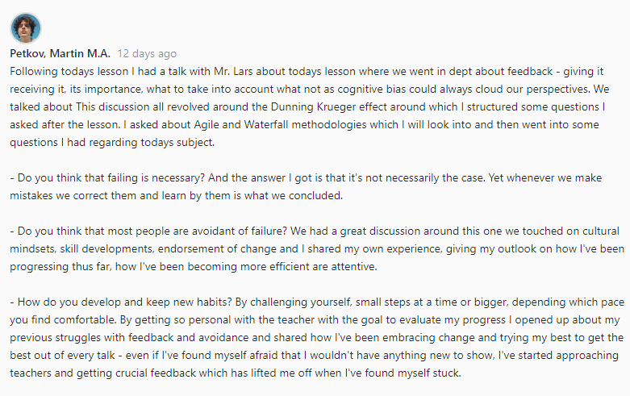

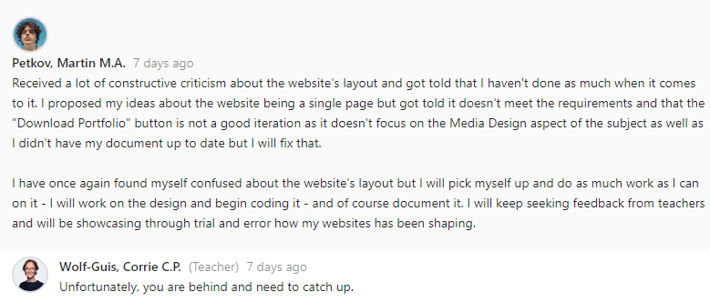

Give an inside to where I got stuck how I unstuck myself and where I am currently (setting myself up for what’s to come)

Group Project Section – My Contribution, Feedback, Reflection, Decisions

This part of my Documentation is meant to showcase my contribution to the group project.

One of our first lessons required us to create groups and discuss the subject. We brainstormed… … . Another thing we had to do is create a poster for our project to “sell the idea” in front of the class. In our research we got to know about the Gestalt method:

**GESTALT** – **“Psychological approach to “how humans gain perceptions“ = How do we process what we see and organize our thoughts. Originally not a graphic design approach – but quickly adapted by the industry - Essential part of visual design.”**

**Another definition is - an organized whole that is perceived as more than the sum of its parts.**

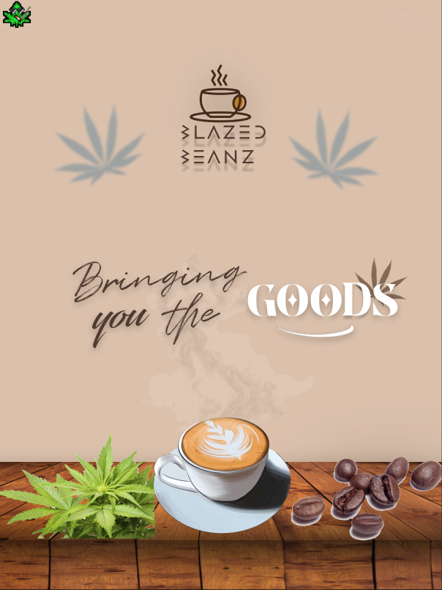

And so by dividing parts for the poster I made the logo

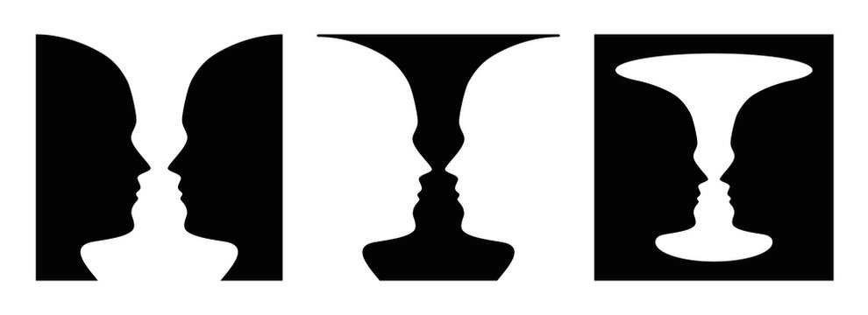

Example I found which I used as inspiration to create the logo for our poster

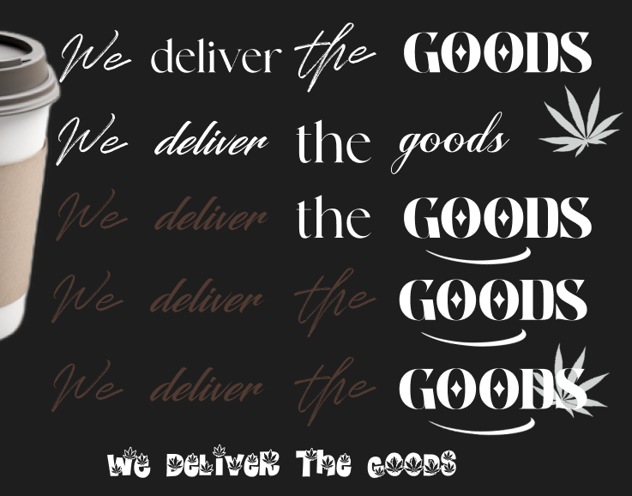

Different logo iterations

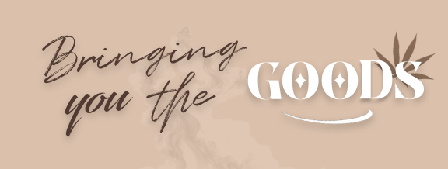

**From the presentation itself I got advice to fix the “D” as it was hardly recognizable from distance, and it had been mistaken for an “N”. Regardless I got positive feedback on the logo itself as most people saw the eyes and face which was the goal.**



This is the version after feedback – fixed color to match the rest of the text as well as made it more readable

Slideshow:

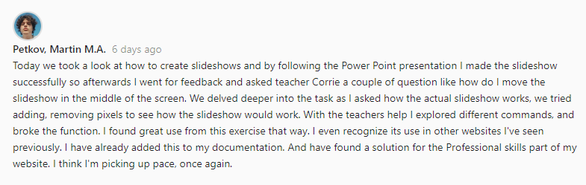

Pokemon Card:

Cat Rescue Website:

# Professional skills:

Establishing the foundation has to be one of the most important and time saving steps to consider when starting off with a project (or subject) that’s why I’m listing what we’re going be focusing on this part of 1st semester – User research, Prototyping, HTML + CSS.

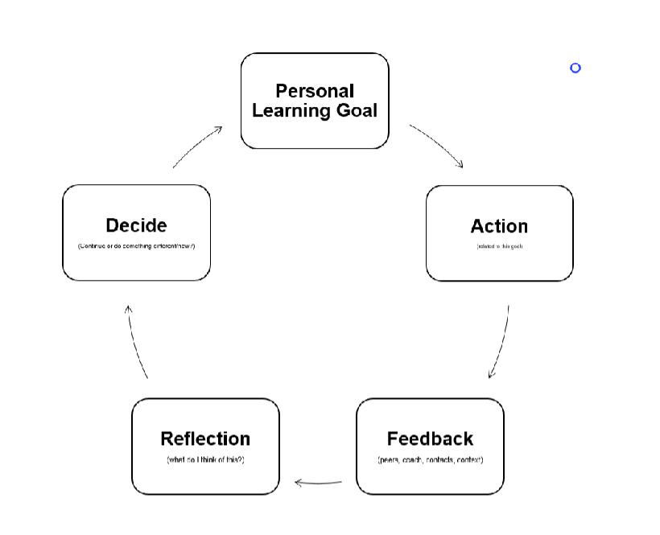

How I aim to go through the profile phase

**First week we went through the establishment of Gestalt method and did a poster for our group’s project which was a group effort each one of us took part in. After coming up with the idea for the website itself.**

Technical Skills

**Quick quiz:**

* **What Sitemap do people use to navigate your website?**
* **Where does a grid start with position 0,0?**
* **How do you combine two grid elements vertically?**
* **Flex: What is the difference between space-around and space-between?**

**Creating a slideshow using the assistance of a PowerPoint**

**Notes to be added in.**

**Comparative analysis**

Starting off with wireframes

* Functionality and color in the low level fo the prototype is not recommended
* Color in the first wireframe is wrong because it takes focus from making the structure
* 1st wireframe is about the composition and balance
* 60 30 10 rule – start out with the main color and the contrast color (often being black or dark red), the 30 percent is what we want the user to observe. It’s important because it helps balance out the layout. Color can fake balance or waver it. If balance already works without colors

Week 11 e twa gore

Week 12

Week 13

Trqq da go naprawq

Week 1 ne e etolkowa mngoo stegni se