Fontys University of Applied Sciences, Eindhoven R10

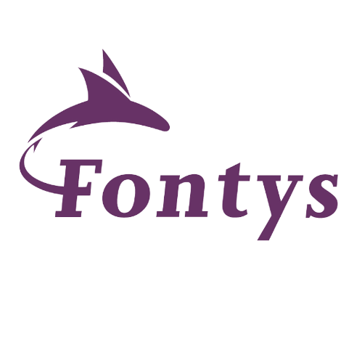
Personal Experience Portfolio Martin Petkov, P-SEM1-CB-CMK, CLASS 7 EINDHOVEN 2023/2024 semester 1

Fontys University of Applied Sciences, Eindhoven R10
Name and Surname: Martin Petkov
Class: 7
School year: 2023/2024
Profile: Software Media Design
Start date of PEP: 10. 6. 2023

CONTENT
WEEK ONE............................................................................................ 3
- Introduction to ICT & Programming – Flowcharts & Python
WEEK TWO............................................................................................6
- Introduction to HTML, Research & Writing skills
WEEK THREE.........................................................................................11
- Introduction to functions, Arduino & computer networks
WEEK FOUR…………………………………………………………………………………………13
- Introduction to business and data analysis, Arduino Programming using Python & and reaching for feedback/retrospective
WEEK FIVE…………………………………………………………………………………………..18
- Introduction to Flask & using Excel efficiently
WEEK SIX……………………………………………………………………………………………..23
- Pitching the website & Interviewing people to get feedback on the website
WEEK SEVEN………………………………………………………………………………………..26
- Working on project: creating a Excel table to include its data into the project

WEEK ONE

Introduction to Programming

Through this matter we learned the importance of making flowcharts before starting programming. We had to make our own flowcharts as well based on given challenges. I had almost no prior experience but I figured it out through trial and error. And of course learned the importance of communication – a lesson that would take time for me to learn.
Introduction to Python

Here we learned the basics of Python and for our start off we had to make a simple function – “High IQ Game” was the task that we all encountered. I had a sliver of experience with coding which made me somewhat aware of what I was doing but of course it wasn’t enough for me to finish it in 5 minutes unlike some of my colleagues. But this simple line of code was just the beginning of the nightmare that was to come after conditions - “if” & “if else” as well as “while loop”
Nonetheless... I tried my best , did extra challenges as well 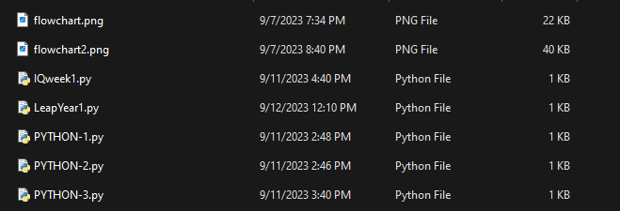
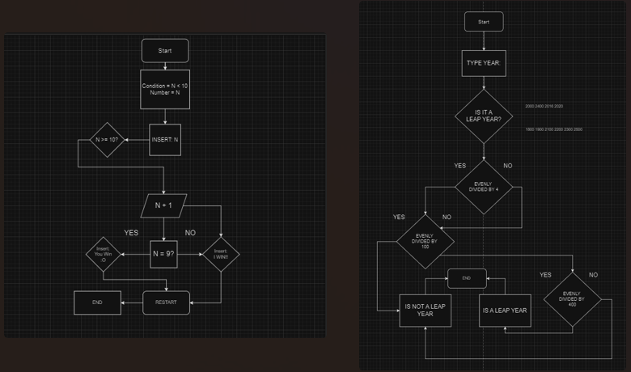

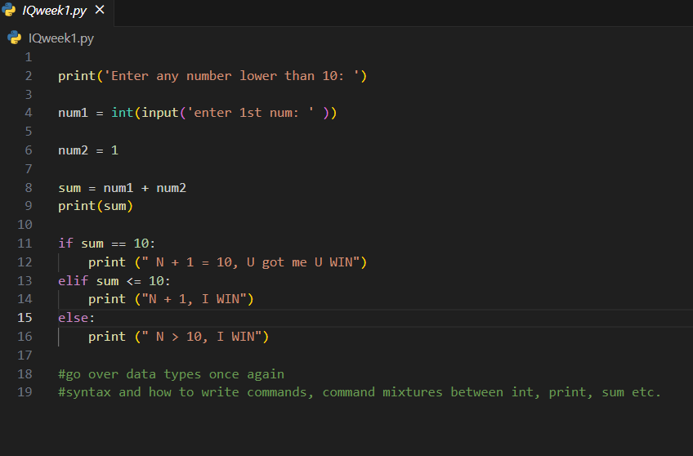
Week One Summary:
In the first week we got introduced to the fundamentals of ICT and the importance of each subject that we would be studying during our orientation phase. Starting off with the basis – the importance of Flowcharts is universal for the success of any project no matter the size. Besides Flowcharts we learned basic Python syntax which we put into practice through tasks like the “High IQ Game”.

Main Takeaway:
- Always think before you start coding.
- Basic Python syntax
- Importance of Prototyping
- Importance of Communication
WEEK TWO

Introduction to lists & loops:
Week two started off with learning the concepts of lists & loops which we would begin to use in flowcharts before implementing them into code. This was the beginning of a downward spiral for me as I spend two days trying to debunk these new concepts – though the teachers all said that I shouldn’t focus this hard on solving every single task I tried very hard and finished some extra tasks – though they were overdue – but that’s how most of everything goes for me: I think about it too hard and before I realize its overdue.

A lot of coding files:
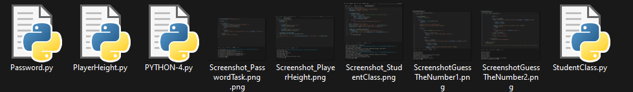
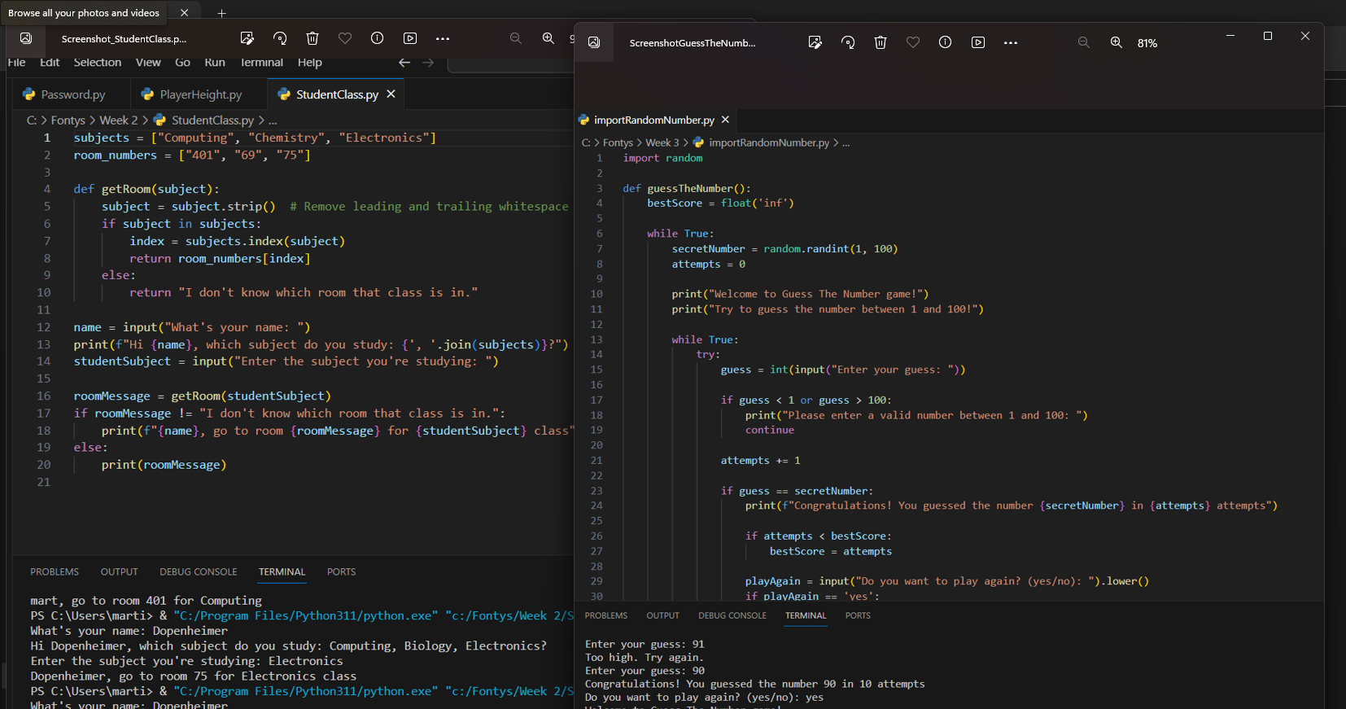
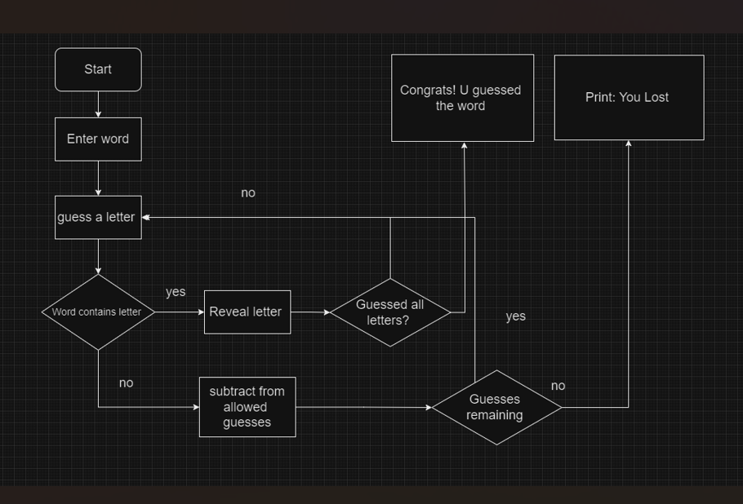

Introduction to HTML & CSS:
We learned the basics of HTML mostly through the assignments that we had to work on – the most significant one of them being making a website. Although my website stands out solely with its questionable silliness to my surprise I got very positive feedback from Mr. Naus Thijs. 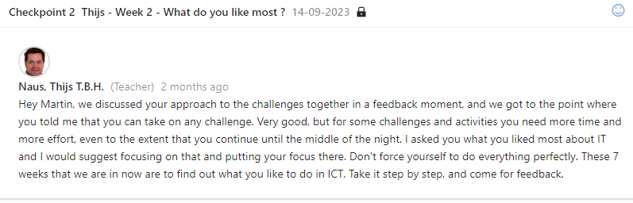
- A website I made. In the CSS file I have experimented with stretching images out as well as trying to reach the new found limits of what I have learned.
- 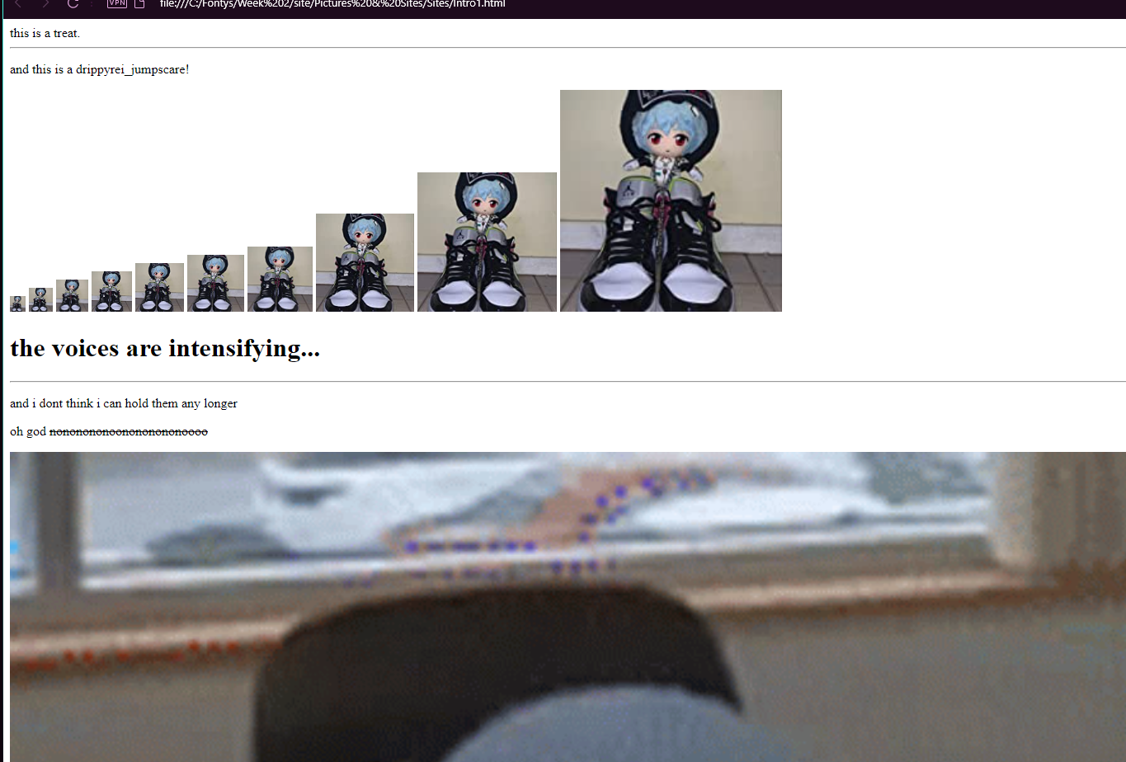
Due to how much I enjoyed making the showcased website I started working on another site but didn’t finish it because it was already week 3 whenever I was getting finished with week 2.
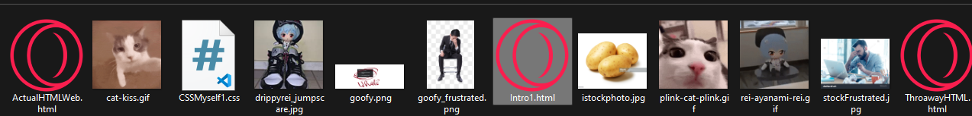

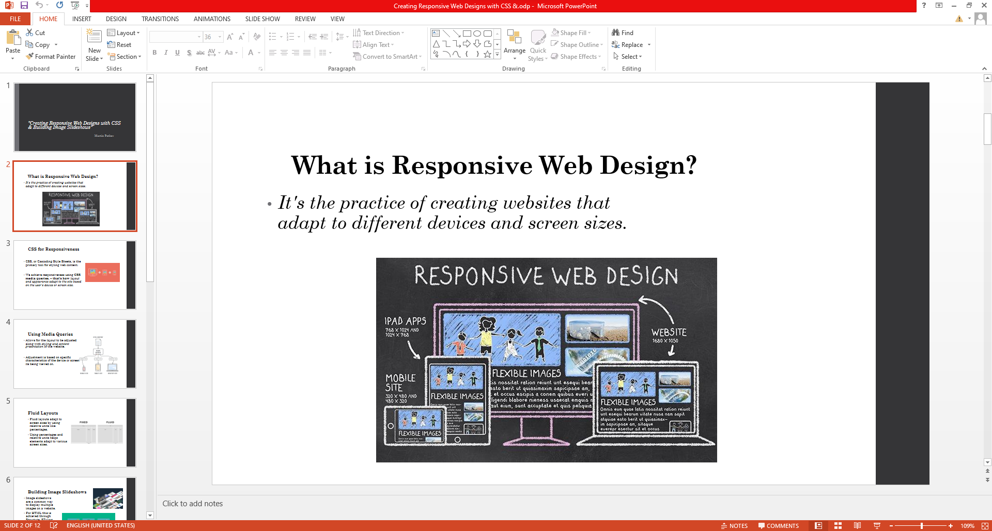

Week Two Summary:
This week we had a lot of programming, starting with lists and loops, followed by introduction to strings. With what little experience I had with coding these concepts were kind of new to me. It was very similar to C#. The following days we learned basic commands in HTML as well as how to create our own website. Though I have made a website before – made is a strong word because I don’t remember finishing it, though I found it really fun, to create my own website, experimenting with CSS to stretch out images and texts into comedic lengths so I am glad I got to learn this again from the beginning. Besides technical skills, this week we learned a bit about writing and doing research on a topic we got to choose and I made a presentation about “Creating Responsive Web Designs with CSS & Building Image Slideshows” for which I would on a later date get a mostly positive feedback.

Main Takeaway:
- Lists, Loops & Strings are a basic yet integral parts of any function I was to create
- Simple website development
- How to research efficiently

WEEK THREE

Introduction to functions and my struggle with them:
These assignments were of high difficulty for me at first but I found the solution to most of my problems – which at first was Chat GPT – which I used quite a lot to explain every single line of code and what it comes down to. Yet I later learned that this is not cutting it and though I was learning faster than before it wasn’t fast enough so I started descending into bliss. Until some colleagues of mine started noticing my major struggles with previous’ week lists, strings. Functions piling up and helped me understand these new concepts.
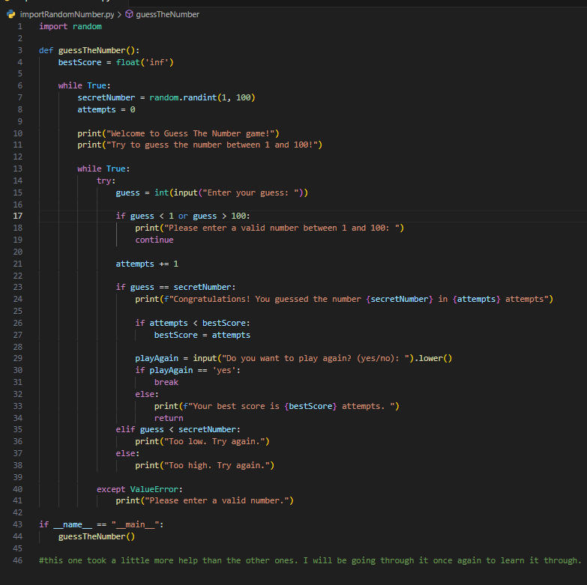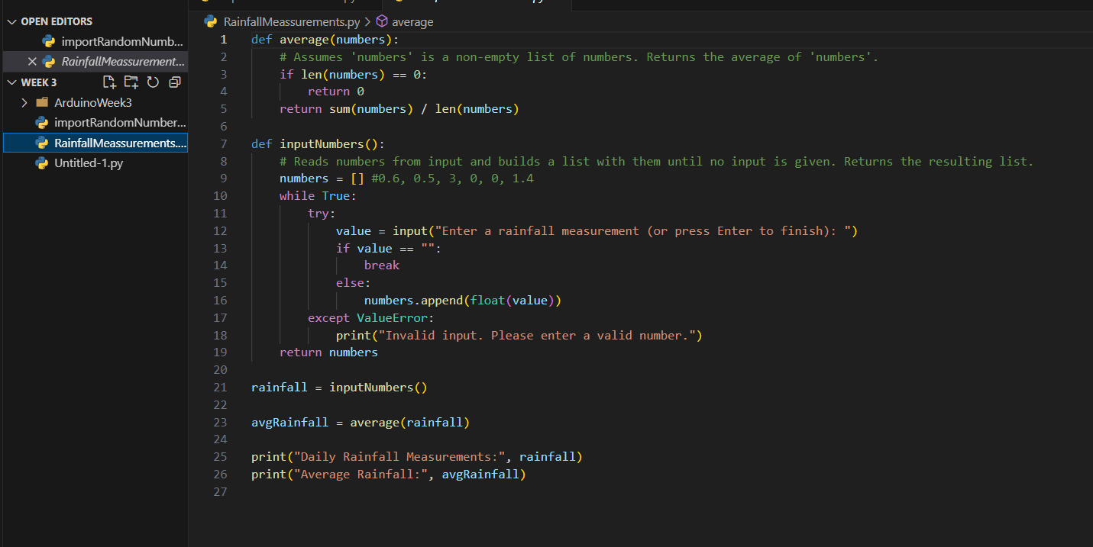

Introduction to Arduino and computer networks:
Through week 3 I learned that Software and Infrastructure does sound interesting but in practice is boring if I say so myself. We did some exercises with the Arduino – blink, dimming. As expected, neither were really interesting to me, though I complete every assignment I had.

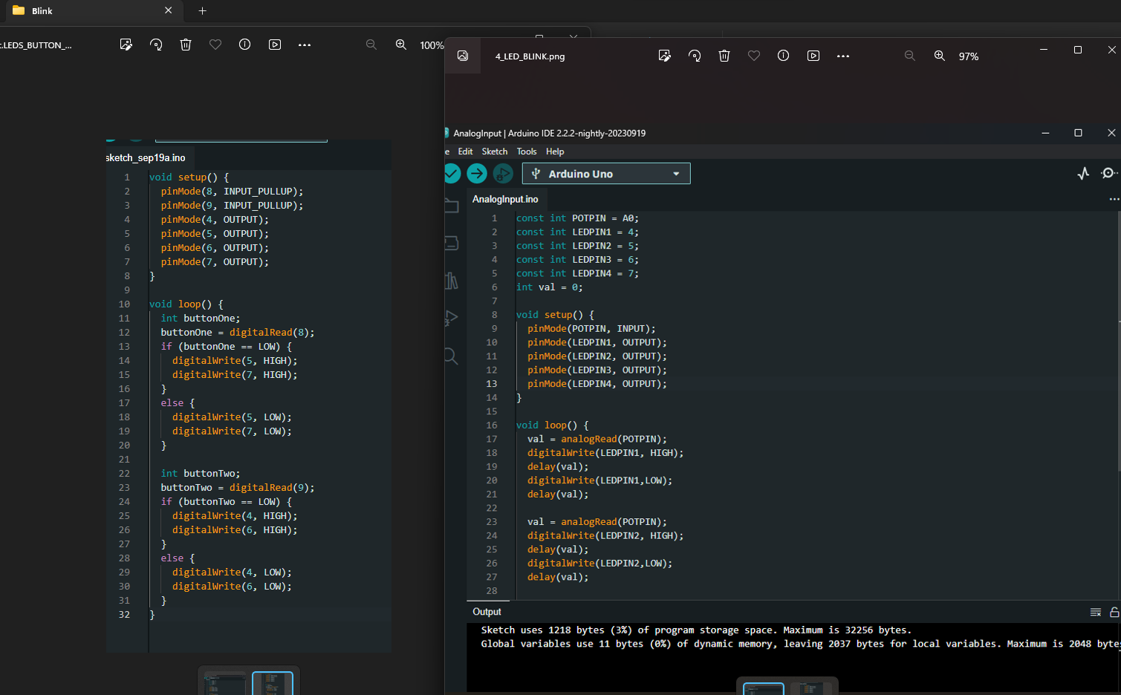
Week Three Summary:
This week was boring for me if I have to be honest. Though I finished my tasks -relatively quickly with the help of some colleagues I was getting close to - for the duration of these following weeks I was starting to develop a fashion of piling up work which would soon turn into a snowball. I was constantly forgetting to send assignments, even If they were finished. Maybe it’s because of how much boredom I was experiencing with Week 3 and Week 4: but at least I learned what’s not for me.

Main Takeaway:
- Network and infrastructure is not my thing – still got something out of it
- Arduino is complicated

WEEK FOUR

Introduction to business & data analysis:
In business class the emphasis was put on analysis (as expected) and its importance. What I gather from this class is that business is about making it easier to find solutions. The Greenhouse research assignment was hefty work. I did a lot of research on the topic of “how to research properly” and that probably took longer than the research itself.
Programming an Arduino using Python:
As I have made it obvious at this point Arduino turned out to be far from my thing but I did enjoy the insanity I got drove to when I started coding the Arduino through VS using Python.
Figuring out and reaching for feedback:
Started realizing more and more that I am not actively pursuing feedback from my teachers and mentors. Working on it, I’m becoming better with each day nonetheless.
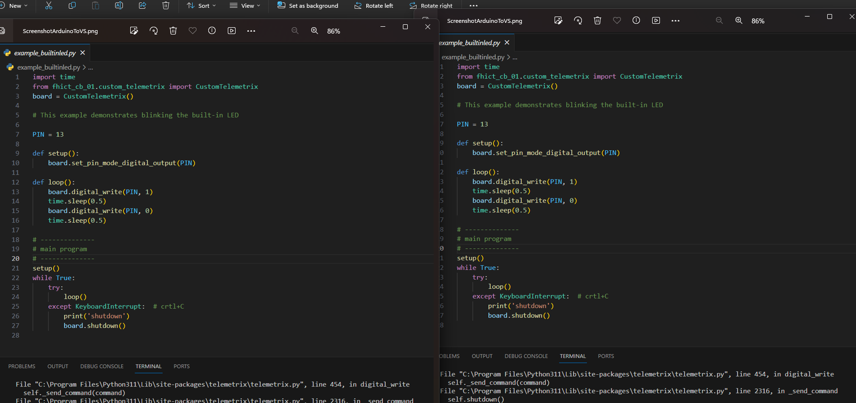

Week Four Summary:
Week 4 was a tough one for me. Definitely felt like I was putting effort in but wasn’t brining success out of it. There were points when I felt lost and would find myself confused from where I should begin. Probably spent more time wondering than working – because when it came to work even if it was disinteresting for the most part I still found fulfillment in the completion of any task. Right now I am working on improving communication, which I feel would better my workflow as well.

Example of how I forget to do simple things: 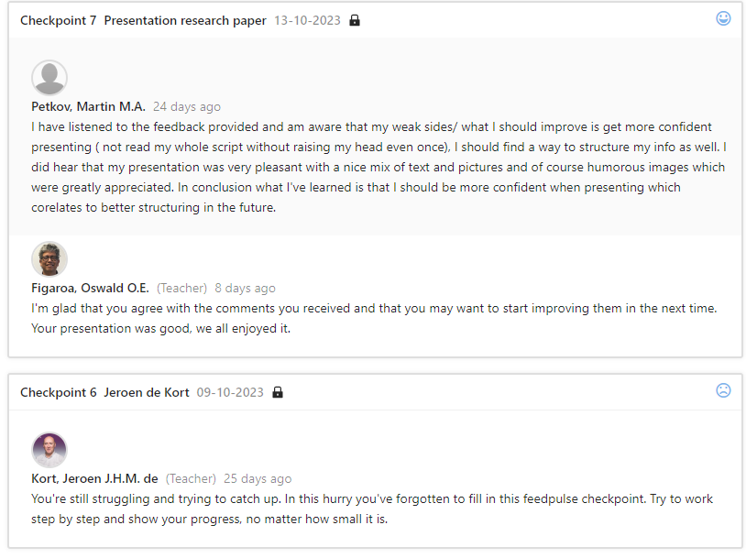

Main Takeaway:
- Business task was interesting to say the least. Challenging but understandable integral part of improving communication.
- More Arduino. This time more painful but somehow I found myself enjoying it more this time around.
- We touched on the subject of algorithmic bias and the faults that come with it. From what I understood avoiding such occurrences is only possible through communication and open-mindfulness.

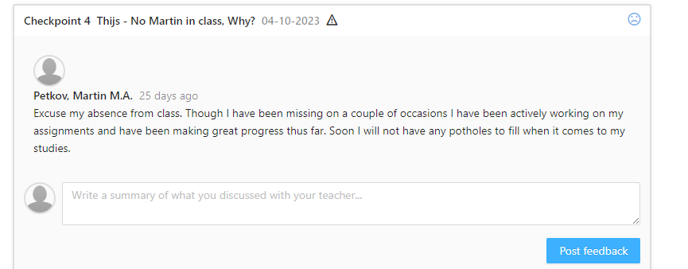

Overall Score thus far:
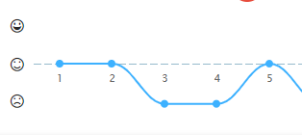

I’d say that I am overall mildly satisfied with this score and could do much better. With that being said only way to do so is to accept it and prove to myself first and foremost that I can achieve anything I put my mind into. Though these couple of weeks there we many times I doubted myself that I would make anything of value but It turns out that I have proven myself wrong at times even with the minimal effort I have been putting out at times I have gotten to a decent point. After the documentation of this PEP that I had been putting off and now finally getting around to rounding it, looking back 4 weeks ago I feel like saying only three words – keep on trying.
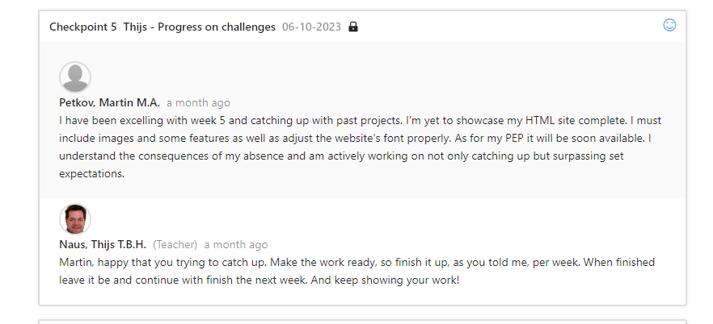
WEEK FIVE, WEEK 6+: GROUP PROJECT

Main takeaway:
- I didn’t quite get to mess around with Flask but understood its use
- Excel had me mentally boom two times but the third I actually had a pleasant experience

Week 5 Summary:
I was mostly absent for week 5 but caught up what had been taught in class – presenting projects like the one mentioned in week 2 as well as introduction to Flask and using it to visualize data measured by Arduino – similar to some tasks I’ve done before where upon pressing a certain button the Arduino displays the input onto the screen of the laptop. Lastly, we worked with Excel which was hard for me at first because I didn’t know how to use it properly but after starting our project with “Hot Towel Cult” I’ve got a decent understanding of the Office Application.
I feel like week 4 and 5 were my worst weeks. I was sick a lot and was finding it hard to find motivation to even wake up some days. But the people I have been around lately have been of great help and to them I owe a big thank you, as they helped me not only formulate my PEP but also learn to ask for help and strive for better days. And of course, try to not let my teammates down.

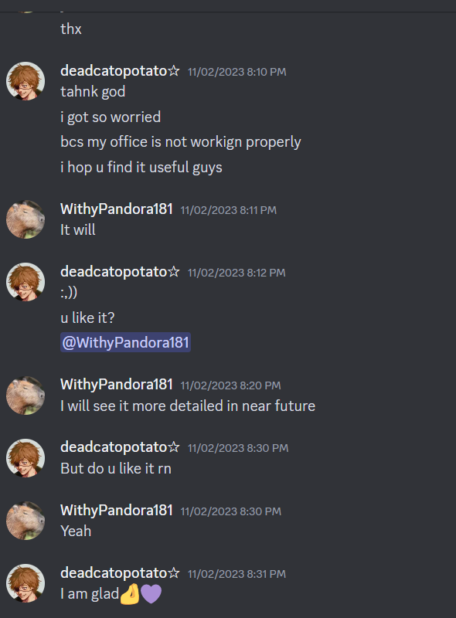
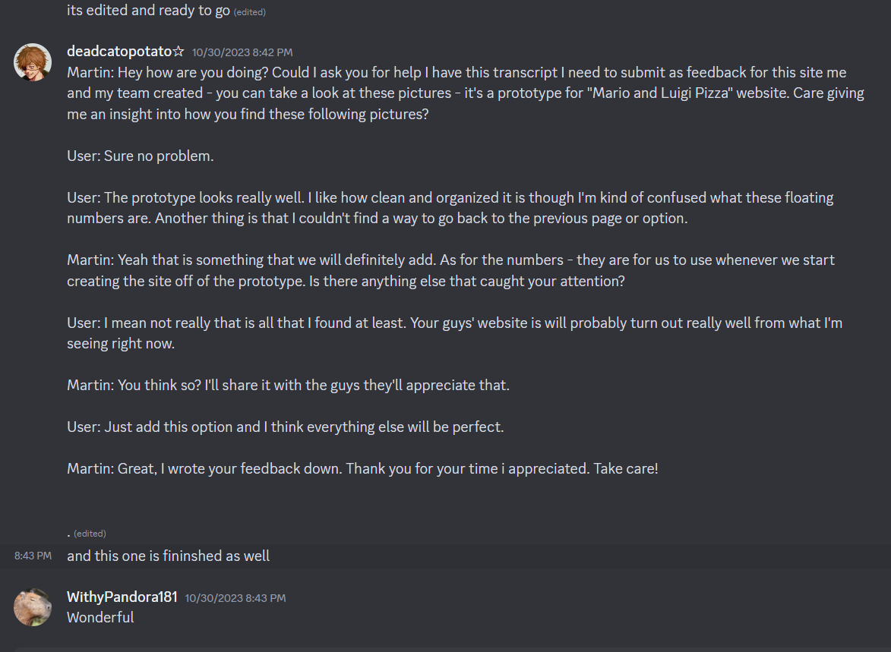

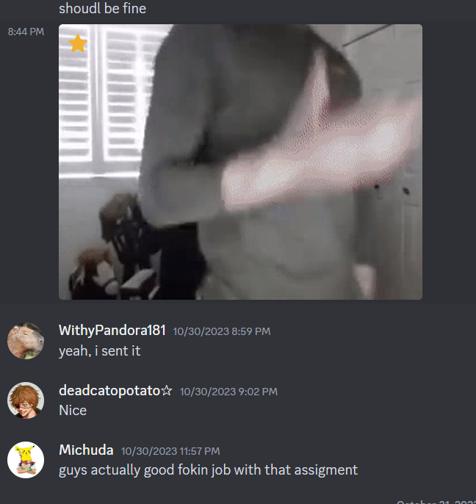

WEEK 6

Pitching ideas for our project:
Following what we had learned previously on our first day of the project we had to pitch the site. We brainstormed, I pitched it and we introduced it to other groups. The feedback was mostly positive. We wrote down what had been missing, but before fixing it we agreed to make an interview with outsiders to see what the regular customers’ impression would be.
Interviewing “customers” for impressions to our pitched website:
After getting feedback from the two interviews I converted them into transcripts which we used to fix add what we were missing as well as submit as it was an assignment as well. We did not too this part only because of the assignment but to see other peoples’ perspectives on our idea.
Forgetting to get feedback from teachers + working from home:
After putting this PEP together I have realized I have a massive problem when it comes to showcasing what I am working on/ have to show. Not only that but forgetting what I have done has made me have an even harder time as I wasn’t submitting my tasks on time even if they were ready. All of this accumulating with my on and off absence during the last few weeks which would turn out to have shaky results as my FeedPulse depicts it.

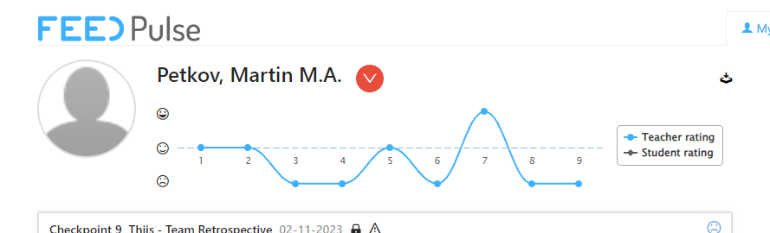
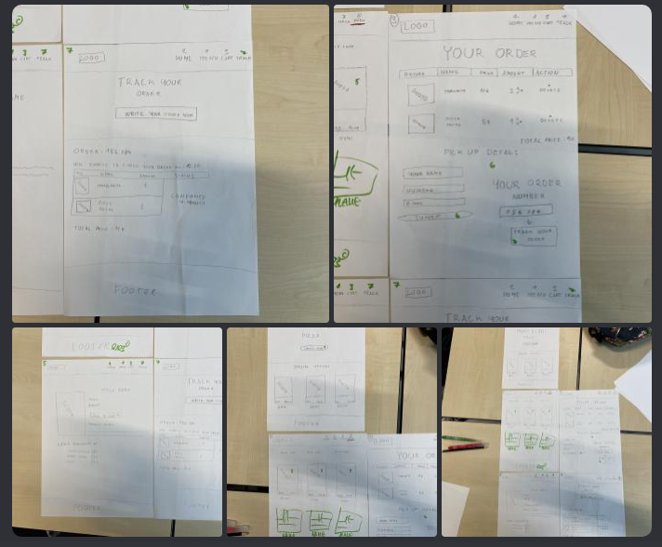

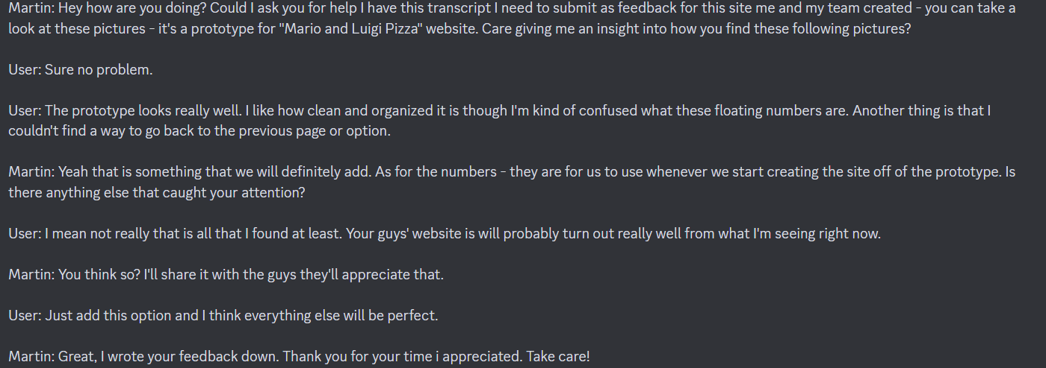
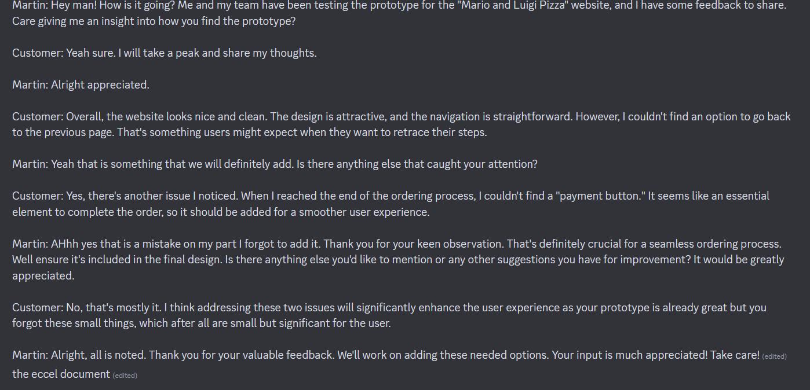

Week 6 Summary:
The only struggle I had this week was with organization. When it came to execution of a task I had everything in tact and would finish anything I started relatively quickly. My communication with the team I’d say was on point as everyone was advancing and very fast. Need to improve my communication with teachers and stop oversleeping.

WEEK 7:

Using more Excel to make a sheet for our site’s database:
In the beginning of week 6 I needed to help my team out with configuring what are we going to include on our website. We agreed that they should do most of the technical stuff and I should help with the design and structuring of the project. That’s why I had the task to create an Excel sheet and it came across as not a big challenge as I was introduced to Excel the previous week. Though this time it was more of a smooth sailing that doesn’t mean that it didn’t come with some challenges. I had to analyze thoroughly what our leader wanted out of the task – but I think I did a good job as I asked him what he wanted specifically and repeated his requests until I was sure I had everything right. Afterwards I started working on my task and the only problem I had was figuring out how to stretch out the brackets which I got over relatively easy.

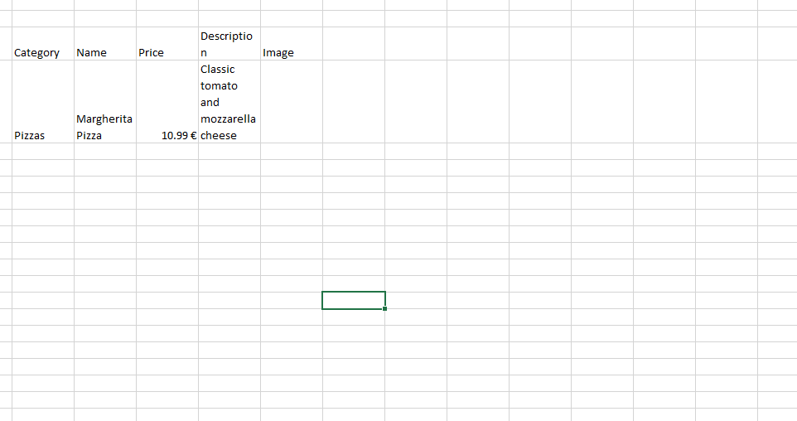

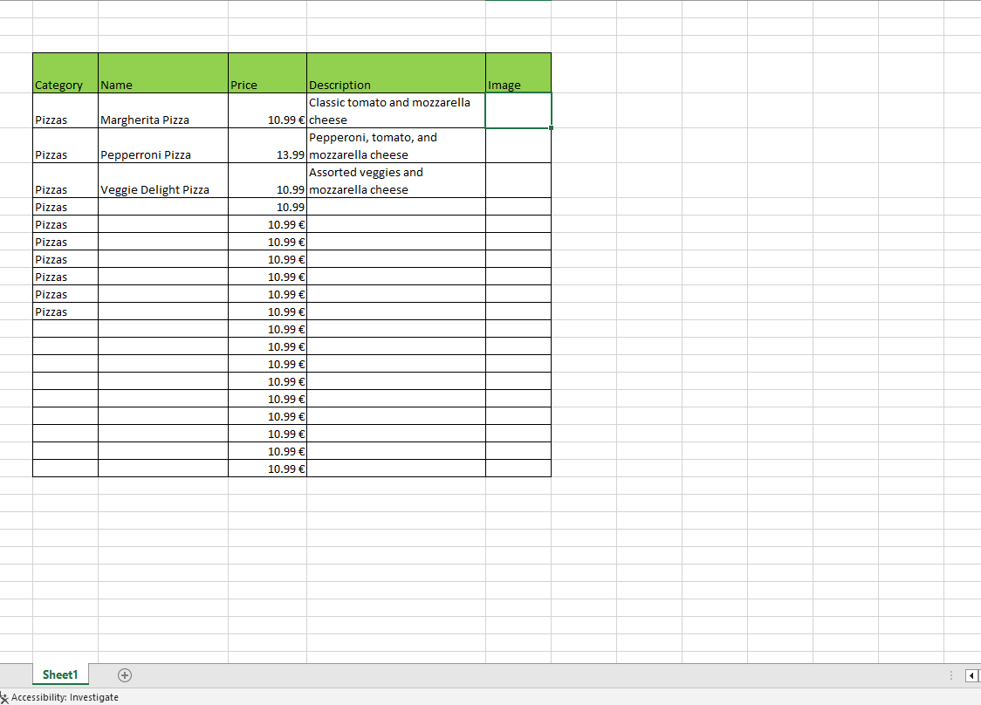

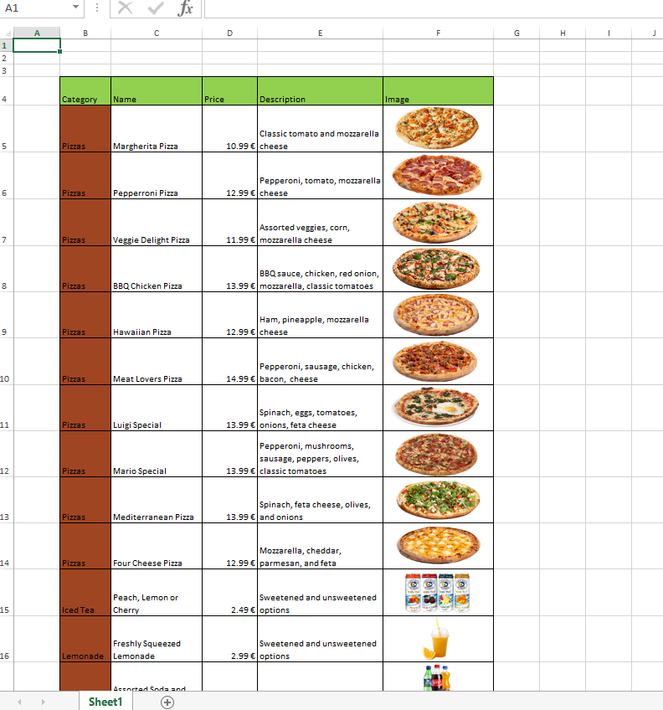

Week 7 summary:
This week went a little better than the previous one with the exception that I still overslept a couple of times but we’re even closer to wrapping the whole project together. That’s good of course but now I realize that I feel as if I could’ve done more as the way we implemented our roles left me hanging at times as I was the least technical guy of the group which meant I would have least to contribute to the project (at least that’s how I feel). Still I am trying to get the best out of this opportunity and learn that’s why I have been making Max explain most of the project. Learning the ins and outs of the project, going through the code of the site, Arduino, etc. Our last task is creating a presentation for which I expressed the wish to make. I will be working off of a template Martin gave me.

