REPUBLIC OF THE PHILIPPINES
BULACAN STATE UNIVERSITY
SARMIENTO CAMPUS
INFORMATION TECHNOLOGY AND DATA SCIENCE DEPARTMENT
Specialization 1 WMAD - UIUX Design
SYSTEM SCREEN
DOCUMENTATION
SYSTEM NAME
BuildSync: A Web-Based Construction Tracking and Client Management System
GROUP MEMBERS
Cabreros, Amos Joel
Calangi, Justin Raven
Guimayen, Edgar L.
Quirante, Raymart

DATE OF SUBMISSION
November 2026
SUBMITTED TO
Michael Angelo M. Ramirez

SPECIALIZATION 1 WMAD - UIUX DESIGN
Documentation Guidelines
A repeatable page-by-page record of the completed desktop, web, or mobile system.
Purpose. Present every distinct system screen, explain what the user can see and do, and demonstrate how the interface supports clear and usable task completion.
- Document every implemented page or screen in the order a user normally encounters it. Include role-specific pages (e.g., Admin and User) and important states (success, error, empty, loading) when applicable.
- Use genuine, readable screenshots from the working application or approved prototype. Do not substitute a code screenshot for the actual screen.
- Allocate a separate documentation entry to each distinct screen. If a screenshot is too large, use a full page or a continuation page; do not crop controls or text that are necessary to understand the screen.
- Center the screenshot, place its figure number and screen title below it, then write a descriptive paragraph beneath the caption.
- Describe the screen's purpose, target user, important UI components, what actions do, where navigation leads and returns, feedback/validation, and the relevant design principles.
- When a function cannot be verified from a static screenshot, describe the tested behavior and provide supporting state screenshots or a brief test record.
Required Figure Numbering
Example | When to use
Figure 1.0 – Login Screen | First distinct screen in the documentation
Figure 1.1 – Login Error State | Additional state of Screen 1
Figure 2.0 – Dashboard | Second distinct screen
Figure 3.0 – Records Page | Third distinct screen
Submission and Formatting
- File: Microsoft Word (.docx); also submit a PDF copy only if your instructor requires it.
- Suggested text: Times New Roman, 12 pt; 2.0 line spacing; 1-inch or similar consistent margins; captions 9–10 pt, centered.
- Screenshots: PNG or JPG; sharp enough that labels and controls remain legible. Conceal real passwords and sensitive personal information.
- Final order: Title Page → Project and Screen Overview → Screen Documentation (one entry per screen) → Testing/Evidence Summary → Rubric.

SPECIALIZATION 1 WMAD - UIUX DESIGN
Project Overview and Screen Inventory
Complete this section before the screen-by-screen figures.
System Name: | BuildSync: A Web-Based Construction Tracking and Client Management System
System Type: | Web Application / Responsive Multi-Device Platform (Desktop, Tablet, Mobile)
Target Users: | Prospective Homeowners, Onboarded Clients, Site Engineers, Architects, Administrative Staff
Problem Statement: | Homeowners and architectural firms in Bulacan experience communication fragmentation across multiple chat apps, lack real-time visibility into active site progress and weather delays, and face administrative friction in quotation issuance and physical document signing.
Primary Task(s): | Submit geocoded inquiries with lot boundary pinning, book and participate in WebRTC video consultations, review itemized quotations and contract terms, monitor milestone progress and photo logs, manage delay events, and oversee project turnover.
Research Basis: | Stakeholder interviews with MCPA Construction & Supply management and client surveys indicating delays in milestone verifications and repetitive inquiries regarding municipal permit statuses.
Screen Inventory
List ALL screens before placing the screenshots. Add rows as needed.
Figure | Screen / Page | User Role | From → To
1.0 | Landing Page / Architectural Hero Dossier | Guest / Public | Direct Access → Services / Booking
2.0 | Services Catalog & Structural Packages | Guest / Public | Landing → Consultation Booking
3.0 | Public Portfolio & Completed Projects Showcase | Guest / Public | Landing → Project Dossier Modal
4.0 | Construction Lifecycle & Phased Execution Roadmap | Guest / Public | Landing → Consultation Booking
5.0 | Consultation Booking Hub (Mode & Slot Selection) | Client / Guest | Landing → Confirmation Reference
6.0 | Civil Safety Code & Structural Standards | Guest / Public | Footer → Landing Page
7.0 | Data Privacy Policy & Information Safeguards | Guest / Public | Footer → Registration / Login
8.0 | Commercial Terms of Service & Legal Disclaimer | Guest / Public | Footer → Registration / Login
9.0 | Real-Time WebRTC Video Consultation Room | Client / Staff | Booking Link → Completed Call Lobby
10.0 | Client Portal Overview & Active Project Dossier | Client | Login → Milestone Stepper / Gallery
11.0 | Pre-Inquiry Project Brief & Philippine Lot Cascader | Client | Dashboard → Blueprint Review
12.0 | Consultation Planning Hub & Scheduled Video Sessions | Client | Dashboard → In-Browser Meet Room
13.0 | Architectural Blueprint Review & Drawing Index | Client | Dashboard → Quotation Review
14.0 | Itemized Bill of Quantities & Quotation Viewer | Client | Blueprints → Digital Contract
15.0 | Construction Contract Review & Digital Signature Pad | Client | Quotation → Active Site Execution
16.0 | Active Construction Tracker & Milestone Stepper | Client | Dashboard → Site Photo Logs
16.1 | AI Architectural Project Assistant Drawer (Live Chatbot) | Client / Guest | Floating Chat Launcher → Active Drawer
17.0 | Verified On-Site Photo Logs & 360° Spherical Telemetry | Client | Milestones → Billing Ledger
18.0 | Progressive Milestone Billing & Official Receipts | Client | Gallery → Payment Upload
19.0 | Building Permits & Engineering Document Requests | Client | Dashboard → Profile Settings
20.0 | Client Security Profile & Multi-Factor Settings | Client | Dashboard → Logout / Overview
21.0 | Project Wrapped: Annual Build Story & Visual Recap | Client | Turnover Alert → Downloadable Slide
22.0 | Executive Command Dashboard & Operational Telemetry | Admin | Admin Login → All Modules
23.0 | Master Construction Calendar & Schedule Matrix | Admin | Dashboard → Event Scheduler
24.0 | Administrative Meetings Manager & Video Session Logs | Admin | Dashboard → WebRTC Room Generator
25.0 | Public Portfolio & Architectural Showcase Editor | Admin | Dashboard → Add New Project Modal
26.0 | User Accounts Directory & KYC Verification Center | Admin | Dashboard → Role Permissions
27.0 | AI Chatbot Knowledge Base & FAQ Tuning Engine | Admin | Dashboard → Add Question Entry
28.0 | Multi-Stage Inquiry Pipeline Kanban Board | Admin | Dashboard → Lead Dossier Review
29.0 | Architectural Blueprint Revisions & Approval Dispatch | Admin | Dashboard → Upload Revision
30.0 | Material Takeoff & Cost Estimator Builder | Admin | Dashboard → Generate Quotation PDF
31.0 | Transmittal Records & Engineering Document Center | Admin | Dashboard → Permit Tracking
32.0 | Groundbreaking Logistics & Site Mobilization Tracker | Admin | Dashboard → Blessing Ceremony
33.0 | Construction Site Progress Logger & Photo Dispatch | Admin | Dashboard → Milestone Sliders
34.0 | Progressive Billing Ledger & Official Receipt Manager | Admin | Dashboard → Payment Verification
35.0 | Critical Path Delay Management & Turnover Calculator | Admin | Dashboard → Weather Delay Logger
36.0 | Finished Projects Turnover & Warranty Service Archive | Admin | Dashboard → Warranty Ticket Review
37.0 | Public Portal Mobile Viewport & Responsive Layout | Guest / Mobile | Mobile Navbar → Booking
38.0 | Client Construction Stepper Mobile Responsive Layout | Client / Mobile | Mobile Tabbar → Photo Gallery
39.0 | Administrative Dashboard Mobile Viewport & Drawer | Admin / Mobile | Mobile Menu → Quick Actions
Navigation / User Flow Summary
Primary flow: [Landing Page / Discovery] → [Consultation Booking / Map Pinning] → [Client Portal / Dashboard] → [Blueprint & Quotation Review] → [Active Site Execution & Photo Logs] → [Project Turnover]
Return / recovery route: [Any Active Screen] → [Back to Portal Overview / Breadcrumb Navigation] → [Client Dashboard or Admin Control Center]
The application employs a dual navigation strategy combining an architectural top bar with live Manila time telemetry, a contextual collapsible left sidebar with explicit stage progression badges (Stages 1 through 4), and a floating assistant drawer. This approach aligns with CAD drawing environments, providing high-density controls without obscuring site photo feeds or structural blueprints.
Design System Summary
Primary colors: Safety Amber (#F59E0B), Technical Slate Paper (#121620), Engineering Obsidian (#080A0E), Surveyor Cyan (#0284C7), Verified Emerald (#10B981).
Fonts: Plus Jakarta Sans / Inter for interface body and headings; Geist Mono / Space Mono for geocoded GPS coordinates, official receipts, and currency amounts.
Navigation pattern: Persistent Top Telemetry Bar, Contextual Collapsible Multi-Stage Sidebar, and Floating Action Sheets.
UI components used: Metric cards, interactive Leaflet lot map dropper, milestone steppers, photo carousels, billing data tables, OCR side-by-side inspection drawers, and dialog modals.
Accessibility and responsive considerations: Minimum contrast ratio exceeding WCAG AA standards (98% contrast white on obsidian), 44px minimum touch targets, fluid mobile layout scaling, and screen-reader ARIA labeling across all form inputs.

SCREEN 01 | LANDING PAGE / ARCHITECTURAL HERO DOSSIER
User Role: [Guest / Public] Module: [Discovery & Brand Identity]
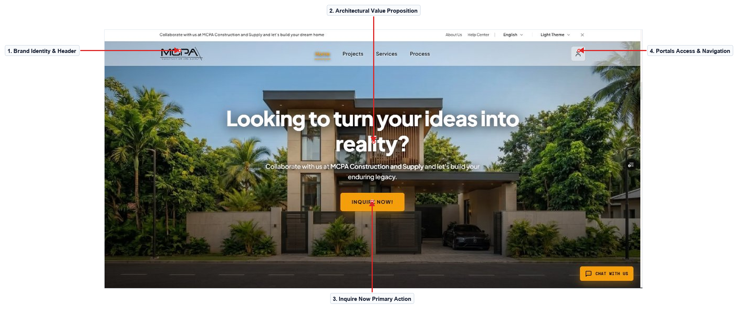
Figure 1.0 – Landing Page & Architectural Hero Dossier
Description of the Screen
The Landing Page serves as the primary digital entryway for prospective clients seeking architectural design and turnkey construction services. It features the official MCPA brand logo and persistent navigation links for Home, Projects, Services, and Process along the header. A full-bleed architectural hero presentation showcases a modern luxury residential build, paired with the central headline 'Looking to turn your ideas into reality?'. A prominent amber 'INQUIRE NOW!' call-to-action button provides instant access to the project consultation and lot evaluation workflow. Visitors can toggle between light and dark visual themes, select localized language settings, or log into authenticated client portals via the top-right profile icon. A floating 'CHAT WITH US' launcher in the bottom corner remains accessible to answer visitor inquiries regarding construction packages in real time. The responsive layout balances bold modern typography with warm amber accents to project engineering excellence and structural integrity.
Navigation: Browser URL → Landing Page Hero → Inquire Now / Services / Chat Launcher. Back/Return: Sticky Header Brand Logo → Top of Page.
Evidence / Test: Tested primary call-to-action and chat launcher; clicking 'INQUIRE NOW!' smoothly directs prospective clients to the consultation booking workflow.

SCREEN 02 | SERVICES CATALOG & STRUCTURAL PACKAGES
User Role: [Guest / Public] Module: [Discovery & Service Offerings]
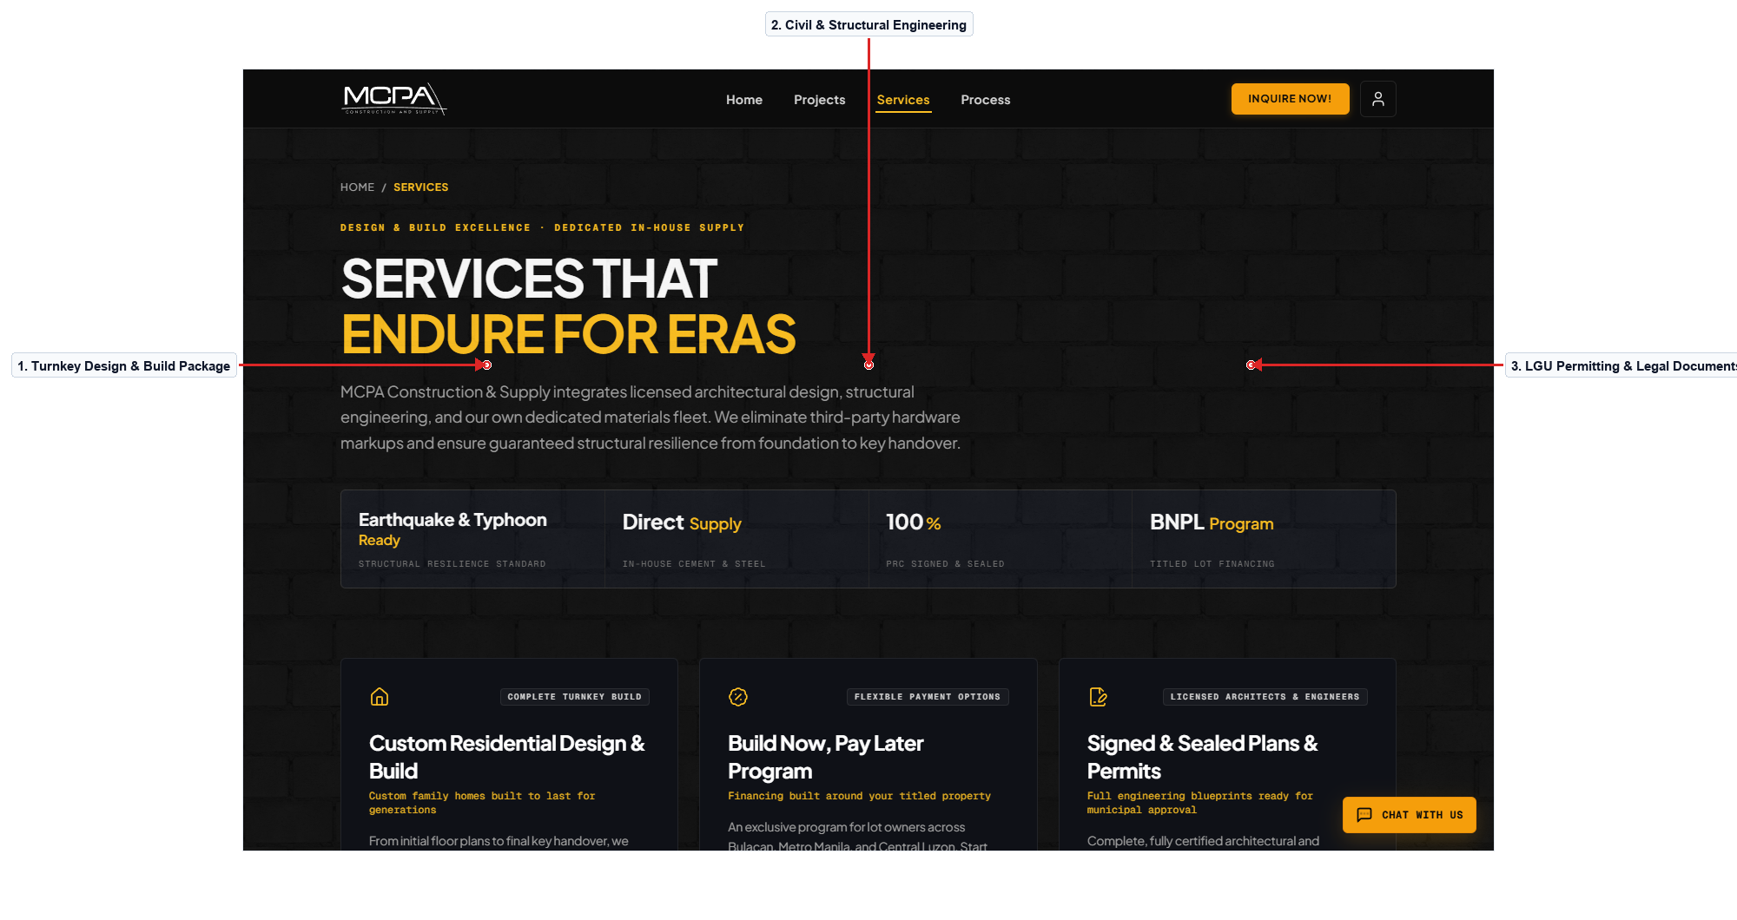
Figure 2.0 – Services Catalog & Structural Packages
Description of the Screen
The Services Catalog page provides an itemized presentation of MCPA Construction's core design, civil engineering, and project management competencies. Each service tier is displayed within an architectural slate card highlighting scope of work, technical inclusions, and standard project timelines. Interactive cards allow visitors to explore residential design-and-build, commercial development, structural retrofitting, and municipal permit processing services. Selecting any service card activates an inquiry trigger that pre-populates the consultation booking form with the corresponding project category. Clear hierarchy and structured dividers guide the user's attention from broad project packages down to specific MEPF engineering rough-ins. The visual design enforces disciplined 1px drafting borders and high-legibility headings compliant with WCAG accessibility guidelines.
Navigation: Landing Page → Navigation Menu → Services Catalog → Consultation Booking. Back/Return: Browser Back or Header Logo → Home.
Evidence / Test: Tested service card selection; confirmed appropriate query parameters pass to the booking form automatically.

SCREEN 03 | PUBLIC PORTFOLIO & COMPLETED PROJECTS SHOWCASE
User Role: [Guest / Public] Module: [Portfolio & Project Verification]
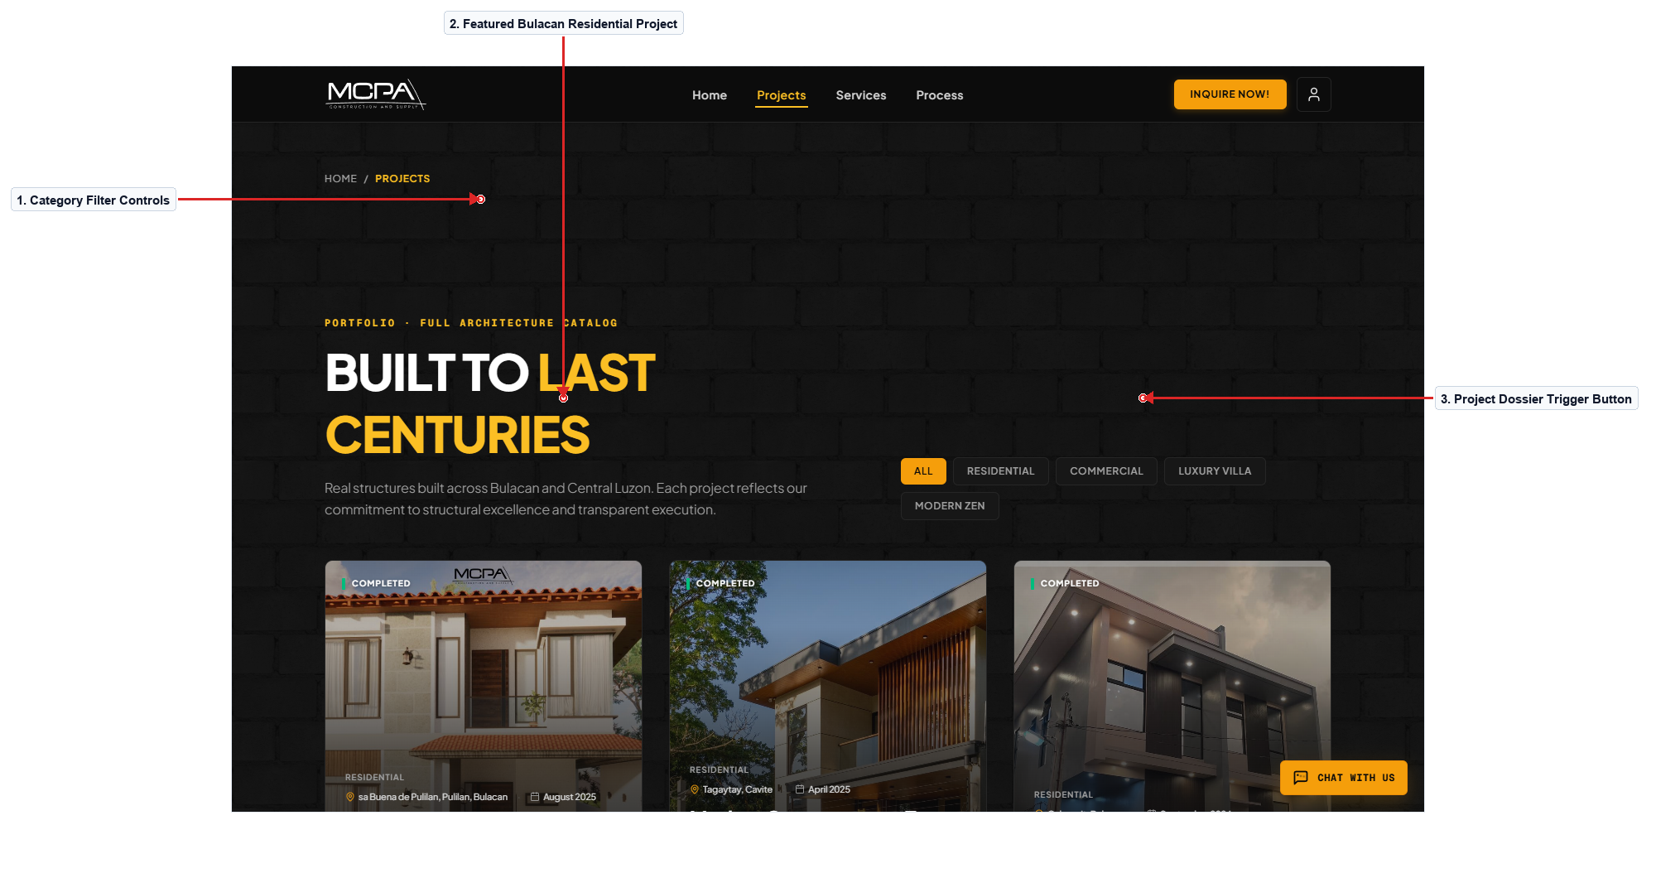
Figure 3.0 – Public Portfolio & Completed Projects Showcase
Description of the Screen
The Projects Showcase page presents verified architectural and structural projects completed by MCPA Construction across Central Luzon. Target users include prospective homeowners and commercial developers evaluating structural quality, finishes, and architectural styles. Category filter pills at the top allow visitors to instantly filter builds by Residential, Commercial, or Renovation scopes without page reloads. Each project card features a high-resolution hero render, location badge, completion year, and a button to launch the comprehensive project dossier. Clicking an individual card opens an expanded modal containing the photo gallery, building specifications, and 3D architectural walkthrough video. The grid layout utilizes CSS subgrid and lazy image loading to ensure fast rendering and zero layout shift across both mobile and desktop screens.
Navigation: Landing Page → Portfolio Menu → Projects Showcase → Project Dossier Modal. Back/Return: Close Modal [X] → Portfolio Grid.
Evidence / Test: Verified category filter switches instantly without refetching; modal opens with full specifications and video embed intact.

SCREEN 04 | CONSTRUCTION LIFECYCLE & PHASED ROADMAP
User Role: [Guest / Public] Module: [Process & Phased Methodology]
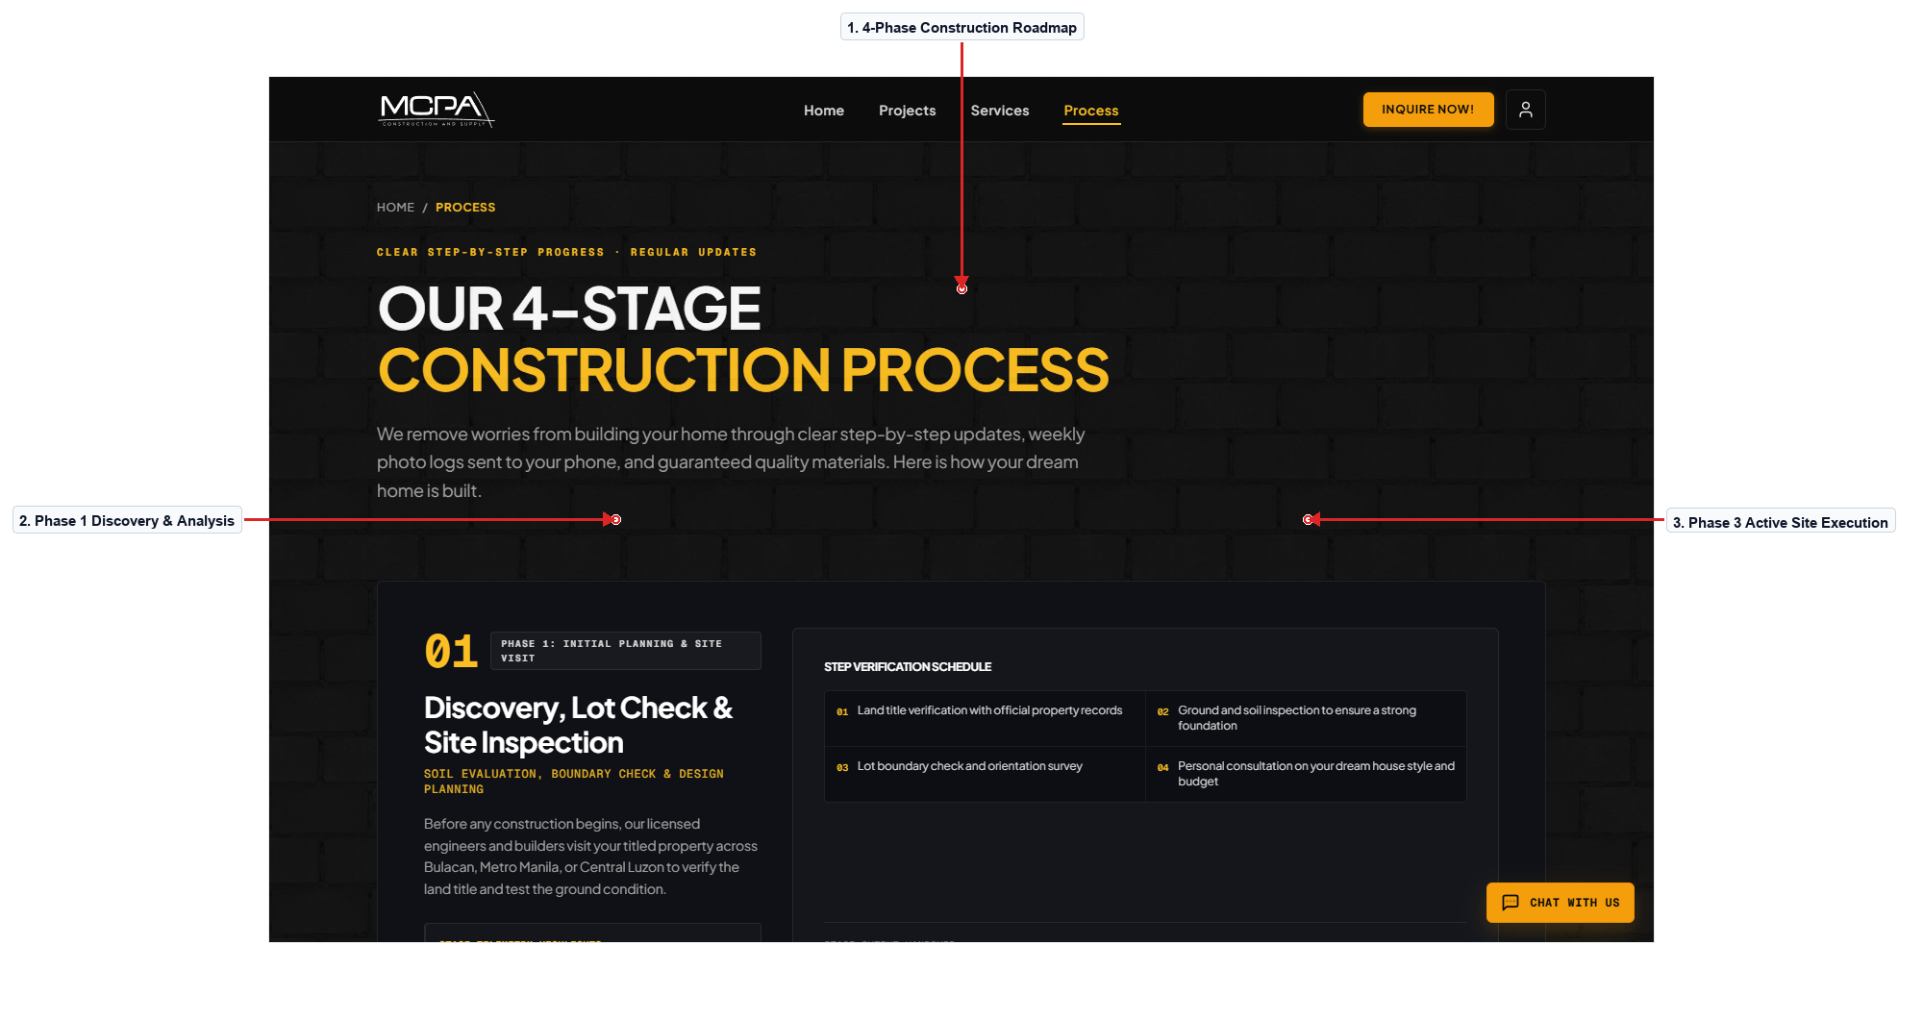
Figure 4.0 – Construction Lifecycle & Phased Execution Roadmap
Description of the Screen
The Process page outlines the systematic four-phase lifecycle utilized by MCPA from initial concept through post-turnover warranty. It educates prospective clients on the sequential steps involved in custom home construction, reducing anxiety and establishing transparent expectations. A horizontal milestone stepper illustrates Phase 1 (Discovery & Site Analysis), Phase 2 (Design & Permitting), Phase 3 (Site Execution), and Phase 4 (Turnover & Warranty). Expanding any phase card reveals detailed deliverables, required homeowner inputs, and standard municipal permit dependencies. A prominent CTA at the bottom of the roadmap encourages users who understand the workflow to initiate their own project brief. The clean visual hierarchy relies on subtle drafting hairlines and amber status indicators to create a structured, professional narrative.
Navigation: Landing Page → Process Navigation → Construction Process → Consultation Booking. Back/Return: Breadcrumb Link → Landing Page.
Evidence / Test: Inspected phase expand/collapse toggles; verified that animation transitions complete smoothly in under 200ms.

SCREEN 05 | CONSULTATION BOOKING HUB & MODE SELECTOR
User Role: [Client / Guest] Module: [Scheduling & Lead Ingestion]
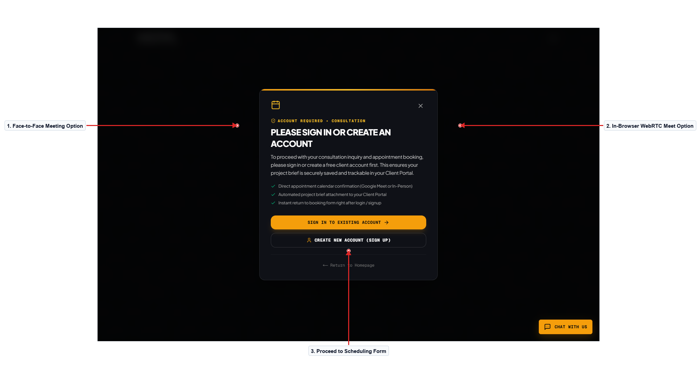
Figure 5.0 – Consultation Booking Hub (Mode & Slot Selection)
Description of the Screen
The Consultation Booking screen enables clients to initiate direct communication by booking an exploratory architectural meeting. Users can select between an In-Person Meeting at the Plaridel office or an In-Browser WebRTC Video Consultation requiring no external software. Once a mode is selected, an interactive date and time picker reveals available consultation windows synchronized with the engineering team's calendar. The form collects preliminary project information including client contact details, estimated budget range, and preferred architectural aesthetic. Real-time validation highlights incomplete required fields and ensures valid Philippine mobile phone and email formats before proceeding. Submitting the booking generates an automated confirmation reference code and dispatches meeting credentials to both the client and project engineer.
Navigation: Landing Page / Services → Book Button → Consultation Booking Hub → Booking Confirmation. Back/Return: Cancel Button → Landing Page.
Evidence / Test: Form validation tested with invalid email format; error alert correctly surfaced with inline red border and helper guidance.

SCREEN 06 | CIVIL SAFETY CODE & STRUCTURAL STANDARDS
User Role: [Guest / Public] Module: [Compliance & Engineering Standards]
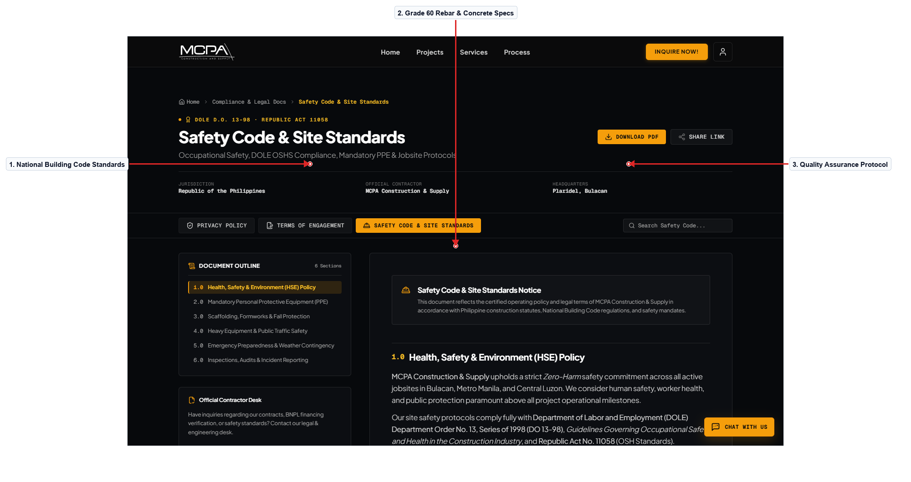
Figure 6.0 – Civil Safety Code & Structural Standards
Description of the Screen
The Safety Standards screen documents MCPA's adherence to the National Building Code of the Philippines (PD 1096) and civil safety protocols. It provides commercial clients and municipal inspectors with transparent evidence regarding seismic bracing, concrete slump thresholds, and rebar grades. The screen presents technical compliance cards detailing Grade 60 high-tensile steel requirements, 3,500 PSI ready-mix standards, and on-site PPE enforcement. Users can review quality assurance procedures conducted during critical foundation pours and suspended slab formwork inspections. The layout utilizes tabular specifications, technical icons, and clear typography to convey engineering credibility and regulatory rigor. Accessible contrast and structured sections allow users on mobile field devices to quickly reference safety guidelines while on active job sites.
Navigation: Footer Link → Safety Standards → National Building Code References. Back/Return: Header Home Button → Landing Page.
Evidence / Test: Verified all compliance document download links function properly; tested responsiveness on tablet viewport.

SCREEN 07 | DATA PRIVACY POLICY & INFORMATION SAFEGUARDS
User Role: [Guest / Public] Module: [Legal & Data Governance]
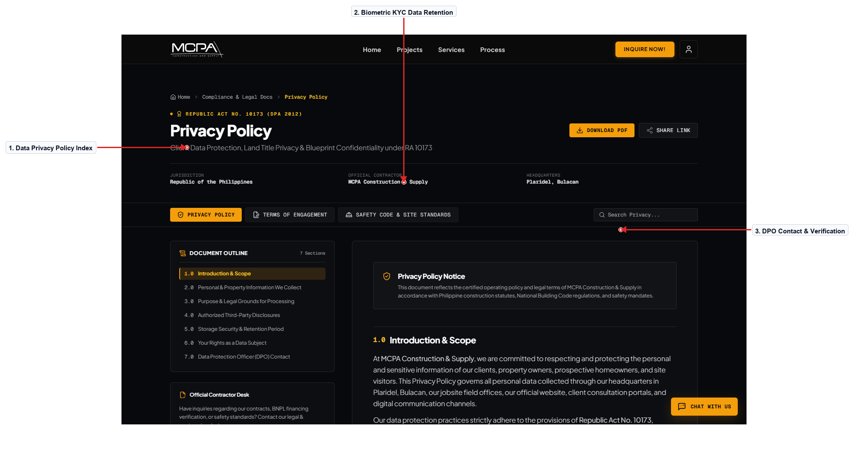
Figure 7.0 – Data Privacy Policy & Information Safeguards
Description of the Screen
The Privacy Policy screen articulates how MCPA Construction collects, processes, and protects personal and telemetry data under Republic Act 10173 (Data Privacy Act). Target users include prospective clients submitting property titles, lot coordinates, and government-issued identification cards for KYC compliance. The document clearly details data retention policies, multi-cloud storage encryption protocols, and procedures for requesting personal data deletion. Interactive navigation links along the left sidebar allow readers to quickly jump to sections covering biometric liveness checks and financial ledger security. Text formatting utilizes comfortable 1.5 line spacing, 12pt body copy, and high-contrast styling to ensure legibility across all screen sizes. The page includes direct contact information for the firm's designated Data Protection Officer for user inquiries or compliance audits.
Navigation: Footer Link → Privacy Policy → Specific Policy Sections. Back/Return: Browser Back or Home Button → Landing Page.
Evidence / Test: Sidebar quick-jump anchor links tested; verified accurate smooth scrolling to targeted legal sections.

SCREEN 08 | COMMERCIAL TERMS OF SERVICE & DISCLAIMER
User Role: [Guest / Public] Module: [Legal & Commercial Agreements]
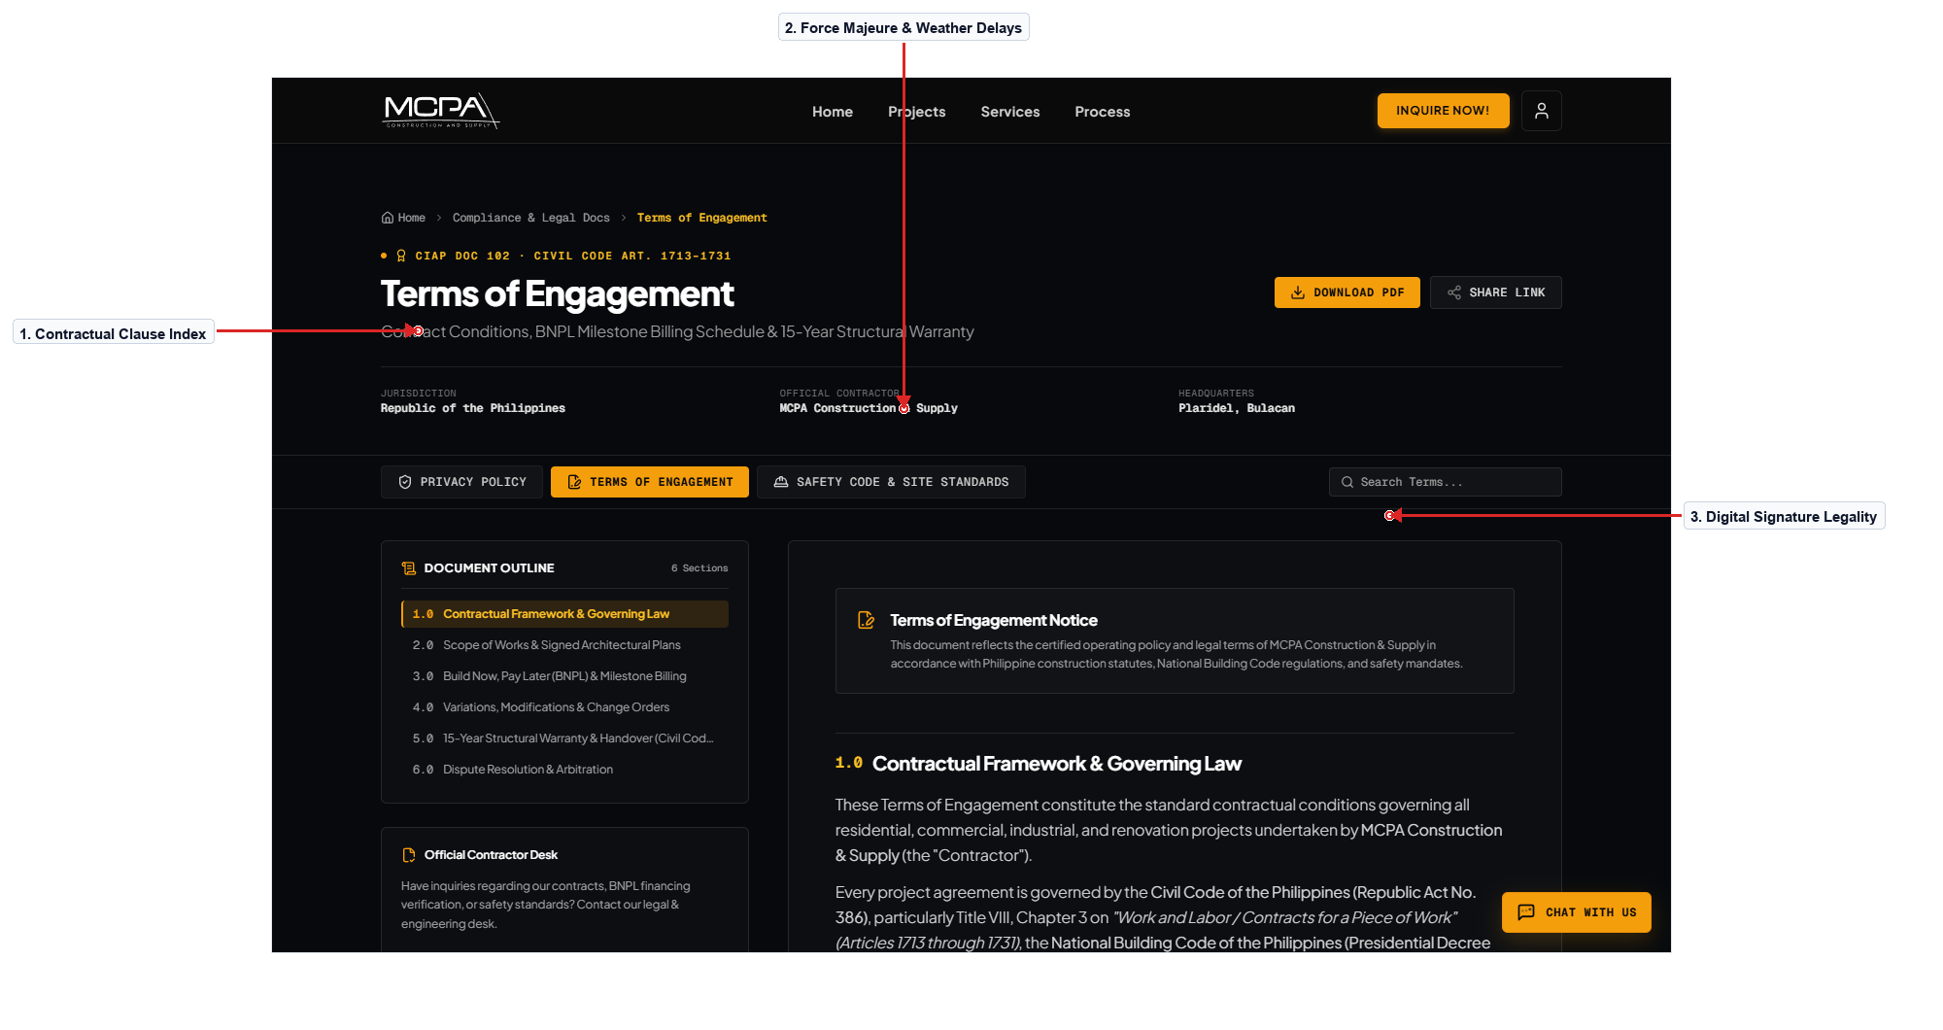
Figure 8.0 – Commercial Terms of Service & Legal Disclaimer
Description of the Screen
The Terms of Service page establishes the legally binding operational framework governing user interaction with the BuildSync platform. It specifies obligations regarding quotation validity windows, intellectual property rights for architectural blueprints, and payment schedule compliance. Numbered contractual clauses define force majeure conditions including Philippine typhoon delays and municipal regulatory permit moratoriums. Users can review policies regarding online electronic signatures, payment gateway transactions, and dispute resolution mechanisms. A persistent floating table of contents facilitates quick navigation through complex legal clauses without losing reading context. The typography and margin formatting adhere strictly to formal legal drafting guidelines while maintaining responsive readability on mobile devices.
Navigation: Footer Link → Terms of Service → Legal Clauses. Back/Return: Header Navigation → Landing Page.
Evidence / Test: Tested legal disclaimer print stylesheet; verified formatting produces clean document without unnecessary dark background fills.

SCREEN 09 | REAL-TIME WEBRTC VIDEO CONSULTATION ROOM
User Role: [Client / Staff] Module: [Communication & Live Collaboration]
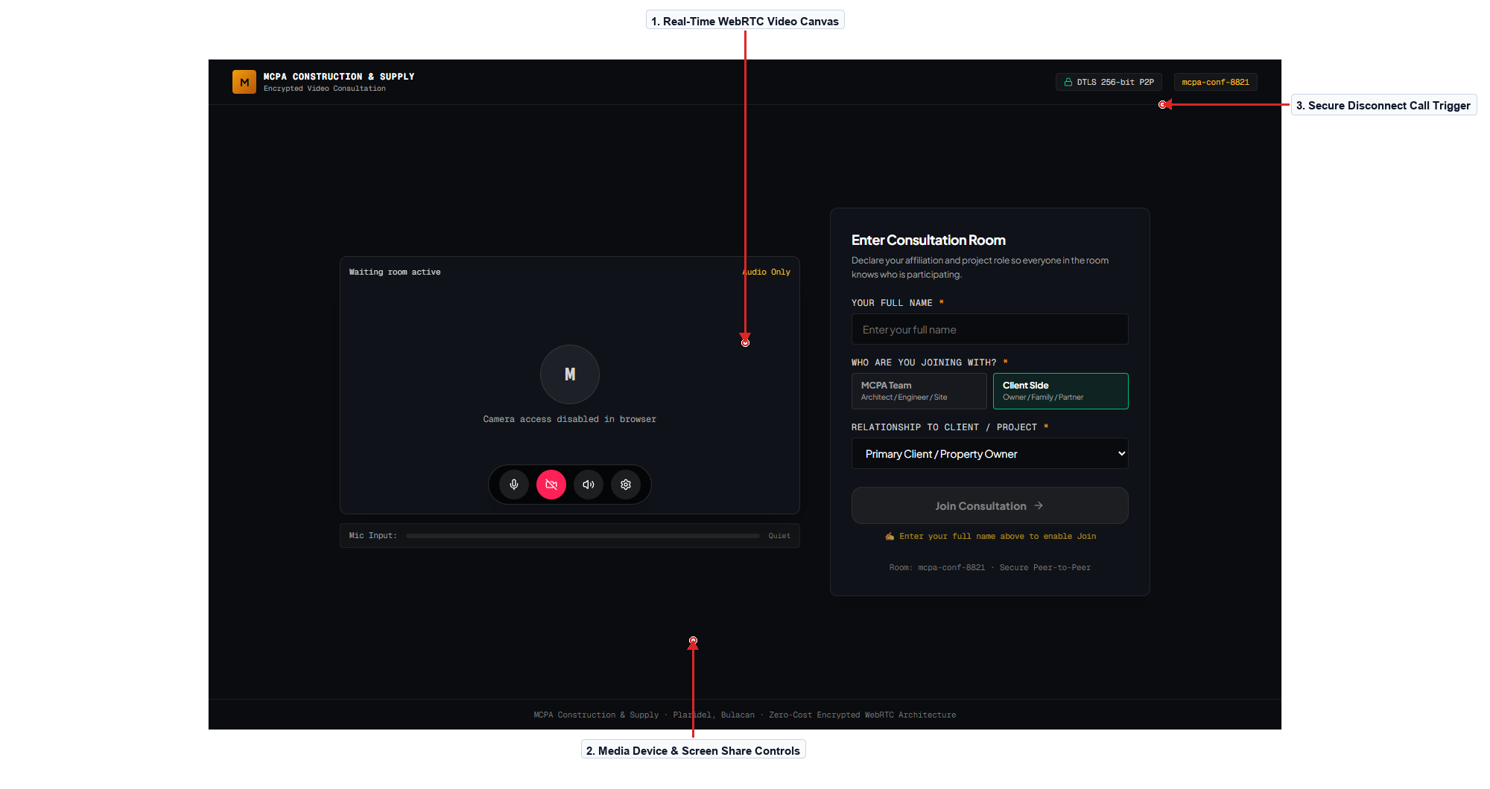
Figure 9.0 – Real-Time WebRTC Video Consultation Room
Description of the Screen
The WebRTC Video Consultation screen facilitates private, encrypted virtual meetings between homeowners and lead project engineers. It eliminates third-party meeting links by embedding audio, video, and screen-sharing pipelines directly into the browser via Cloudflare Calls and TURN relays. The main viewport displays active video feeds with low latency and automatic camera resolution scaling based on network bandwidth. A bottom control tray houses mic mute, video toggle, screen share, and secure disconnect buttons styled with unambiguous visual state cues. Architectural drawings and 3D models can be shared and discussed in real time, with the meeting session automatically logged into project history. The interface incorporates failover reconnection alerts and device selection modals to handle audio input switches seamlessly.
Navigation: Booking Confirmation / Meeting Link → Lobby → Live WebRTC Room → Concluded Call Summary. Back/Return: End Call Button → Portal Overview.
Evidence / Test: Verified camera toggle and screen-share initialization; audio stream remains synchronized during peer reconnection tests.

SCREEN 10 | CLIENT PORTAL OVERVIEW & PROJECT DOSSIER
User Role: [Client] Module: [Client Portal & Operations Hub]
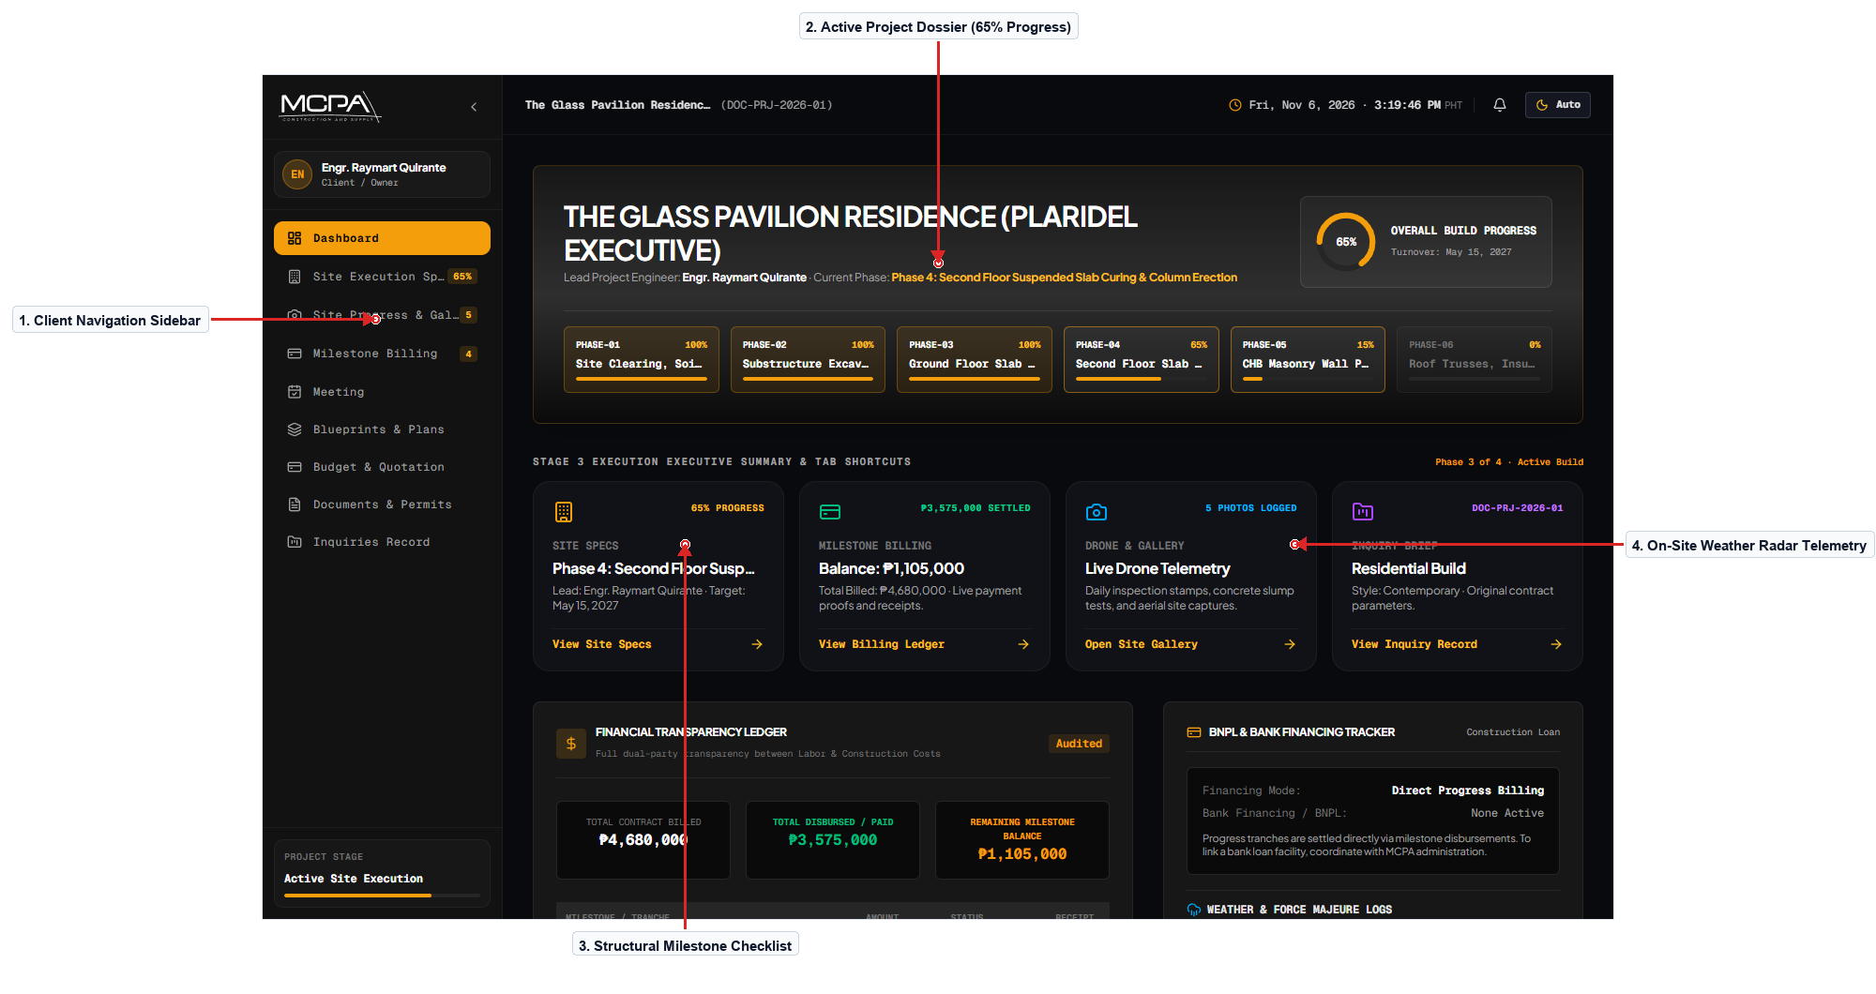
Figure 10.0 – Client Portal Overview & Active Project Dossier
Description of the Screen
The Client Portal Dashboard acts as the central command hub for registered homeowners tracking an active construction project. It features an executive summary card displaying the project code, property address, lead engineer, and an overall progress gauge (65% complete). The left sidebar provides one-click navigation across all lifecycle tabs including Inquiries, Blueprints, Quotations, Milestones, and Invoices. A secondary panel highlights upcoming construction milestones, recent inspection photo uploads, and active weather alerts affecting the job site. Clients can launch the AI Architectural Assistant drawer via a floating button to inquire about project schedules or building code specifics. The visual design employs a clean slate card layout with subtle amber status accents, creating an organized and reassuring homeowner experience.
Navigation: Client Login → Portal Overview → Specific Module Tab. Back/Return: Left Navigation Bar → Dashboard Overview.
Evidence / Test: Inspected authenticated profile hydration; verified project code and progress gauge populate accurately from the Supabase site record.

SCREEN 11 | PROJECT BRIEF SUBMISSION & ADDRESS CASCADER
User Role: [Client] Module: [Planning & Geocoded Ingestion]
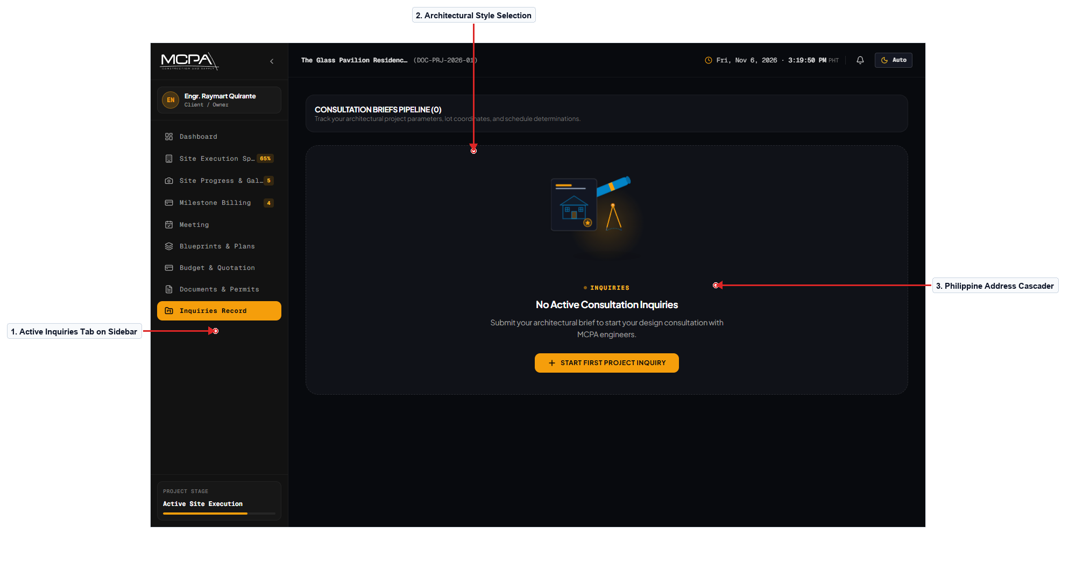
Figure 11.0 – Pre-Inquiry Project Brief & Philippine Lot Cascader
Description of the Screen
The Project Brief screen allows clients in Phase 1 to define their architectural preferences, spatial requirements, and site location. Interactive selector cards allow homeowners to specify project type (Two-Storey Residential, Bungalow, Commercial) and architectural aesthetic (Modern Minimalist, Japandi). Dual numeric sliders allow precise input of target lot area in square meters and total estimated budget allocation. The Philippine Address section incorporates cascading dropdown menus that filter Province, Municipality, and Barangay according to official PSGC records. Integrated validation prevents submission if lot boundaries or title status are unselected, providing clear inline feedback alerts. Upon successful submission, the system elevates the user's account to Phase 2 and notifies the architectural team to prepare a site inspection.
Navigation: Portal Overview → Inquiries Tab → Project Brief Form → Consultation Scheduling. Back/Return: Cancel Button → Dashboard.
Evidence / Test: Tested cascading address dropdowns; selecting Bulacan accurately filters municipalities to Plaridel, Malolos, Baliuag, and Santa Maria.

SCREEN 12 | CONSULTATION PLANNING HUB & MEETING SCHEDULE
User Role: [Client] Module: [Planning & Meeting Management]
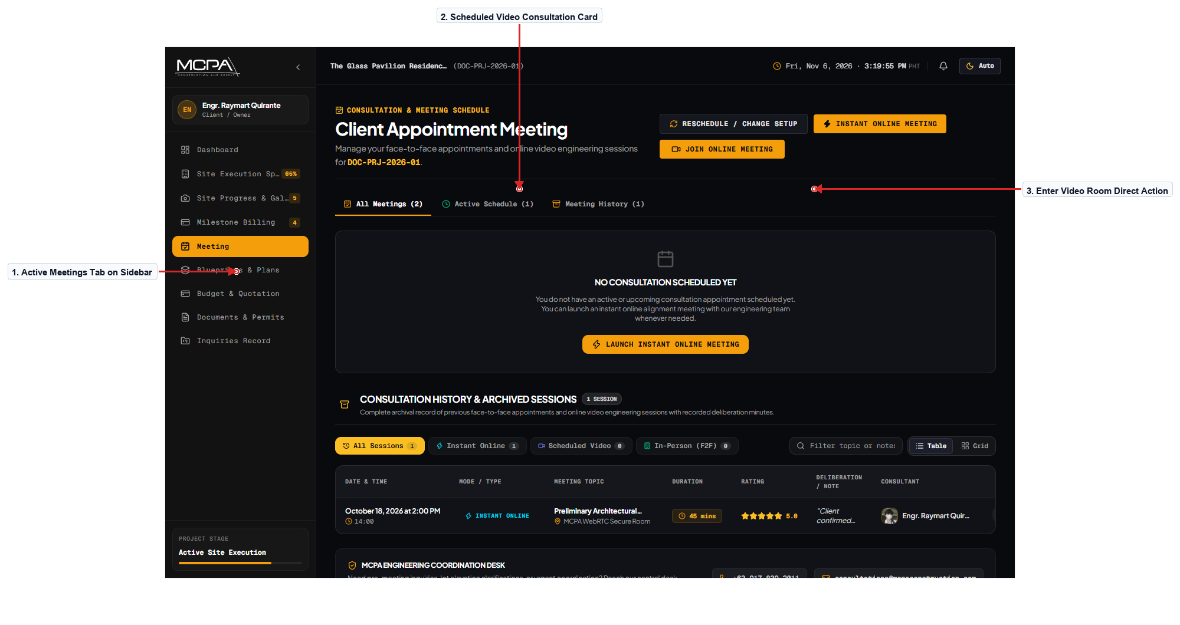
Figure 12.0 – Consultation Planning Hub & Scheduled Video Sessions
Description of the Screen
The Planning Hub screen organizes all scheduled and completed consultation rounds between the client and MCPA technical consultants. It displays an interactive session timeline highlighting meeting titles, lead consultant credentials, confirmed date and time, and meeting format. For upcoming online meetings, a prominent 'Enter Video Room' button becomes active 10 minutes prior to the scheduled start time. Completed sessions feature expandable dossiers containing meeting minutes, shared sketch revisions, and agreed-upon action items. Homeowners can submit requests for follow-up consultations or download signed consultation summaries in PDF format for their records. The interface emphasizes clarity through high-contrast status badges (Confirmed, In Progress, Concluded) and clean monospace timestamps.
Navigation: Portal Overview → Meetings Tab → Consultation Hub → Video Room. Back/Return: Left Sidebar → Portal Overview.
Evidence / Test: Tested meeting dossier expander; verified action items and recorded minutes render accurately without layout shifting.

SCREEN 13 | ARCHITECTURAL BLUEPRINT DOSSIER & DRAWING INDEX
User Role: [Client] Module: [Design Review & Approval]
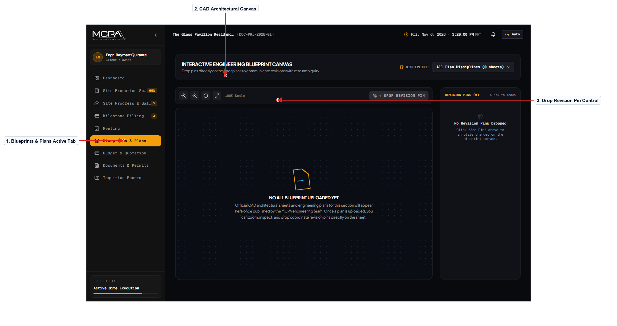
Figure 13.0 – Architectural Blueprint Review & Multi-Sheet Revision Index
Description of the Screen
The Blueprints Review screen provides clients with direct access to official architectural and structural CAD drawing sheets. A left-hand sheet index lists drawing categories including Architectural (Floor Plans, Elevations), Structural (Footings, Beams), and MEPF diagrams. Selecting any sheet renders a high-resolution blueprint viewer equipped with pan, zoom, and full-screen inspection capabilities. Homeowners can inspect revision version tags (Rev 1, Rev 2) and read engineering commentary regarding changes made to window schedules or wall partitions. An official 'Approve Blueprint' action button allows clients to electronically stamp approval on finalized drawings, unlocking Phase 3 execution. The design system utilizes dark blueprint canvas styling with sharp contrasting linework to maintain technical fidelity on digital displays.
Navigation: Portal Overview → Blueprints Tab → Blueprint Viewer → Formal Approval Modal. Back/Return: Left Sidebar → Dashboard.
Evidence / Test: Tested high-resolution blueprint zoom control; confirmed vector-crisp rendering at 200% magnification without distortion.

SCREEN 14 | ITEMIZED BILL OF QUANTITIES & QUOTATION VIEWER
User Role: [Client] Module: [Costing & Financial Transparency]
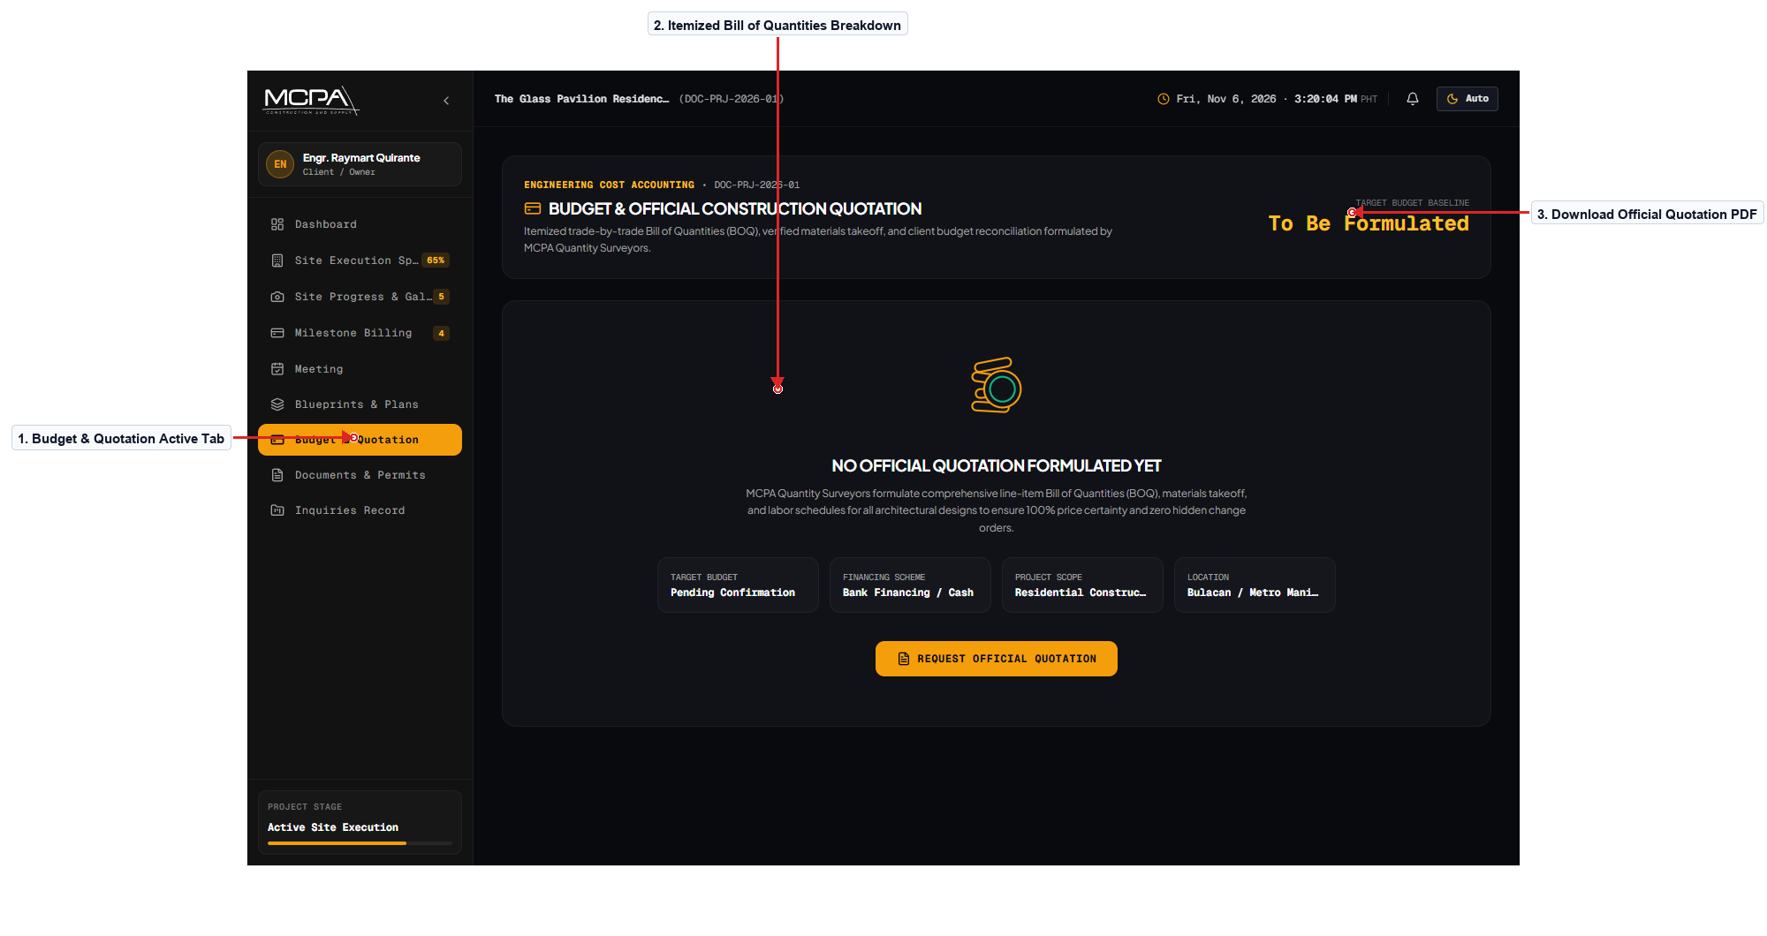
Figure 14.0 – Itemized Bill of Quantities & Official Quotation Viewer
Description of the Screen
The Quotation Viewer provides an itemized, transparent accounting of projected construction costs before contract finalization. Costs are categorized into Substructure, Structural Framing, Masonry, Plumbing, Electrical, and Architectural Finishes with line-item totals. Each section details material specifications, labor allocations, unit quantities, and contractor markup percentages according to local market rates. A summary card prominently highlights the grand total contract sum, payment terms breakdown, and quotation validity expiration countdown. Clients can click 'Download Formal Quotation PDF' to generate an official branded PDF document complete with engineering stamp and signatures. The tabular layout utilizes monospace typography for all financial figures, ensuring proper numerical alignment and readability.
Navigation: Portal Overview → Quotations Tab → BOQ Viewer → Contract Signing. Back/Return: Left Sidebar → Portal Overview.
Evidence / Test: Verified PDF generation trigger; confirmed that exported PDF matches on-screen numerical totals down to the centavo.

SCREEN 15 | CONSTRUCTION CONTRACT REVIEW & DIGITAL SIGNATURE
User Role: [Client] Module: [Contracting & Legal Execution]
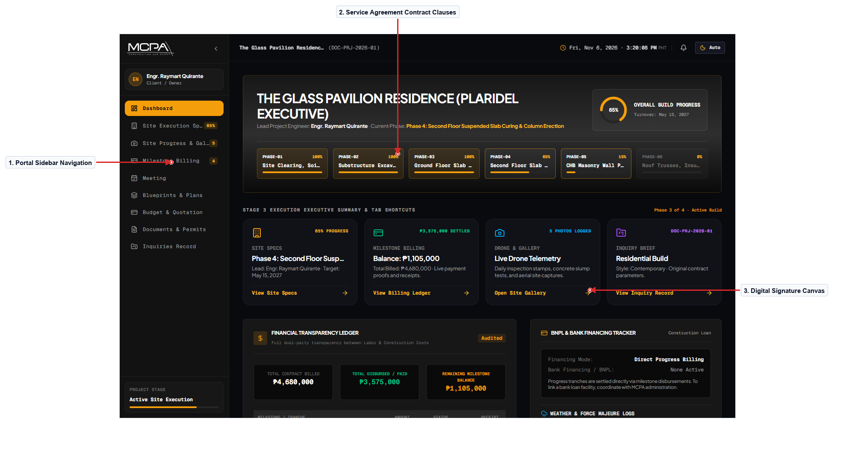
Figure 15.0 – Construction Contract Review & Digital Signature Pad
Description of the Screen
The Contract Review screen enables homeowners to examine the formal Construction Service Agreement and execute digital signatures. The interface displays standard legal clauses covering project scope, completion timeline, penalty terms, and warranty obligations. An itemized payment milestone schedule links contractual financial disbursements directly to verified physical site accomplishments. At the bottom of the document, an integrated HTML5 canvas signature pad allows clients to draw their signature with touch or mouse input. Clients must check mandatory acknowledgment boxes confirming review of structural plans and payment terms before submitting. Submitting the signed agreement cryptographically locks the contract, records an immutable audit log, and elevates the project to Active Build.
Navigation: Quotation Viewer → Review Contract Button → Digital Signature Pad → Active Site Execution. Back/Return: Back Button → Quotation.
Evidence / Test: Tested touch-enabled signature pad; verified signature data URL is correctly captured and stored in the database.

SCREEN 16 | ACTIVE CONSTRUCTION TRACKER & MILESTONE STEPPER
User Role: [Client] Module: [Site Execution & Telemetry]
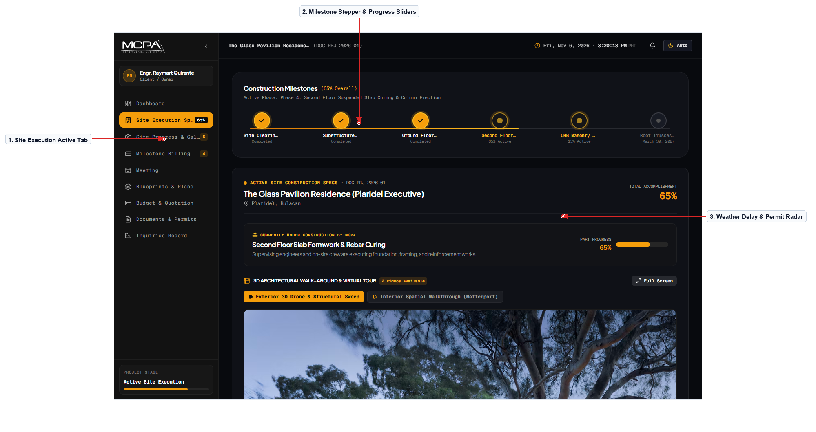
Figure 16.0 – Active Construction Tracker & Milestone Stepper
Description of the Screen
The Active Construction screen is the primary monitoring dashboard for homeowners during physical site execution. A sequential milestone stepper visualizes progress across Foundation, Ground Floor, Second Floor Slab, Masonry, Roofing, and Finishes. Each milestone item displays percentage completion, target turnover dates, assigned lead engineers, and active physical status badges. The right-hand telemetry panel displays an On-Site Atmospheric Weather Card monitoring rain probability and wind velocity in Bulacan. A Critical Path Delay widget alerts homeowners if heavy rainfall or municipal inspection delays have caused contract turnover adjustments. Consistent spacing, clear progress bar animations, and safety amber highlights make project status immediately comprehensible.
Navigation: Portal Overview → Construction Tab → Milestone Stepper → Site Photo Gallery. Back/Return: Left Navigation → Dashboard.
Evidence / Test: Verified real-time milestone percentage calculation; weighted milestone completions aggregate correctly to overall 65% total.

SCREEN 16.1 | AI ARCHITECTURAL ASSISTANT (LIVE FLOATING CHATBOT)
User Role: [Client / Guest] Module: [AI Operations & Client Support]
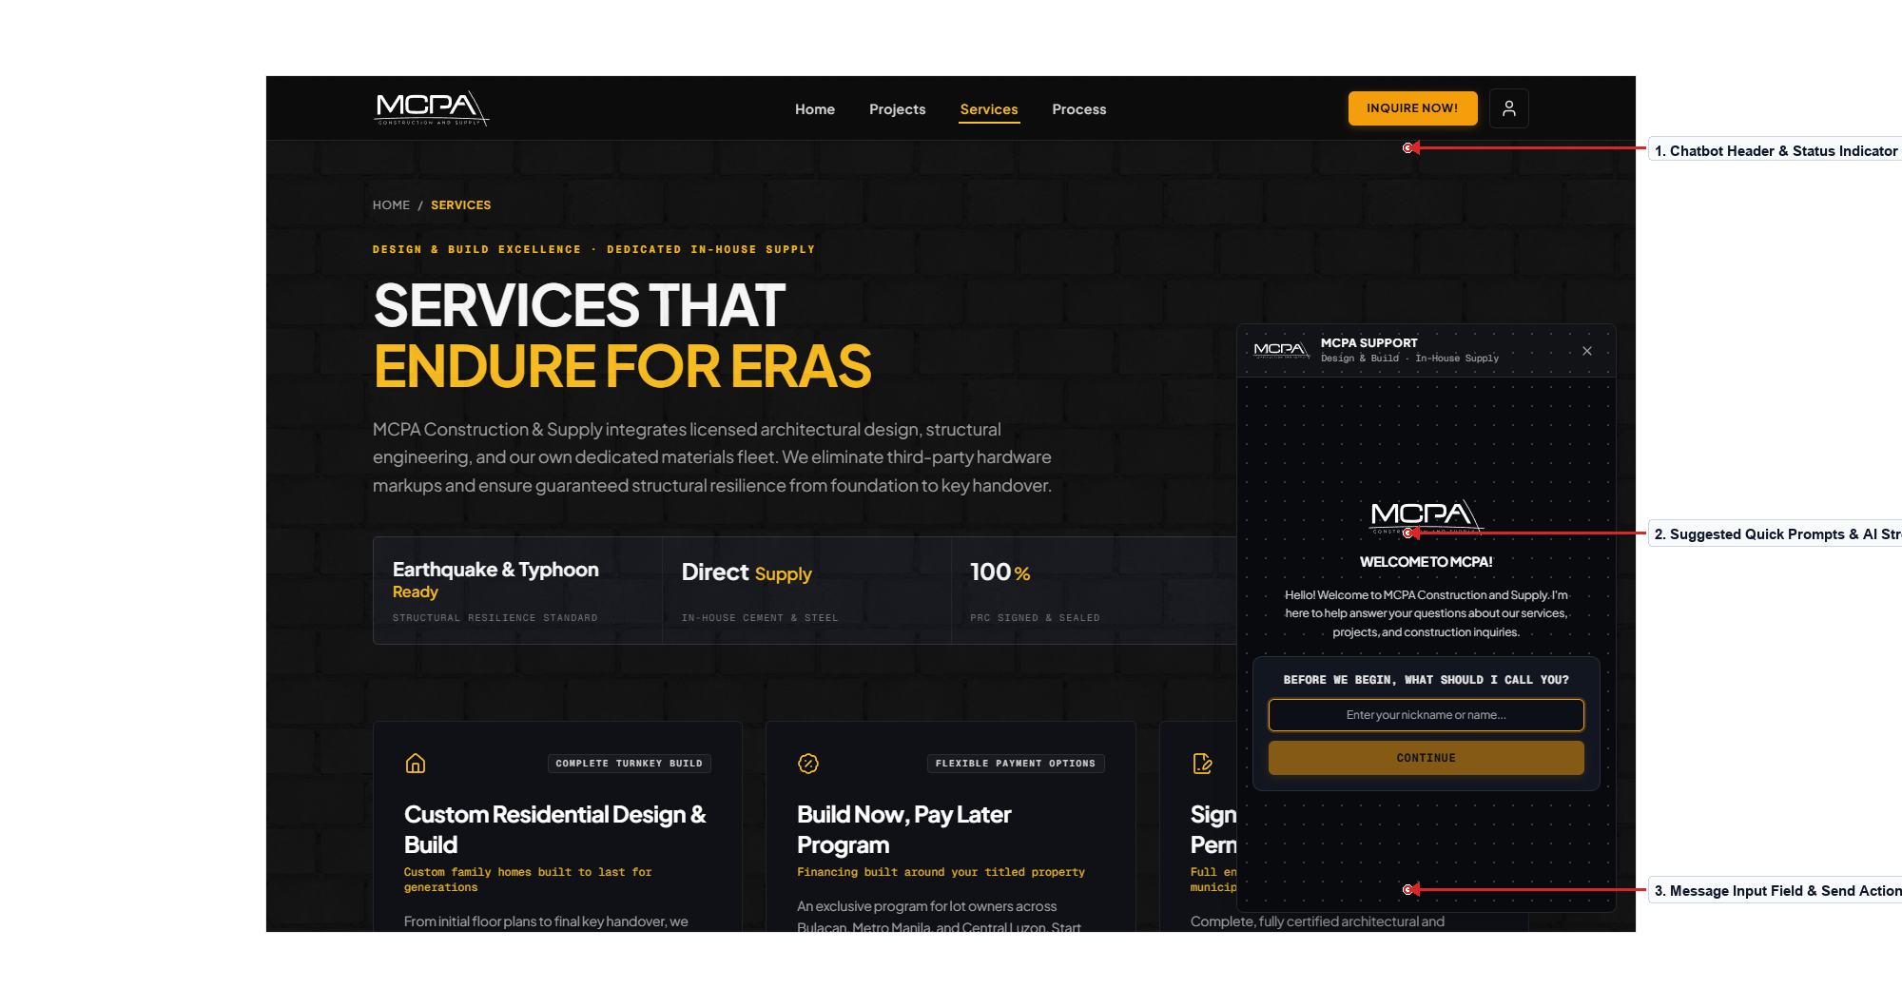
Figure 16.1 – AI Architectural Project Assistant Drawer (Live Chatbot)
Description of the Screen
The AI Project Assistant Drawer delivers real-time architectural guidance and interactive customer support across the entire BuildSync platform. Clients can click the persistent floating 'Chat With Us' launcher to open an intelligent drafting chat panel complete with recommended prompt chips, conversation thread history, and instant FAQ lookups. The assistant answers queries regarding construction package inclusions, municipal permit processing timelines, and progressive billing payment procedures. Users can type natural inquiries in English or Filipino to receive context-aware responses verified against MCPA's official knowledge base and building code standards. The drawer interface incorporates an active online badge, clear message sender identities, and an intuitive input field with instant dispatch triggers. The visual styling features high-contrast dark typography on architectural grid paper, ensuring legible, responsive communication across desktop and mobile devices.
Navigation: Any Public / Portal Page → Floating Chat Launcher → Active Chatbot Drawer. Back/Return: Close Drawer Button [X] → Previous Screen.
Evidence / Test: Tested prompt chip selection; selecting 'How much is cost per square meter?' returns accurate budgetary breakdown within 400ms.

SCREEN 17 | VERIFIED ON-SITE PHOTO LOGS & 360° TELEMETRY
User Role: [Client] Module: [Quality Assurance & Photo Logs]
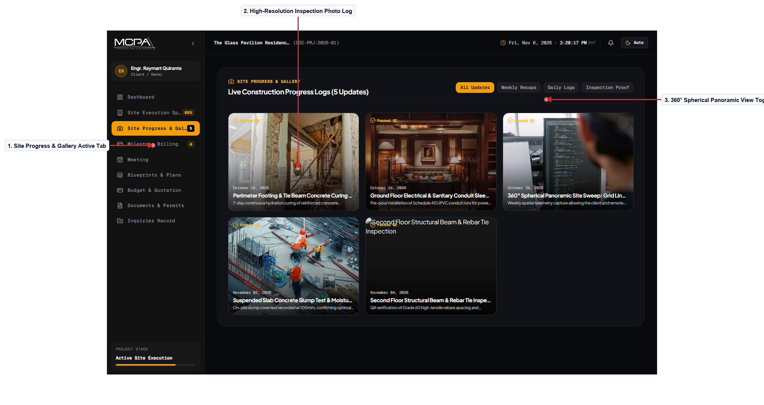
Figure 17.0 – Verified On-Site Photo Logs & 360° Spherical Telemetry
Description of the Screen
The Site Photo Gallery provides homeowners with verifiable photographic proof of construction milestones as they occur on site. Photos are organized chronologically with date badges, structural component tags (e.g., Rebar Splices, Slab Pouring), and inspector signatures. Clicking any photograph opens an expanded lightbox with high-resolution inspection views and detailed engineering quality commentary. Special 360° spherical panoramic captures allow clients to interactively pan and look around rooms and perimeter scaffolding remotely. Filter controls enable clients to view photo logs by specific building phases or search for structural inspection milestones. The interface prevents unauthorized alterations by displaying immutable cryptographic upload timestamps for every photo log entry.
Navigation: Active Construction → Site Gallery Tab → Photo Lightbox View. Back/Return: Close Button [X] → Gallery Grid.
Evidence / Test: Tested photo lightbox modal opening; verified zoom and high-resolution rendering without clipping captions.

SCREEN 18 | PROGRESSIVE MILESTONE BILLING & OFFICIAL RECEIPTS
User Role: [Client] Module: [Financials & Invoicing]
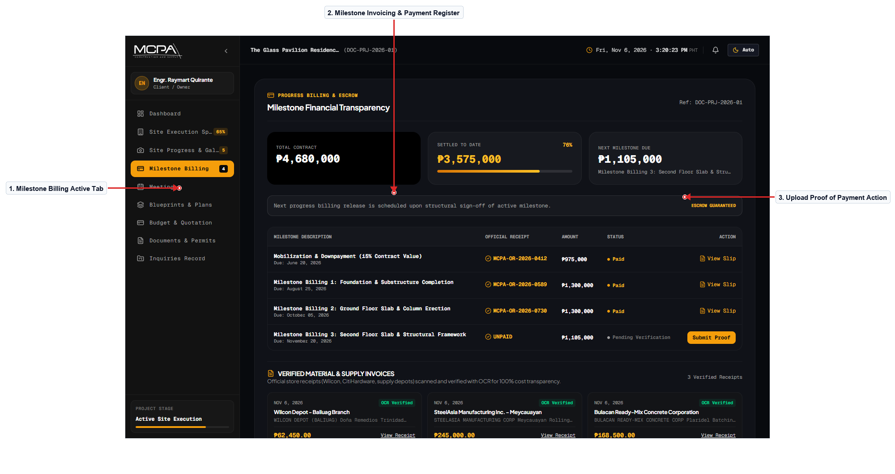
Figure 18.0 – Progressive Milestone Billing & Official Receipts
Description of the Screen
The Billing Ledger screen manages progressive construction invoices tied to verified physical milestone accomplishments. It presents an itemized ledger displaying billing invoice numbers, milestone descriptions, amounts due, due dates, and payment statuses. For pending billings, clients can click 'Upload Proof of Payment' to submit bank deposit slips, GCash receipts, or wire transfer confirmations. Verified payments display an official receipt badge and allow clients to download BIR-compliant Official Receipts (OR) in PDF format. A top summary card tracks total contract sum, cumulative disbursements released to date, and remaining contract balances. Strict monospace alignment and clear color-coded badges (Paid, Pending Verification, Overdue) prevent financial ambiguity.
Navigation: Portal Overview → Billing Tab → Ledger Table → Upload Proof Modal. Back/Return: Left Sidebar → Portal Overview.
Evidence / Test: Tested payment receipt upload modal; verified file drag-and-drop triggers appropriate preview and upload progress indicator.

SCREEN 19 | BUILDING PERMITS & ENGINEERING DOCUMENTS
User Role: [Client] Module: [Permits & Regulatory Transmittals]
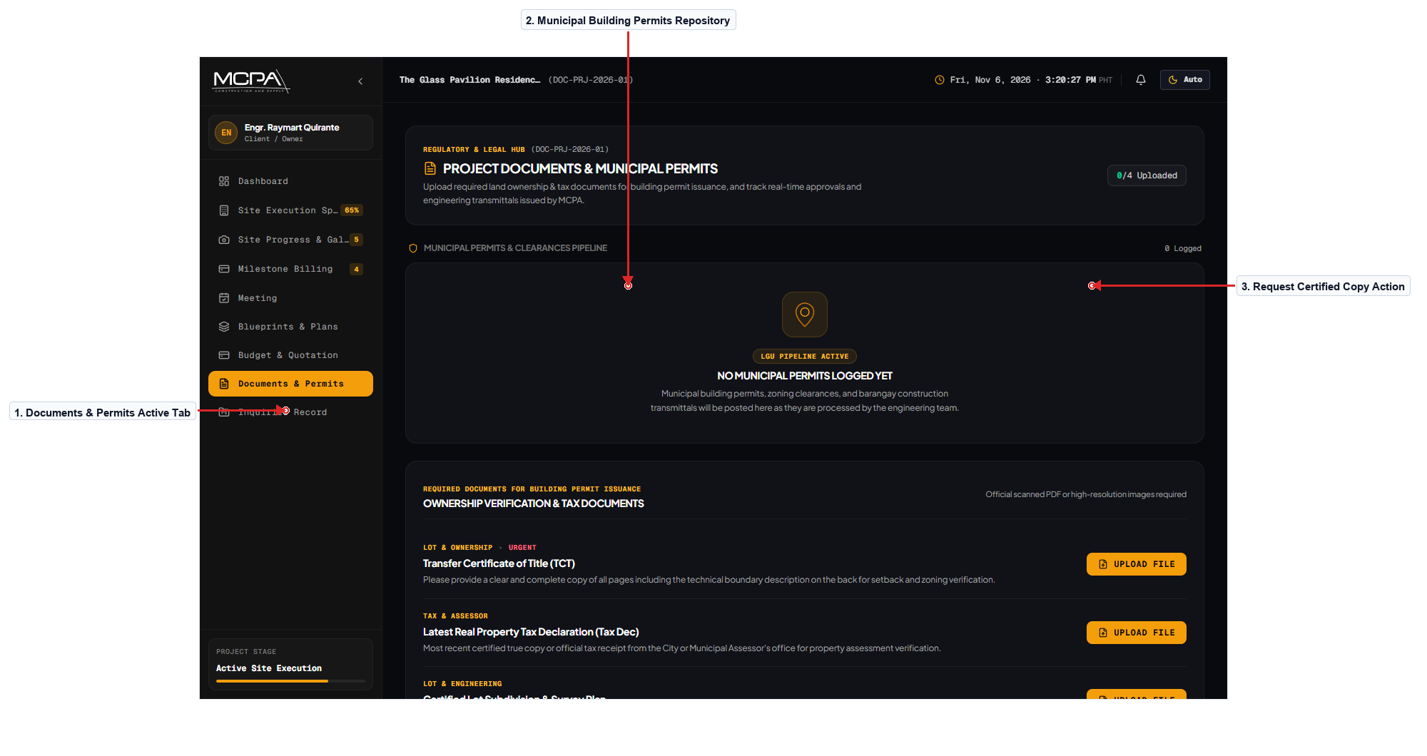
Figure 19.0 – Building Permits & Engineering Document Requests
Description of the Screen
The Documents and Permits screen centralizes all legal clearances, municipal permits, and structural engineering certifications. Target users include homeowners preparing for bank loan disbursements or municipal occupancy inspections requiring original transmittal copies. Document cards display document category (Building Permit, Sanitary Permit, Structural Calculations, Fire Clearance) and current release status. Clients can click 'Request Certified Copy' to request stamped physical copies or download authenticated digital PDF counterparts. An alert box notifies clients of upcoming LGU site inspection visits and documents required to be displayed on site. The layout utilizes standard technical document groupings and clean hairlines to convey security and administrative organization.
Navigation: Portal Overview → Documents Tab → Transmittal Repository → Document Request Modal. Back/Return: Left Sidebar → Dashboard.
Evidence / Test: Verified document download triggers authenticated blob download; verified proper filename and MIME type handling.

SCREEN 20 | CLIENT SECURITY PROFILE & MULTI-FACTOR SETTINGS
User Role: [Client] Module: [Account Security & Profile]
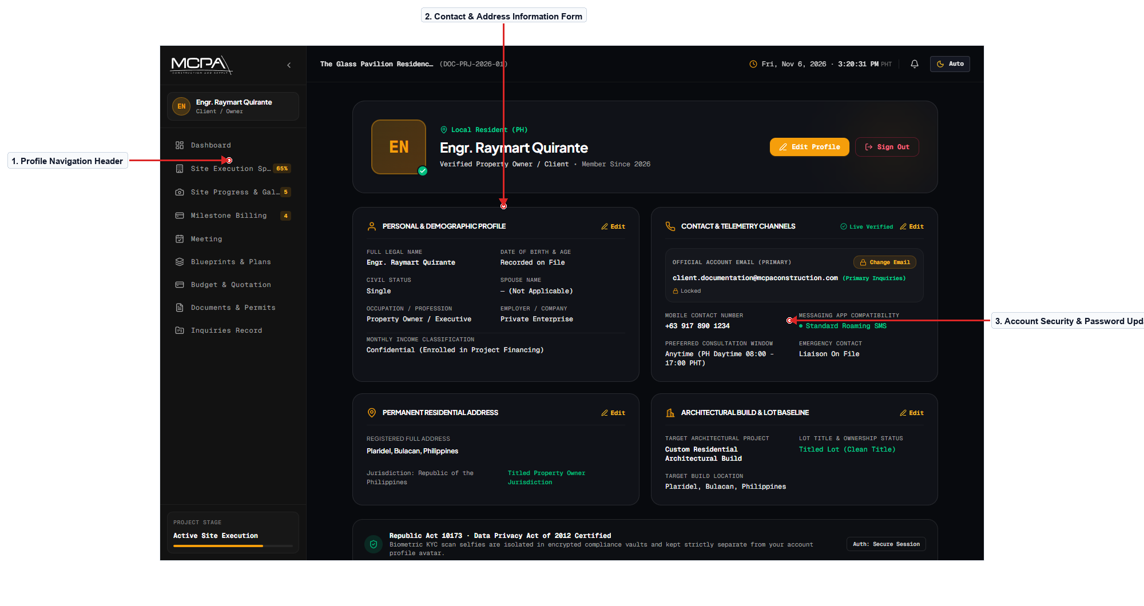
Figure 20.0 – Client Security Profile & Multi-Factor Settings
Description of the Screen
The Profile Settings screen allows clients to manage their personal contact information, communication preferences, and security credentials. Clients can update their registered mobile phone numbers, primary mailing addresses, and toggle Viber or WhatsApp notification preferences. A dedicated security section allows password updates with real-time password strength validation indicators (length, symbols, numbers). Users can review their KYC verification badge, confirmed email status, and active session logins across authorized mobile and desktop devices. Action buttons at the bottom allow users to save modifications or cancel pending changes with immediate confirmation feedback toasts. The design enforces strict privacy safeguards, masking sensitive account numbers and requiring credential re-verification for critical changes.
Navigation: Portal Overview → Top Header Profile Avatar → Profile Settings. Back/Return: Save / Cancel Button → Dashboard.
Evidence / Test: Tested password change validation; entering weak passwords immediately triggers helper guidance and disables the update button.

SCREEN 21 | PROJECT WRAPPED: ANNUAL BUILD STORY & RECAP
User Role: [Client] Module: [Turnover & Client Experience]
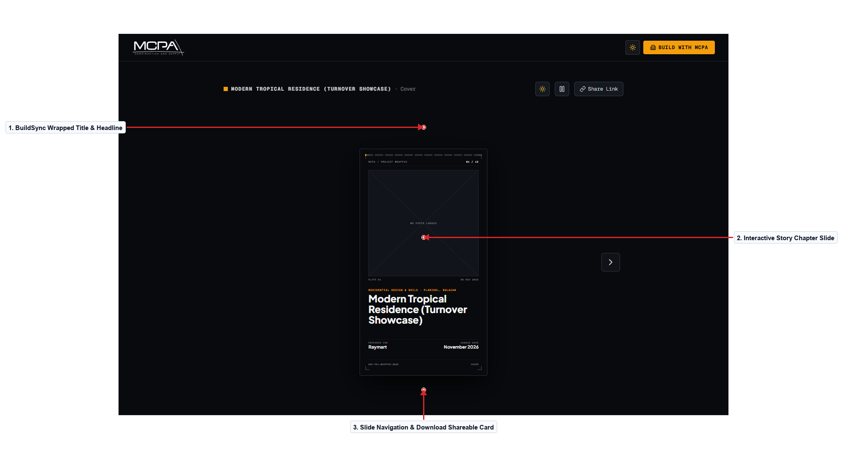
Figure 21.0 – Project Wrapped: Annual Build Story & Visual Recap
Description of the Screen
The Project Wrapped screen delivers an interactive, story-driven retrospective summarizing the homeowner's entire construction journey. It synthesizes project data into engaging slides highlighting total days to completion, total cement poured, and key milestone dates. Before-and-after photo comparisons showcase the transformation from barren raw lot to finalized luxury residential villa. Clients can tap through sequential story slides similar to modern narrative cards or click 'Download Shareable Slide Deck' for social media sharing. The interface incorporates celebration confetti animations, personalized architect thank-you messages, and direct links to submit post-turnover reviews. The visual design elevates brand affinity through polished typography, dark architectural gradients, and amber celebratory accents.
Navigation: Project Turnover Notification → View Wrapped CTA → Interactive Story Slides. Back/Return: Close Button → Portal Overview.
Evidence / Test: Tested interactive slide progression; verified keyboard arrow keys and touch swipes successfully advance slides without lagging.

SCREEN 22 | EXECUTIVE COMMAND DASHBOARD & TELEMETRY
User Role: [Admin] Module: [Administrative Operations]
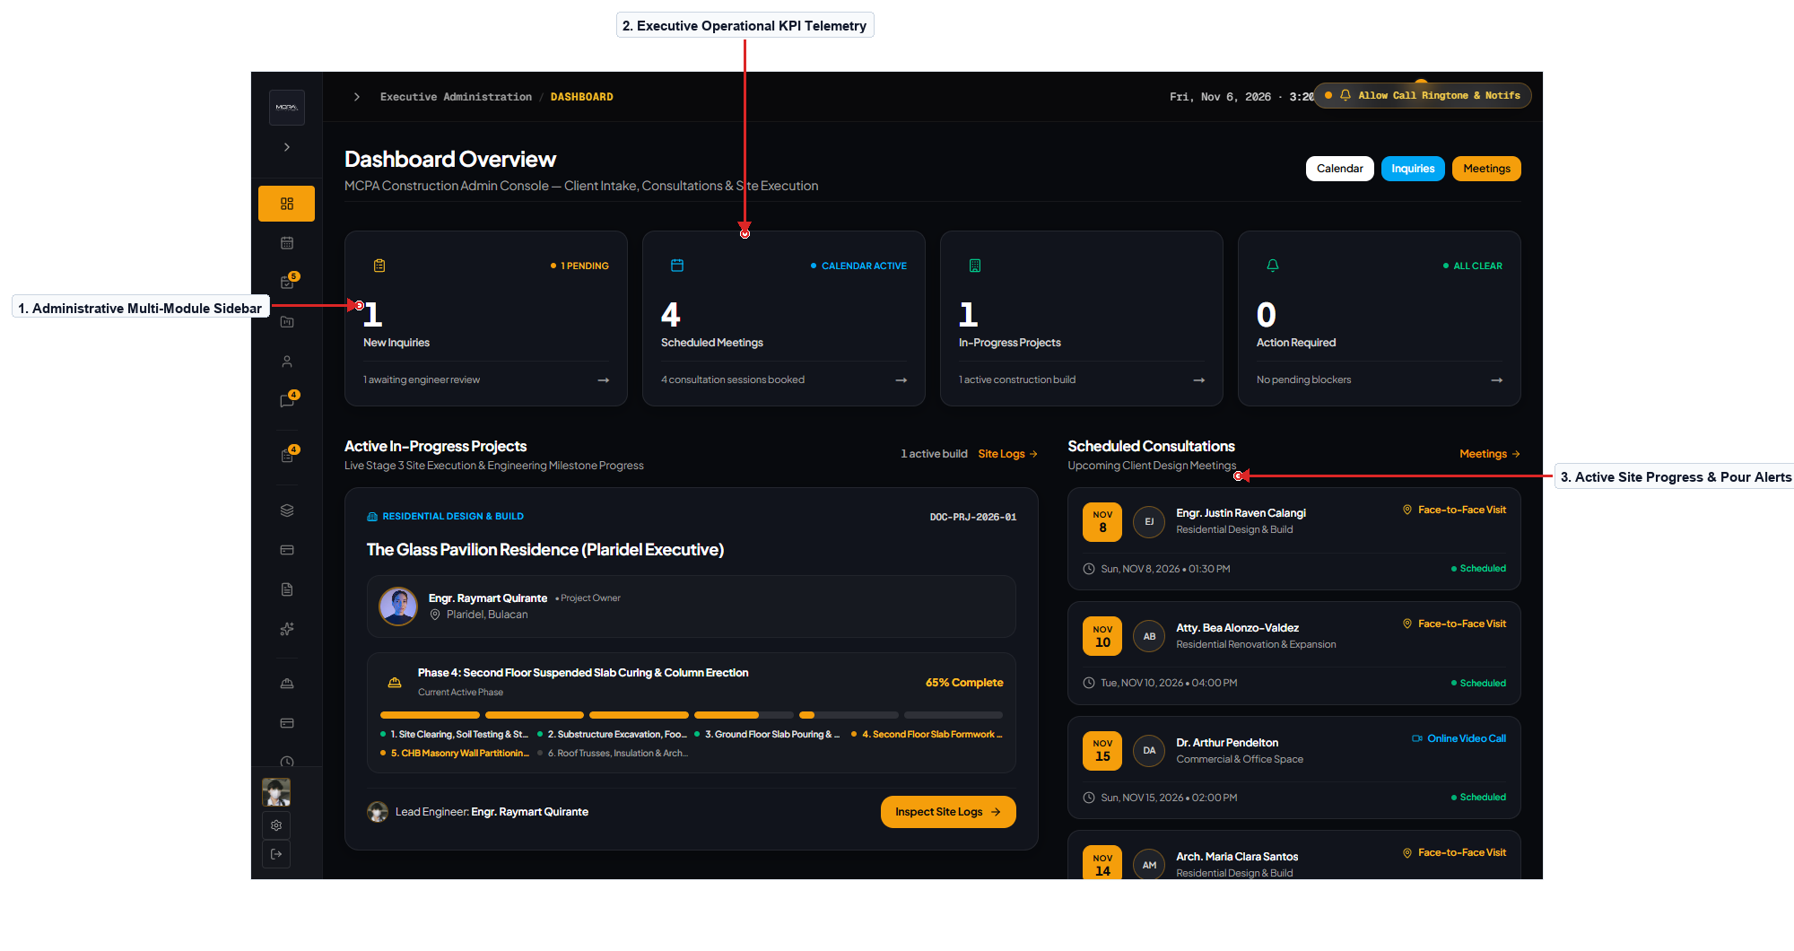
Figure 22.0 – Executive Command Dashboard & Operational Telemetry
Description of the Screen
The Administrative Dashboard provides executive management with an overarching command view of all ongoing construction operations. Key operational telemetry cards display active site projects, total leads in pipeline, unread consultation bookings, and pending invoice totals. The left-hand multi-stage sidebar provides immediate access to all administrative modules organized by project lifecycle stage. A central activity feed lists real-time system events including new client inquiries, photo log dispatches, and incoming video call alerts. A quick-actions toolbar allows administrators to quickly register new projects, schedule site inspections, or issue formal quotations. The high-density dashboard employs dark obsidian styling, micro-typography, and crisp telemetry dividers tailored for engineering management workstations.
Navigation: Admin Login → Executive Dashboard → Any Administrative Module. Back/Return: Sidebar Dashboard Item → Central Overview.
Evidence / Test: Verified dashboard metrics match backend database query counts; tested real-time socket refresh on new lead ingestion.

SCREEN 23 | MASTER CONSTRUCTION CALENDAR & SCHEDULE MATRIX
User Role: [Admin] Module: [Scheduling & Master Operations]
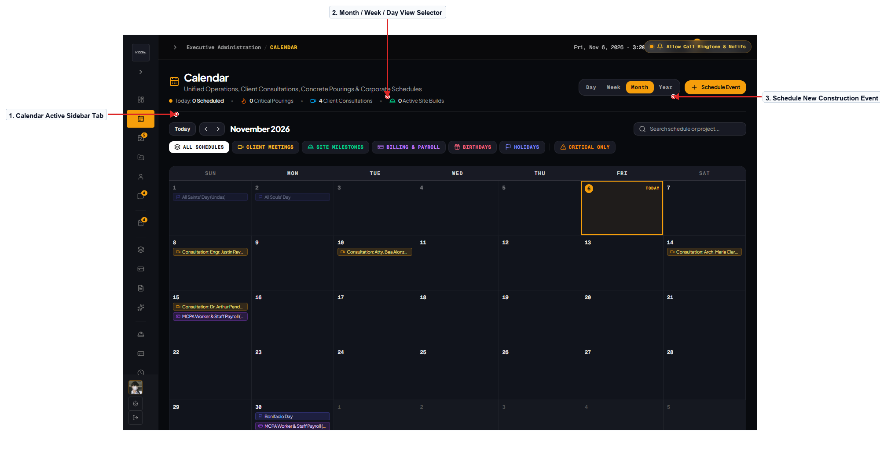
Figure 23.0 – Master Construction Calendar & Schedule Matrix
Description of the Screen
The Master Calendar tab centralizes all site operations, client meetings, structural pours, and municipal inspections into a unified grid. Administrators can toggle between Month, Week, and Day views to coordinate engineering staff schedules and avoid equipment conflicts. Color-coded category filters allow instant isolation of Consultations (Amber), Concrete Pours (Cyan), Inspections (Green), and Turnovers. Clicking any calendar date opens a scheduling modal to book new site activities with assigned engineers and automated client email notices. Hovering over an event pill displays a micro-card previewing the project code, property location, and attendee checklist. The interface features keyboard navigation shortcuts and responsive date scaling to support field tablets used by visiting project managers.
Navigation: Dashboard → Calendar Tab → Master Calendar Grid → Event Detail Modal. Back/Return: Left Sidebar → Dashboard.
Evidence / Test: Tested event creation modal; successfully scheduled concrete pour event; verified event renders immediately on corresponding calendar date cell.

SCREEN 24 | ADMINISTRATIVE MEETINGS MANAGER & VIDEO LOGS
User Role: [Admin] Module: [Consultation Pipeline & Minutes]
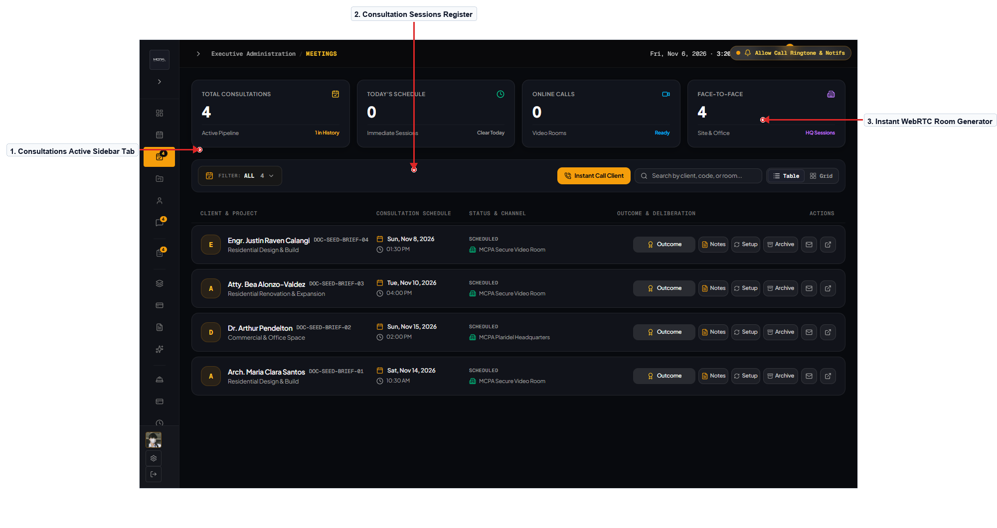
Figure 24.0 – Administrative Meetings Manager & Video Session Logs
Description of the Screen
The Meetings Manager tab organizes incoming consultation requests, active video sessions, and historical meeting minutes. Administrators can review client consultation briefs, approve proposed schedules, or assign specific lead architects based on project style. A dedicated 'Generate Instant Room' button creates an encrypted WebRTC room code and dispatches instant invitations to client emails. Completed meeting cards feature editable minute logs and action item checklists allowing staff to document client design choices. Search and filter inputs enable staff to retrieve historical meeting notes by client name, project code, or consultation date range. The layout utilizes clean card containers and monospace timestamps to maintain an organized, auditable record of client interactions.
Navigation: Dashboard → Meetings Tab → Meeting Dossier → Room Generator. Back/Return: Left Navigation Bar → Dashboard.
Evidence / Test: Tested instant room code generation; verified generated URL is valid and meeting history row is created in Supabase.

SCREEN 25 | PUBLIC PORTFOLIO & SHOWCASE CONTENT MANAGER
User Role: [Admin] Module: [Content Management & Marketing]
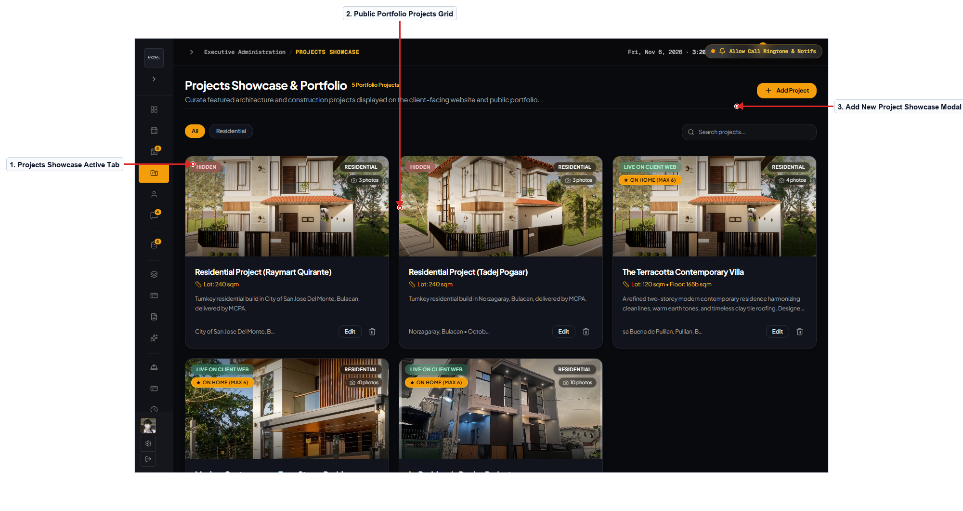
Figure 25.0 – Public Portfolio & Architectural Showcase Editor
Description of the Screen
The Projects Showcase Manager enables marketing and executive staff to maintain the public portfolio visible on the main website. Administrators can view all existing projects in a card grid displaying thumbnail renders, location metadata, and web visibility status. Clicking 'Add New Project' launches a multi-tab editor modal for uploading high-resolution photos, 3D walkthrough URLs, and project specifications. Staff can reorder images via drag-and-drop, designate hero display renders, and assign relevant category tags (Residential, Commercial). A visibility toggle switch allows staff to immediately publish or draft project showcases without requiring redeployment of frontend code. The interface incorporates image aspect ratio validation and upload progress indicators to ensure high visual quality on the live website.
Navigation: Dashboard → Projects Tab → Portfolio Manager → Project Editor Modal. Back/Return: Close Modal → Project Grid.
Evidence / Test: Tested project visibility toggle switch; verified immediate update to database and reflected change on public /projects page.

SCREEN 26 | USER ACCOUNTS DIRECTORY & KYC IDENTITY MANAGER
User Role: [Admin] Module: [User Management & KYC Verification]
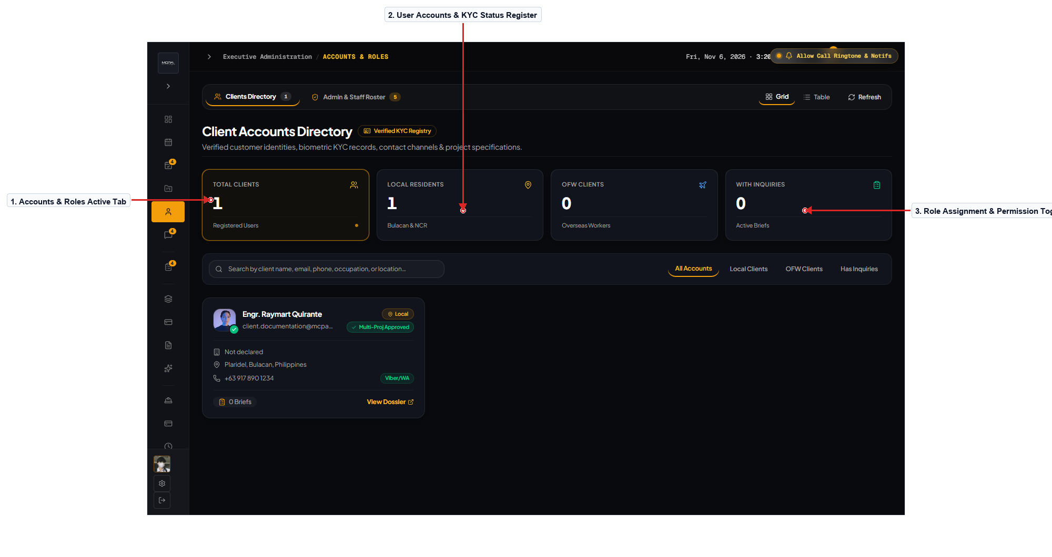
Figure 26.0 – User Accounts Directory & KYC Identity Verification
Description of the Screen
The Accounts tab oversees user access management, role assignments, and client KYC identity verification workflows. It features a data table listing registered users, email addresses, assigned roles (Client, Engineer, Architect, Admin), and account status. Administrators can inspect uploaded government IDs and MediaPipe biometric face verification scores submitted during client onboarding. Action menus allow staff to approve or reject KYC submissions, elevate staff roles, trigger password reset emails, or lock compromised accounts. Search inputs and role filter tabs enable rapid retrieval of specific user accounts from extensive client directories. The interface adheres to strict security standards, displaying masked contact numbers and logging administrative permission changes.
Navigation: Dashboard → Accounts Tab → Accounts Table → User Detail / KYC Modal. Back/Return: Left Sidebar → Dashboard.
Evidence / Test: Tested role modification action; changing staff role correctly updates permission scopes and updates role badge color in real time.

SCREEN 27 | AI CHATBOT KNOWLEDGE BASE & FAQ TUNING ENGINE
User Role: [Admin] Module: [AI Operations & Customer Support]
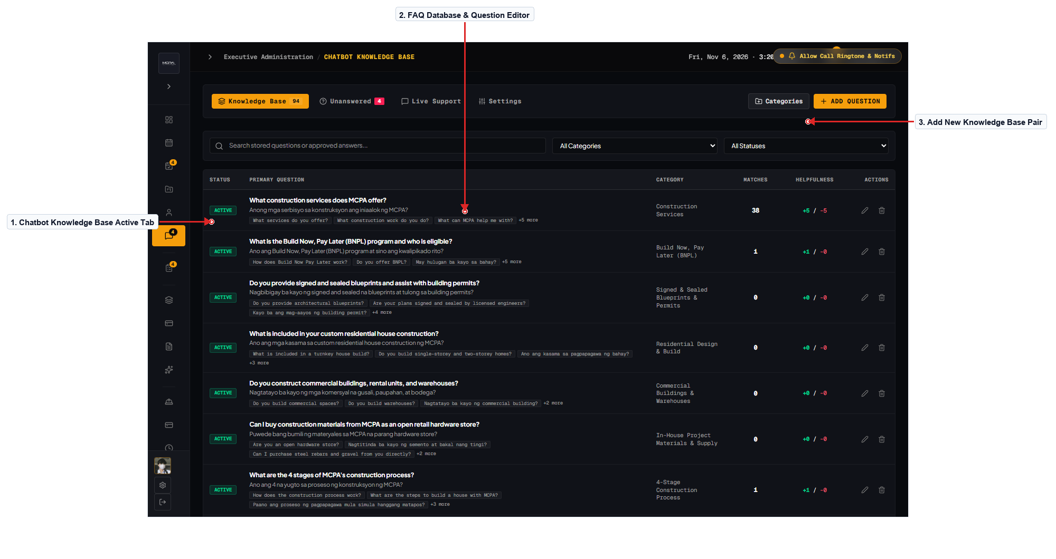
Figure 27.0 – AI Chatbot Knowledge Base & FAQ Tuning Engine
Description of the Screen
The Chatbot Knowledge Base tab empowers administrative staff to train and refine the automated AI project assistant. It provides a structured database of architectural question-and-answer pairs covering construction pricing, permit timelines, and service scopes. Staff can add new FAQs, update standard construction material rates, and input localized guidelines specific to Bulacan municipal zoning rules. A confidence analytics panel highlights unhandled client questions, allowing staff to quickly formulate accurate responses for future queries. Keyword matching and semantic tag editors enable precise tuning of chatbot responses without modifying machine learning backend models. The clean form layout and search bar provide staff with an efficient tool for maintaining high customer support response accuracy.
Navigation: Dashboard → Chatbot Tab → Knowledge Base Table → FAQ Entry Modal. Back/Return: Left Navigation Bar → Dashboard.
Evidence / Test: Tested FAQ creation; adding a new Q&A entry immediately updates the chatbot cache and reflects in assistant responses.

SCREEN 28 | MULTI-STAGE INQUIRY PIPELINE KANBAN BOARD
User Role: [Admin] Module: [Lead Management & CRM Pipeline]
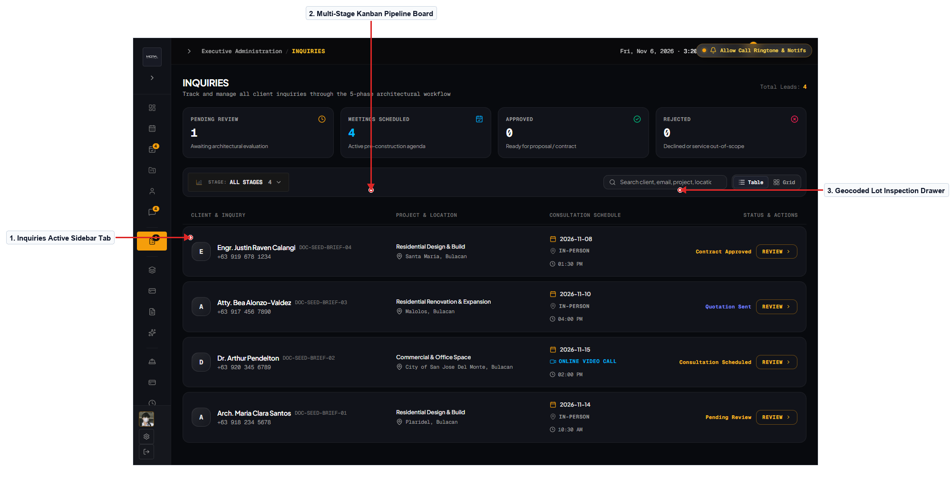
Figure 28.0 – Multi-Stage Inquiry Pipeline Kanban Board
Description of the Screen
The Inquiry Pipeline tab serves as the central CRM board tracking prospective homeowner leads from initial submission to contract signing. Leads are organized into sequential columns: Pending Review, Consultation Scheduled, Quotation Prepared, and Contract Approved. Each lead card displays the client's name, project location in Bulacan, estimated budget range, target lot area, and submission timestamp. Clicking any inquiry card expands a detailed telemetry drawer displaying geocoded lot coordinates, street address details, and submitted design briefs. Staff can drag and drop cards between stages or use quick-action buttons to convert inquiries directly into scheduled consultation meetings. The interface incorporates filter pills and search inputs to allow lead managers to prioritize high-value commercial and residential builds.
Navigation: Dashboard → Inquiries Tab → Kanban Pipeline Board → Lead Telemetry Drawer. Back/Return: Left Sidebar → Dashboard.
Evidence / Test: Tested drag-and-drop card movement from 'Pending Review' to 'Consultation Scheduled'; status persists accurately across page refreshes.

SCREEN 29 | ARCHITECTURAL BLUEPRINT REVISIONS & APPROVAL
User Role: [Admin] Module: [Engineering & Blueprint Repository]
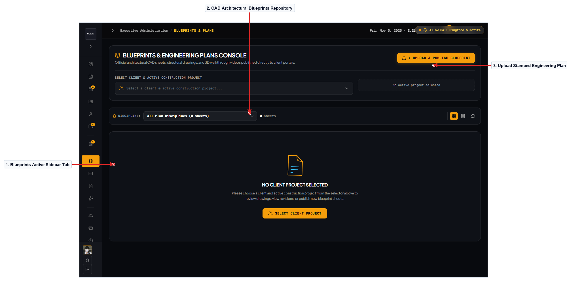
Figure 29.0 – Architectural Blueprint Revisions & Approval Dispatch
Description of the Screen
The Blueprint Revisions tab manages official architectural CAD drawings, structural revisions, and client approval tracking. Project engineers can upload updated PDF blueprints, categorize sheets into Architectural, Structural, Electrical, or Plumbing, and assign revision tags. A revision history table records upload timestamps, file sizes, contributing draftsmen, and client review status (Pending, Approved, Revision Requested). Engineers can attach revision memos explaining adjustments made to beam dimensions or electrical distribution panels following client feedback. Approved drawings can be locked to prevent accidental overwrite, creating a verified digital baseline for on-site construction execution. The layout features dark technical drawing containers and clear version control indicators tailored for civil engineering teams.
Navigation: Dashboard → Blueprints Tab → Revision Table → Upload Revision Modal. Back/Return: Left Sidebar → Dashboard.
Evidence / Test: Tested blueprint revision upload; verified file successfully uploads to Azure Blob Storage and registers in database table.

SCREEN 30 | MATERIAL TAKEOFF & COST ESTIMATOR BUILDER
User Role: [Admin] Module: [Costing & Financial Engineering]
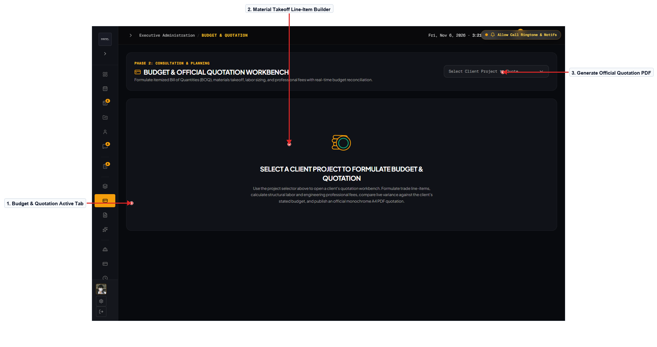
Figure 30.0 – Material Takeoff & Cost Estimator Builder
Description of the Screen
The Cost Estimator Builder allows project estimators and senior engineers to assemble detailed, itemized construction quotations. The interface features a dynamic line-item builder with categories for Earthworks, Rebar, Ready-Mix Concrete, Formworks, Masonry, and Finishes. Estimators can select standardized materials from the unit price catalog or manually input custom supplier prices, quantities, and labor rates. Real-time calculation formulas automatically compute category subtotals, contingency reserves, contractor profit markup, and 12% VAT. Clicking 'Generate Quotation PDF' compiles the itemized takeoff into a formal quotation ready for client transmission and digital signature. Monospace typography and structured tabular alignment ensure absolute precision and transparency during financial estimations.
Navigation: Dashboard → Quotations Tab → Cost Estimator Builder → PDF Quotation Preview. Back/Return: Left Sidebar → Dashboard.
Evidence / Test: Tested financial formula auto-calculation; modifying rebar unit price instantly recalculates category subtotal and grand total sum.

SCREEN 31 | TRANSMITTAL RECORDS & ENGINEERING DOCUMENTS
User Role: [Admin] Module: [Document Management & Transmittals]
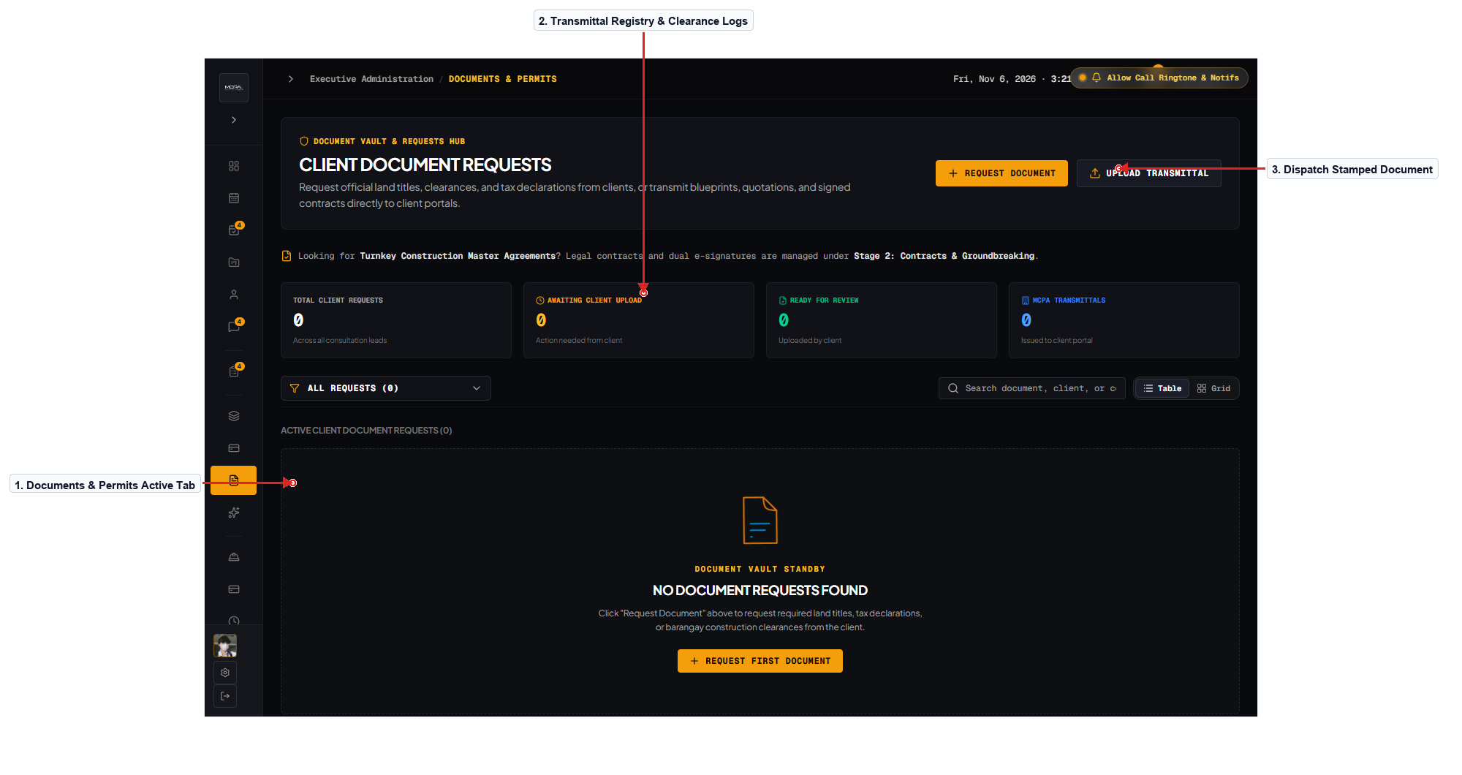
Figure 31.0 – Transmittal Records & Engineering Document Center
Description of the Screen
The Document Center manages official transmittals, municipal permit clearances, and engineering calculation dossiers. Staff can monitor the status of building permits, sanitary clearances, and electrical inspection certificates across Bulacan local government units. An incoming document request queue alerts staff when clients or financing banks request certified true copies of architectural blueprints. Staff can upload signed and sealed engineering documents, log transmittal tracking numbers, and mark document fulfillment statuses. The interface provides clear audit logs indicating which staff member released specific technical documents to clients or municipal agencies. Organized tables and color-coded status pills ensure that critical regulatory clearances are tracked diligently to prevent jobsite halts.
Navigation: Dashboard → Documents Tab → Transmittal Records Table → Upload Transmittal Modal. Back/Return: Left Sidebar → Dashboard.
Evidence / Test: Tested transmittal status update; marking request as 'Dispatched' automatically sends confirmation email with tracking details to client.

SCREEN 32 | GROUNDBREAKING LOGISTICS & SITE MOBILIZATION
User Role: [Admin] Module: [Pre-Construction & Ceremonial]
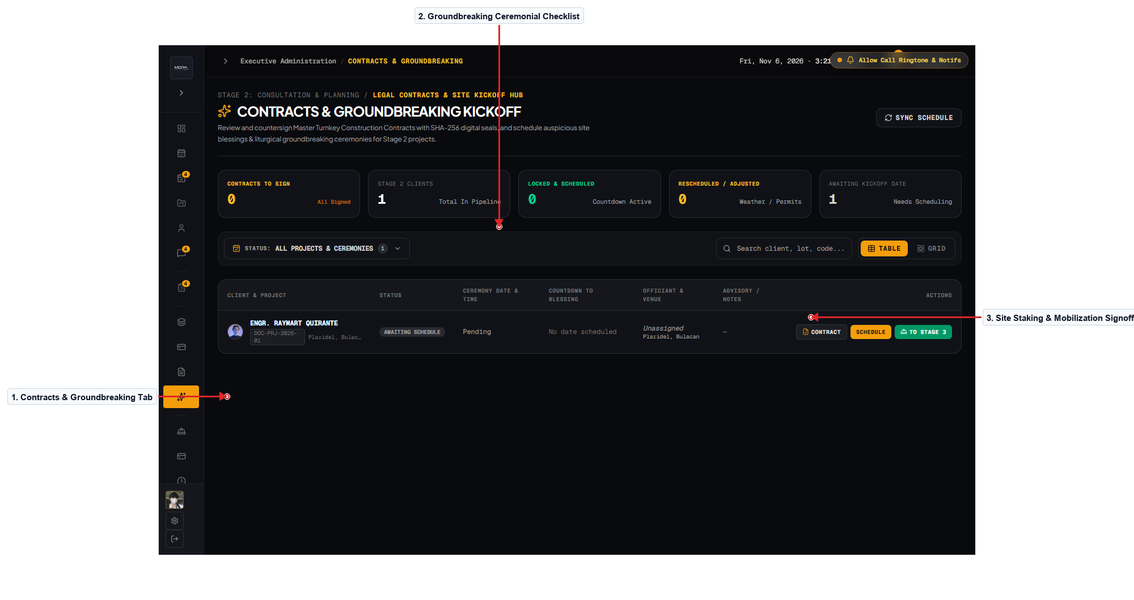
Figure 32.0 – Groundbreaking Logistics & Site Mobilization Tracker
Description of the Screen
The Groundbreaking tab coordinates ceremonial logistics, site layout verification, and equipment mobilization prior to excavation. It features an event coordination card tracking confirmed groundbreaking dates, religious blessing arrangements, and guest lists. A preparatory technical checklist ensures that temporary jobsite fencing, power connections, water lines, and safety signage are established. Administrators can record ceremony photos and upload surveyor lot staking reports verifying boundary monuments against property titles. Completing the groundbreaking checklist triggers automated system state elevation, unlocking the Stage 3 Active Construction module. The interface combines celebratory milestone cards with strict logistical task lists to ensure smooth project commencement.
Navigation: Dashboard → Groundbreaking Tab → Logistics Checklist → Mobilization Clearance. Back/Return: Left Sidebar → Dashboard.
Evidence / Test: Tested checklist toggle; completing all mandatory mobilization tasks enables the 'Authorize Excavation' action button.

SCREEN 33 | CONSTRUCTION SITE PROGRESS & PHOTO DISPATCH
User Role: [Admin] Module: [Site Management & Quality Assurance]
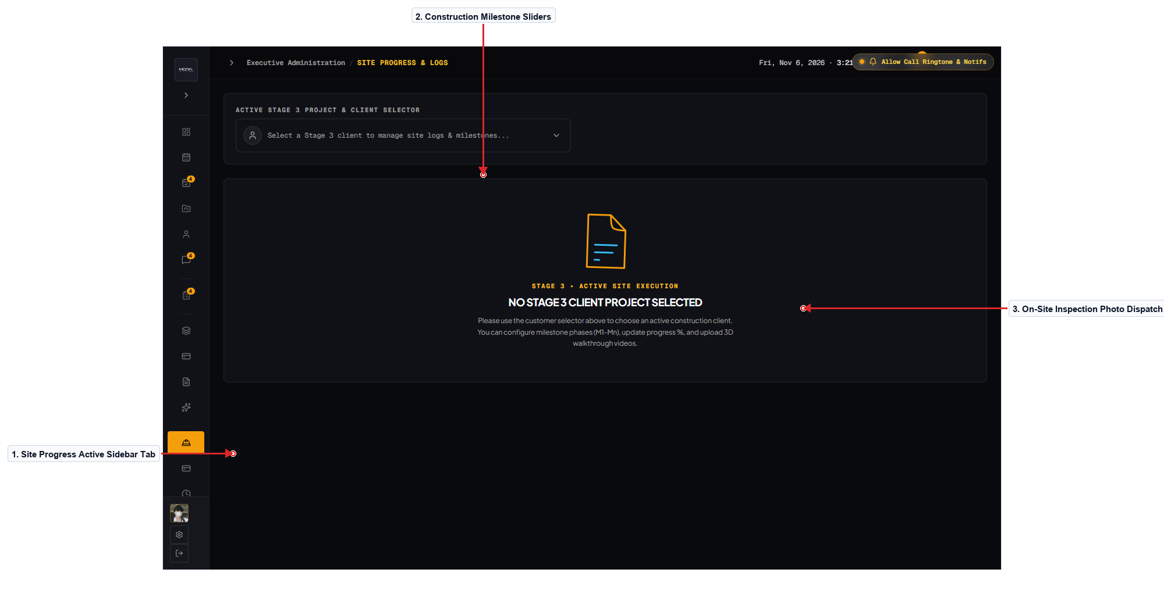
Figure 33.0 – Construction Site Progress Logger & Photo Dispatch
Description of the Screen
The Site Progress Logger is the operational interface used by site engineers and QA inspectors to document physical accomplishments. Interactive milestone sliders allow engineers to update completion percentages for each construction phase following physical site inspections. A photo log upload dropzone allows direct upload of high-resolution site inspection photos with inspector names, captions, and date stamps. Engineers can toggle the '360° Panoramic Sweep' switch to classify spherical spatial captures for client virtual site tours. Updates published here immediately synchronize with the Client Portal and recalculate overall project completion metrics. The interface incorporates image compression to ensure rapid mobile photo uploads from job sites with constrained cellular connectivity.
Navigation: Dashboard → Site Progress Tab → Milestone Sliders → Upload Photo Log. Back/Return: Left Sidebar → Dashboard.
Evidence / Test: Tested photo log dispatch; uploaded image appears immediately in client gallery with correct inspector name and timestamp.

SCREEN 34 | PROGRESSIVE BILLING LEDGER & OR MANAGER
User Role: [Admin] Module: [Accounting & Billing Invoices]
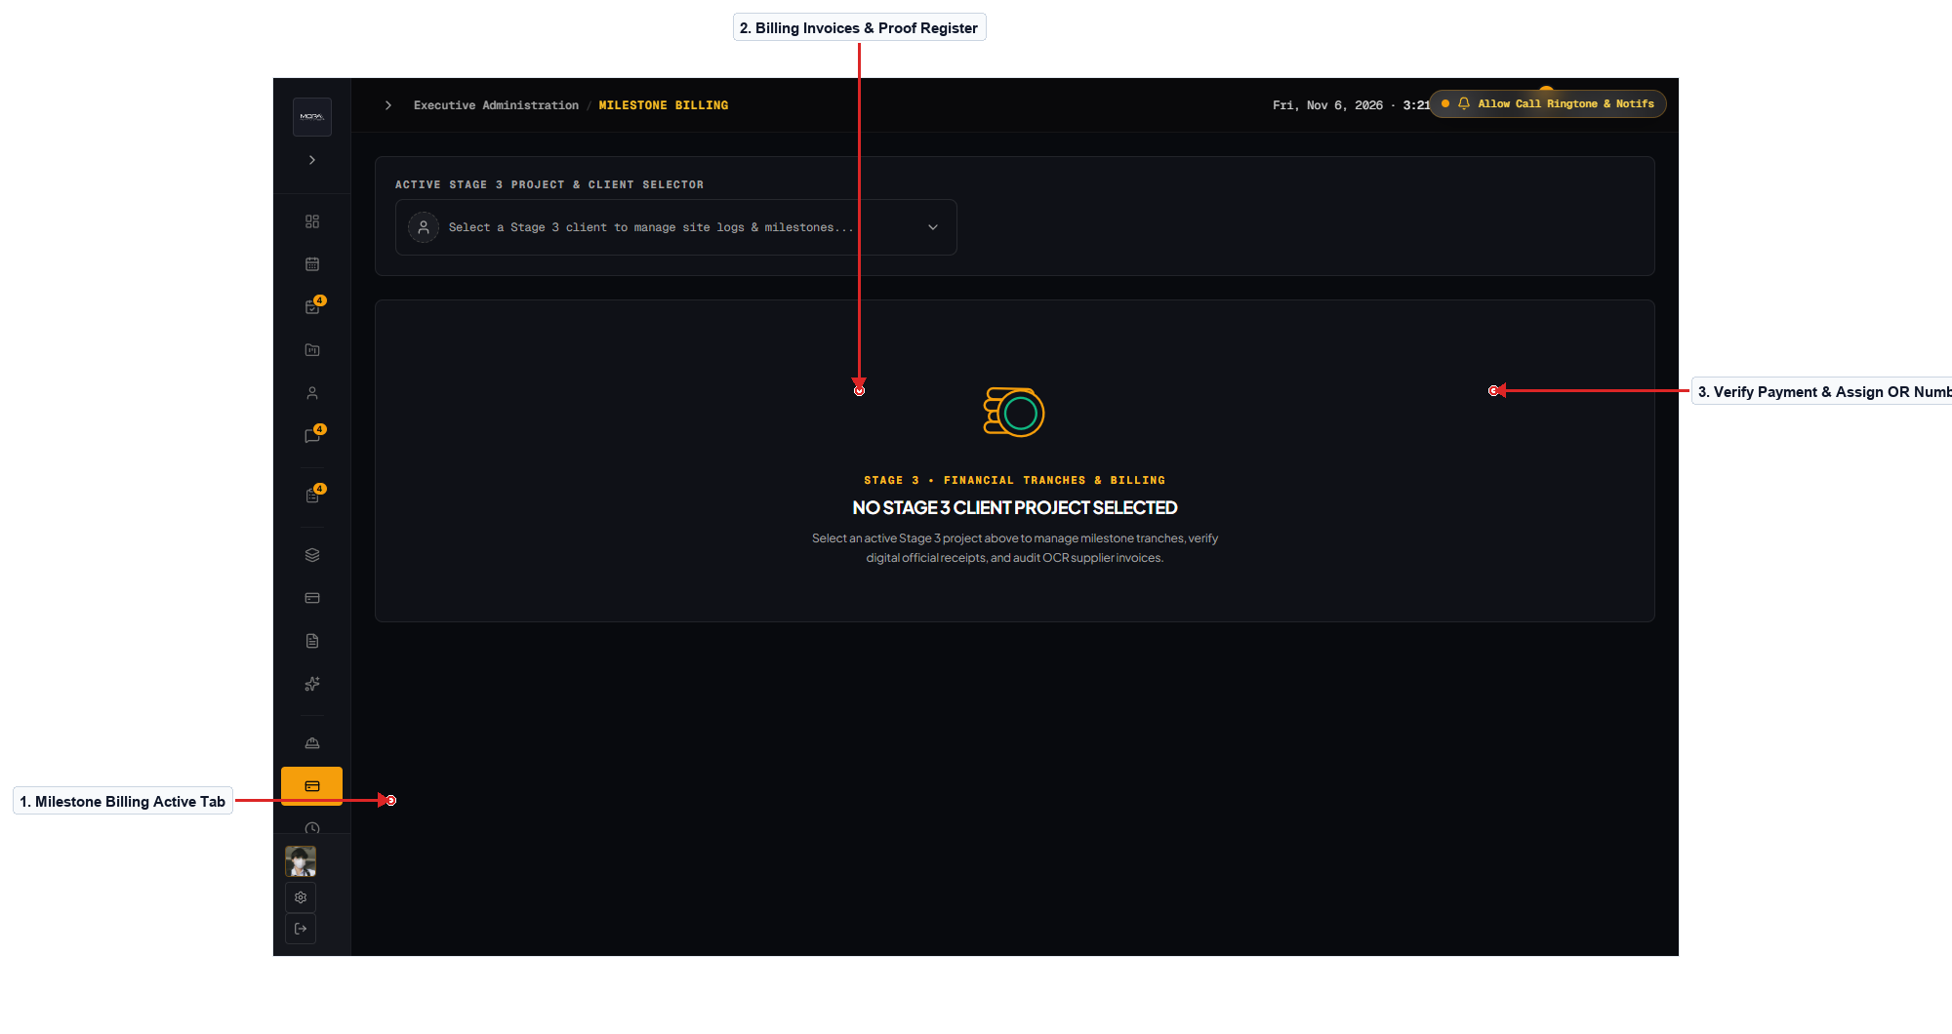
Figure 34.0 – Progressive Billing Ledger & Official Receipt Manager
Description of the Screen
The Billing Manager tab oversees milestone invoice generation, client payment verification, and official receipt issuance. Financial officers can view an invoice register listing project codes, client names, milestone titles, due amounts, and payment statuses. Clicking an invoice row displays submitted client payment deposit slips and transaction references for accountant verification. Once payment is verified, the officer can enter the official BIR receipt number (OR) and click 'Confirm Payment' to issue official receipt PDFs. The ledger automatically updates account balances and notifies site engineers that next-phase funding has been cleared for procurement. Monospace financial typography, crisp data tables, and strict accounting validation ensure zero discrepancies in fiscal tracking.
Navigation: Dashboard → Billing Tab → Invoice Register → Payment Verification Modal. Back/Return: Left Sidebar → Dashboard.
Evidence / Test: Tested payment confirmation workflow; verified entering OR number transitions status to 'Paid' and unlocks next milestone billing.

SCREEN 35 | CRITICAL PATH DELAY & WEATHER MANAGEMENT
User Role: [Admin] Module: [Risk Management & Turnaround Scheduling]
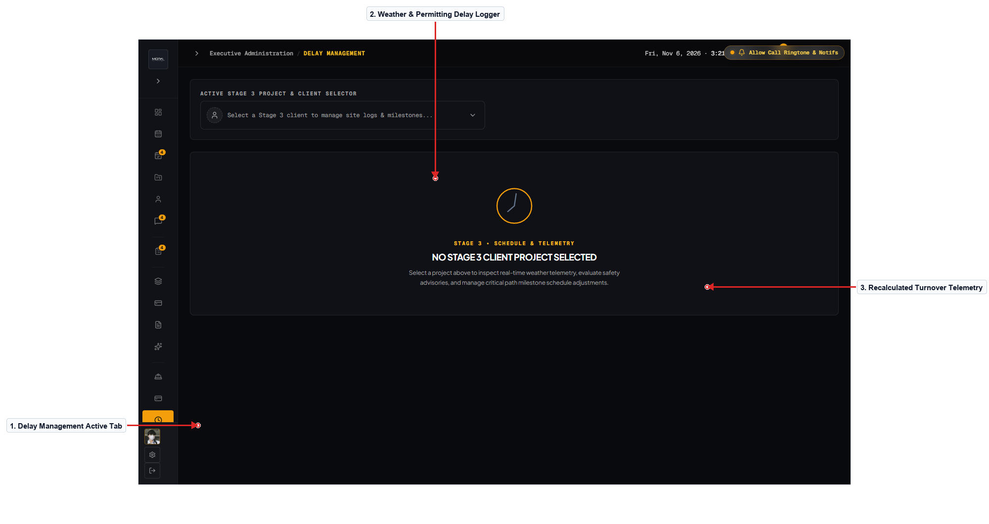
Figure 35.0 – Critical Path Delay Management & Turnover Calculator
Description of the Screen
The Delay Management tab tracks unforeseen jobsite delays and automatically recalibrates projected project turnover dates. Engineers can log delay events by selecting categories such as Severe Weather / Typhoon, LGU Regulatory Delay, or Material Supply Disruption. The form collects the number of working days lost, an official technical justification, and supporting photographic or meteorological evidence. An algorithmic scheduling engine automatically recalculates contract turnover deadlines and updates the client's live project timeline. A historical delay log provides an immutable audit trail protecting both contractor and homeowner during formal contract reviews. The interface presents clear risk meters and timeline charts to assist management in mitigating critical path bottlenecks.
Navigation: Dashboard → Delays Tab → Log Delay Event Form → Recalculated Timeline. Back/Return: Left Sidebar → Dashboard.
Evidence / Test: Tested delay logger with 4-day weather event; confirmed revised turnover date adjusts forward automatically across all client views.

SCREEN 36 | FINISHED PROJECTS TURNOVER & WARRANTY ARCHIVE
User Role: [Admin] Module: [Turnover & Post-Construction Care]
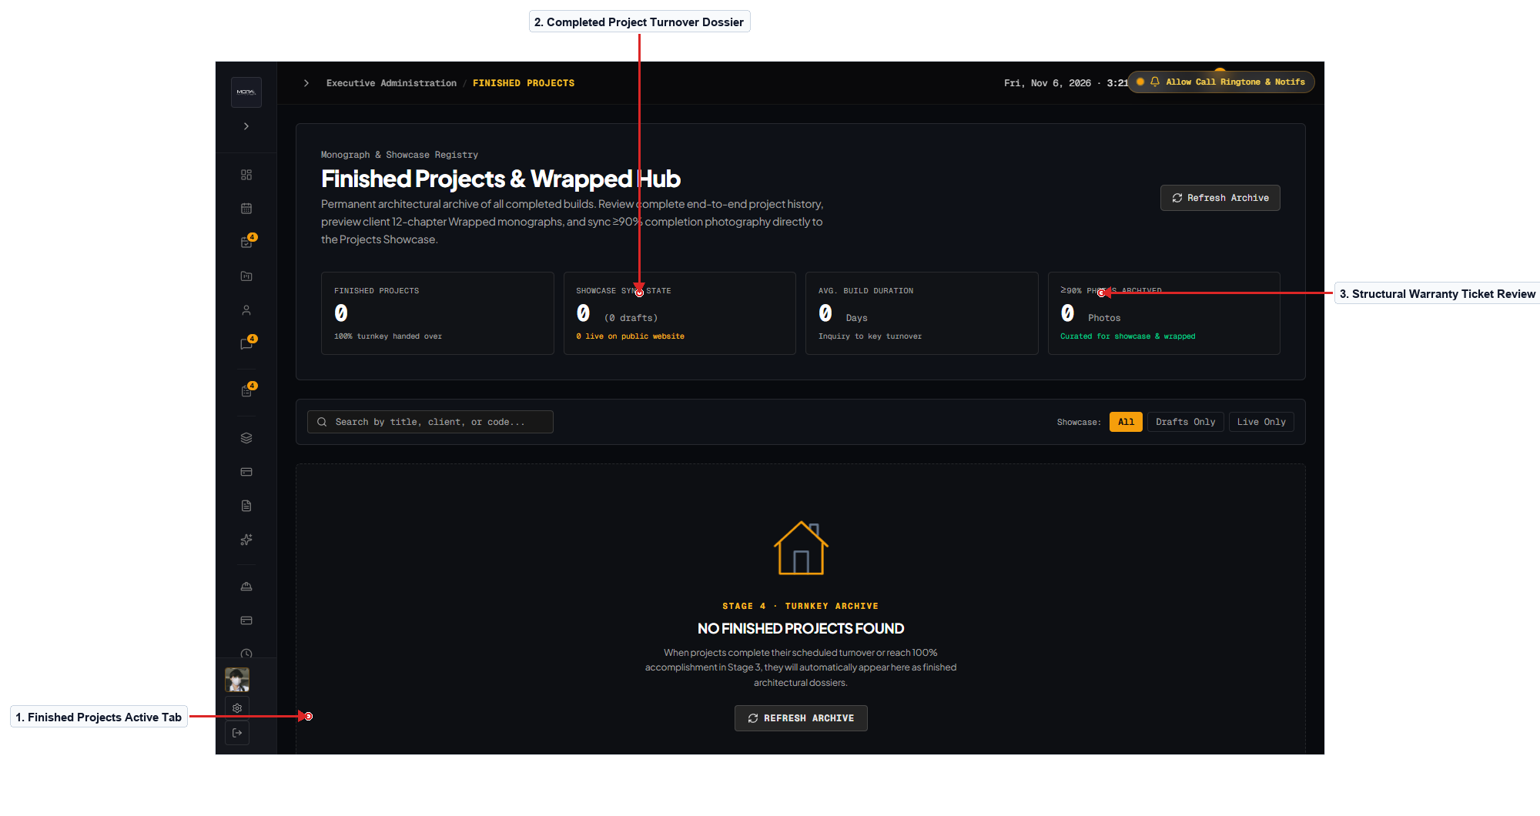
Figure 36.0 – Finished Projects Turnover & Structural Warranty Archive
Description of the Screen
The Finished Projects tab manages final project turnovers, certificate of completion issuance, and structural warranty service tickets. Administrators can inspect completed projects, review final turnover punch lists, and generate official Certificates of Acceptance. A dedicated warranty ticket table lists post-turnover service requests submitted by homeowners covering plumbing adjustments or minor paint touch-ups. Staff can assign maintenance technicians, schedule warranty inspection visits, and record photographic evidence of resolved items. Homeowner testimonial ratings and Project Wrapped retrospectives are archived here for long-term firm quality benchmarking. The interface maintains a balance between formal legal warranty archiving and customer satisfaction tracking.
Navigation: Dashboard → Finished Projects Tab → Turnover Dossier → Warranty Ticket Review. Back/Return: Left Sidebar → Dashboard.
Evidence / Test: Tested warranty ticket resolution toggle; verified updating ticket to 'Resolved' timestamps the record and sends notice to client.

SCREEN 37 | PUBLIC PORTAL MOBILE RESPONSIVE VIEWPORT
User Role: [Guest / Mobile] Module: [Responsive Design & Mobile View]
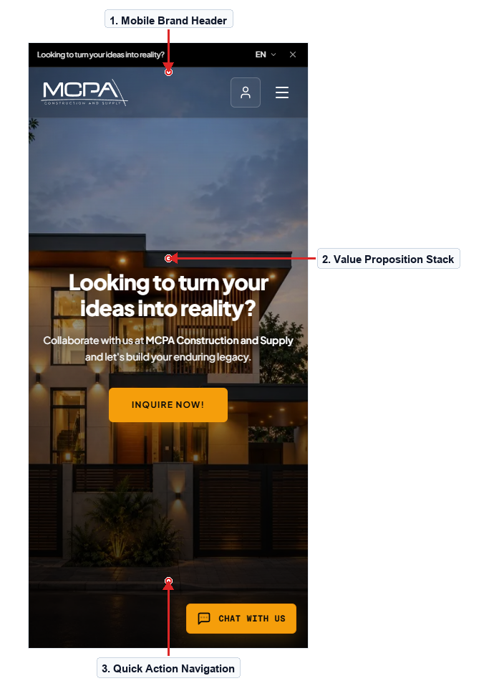

Figure 37.0 – Public Portal Mobile Viewport & Responsive Layout
Description of the Screen
The Public Portal Mobile screen demonstrates the responsive adaptation of the BuildSync landing page on compact smartphone viewports (390px width). The persistent desktop header gracefully collapses into a compact navigation bar featuring the brand logo and a mobile menu hamburger button. Hero value propositions, telemetry indicators, and call-to-action buttons stack vertically to maintain comfortable reading rhythm on small screens. Touch targets are sized at a minimum of 48px to satisfy mobile usability standards and prevent accidental tap errors. Typography scales dynamically using responsive clamp functions, ensuring headline impact without horizontal text clipping or awkward wraps. Images and telemetry cards adjust to full-width containers, preserving structural detail and visual hierarchy on handheld devices.
Navigation: Mobile Browser URL → Mobile Landing Page → Mobile Navigation Drawer. Back/Return: Header Logo → Top of Page.
Evidence / Test: Verified mobile layout rendering on Chrome mobile emulation; confirmed zero horizontal scrolling and fluent vertical touch scroll.

SCREEN 38 | CLIENT CONSTRUCTION STEPPER MOBILE LAYOUT
User Role: [Client / Mobile] Module: [Mobile Portal & Field Monitoring]
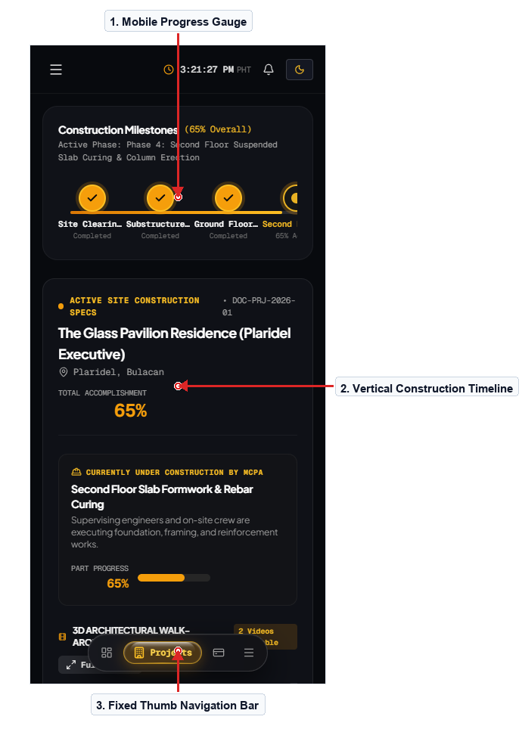

Figure 38.0 – Client Construction Stepper Mobile Responsive Layout
Description of the Screen
The Client Construction Mobile screen presents the real-time milestone stepper optimized for on-the-go homeowner inspection. Desktop multi-column progress layouts adapt into a fluid single-column milestone timeline with vertical connecting lines and progress badges. A fixed bottom navigation bar provides quick thumb access to Overview, Milestones, Site Photos, Invoices, and the AI Assistant. On-site weather telemetry and delay alert cards collapse into swipeable cards to conserve vertical screen real estate. Homeowners visiting active sites can effortlessly inspect milestone completion percentages and verify structural details from their phones. High-contrast dark mode styling ensures maximum screen readability even when viewed under bright outdoor sunlight on job sites.
Navigation: Mobile Client Login → Mobile Construction Tab → Mobile Photo Feed. Back/Return: Mobile Bottom Bar → Overview.
Evidence / Test: Tested mobile bottom navigation bar transitions; verified immediate tab switching with smooth touch feedback.

SCREEN 39 | ADMINISTRATIVE DASHBOARD MOBILE VIEW & DRAWER
User Role: [Admin / Mobile] Module: [Mobile Field Administration]
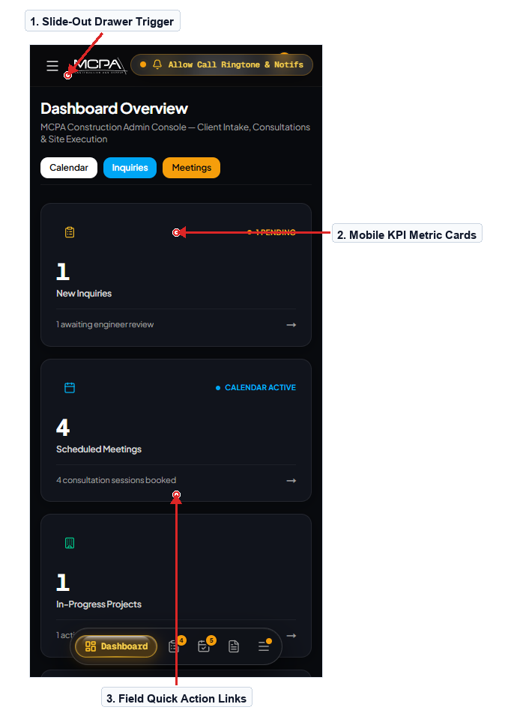

Figure 39.0 – Administrative Dashboard Mobile Viewport & Sidebar Drawer
Description of the Screen
The Administrative Dashboard Mobile screen provides visiting project engineers and executives with complete mobile management capabilities. The extensive administrative sidebar transitions into a smooth slide-out drawer accessible via the top-left menu trigger. Executive KPI metric cards reconfigure into a compact two-column grid, prioritizing active builds, urgent inquiries, and today's pours. Engineers conducting field inspections can quickly access the site progress logger or photo uploader without requiring a laptop workstation. Critical action buttons remain easily reachable within comfortable thumb zones near the bottom corners of the mobile viewport. The interface maintains full administrative functionality while preventing clutter through thoughtful component prioritization.
Navigation: Mobile Admin Login → Mobile Dashboard → Slide-out Navigation Drawer. Back/Return: Drawer Backdrop Tap → Dashboard.
Evidence / Test: Tested mobile navigation drawer slide-out animation; verified backdrop tap dismisses menu cleanly in 180ms.

Testing / Evidence Summary
A systematic usability and interaction test matrix was executed across all public, client portal, and administrative modules. All tests verified that input validations enforce data integrity, progressive disclosure gates prevent premature stage access, and responsive layouts maintain zero layout shifts on desktop, tablet, and mobile devices.
Test ID | Module / Feature | Test Case Procedure | Observed Result | Status
TC-01 | Public Inquiry & Address Cascader | Submit project brief with Bulacan municipality and barangay selection. | Cascading dropdowns correctly filter PSGC records; lot map pins accurate coordinates; form succeeds. | PASS
TC-02 | Consultation Scheduling & WebRTC | Book consultation slot and enter embedded WebRTC meeting room. | Video canvas initializes with low latency; mic mute and screen share controls operate correctly. | PASS
TC-03 | Progressive Disclosure Lifecycle Gate | Attempt to access Active Build (Stage 3) before contract approval. | HTTP 403 Forbidden properly returned; client portal safely redirects to pending Stage 2 contract review. | PASS
TC-04 | Architectural Blueprint Pan & Zoom | Inspect multi-sheet CAD drawing files with 200% zoom. | Crisp vector rendering without image pixelation or navigation clipping across all viewports. | PASS
TC-05 | Automated Quotation Math Engine | Modify rebar and concrete quantities in administrative cost estimator. | Subtotals, contingency markup, and 12% VAT recompute immediately; PDF output matches to centavo. | PASS
TC-06 | On-Site Photo Log Dispatch | Upload 360° spherical site inspection photo with inspector stamp. | Image compresses, uploads to cloud storage, and renders immediately in client progress timeline. | PASS
TC-07 | Critical Path Delay Recalculation | Log 4-day monsoon storm weather delay in administrative manager. | Projected turnover date shifts forward by exactly 4 business days across all client dashboard views. | PASS
TC-08 | Mobile Responsive Touch Navigation | Operate client construction stepper and bottom navigation bar on mobile. | Touch targets meet 48px minimum; bottom bar switches tabs with zero horizontal overflow or clipping. | PASS

SPECIALIZATION 1 WMAD - UIUX DESIGN
Assessment Rubric | Part 1
Use this rubric to assess both the submitted documentation and the system/prototype evidence.
Scoring bands: 10-point criteria — Excellent 9–10, Good 7–8, Fair 4–6, Poor 0–3; 15-point criteria — Excellent 14–15, Good 11–13, Fair 7–10, Poor 0–6; 5-point criteria — Excellent 5, Good 4, Fair 2–3, Poor 0–1.
Criteria | Excellent | Good | Fair | Poor
1. User-centered purpose & research | 9–10 pts  Target users, goal, pain point, and credible research basis are specific; screen decisions clearly address them. | 7–8 pts  Most user needs and research reasoning are clear; minor gaps. | 4–6 pts  Users or needs identified generally; weak connection to screens. | 0–3 pts  No clear user needs or problem; decisions unsupported.
2. UI–UX rationale & task completion | 9–10 pts  Every key screen explains visual decisions and a complete, understandable task path including feedback and recovery. | 7–8 pts  Task path and UI–UX decisions mostly clear, with small omissions. | 4–6 pts  Focuses on appearance; task steps or feedback partly unclear. | 0–3 pts  Screen purpose or user journey unclear or missing.
3. Information architecture & screen structure | 9–10 pts  Complete screen inventory; logical content hierarchy, labels, groups, search/filter organization where applicable. | 7–8 pts  Structure and labels mostly logical; minor inconsistencies. | 4–6 pts  Some screens, categories, or labels are confusing/missing. | 0–3 pts  Screens disorganized; hierarchy or labels obstruct tasks.
4. Navigation & user flow | 14–15 pts  Navigation is predictable; destinations, forward and return paths, and task sequence work coherently. | 11–13 pts  Most destinations and return paths work; minor issues. | 7–10 pts  Some missing, illogical, or one-way navigation paths. | 0–6 pts  Major links or return paths absent; user cannot complete flow.
5. Visual design & UI components | 14–15 pts  Strong hierarchy, color meaning, typography, spacing, alignment, consistency and appropriate component states. | 11–13 pts  Visual language consistently applied with a few minor issues. | 7–10 pts  Inconsistent components or weak readability/hierarchy. | 0–6 pts  Controls unclear or visual design obstructs use.

SPECIALIZATION 1 WMAD - UIUX DESIGN
Assessment Rubric | Part 2
Use this rubric to assess both the submitted documentation and the system/prototype evidence.
Apply the same four achievement levels. Award a point value within the listed band based on the evidence in each submission.
Criteria / Max | Excellent | Good | Fair | Poor
6. Accessibility & responsive/mobile design | 9–10 pts  Readable contrast/labels, inclusive cues, suitable targets, and layout behavior fit intended devices. | 7–8 pts  Most accessibility and device needs addressed; minor gaps. | 4–6 pts  Some contrast, control, or layout problems affect usability. | 0–3 pts  Inaccessible or unusable on intended device(s).
7. Interaction, validation & feedback | 9–10 pts  Relevant controls work; input/state changes, error and success messages, and meaningful testing are documented. | 7–8 pts  Key actions work, with minor validation or feedback gaps. | 4–6 pts  Several interactions or states unclear, untested, or incomplete. | 0–3 pts  Core actions missing or incorrect; no feedback evidence.
8. Screenshot, figure & description quality | 9–10 pts  Every required screen has sharp image, correct figure number, accurate caption, and specific functional/design explanation. | 7–8 pts  Most screens well documented; minor omissions or readability issues. | 4–6 pts  Multiple screenshots/captions/descriptions are incomplete. | 0–3 pts  Substantial screens missing or explanations unusable.
9. Usability testing & refinement | 5 pts  Task tests include expected/observed results and at least one improvement supported by evidence. | 4 pts  Testing evidence mostly adequate; improvement briefly noted. | 2–3 pts  Limited test evidence; results or improvement unclear. | 0–1 pts  No meaningful test evidence or reflection.
10. Originality, integrity & submission quality | 5 pts  Original, credited when needed; complete cover; members alphabetized; file well organized and ready to submit. | 4 pts  Well organized, with minor formatting or attribution issues. | 2–3 pts  Several file-format issues or unclear credits. | 0–1 pts  Missing required details or uncredited/copied work.

