L. Cantuti-Castelvetri et al., Science 10.1126/science.abd2985 (2020).

<https://www.science.org/cms/asset/be8a4726-631c-474e-bfb7-51cb8fc7a7cc/pap.pdf>

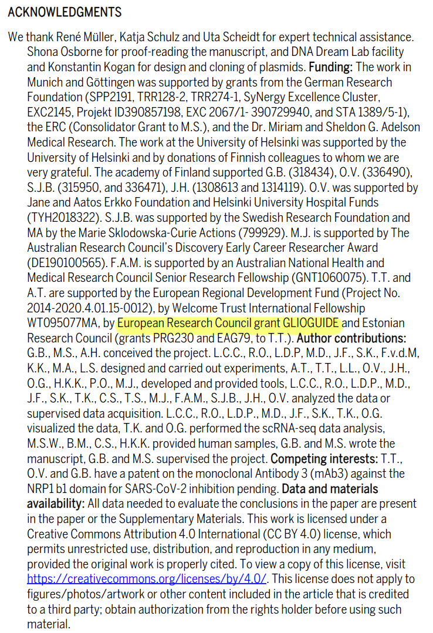

---

Pemmari, Toini et al. Molecular Therapy, Volume 28, Issue 8, 1833 - 1845

<https://www.cell.com/molecular-therapy-family/molecular-therapy/pdf/S1525-0016(20)30251-3.pdf>

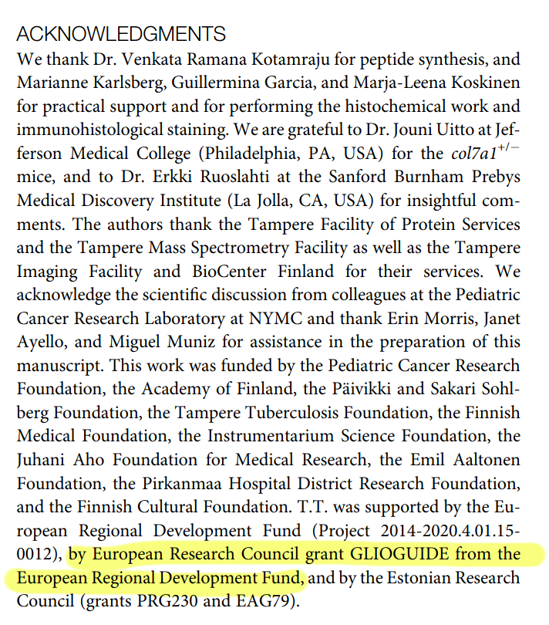

Lingasamy, P.; Põšnograjeva, K.; Kopanchuk, S.; Tobi, A.; Rinken, A.; General, I.J.; Asciutto, E.K.; Teesalu, T. PL1 Peptide Engages Acidic Surfaces on Tumor-Associated Fibronectin and Tenascin Isoforms to Trigger Cellular Uptake. Pharmaceutics **2021**, 13, 1998. https://doi.org/10.3390/pharmaceutics13121998

<https://www.mdpi.com/1999-4923/13/12/1998>

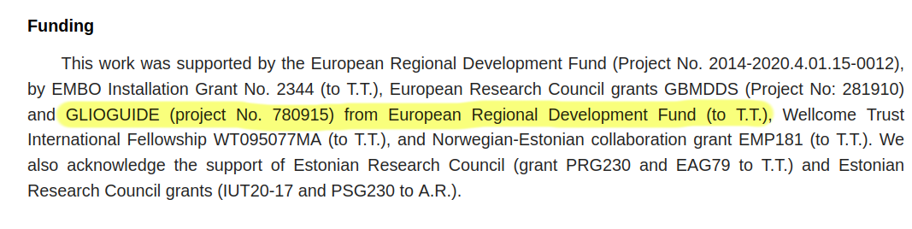

---

Lingasamy P, Laarmann AH, Teesalu T. Tumor Penetrating Peptide-Functionalized Tenascin-C Antibody for Glioblastoma Targeting. Curr Cancer Drug Targets. 2021;21(1):70-79. doi: 10.2174/1568009620666201001112749. PMID: 33001014.

<https://pubmed.ncbi.nlm.nih.gov/33001014>

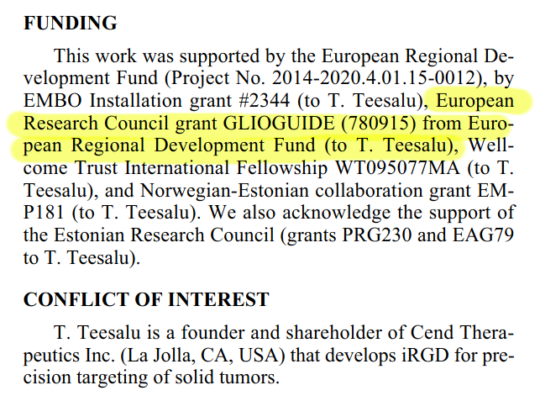

J. L. Daly et al., Science

10.1126/science.abd3072 (2020).

<https://www.science.org/cms/asset/b7734c5b-6668-41ee-a2a4-c252ba76fc5b/pap.pdf>

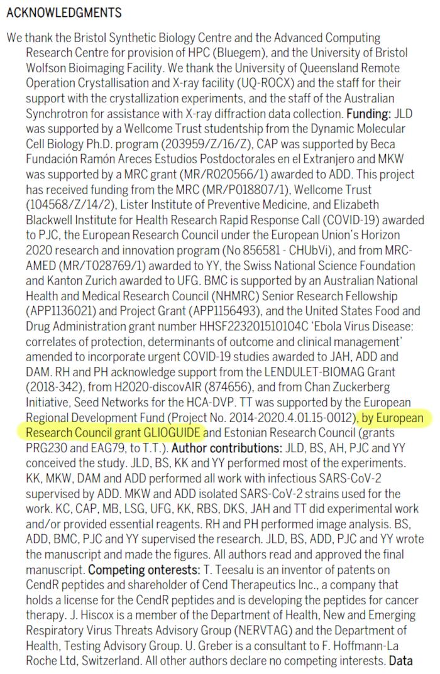

---

Angew. Chem. Int. Ed. 2021, 60, 17018 – 17027. doi.org/10.1002/anie.202016421

<https://onlinelibrary.wiley.com/doi/pdfdirect/10.1002/anie.202016421>

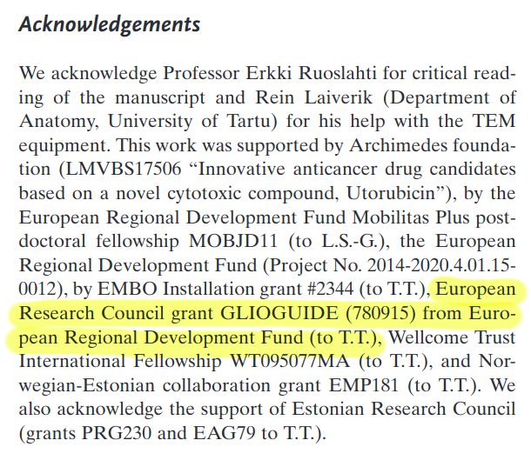

Lingasamy, P., Tobi, A., Kurm, K. *et al.* Tumor-penetrating peptide for systemic targeting of Tenascin-C. *Sci Rep* **10**, 5809 (2020).

<https://www.nature.com/articles/s41598-020-62760-y.pdf>

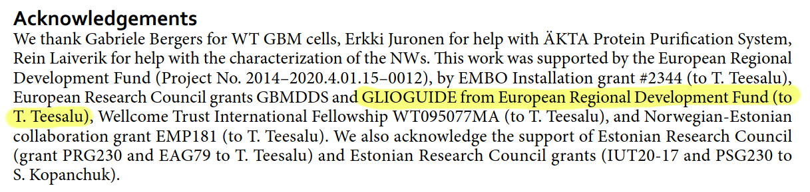

---

Tobi, A., Willmore, A.-M.A., Kilk, K., Sidorenko, V., Braun, G.B., Soomets, U., Sugahara, K.N., Ruoslahti, E. and Teesalu, T. (2021), Silver Nanocarriers Targeted with a CendR Peptide Potentiate the Cytotoxic Activity of an Anticancer Drug. Adv. Therap., 4: 2000097.

<https://onlinelibrary.wiley.com/doi/pdfdirect/10.1002/adtp.202000097>

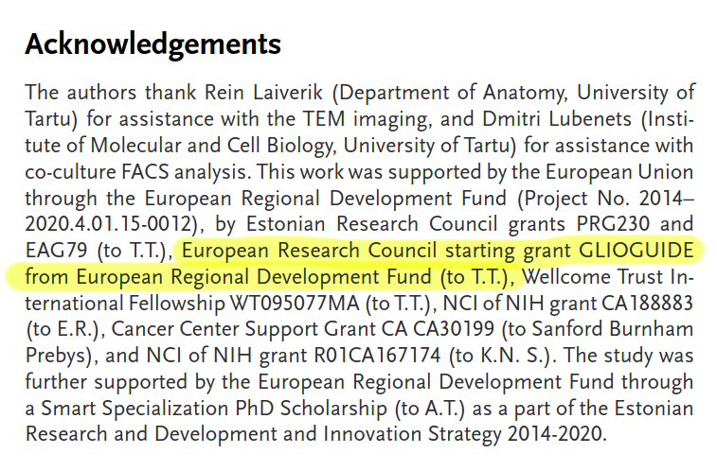

---

Nucleic Acids Research, 2021, Vol. 49, No. 7 e38

doi: 10.1093/nar/gkaa1279

https://academic.oup.com/nar/article-pdf/49/7/e38/37123769/gkaa1279.pdf

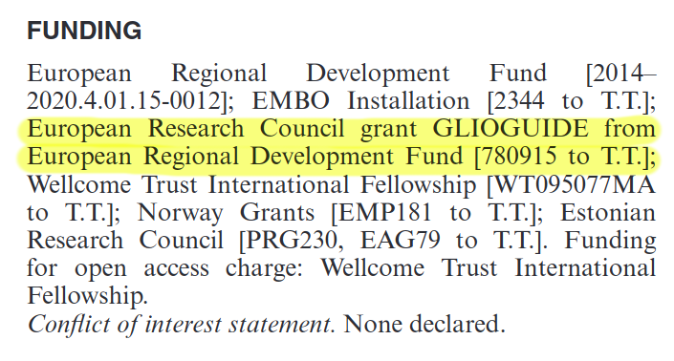

---

A phage display derived peptide binds to human CD206 and modeling reveals a previously untargeted binding site in the receptor

Eliana K. Asciutto, Sergei Kopanchuk, Anni Lepland, Lorena Simon Gracia, Carlos Aleman, Tambet Teesalu, Pablo Scodeller

<https://upcommons.upc.edu/bitstream/2117/172370/1/manuscript_muno_v15tt_ea.pdf>

