Faking Global Illumination on the GPU

# Reflection & Refraction

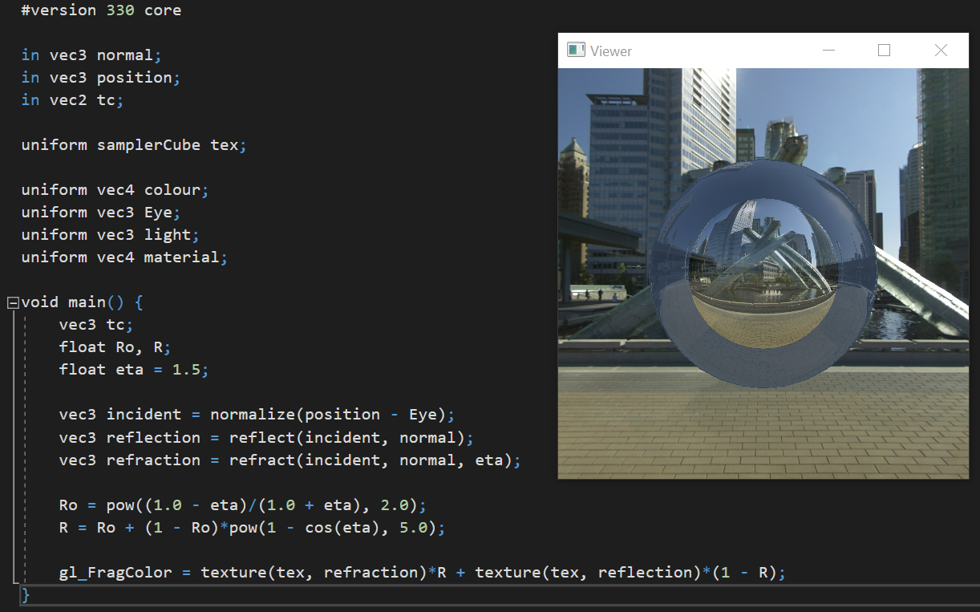

I applied Schlick’s approximation to the fragment shader code (example10.fs) to calculate the approximate Fresnel reflection. First, find the reflectance at , where light is going straight at the surface. To do this, use the refractive indices of air, 1.0, and glass, 1.5. Then find the specular reflection coefficient, R.

Next, I apply the texture to the fragment shader. Use textures from the refraction vector and the reflection vector. This creates an inner sphere for refraction and an outer sphere for reflection. The sum of the two textures defines the colors of each pixel on each sphere. As a result, the outer sphere comes out more opaque than the inner sphere.

# Diffuse Reflection – Part 1

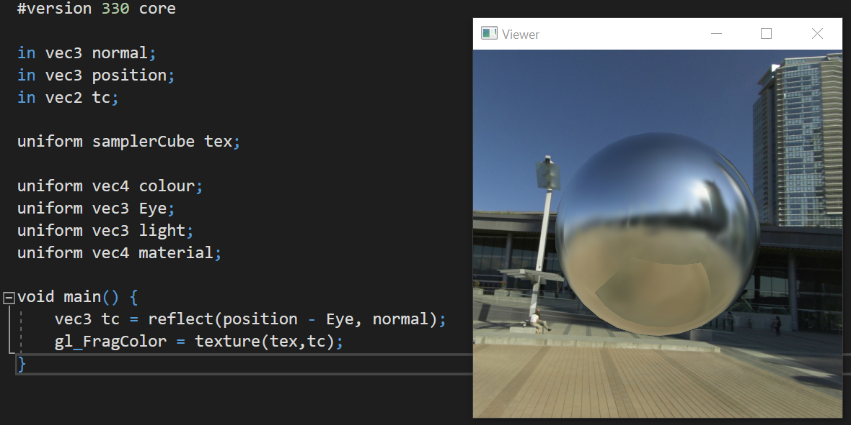

I reverted all changes made in the fragment shader back to its original code. I created a new folder in the VancouverConventionCentre directory to store the blurred images. In the viewer.cpp code, I then create a new environment map, blurMap, and load it in the same way you load in the environment map envMap.

I also created a new texture, blurred, which would be the texture for the irradiance map. First, call glGenTextures and glBindTextures to create textures on the blurMap. Iterate through each image in the VancouverConventionCentre/blurred directory and assign each image to the blurred texture and set the texture parameters for the blurMap. The blurMap has now been loaded. Afterwards, in the display method bind irradiance map to the blurMap using glBindTexture.

# Diffuse Reflection – Part 2

Unfortunately, this section is incomplete…