CS388 Final Project: Pandemic! GDD

**Game Concept:** Top Down physic-based game in which you shoot a ball thought other balls in the level and your goal is to “infect” every ball in the screen in order to pass it to the next stage.

-you will need to manage the possible ability button in order to easily infect the other balls.

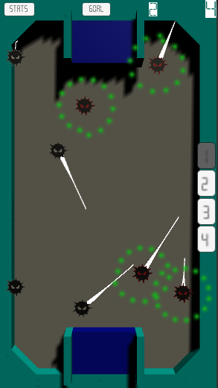**Main Mechanics:** The player has two main shoot per level with a direction and a force.

-You can use **abilities** (that can be used only one time per level),

each ability will boost the player shoot and adding advantages for the infection.

**List of Abilities:**

**-Mutant Virus**

the infection aura around the ball has been increased, easily infections between the balls.

**-Save the Economy**

the balls move faster in all directions compulsively.

**-Socially Irresponsible**

the balls attract each other, making the infection by contact easier.

**-Panic Shopping**

the balls tend to go to the store to buy for a while, making it easier for the player to shoot them in the same area.

**Win Condition:** Infect all the balls of the level before it goes out of time.

**Loose condition:** remain any ball in the level as not infected.

**Hud / Panels:** visual information for the player, showing the remaining time on the level to finish it, the goal, and stats about infections.

**Hook Points:** Since **COVID_19** is trendy at this time, so we want to focus on the infect effect + **physic-based game** with balls.

**Public:** Mostly focused on casual player + Whales

**Monetization plan:** Adds + Extra Life for trying again a Level.

**Reference Images of Gameplay:**

