 |  | ASSIGNMENT COVER SHEET  Electronic or manual submission  Form: SSC-115-07-06

UNIT  Code: ENS1161  TITLE: Computer fundamentals | NAME OF STUDENT (PRINT CLEARLY)  Ponce Martin  FAMILY NAME FIRST NAME | STUDENT ID. NO.  10371381
NAME OF TUTOR (PRINT CLEARLY)  Wlodzimierz gornisiewicz |  | DUE DATE  3-OCT-14

Topic of assignment
assignment 2
Group or tutorial (if applicable)  Wlodzimierz gornisiewicz | Course  u67 bachelor of information technology | Campus  es
I certify that the attached assignment is my own work and that any material drawn from other sources has been acknowledged.  Copyright in assignments remains my property. I grant permission to the University to make copies of assignments for assessment, review and/or record keeping purposes. I note that the University reserves the right to check my assignment for plagiarism. Should the reproduction of all or part of an assignment be required by the University for any purpose other than those mentioned above, appropriate authorisation will be sought from me on the relevant form. |  | OFFICE USE ONLY
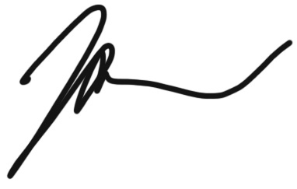
If handing in an assignment in a paper or other physical form, sign here to indicate that you have read this form, filled it in completely and that you certify as above.

Signature Date 21-SEPT-14
OR, if submitting this paper electronically as per instructions for the unit, place an ‘X’ in the box below to indicate that you have read this form and filled it in completely and that you certify as above. Please include this page in/with your submission. Any electronic responses to this submission will be sent to your ECU email address.
Agreement x Date 21-SEPT-14

PROCEDURES AND PENALTIES ON LATE ASSIGNMENTS

Admission, Enrolment and Academic Progress Rule 24(6) and Assessment Policy
- A student who wishes to defer the submission of an assignment must apply to the lecturer in charge of the relevant unit or course for an extension of the time within which to submit the assignment.
- Where an extension is sought for the submission of an assignment the application must :
- be in writing - preferably before the due date; and
- set out the grounds on which deferral is sought.
- Assignments submitted after the normal or extended date without approval shall incur a penalty of loss of marks.

Academic Misconduct Rules (Students)
All forms of cheating, plagiarism or collusion are regarded seriously and could result in penalties including loss of marks, exclusion from the unit or cancellation of enrolment.
- - - - - - - - - - - - - - - - - - - - - - - - - - - - - - - - - - - - - - - - - - - - - - - - - - - - - - - - - - - - - - - - - - - - - - - - - - - - - - - - - - - - - - - - - - - - - - - - - - - - - - - - - - - - - - - - - - - - - -

ASSIGNMENT RECEIPT To be completed by the student if a receipt is required (not normally given)
UNIT | NAME OF STUDENT | STUDENT ID. NO.
NAME OF LECTURER |  | RECEIVED BY
Topic of assignment |  | DATE RECEIVED

