Sample Business Rules Diagrams

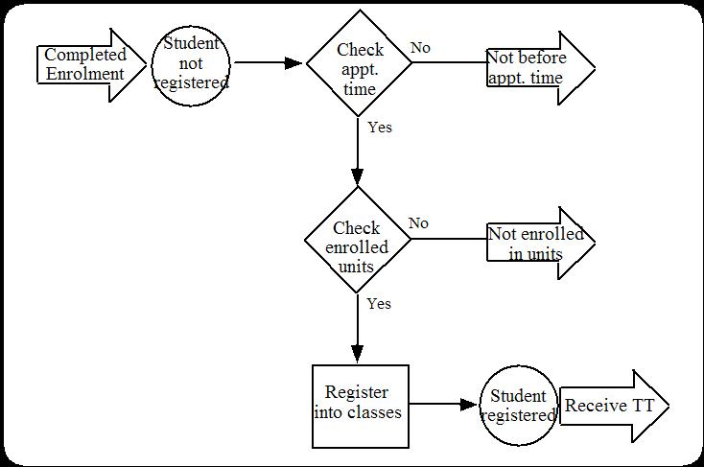
Student Enrolment

Side bar - Use of the Harel Blob

1. Simultaneous action - all constructs in the blob will occur or none of them

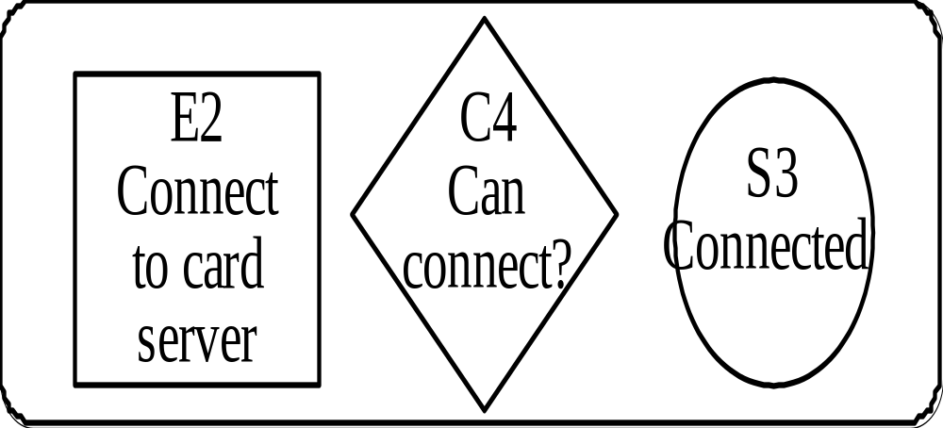

2. Selection - only one of the constructs in the blob is selected

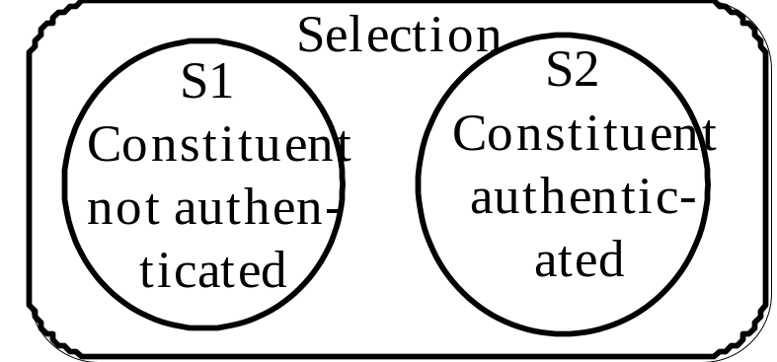

2a. Often a business may wish to perform an event but the event may potentially fail (similar to alternate courses of action in an elaborated use case). One way to model this situation is:

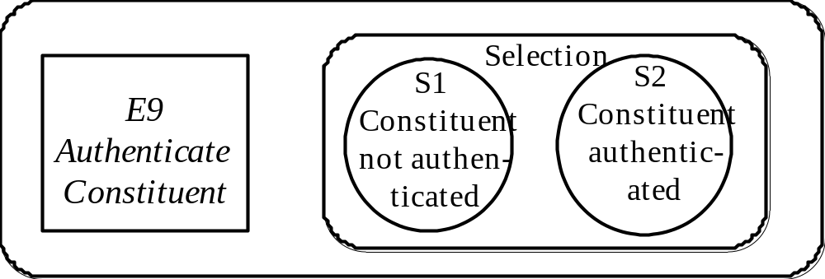

E-Journal Publishing

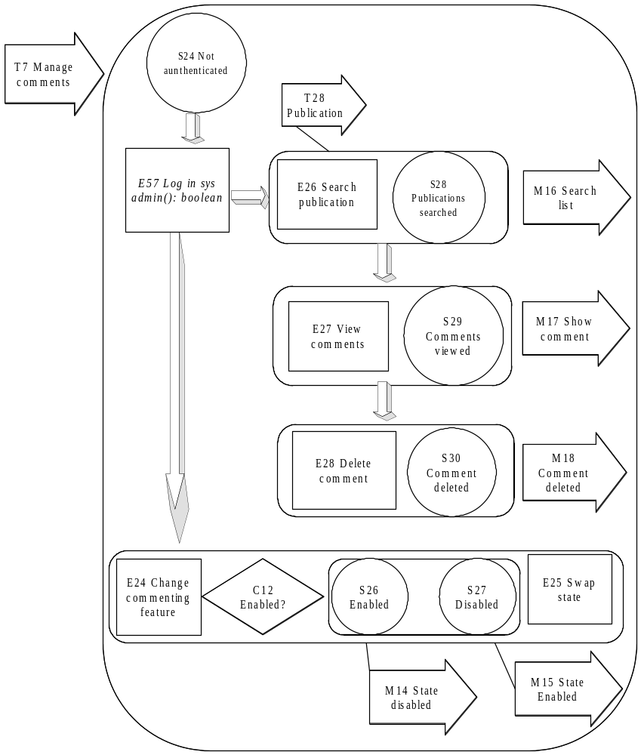
A Feature of a Digital Library

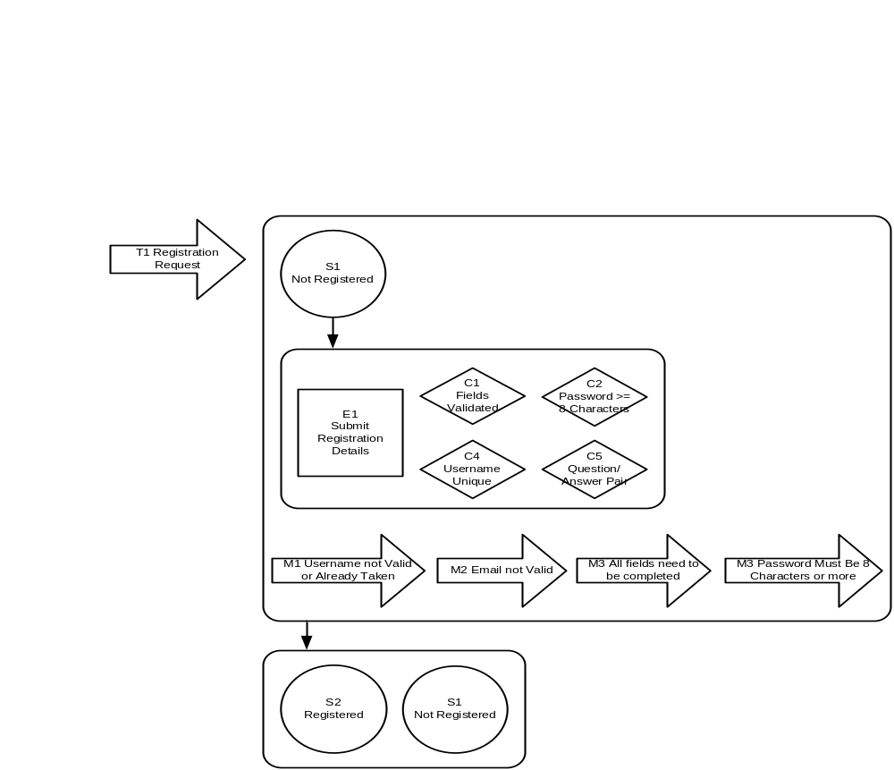
Creating User Accounts for an E-commerce System

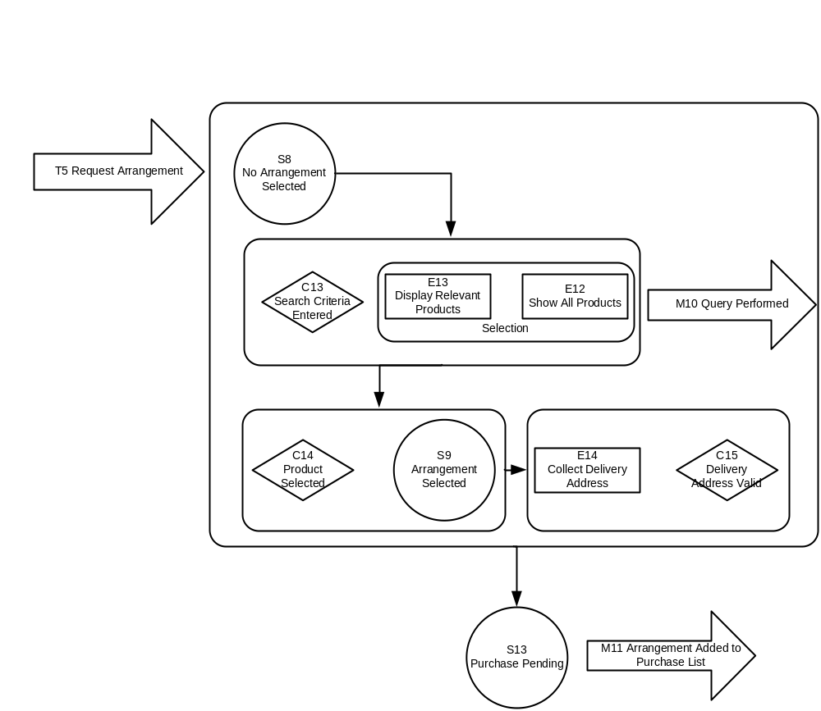
Choosing a Flower Arrangement

