
CSG1102 – Operating Systems

Workshop 01 – Getting Started with Schedulers

Background
During the semester we will be experimenting with different schedulers. In order to accomplish this task it will be your job to translate pseudo code examples into actual programming code that simulates various scheduling algorithms. During this first workshop the task will be guided and all code provided. You should step through the task and ensure you are able to complete it.

The first step is to examine the provided pseudocode. The code provided below is for a shortest job first CPU scheduler.

// create job type
job type = [id, cpuReq, jobState]

// create jobs
job1 = 1,14,Inactive
job2 = 2,7,Inactive
job3 = 3,19,Inactive

// create our run queue
create runQueue

// add jobs to run queue
add job1 to runQueue
add job2 to runQueue
add job3 to runQueue

// Start Scheduler
while job remain:

shortestJob = find shortest remaining job
shortestJob.jobState = active

// run job while it still needs time
while shortestJob.cpuReq > 0:
print time
print runQueue
shortestJob.cpuReq = shortestJob.cpuReq - 1

// remove job from run queue
runQueue.remove(shortestJob)

print "programs done"

Task
It is your task during this workshop to take the provided code and experiment with it in order to test the functionality of the shortest job first scheduler and ensure you have the environment working correctly.

Step 1. Download the Portable Python installer for your operating system from portablepython.com

Step 2. Install Portable Python, if you are using a lab computer then your desktop is a good location to install to.

Step 3. Open PyScripter-Portable.exe
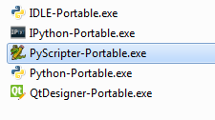
Step 4. Open the “module1.py” file in this week’s materials

Step 5. Press run to begin the program execution.
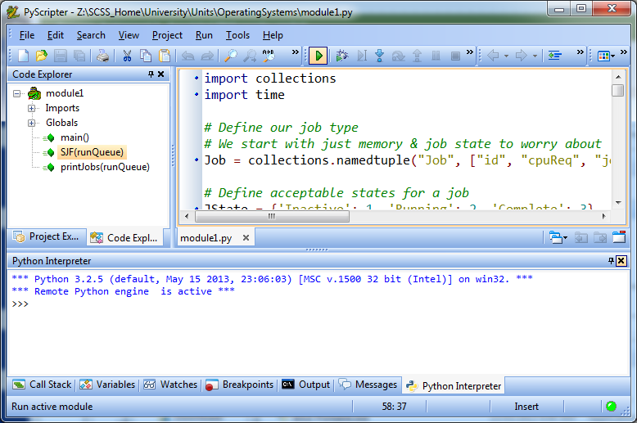

Step 6. Experement by adding additional jobs to the run queue.

Step 7. Compare the provided code to the pseudocode and think about how you might implement other algorithims.

