GitHub: https://github.com/martysiaklak/simulation
To start with, let’s recall a process-based modeling approach that we defined in the first assignment.
- Active processes → Patients (they have their own life cycle).
- Passive resources → Prep rooms, surgery theatre, recovery rooms.
- Semaphores/Resources → These handle queuing and capacity.
Active entity: Patient(i)
Passive resources: PrepRoom(P), OperatingTheatre, RecoveryRoom(R)
Main controller: simulation clock + patient generator
Patient Life Cycle
Each patient follows a defined sequence of actions during the simulation.
The ordered steps of the patient life cycle are:
- Arrival – The patient enters the system at a time determined by the inter-arrival distribution generated by the Patient Generator. The process becomes active when created and starts executing its lifecycle.
- Preparation – The patient requests one of the available preparation facilities.
  - If all are busy, the process passivates and waits in the preparation queue until a facility becomes available.
  - Once granted, the process holds for a random duration PrepTime[i], representing the pre-operative procedure. After completion, the preparation facility is released.
- Operation – The patient requests access to the operating theatre.
  - If it is occupied, the process passivates in the surgery queue.
  - When the theatre becomes available, the process holds for a stochastic duration SurgeryTime[i], representing the operation time.
- Transfer to Recovery – After surgery, the patient attempts to move to a recovery bed.
- If all recovery beds are occupied, the patient joins the recovery queue and waits in operation theater until a bed becomes available.
- During this time, the operating theatre remains blocked, as the operated patient cannot be released. The theatre process passivates until recovery capacity becomes free.
- When a recovery bed becomes available, the patient is activated, leaves the queue, and is transferred to recovery.
- The patient occupies a recovery bed and holds for a random recovery duration RecoveryTime[i]. After this period, the recovery resource is released.
- Discharge – The patient completes the process, terminates its lifecycle, and the performance metrics (throughput time, blocking time, and resource utilisation) are recorded.
Throughout the simulation, the Hold–Activate–Passivate paradigm governs the control flow of all processes:
- Hold(t) corresponds to waiting for a defined time period (e.g., service time). Wait for time t
- Activate() starts or reawakens a process when resources become available. Start process (next patient)
- Passivate() suspends a process when it must wait for a resource or condition to be fulfilled. Wait until resources are available
In the implementation phase, each hold(t) corresponds to env.timeout(t) in SimPy, while activation and passivation are represented by process scheduling and resource requests/releases within the simulation environment.
Parameter | Meaning | Example Value | Distribution / Note
InterArrivalTime | Mean time between arrivals | 25 | Exponential
PrepTime | Average preparation duration | 40 | Exponential
SurgeryTime | Average surgery duration | 20 | Exponential
RecoveryTime | Average recovery duration | 40 | Exponential
P | Number of preparation rooms | 3 | Fixed
R | Number of recovery rooms | 3 | Fixed
OperatingTheatre | Single surgery room | 1 | Fixed
QueueCapacityPrep | Max prep queue length | ∞ | Fixed
QueueCapacitySurgery | Max surgery queue length | ∞ | Fixed
QueueCapacityRecovery | Max recovery queue length | ∞ | Fixed
SimulationDuration | Total simulated time | 500 | Fixed
MonitorInterval | Time interval between monitoring snapshots | 10 | Fixed
Seed | Random number generator seed | 42 | Fixed

In the baseline model, all queues are assumed to have unlimited capacity. This ensures that no patients are rejected from the system and all arrivals are eventually served. Consequently, system congestion is only caused by limited service capacity in the preparation, operation, and recovery phases. In future experiments, the queue capacities may be restricted to study the effects of patient rejection and limited buffer space. Also, in the future extensions there will be multiple patient types (light/severe) with different average times.
Simulation Outputs (according to the assignment requirements)
The main simulation outputs are:
- Average queue length at the entrance – the mean number of patients waiting for a preparation room. This indicator reflects congestion before the preparation stage and helps assess whether the number of preparation facilities (P) is sufficient.
- Utilisation of the operating theatre – the fraction of time the operating theatre is occupied. This measure reflects how efficiently the theatre is used and serves as the main performance target (around 90 % utilisation in the optimal configuration).
In addition, our implementation extends the monitoring process to collect further statistics:
- Average queue lengths for all stages (preparation, surgery, and recovery), allowing identification of possible secondary bottlenecks.
- Average utilisation of all resources (preparation rooms, operating theatre, recovery beds) to evaluate system balance and efficiency.
- Time-series snapshots of all monitored variables taken every fixed interval, which are saved in monitor_results.csv for detailed analysis and visualisation.
- Aggregate summary statistics (e.g., mean utilisation and queue lengths) saved in summary_results.csv, enabling easy comparison between different parameter configurations.
- Individual patient total time in system, printed during execution to provide insight into throughput and waiting-time variability.
These extended outputs allow the simulation to be used not only for basic validation but also for experimentation and optimisation, such as testing how different values of P, R, or interarrival time affect bottlenecks and resource utilisation.

Simulation model development
In this part of the project, we developed the main simulation model using SimPy, following the process-oriented approach introduced in the first assignment.
The system consists of P preparation rooms, one operating theatre, and R recovery rooms, each represented as a passive resource with limited capacity.
Patients are modeled as active processes that move sequentially through these stages—preparation, surgery, and recovery—each with their own individual service times.
This design allows easy future extensions, such as introducing multiple patient types with distinct service-time characteristics.
1. Selection of simulation environment
SimPy was chosen because it natively supports the process-based worldview, which includes active entities (patients), passive resources (facilities), and resource control using semaphores.
Its coroutine-based syntax (yield env.timeout(), resource.request()) naturally represents the hold–activate–passivate behavior described in lectures.
2. Patient generator with individual service times
The patient generator continuously creates patient processes according to an exponential interarrival distribution.
Each patient samples its own random preparation, surgery, and recovery times from exponential distributions defined by the assignment parameters.
These parameters are stored in functions (prep_time(), surgery_time(), etc.) for easy modification and reuse.
3. Sequence of service pools
The model implements a chain of service pools:
- Preparation: a pool of P rooms
- Operation: a single operating theatre
- Recovery: a pool of R recovery beds
Patients pass through these resources without intermediate buffers, meaning that downstream unavailability causes the current stage to block—exactly as required in the assignment.
4. Request–Hold–Release logic and blocking handling
Each patient follows the request–hold–release paradigm implemented via SimPy’s with resource.request() construct.
If the next resource is busy, the process waits (blocks) while still holding its current resource, ensuring that:
- a preparation room remains occupied until the operating theatre becomes available, and
- the operating theatre remains blocked until a recovery bed is free.
This mechanism accurately reproduces the required blocking behavior between consecutive stages.
5. Flexible parameterisation
All model parameters—including interarrival time, service-time means, number of preparation and recovery rooms, and total simulation duration—are placed at the top of the code.
This structure allows easy testing of alternative configurations in future experiments.

Monitoring approach
To evaluate the system’s performance, a monitoring process was implemented in the simulation model.
The monitor runs as a continuous SimPy process (while True loop) that periodically collects snapshot values of key performance indicators every 10 simulation time units.
At each interval, it records:
- Queue lengths at the preparation, operating, and recovery stages
- Current utilisation of each resource (number of busy units divided by total capacity)
This approach corresponds to the approximate monitoring method described in the assignment instructions — it provides averaged behaviour over time without manually tracking every individual event, offering a good balance between accuracy and simplicity.
Collected data
During the simulation, the monitoring process produced two types of output:
- Time-series data (monitor_results.csv)
Includes queue lengths and resource utilisation measured periodically.
These data were later used to generate performance plots using Matplotlib.
- Summary statistics (summary_results.csv)
Contains averaged metrics across the full simulation run:
  - Mean queue lengths for each stage
  - Mean utilisation rates (%) for all facilities
The collected data allows both dynamic and aggregate performance analysis.
Results overview
Metric | Value
Avg preparation queue length | 1.68
Avg theatre queue length | 1.04
Avg recovery queue length | 0.00
Avg utilisation of preparation rooms | 79.3%
Avg utilisation of operating theatre | 84.0%
Avg utilisation of recovery rooms | 15.3%
Table 1. Summary of performance metrics
The monitoring results show that the operating theatre is the main bottleneck of the system, with an average utilisation of 84% and an average queue length of about one patient. Preparation rooms are moderately loaded (79% utilisation), while recovery facilities are underutilised (15%), indicating that the recovery capacity exceeds the current patient flow. No significant blocking at the recovery stage was observed, as the queue length remained near zero.
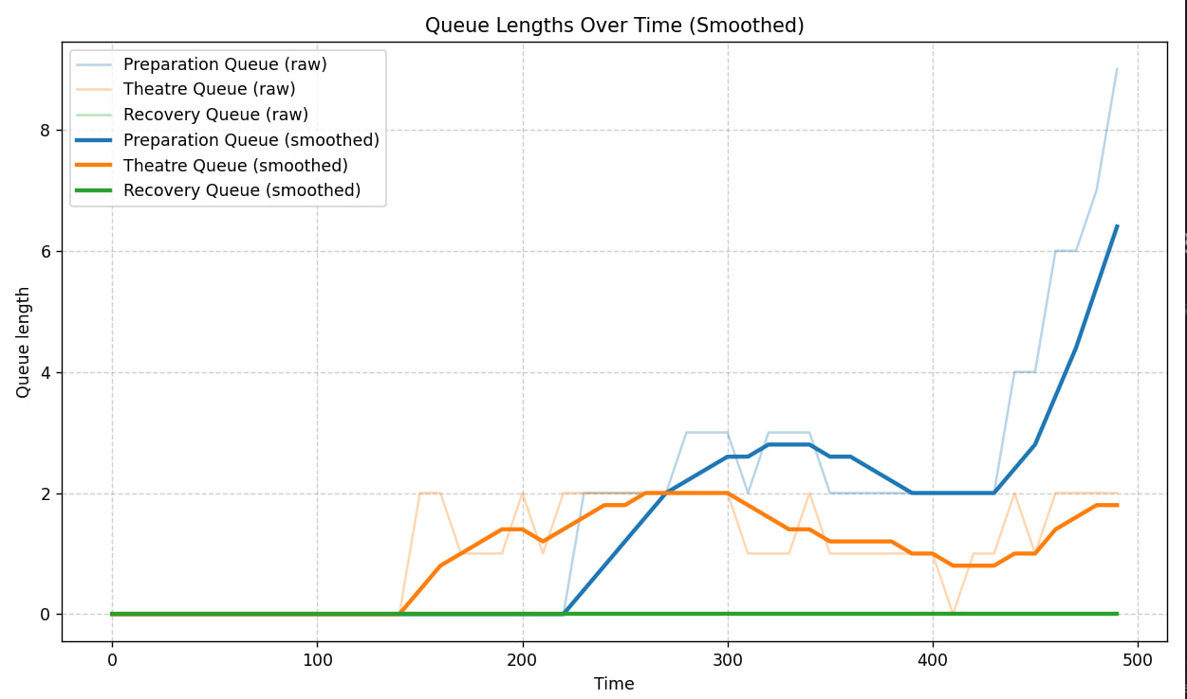
Figure 1. Queue lengths over time (smoothed)

Queue length behaviour
The queue length plot (Figure 1) illustrates how the number of waiting patients evolves during the simulation.
The preparation queue grows steadily over time, indicating that the preparation phase occasionally becomes a bottleneck as patient inflow exceeds processing capacity.
The theatre queue remains moderate, oscillating between one and two patients, while the recovery queue is nearly flat at zero, showing that the number of recovery beds is more than sufficient.
Interpretation:
The preparation phase experiences moderate congestion, while the recovery phase is underutilised.
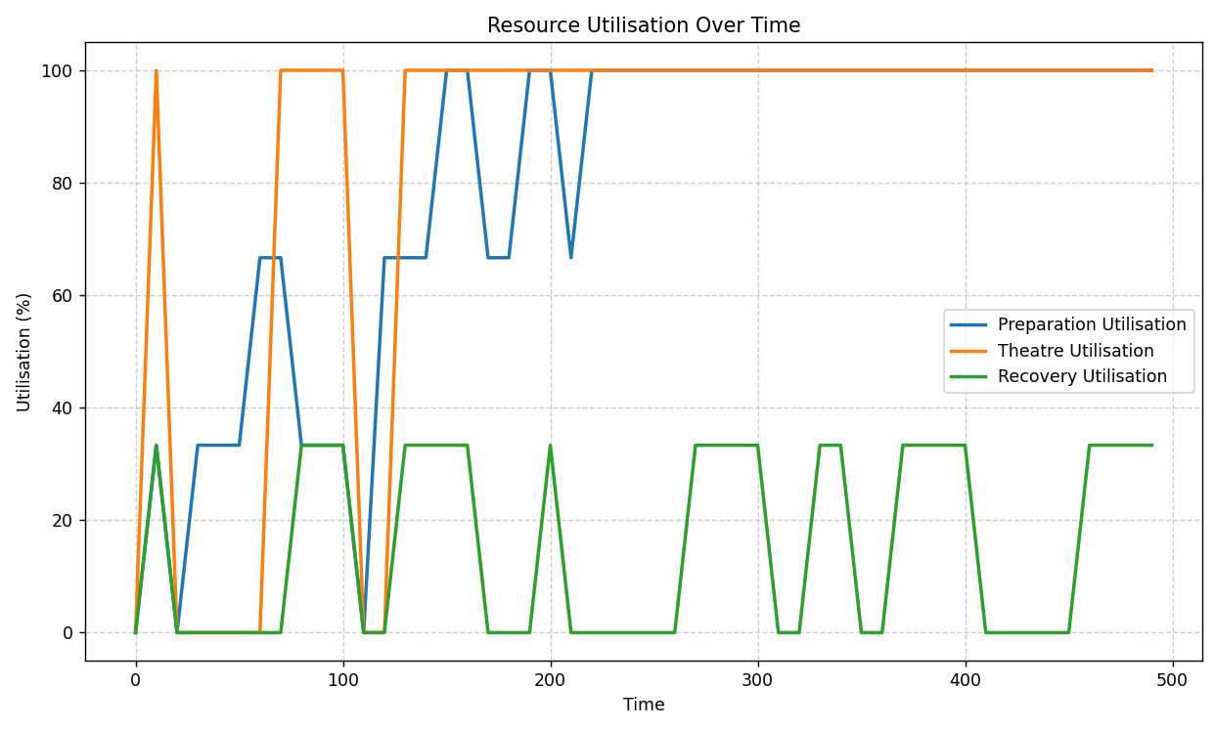
Figure 2. Resource utilisation over time
Resource utilisation
Figure 2 presents the utilisation of each facility.
The operating theatre works close to its maximum capacity (near 100%) throughout the simulation, confirming it as the critical bottleneck of the system.
Preparation rooms operate at around 70–80% utilisation, showing efficient but not saturated use.
Recovery beds, however, remain idle most of the time, with utilisation averaging only 15%.
Interpretation:
The system’s throughput is limited by the single operating theatre, while recovery resources are oversized relative to demand.
Overall insights
The monitoring results provide a clear understanding of system performance dynamics:
- The operating theatre is the main bottleneck due to continuous full utilisation.
- Preparation facilities handle patient inflow efficiently but accumulate moderate queues.
- Recovery resources are underutilised and could be reduced without affecting overall throughput.
In future experiments, balancing resource capacities (e.g., adding another theatre or reducing recovery beds) could improve overall performance and resource efficiency.

