The Ultimate Guide to Sipping Tea Ш. И. Р.

**Brief Brexit reminder :**

**(2016: referendum: 52% OUT vs 48% IN**

**(2016-2020: deal-no deal? Out date postponed over and over again**

**Dec 24th 2020: UK/EU deal**

**Dec 31st 2020/Jan 1st 2021: UK out)**

**A)** **The United Kingdom of Great Britain and Northern Ireland**, or the **U.K.** for short. (since 1927 ~~United Kingdom of Great Britain and Ireland)~~ <- coined to recognize in name the Independence of the **Irish Free State** (1922).

The inhabitants of **the UK** = **Britons**  (**Breton**, from **Brittany** in France).

**British** by nationality

**B)** **The British Isles** = geographical term for the group of islands in Western Europe:

* Ireland, Great Britain, the islands of Wight and Anglesey, the Isle of Man, the Hebrides, the Orkney Islands, the Shetland Islands, the Channel Islands, the Scilly Islands

**C)** **Great Britain** is both a geographical and political designation.

* Largest island in the British Isles
* Separated from the mainland of western Europe by the **English Channel** and the **North Sea**.
* Separated from Ireland by the **Irish Sea**, the **North Channel** and **St George’s Channel**.
* Separation: 6, 000 BC
* **Great Britain** = **England** + **Scotland** + **Wales**.

**D) England**

* Largest division of Great Britain
* Kingdom since the 9th century.
* 1649-1660: **The Commonwealth of England**.

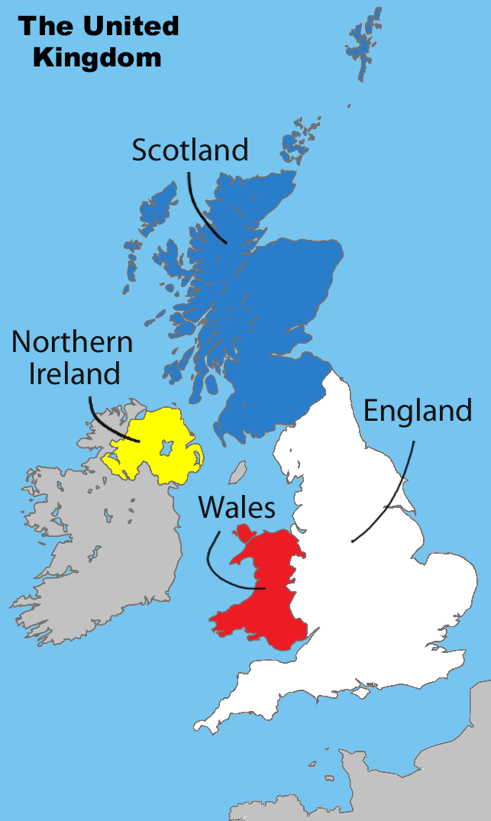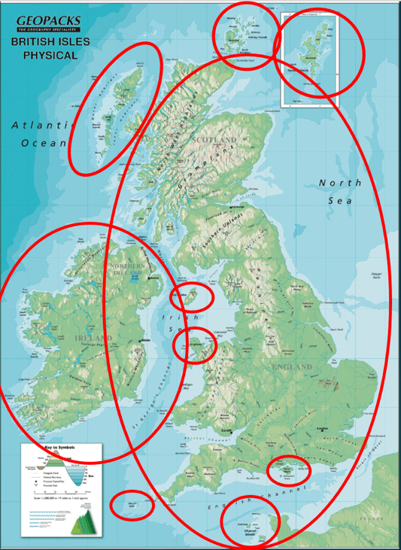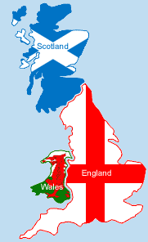

Kingdom since the 9th century,

Only exception to the monarchy = Oliver Cromwell (Lord Protector), Cromwell was one of the signatories of King Charles I's death warrant in 1649, during the civil war between the monarchists and the Republicans. After the king’s death he was defacto the ruler + there was the parliament. After his death in 1660 the prince/son of the King Charles I returned to power (Charles II). It was the parliament’s decision to give the prince the status of an official King.

**E) Scotland**

* North of Great Britain.
* 1603 : Union of the Crowns (James VI of Scotland was the first king with both titles)
* 1707: Union of parliaments

**F) Wales**

* West of Great Britain.
* Principality
* 1277-1283: conquest by English king Edward I
* 1536: Parliamentary union

I) Ireland

* 16th and early 17th centuries: conquest
* Dependency + colonization
* 1801: Union with Great Britain -> UK
* 19th century: unionists vs nationalists

**a) Northern Ireland**

* Very complex <- ethno-nationalist conflict for several decades
  + Unionists vs Nationalists (now : Democratic Unionist Party aka DUP vs. Sinn Féin)
  + Protestants vs Catholics
  + Paramilitary fights Black and Tans vs. IRA

= Civil War & Troubles

* + Very long peace process with help from the EU and the US in the 80s and 90s
  + Good Friday Agreement (/Belfast Agreement) on April 10th 1998.
* Now described as a country, a region or a province.
* Ulster = nickname of Northern Ireland and was one province before the division
* **1461**: Ulster passed to the English crown.
* **1921**: partitioned into the six counties of Northern Ireland **and** the Ulster province of the Republic of Ireland.

**b) The Republic of Ireland**

* Most of Ireland.
* - 1916 : **Easter Rising**
* - 1919 Declaration of Independence (unilateral) => **Irish Republic:** revolutionary state (**1919-1922**)
* - December 1922 the entire island => self-governing Dominion (= a semi-independent state) : **the Irish Free State** (*Saorstát Éireann*, **1922-1937**) .

- Still part of the Commonwealth.

- Irish Civil War (1922-1923)

* - 1937 : New Constitution and new name : **Éire**
* - 1949 : **full independence** as a **Republic**, out of the Commonwealth
* - 1973 : joined the **EEC** (former EU).
* Organisation: President (representation only) + Taoiseach & Tánaiste

|  |  |  |
| --- | --- | --- |
| Parts of the UK | State symbol part of the Union Jack | Capital |
| England | St George's cross | London |
| Scotland | St Andrew's Cross | Edinburgh |
| Northern Ireland | St Patrick's Cross | Belfast |
| Wales | N/A | Cardiff |

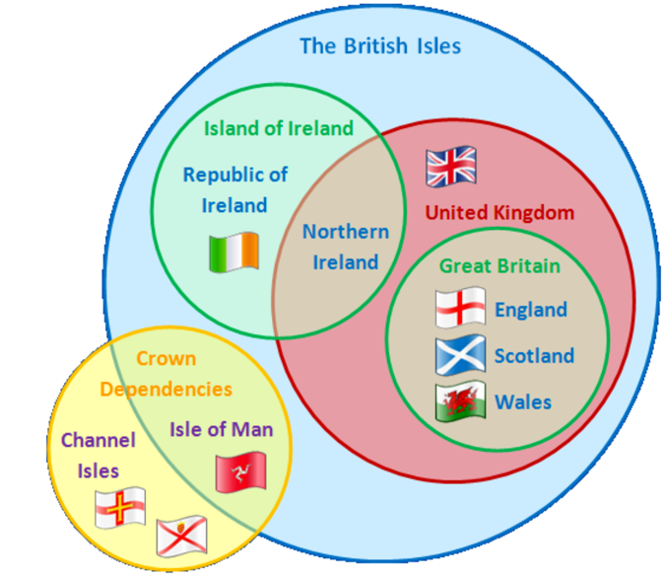

The **U.K.**

* + member of the United Nations & former member of the EU (since Jan 1st, 2021)
  + one single and unitary **state (land with a sovereign government)**
  + constitutional monarchy
  + Queen = symbol of this state.
* **A) Population**

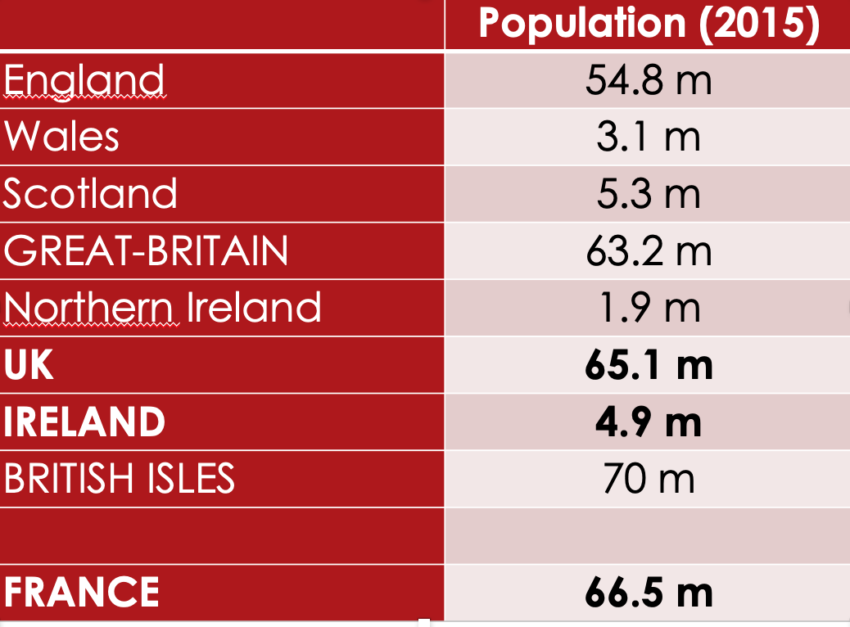

* No longer only WASP (White Anglo Saxon Protestant)
* Great diversity of culture thanks to various

Migration processes and waves

* + Sadiq Khan (current mayor of London of Pakistani descent)

Early settlement:

* 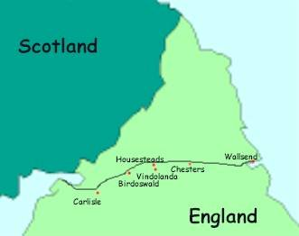500 BC: Migration from the Celts (warrior peoples ex. Picts and Scotti)
* Roman invasion (300 AD)
  + Pushed the Celts in Ireland, Wales and Scotland
  + Local resistance (Picts)
* Vestiges = Hadrian’s Wall (Separated the Romans and

the tribes in the north)

* 5th century: final Roman withdrawal
* Invasion by Angles, Saxons and Jutes (Germanic tribe) from Northern Europe.
* Raids and settlements by Vikings from Scandinavia.
* 1066: Duke William of Normandy defeated the English at the battle of Hastings.
* Spread of French culture, first survey conducted (Doomsday book), construction of castles, religious influence
* Last four centuries: religious persecution, economic hardship, or political considerations => other immigration waves
* Protestants/Jews
* Irish people (poverty, famines)
* 20th century, immigration from the old Empire and the Commonwealth
* 1948: arrival of the Empire Windrush -> Immigration from the west indies (Carribian Isles)
* British multiculturalism (sadly not deprived of tensions/xenophobia and racism. Cf pro-Brexit campaigns for instance)

Language spread:

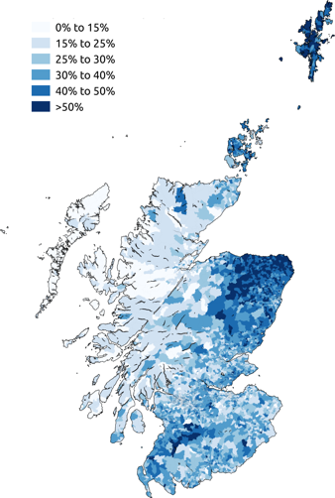Scots Welsh Gaelic Irish Gaelic

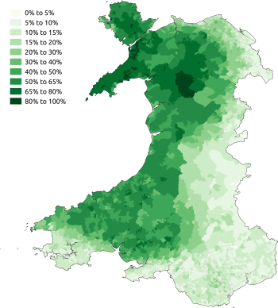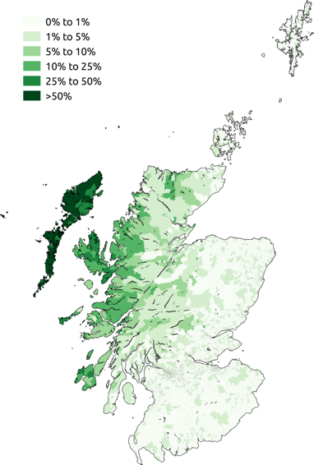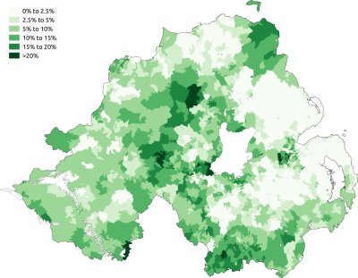

**B) Language**

* Official language of the U.K. = English
* Some other languages
* Celtic groups.
* **Scotland** = Scots (South & Midlands)+ Gaelic (Highlands and islands)
  + As of 2020, about 1 million Scots speakers (over 5.46 million people)
  + 57,000 fluent L1 and L2 Scottish Gaelic speakers (2011)
  + Neither is an official language
* **Wales** = Welsh language (//Breton)
  + From 30% in 1890 to 2% in 1950
  + 2020: ~29% Welsh people said were able to speak Welsh + ~16% speak Welsh daily.
  + 1967 Welsh Language Act: gave some rights to use  Welsh  in legal proceedings. Cf *Sianel Pedwar Cymru* (S4C) TV station.
  + The Welsh Language Measure (2011): Welsh language given official status in Wales (both the Welsh language and English official languages of the Senedd Cymru/Welsh Parliament)
  + The Welsh government plans to have 1 million Welsh language speakers by 2050.

Institutions and London

* London borough
  + west central London
  + the Houses of Parliament
  + Buckingham Palace
* The two Houses of Parliament (the House of Commons and the House of Lords) are located in the Palace of Westminster
* The parliamentary system is known as the Westminster model:
* A head of state: the monarch
* A head of  Government: the Prime Minister
* An elected Parliament, with one or two Houses
* Separation of powers between the three branches of government:
  + The **Legislature** (Parliament)
  + The **Executive**
  + The **Judiciary**

**Constitutional monarchy**?

* The British constitution is uncodified
* Magna Carta (1215), first document that gave rights to the population, signed by King John to make peace with the nobility and obliges the monarch to respect the law
* Bill of Rights (1689), it was written after King James who tried to rule without the agreement of Parliament, after he was deposed, Parliament felt like they had to write a document to stop future rulers from ruling on their own. It enforces the power of Parliament, it asserted some rights to Englishmen (a fair trial)
* + customs, tradition and precedents (case law)
* The sovereign reigns but does not rule.
* **Monarch is ‘advised’ by the government**
  + Opens parliamentary session
  + Dissolves parliament
* Bill -> law : Approval of the Queen, **House of Commons** and the **House of Lords** required.
* In practice, parliament is supreme.
  + Royal assent = approval of a law by a monarch is now automatic

**Legislative power**

* **Bicameral legislature.**
  + **House of Commons** (lower chamber)
  + **House of Lords** (upper chamber).
* **House of Commons** (lower chamber)
* 650 **Members of Parliament (MPs)**
* Elections:
  + Every 5 years
  + 1 MP/ constituency
  + First-past-the-post system
  + Today, the Conservative party has a majority, followed by the Labour party
  + MPs roles:

- Consider and propose new laws

- Scrutinize government policies: they ask questions to the members of government, the check and challenge the government and what they do.

* In the House of Commons there is only a place for two parties not like in France. Some people think that Britain is a two-party system.
* In the 20th century, the UK was a two-party system, with the conservatives and the liberals: Conservative party (Tories) and Labor Party.

**House of Lords**

* Not elected!
* Inherit the title from your parent = **hereditary peers**
* House of Lords Act of 1999
  + 1,330 Lords => ~ 760.
  + Most lords now appointed by the Prime Minister /House of Lords appointment commission = **life peers**
* Bishops (26)
* The Lord's role is to make and shape laws. They also check and challenge the work of the government.

Main political parties

The English parliament = oldest in the world (**1265**)

* Before the late 17th century, no political parties (members of parliament = aristocrats and wealthy men)
* Exclusion Crisis (1679-1681) divided Parliament => most members formed into two parties, the **Whigs** and the **Tories**.

Tories: Rural areas, Strong monarch, Defense of royal absolutism, Passive obedience, no resistance = Monarchists, traditionalists

* + 1850s: the **Whig Party** => the **Liberal Party**.
  + 1989: the Liberal Party => **Liberal Democrats.**

Whigs: Urban areas, Strong legislative power, Defense of Parliament power, Resistance, right to overthrow ruler = Liberalists, reformers

* + 1834: the **Tory Party** => the **Conservative Party (unionist)**
* After WWI = **Labour Party**.
* 1929: **Labour** first majority.

= took over the Liberals as alternative to Conservatives

* Rise of **Labour** = consequence of major changes in society at the time
* After that, 2 (3?) main parties and not much change on the political stage in the 20th /early 21st centuries

Current political landscape:

* **Conservative (and unionist) Party** 
  + British Party of the right, Free market, Law & order /Moral values (family and work), Headed by Boris Johnson since July 2019
  + Some major differences of opinions : wide political scope
    - Neoliberalists vs social conservatists
    - Eurosceptic vs Eurofriendly

**Labour Party**

* Left wing politics (socialism / link with trade unions)
* **Tony Blair**’s leadership (1997-2007) = centre-left (**New Labour**).
* **Jeremy Corbyn** (2015-2020) = return to core leftist, socialist values.
* **Keir Starmer** (2020-?) = ‘soft left’ / ‘red-green’ Labour

**Liberal Democrats** (**Lib Dems**)

* + party of the centre
  + Most pro-European
  + 2010-2015: coalition with the Conservatives (Nick Clegg)
  + Co-headed by Ed Davey since August 2020

Pre 2016 : Controversy over immigration => Rise of the **UK Independence Party** (**UKIP**)

Political programme besides EU-bashing and xenophobia = ??/non-existant

**UKIP & Post-Brexit referendum :**

- Nigel Farage out (Current leader : Neil Hamilton, by interim)

* Huge party crisis
* 0.1% votes in the Dec 2019 General election = lowest rate ever

Currrently has no seats anywhere, not even in the European Parliament

Whitehall = name of a street, south of Trafalgar Square -> refers to the British government depts / executive power

10 Downing Street = The Prime Minister

**Prime Minister** = **head of the government** ("Ministry")

* Appointed by the **sovereign**
* Appoints:
  + - 22 senior ministers (= the Cabinet)
    - 98 junior ministers

= 120 ministers

The members of government also sit in the House of Commons, they are MPs. This lead people to make a difference between the front-benchers (members of government) and back-benchers (not members of the government).

The City = Financial district of London, located in the ‘Square Mile’

* Established in around AD50
* Londinium
* Geographically strategic, Commerce and trade, Guilds

Early 17th century =

-> Guilds + major trade companies (ex the East India Company) had headquarters there.

-> Tradesmen gathered in coffee houses => gradually became financial institutions

Jonathan’s Coffee House => London Stock Exchange

1694: founding of the Bank of England to regulate exchanges

1773 = “The Stock Exchange” coined.

1801 = official creation of the London Stock Exchange

1986: ‘Big Bang’: huge deregulation & structural/technological changes

Late 20th / early 21st = New York took over London as financial ‘capital’ of the world

**The fourth power: the Press (‘Fleet Street ’)**

* HQ of the British national Press since 16th century
* Tabloids
* Mostly working class readership, Selling sensational “news”, Poor quality press
* *The Sun*, *The Daily Mail*, *The Daily Mirror*
* Broadsheets
* Middle class readership, Reporting about current topics & issues, Good quality press
* *The Times*, *The Daily Telegraph*, *The Guardian*

The North-South divide is the affluent South vs. the less affluent North:

*Differences: At an economic level, life expectancy, average income, access to employment, access to elite universities, long term illness*

1. **Historical & Geographical Data**

* Uneven regional development
* Middle ages: agriculture in the South vs North = less developed & less populated.
* Northern reputation = rough
* Develoment boost in the North <- Industrial Revolution
* Cotton factories
* Coal Mines = Main source for energy, Peak 1913 = 287 million tons
* Liverpool became a very expanding port because of cotton
* Post WWI = decline
* From 1930 onwards= economic recession.
  + WWI- early 1960s:
  + British coal and steel : crisis
  + pop in the North = 35 % => 30 %.
  + Exacerbated N/S gap

Division exacerbated by the restructuring of the British/English economy

* + From manufacturing to services: London & South = big winners vs North = not so much
  + Restructuring meant:
    - less investment in manufacturing
    - Fewer jobs
    - Growing unemployment
  + Still the case today.

London Effect:

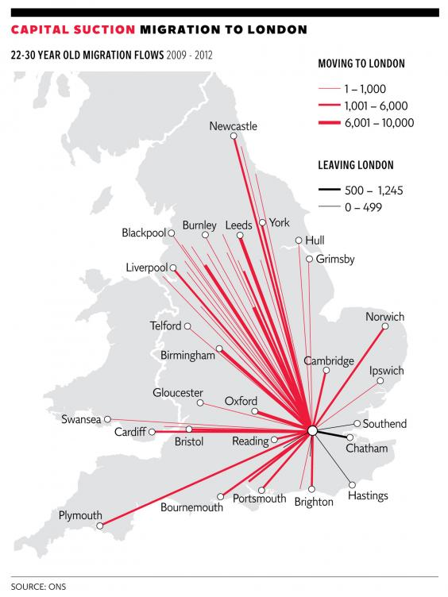

**2. Socio-Economic Differences**

* North VS South:lower employment rates, lower average incomes.
* Ex industrial cities hit particularly hard by unemployment
  + Bradford (Yorkshire and the Humber)
  + Middlesbrough (North East)
  + Unemployment => rapidly rising demand for social services
  + BUT North East and North West regions were imposed budget cuts (12%, VS 4.6% for the South East) = inequalities & poverty made worse
* 9/10 of the poorest areas in England = in the North West Region.

**3. Is the North-South Divide a Myth?**

* ‘Islands of affluence in a sea of poverty’. Examples:
* Ex: Sheffield – Hallam (South Yorkshire)
  + Lowest level of child poverty in the UK
  + Wealthy constituency
* Northern cities
* More entrepeneurs?
* Brand new universities
* Revitalizing of business
* Manchester and Leeds
* Yuppies (**Y**oung **U**rban **P**rofessionals)
* Regenerated city centres

BUT:

* London and the south-east = Still top for education, income, employment and health.
* North-east = still bottom for jobs, household disposable income and broadband access.
* 1997 – 2010= economic growth still mainly in the South (+90% vs. +60% of GVA (Gross Value Added))
* London
  + one in four children live in overcrowded homes.
  + 7 out of the 20 English local authorities with the highest levels of child poverty are in London
  + Housing crisis: 25% of Londoners with housing benefits to pay rent.
  + Inequality = not just a North/South matter.

**4. Political Implications**

* Problem of image for both parties:
  + Conservative: party of one class (the rich)?
  + Labour: party of one region (the North) (+ London) ?
  + Conservative Party
    - Gained ground in the North in the 2019 election.
    - 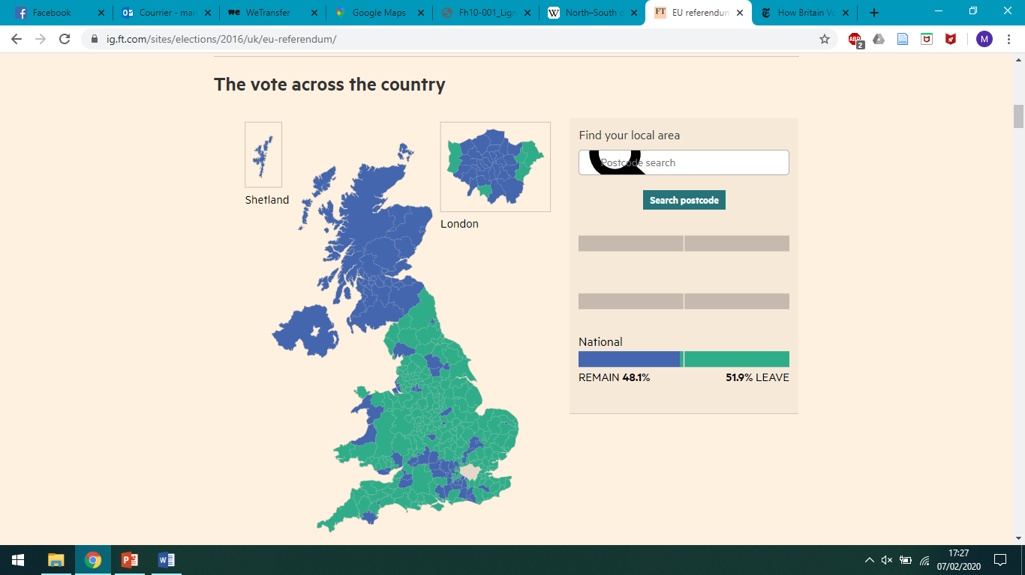Still, remains mostly invisible in cities and in former coal-mining areas

**Brexit vote:**

Large, cosmopolitan **cities** = **Remain**

vs.

**Rural areas & postindustrial towns** (little benefit from globalization)

incl. many traditional Labour strongholds = **Leave**.

=> Brexit vote = not a partisan / regional vote

**5. The Legacy of Thatcherism**

PM: 1979-1990, «Iron Lady »

* End of WW2: *The Beveridge Report* (1942): ”5 Giant Evils” to eradicate: Want, Disease, Ignorance, Squalor and Idleness.
  + Welfare State:
* 1945: Family Allowances Act
* 1946: National Insurance Act
* 1946: National Health Service (NHS)
* « From the craddle to the grave »
* Policies funded with taxes or contribution
* Nationalisation of the economy
* WWII-1970s: general consensus
* Early 1970s:
* Economic and social changes => Britain as the ‘sick man of Europe’
  + Strikes, social unrest, economic stagnation
  + ‘Winter of Discontent’ (1978-1979)
  + Thatcher = Promise of a radical alternative
* « Thatcherism » : goes against all the Welfare State stood for (ie social and societal solidarity)
  + Low taxation
  + Small government
  + Deregulation
  + Privatisation
  + Reduced trade union power
  + Individualism
* From state regulation to free market
* Implemented the ‘trickle-down economy’ => benefitting the wealthy only
* Thatcherism = Economic growth but no social gains.
* Social unrest: early 1980s=
  + Loss of manufacturing jobs => increase in service jobs
  + Closing down of the coalmines (North)
    - 1984-85 miners’ strike (142,000 strikers)
    - Strike declared illegal => police use
    - Trade unions designated as the ‘Enemy within’
* Refusal to negotiate with the trade unions => major loss of TU influence => dire structural and human consequences
* Increased class division and hostility, still noticeable today
* World politics: British leadership in the world restaured?
  + Falkland Islands war
  + ‘Special Relationship’ with Reagan
* Home politics: highly controversial legacy (Ireland, society, economics)

Wales

**1. Historical Reminders**

* Middle Ages: autonomous region
* Edward I (1272-1307)
  + Conquest (against Llywen ap Gruffyd)
  + Built castles to assert domination
* 1282: Rebellion crushed
* 1284: Statute of Rhuddlan (=provided the constitutional basis for the government of the Principality of Wales from 1284 until 1536. The Statute introduced English common law to Wales but also permitted the continuance of Welsh legal practices within the Principality.)
  + Annexation of Wales
* 1536: Act of Union
  + Same law
  + Same Parliament (26 MPs)
  + Same language

Economic activities: first farming, then diversification (mining, metallurgy)

Industrial take-off

* + 2nd half of the 18th /early 19th: lots of wars
    - American War of Independence
    - French Revolutionary & Napoleonic Wars, etc…
  + Great need for industrial goods (metal, fuel etc)
  + Wales had the natural resources and developed the necessary infrastructures
  + By 1851:
    - 2/3 of Welsh families’ living depended on the industry
    - Wales = World's second industrial nation after England
  + Coalmining (North East + mostly South)
  + Migration to South Wales
* Coal production
  + peak in 1913 but non-sustainable (war demands)
* Decline
  + increased coal production elsewhere, transition to oil, Post-war mismanagement
  + => collapse in 1921
* Unemployment for miners:
  + April 1924: 2%
  + January 1925: 12.5%
  + September 1925: 28.5%
* Huge economic/social /cultural impact
* Wall Street crash of 1929:
  + Steel and transport workers
  + Agriculture also hit hard
* 1932-33= end of depression BUT also end of the industrial growth
* Massive emigration:
  + 1925-1939: 390,000 people
  + 1973: back to the 1925 demographic level
* 1945
  + Still low standard of living
  + Coal and steel industries = 30% of the Welsh male workforce
  + Agriculture = 10% (WWII= Food shortages => increase in prices => prosperous agriculture)
* Late 20th century: Coal industry almost completely vanished

1. **Economic Characteristics Today**

* So-far vain efforts to replace/create jobs in former mining areas
* Regional level: Wealth gap (recently widening further)
* National level: Among the poorest regions of the UK with Northern Ireland and the North East of England
  + GVA (Gross Value Added) : lowest level in the UK (exception: Cardiff, even more dynamic than London!)
  + Anglesey
    - GVA: only around half the UK figure
    - Closure of Anglesey Aluminium in 2009
  + South Wales Valleys:
    - Poorest region
    - Erosion of jobs
* REASONS FOR HOPE:

Unemployment rate: consistent decrease = 4.1% (July 2016) vs. 3.9 (August 2019)

Aberystwyth (cultural capital)

* + 25% growth in population
  + National Library of Wales
  + Aberystwyth University
* Current focus: services and tourism

Booming sectors

* **Tourism =**
  + Outdoor activities, National Parks, City tourism
  + 3 billion pounds /year
  + Job creation
  + = major area of employment growth and investment
* **Cultural & creation industries :**
  + 2006= 17,500 employees; revenue: £400 million/year
  + Today= 40,000 jobs.

Public sector

• Health, education, and government

• 60% of the economy

• 2009: 27.4% of the Welsh workforce BUT austerity cuts => 2018: 20.0%

Private sector

* Resurgence of small, local businesses (ex organic farming)
* Steel & coal => lighter manufacturing
  + electronics, spare part, high technology industries
* Start-up support for small high-tech companies
* The Welsh Government’s goal = Investment in these sectors, in research & licensing (ex Institute of Life Science at Swansea University)

Yet, productivity lags behind:

* exports fare very poorly (# 19th cent)
* very few company head-quarters in Wales
* poor record in business start-ups
* a relatively small financial services sector.
* attempts at revitalizing the private sector but remains quite weak
* **Economic growth: slower than the UK/England/Scotland’s.**
* Economic and political matters closely linked
* Political Devolution (1999):
  + Management of eco development transferred to the Welsh Government
  + Department for the Economy and Transport (June 2007). Objectives:
    - Create jobs across Wales
    - Stimulate enterpreneurship and growth
    - Enhance skills for jobs

1. **Political Devolution**

* England and Wales often quoted together as one single entity
* Cf incorporation/annexation: unilateral Eng decision, never approved by the Welsh (# Scot) early in the Middle Ages
* E & W:
  + a single legal system
  + common features: education, religion, business, etc.
* Welsh & Berwick Act (1746) = decided that the word “England” also meant Wales (in the dico: “for Wales, see England”)
* “Welsh” = name given by the English; comes from “Wealhas” ie foreigners # “Cymru” ie “companions” .
* The English tried to make Welsh culture and language disappear => deep mutations.
* => Problem of national identity: what does it mean to be Welsh?
* First referendum about more self-government in 1979 => NO
* But in the 80s: Thatcherism + environmental pbs
* => September 1997: referendums in Scotland and Wales on devolution of powers (Wales: 50,3% YES)
* Devolution = some level of political and legislative autonomy through decentralisation
* Scottish Parliament and a National Assembly for Wales
* Government of Wales Act 1998

**Senedd Cymru (Welsh Parliament)**

* + Before May 2020: called the National Assembly for Wales /Cynulliad Cenedlaethol Cymru, currently Labour has the majority
  + Unicameral
  + 60 Assembly Members (AMs)
  + Elections every 5 years
  + UK Parliament remains sovereign
  + Mostly secondary legislation (= adapting laws, not initiating them)
  + Government of Wales Act 2006: introduced limited primary legislation
  + March 2011 referendum: direct law-making powers
  + Only 20 devolved subjects; the rest are ‘reserved matters’ (Westminster only)

The UK government is responsible for national policy on all powers which have not been devolved

What Powers are devolved?

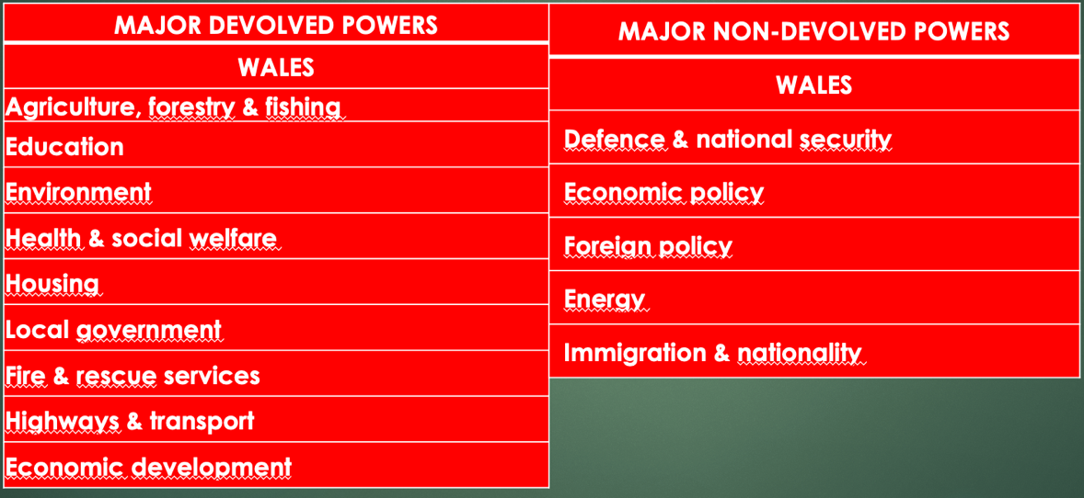

Current First Minister of Wales = Mark Drakeford (Labour)

Regional party:

* Plaid Cymru
  + Created in 1925; first seat in Parliament in 1966
  + Pro-Welsh independence from the UK
  + Social-democratic
  + Pro-European

Devolution = a success? Mitigated.

* Closing the GDP gap with England: aim but unachieved
* Number of people in work = success: unemployment in Wales = 3.9% (much lower than the UK average)
* Credit to the Welsh government or the UK government?
  + Welsh government= just one of several factors
  + UK government = raising taxes and determining welfare payments + Bank of England = monetary policy and interest rates
* Legal system: W & E still under one jurisdiction
  + Increasing divergence in law since devolution? More and more laws specific to Wales
  + lack of a separate Welsh legal system: constraining the development of democracy in Wales?
  + Assembly committee: in charge of examining the idea of breaking from the single, shared legal system
* Unhappy English voters: no political or constitutional existence or representation for England

=> is the current political model viable (for both Wales & England)?

Scotland

* Historical name: Alba
* Capital: Edinburgh
* Population: 5.3 million (2015)
* Symbols:
  + The thistle
  + The unicorn

1. **European Scotland**

France & Scotland: the ‘Auld Alliance’:

* 1295
* Mutual support against England
* Diplomatic & military alliance during the Hundred Years’ War (1337-1453)
  + 1415: Battle of Agincourt (S/F defeat)
  + 1429: Joan of Arc and Orleans => Scottish help
* French King’s “Garde Écossaise”
* After HYW, many Scots became French residents
* Long-lasting trade agreements (ex: privileged trade agreements for Scottish sellers of French/Bordeaux wine)
* Long-established friendship

The (long) end of the Auld Alliance:a

* Reformation:
  + divided 16th century Europe
  + Scotland became Protestant vs. France remained Catholic
  + = unofficial end of the Auld Alliance
* 1707: Union of Parliaments with England => deeper schism
* 1906: Official end of the Auld Alliance
  + Until then, French citizens automatically had dual nationality with Scotland and vice versa

Other European ties for Scotland:

* + Scotland and Germany:
    - trade (Hanseatic League)
    - religion (Protestant religion imported from Germany => deep influence over Scottish mindset/identity
  + Proximity with Scandinavia
    - long history of Viking and Norse settlement in Scotland + linguistic & cultural ties
  + Gaelic connection with Ireland

=> Scotland as much shaped by its relationships with continental Europe as by its close ties with England / the rest of the UK

1. **Economic overview**

* GDP :
  + higher than in all other areas of the UK outside London and England’s South
  + Second best in the UK after England (3rd: NI; 4th: Wales)
* Unemployment:
  + Consistently lower than the UK average
  + Decreasing rate (2017: 4% => 2019: 3.2%)

Scottish Industry

* Similar development to England/Wales
  + Industrial revolution => heavy industries (coal, steel, ship construction); peak in 1913.
  + Then decline (foreign competition, transition to oil) => 2002: last coal mine closed => unemployment
  + Then gradually diversified and modernised
* Heavy industry: new sectors
  + High technology + consumer goods (electronics, office supplies)
  + major source of economic growth, employment & export earnings
  + “Silicon Glen” (Midland Valley)

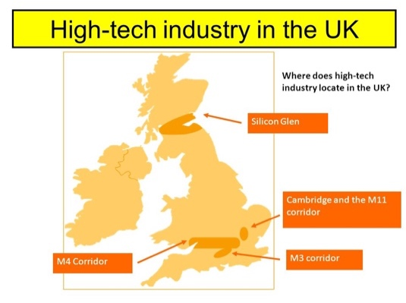

Scottish service sectors

* Financial and business services
  + 1960s onwards: significant growth
  + Edinburgh: 2nd biggest British financial centre after London
* Tourism: a sector with vital importance
  + 14.6 million visitors (mostly Scottish & English people but also Americans & Europeans)
  + 8.9 billion pounds
  + Spending by tourists = £12 billion of economic activity / 5% of the total Scottish GDP
  + 196,000 jobs in 2014 (7.7% of employment)

Public sector

* Public services
  + 2016: 21% of the workforce
  + £71.2 billion in 2016/17
  + Represent 1/5 of GDP

(private services = 2/5 of GDP)

* + High public spending:
  + The public sector is larger in Scotland (ex: public water industry)
  + Some areas: high level of demand (ex academic cities with lots of students)

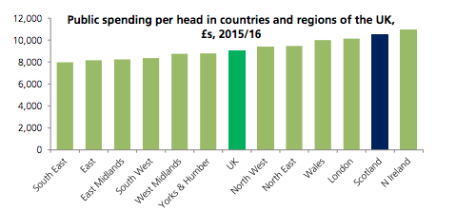

The petroleum industry

* Started in the 1970s (North Sea)
* On/offshore oil & gas-related industry => 10s of thousands of jobs
* Aberdeen (‘the oil capital of Europe’)
* Shetland islands (2017 discovery)
* Fluctuating international markets but still a prosperous and profitable sector
* Still, future challenges (shift to cleaner energy + what happens once oil deposits run dry?
* Controvesy: oil fields = Scottish waters BUT owned by the British government.

1. The Long Road to the Referendum

* 12th-13th centuries:
  + Since 9th century (Kenneth I): most of Scotland under the control of a single ruler: nation-state with a feudal system
  + Still some Gaelic clans
  + Nation united by the Gaelic language + an emerging Scottish national consciousness
  + Several English invasions in Scotland to prevent Scottish expansion into Northern England
  + Demands from English Crown for Scotland to surrender but Scottish rulers refused
* Auld Alliance (1295) seen by the English as a declaration of war
  + England invaded Scotland (1296)
  + “First War of Scottish independence” (William ‘Braveheart’ Wallace) 1296-1328 => Scottish victory

14-16th centuries :

* + The Scottish Stewart/Stuart dynasty imposed its rule over Scotland => period of prosperity
  + Still clashes on the Scottish/English border but truces (ex: 1502 ‘Treaty of Perpetual Peace’)

17th century:

* + 1603: James VI, King of Scots inherited the Kingdoms of England and Ireland (=> James I: “Jacobean era”)
    - Union of Crowns
    - Parliaments of Scotland and England remained separate => tensions between the two
  + Glorious Revolution (1688): James VII/James II overthrown for being a Catholic & replaced by Mary and William of Orange= end of Stuart dynasty
  + Famines and economic hardships in Scotland

18th century:

* 1707: Union of Parliaments
  + Presented as a “win-win situation”
    - Economic security for Scotland
    - Manpower and resources for England
  + Still, many riots and protests in Scotland
* Jacobite (= pro-James/pro Catholic) risings (1719, 1745): failures
  + End of Scottish armed rebellion
  + heavy restrictions on the Scots, ending hopes of independence for the next two centuries
* 19th century/early 20th:
  + Political campaigns for Scottish self-government (demands for home rule within the United Kingdom)

Scottish National Party (SNP)

* + Creation: 1934
  + Demands: first a devolved Scottish Assembly, then full independence
  + Social democratic party (left/centre-left + pro-European)
  + 2nd half of 20th century: gathered momentum
    - Oil in the North Sea in the 1970s claimed by the British => strong disapproval in Scotland (SNP campaign: “It’s Scotland’s oil!”)
    - 1974 = 30 percent of the Scottish vote => 11 seats in Westminster
    - Thatcherism

Scottish Devolution

1997 = referendum on devolution

1998 = Scotland Act (=> creation of devolved SP)

1999 = Scottish parliament re-established: first session on May 12th

**Scottish Parliament / Pàrlamaid na h-Alba / Scots Pairlament**

* Unicameral legislature
* 129 members: MSPs (Members of the Scottish Parliament)
* Elections every 4 years
* Full legislative power ever since 1999 (primary legislation)
* Devolved & reserved matters

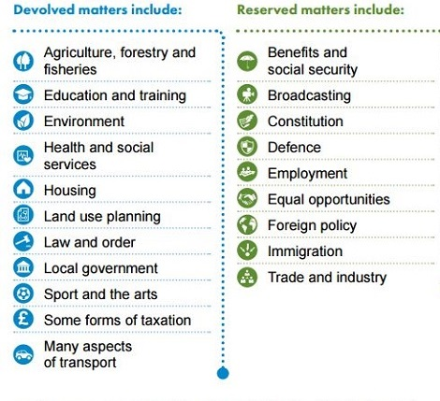

Scottish Devolution: not enough?

* 2007: SNP = first majority in the Scottish

Parliament; majority party ever since.

* Growing pressure for referendum
* Alex Salmond (SNP)
  + First Minister (2007-2014)
  + 2012: had David Cameron agree to a referendum on independence for Scotland (=> Scottish Independence Referendum Act 2013)

September 18th 2014 referendum

* + Referendum terms
    - Age to vote: lowered to 16
    - Wording: “Should Scotland be an independent country?”
    - Campaign: “Yes Scotland” vs. “Better Together”
  + Turnout: 84.6% (historic number)
  + Result: 55.3% NO vs. 44.7% YES
  + Major reasons behind votes:
    - In favour of NO = “retention of the pound sterling” + threat of end of EU membership (!)
    - In favour of YES = "disaffection with Westminster politics“
  + ‘Once in a generation vote’ => consensus that no other referendum before long

Still, overall positive outcome for Scotland’s autonomy:

Polls before the ref => British gov afraid => offered greater autonomy:

* + Scotland Act 2012; gave the Scottish Parliament
    - right to raise or lower income tax more freely
    - limited (but extra) powers regarding drugs, driving, and guns, etc.
    - + guaranteed Scottish representation in/on the BBC

Further autonomy even after the referendum:

* + Scotland Act 2016: gave the Scottish Parliament
    - more tax-raising powers
    - widely increased fiscal autonomy
    - more control over public expenditure
    - more control over welfare rates

1. **Brexit: the game-changer?**

* before Brexit, main argument against Scottish independence /main reason for the NO vote in 2014 =
* threat that independent Scotland = no UK but also no EU membership
* (Scotland could have applied for EU membership but the UK could have refused it)
* Would have left Scotland in position of acute isolation
* Scottish vote = Remain (62%)
* Brexit => changed circumstances => new talks about independence
* Nicola Sturgeon (First Minister, SNP):
  + => need for a new debate on independence
  + SNP’s responsibility to lead this debate
  + “My message to the prime minister is this: you may have a mandate in England and Wales to leave the EU but you do not have a clear mandate to take any part of the UK out of the single market.”
  + Ironic reversal: independent Scotland= formerly presented as a dangerous prospect (meant it could not stay in the EU) => now the only hope for Scotland to become part of the EU again.

Towards a second referendum?

* + March 28th 2017: Scottish Parliament approved SNP’s plans to ask for a new referendum
    - BUT reserved matter => need for British gov’s consent and initiative
    - Formal request sent to British Parliament soonafter
    - Theresa May’s answer: “Now is not the time”
  + 2019 UK elections: SNP won 48 out of 59 possible seats in Westminster (+13 seats) => reinforced power and legitimacy
    - New request to B. Johnson in Dec 2019 => refused in Jan 2020 because:
      * 2014: Sturgeon’s “a once-in-a-generation vote” promise
      * BJ: “The UK government will continue to uphold the [2014] democratic decision of the Scottish people and the promise you made to them.”
    - Ever since, BJ has been trying to undermine support for SI by promising big funding for infrastructure in Scotland
* From the UK’s perspective:
  + British naval bases in Scotland (nuclear submarines): Scottish Independence => weakening of the British defense?
  + Oil (cf Moodle)
  + Most importantly (?) symbolical blow: DisUnited Kingdom
* From the EU’s perspective:
  + Administratively speaking: completely possible: existing legal framework ensuring smooth transition (between referendum & actual independence) towards independent membership (ex Lisbon Treaty, Article 48)
  + EU’s self interest? = accepting Scotland’s application
    - Scotland’s membership in the single market would be a plus
    - Scotland’s more than willing to be part of the EU (cf 2014 NO vote, Brexit vote, subsequent moves to maintain links with the EU ex Erasmus programme)
    - EU’s principle = enlargement, not contraction

2021: a turning point?

* SNP/Sturgeon: reaffirmed political determination, exacerbated by criticism faced by BJ in Scotland regarding his (mis)management of the Covid-19 crisis
* Crucial May 2021 elections in Scotland. Recent Ipsos poll:
  + - * 52% are likely to vote for the SNP (Scottish Conservatives = 23%; Scottish Labour 15%)
      * 52% would vote Yes in an independence referendum, (Nov 2020: 56%)
      * Independence is seen as the top issue helping people decide which party to vote for (44%)
  + If SNP wins the 2021 elections, Sturgeon:
    - will hold an advisory referendum on independence (with or without Westminster’s consent)
    - will request from the UK gov a Scotland Act 1998 section 30 order (allows Holyrood to pass laws normally reserved to Westminster)
  + 2021 four-nation polling (*Sunday Times*): a majority of voters in Scotland and Northern Ireland want referendums on the breakup of Britain=> major change on the horizon?

6 may 2021 election results:

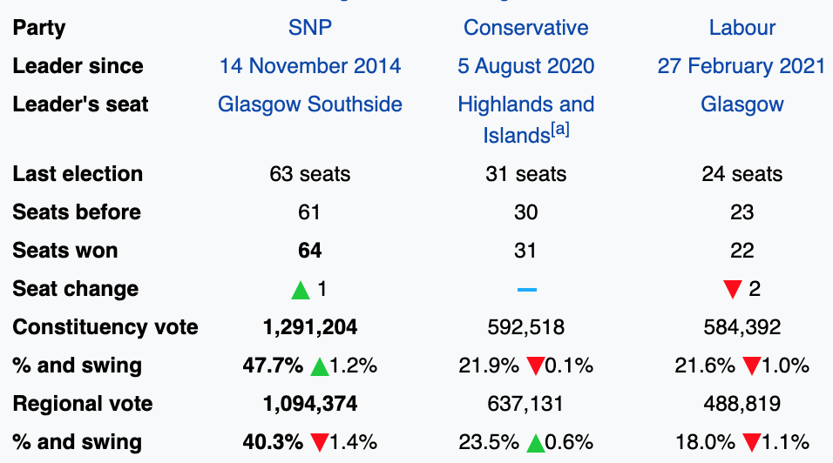

Ireland

* Irish name: Tuaisceart Éireann

1. **Catholics and/vs. Protestants**

* Invasions & colonisation
  + Henry VIII (1509-1547): self-proclaimed king of Ireland
  + James I (1603-1625): colonisation of Ulster by the English and the Scots
  + Nine Years’ War (1593–1603) against English rule => Irish defeat => “Flight of the Earls” (1607)
  + = ‘free’ land + will to eradicate Irish rebellion by controlling, anglicising and "civilising" Ulster => “Plantation of Ulster” (1609-end of 18th century)
* Major pb: religion
  + Since 5th century: Catholic Ireland (syncretism with elements of Gaelic culture & identity)
  + Native Catholic Irish vs. immigrant Protestant English ppl and Scots

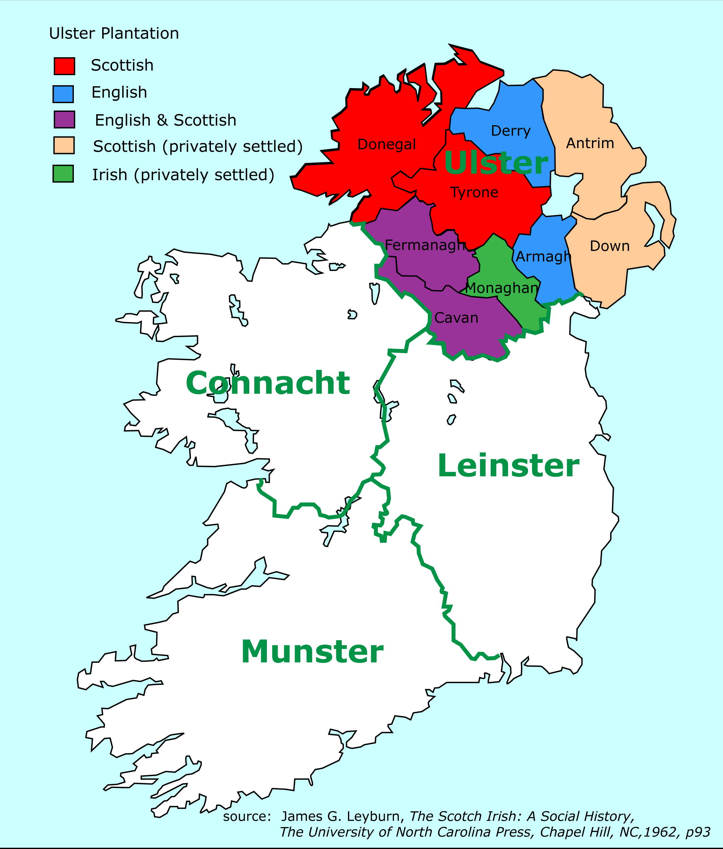

* 17-18th centuries: series of (failed) Irish rebellions to defend right to land, representation & religious freedom. Ex:
  + 1641 Irish Rebellion
  + 1690 Battle of the Boyne (July “Orange Marches”)
  + 1798: Irish rebellions led by the United Irishmen
  + Systematic severe English/British repression
  + 1801: Act of Union (to officially assert Eng. authority)
* 1830s & 1840s: failed attempts to repeal the Act of Union

Home Rule

* Island of Ireland: ”Home Rule” (indep self-gov) movement
  + dominant political movement of Irish nationalism from 1870 to the end of WWI
  + 1886 and 1896: Home Rule bills defeated
* 1905: Sinn Féin created
* 1912: 3rd Home Rule Bill => Ireland gets a parliament Crisis in Ulster:
  + “Home Rule is Rome Rule”
  + Ulster Unionists wanted Ulster to be excluded from Home Rule plans: first mention of partition
  + Ulster Volunteer Force (UVF) (paramilitary) vs. Irish Volunteers
  + WWI= suspension of Home Rule process + weakened British power => Irish Republican Brotherhood (IRB) organised the Easter Rising (April 1916)
  + Harsh repression of ER + 1918 conscription crisis => most Irish people started supporting independence more than Home Rule.

Partition

* 1918 general election: landslide victory for Sinn Féin in Southern Provinces =>
  + First Dáil Éireann (Lower chamber of parliament) + Declaration of Independence
  + BUT in Ulster: Unionist victory = clear gap bet U & rest of Ireland
* 1919-1921: Anglo-Irish war for independence
* 1921: partition & creation of separate Home Rule Parliaments in Dublin and in Northern Ireland.
  + (The Dublin Parliament/ Home Rule in the South was never implemented as the self-governing Irish Free State was established in 1922).

The Parliament of NI

* + Nickname: ‘Stormont’
  + Set up by the Government of Ireland Act 1920
  + Was active from 1921 to March 30th 1972
  + Protestant domination throughout (majority = Ulster Unionist Party)
    - was then suspended because of the Troubles => direct rule by London / the Northern Ireland Office
    - was officially abolished under the Northern Ireland Constitution Act 1973.
    - 1972-1998: Intermittent home rule through various forms of Northern Ireland Assembly, trying to balance representation of unionist (/mostly Protestant) and republican (/mostly Catholic) rights.
  + Still today, religion & sense of national identity = tightly interwoven /mostly synonymous

NI politics & society 1921-1970s:

* Population = mainly Protestant.
  + Presbyterians + Church of Ireland
  + Protestants = mostly Unionists
* Catholics (35% of the population in the 1961 census).
  + Unemployment
  + Emigration
  + Catholics = mostly nationalists
* Institutionalized separation of the two communities through gerrymandering (manipulation of voting district boundaries)
* Economic dimension
  + Discriminating legislation against Catholic community (access to jobs, services etc) by the Unionist/Protestant government
  + Lack of political representation for Catholics
* 1967-69: non-sectarian civil right movements created to protest discrimination (especially against Catholics); opposed by loyalist ultra-Protestant groups (ex. UVF)
  + - UVF offensives to discourage unionist government from negotiating with NI Catholics & Dublin.
    - Some civil right movements leaders became involved in nationalist /republican movements
    - From 1969 on, growing tensions:
      * Escalating police brutality (ex: Oct. 5th 1968 Derry March)
      * Increased tensions with /attacks from Protestant paramilitary groups (Belfast, Derry => August 1969 ‘Battle of the Bogside’)
      * Militarization of conflict (UVF vs. IRA) + British troops sent to Ulster
      * The IRA took over civil right movements associations as ‘defender’ of Catholics

1. **The ‘Troubles’ / Na Trioblóidí**

The (Provisional) Irish Republican Army (IRA) / Óglaigh na hÉireann (‘soldiers of Ireland’)

Irish Republican paramilitary group

* + Main objectives since 1969:
    - Protect Catholic community from attacks by ultra Protestant groups
    - End British presence & rule in Northern Ireland
    - Irish reunification + establishment of a socialist Irish Republic
  + Guerilla tactics => highly controversial:
    - Considered a terrorist group by the UK
    - Declared illegal in the Republic of Ireland
  + Relation with Sinn Féin?
    - Overlapping interests & goals & often overlapping membership
    - Some senior members of SF allegedly part of PIRA’s Army Council
      * Ruairí Ó Brádaigh (established)
      * Gerry Adams (alleged/denied)
      * Martin McGuinness (alleged/denied)

vs. Ulster loyalists

* = NI Protestants opposing Catholic emancipation (18-early 20th cent), Irish independence (20th cent) & NI independence from the UK (20th-21st cent)
* Paramilitary groups ex
  + - * the Ulster Volunteer Force (UVF) (considered a terrorist group by the UK since 2000)
      * Ulster Defence Association (UDA) /Ulster Freedom Fighters (UFF) (considered a terrorist group by the UK since 1992)
      * the Red Hand Commando (RHC) (considered a terrorist group by the UK since 2000)
* Political parties
  + - * Ulster Democratic Party (1981-2001); links with the UDA
      * Progressive Unionist Party (1979-): links with the UVF and the RHC
      * Democratic Unionist Party (1971): links with the UVF and the UDA. Created by Ian Paisley.
* 1969:
  + deployment of British troops against CRMs
  + “Peace Walls” built (Belfast, Derry)
* 1971: ‘Operation Demetrius’:
  + internment (detention without trial) for suspected IRA members
  + torture-like interrogation methods
  + => huge backlash & protests
* 1972:
  + deadliest year (500 casualties, half of whom civilians)
  + 30th January in Derry: ”Bloody Sunday” (anti-internment march) => 14 unarmed protesters shot dead by British paratroopers
    - Fueled Catholic & Republican hostility against the Brits & British troops in particular
    - Renewed support for the IRA
* Unionist-controlled Stormont unable to manage the situation / restore peace => Northern Ireland (Temporary Provisions) Act 1972) =>
  + - suspension of the NI Parliament
    - “direct rule” from London (supposedly a short term measure but lasted well into the 1990s)
    - Successive British gov. failed to find a solution
  + Political & military deadlock => the Troubles continued throughout the 1970s, 1980s, and the 1990s
    - 1969-1994: 3,000 people killed
    - Republican/Catholic-controlled "no-go areas" in Belfast and Derry
    - Strikes, bombings & attacks from/on both sides
    - 1979: PIRA attack killed Lord Mountbatten (last Viceroy of India/ Prince Philip’s uncle)
    - 1981 Hunger strike (ten prisoners died, incl. Bobby Sands) => escalation of violence
    - 1984: Grand Hotel in Brighton (where politicians including Thatcher, were staying for the annual Conservative Party conference) bombed => conflict even outside NI
* Late 1980s-early 1990s: still attacks & violence but need for a solution for both sides
  + Sinn Féin (led by Gerry Adams) started advocating for peace & +/- secretly working on a (long) peace process.
  + Loyalists also engaged behind-the-scenes talks to end the violence
  + John Hume (Irish nationalist) & David Trimble (Ulster Unionist) (conjoint Peace Nobel Prize in 1998)
  + Growing international pressure (Brussels, Washington/Reagan <- Irish-American lobbying) => Thatcher had to make concessions
* 1985: Anglo-Irish agreement between Garret FitzGerald (Irish Taoiseach) & Margaret Thatcher (British PM):
  + Cooperation between Dublin and London to make decisions regarding NI
  + Encouraging a NI power-sharing devolved government
  + Agreement criticized by Unionists (going too far) & nationalists (not going far enough)
  + Still, improved London/Dublin cooperation = laid ground for the peace process
* Dec 1993: Downing Street Declaration by UK PM John Major and Taoiseach Albert Reynolds
  + Right of the people of Ireland to self-determination
  + Northern Ireland would be transferred to the Republic of Ireland from the United Kingdom only if a majority of its population was in favour of such a move.
  + Principle of consent : the people of the island of Ireland have the exclusive right to solve the issues between North and South by mutual consent = instrumental in convincing republicans to commit to a negotiated settlement.
  + Insurance that parties linked with paramilitaries (ex Sinn Féin) could take part in the talks, so long as they abandoned violence.
* General popular support
* Declaration considered sufficient by the PIRA to announce a ceasefire on 31 August 1994.
* October 1994: Protestant ceasefire.

Towards the Good Friday Agreement

* 1995: Sen. George Mitchell appointed as US Special Envoy for Northern Ireland (= Clinton’s representative for NI)
* Feb. 1996: IRA cancelled its cease-fire (blamed on the British Government's refusal to begin all-party negotiations until the IRA had decommissioned its weapons) => Negotiations blocked.
* May 1997: Tony Blair became PM => new phase of negociations (without Sinn Féin)
* July 1997: IRA ceasefire
* Sept 1997: Sinn Fein readmitted to the talks
* Main protagonists: Tony Blair (British PM), Bertie Ahern (Irish Taoiseach) & George Mitchell

10th April 1998: The Good Friday Agreement (/’Belfast Agreement’)

* “Three Strands” determining:
  + The status and system of government of Northern Ireland within the United Kingdom. (Strand 1)
  + The relationship between Northern Ireland and the Republic of Ireland. (Strand 2)
  + The relationship between the Republic of Ireland and the United Kingdom. (Strand 3)
* The agreement acknowledged the legitimacy of two contradictory claims:
  + the majority of the people of Northern Ireland wished to remain a part of the United Kingdom;
  + a substantial section of the people of Northern Ireland, and the majority of the people of the island of Ireland, wished to bring about a united Ireland.
* The Agreement recognized
  + that Northern Ireland = part of the United Kingdom until a majority of the people both of Northern Ireland and of the Republic of Ireland wished otherwise, in which case Brit. & Irish govs = “binding obligation" to implement that choice.
  + the right of "the people of Northern Ireland" to "identify themselves and be accepted as Irish or British, or both" (as well as their right to hold British or Irish citizenship or both)
* The Agreement also imposes
  + The decommissioning of weapons held by paramilitary groups
  + The respect of equality & human rights
* May 1998: Agreement approved in a referendum

Northern Irish Government

* Power-sharing principle: unionists (DUP) & nationalists (Sinn Féin) must both participate in governing the region = ‘mutually inter-dependent’ system
* First Minister (one party) and deputy First Minister (other party)
  + Since 2020: First Minister = DUP’s Arlene Foster + Deputy FM = SF’s Michelle O’Neill
* ‘D’hont formula’ to appoint ministers:
  + - ministerial portfolios are divided among the parties in proportion to their strength in the Assembly
    - Exception: Minister of Justice, elected by a cross-community vote in the NIA
    - NI Executive is answerable to the Assembly
  + Ministers have to participate fully in
    - the devolved Executive
    - the North/South Ministerial Council
    - the British-Irish Council

Northern Irish Assembly/Stormont

* Established by the Northern Ireland Act of 1998
* Devolved legislature of NI => devolved & restricted matters
* Unicameral
* 18 constituencies; 90 seats
* 90 MLAs (Members of the Legislative Assembly / Comhaltaí den Tionól Reachtach)
* Proportional representation
* Some executive positions & contentious motions require a cross-community vote to be approved

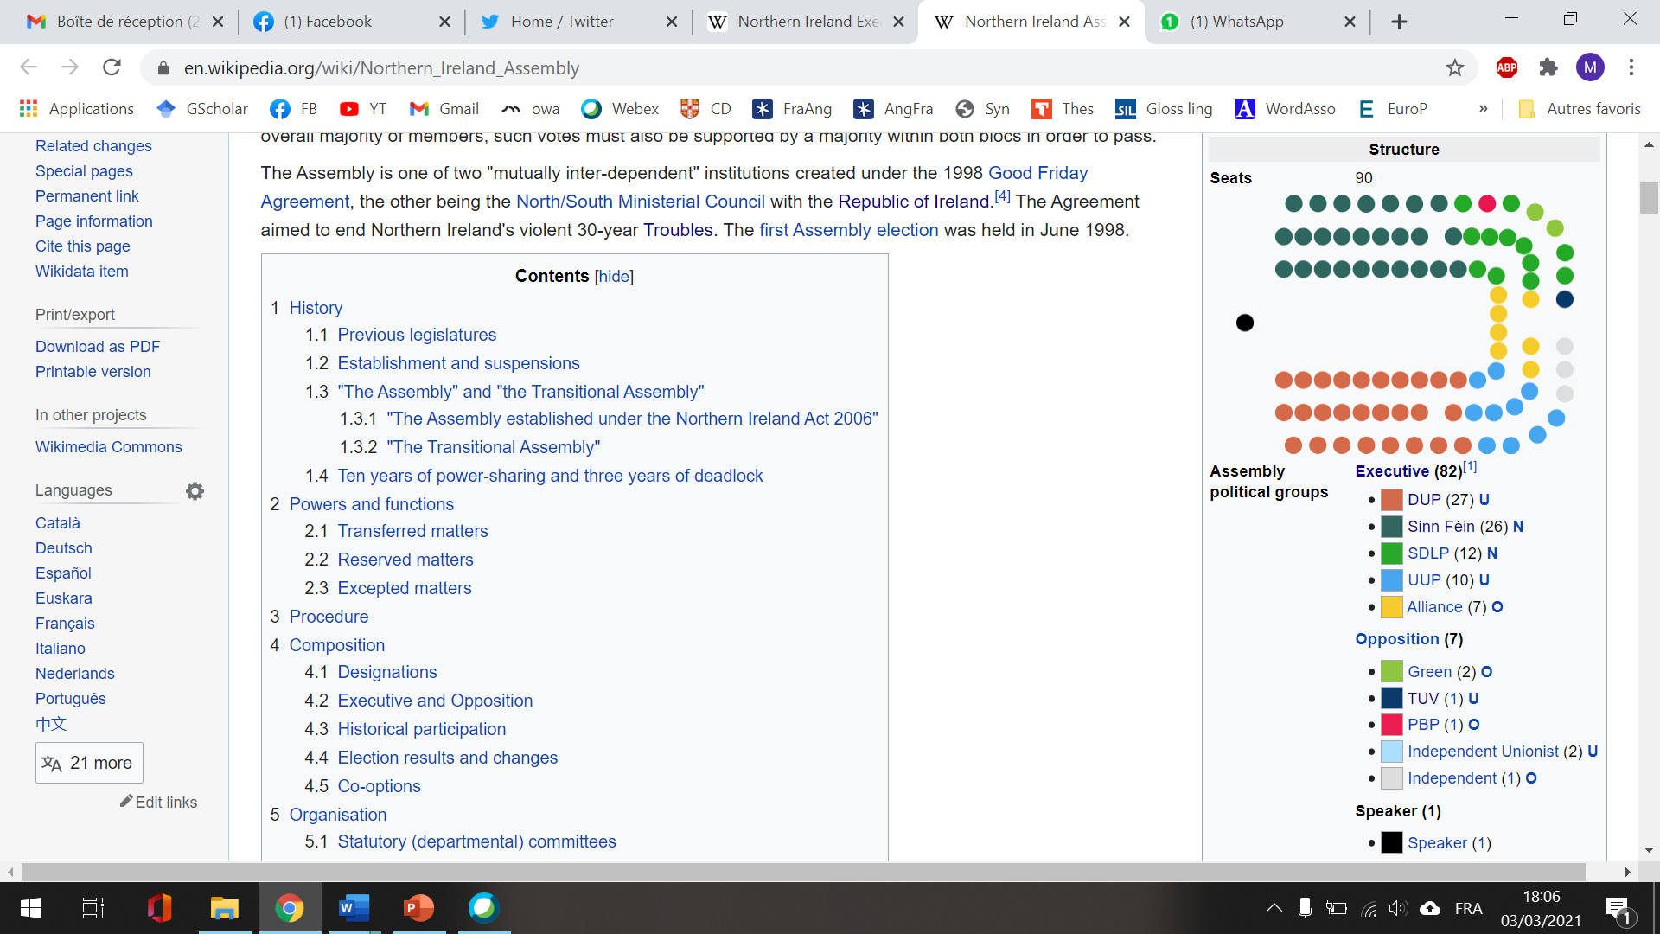

* 5 suspensions, incl. 3 very short ones (2000, 2001x2) and two longer ones:
* 14 October 2002 – 7 May 2007 : disagreement on formation of the executive
  + Unionist withdrawal => suspension
  + Direct rule from London
  + 2006: Saint Andrew’s agreement: DUP & SF agreed to power-sharing => Ian Paisley (DUP) as First Minister and Martin McGuinness as deputy First Minister (SF). First Assembly to complete a term.
* 9 January 2017 – 11 January 2020: new breakdown
  + Renewable Heat Incentive scandal involving DUP First Minister Arlene Foster
  + Resignation of Sinn Féin Deputy First Minister Martin McGuinness in protest => Foster removed from position
  + Elections in 2017 but failure to form an Executive (disagreements bet DUP & SF over social issues ex. abortion, official status of the Irish language, same-sex marriage)
  + Eventual restoration in 2020
  + Towards a new suspension? Feb 2021: DUP MLAs threatened to bring down the Assembly in protest at the Brexit deal setting a NI/UK border in the Irish Sea (‘NI Protocol’)

1. **What Future for Northern Ireland?**

Northern Irish Economy

* 1990s: Peace Agreement & end of the ‘Troubles‘: relative peace =>
  + cultural vitality, pride and optimism
  + economic development
* IT industry (traditionally: shipbuilding, rope manufacture & textiles)
* Replaced by services:
  + Public sector (70% of the economy)
  + Tourism (4.9% of NI’s GDP / over 40,000 jobs): landscapes & castles, ‘Troubles tourism’, film tourism
  + Local film industry: *Game of Thrones, Derry Girls*

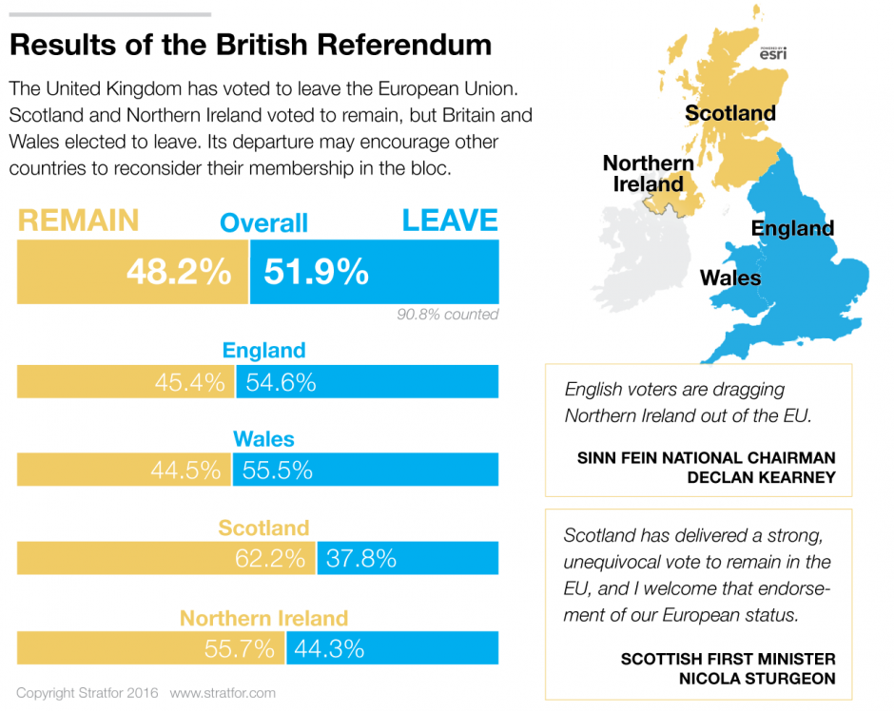Northern Ireland & the EU

* Major role of the European Union
  + In NI’s politics / 1998 peace process
  + In NI’s economy
    - €2.8bn in the last EU funding round
    - €2.2bn more by 2020
    - 90% of Northern Irish farmers’ income
* Cross-border programmes
  + Intertrade, Peace and Tourism Ireland
  + Erasmus programme
  + Good integration in the EU
* 2016 Brexit vote
  + huge shock for NI
  + 55.7% vote to Remain in NI

Consequences of Brexit on NI = ?

* Withdrawal of EU funds NI heavily relied on
* Threatens the precarious balance reached through the Good Friday Agreement & creates risk of renewed tensions due to custom checks
* Ex: pb of the Border => unsolvable Brexit Trilemma;
  + no hard border on the island
  + no customs border in the Irish Sea
  + no British participation in the European Single Market and the European Union Customs Union
  + Long & tense negotiations between British PMs (May, Johnson) & Irish Taoisigh (Enda Kenny, Leo Varadkar, Micheál Martin)
  + Controversial Northern Ireland Protocol (rejected by Unionists)

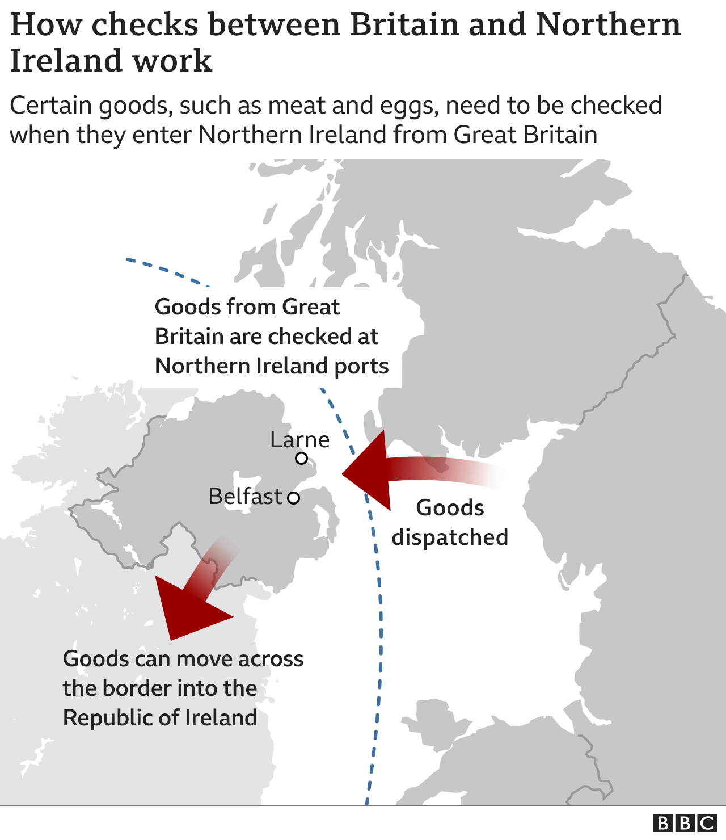

North Ireland Protocol

After Brexit: towards reunification?

* Democratic Unionist Party (DUP), pro-Leave (the EU)
  + don’t agree with BJ’s deal with the EU
  + complex position as Brexit threatens unionism / some U feel abandoned by the British gov.
* Sinn Féin’s reaction to Brexit:
  + leader Mary Lou McDonald calling for a referendum on reunification with the Republic of Ireland
  + Calls for referendum rejected by Brit. gov. & Unionists (argument: no evidence that opinion in Northern Ireland had shifted towards reunification)
  + But 2017 Assembly election=> the DUP lost ten seats (only one seat ahead of Sinn Féin)
  + April 2017:  European Council => in the event of Irish unification, "the entire territory of such a united Ireland would [...] be part of the European Union”
  + Turning points? Jan 2021:
  + Polls: 51% of the NI population support a referendum on reunification in the next five years
  + In NI, 47% still want to remain in the UK (65% pre-Brexit) vs.42% now in favour of a United Ireland (17% pre-Brexit)+ 11% (big portion) undecided (17% pre-Brexit): not ready yet but soon?
  + In the Republic, 65% in favour of a united Ireland (vs.19% against) (May 2019 RTÉ/REDC poll)
  + To be continued…