# 1st PRESENTATION: BUSINESS CULTURE IN THE UK AND THE US

## 1 - Sectors of the economy

### I.Primary sector

The primary sector refers to everything that comes from the earth. It extracts or harvests products from the earth.

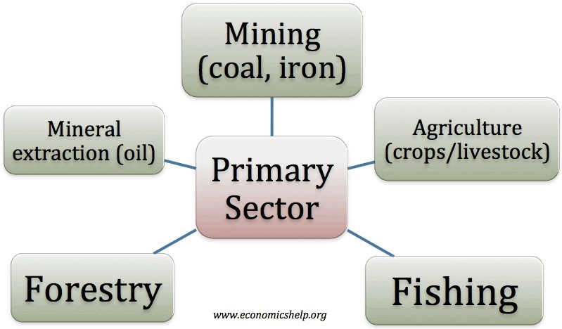There are different activities in this sector:

ᵩ Agriculture,

ᵩ Forestry and logging

ᵩ Fishing (sea and river fishing) and hunting

ᵩ Mining and quarrying

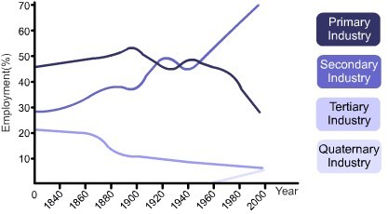It usually includes the packaging and processing of the raw materials. It can be hard to find the limits with the secondary sector. As long as the elements are not transformed it's still the primary sector. Some companies operate both in the primary and secondary sector.

The proportion of workers keeps decreasing in most countries, it has reached a minimum level, it won’t decrease more than the current level (around 1% of the working class in many countries) although it's an essential sector.

### II.Secondary sector

It corresponds to the manufacture of finished goods.

There are different activities in this sector:

ᵩ Metal working and smelting ᵩ Car production ᵩ Textile production ᵩ Chemical industries ᵩ Energy utilities ᵩ Breweries and agri-food industry ᵩ Construction and shipbuilding

ᵩ Aerospace manufacturing

In the past 30 years, the UK's manufacturing sector has shrunk by 2/3, it is the greatest de-industrialization of any major nation. It created a lot of unemployment. The economic background of the voters influences the votes.

In the US, the secondary sector generally rose after the Great Depression until peaking at about 1/3 of the economy in the 1960's. Since then a deindustrialization has happened.

### III.The tertiary sector

The tertiary sector is also called the service sector, it refers to: ᵩ Banks

ᵩ Transportation and distribution ᵩ Retail and wholesale sales ᵩ Entertainments ᵩ Tourism ᵩ

Restaurant ᵩ Media ᵩ Insurance ᵩ Healthcare ᵩ Law ᵩ Various services like hairdressing

In the middle of the 19th century, less than 20% of the American labor force was engaged in the provision of services. The figure rose to roughly 30% in 1900, 50% in 1950, and 80% in 2000. When Donald Trump was elected he built his campaign on re-developing the secondary sector because according to him too many people were employed in the tertiary sector. A lot of specialists think that we should try to balance the working force.

In 1841, in England and Wales, 1/3 of the working class were to be found in the service industries. In 2001, almost 4/5 workers were employed in service industries.

Services are sometimes classified as direct services (to people) and commercial services (to businesses). However, this is not a completely accurate classification. Because sometimes you sell your products to individuals and businesses, but the products remain the same. The only thing is that the price can be different.

### IV.Traditional and new model

#### 1)Traditional model

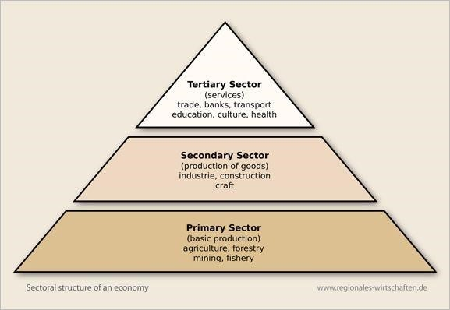

This model is no longer the right model for many specialists because there are so many services in the tertiary sector. This is why people are trying to separate the tertiary sector.

#### 2)New model

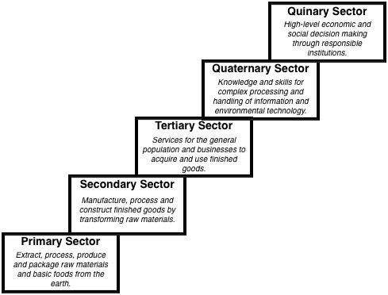

In this model we add a quaternary sector which has a notion of knowledge (intellectual activities, government, culture, libraries, scientific research, education). And the tertiary sector would be reserved for a notion of profit. Some people add a quinary sector for macroeconomic decision maker like governments, CEOs of huge companies.

V.Public or private sector?

The public sector is what is owned by the state, it provides essential services to citizens, even though the word essential means something different for everyone. The importance of the public sector depends on the political regime.

The private sector corresponds to what's owned by individuals or groups of individuals, the aim is to make a profit. Most companies belong to the private sector.

People in charities contribute to the economy even if they don't make any profit. This is what we called the third sector: non-governmental and nonprofit making organizations or associations (charities, voluntary and community groups…).

## 2 - Types of businesses and key elements

Introduction: what is a business?

A business is an organized effort to produce goods or services which can be supplied to satisfy the needs or wants of customers in exchange for a reward or payment which will give the producer or supplier an adequate return on his investment, i. e. make a profit.

A product is something sold by a business, it can be a good or a service.

A business is here to make a profit.

### I.Types of businesses

Some are small, local firms that only operate in their own neighborhoods.

Other are large corporations that may trade nationally or internationally.

Some may produce goods, some provide a service and some others do both, like computer stores that sell computers and also offer maintenance or/and advice.

Some organizations are considered as businesses, although we usually do not think of them in this way, like football clubs and even charities.

Whatever the size or the activity, all businesses exists for a purpose, which means that they all do something and have a (not so) good reason for doing it.

### II.Key elements for a business to operate

#### 1)Finance

Finance, funds, money to fund its activities. Depending on the activity you'll need more money. This money may come from the owner but most of the times it comes from the banks. It can be difficult to start a business because you need to collect money.

A venture capital is a risky investment.

#### 2)Labour

Labour to help develop a product or a service, and then to produce or deliver it.

3)Customers

Customers to buy the products or services.

#### 4)Suppliers

Suppliers to provide raw materials. You need to choose to locate your company either close to the suppliers or the customers, sometimes this choice is logical. If the supplier can't supply you then it will shut down your company. You may have several suppliers for the same raw material.

There can be a problem with duties.

5)Premises and equipment

The premises and equipment depend on the activity of the company.

#### 6)Management, organization and structure

Management refers to the way the management is realized, how orders are given in a company.

#### 7)Competitive edge

To retain a competitive edge over its competitors, a business needs to protect its innovations, its ideas and products.

→ By using patents or copyrights which make it illegal for another business to copy the product. The business can also authorize other businesses to use its products or its brand name, it will then receive royalties. A patent is an official document that gives a person or company the right to be the only one that makes or sells a product for a certain period of time. You don't have to fill a patent in every country anymore. You must pay to fill a patent. When you make a patent, your manufacturing process and formula are public. A copyright is the legal right to be the only one to reproduce, publish, and sell a book, a musical recording, etc., for a certain period of time.

→ By using secrecy like Coca Cola. On the 27 of May of 2016 the EU gave a directive on trade secrets.

→ By focusing on retaining key staff. People working in a company for a long time know many things about the company (suppliers, customers…), they're very important.

#### 8)Clear objectives

Aims and targets that the business sets itself and whishes to reach. You need many objectives at the same time: long-term and short-term objectives. You should compare regularly the objective and the result to figure if the objective is realistic. The objectives must be regularly reviewed so that progress can be monitored, and objectives adjusted.

Several possible objectives:

* To maximize profits
* To survive in the market
* To break even
* To increase market share
* To grow in size
* To sell abroad, to export
* To diversify and sell different products or services
* To give out more dividends to shareholders
* To improve its image
* To boost motivation among employees

#### 9)The strategy

To manage all these activities, a business needs a strategy.

An organization's strategy shows what the organization wants to achieve and how it will achieve it.

The strategy is about where the business is going to get in the short, medium or long term.

The strategy will determine which markets a business should compete in, how a business can perform better than its competitors, which resources are required in order to be able to compete. Your goal and strategy must be realistic and accorded to your company.

Depending on the strategy which will be finally implemented, a particular type of business structure will be chosen.

## 3 - Businesses in Britain

There are various business structures, each of them has advantages and drawbacks. A lot of companies start with a structure and then changes it when they grow in size. Choosing the structure depends on the activity.

There are 4 main business structures in the UK

ᵩ The sole proprietorship ᵩ The ordinary partnership ᵩ The

limited liability partnership ᵩ The company

### I.General notions

Two of these structures are created through the process of incorporation which means incorporated business structures. Incorporated means that the process enables the company to become a separate legal entity from the owner. In an incorporated business, the business can survive even if the owner are no longer in the picture. The business exists in its own right, it will operate whatever happens to the owner. The owner receives protection of its personal assets.

Other structures are unincorporated: sole proprietorship or ordinary partnership. The business entity and owners are one and the same. When the owner dies or disappears so does the business. The owners own the business in full and gets all the generated profits and also the losses. It is riskier.

### II.The sole proprietorship

It is the simplest and the most popular business structure.

A sole proprietorship is just a single natural person carrying on some form of business activity on his/her own account.

They can still have employees although most of them do not. The sole proprietors is the only one in charge.

The key point is that the sole proprietor is not incorporated, nor does the sole proprietor carry on business in partnership with anyone else.

The are two forms of proprietorships: sole practitioners and sole trader.

ᵩ A sole practitioner is a proprietor of a professional practice, therefore a member of a "profession". The word professional is currently used to broadly distinguish those who are paid for an activity and those who are not. It can be used more narrowly to describe a person who is the member of a profession. Form the time of the Middle Ages there were three accepted or recognized "learned" professions, namely the Church, the Law, and Medicine. So, today, when you use the expression "the profession" you mean professions related to law like lawyers and medical profession.

ᵩ A sole trader is everyone else. It is the most common form of business ownership in the UK (62.7%). A sole trading business is usually small in size, with a low turnover, and few, if any, employees.

There are an estimated 4.8 million active private sector businesses in the UK 3.6 million of these are class zero business, that is businesses without employees. This majority of sole trading enterprises are in the service sector, including photographers, plumbers, hairdressers, shops, real estate agencies and bed and breakfast hotels. Approximately 1 million size class zero businesses are in the construction sector and 1.1 million are in businessrelated services.

Starting business as a sole proprietor is highly simplified and involves much less formality than creating an LLP or company. Sole proprietors must register with HM Revenue and Customs (HMRC) and follow certain rules or running and naming their business. Being self-employed sole proprietors are required to complete their own tax returns. As a consequence, sole proprietors should maintain clear and accurate records of all transactions entered into.

Sole proprietors' duties:

→ Business Startup: you are in charge of coming up with a name for your business, securing the financing, finding a location for the business and registering your business as a sole proprietorship.

→ Day to Day Operations

→ Inventory and Stock: if your sole proprietorship is one that carries a lot of stock, it will be your responsibility to take inventory and to process orders. It will also be your job to unload orders as they are delivered.

→ Bookkeeping and Payroll: unless you hire an accountant, which many sole proprietors do, you will be responsible for keeping track of the books in your operation. And deal with human resources.

Sole proprietors often face challenges when trying to raise money. If partnerships can raise finance by admitting new partners, and public companies can finance by selling shares these options are not available to a sole proprietor who wishes to remain a sole proprietor. A sole proprietor will either need to invest his own money into the business or obtain a loan from a bank. However, banks are hesitant to lend to a sole proprietorship because of perceived lack of credibility when it comes to repayment if the business fails.

The main drawback of a sole proprietorship is that the liability of the sole proprietor is personal and unlimited. The liability is what it said by the law. So, you could lose everything if the business loses a lot of money. Because there is no legal separation between you and your business, you can be held personally liable for the debts and obligations of the business. For exemple, lawyers and doctors may pay huge fines. The sole proprietor's personal assets can be seized and sold (house, car, bank, account…). When the sole proprietor cannot pay his debts, he may be forced to dissolve his business by his creditors under a process called bankruptcy. The creditors ask the court for a bankruptcy order.

A trustee will then deal with assets and generally sell them.

The advantages are that it is small, easy to operate. It is easy to set up (little capital, few formalities). You are close to customers. There is no sharing of the profits.

The drawbacks are the financial liability, the limited funding, limited work resources (relies on one person only, little free time, not competent in every activity), the small profits.

### III.The partnerships

It's very similar to the sole proprietorship but there is not only one proprietor.

Partnerships are businesses owned by two or more people who have agreed to share the profits of a business carried on by all of them or any of them acting for all. The owners of partnership business are individually known as partners and collectively as a firm.

Partnerships are built on trust because you will share everything with the other partners. Each partner will act for the firm.

#### 1)The ordinary partnership

A partnership is a simple and flexible way for two or more people to own and run a profit-making business together.

The members of a general partnership have no financial protection if the business runs into trouble : each partner is responsible for the debts of the partnership as a whole. This means that the personal assets of each partner may be at risk if the business fails. Each partner are liable for the debts in full.

Disagreements or disputes between partners can cause difficulties, and the partnership may have to be dissolved if one of its members resigns or dies. There is no difference between the business and the owners, this is not an incorporated structure.

The solution to these problems is to right a document which will explain what will happen if one of the partners decide to leave or dies. This document is called "The deed of partnership". It is not compulsory but very practical. You can also right things about the day to day operations. A deed of partnership is a legally binding agreement which describe how the partnership will be run and what the rights and duties of the partners will be. In this document you'll find the name of the business, the name of the partners, the address… The deed of partnership will detail:

* The amount of capital that each partner will invest into the business. Not every partner must invest the same amount of money.
* The way in which partners will share profits or losses, and whether any of the partners should be paid a salary.
* Working arrangements: how much time each partner should contribute to the business, who does what, management tasks, and which decisions need collective agreement.
* Changes to the partnership: how new partners can be appointed and what happens if a partner wishes to leave or dies.

Even if the deed of partnership says that the partners decided to share the debts equally, they are still fully liable of the debts in full.

Any group of natural persons who want to set up a profit-making business together can form a partnership. However, if a member of a partnership is under the age of 18, he cannot be legally bound by the terms of the partnership agreement. It is also possible for companies and limited partnerships which are legal entities, to be members of a partnership.

If the rights and responsibilities of a partner depend on the partnership agreement or deed of partnership, they also depend on what type of partner they are.

There 3 types of partners:

* General partners: they invest in the business and have full responsibility for debts, as well as a share of profits. They engage fully in the day-today running of the partnership. All partnerships must have at least one general partner.
* Limited partners: they invest in the business and are only responsible for the initial amount invested. They are not legally allowed to take part in day-to-day decision-making.
* Sleeping (or dormant) partners: they invest money in the business and draw form its profits but cannot be involved in the day-to-day decision making. They are fully liable for any company debt. In general, they are former general partners or relatives wanting to help.

Legally the number of partners is limited to 20 partners but generally you have between 2 and 4 partners. The size is limited because it limits the risks.

The name of the company is generally the names of most important partners (ex: Smith, Martins and Jones) but partners can trade in any name as long as it is not the same as that of a competitor and as long as it does not deceive customers.

Each partner is the agent of his/her co-partners and enters into transactions on behalf of the firm.

The advantages : it is easier to find investment, partners can divide the control of the business and specialize, time off is possible (several people work together), the business can continue if one partner disappears provided you wrote a deed of partnership, taxation (firm not taxed on profits, only partners).

The drawbacks : the need to agree with other partners, the distribution of profits, the unlimited liability which is the major problem.

#### 2)The limited liability partnership (LLP)

It was created by the limited liability partnerships act 2000 (LLPA 2000): two or more person can now form an LLP.

Before the act was enacted, large professional firms (solicitors, accountants, etc.) were subject to the joint and several liability rule, even if they had hundreds of partners worldwide. Joint and several liability is when multiple parties can be held liable for the same event or act and be responsible for all restitution required. While the number of partners in firms is normally limited to 20 partners, there are exceptions to this rule: firms of both solicitors and accountants exist with well over 200 partners.

A limited liability partnership (LLP) shares many of the features of normal partnership but offers reduced personal responsibility for business debts. Unlike members of an ordinary partnerships, the LLP itself is responsible for any debts that it runs up, not the individual partners. The partners in a limited liability partnership are not personally liable for debts the business cannot pay. Their liability is limited to the amount of money the invest in the business. Limited liability partnerships are most often set up by professional services firms, like solicitors or accountants.

It will be more complicated to set up, it will have to meet some requirements of a limited company (incorporated). The less liability you have, the more control by the state you get. It is mostly used by professionals like accountants, lawyers, architects… But it is not much used: only 60k in the UK in 2014, still it is becoming increasingly popular.

Differences between the ordinary partnership and the LLP:

|  |  |
| --- | --- |
| Ordinary partnership | LLP |
| Can be formed informally | Formally incorporated (Registrar of companies) |
| No corporate personality | Corporate personality |
| Created by the Partnership Act of 1890 | Created by the LLPA 2000 |
| Owners are "partners" | Owners are "members" |
| Joint and several liability | Members are not liable (limited liability), the LLP is. |
| No disqualification | Disqualification it means that you can't join the LLP because of things you did in the past. |

#### 3)The limited partnerships

It is a general partnership with at least one limited partner and one general partner having full liability.

Limited partners are investors.

This structure is very rare.

### IV.Companies

They can be either private companies or public companies. Any company which is not public is private. Be careful, do not mix up with public sector. A public company is a company that sells its shares to the public. Most private companies are private limited companies.

#### 1)Private limited companies (Ltd)

The owners of Ltd are called shareholders and its means that they buy a share of a company. The liability is limited to the nominal value of the share. Shares cannot be sold to the general public, you can only sell your share to somebody who's approved by the other shareholders. Shareholders do not have to work in the company, it is an investment, but it's not forbidden for them to work in the company.

There are huge Ltd, very often they belong to a family.

A Ltd is a legal entity, it is incorporated.

To create a Ltd Co, you have to:

* Appoint directors, they will be in charge of running the company but they're not the owners. They are chosen by the shareholders to represent them in the day to day operations. All of them form the board of directors. Some shareholders may also be directors.
* Register the company in the Company House which is an executive agency of the department of business, innovation and skills (BIS). You will have to give the company's name and the registered address (which must be in the UK). The Ltd Co must have at least one director and at least one individual mini 16 years old. The minimum number of shareholders is one (maximum 50).
* Articles of Association which explains everything related to the day to day operations and the changes in the administration (shareholders…).
* There is no minimum capital, you can start a Ltd Co with very little money.

The director or the board of directors makes the management decisions. Directors may also be shareholders.

Finance comes from shareholders, loans and retained profits. Profits are usually distributed to shareholders in the form of dividends, apart form profits retained in the business as working capital. The shareholders have a real interest in the company, there is a real attachment to the company, instead of insisting on getting more dividends they'll prefer to do what is best for the company.

At the end of the fiscal year, they have to file their accounts with the Registrar of Companies. It's a way for the State to verify that the company respects the law, is viable… The advantages:

→ Limited liability

→ Dividends

→ Minimum 1 shareholder

The drawbacks:

→ Cannot sell share on the Stock market, you must sell your share to somebody approved by the shareholders, it's a long process. →

Limited capital (maximum of 50 shareholders) → Accounts are made public.

#### 2)Private unlimited companies

It is very rare and dangerous because there are no limit to the liability of the members. But there is more secrecy because you don't have to file your accounts except if it is a subsidiary of a limited company.

Creating this type of company means that you're willing to risk your own money. This creates more trust from your business partners (suppliers, customers, and banks).

This type of company only represents 1% of the private companies.

#### 3)Public limited companies (PLC)

There are also shareholders, but there is the possibility to sell shares to the public on the Stock Exchange or not. It is very quick and easy to buy a share.

This can also be a drawback because most of the time people don't even know the name of the company they invest in, which means the only interest is money.

The minimum of shareholders is 2 and there is no maximum.

The accounts must be filed within 6 months of end of year, PLCs must send a return to the Companies House once a year, this document explains how profits will be shared. Those documents are made to protect the public who will invest in the company. The easier to buy a share, the more control by the state.

The company secretary must be qualified. It is one of the directors and it is in charge of writing everything that is said or decided during the meetings of the board. This person must decide if what their decisions are legal or not.

There is a minimum of 2 directors (at least one individual over 16, and all directors who are individuals have to be over 16).

The minimum capital is £50k.

The company has to be incorporated at the Companies House.

Most public companies are not listed. Listed means that your company is on the stock exchange. In 2014, there were approximately there were 7,800 public companies in the UK, of which only about 2,400 were listed on the stock exchange.

In the UK Stock Exchange, the AIM (alternative investment market) is a market that is a stock exchange only for startups and recent firms. Whereas the main market is more for established companies.

If they are listed, PLCs must comply with the Listing Rules. The listing rules are drafted, administrated and updated by the Financial Conduct Authority which regulates all financial services in the UK. The PLCs must respect the rules of supply and demand. You can't use the secrets of the company to your own advantage. They impose obligations upon listed companies in relation to the disclosure of information and in terms of internal control. You must hire experts like accountants and auditors to control the accounts of the company.

It means that listed PLCs are regulated even more strictly than the other PLCs.

The advantages :

→ Better access to capital

→ Easy to buy and sell shares

→ It gives a company a more prestigious profile

The drawbacks

→ Financial markets govern the value of the company

→ Large number of shareholders who don't really care about the company.

→ Public scrutiny of company's finances

### V.Worker cooperatives

A co-op is a group of people that organize together, as equals, to help everyone in the group. A workers' co-op could be defined as a business owned and managed collectively by its workers for their mutual benefit. It's organized democratically and fairly by (and only by) its members.

This type of business is developing a lot. It started when companies had trouble and the workers took the companies.

The membership is open and voluntary. It is controlled only by their members, who each have equal control. All members have a fair stake in the co-op. Investment does not give control and only gives a small return. The goal is to ensure that the company will survive, not to make huge profits.

All the workers are autonomous and there is an independent self-help organization. The aim is also to educate and train their members, so they can contribute to the co-op. There is also co-operation among co-ops benefits members and the wider co-op movement. Co-ops act with concern for the community.

The principle is one worker, one share, one vote, and also the pay-scale difference ratio which means that there are different salaries depending on the activity, but the difference is limited to 4 times, the highest salary can only be 4 times higher than the lowest one. There is also patronage dividend, it means they'll get a dividend but not a big one.

The advantages:

→ Democratic management

→ Commitment of workers

→ Fulfilment of workers

The drawbacks:

→ Conflicts between workers

→ Long decision-making process

→ Limited finances

## 4 - Businesses in the USA

There are three basic types of business organizations :

* The sole proprietorship is the simplest business structure. The sole owner and his/her business are not legally distinct entities. The owner has unlimited liability for debts of the business.

* The partnership is the required structure (no choice) when two or more individuals are the owners, having expressly or implicitly agreed to establish and run a business for profit.

There are two basic type of partnership: general and limited.

* The corporation which has a distinct legal entity, an existence separated from its shareholder owners. It is usually created under state law. For business purposes, a business entity is deemed a corporation rather than a partnership only if the entity has at least three of the following four traits:

→ Limited liability

→ Centralized management

→ Continuity of life

→ Free transferability if interest

However, there are many subtypes like S corporations, close corporations, professional corporations, nonprofit corporations…

### I.The sole proprietorship

It is the simplest and the most common structure chosen to start a business.

It is an unincorporated business owned and run by one individual with no distinction between the business and the owner.

No formal action is required to form a sole proprietorship. As long as there is one only owner: this status automatically comes from the business activities.

In fact, one may already own one without knowing it. A freelance writer, for instance, is a sole proprietor.

It is necessary to obtain the obligatory licenses and permits.

In the USA, regulations vary by industry, state and locality.

If owners choose to operate under a name different than their own, they will most likely have to file a fictitious name (also known as an assumed name, trade name, or DBA). Sometimes, you need to file in every county.

In the USA, the expression sole practitioner or solo practitioner often refers to a self-employed lawyer engaged in the private practice of law. A sole trader is a more common way to call a sole proprietor, which is the expression used in legal documents.

### II.The partnership

1)The general partnership It is very easy to set up.

You only need a partnership agreement; it can be implicit. It is created by implied or express agreements, oral or written. In a partnership every partner is liable for the debts in full.

For implied partnerships, the court generally must find:

* Joint ownership of a business
* Sharing of profits or losses
* Equal management of rights

The Uniform Partnership Act (UPA) provides guidance on partnership issues not covered by the partnership agreement.

In most ordinary business matters, a partner's actions may bind the entire partnership. Routine decisions are usually decided by majority vote, with each partner having one vote.

Partners are tenants in partnership. They have duties to give partnership information to other partners, work on behalf of the partnership, and not compete with the partnership.

Partners are principals and agents for each other. Each partner must act in good faith for the benefit of the partnership.

#### 2)Limited partnership

They key feature of a US Limited Partnership is that there are two distinct types of partners, general and limited.

A general partner in a limited partnership has essentially the same rights and duties as do general partners in a general partnership.

A limited partner (sometimes referred to as "silent partner") contributes financially and receives a specified share of the limited partnership's profits.

He does not participate in management, he has no voting power or control over its day to day operation and is not held personally liable for partnership obligations beyond the amount he invested.

The limited partnership must meet state statutory requirements. The applicable law is the individual state's version of the revised uniform limited partnership act (RULAP) as well as the written partnership agreement.

Unlike a general partnership, a limited partnership must be based on a written agreement that is signed by all partners (limited and general) it is filed with designated state office, being the Corporations and Securities Bureau.

Forms must give information about the partners, assets and resources of the limited partnership, the purpose of the business, and other relevant information.

In some states where filling for an assumed name for a general partnership is done county by county, obtaining an assumed name for use throughout the state is easier for the limited partnership than for the general partnership.

Limited partnerships have at least one of each of the two types of partners: general and limited

A limited partner is protected from unlimited liability so long as he does not participate in management on any way. This prohibition on participation in management must be observed carefully and stringently. Otherwise, a limited partner loses his or her status as a limited partnership and is treated a general partnership with respect to the partnership's liabilities.

#### 3)Limited liability partnerships

Each partner in an LLP has unlimited liability for his own actions but is protected from personal liability for the partnership's or other partners' act or obligations.

This protection applies so long as the partners are not supervising, directing, or otherwise involved in the negligent activity.

The partner who engages in malpractice is, however personally liable for his or her own tort.

It doesn't exist in all American states. This is true in most states, but rules for the LLPs vary greatly from state to state. For example, a few states (Oregon, New York, Nevada, California) allow LLPs only for professionals of law, accounting architecture…

#### 4)Limited liability limited partnerships

The LLLP is found in only about ten states, among which Arizona, Arkansas, Colorado, Delaware, Florida, Georgia, Maryland, Nevada, Texas, and Kentucky.

An LLLP is a type of limited partnership, with both general and limited partners, but the LLLP status affords even the general partners limited liability for the LLLP's debts and obligations.

Therefore, the general partners are only liable for the debts and obligations of their own actions and are not liable for the negligence or misconduct of the other general partners.

A limited liability partnership (LLP) differs from a limited liability limited partnership (LLLP) in that the LLP does not have limited partners.

The best way to think about the difference between an LLP and an LLLP is that an LLP is a general partnership with limited liability protection, whereas an LLLP is a limited partnership with limited liability protection:

* LLP = GP with limited liability protection
* LLLP = LP with liability protection

### III.Corporations

Company and corporation are not synonymous.

In Britain, when people talk about a corporation, they often allude to an American corporation , or a multinational corporation. Or, they may refer to an organization or a group of organizations that is recognized by law as single unit, like the British Broadcasting Corporation. They often mean a public corporation, a state-owned enterprise. In fact, the British equivalent of an American corporation is often a public limited company.

This separation gives the corporation a life of its own and the responsibility and accountability to the law that are attributable to a natural person. If all the shareholders, directors and employees of a corporation were to die ina common accident, the corporation would continue to exist: stock ownership would pass to heirs of the deceased shareholders.

Since a corporation is a legal entity separated from its shareholders, it is liable for its debts. However, the courts will hold the principal personally liable if the corporate name is used as a false front.

One must add that US courts are often reluctant to disregard the corporate protection that is given to shareholders. Piercing the corporate veil is extremely rare. In the whole US, reported court decisions piercing the corporate veil may represent 15 to 20 cases a year.

Now, one of the problems that arises is the implications this might have for corporate responsibility.

#### 1)Public corporations

It is formed to meet a governmental or public purpose. Generally, a public corporation is created for the direct function of government – town, city, or county.

The National Railroad Passenger Corporation, doing business as Amtrak, is a publicly funded railroad service operated and managed as a for-profit corporation to provide intercity passenger train service in the USA.

#### 2)Hybrids

They have features of both public and private corporations. These quasipublic corporations are public utilities - privately owned businesses created for public purposes.

These monopolies, or partial monopolies, are strictly controlled in terms of services and prices.

Many quasi-public corporations were originally federal agencies that have been privatized. Among the best known are Fannie Mae and Freddie Mac which securitize consumer loans. The US Postal Service is also a quasipublic corporation.

#### 3)Private corporations

A corporation is said to be domestic in the state of its incorporation, the state of its birth. With respect to all other states, it is a foreign corporation. Thus, in Maryland, a Maryland corporation is a domestic corporation. In all other states, it is foreign.

Corporations formed in foreign countries are called alien corporations.

#### 4)C Corporations

A C corporation is an independent legal entity owned by shareholders. This means that the corporation itself (not the shareholders) is held legally liable for the actions and debts of the business.

Corporations are more complex than other business structures because they tend to have costly administrative fees and complex tax and legal requirements. Because of these issues, corporations are generally suggested for established, larger companies with multiple employees.

For businesses in that position, corporations offer the ability to sell ownership shares in the business through stock offerings.

Now, in the USA, for most legal purposes a corporation is considered to be a person. Like any citizen, it can sue and be sued, make contracts, own property, and perform other personal acts. It can be charged with almost any crime except crimes for which the sole punishment is imprisonment. So, if a corporation is convicted of a crime, the corporation's penalty could be a fine, or the corporation could lose its corporate charter (usually granted by a state), or a government license… This is very rare, and it would mean a very serious crime.

What is more, for most purposes, a corporation is entitled to the protections given to citizens under the Bill of Rights excepted right against selfincrimination provided for in the 5th Amendment.

#### 5)Publicly held corporations

The word corporation often refers to a publicly held corporation. A publicly held corporation is a publicly traded corporation. The shares of such corporations are traded on a public stock exchange (New York Stock Exchange or Nasdaq.)

The affaires of publicly held and closely corporations are similar in many respects. The main difference is that, publicly held corporations have the burden of complying with additional securities laws.

They may also require stricter corporate governance standards, and additional procedural obligations in connection with major corporate transactions such as mergers, acquisitions or elections of directors (antitrust laws).

Publicly held corporations must follow the financial reporting and disclosure requirements of the Securities and Exchange Commission (SEC). The SEC regulates all stock offerings. The SEC regulations are designed to keep stockholders informed of the financial condition of the corporation.

Publicly held corporations are responsible for much of the business activity of the USA. Even if most people do not work for this type of corporation.

Corporations that have the ability to raise capital by selling share to the general public can accumulate large amounts of capital for use in their business. It must be remembered however, that not all corporations are publicly held, and there are some very large corporations that remain privately held. There are also many other forms of corporations in the USA.

#### 6)Close corporations

A close corporation is generally a small stock corporation whose shares are held by relatively few people, frequently members of a family.

There are therefore entitled to operate without the strict formalities normally required for standard corporations. In fact, a close corporation is a corporation whose shareholders and directors are entitled to operate much like a partnership. Some states do not authorize them.

In most states, a close corporation cannot have more than 30 to 35 shareholders. A close corporation cannot make a public offering of its stock.

Close corporation enjoy relaxed rules with respect to the formalities of governance. For example, close corporation shareholders typically need not hold formal annual meetings.

#### 7)S Corporations

S Corporations are organized to minimize the effect of federal income taxes on small businesses, by eliminating double taxation.

In the USA, federal taxation is applied first to the corporation's income, and second to the individual shareholders' income in the form of earnings and dividends. What makes the S Corp different from a traditional corporation is that profits and losses can pass through shareholders' personal tax returns : the business is not taxed itself, only the shareholders are taxed.

However, there is an important limit: any shareholder who works for the company must pay himself "reasonable compensation". Basically, the shareholder must be paid fair market value.

S Corps must have 100 or fewer shareholders.

They do not exist in every state. It exists in liberal states.

#### 8)Professional corporations

Professional corporations are created by lawyers, doctors, accountants, architects, engineers, and other professionals in order to gain corporate tax advantages for traditional partnership or proprietorship activities.

These corporations are organized under state law enacted in conformity with internal revenue code requirements.

Professional corporations are generally identified by abbreviations:

→ P.A. : Professional Association

→ P.C. : Professional Corporation

→ S.C. : Service Corporation

#### 9)Conclusion on large companies

Although there are many small and medium-sized companies, big business units play a dominant role in the American economy.

Corporations in the USA account for more than 85% of business sales, although they are 20% of all companies.

Large companies can supply goods and services to a greater number of people, and they are often more efficient than small one.

They have an advantage in the marketplace because many consumers are attracted to well-known brand names, which they think guarantee a certain level of quality.

Advantages of large corporations:

* A lot of financial resources (R&D)
* More job opportunities and job stability.
* Better wages, retirement and health benefits.

Disadvantages of large corporations:

* Less choice for consumers
* Inflexibility

### IV.Employee Stock Ownership Plan (ESOP)

A separate entity acquires some of the company's stock for the benefit of employees.

The employees are not the owners of the shares. They are not shareholders. They are part of a group and the group owns shares.

It is not necessarily a democratic structure.

Workers receive the amount of their shares when leaving the company.

There is a gain in productivity.

## 5 - Mergers and acquisitions

This is a way for businesses to expand or reorganize their activities.

### I.Mergers

A merger is a corporate strategy of combining different companies into a single one in order to improve the financial and operational strengths of the existing organizations.

Company A + Company B = Company C

A merger usually involves combining two companies into a single larger one.

The combination of the two companies involves a transfer of ownership, either through a stock swap or a cash payment between the two entities.

#### 1)Horizontal mergers

Horizontal mergers may happen between two companies in the same industry, such as banks or steel companies. Acquiring a competitor in the same field of activity means:

* Acquiring a larger market share
* Reducing competition

#### 2)Vertical mergers

Vertical mergers occur between two companies in the same industry value chain, such as a supplier or distributor or manufacturer.

* Backward integration: acquiring suppliers or raw materials.
* Forward integration: taking over distributors or retail outlets.

A merger sometimes involves new branding or identity of the merged companies. Otherwise, a merger may lead to a combination of the names of the two companies, capitalizing on the brand identity of both companies.

Mergers may result in a stronger company with combined assets, competencies, and markets, but mergers can fail because of the clash of corporate cultures between the two companies.

### II.Buyouts

A buyout as the name suggests is a situation in which a person or groups gains control of a company by buying all or most of its shares. In practice, the purchase of at least 51% of a company may suffice to control it. Under a buyout, the previous ownership loses control over the company in exchange for compensation.

The buyout process usually begins when an interested purchaser or group of purchasers makes a formal buyout offer to a company's board of directors, who are the representatives of the company's shareholders.

Negotiations and/or a tender offer ensue, and the board of directors eventually either recommends that the shareholders sell their shares to the purchaser or discourages the shareholders from doing so.

Buyouts occur for several reasons:

* Because the purchaser believes a company's assets are undervalued and can be resold for a profit.
* Because the purchaser believes it will receive financial and strategic benefits from the buyout such as higher revenues, easier entry into new markets, less competition, or improved operational efficiency.
* Ultimately, nearly all buyouts occur because the purchaser believes it can provide more value to a company's shareholders than the company's current management can.

Sharks buyout companies in difficulties and make them wealthier and then they sell them with a profit.

### III.Takeovers

A takeover is also the act of getting control of a company by buying more than half of its shares. In fact, a friendly takeover is very much like a buyout.

It can happen on the stock exchange.

A hostile takeover is the acquisition of one company (called the target company) by another (called the acquirer) that is accomplished not by coming to an agreement with the target company's management, but by going directly to the company's shareholders or fighting to replace management in order to get the acquisition approved. Either you buy the shares on the stock exchange or you convince the shareholders to sell their shares. You can also convince the shareholders to choose new directors.

Most takeovers are launched for industrial reasons: for instance, pharmaceutical companies will want to acquire their competitors to become market leader, achieve economies of scale, or find new customers.

Hostile takeovers are usually bad news, affecting employee morale at the targeted firm, which can quickly turn to animosity against the acquiring firm.

### IV.Vocabulary

A tender offer is an offer to purchase some or all of shareholders' shares in a corporation. The price offered is usually at a premium to the market price.

A proxy is a document that you sign when you can't attend a meeting in which there is a vote. You give your proxy to another shareholder who will vote for you.

The joint venture is when a business arrangement in which two or more parties agree to pool their resources for the purpose of accomplishing a specific task.

The dawn raid is when a firm or investor buys a substantial number of shares in a company when the stock markets opens. By getting the brokers to conduct the buying of shares in the target company a.k.a. the “victim”, the acquirer

a.k.a. the "predator“ masks its identity and thus its intention. Because this is done early in the morning, the target firm usually does not get informed about the purchases until it is too late, and the acquirer has got control. There are now restrictions on such practices.

A Saturday night special is a sudden attempt by one company to take over another by making a public tender offer. The name comes from the fact that these maneuvers used to be done over the weekends. This has been restricted by the Williams Act (1968) in the U.S., whereby acquisitions of 5% or more of equity must be disclosed to the Securities Exchange

Commission. In many cases the target company does not want to be taken over. That type of strategy aims at affecting the value of the target's stock.

A white knight is a company "the good guy" that rushed in to make a friendly takeover offer to a target company that is facing a hostile takeover from another corporation "the black knight".

A poison pill is a strategy used by corporations to discourage hostile takeovers. With a poison pill, the target company attempts to make its stock less attractive to the acquirer. For example, it allows existing shareholders (except the bidding company) to buy more shares at a discount. Thus, investors get instant profits and, more importantly, they dilute the shares held by the acquirer. This makes the takeover attempt more difficult and more expensive.

→ Lobster trap (voting rights)

→ Shark repellent

→ Macaroni defense (bonds)

→ Whitemail (below-market prices)

→ Bankmail

→ Greenmail = bon voyage bonus= goodbye kiss

→ Black knight

→ Yellow knight

→ Lady Macbeth strategy

→ Pac Man

→ Sleeping Beauty

## 6 - Other types of companies

### I.Blue chips

Blue chips are nationally recognized, well-established and financially sound companies. They generally sell high quality, widely accepted products and services.

Blue chip companies are known to withstand economic downturns and operate profitably in the face of adverse conditions, i.e. they are stable and reliable.

There is no precise definition but characteristics like private capital, quoted on major SE, and large capitalization.

→ Small cap companies ($300m-$2bn)

→ Mid cap companies ($2bn-$10bn)

### II.Parent companies

A parent company controls other companies by owning all, or a majority of, their stock. Parent companies will typically be larger entities that exercise control over one or more small subsidiaries, whether in the same industry or in other industries.

Parent companies can be either hands-on or hands-off with subsidiaries, depending on the amount of managerial control given to subsidiary managers. A hands-on policy means that they control their subsidiaries tightly, a handsoff policy entails that they leave a large autonomy to their subsidiaries, provided the latter make enough money to justify their independence.

Companies can become parent companies by many different means. The two most common ways are through the acquisition of smaller companies or the creation of subsidiaries. When a parent company owns a subsidiary completely and there are no minority shareholders, then the subsidiary is known as a wholly owned subsidiary.

#### 1)Holding company

Sometimes a parent company is structured as a holding company. A holding company’s only purpose is to control another company rather than to produce its own goods or services. A holding company’s operations consist of overseeing the companies it owns. It can hire and fire managers if necessary, but those companies’ managers are responsible for their own operations, the holding company is not.

One of the main reasons for creating a holding company is to protect oneself against losses. If one of the companies goes bankrupt, the holding company experiences a capital loss and a decline in net worth, but the bankrupt company’s debtors and creditors cannot pursue the holding company for remuneration.

Thus, a major corporation might structure itself as a holding company with one subsidiary to own its brand name and trademarks, another to own its equipment, etc. This way, each subsidiary as well as the holding company itself has limited financial and legal liability.

### III.Multinational companies (MNC) or transitional corporation

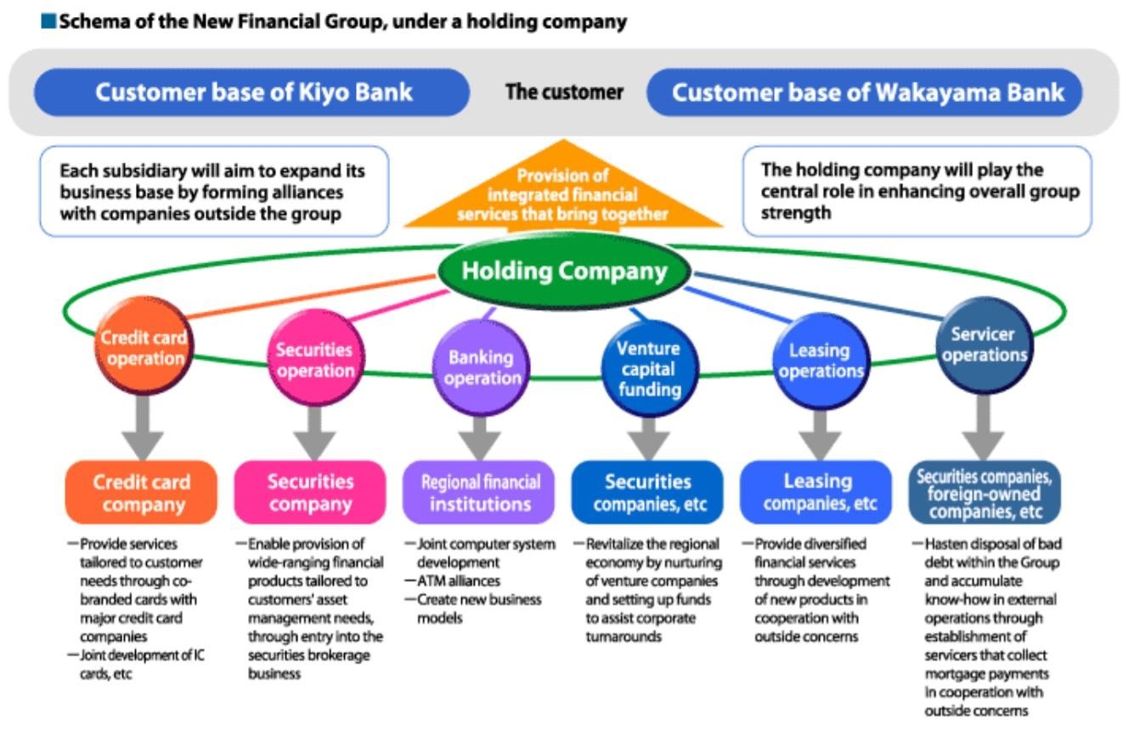

### (TNC)

An enterprise operating in several countries but managed from one country (=home country). Generally, any company or group that derives a quarter of its revenue from operations outside of its home country is considered a multinational corporation.

Executive headquarters/Production facilities

Four main categories:

→ a multinational, decentralized corporation with strong home country presence.

→ a global, centralized corporation that acquires cost advantage through the outsourcing of production wherever cheaper resources are available.

→ an international company that builds on the parent corporation's technology or research & development.

→ a transnational enterprise that combines these three approaches.

According to the United Nations, some 35,000 companies have direct investment in foreign countries, and the largest 100 of them control about 40% of world trade.

A conglomerate is a corporation that is made up of a number of different, seemingly unrelated businesses. In a conglomerate, one company owns a controlling stake in a number of smaller companies, which conduct business separately.

An affiliate is a type of inter-company relationship in which one of the companies owns less than a majority of the other company's stock.

In Europe and the USA, conglomerates have known their heyday in the period between the 1960s and the 1980s.Since then, many conglomerates have reduced the number of businesses under their management (downsizing) to concentrate on a few choice subsidiaries.

However, gigantic conglomerates are still on a roll in other parts of the world, notably Korea where they are known as chaebol. Each chaebol is owned, controlled or managed by the same family dynasty, generally that of the group's founder. LG, Hyundai and Samsung are among the biggest and most prominent chaebol.

### IV.Startup companies

A startup is a company that is in the first stage of its operations. These companies are often initially founded to develop a product or service for which it is believed there is a demand.

Due to limited revenue or high costs, most of these small-scale operations are not sustainable in the long term without additional funding from venture capitalists.

Startups need to consider what legal structure best fits their entity.

# 2nd PRESENTATION: HISTORY AND GLOBALIZATION

## 1 - Brief history of corporations

Whether in Britain or in the USA, most of the production of goods and services in undertaken by incorporated businesses, whose legal identity is distinct from the individuals that own them. The main exceptions include agriculture and crafts where family-based production still predominate and relies on other business structures (sole proprietorship, partnership…) Also, basic public services such as education, defense or police are provided by government organizations (military forces…).

The idea of big companies is quite recent, before the industrial revolution, biggest companies were agricultural plantations (US) or companies involved in selling products in colonies. Manufacturing was a network of self-employed, home-based workers. It led to the industrial revolution with the steam engine and steam-powered machinery. Workers began to be gathered in factories.

I.Modern corporation in the second half of the 19th century Modern corporations date back to second half of the 19th century.

Their ancestors are the colonial trading companies such as the East India Company or the Hudson's Bay Company which thrived on a quasimonopoly. The British East India Company was the most fully developed and was instrumental in the spread of the empire and also in inventing the legal concept according to which a corporation is a separate entity form its owners.

### 1)Elements of context

1. Boston Tea Party

It's a rebellion of some Americans against England. England was conducting a lot of wars, so they needed money. They increased taxes and created taxes, they decided to tax all the products that came from the colonies (tea, spices…). The Americans weren't pleased to pay taxes for the tea, so they decided to smuggle tea, the East India Company started to lose money. They put pression on the English government to do something. The government decided to keep the tax imposed except for the East India Company. The Americans didn't agree. They decided to through away the tea.

This revolution led to independence.

1. Adam Smith: The Wealth of Nations

It is a very important book that started to define a certain number of principles that we still use today.

He insists on the fact that big companies are going to be dangerous for democracy. He says that it is the responsibility of states to limit their powers. He thinks that their power can become higher than some states'.

1. Chartered companies

A chartered company isn't publicly owned, but it is a privately-owned company that can be in charge of an activity that corresponds to a public service, but the government has to give permission. It is a sort of contract between the government and a private owned company, in this contract the government allows a company to operate a public service. Most of the time is for a limited time.

### 2)Creation of limited liability in the UK

Joint Stock Companies Registration and Regulation Act in 1844. It created the Registrar of Joint Stock Companies, it created the fact that companies must be incorporated and registered in this document.

In 1856 the Joint Stock Companies Registration and Regulation Act was passed, and it created limited liability.

### 3)Creation of limited liability in the USA

The first modern limited liability law was enacted by the state of New York in 1811. A majority of US states had adopted similar statutory regime by 1860.

The decisions taken by the Supreme Court are very important in the US like the Santa Clara County vs. Southern Pacific Railroad in 1886. This decision entitled to protection under the Bill of Rights. The 14th amendment to the US constitution says: "no state shall deprive any person of life, liberty or property".

4)Railroad tycoons and robber barons This is about cartels and monopolies.

A law was enacted against the monopolies : the Sherman Antitrust Law of 1890, it targeted contract to restrain free trade and protected consumers from unfair business practices.

This law wasn't enough no they created the Clayton Act in 1914 which provided more detailed provisions to prohibit anticompetitive price discrimination. There are 2 sides, the first one is to prevent anticompetitive mergers, the second one is to protect the unions.

### II.Effects of the WW1 and WW2

Many things happened during this period:

* The creation of the Labour movement between the two World wars
* The Great Depression of the 1930's
* The ensuing New Deal in the US
* WW2
* The creation of welfare states in Europe

It created the return of state intervention with the Wagner Act of 1935 it's also called National Labour Relations Act it's going to promote unionism and give a lot of powers to trade unions. These powers were limited by the Taft-Hartley Act of 1947, it created restrictions over:

* closed shop: if you wanted to imply to a job in a company you needed to join the union, this act stopped it.
* jurisdictional strike: with this act a strike could only happen if there was a dispute between the workers and their boss inside the company.

Harry Truman's Fair Deal of 1945 to 1953, he tried to have the same kind of policies as the New Deal, he was against the Taft-Hartley Act, so he vetoed this law, but he was overruled by both chambers.

The "banana republic" in 1953 in Guatemala.

In the 1960s a form of social activism was created in the US, it is a bit special because it is linked to the black liberation movement.

From the 1950's to1980's : social welfare provision and state intervention are developed everywhere.

Milton Friedman unfettered capitalism (neoliberalism), he thought that liberalism itself was a good thing, if capitalism was left alone it would bring good things. In the early 1980's, Thatcher, Mulroney and Reagan embodied this idea that capitalism should be left alone as much as possible. Their strategy was : the less state intervention, they would never intervene in economic matters. They advocate tax cuts, a reduction in social welfare, and more privatizations because they consider that governments are not very skilled in dealing with economic matters and they're not very able to manage corporations. They are in favor of free trade and deregulation (fewer intervention of the state on economic matters and fewer regulations), they also want to downsize government. Margaret Thatcher used the expression : there is no alternative (TINA).

## 2 - Globalization

Globalization is the process of increasing inter-connectedness between societies, which entails that events in one part of the world have deeper effects on faraway people and societies. Each country is influenced by the international influence.

The word seems to be shrinking – a global village – and people are increasingly aware of this situation.

In other words, societies are affected more and more extensively and more and more deeply by events of other societies. The events are usually divided into three main types: social, political, and economic.

I.Is globalization synonymous with internationalization ?

Can we say that we live in a truly global society or are they differences? We live in an international society but not on a global one.

There is a progressive removal of official restrictions on transfers of resources between countries, which means the creation of a world based on open borders. If there are no borders at all then there is a total liberalization.

Liberalization is the process according to which people, goods, services can circulate throughout the world economy free from state-imposed controls.

Internationalization occurs through trade, which is the sale and shipment of goods, services, from one country to another, or through direct investment which means building or acquiring productive assets in another country.

### II.Types of industries

#### 1)Sheltered industries

Sheltered industries are served almost exclusively by local firms. They are sheltered from international competition by regulation, public ownership, barriers to trade. Above all, the goods and services they propose are more suited to small local businesses than to big multiunit corporations.

Examples:

→ Dry-cleaning

→ Hairdressing

→ Railroads

#### 2)Trading industries

Trading industries are those whose internationalization occurs primarily through imports and exports. If a product is transportable and not nationally differentiated, exporting from a single location is the most efficient way to exploit overseas markets.

Example :

→ agriculture

→ aerospace

→ shipbuilding

→ Coltan mining

→ military hardware

#### 3)Multidomestic industries

Multidomestic industries are those that internationalize through direct investment, either because trade is not feasible (as in the case of service industries such as banking, consulting or hotels). Or because products are nationally differentiated (frozen food, recorded music…).

#### 4)Global industries

Global industries are those in which both trade and direct investment are important. Most large-scale manufacturing industries evolve towards global structures (cars, consumer electronics, pharmaceuticals) Examples:

→ Automobiles

→ Oil

→ Pharmaceuticals

→ Consumer electronics

### III.Joint venture and strategic alliance

During the past two decades, an interesting feature of the development of international business has been the increase in the numbers of joint ventures and strategic alliances across national borders.

#### 1)Joint venture

A joint venture is a partnership in which two or more companies (often from different countries) join forces to undertake a major project.

Governments in fast developing countries like China or India often oblige foreign companies to take a local partner.

Advantages of joint ventures:

* Shared technology
* Shared marketing and management expertise
* Shared risk
* Entry into markets where foreign companies are often not allowed

Drawbacks of joint ventures:

* Theft of technology
* Obsolete technology
* Lack of flexibility

Examples of Joint Ventures:

* Britain's luxury car maker Jaguar Land Rover with Chinese company Chery Automobile.
* Kellogg Company (NYSE: world's leading producer of cereal) and Wilmar International Ltd (SGX – Singapore SE: Asia's leading agribusiness group)

#### 2)Strategic alliance

A strategic alliance is a long-term partnership between two or more companies established to help each company build competitive market advantages. Such alliances can provide access to markets, capital, and technical expertise.

Unlike joint ventures, they do not typically involve sharing costs, risks, management or even profits.

### IV.Extra-vocabulary

A single market is an enhanced free-trade area where goods, services, investments, people circulate freely. It is created to harmonize regulations.

A customs union is a free trade area which means a common system of tariffs and import quotas that apply to non-members (CET = Common External Tariff).

Free trade agreements (free trade area) :

* North American Free Trade Agreement (NAFTA) with Canada, the US and Mexico
* Association of Southeast Asian Nations Free Trade Area (AFTA) with

Brunei, Indonesia, Malaysia, Philippines, Singapore, Thailand, Vietnam, Laos, Myanmar…

# 3rd PRESENTATION: STRUCTURES AND MANAGEMENT

1 - The structures inside the company

## I.Vertical structures

1)Traditional structure : top down There is communication that is vertical.

(mettre graphique sur moodle)

The organization is called top down, which means that the information comes from the top and goes down. At the top there is a person that oversees everything.

The central person is the CEO, then there are :

* Executive vice-presidents
* Division managers
* Department managers
* Supervisors
* Foremen/forewomen
* Workers

Each layer gives orders to the layer under it.

Top management decides on objectives, provides information, plans and guidelines. They are the only one who have the full picture, and who know everything going on in the company. Top management funds processes.

This type of management is called predict and control management. Managers are at the core; they are responsible for the failures. Managers behave like parents and workers behave like children.

The advantages:

* Long term planning easy
* Consistency: you will find the same organization in all departments.

The drawbacks:

* There is only one person in charge
* Inflexibility
* People do not feel listened to, which leads to a lack of motivation
* Burden on managers
* Stovepipe model: it can be useful but not in a company, this is the kind of model that you find in secret services.

### 2)Bottom up structure

Managers will only communicate the goals and the values, that's called milestone planning. Teams must reach these milestones. Teams are free to decide on methods and ways to reach the milestones.

This was invented to solve the problems of top-down organization, and to improve the communication. (mettre graphique voir moodle) The advantages:

* More input from the workers
* More motivation
* More creativity
* Employees feel valued
* More transparency

The drawbacks:

* Long-term planning is difficult
* Less consistency

Both top-down and bottom-up are vertical structures, both have advantages and drawbacks. A mix is always possible and even advisable. When everything is going normally we can use a bottom-up structure but when there is an emergency situation we go back to a top-down structure.

### 3)Current problems

Workers want more freedom because they are more educated. They also want more autonomy, they do not want to obey without thinking, they want to have a say, they are highly-skilled so they are less easily managed. They want fulfillment.

Vertical structures don’t fit to the new workers.

### 4)The words of the day

→ Empowerment of the workers, every worker should get power when possible.

→ Initiative

→ Engaging workers, to be committed to the company.

→ Managers vs. mentors

## II.Horizontal/flat structures

(mettre graphique moodle)

Fewer layers in the hierarchy so each manager supervises a larger number of people. Fewer managers above one to rely on for guidance.

The advantages:

* Quick decision-making
* Fixability
* Cross-training: helping each other, sharing what they know. - Less bureaucracy

The drawbacks:

* Workforce reduction, there is a loss of experienced managers

(institutional memory)

* Breaking up of specialized lines of business (lack of expertise) - Uncertain career paths

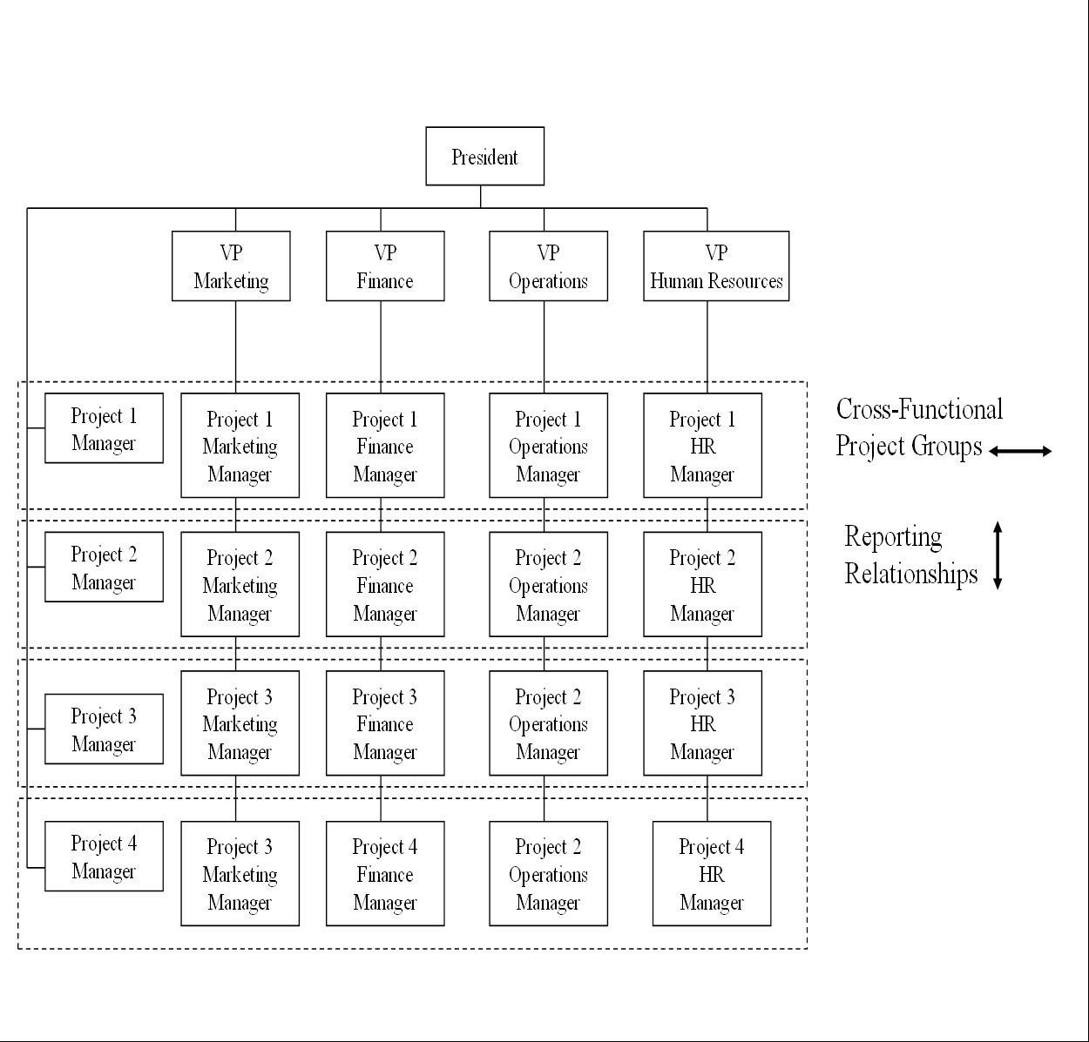

III.



Matrixed organizations



The company keeps its lines of business expertise and brings together specialists from each vertical organisation to work on temporary projects

There is double accountability: vertical to line-of-business superiors and horizontal to project’s teammates.

The advantages:

* Core competencies are maintained
* Using the best specialists for each project
* Better contact between different lines of business expertise

The drawbacks:

* Accountability
* Authority
* Loyalty
* Fragmentation

## IV.Holacracy

Arthur Koestler: The Ghost in the Machine

→ "Holons" are the parts that are autonomous and self-reliant but also dependent on the whole they belong to. They are both autonomous wholes and dependent parts.

Holacracy was invented by Brian Robertson /Ternary Software. It's an organisation split into different "roles", which means functions. Nobody is permanently attached to these roles. People energise these roles in turn. Roles organised in "circles", these circles have the authority to create, execute, and measure their own processes in achieving their aims. The circles are connected by special roles called links.

The advantages:

* increases agility, creativity, innovation
* increases transparency
* encourages team members to take initiative
* increases accountability so reduces the burden on leaders

(distributed responsibility)

The drawbacks:

* People have to get used to it
* Implies that workers are willing to take more responsibility

The relationship between organisational structure and culture depends on the type of activity or industry and on the location.

2 - Management and leadership

## I.Management vs. leadership

Leaders can be:

→ appointed, in that case they need endorsement of the group.

elected, this is more democratic, but it creates problems of

individuals. → emergent which means they are out of necessity.

According to T. Harris and J. Sherblom in "small group and team communication", there are different types of leaders:

* Leader-as-technician
* Leader-as-conductor
* Leader-as-coach
* Task-oriented
* People-oriented

## II.Different management styles and adapting styles to the situation and the people

### 1)Different management styles

There are different management styles like:

* The autocratic style, which means
* The democratic or participative style, which means
* The free-reign style, which means

### 2)Adapting styles to the situation and the people

→ Telling-directing

→ Selling-coaching

→ Participating-supporting

→ Delegating

# 4th PRESENTATION: CONTROL OF THE BUSINESS ACTIVITY

## Introduction

The control can be internal or external.

→ An internal control is a control system within the organization, for example for monitoring employee absence rates or to ensure that the best candidates are recruited, etc.

An external control consists in the fact that trade unions can demand rules and regulations about safe working practice or discuss changes to the employees’ terms and conditions. This is called "collective bargaining".

Government appointed bodies can regulate competition and administrations can set out rules to pay appropriate levels of taxes on time.

Company Law provides a common set of rules that help shareholders, directors, employees, creditors, and other stakeholders such as consumers, the community and the environment to interact with one another. Company law is often divided into corporate governance, which concerns the various power relations within a company, and corporate finance, which concerns the rules on how capital is used.

## I.Control of the business activity in the UK

In the United Kingdom, company law has traditionally been based around a central Companies Act establishing the current legislative framework but mostly a self-regulatory system.

The UK Corporate Governance Code from 2010:

→ Gives principles related to vital areas of corporate governance.

→ It ensures that the board of directors is effective and accountable, or that the powers of the chairman and managing director are not abused.

→ It emphasizes the importance of an open and effective dialogue between the board of directors and the members/shareholders of a company.

The Code comes above all for big companies, only listed companies have a legal obligation to comply with the Code, but smaller companies are encouraged to comply with it too.

The main problem is the separation of ownership and control, because there is shareholder activism. To solve that, there is the Annual General Meetings of Shareholders (AGMs).

## II.Control of the business activity in the USA

Before the 20th century, the business activity was governed by private contracts. Then trade unions controlled it.

The contemporary labor law aims at balancing two goals:

→ It encourages industrial peace and stability through collective bargaining and dispute settlement

It tends to equalize the balance of bargaining power between workers and management.

In 1932, the Norris-LaGuardia Act withdrew from federal courts the power to issue injunctions in nonviolent labor disputes. It created the federal policy that employees are free to form unions. What is more, the act outlawed "yellowdog contracts", which means letters in which workers pledged not to join any labor organization.

In 1935, the National Labor Relations Act (NLRA) also called Wagner Act was created to protect the rights of employees and employers. It encouraged collective bargaining, and curtailed certain private sector labor and management practices, which can harm the general welfare of workers, businesses and the US economy. Section 8 of the NLRA prohibits certain specific acts by employers known as unfair labor practices, namely:

→ Interference with rights to unionize and to bargain collectively

→ Domination of, or contributing to, unions

→ Discrimination against employees because of their union activities or because they filed charges or testified under the NLRA

→ Refusal to bargain in good faith with the employees’ elected representatives.

However, an NLRA amendment, the Taft-Hartley Act of 1947 sets forth unfair labour practices by unions:

→ Refusing to bargain in good faith with the employer

→ Having employees paid for work not actually performed

→ Charging excessive or discriminatory fees or dues

→ Interfering with employees’ choice of labour union

→ Discrimination against certain employees and/or seeking the employer’s against certain employees or potential employees

→ Picketing, striking, and carrying out boycotts against businesses other than the employer involved in the primary labor dispute, etc.

The act established the concept of "employer free speech".

The Taft-Hartley Act bans the closed shop, which forced all employees to belong to the union before being hired and to remain members throughout their employment. But it does not ban union shops. The union shop, instead of requiring union membership before a worker obtains employment, simply requires that membership must come within a specified time after employment begins. However, the act allows states to outlaw union shops. In states with right-to-work laws, union membership cannot be required for continued employment.

In1959, the Landrum-Griffin Act also called Labour-Management Reporting and Disclosure Act prohibited unions from restricting a member’s right of free speech, assembly, or participation in union elections and union meetings. It provided for federal regulation of union internal operations.

Picketing is protected by the constitution if it is conducted in a peaceful manner and for a lawful objective. Primary picketing, which means picketing form the employees, receives the greatest degree of constitutional protection. Stranger picketing, which means picketing from nonemployees, is only protected if it is for a lawful purpose and conducted in a peaceful manner.

US labor law recognizes a right to strike. If the strike concerns an employer’s unfair labour practices, upon the strike’s settlement the employer must rehire the striking employees. If the object of the strike is an economic issue (for example wages) then the employer does not have to rehire the strikers upon the conclusion of the strike, or to discharge substitute employees hired during the strike. Employers may use lockouts to combat strikes. Sometimes, in anticipation of a strike, offensive lockouts are permitted.