Vowels
/ɪ/ | /iː/ | /ʊ/ | /uː/
ship | sheet | put | blue
/e/ | /ə/ | /ɜː/ | /ʌ/
ten | about | girl | sun
/æ/ | /ɑː/ | /ɒ/ | /ɔː/
cat | car | dog | law
/aɪ/ | /eɪ/
hi | play
/əʊ/ | /ɔɪ/
know | boy
/aʊ/ | /ɪə/
allow | cheers
/eə/ | /ʊə/
hair | euro
Consonants
/p/ | /b/ | /t/ | /d/ | /tʃ/ | /dʒ/ | /k/ | /g/
Pen | Baby | Tin | Daisy | match | judge | Cup | get
/f/ | /v/ | /θ/ | /ð/ | /s/ | /z/ | /ʃ/ | /ʒ/
Fun | Very | Thin | The | Soon | Zen | Sure | measure
/m/ | /n/ | /ŋ/ | /h/ | /l/ | /r/ | /w/ | /j/
Mum | No | Sing | Hello | Light | Red | One | yet

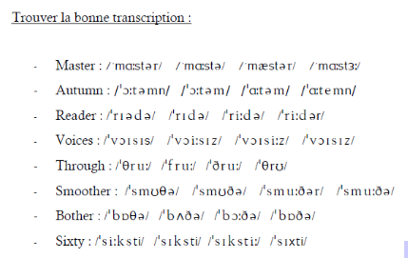

“:” = voyelle longue
“ ‘ “ = accent

EN US

master 2 3

autumn 2 3

reader 3 4

voices 4 4

through 1 1

smoother 4 3

bother 4 /b/

sixty
Transcrire les mots suivant en alphabet latin :
/ˈməʊst/ → most
/əˈlaʊ/ → allow
/ˈlɔː/ → law
/bɪˈləʊ/ → below
/ˈnaɪs/ → nice
/ˈdʌbəl/ → double
/ˈɑːsk/ → ask

Introducing the news :

- Key words
- Wh- questions
- Type of doc.
  - News report = desc of an event that happened recently in the news

  - Interview = conversation between a journalist and a person of public interest

  - Obituary = report, especially in newspaper, that gives the news of someone’s death

  - Speech = formal talk given to a large nb of people

Extract 1 : Obituary, Charlie Watts died age 80 spent 60 years as Rolling Stones’ drummer.

Extract 2 : interview, images of women in congress wearing white. Book “finish the fight” by Veronica Chambers, about the right to vote for women.

Extract 3 : news report : NSO Group, cyber security international scandal, spying, country = Israel,

Extract 4 : speech by Camilla Harris, about congressman Jean Louis, America’s democracy is not guaranteed, it is only as strong as our willingness to fight for it, protecting it takes struggles, sacrifice, but it brings joy and happiness, and we, the people, have the power to build a better future.

