AviTON
  - Database ERD and Data Dictionary
Three-table schema, relationships, JOINs and stock rules
Web Application Development | Prepared 31 August 2026 | For team review
inventorydb has three InnoDB tables using utf8mb4_unicode_ci. The diagram shows key fields; the dictionary lists every column.
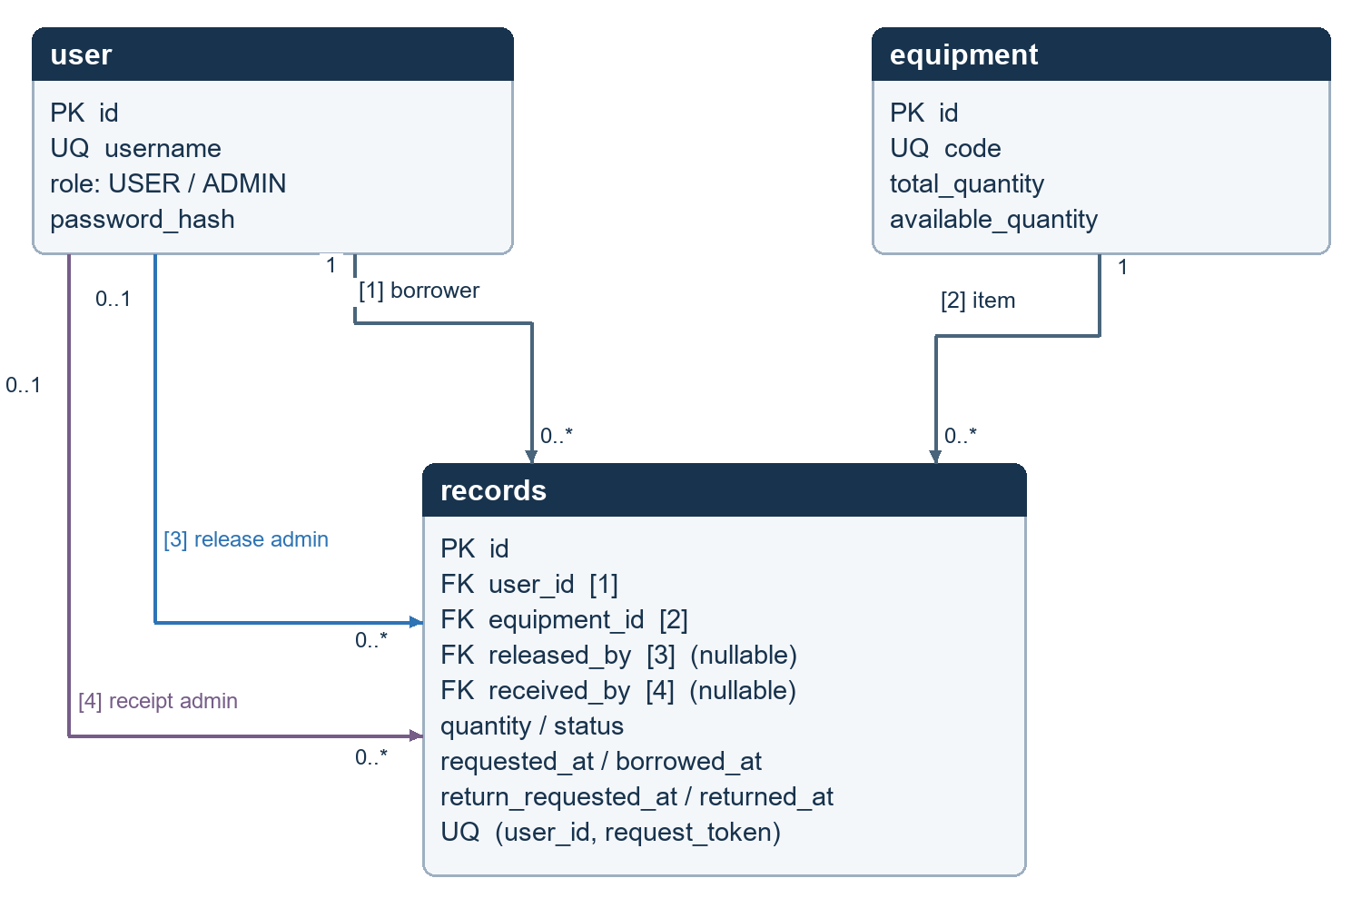
Figure 1. AviTON entity relationships; [1]–[4] identify the four foreign keys.
FK | Relationship | Per record
[1] user_id | records.user_id → user.id | Exactly one borrower
[2] equipment_id | records.equipment_id → equipment.id | Exactly one item
[3] released_by | records.released_by → user.id | Zero or one release admin
[4] received_by | records.received_by → user.id | Zero or one receipt admin

Each parent can have zero or many related records. All four foreign keys use ON DELETE RESTRICT. The ADMIN requirement for release/receipt is enforced by procedures, not by the foreign keys. PK = primary key; FK = foreign key; UQ = unique key.

Data dictionary: user
The user table stores account identity, password hashes and session-revocation state. It is also referenced for the administrators who release and receive equipment.
Column | SQL type | Null / default | Purpose or rule
id | INT UNSIGNED | No / auto | Primary key; AUTO_INCREMENT
username | VARCHAR(40) | No | Unique sign-in name
password_hash | VARCHAR(255) | No | Hash from password_hash
role | ENUM('USER','ADMIN') | No / USER | Authorization role
first_name | VARCHAR(80) | No | First name
last_name | VARCHAR(80) | No | Last name
email | VARCHAR(190) | No | Email; not a unique DB key
mobile | VARCHAR(20) | No / '' | Optional phone stored as text
is_active | TINYINT(1) | No / 1 | CHECK restricts values to 0 or 1
session_version | INT UNSIGNED | No / 1 | Invalidates older sessions after password change
created_at | DATETIME | No / current time | Account creation time

Account rules
- Public registration always creates a USER. It cannot grant ADMIN by changing a form value.
- Registration normalizes usernames to lowercase. The database collation also makes username uniqueness case-insensitive.
- Password confirmation is a form field only. The readable password and confirmation are never stored as account columns.
- is_active is checked during access control. The current website does not include a separate account-deactivation administration page.
Sample credentials are documented in the system guide. They are setup-only exceptions to the stronger password rule applied to new registration and password changes.

Data dictionary: equipment
Column | SQL type | Null / default | Purpose or rule
id | INT UNSIGNED | No / auto | Primary key; AUTO_INCREMENT
code | VARCHAR(30) | No | Unique equipment code
name | VARCHAR(120) | No | Display name
category | VARCHAR(80) | No | Category name
location | VARCHAR(120) | No / '' | Optional storage location
description | VARCHAR(1000) | No / '' | Optional details
total_quantity | INT | No | Total units owned
available_quantity | INT | No | Units available for release
history | LONGTEXT | Yes | Equipment change-history lines
version | INT UNSIGNED | No / 1 | Rejects stale edits/deletes
created_at | DATETIME | No / current time | Creation time
updated_at | DATETIME | No / current time | Updated by equipment procedures

Stock consistency
The table CHECK requires total_quantity to be between 0 and 1,000,000 and available_quantity to be between 0 and total_quantity. The application and procedures apply further validation before changing either value.
On-loan units = total_quantity − available_quantity. When an administrator changes the total, the procedure preserves the units already on loan. A pending request is not a reservation and does not change available_quantity.

Indexes and history
The primary key identifies an entry; a unique code prevents duplicate item codes; idx_equipment_name supports name lookup. Equipment history remains in this row to keep the requested three-table design. History is text, not a fourth event table.
Permanent deletion removes the entry and its equipment history only when no records reference it. It cannot remove an item with returned, rejected, cancelled or active borrowing records.

Data dictionary: records
One row represents one item and one quantity requested by one borrower. Multiple requests create separate rows. Blank event timestamps mean the event has not occurred.
Column | SQL type | Null / default | Purpose or rule
id | INT UNSIGNED | No / auto | Primary key
user_id | INT UNSIGNED | No | FK: borrower
equipment_id | INT UNSIGNED | No | FK: equipment
quantity | INT | No | Whole quantity, 1–1,000,000
request_token | CHAR(32), ascii_bin | No | Retry token; unique with user_id
equipment_name | VARCHAR(120) | No | Name snapshot at request time
equipment_code | VARCHAR(30) | No | Code snapshot at request time
note | VARCHAR(500) | No / '' | Borrower note
history | LONGTEXT | Yes | Status/action history lines
status | ENUM | No / PENDING | Six allowed states, listed below
requested_at | DATETIME | No | Request creation time
borrowed_at | DATETIME | Yes | Confirmed release time
return_requested_at | DATETIME | Yes | Borrower return request time
returned_at | DATETIME | Yes | Confirmed receipt time
released_by | INT UNSIGNED | Yes | FK: releasing ADMIN
received_by | INT UNSIGNED | Yes | FK: receiving ADMIN

Status values: PENDING, BORROWED, RETURN_PENDING, RETURNED, REJECTED and CANCELLED. Time/state CHECK constraints reject contradictory release/return timestamps. The unique (user_id, request_token) pair prevents duplicate requests; procedures also compare the retry payload.
Indexes cover (user_id, status, id), (equipment_id, status) and (status, id). History lines hold a timestamp, event type, actor ID and hex-encoded actor/text fields separated by tabs. Encoding prevents embedded tabs or newlines from breaking the record format.

Transactions and JOINs
From → to | Actor / action | Available stock
PENDING → BORROWED | ADMIN confirms release | Subtract quantity
PENDING → REJECTED | ADMIN rejects request | No change
PENDING → CANCELLED | Owner cancels request | No change
BORROWED → RETURN_PENDING | Owner requests return | No change
RETURN_PENDING → RETURNED | ADMIN confirms receipt | Add quantity
RETURN_PENDING → BORROWED | ADMIN rejects receipt | No change

sp_borrow_request and sp_record_transition enforce the borrowing rules. The transition procedure runs its state checks, row locks, stock change, timestamps and history update in a database transaction. A failure rolls back the transaction; PHP does not manage these stock transactions.
Release checks availability again while holding the equipment row lock. Receipt restores stock once only, because the required prior state is RETURN_PENDING. Partial returns and due dates are not part of this schema.

Why each JOIN is used
Procedure | JOIN and purpose
sp_record_list | INNER JOIN user/equipment; LEFT JOIN optional release and receipt admins for readable record lists.
sp_report_equipment | LEFT JOIN records to retain equipment with no requests.
sp_report_users | RIGHT JOIN user to retain users with no borrowing records.
sp_report_full | LEFT JOIN plus unmatched RIGHT JOIN rows using UNION ALL: a FULL OUTER JOIN equivalent.

Foreign keys prevent records from pointing to missing equipment, so the unmatched-activity branch of the FULL JOIN equivalent should be empty. Explain this constraint; do not create invalid rows to demonstrate the branch.

Sources and scope
database/schema.sql: authoritative table definitions, constraints, indexes and procedure bodies.
WEB-APPLICATION-DEVELOPMENT-PROJECT.pdf, pp. 1–3, 6–8 and 15: related data, meaningful JOINs and ERD requirement.
Current schema reviewed 31 August 2026. This Word dictionary does not replace the executable schema.sql submission.

