AviTON
  - System Architecture and Design Pattern
How requests move through the PHP application
Web Application Development | Prepared 31 August 2026 | For team review
AviTON uses a layered architecture: presentation, request handling, validation/access control and database access have separate responsibilities. Config acts as a data-access facade by exposing named methods that hide PDO statement handling and stored-procedure calls.
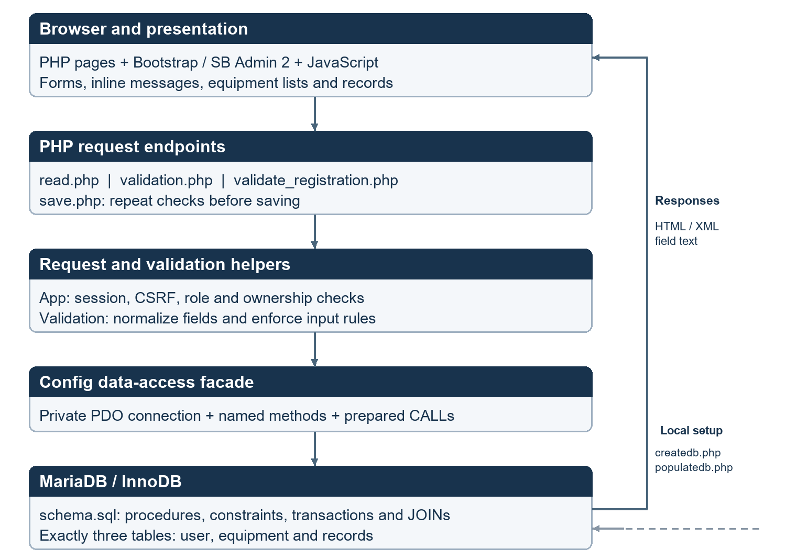
Figure 1. Application layers and the separate local setup path.
This is a small PHP application with shared includes, not a strict MVC framework. Bootstrap and SB Admin 2 supply interface styling and components; they are not the backend architecture or design pattern. Some request orchestration is shared between endpoints and helper classes.

Responsibilities and OOP
Part | What it owns
index.php / register.php | Public sign-in and registration pages
dashboard.php / admin-dashboard.php | Role-specific page entry points and shared dashboard layout
includes/ UI sections | Navigation, overview, equipment, records, reports and dialogs
read.php / validation endpoints / save.php | Request dispatch, preflight checks, reads and writes
App / HttpError | Sessions, request checks, authorization and controlled errors
Validation | Private input/error state and reusable validation rules
Config | Private PDO connection and named procedure-call methods
schema.sql | Relations, stock rules, transaction state changes and joined queries

Pattern: data-access facade
A caller asks Config for a business-related operation instead of preparing statements throughout the pages. The method below is from config/config.php. Its placeholders receive bound parameter values; the detailed SELECT and JOIN logic stays in schema.sql.
public function getEquipment(int $actor, int $equipmentId): array
{
return $this->executeProcedure('CALL sp_equipment_get(?,?)',
[$actor, $equipmentId]);
}
The example is line-wrapped for readability; it retains the existing method behavior. executeProcedure prepares the call, executes parameters, fetches results and closes the cursor.

OOP concepts to explain
Encapsulation: Config keeps PDO private; Validation keeps its data and errors private. Construction: Config opens its PDO connection when created. Reuse: the same Validation rules serve AJAX and saving. Inheritance: HttpError extends RuntimeException to represent expected request errors. Dashboard is also implemented as a JavaScript class.

Request walkthroughs and design choices

Registration with AJAX
- Inline oninput/onblur handlers call checkField in assets/js/ajax.js. Normal text is normalized by server rules; passwords remain exactly as entered.
- XMLHttpRequest sends a field to validate_registration.php with the CSRF token. The response is VALID or INVALID|message; JavaScript updates the nearby span.
- Debouncing limits repeated calls, and stale responses are ignored. Username availability is checked on blur and submission.
- Submission waits for field checks, then sends the whole form to validation.php. Any errors are shown without saving.
- A valid form is posted to save.php. It repeats validation, hashes the password and calls Config::registerUser, which invokes sp_register.
- The server returns XML for the complete-form result. The client displays the outcome; it never uses localStorage as the database.

Borrow release and return
save.php takes the actor from the authenticated session, not a client-supplied user ID. It checks role and ownership before calling Config. The stored procedure checks the actor, current record state and stock again, then commits related updates together. This keeps concurrent requests from applying the same stock movement twice.

Security and setup boundaries
Sessions identify accounts; CSRF tokens protect state-changing requests; authorization restricts operations. Password hashes protect stored secrets and escaped output protects rendered pages. These controls serve different purposes.
createdb.php loads schema.sql; populatedb.php inserts samples. Config does not parse SQL files or rewrite settings. Setup has a local-access guard. Normal operations use prepared CALLs; transaction handling stays in the procedures.

Sources and scope
config/config.php; request and validation helpers in includes/; register.php; assets/js/ajax.js; validation.php; validate_registration.php; save.php; read.php; database/schema.sql.
WEB-APPLICATION-DEVELOPMENT-PROJECT.pdf, pp. 1–3 and 6–8: OOP and identifiable architecture/design pattern.
This describes the current implementation. It does not claim a framework or additional abstraction that the source does not contain.

