Vishal Maru

Dr. Rajeev

IT 340

May 1, 2018

1.

USE AdventureWorks2012;

GO

SELECT SalesOrderNumber, TotalDue,

CAST(TotalDue AS varchar) AS TotalDueCast,

OrderDate, CAST(OrderDate AS date) AS OrderDateCast

FROM Sales.SalesOrderHeader;

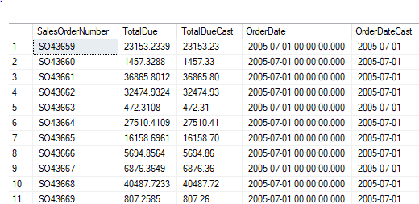

2.

USE AdventureWorks2012;

GO

SELECT p.FirstName, p.LastName, sh.Status, sh.OrderDate,

AVG(sd.OrderQty) AS AverageQtyOrdered,

sd.OrderQty AS ItemsCount, COUNT(sd.ProductID)

FROM Sales.SalesOrderDetail AS sd

INNER JOIN Sales.SalesOrderHeader AS sh

ON sd.SalesOrderDetailID = sh.SalesOrderID

INNER JOIN Sales.Customer AS c

ON sh.CustomerID = c.CustomerID

INNER JOIN Person.Person AS p

ON c.PersonID = p.BusinessEntityID

GROUP BY p.FirstName, p.LastName, sh.Status;

3.

USE AdventureWorks2012;

GO

SELECT ProductID, SpecialOfferID,

AVG(UnitPrice) AS [Average Price],

SUM(LineTotal)

FROM Sales.SalesOrderDetail

GROUP BY ProductID, SpecialOfferID

ORDER BY ProductID;

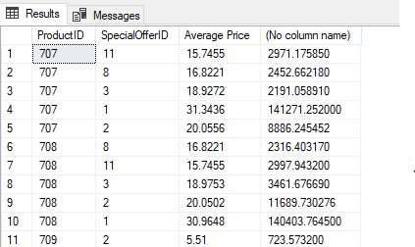

4.

USE AdventureWorks2012;

GO

SELECT p.Name AS [Product Name],

[Non Disount Sales] = (sd.UnitPrice * sd.OrderQty),

[Discount Sales] = (sd.UnitPrice * sd.OrderQty) * sd.UnitPriceDiscount

FROM Production.Product AS p

LEFT OUTER JOIN Sales.SalesOrderDetail AS sd

ON p.ProductID = sd.ProductID

ORDER BY p.Name DESC;

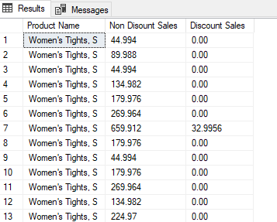

5.

USE AdventureWorks2012;

GO

UPDATE Production.Product

SET ListPrice = (ListPrice * 1.10)

WHERE ProductSubcategoryID = 23;



6.

USE AdventureWorks2012;

GO

SELECT DISTINCT p.ProductID, p.Name, p.ProductNumber, p.FinishedGoodsFlag, p.ListPrice

FROM Production.Product AS p

LEFT OUTER JOIN(SELECT BillOfMaterialsID

FROM Production.BillOfMaterials) AS bm

ON p.ProductID = bm.BillOfMaterialsID

WHERE p.ProductSubcategoryID IS NULL;

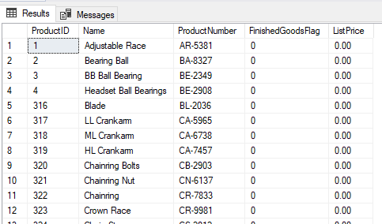

7.

USE AdventureWorks2012;

GO

SELECT Name, ProductNumber, ListPrice

FROM Production.Product

WHERE DaysToManufacture < 4 AND ProductLine = 'R'

ORDER BY Name;

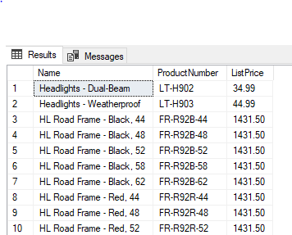

8.

USE AdventureWorks2012;

GO

CREATE PROCEDURE Sp_UniqueEmp AS

SELECT DISTINCT JobTitle

FROM HumanResources.Employee

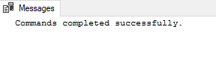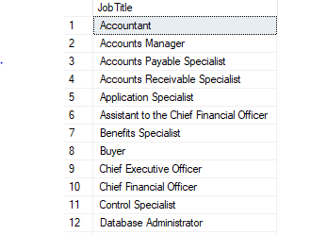

9.

USE AdventureWorks2012;

GO

SELECT DISTINCT sm.Name, SUM(ph.TotalDue) AS [Total Due],

AVG(ph.TotalDue) AS [Average Total Due],

SUM(ph.EmployeeID) AS [Number Of Employee],

COUNT (DISTINCT ph.EmployeeID)

FROM Purchasing.PurchaseOrderHeader AS ph

INNER JOIN Purchasing.ShipMethod AS sm

ON ph.ShipMethodID = sm.ShipMethodID

GROUP BY ph.OrderDate, sm.ShipMethodID;

10.

USE AdventureWorks2012;

GO

DECLARE @StartingHireDate datetime

SELECT @StartingHireDate = '12/31/2001'

SELECT e.BusinessEntityID, p.FirstName,

p.LastName, e.Hiredate

FROM HumanResources.Employee AS e

INNER JOIN Person.Person AS p

ON e.BusinessEntityID = p.BusinessEntityID

WHERE e.HireDate <= @StartingHireDate;

