**SQL Practice Exercises**

1. **Use the AdventureWorks database to complete this exercise. Be sure to check your results to ensure that they make sense.**
2. **Write a query displaying the order ID, order date, and total due from the Sales.SalesOrderHeader table. Retrieve only those rows where the order was placed during the month of September 2005.**
3. **Write a query with the same columns as question 1. Include rows where the Total Due is $10,000 or more or the SalesOrderID is less than 43000.**

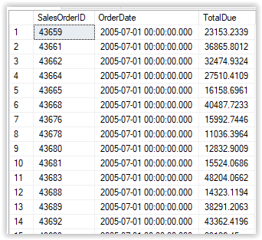

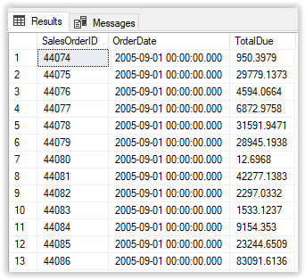

2. Write a query that returns data from the Person.Address table in this format AddressLine1 (City PostalCode) from the Person.Address table.

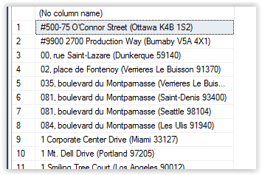

1. The DATEDIFF function allows you to find the difference between two dates. The function requires three parameters: the date part and the two dates. The DATEDIFF function might be used to calculate how many days have passed since unshipped orders were taken, for example.

DATEADD(<date part>,<number>,<date>)

Using the Sales.SalesOrderHeader table, create the following output.

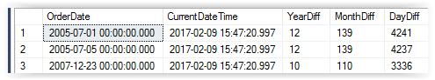

1. Retrieve the following results using the Sales.SalesOrderHeader table. HINT: WHERE SalesOrderID in (43659,43714,60621);

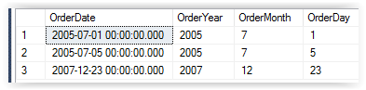

1. Write a query that displays only the date, not the time, for the order date and ship date in the Sales.SalesOrderHeader table. HINT: Use CONVERT. For example:

SELECT CONVERT(VARCHAR,OrderDate,111) AS OrderDate,……………

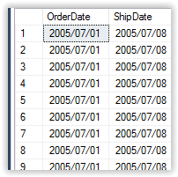

1. The ROUND function allows you to round a number to a given precision. The ROUND function is used frequently to display only the number of decimal places required in the report or application. Create the following output:

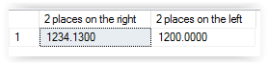

1. Write a query using the Sales.SalesOrderHeader table that displays the SubTotal rounded to two decimal places. Include the SalesOrderID column in the results.

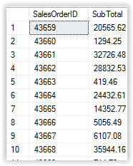

1. Modify the query from previous question so that the SubTotal is rounded to the nearest dollar but still displays two zeros to the right of the decimal place.

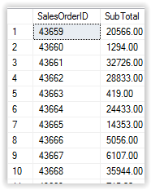

1. Write a query using the Sales.SalesOrderHeader, Sales.SalesOrderDetail, and Production.Product tables to display the total sum of products by Name and OrderDate.

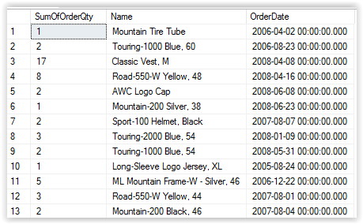

1. Return all the sales from May 1, 2007, through December 12, 2007 using Sales.SalesOrderHeader.

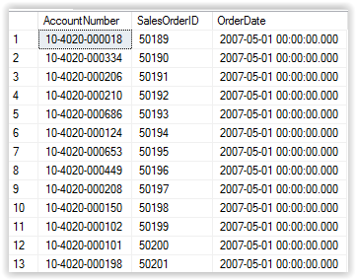

1. Use a UNION query to return a list of products that are black and silver in the Production.Product table.

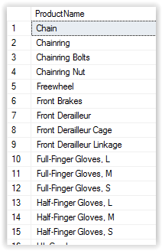

1. Using the Purchasing.PurchaseOrderHeader (poh) and Purchasing.ShipMethod (sm) table, retrieve the following columns. HINT: This query will use aggregate functions (SUM, AVG, and COUNT) and GROUP BY sm.Name.

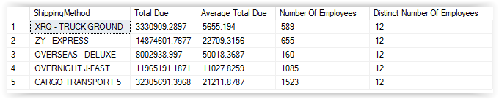

1. Using the query in question 4, create a stored procedure called myProcExample. In addition, retrieve the results where Total Due is greater than 5000000. HINT: GROUP BY sm.Name,YEAR(poh.OrderDate)

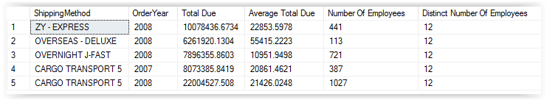

1. Using a subquery, join the Sales.SalesOrderHeader table to the Sales.SalesOrderDetail table. Display the SalesOrderID, OrderDate, and ProductID columns in the results. The Sales.SalesOrderDetail table should be inside the derived table query.

