**Protractor:**

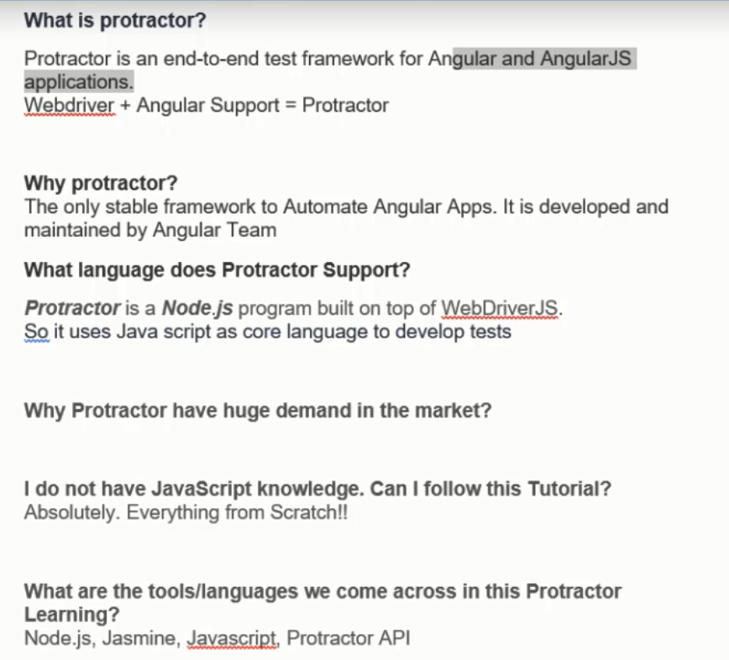

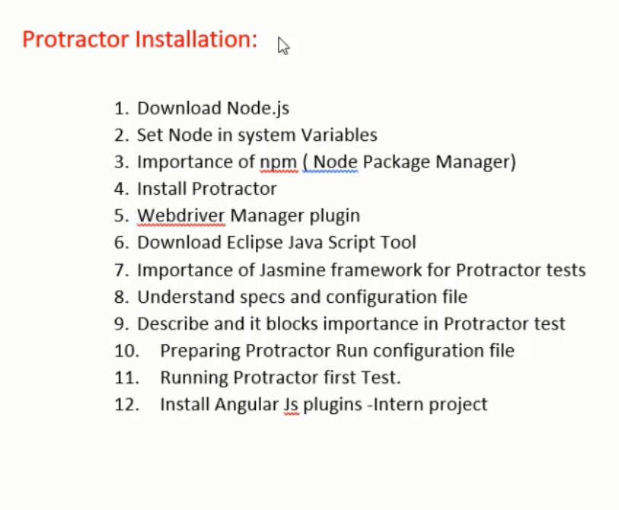

**To check node version:**

node –v

**To check npm version:**

npm –v

**Install Protractor:**

npm install –g protractor

If you see any invalid tag name, go to start programs,select node js and open node js command prompt and run as an administrator

**To check protractor version:**

protractor –version

**To update Webdriver Manager:**

webdriver-manager update

**Start Selenium Server:**

webdriver-manager start

Download Eclipse for JavaScript

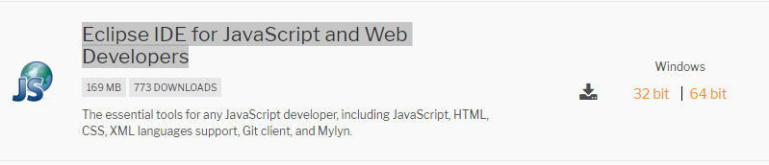

**Reporting:**

npm install -g protractor-jasmine2-html-reporter

npm install protractor-jasmine2-screenshot-reporter --save-dev

**Install AngularJS plugin**

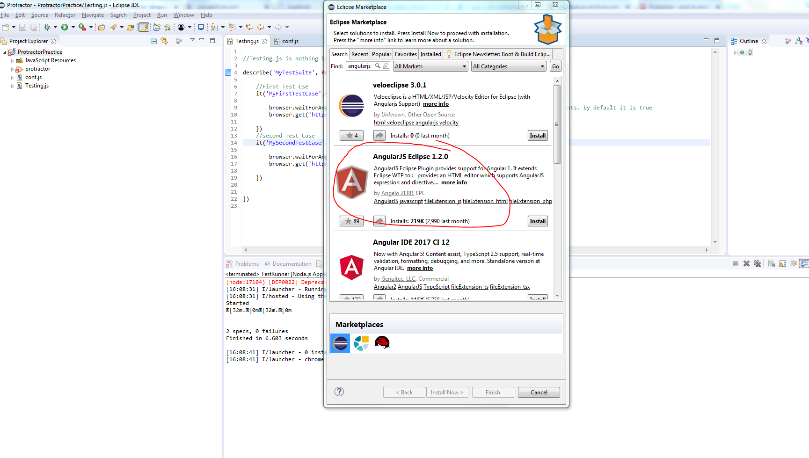

**JASMINE:**

This is JavaScript Testing framework (Like TestNG, Juint) – Below are Jasmine Terminologies

**Describe** --- This is nothing but “TestSuite”

**It** --- This is nothing but “Test Case”

**Spec.js** --- This is nothing but Test Class (Test File)

**Conf.js** --- This is configuration file. We need to run this file only by including all spec.js inside that --- We can’t run spec.js file (Kind of tesng.xml)

**Spec.js Creation:**

1. Create new JavaScript File as below
2. //Testing.js is nothing but spec.js file
3. describe('MyTestSuite', **function**(){
5. //First Test Cse
6. it('MyFirstTestCase',**function**(){
8. browser.get('https://www.verifone.com');
10. })
11. //second Test Case
12. it('MySecondTestCase',**function**(){
14. browser.get('https://www.tcs.com');
16. })

19. }

**Conf.js Creation:**

1. Create new JavaScript File and paste below configuration details
2. exports.config = {
3. seleniumAddress: 'http://localhost:4444/wd/hub',
4. specs: ['Testing.js']
5. };

**Run Configuration:**

* We can’t run the conf.js file directly
* Need to define Run Configuration
* Navigate to Run-🡪Run Configuration-🡪 Select Node.js application-🡪 Create Launch Configuration
* Enter below details

1. Project
2. Main File --- For this one copy the protractor folder from C:\Users\T_BalamuruganM1\AppData\Roaming\npm\node_modules

And paste it under Project folder

1. Then browse for cli.js file inside protractor-🡪 built-🡪 cli.js

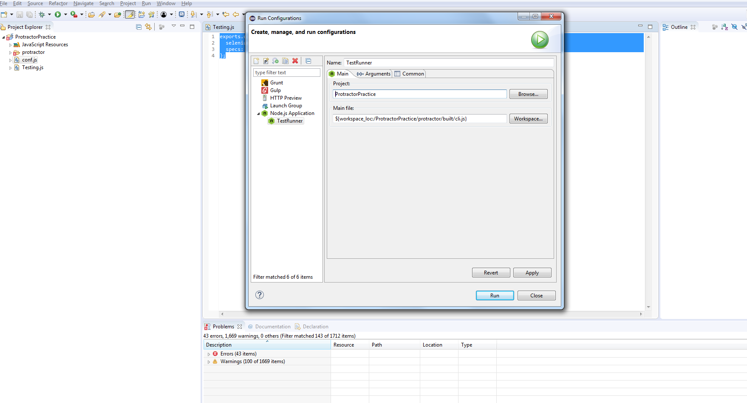

1. Navigate to Arguments tab and give conf file name as shown below

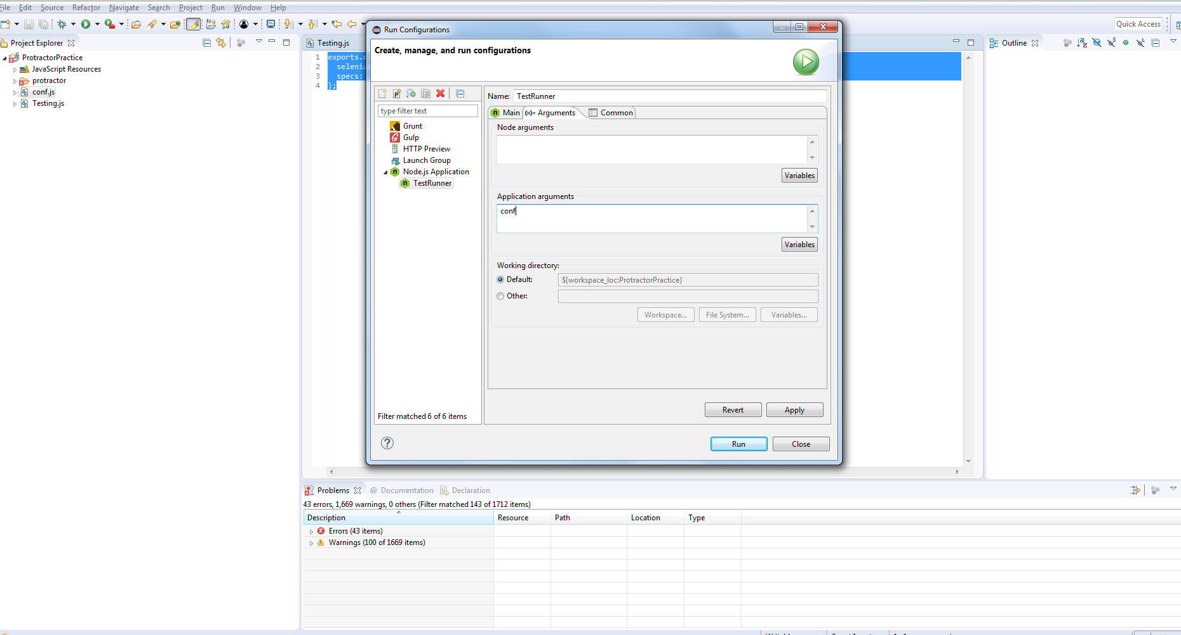

1. Click Apply and Close
2. Now go to Run-🡪 Run Configuration-🡪Under node.js application, you would see your configuration. Just select and click Run button

**Note: Protractor by default runs on Chrome browser.**

**Convert into Tern Project:**

1. After installing AngularJS plugin, right click on Project select Configure-🡪 Convert into Tern Project
2. Check Protractor
3. Click Apply and Close

This option will enable auto suggestion – To get auto suggestion, after “.” We have to click ctrl + Space

**Promise:**

JavaScript is Asynchronous – Nothing but it does not wait for current step to be completed. Even if the current step is executing control goes to next step and any step that can be executed.

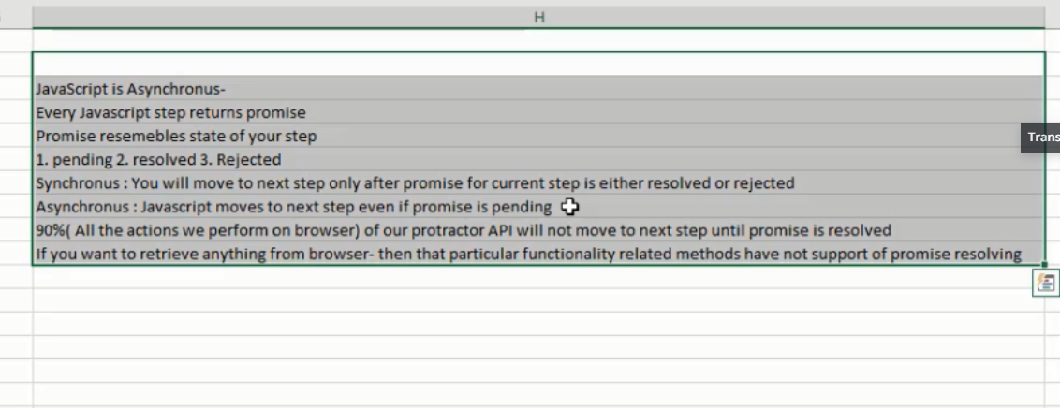

describe('MyTestSuite', **function**(){

//First Test Cse

it('MyFirstTestCase',**function**(){

browser.waitForAngularEnabled(**false**); //this is to turn off wait time to find angular elements. by default it is true

browser.get('https://www.verifone.com');

})

//second Test Case

it('MySecondTestCase',**function**(){

browser.waitForAngularEnabled(**false**);

browser.get('https://www.tcs.com').then(**function**(){

console.log("Capture logs");//to capture logs

})

//browser.sleep(5000); //wait

//

})

})

**JAVASCRIPT Basics:**

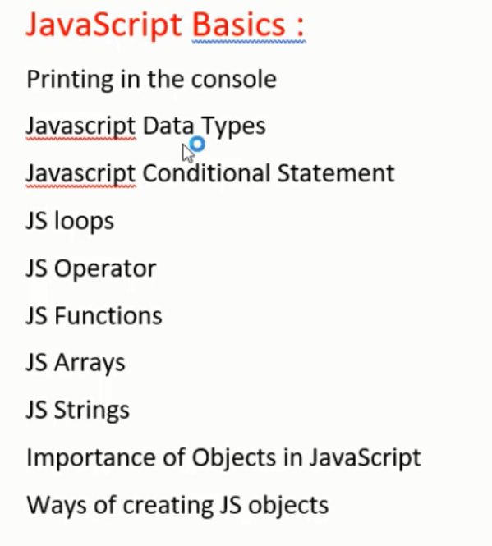

* JavaScript is an Asynchronous language
* JavaScript is dynamic type language – User does not need to specify Variable type while declaring variable

Var a= 4;

Var b =”hi”;

Var c = new Array();

* Functions are written with below syntax

function add(a,b)

{

return a+b;

}

**Protractor:**

* Protractor is a wrapper on top of selenium webdriverJS
* Protractor is developed by Google Angular Team
* Protractor supports both non AngularJS and Angular JS applications

Below are some of global variables of Protractor:

1. Browser
2. Element
3. By

Locators:

1. Model
2. Binding
3. Repeater
4. Css
5. Id
6. Name
7. Xpath

CSS Syntax:

Tagname[attribute=’value’]

**JavaScript:**

//search for "Mozilla developer network and select javascript"

alert("if you want to display pop up alert in a page, then use alert function");

document.write("If you want to write something on page, then please use document write");

console.log("This is to display info for developers for debugging");

//variables

//variable names can't start with number but they can end with a number

//Variable names can have character, number, $ and _

var string = "Assigning String Value";

var integer = 5;

document.write(string);

//to capture user input

var age = prompt("Please enter your age: ");

document.write(age);

//Combine Strings together OR Concatenation

var str1 = "STring 1";

var str2 = "string 2";

document.write(str1+str2);

//how to make a text hyperlink

var hyper = "Verifone";

var URL = "https://www.verifone.com";

document.write("Navigate to Verifone site using "+ hyper.link(URL));

//Number

//

//Math

//https://developer.mozilla.org/en-US/docs/Web/JavaScript/Reference/Global_Objects/Math

//The Math.random() function returns a floating-point, pseudo-random number in the range 0–1 (inclusive of 0, but not 1) with approximately uniform distribution over that range

var num = prompt("Max of random number:");

alert(Math.floor(Math.random()*num));

//Math.floor -- Returns largest integer less than or equal to number

//Math.ceil -- Returns smallest integer greater than or equal to number

//Math.round -- Make the floating number to nearby integer

//Math.sqrt -- Gives the square root of the number