37495 Statistical Design and Models for Evaluation Studies
Assessment Task 2: R Assignment
Student: Mario Rubiano
Student ID: 24900627
Submission file: 37495_Assignment_Rubiano_Mario.docx
This report includes the R code and the output that is used in the answers. The analysis uses
the R functions and packages introduced in the laboratory solution files, including aov,
resid, shapiro.test, nortest::cvm.test, nortest::ad.test, lawstat::levene.test, MASS::boxcox,
DescTools::BoxCox, emmeans, contrast with Scheffe adjustment, durbinWatsonTest, and
cooks.distance.
Question 1
An appropriate design for this situation is a randomised complete block design. The response
variable is the yield of the chemical process. This yield must be measured in the units used
by the plant, for example grams, kilograms, or percent yield. The experimental factor is the
chemical input, with five treatment levels because there are five chemicals. The blocking
factor is technician, with three blocks because there are three technicians.
There are 15 experimental units in total. Each experimental unit is one individual execution
of the chemical process by one specific technician using one specified chemical input. The
measurement unit is the physical batch or final product sample where the yield is measured.
Within each technician block, the five chemicals should be randomly allocated to the five
process runs done by that technician. In this way, each chemical has three observations, and
the design controls for differences between technicians.
A suitable model is y_ij = mu + tau_i + beta_j + e_ij, where tau_i is the effect of chemical
i, beta_j is the effect of technician j, and e_ij is the random error.
Question 2
(a)
For production run 1, H0: mu_1 <= 0.78 and H1: mu_1 > 0.78. The sample mean is 0.831, t =
1.6719, df = 19, and p-value = 0.05546. The 95 percent one-sided lower confidence bound is
0.7782551. Since p > 0.05, there is not enough evidence at the 5 percent level to conclude
that the mean impact strength for production run 1 is greater than 0.78.
Manual one-sample t-test output:
mean = 0.831
t = 1.67193
df = 19
p-value = 0.05546308
95 percent one-sided lower confidence bound = 0.7782551
(b)
The bootstrap distribution was generated using 100000 re-samples with replacement. The
bootstrap mean is approximately 0.8309 and the bootstrap standard deviation is approximately
0.02986.
A Shapiro-Wilk test on a random sample of 50 bootstrap means gave W = 0.96968 and p-value =
0.2246. Since p > 0.05, the test does not show evidence against normality for the sampled
bootstrap means. Together with the histogram, this suggests that the bootstrap distribution is
approximately normal.
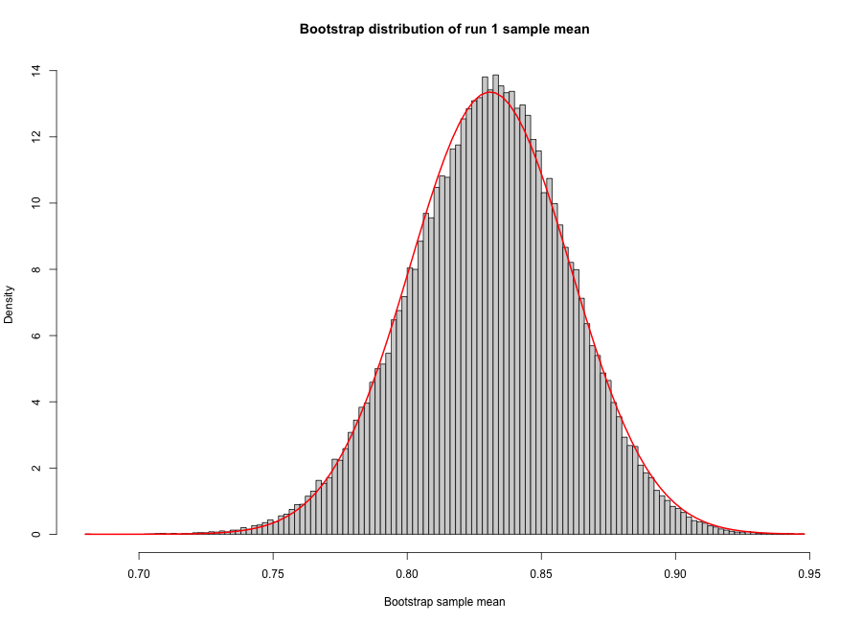
Question 2(b): Bootstrap distribution of run 1 sample mean.
Bootstrap summary:
Min. 1st Qu. Median Mean 3rd Qu. Max.
0.6805 0.8110 0.8315 0.8309 0.8510 0.9470

Shapiro-Wilk test:

Shapiro-Wilk normality test

data: sample(boot_means, 50)
W = 0.96968, p-value = 0.2246

(c)
The one-way ANOVA model strength ~ run tests whether mean impact strength differs among
production runs. Since the ANOVA p-value is less than 0.05, the null hypothesis that all run
means are equal is rejected. This result shows strong evidence that the mean impact strength
changes with production run.
ANOVA table:
Df Sum Sq Mean Sq F value Pr(>F)
run 4 2.791 0.6978 61.33 <2e-16 ***
Residuals 95 1.081 0.0114
---
Signif. codes: 0 '***' 0.001 '**' 0.01 '*' 0.05 '.' 0.1 ' ' 1
(d)
For the original ANOVA residuals, Shapiro-Wilk, Cramer-von Mises and Anderson-Darling all do
not reject normality at the 5 percent level. However, the modified Brown-Forsythe Levene test
from lawstat rejects the constant variance assumption at the 5 percent level. Thus, the
original ANOVA residuals are acceptable for normality, but they show evidence of unequal
variances.
Normality tests for original residuals:

Shapiro-Wilk normality test

data: insulation$resid
W = 0.97714, p-value = 0.07935

Cramer-von Mises normality test

data: insulation$resid
W = 0.058549, p-value = 0.3919

Anderson-Darling normality test

data: insulation$resid
A = 0.43981, p-value = 0.2865

Modified Brown-Forsythe Levene test for original residuals:

Modified robust Brown-Forsythe Levene-type test based on the absolute
deviations from the median with modified structural zero removal method
and correction factor

data: insulation$resid
Test Statistic = 3.2344, p-value = 0.01579

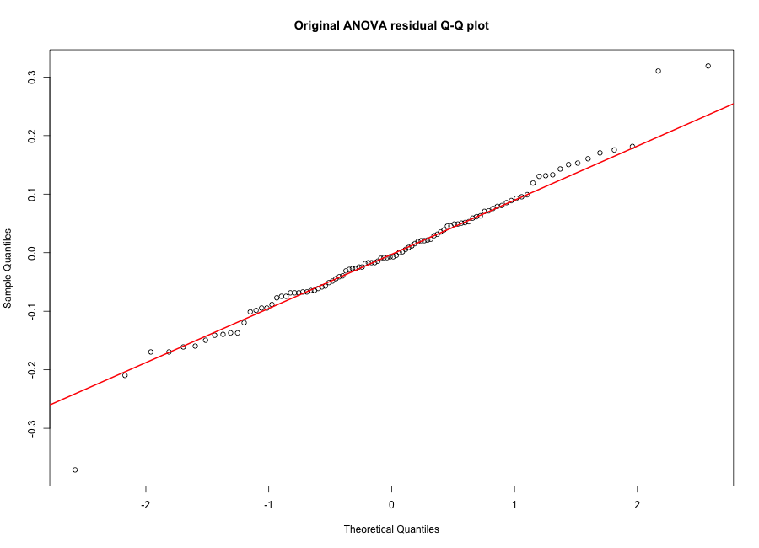
Question 2(d): Original ANOVA residual Q-Q plot.
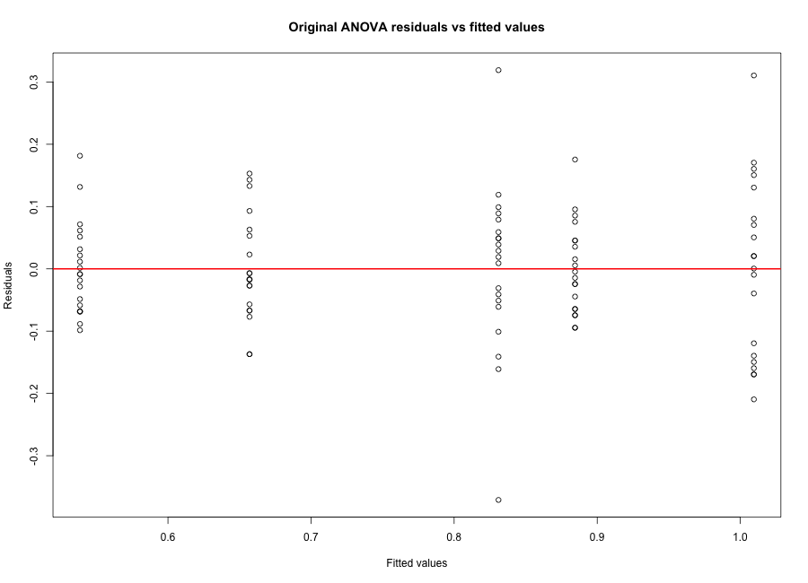
Question 2(d): Original residuals vs fitted values.
(e)
Using boxcox from the MASS package, the optimal Box-Cox parameter was lambda = 0.245409. The
transformed response was computed using DescTools::BoxCox(strength, lambda), matching the Lab
3 solution pattern.
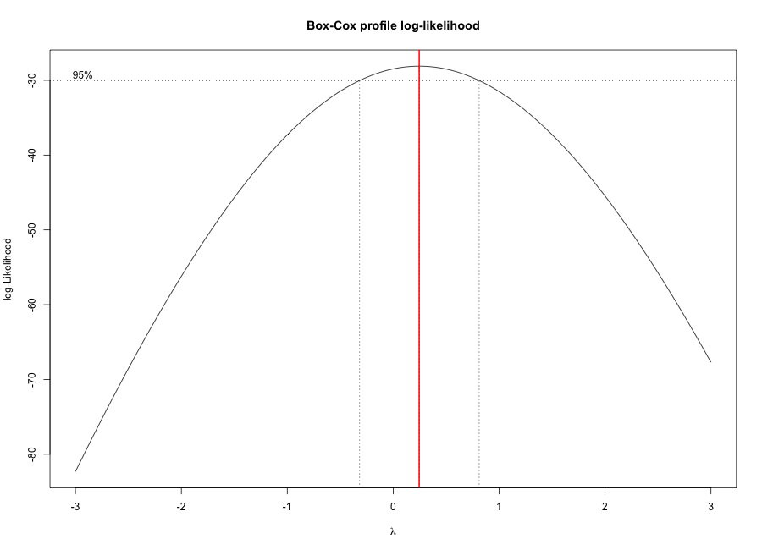
Question 2(e): Box-Cox profile log-likelihood.
(f)
For the Box-Cox transformed ANOVA, the production run effect remains significant with p-value
less than 0.05. For the transformed residuals, Shapiro-Wilk rejects normality at the 5 percent
level, while Cramer-von Mises and Anderson-Darling do not reject it. The modified
Brown-Forsythe Levene test does not reject the constant variance assumption. The
transformation improves the variance condition.
Box-Cox transformed ANOVA table:
Df Sum Sq Mean Sq F value Pr(>F)
run 4 4.306 1.0765 66.75 <2e-16 ***
Residuals 95 1.532 0.0161
---
Signif. codes: 0 '***' 0.001 '**' 0.01 '*' 0.05 '.' 0.1 ' ' 1

Normality tests for transformed residuals:

Shapiro-Wilk normality test

data: insulation$resid_bc
W = 0.97188, p-value = 0.03082

Cramer-von Mises normality test

data: insulation$resid_bc
W = 0.030456, p-value = 0.8391

Anderson-Darling normality test

data: insulation$resid_bc
A = 0.2938, p-value = 0.594

Modified Brown-Forsythe Levene test for transformed residuals:

Modified robust Brown-Forsythe Levene-type test based on the absolute
deviations from the median with modified structural zero removal method
and correction factor

data: insulation$resid_bc
Test Statistic = 1.3594, p-value = 0.2544

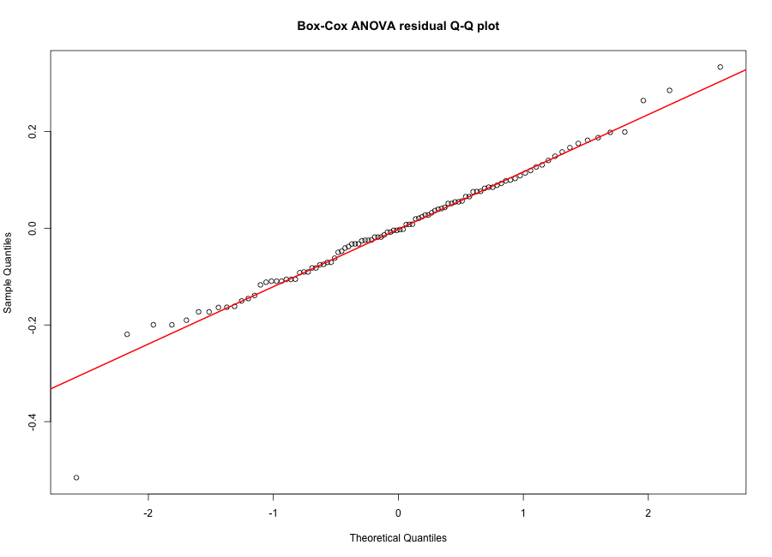
Question 2(f): Box-Cox residual Q-Q plot.
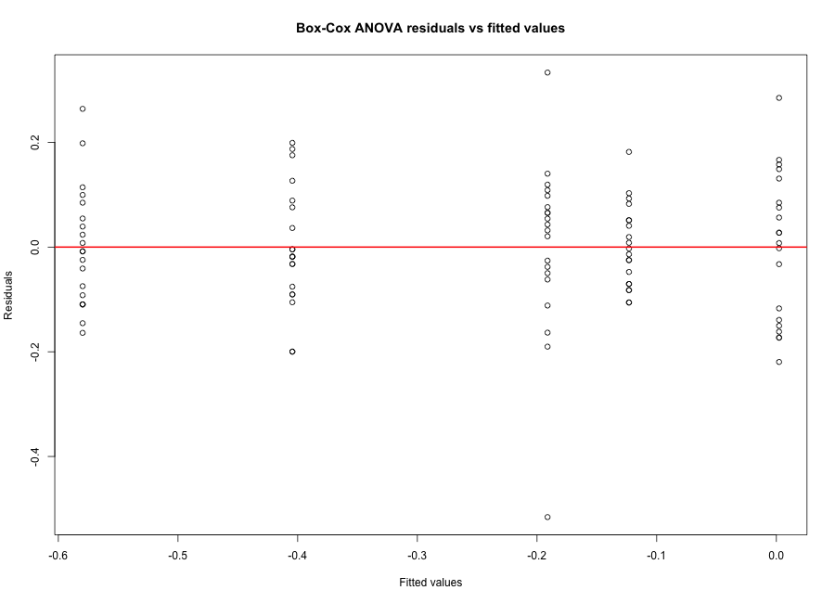
Question 2(f): Box-Cox residuals vs fitted values.
(g)
Using Scheffe adjustment on the Box-Cox transformed scale, the contrast comparing run 1 with
the average of runs 2-5 is not significant at the 5 percent level. The contrast comparing run
1 with run 3 is significant. The contrast comparing the average of runs 1, 2 and 4 with the
average of runs 3 and 5 is also significant.
Scheffe contrasts:
contrast estimate SE df lower.CL upper.CL t.ratio p.value
run1_vs_avg_run2_5 0.085 0.0317 95 -0.00532 0.175 2.679 0.0734
run1_vs_run3 0.213 0.0402 95 0.09892 0.328 5.310 <0.0001
avg_run124_vs_avg_run35 0.388 0.0259 95 0.31425 0.462 14.969 <0.0001

Confidence level used: 0.95
Conf-level adjustment: scheffe method with rank 3
P value adjustment: scheffe method with rank 3
(h)
The Durbin-Watson test rejects the null hypothesis of no autocorrelation. This clear pattern
occurs because the observations in the table are sorted within each production run, and not
listed in random experimental order. Therefore, the residual plot mainly reflects the
artificial order of the data, not necessarily time-based autocorrelation in the process.
Durbin-Watson test:
lag Autocorrelation D-W Statistic p-value
1 0.5695786 0.6416623 0
Alternative hypothesis: rho != 0
(i)
Cook's distances greater than 0.05 remove 3 observations, leaving 97 observations. The first
40 filtered records are included below.
Removed observations: 3
Remaining observations: 97

First 40 records of filtered data:
strength_bc run
-0.38142711 1
-0.35467008 1
-0.30286466 1
-0.25315901 1
-0.24103808 1
-0.22903385 1
-0.21714374 1
-0.17067592 1
-0.15932067 1
-0.14806578 1
-0.13690923 1
-0.12584902 1
-0.12584902 1
-0.11488325 1
-0.09322766 1
-0.08253430 1
-0.07192829 1
-0.05097181 1
-0.21714374 2
-0.17067592 2
-0.17067592 2
-0.15932067 2
-0.14806578 2
-0.13690923 2
-0.11488325 2
-0.03034565 2
0.00000000 2
0.00996249 2
0.02966627 2
0.02966627 2
0.05868752 2
0.07769242 2
0.08709543 2
0.13315767 2
0.15115612 2
0.16006766 2
0.16892191 2
-0.60415333 3
-0.60415333 3
-0.50988698 3

Removed observations:
run strength strength_bc cooksD
1 1 0.46 -0.7070227 0.18279886
20 1 1.15 0.1421864 0.07637505
40 2 1.32 0.2873082 0.05582352
Question 3
The model is y_ij = mu + tau_i + e_ij, where i = 1,...,a and j = 1,...,n, with constraint
sum_i tau_i = 0. The least squares criterion is S(mu, tau) = sum_i sum_j (y_ij - mu -
tau_i)^2.
Using a Lagrange multiplier for the constraint, minimise L = sum_i sum_j (y_ij - mu - tau_i)^2
+ 2 gamma sum_i tau_i.
Differentiating with respect to mu gives -2 sum_i sum_j (y_ij - mu - tau_i) = 0. Therefore
sum_i sum_j y_ij - an mu - n sum_i tau_i = 0. Since sum_i tau_i = 0, y_dotdot = an mu and
mu_hat = ybar_dotdot.
Differentiating with respect to tau_i gives -2 sum_j (y_ij - mu - tau_i) + 2 gamma = 0, so
y_i_dot - n mu - n tau_i + gamma = 0. Summing over i shows gamma = 0. Substituting back gives
y_i_dot - n ybar_dotdot - n tau_i = 0, hence tau_i_hat = ybar_i_dot - ybar_dotdot.
The fitted value is yhat_ij = mu_hat + tau_i_hat = ybar_i_dot, and the residual is ehat_ij =
y_ij - ybar_i_dot. Since ybar_i_dot is the mean of the n observations in treatment i,
Var(ehat_ij) = Var(y_ij - ybar_i_dot) = Var(y_ij) + Var(ybar_i_dot) - 2 Cov(y_ij, ybar_i_dot).
Now Var(y_ij) = sigma^2, Var(ybar_i_dot) = sigma^2/n, and Cov(y_ij, ybar_i_dot) = sigma^2/n
because only the j-th term contributes to the covariance. Therefore Var(ehat_ij) = sigma^2 +
sigma^2/n - 2 sigma^2/n = sigma^2(1 - 1/n).

Appendix: R code used for the analysis
library(MASS)
library(car)
library(emmeans)
library(nortest)
library(lawstat)
library(DescTools)

alpha <- 0.05
show_plots <- TRUE
save_plots <- TRUE

if (!dir.exists("figures")) {
dir.create("figures")
}

strength <- c(
0.46, 0.67, 0.69, 0.73, 0.77, 0.78, 0.79, 0.80, 0.84, 0.85,
0.86, 0.87, 0.88, 0.88, 0.89, 0.91, 0.92, 0.93, 0.95, 1.15,
0.80, 0.84, 0.84, 0.85, 0.86, 0.87, 0.89, 0.97, 1.00, 1.01,
1.03, 1.03, 1.06, 1.08, 1.09, 1.14, 1.16, 1.17, 1.18, 1.32,
0.52, 0.52, 0.58, 0.59, 0.59, 0.60, 0.63, 0.63, 0.64, 0.64,
0.64, 0.65, 0.65, 0.68, 0.71, 0.72, 0.75, 0.79, 0.80, 0.81,
0.79, 0.79, 0.81, 0.81, 0.82, 0.82, 0.84, 0.86, 0.86, 0.87,
0.88, 0.89, 0.90, 0.92, 0.93, 0.93, 0.96, 0.97, 0.98, 1.06,
0.44, 0.45, 0.47, 0.47, 0.47, 0.48, 0.49, 0.51, 0.52, 0.53,
0.53, 0.54, 0.55, 0.56, 0.57, 0.59, 0.60, 0.61, 0.67, 0.72
)

run <- factor(rep(1:5, each = 20))
insulation <- data.frame(run, strength)

cat("\nQuestion 2(a): one-sample t-test for run 1 mean > 0.78\n")
run1 <- insulation$strength[insulation$run == 1]
n_run1 <- length(run1)
mean_run1 <- mean(run1)
sd_run1 <- sd(run1)
t_run1 <- (mean_run1 - 0.78) / (sd_run1 / sqrt(n_run1))
df_run1 <- n_run1 - 1
p_run1 <- 1 - pt(t_run1, df_run1)
lower_ci_run1 <- mean_run1 - qt(0.95, df_run1) * sd_run1 / sqrt(n_run1)
cat("mean =", mean_run1, "\n")
cat("t =", t_run1, "\n")
cat("df =", df_run1, "\n")
cat("p-value =", p_run1, "\n")
cat("95 percent one-sided lower confidence bound =", lower_ci_run1, "\n")

cat("\nQuestion 2(b): bootstrap distribution of run 1 sample mean\n")
set.seed(37495)
boot_means <- replicate(
100000,
mean(sample(insulation$strength[insulation$run == 1], replace = TRUE))
)
print(summary(boot_means))
cat("Bootstrap SD:", sd(boot_means), "\n")

if (show_plots) {
hist(boot_means, breaks = 100, probability = TRUE,
main = "Bootstrap distribution of run 1 sample mean",
xlab = "Bootstrap sample mean")
curve(dnorm(x, mean = mean(boot_means), sd = sd(boot_means)),
add = TRUE, col = "red", lwd = 2)
}

if (save_plots) {
png("figures/q2b_bootstrap_histogram.png", width = 900, height = 650)
hist(boot_means, breaks = 100, probability = TRUE,
main = "Bootstrap distribution of run 1 sample mean",
xlab = "Bootstrap sample mean")
curve(dnorm(x, mean = mean(boot_means), sd = sd(boot_means)),
add = TRUE, col = "red", lwd = 2)
dev.off()
}

set.seed(37495)
cat("\nShapiro-Wilk test on a random sample of 50 bootstrap means\n")
print(shapiro.test(sample(boot_means, 50)))

cat("\nQuestion 2(c): one-way ANOVA\n")
fit <- aov(strength ~ run, data = insulation)
print(summary(fit))
insulation$resid <- resid(fit)

cat("\nQuestion 2(d): residual checks for original ANOVA\n")
cat("\nNormality tests\n")
print(shapiro.test(insulation$resid))
print(nortest::cvm.test(insulation$resid))
print(nortest::ad.test(insulation$resid))
cat("\nLevene test of equal variances\n")
print(lawstat::levene.test(insulation$resid, insulation$run,
location = "median",
correction.method = "zero.correction"))

if (show_plots) {
qqnorm(insulation$resid, main = "Original ANOVA residual Q-Q plot")
qqline(insulation$resid, col = "red", lwd = 2)
}

if (save_plots) {
png("figures/q2d_original_residual_qq.png", width = 900, height = 650)
qqnorm(insulation$resid, main = "Original ANOVA residual Q-Q plot")
qqline(insulation$resid, col = "red", lwd = 2)
dev.off()
}

if (show_plots) {
plot(fit$fitted.values, fit$residuals,
xlab = "Fitted values", ylab = "Residuals",
main = "Original ANOVA residuals vs fitted values")
abline(h = 0, col = "red", lwd = 2)
}

if (save_plots) {
png("figures/q2d_original_residuals_vs_fitted.png", width = 900, height = 650)
plot(fit$fitted.values, fit$residuals,
xlab = "Fitted values", ylab = "Residuals",
main = "Original ANOVA residuals vs fitted values")
abline(h = 0, col = "red", lwd = 2)
dev.off()
}

cat("\nQuestion 2(e): Box-Cox transformation\n")
bc_grid <- boxcox(fit, lambda = seq(-3, 3, length = 600), plotit = FALSE)
lambda <- bc_grid$x[which.max(bc_grid$y)]
cat("Optimal lambda:", lambda, "\n")
insulation$strength_bc <- DescTools::BoxCox(insulation$strength, lambda)

if (show_plots) {
boxcox(fit, lambda = seq(-3, 3, length = 600))
title("Box-Cox profile log-likelihood")
abline(v = lambda, col = "red", lwd = 2)
}

if (save_plots) {
png("figures/q2e_boxcox_profile.png", width = 900, height = 650)
boxcox(fit, lambda = seq(-3, 3, length = 600))
title("Box-Cox profile log-likelihood")
abline(v = lambda, col = "red", lwd = 2)
dev.off()
}

cat("\nQuestion 2(f): ANOVA and residual checks after Box-Cox transform\n")
fit_bc <- aov(strength_bc ~ run, data = insulation)
print(summary(fit_bc))
insulation$resid_bc <- resid(fit_bc)
cat("\nNormality tests\n")
print(shapiro.test(insulation$resid_bc))
print(nortest::cvm.test(insulation$resid_bc))
print(nortest::ad.test(insulation$resid_bc))
cat("\nLevene test of equal variances\n")
print(lawstat::levene.test(insulation$resid_bc, insulation$run,
location = "median",
correction.method = "zero.correction"))

if (show_plots) {
qqnorm(insulation$resid_bc, main = "Box-Cox ANOVA residual Q-Q plot")
qqline(insulation$resid_bc, col = "red", lwd = 2)
}

if (save_plots) {
png("figures/q2f_boxcox_residual_qq.png", width = 900, height = 650)
qqnorm(insulation$resid_bc, main = "Box-Cox ANOVA residual Q-Q plot")
qqline(insulation$resid_bc, col = "red", lwd = 2)
dev.off()
}

if (show_plots) {
plot(fit_bc$fitted.values, fit_bc$residuals,
xlab = "Fitted values", ylab = "Residuals",
main = "Box-Cox ANOVA residuals vs fitted values")
abline(h = 0, col = "red", lwd = 2)
}

if (save_plots) {
png("figures/q2f_boxcox_residuals_vs_fitted.png", width = 900, height = 650)
plot(fit_bc$fitted.values, fit_bc$residuals,
xlab = "Fitted values", ylab = "Residuals",
main = "Box-Cox ANOVA residuals vs fitted values")
abline(h = 0, col = "red", lwd = 2)
dev.off()
}

cat("\nQuestion 2(g): Scheffe contrasts after Box-Cox transform\n")
run_means <- emmeans(fit_bc, "run")
contrast_list <- list(
"run1_vs_avg_run2_5" = c(1, -0.25, -0.25, -0.25, -0.25),
"run1_vs_run3" = c(1, 0, -1, 0, 0),
"avg_run124_vs_avg_run35" = c(1 / 3, 1 / 3, -1 / 2, 1 / 3, -1 / 2)
)
scheffe_results <- contrast(run_means, method = contrast_list, adjust = "scheffe")
print(summary(scheffe_results, infer = c(TRUE, TRUE), level = 0.95,
side = "two-sided"))

cat("\nQuestion 2(h): Durbin-Watson test noted in assignment\n")
print(durbinWatsonTest(fit_bc))

cat("\nQuestion 2(i): Cook's distance filtering\n")
insulation$cooksD <- cooks.distance(fit_bc)
filtered <- insulation[insulation$cooksD <= 0.05, c("strength_bc", "run")]
cat("Removed observations:", sum(insulation$cooksD > 0.05), "\n")
cat("Remaining observations:", nrow(filtered), "\n")
print(filtered[1:40, ], row.names = FALSE)
cat("\nRemoved observations were:\n")
print(insulation[insulation$cooksD > 0.05, c("run", "strength", "strength_bc", "cooksD")])

37495 Statistical Design and Models for Evaluation
Studies
Assessment Task 2: Assignment
This assessment task is marked out of 50
Please submit in PDF format with file name
37495 Assignment LastName FirstName
Include all R code and any output you refer to in your report
Due 23:59PM Monday 20 April 2026
Use of R packages: Students are expected to use the R packages and functions introduced
in the workshops for this assignment.
If you choose to use alternative R packages or functions, you must:
•demonstrate that the results are equivalent (up to simulation or numerical variation),
or
•clearly explain the reasons for any diﬀerences in results (e.g. diﬀerent default settings,
algorithms, or assumptions).
Answers that use alternative packages without justification or explanation may not receive
full marks.
1
Question 1 [10 marks]
Three technicians in a chemical plant are given the task of investigating the yield of a
chemical process by using one of five chemicals as inputs. Three responses are to be observed
for each chemical input. Design an appropriate experiment suitable for this purpose. Make
sure you identify the response variable, the experimental factor, the blocking factor, the
measurement units and describe how treatments should be allocated.
Question 2 [30 marks]
A manufacturer of roofing insulation wanted to test their product for impact strength
as part of its quality control procedure. A completely randomised design experiment was
conducted where twenty samples each from five daily production runs were randomly se-
lected and tested, with impact strength measured and recorded. The data is presented in
the table below.
run 1 strength
0.46 0.67 0.69 0.73 0.77 0.78 0.79 0.80 0.84 0.85
0.86 0.87 0.88 0.88 0.89 0.91 0.92 0.93 0.95 1.15
2 0.80 0.84 0.84 0.85 0.86 0.87 0.89 0.97 1.00 1.01
1.03 1.03 1.06 1.08 1.09 1.14 1.16 1.17 1.18 1.32
3 0.52 0.52 0.58 0.59 0.59 0.60 0.63 0.63 0.64 0.64
0.64 0.65 0.65 0.68 0.71 0.72 0.75 0.79 0.80 0.81
4 0.79 0.79 0.81 0.81 0.82 0.82 0.84 0.86 0.86 0.87
0.88 0.89 0.90 0.92 0.93 0.93 0.96 0.97 0.98 1.06
5 0.44 0.45 0.47 0.47 0.47 0.48 0.49 0.51 0.52 0.53
0.53 0.54 0.55 0.56 0.57 0.59 0.60 0.61 0.67 0.72
(a) Perform a hypothesis test to determine if mean impact strength of insulation from
production run 1 is greater than 0.78 [4 marks].
(b) Create a “bootstrapped” distribution of the sample mean of impact strength for pro-
duction run 1 by re-sampling this sample data with replacement 100000 times, com-
puting the mean for each re-sample and plotting these in a histogram with 100 bins.
Over the top of this histogram fit a normal density curve to the data and assess
whether the bootstrapped sample mean is approximately normally-distributed using
2
the plot produced and statistical test (based on a random sample of 50 observations).[4
marks].
(c) Fit an ANOVA model and determine whether the mean impact strength of the insu-
lation varies with production run, using 0.05 significance level [4 marks].
(d) Perform appropriate hypothesis tests to determine if the residuals from the model in
(c) are normally-distributed and have constant variance, using 0.05 significance level
[4 marks].
(e) Apply the optimal Box-Cox transform to the response variable yij= strengthij , mak-
ing sure to report the value of λ applied [2 marks].
(f) Using the Box-Cox transformed data, fit an ANOVA model and perform appropriate
hypothesis tests to determine if the residuals from this model are normally-distributed
and have constant variance, using 0.05 significance level [4 marks].
(g) Using the fitted model from (f) and Scheﬀe’s method to control family-wise error rate
to 0.05, perform hypothesis tests to determine if there are significant diﬀerences in
mean impact strength for
i. production run 1 versus the average of production runs 2-5
ii. production run 1 versus production run 3
iii. the average of production runs 1, 2, 4 versus the average of production runs 3, 5
using 0.05 significance level [4 marks].
(h) The Durbin-Watson test of autocorrelation applied to the residuals from the fitted
models results in the null hypothesis of no autocorrelation being rejected. A plot of
the residuals against observation number is below.
3
Plot of residuals from Box−Cox model
residuals
−0.4 −0.2 0.0 0.2
0 20 40 60 80 100
observation number
Explain why such clear patterns appear in this case [2 marks].
(i) Save Cook’s Distances into your data frame by passing the fitted “aov” object from
(f) into the R function “cooks.distance”. Using R, create a filtered data set consisting
of the Box-Cox transformed response data and the production run data by removing
observations with Cook’s D greater than 0.05. Print out the first 40 records of this
filtered data set [2 marks].
Question 3 [10 marks]
Consider a completely randomised design with statistical model
yij= µ+ τi + eij , i∈{1,...,a}, j ∈{1,...,n},
with
a
i=1
τi = 0
where eij ∼N(0,σ2) and independent.
(a) Showing and justifying each step, derive the normal equations and obtain the least
squares estimates
µ= y..,
τi = yi−y..
4
where
1
y..
=
an
1
yi. =
n
a
i=1
n
j=1
n
j=1
yij ,
yij.
(b) Showing and justifying each step, find var(eij ) where eij is

