Improvements

1.Multi Scale Diffusion:

Dataset: Cora  
Results:

=== STEP 1 RESULTS ===

Enhanced Training completed! Best NMI: 0.5620 at epoch 40

Training time: 21.56 seconds

Improvement expected: +1-2% over baseline (~0.588)

=== Final Comparison (All Metrics) ===

Testing Original features (AX + SX)...

Testing Enhanced PPR features (AX + MSX_ppr)...

Testing Enhanced Heat features (AX + MSX_heat)...

=== COMPREHENSIVE RESULTS SUMMARY ===

Best method: Heat with NMI = 0.5847

Heat improvement: NMI +0.0153, ACC +0.0137

SUCCESS: Multi-scale diffusion improved NMI by 0.0153

============================================================

COMPONENT PERFORMANCE STATISTICS

============================================================

ENCODER:

Total Time: 2.253s

Avg Time: 0.005s

Total Memory: 20.7MB

Avg Memory: 0.0MB

Calls: 450

RANDOM_WALK:

Total Time: 0.084s

Avg Time: 0.000s

Total Memory: 1.0MB

Avg Memory: 0.0MB

Calls: 900

EMBEDDINGS:

Total Time: 0.049s

Avg Time: 0.005s

Total Memory: 0.0MB

Avg Memory: 0.0MB

Calls: 10

LOSS:

Total Time: 1.954s

Avg Time: 0.004s

Total Memory: 54.2MB

Avg Memory: 0.1MB

Calls: 450

KMEANS:

Total Time: 0.377s

Avg Time: 0.054s

Total Memory: 1.5MB

Avg Memory: 0.2MB

Calls: 7

PREPROCESSING:

Total Time: 0.069s

Avg Time: 0.017s

Total Memory: 104.6MB

Avg Memory: 26.2MB

Calls: 4

Dataset: Citeseer  
Results:

=== STEP 1 RESULTS ===

Enhanced Training completed! Best NMI: 0.4857 at epoch 10

Training time: 57.41 seconds

=== Final Comparison (All Metrics) ===

Testing Original features (AX + SX)...

Testing Enhanced PPR features (AX + MSX_ppr)...

Testing Enhanced Heat features (AX + MSX_heat)...

=== COMPREHENSIVE RESULTS SUMMARY ===

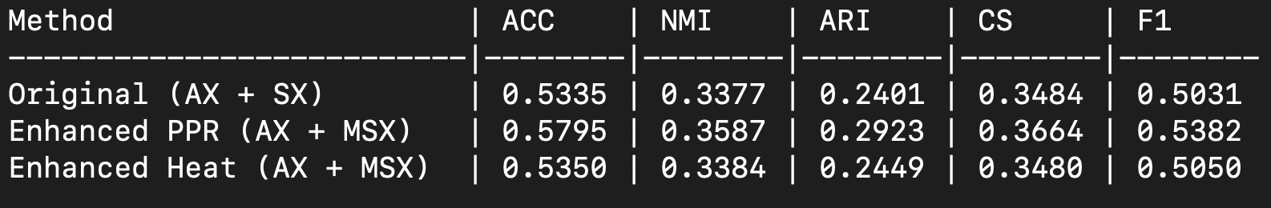

Best method: PPR with NMI = 0.3587

PPR improvement: NMI +0.0210, ACC +0.0460

Heat improvement: NMI +0.0007, ACC +0.0015

SUCCESS: Multi-scale diffusion improved NMI by 0.0210

Ready to proceed to Step 2!

============================================================

COMPONENT PERFORMANCE STATISTICS

============================================================

ENCODER:

Total Time: 12.233s

Avg Time: 0.023s

Total Memory: -5.7MB

Avg Memory: -0.0MB

Calls: 525

RANDOM_WALK:

Total Time: 0.155s

Avg Time: 0.000s

Total Memory: 0.0MB

Avg Memory: 0.0MB

Calls: 1050

EMBEDDINGS:

Total Time: 0.234s

Avg Time: 0.023s

Total Memory: 51.7MB

Avg Memory: 5.2MB

Calls: 10

LOSS:

Total Time: 5.335s

Avg Time: 0.010s

Total Memory: 30.7MB

Avg Memory: 0.1MB

Calls: 525

KMEANS:

Total Time: 0.502s

Avg Time: 0.072s

Total Memory: 1.8MB

Avg Memory: 0.3MB

Calls: 7

PREPROCESSING:

Total Time: 0.201s

Avg Time: 0.050s

Total Memory: 330.1MB

Avg Memory: 82.5MB

Calls: 4

Dataset: Pubmed  
Results:  
=== STEP 1 RESULTS ===

Enhanced Training completed! Best NMI: 0.2843 at epoch 10

Training time: 333.98 seconds

=== Final Comparison (All Metrics) ===

Testing Original features (AX + SX)...

Testing Enhanced PPR features (AX + MSX_ppr)...

Testing Enhanced Heat features (AX + MSX_heat)...

=== COMPREHENSIVE RESULTS SUMMARY ===

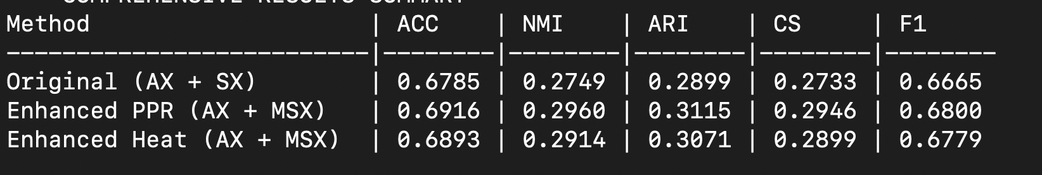

Best method: PPR with NMI = 0.2960

PPR improvement: NMI +0.0211, ACC +0.0131

Heat improvement: NMI +0.0164, ACC +0.0108

SUCCESS: Multi-scale diffusion improved NMI by 0.0211

Ready to proceed to Step 2!

============================================================

COMPONENT PERFORMANCE STATISTICS

============================================================

ENCODER:

Total Time: 57.164s

Avg Time: 0.019s

Total Memory: 41.6MB

Avg Memory: 0.0MB

Calls: 3000

RANDOM_WALK:

Total Time: 0.537s

Avg Time: 0.000s

Total Memory: -3.8MB

Avg Memory: -0.0MB

Calls: 6000

EMBEDDINGS:

Total Time: 0.359s

Avg Time: 0.036s

Total Memory: 250.3MB

Avg Memory: 25.0MB

Calls: 10

LOSS:

Total Time: 32.075s

Avg Time: 0.011s

Total Memory: 129.2MB

Avg Memory: 0.0MB

Calls: 3000

KMEANS:

Total Time: 0.406s

Avg Time: 0.058s

Total Memory: 2.2MB

Avg Memory: 0.3MB

Calls: 7

PREPROCESSING:

Total Time: 0.221s

Avg Time: 0.055s

Total Memory: 266.8MB

Avg Memory: 66.7MB

Calls: 4