 **University of Asia Pacific**

Department of Computer Science and Engineering

**Software Development Final Lab Report**

**Course Title:** Software Development Lab

**Course Code:** CSE 410

**Section:** C2

**Project Title:** **Online Driver Hiring**

|  |  |
| --- | --- |
| **Team Members** | **Registration ID** |
| 1. Naimul Islam | 21201142 |
| 2. Marud Ahammed | 21201144 |

|  |
| --- |
| **Instructor** |
| **Md Mubtasim Fuad**  Lecturer, Department of Computer Science & Engineering,  University of Asia Pacific |

**Project Title:** **Online Ride Booking and Driver Hiring Platform**

**Git Link:** [**https://github.com/Naimul2580/Driver_Hiring**](https://github.com/Naimul2580/Driver_Hiring)

**Vercel Link:** [**https://driverhire.vercel.app/**](https://driverhire.vercel.app/)

**Problem Statement:**

In today’s fast-paced urban environments, the demand for convenient, safe, and trustworthy transportation is rapidly growing. People often face challenges when trying to:

1. Book a ride quickly, especially in emergencies:
2. Find verified and trustworthy drivers
3. Manage rides, payments, and driver details efficiently
4. Report issues or seek support in case of disputes or emergencies

On the other hand, drivers also struggle to:

1. Find consistent job opportunities.
2. Build a reputation or trust without a formal platform.
3. Manage their availability and documents in one place.

Meanwhile, administrators face difficulties in:

1. Managing users and drivers securely.
2. Handling support requests and complaints.
3. Verifying driver documents manually.
4. Monitoring system activity to ensure compliance.

Traditional solutions like phone calls, informal hiring, or loosely managed apps lack the structure and security needed for such a service.

**Solution:**

To address these gaps, we propose a web-based application with the following features:

1. Users can create accounts, add their vehicles, book rides, and make payments securely.
2. Drivers can register, accept rides, manage their availability, and go through document verification.
3. Admins can oversee platform activity, approve/suspend users, post job opportunities, manage tickets, and ensure system integrity.

**This platform ensures:**

1. Secure authentication
2. Transparent ride management
3. Real-time user-driver communication
4. Scalable job and support handling
5. Verified and trusted driver onboarding

By digitizing and streamlining the process, this system improves safety, convenience, and efficiency for all parties involved.

**Motivation:**

The motivation behind developing this project stems from the growing need for a reliable, secure, and user-friendly platform that addresses everyday transportation and driver hiring challenges. In many cities, especially in developing regions, people still rely on traditional, unstructured methods to find drivers or book rides often making calls, depending on word of mouth, or using unverified services. This not only creates inconvenience but also raises concerns regarding safety, trust, and accountability. We observed that there is a noticeable gap in the availability of a system that can digitally transform and streamline this process. Our goal was to build a web-based solution that would connect users, drivers, and administrators on a single platform, offering features like user and driver registration, vehicle management, ride booking, driver hiring, real-time status tracking, support ticket handling, and secure payments. We were inspired by the potential of digital systems to simplify lives, support local employment, and ensure transparency and security in every step from document verification to ride completion. By digitizing the entire process, this platform not only improves user convenience but also provides job opportunities for drivers and empowers administrators with tools to manage everything efficiently. The project reflects our ambition to contribute to the evolving smart transport systems and promote digital transformation in a sector that still largely depends on manual processes.

**Comparative Analysis & Existing Solution:**

As the demand for convenient and efficient transportation services continues to rise, several well-known applications like Uber, Pathao, Shohoz, and Bolt have gained significant traction in urban areas. These platforms provide core functionalities such as real-time ride booking, fare estimation, and driver tracking. However, upon a closer look, it becomes evident that while these services address some transportation needs, they also exhibit several limitations, especially in the context of driver hiring, admin control, and local job management.

Most of these existing solutions are ride-centric, meaning they are designed solely for immediate ride requests rather than long-term or dedicated driver hiring. They do not provide users the flexibility to hire drivers for personal vehicles on a contract or daily basis. Moreover, these apps lack a dedicated job portal, which is crucial for organizations or individuals looking to employ drivers for full-time roles.

In essence, while existing ride-hailing apps have brought innovation to transportation, they fail to address the complete ecosystem of driver hiring, admin verification, job management, and personalized service control. Our project aims to fill these gaps by integrating all these features into a unified and scalable platform.

# Objectives

* To develop a web-based platform that connects users, drivers, and administrators in a centralized system.
* To allow users to book rides and hire drivers for short-term or long-term use.
* To enable drivers to register, manage their profiles, and receive ride or job requests.
* To build an admin panel for managing users, drivers, jobs, support tickets, and verification.
* To introduce a job posting and application system for hiring professional drivers.
* To implement a support ticket system for resolving user and driver issues efficiently.
* To ensure secure and verifiable document submission and approval for driver authenticity.
* To offer a flexible and transparent payment system, including payment history tracking.
* To maintain safety, accountability, and transparency through admin-level control and verification.
* To deliver a scalable, modular, and user-friendly application that improves the overall transportation experience.

# Project Output

* A fully functional **web application** for ride booking and driver hiring with separate roles for User, Driver, and Admin.
* **User Module** with features like registration, profile management, vehicle management, ride booking, and payment tracking.
* **Driver Module** for driver registration, profile updates, job applications, and ride management.
* **Admin Dashboard** to manage users, drivers, support tickets, verification requests, and job postings.
* **Job Management System** allowing admins to post jobs and drivers to apply directly through the platform.
* **Customer Support System** where users and drivers can create and track support tickets.
* Clean **UI/UX design** with responsive frontend for smooth interaction across devices.

**Project Timeline**:

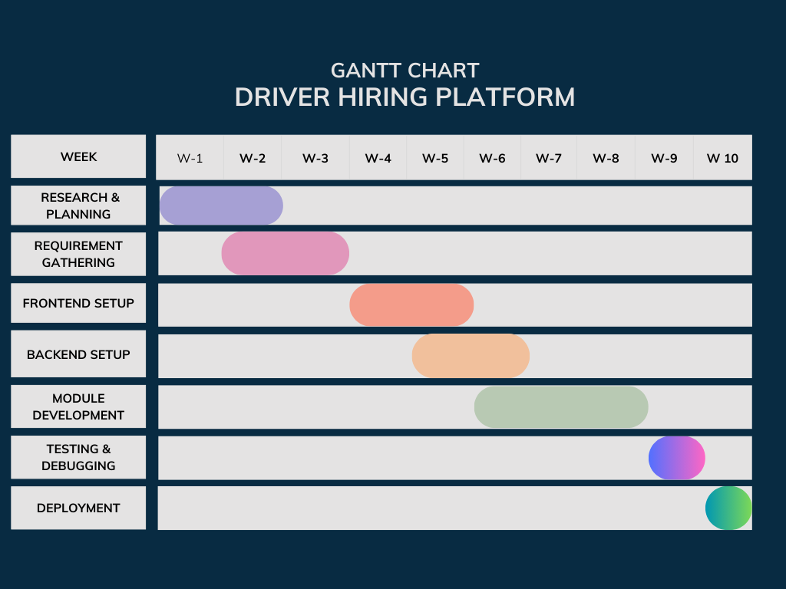

# Functionalities

**User Management:**

**User Registration/Login:**

1. Users can register and log in to the platform using their email and password.
2. Passwords are securely hashed using. JWT tokens are used for authentication.

**User Profile Management:**

1. Users can view and update their profiles.
2. Admins can fetch all user profiles or delete user accounts.

**Driver Management:**

**Driver Profiles:**

1. Drivers can create profiles with details like name, email, phone, and role.
2. Admins can approve or suspend drivers.

**Driver Verification:**

1. Drivers can submit documents (e.g., ID, license) for verification.
2. Admins can approve or reject submitted documents.

**Ride Booking System:**

**Ride Booking:**

1. Users can book rides by providing pickup and drop-off locations, and charges.
2. Rides are stored with statuses like "pending," "accepted," "in-progress," "completed," or "canceled."

**Ride Management:**

1. Drivers can accept rides.
2. Users or admins can update ride statuses or cancel rides.
3. Users can view their ride history.

**Job Posting and Applications:**

**Job Applications:**

1. Drivers can apply for jobs by submitting their details.
2. Admins can view applicants for each job.

**Security Features:**

**Data Validation:**

* Input data is sanitized using express-mongo-sanitize and prevent injection attacks.

**Authentication:**

* JWT tokens are used for secure user authentication.

**Methodology:**

1. **Agile Development**: Iterative development with sprints for continuous delivery and feedback.

2. **RESTful API Design:** Modular endpoints using standard HTTP methods (GET, POST, PUT, DELETE).

3**. Separation of Concerns:** Layers for controllers (HTTP handling), services (business logic), and models (database).

**Design Pattern:**

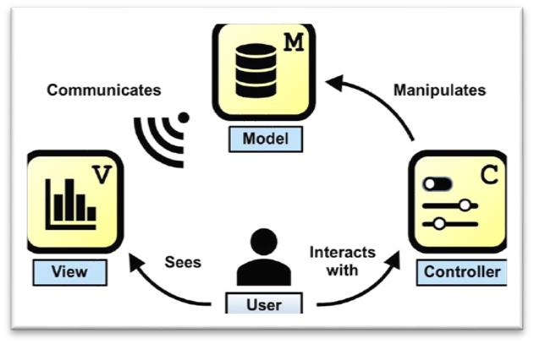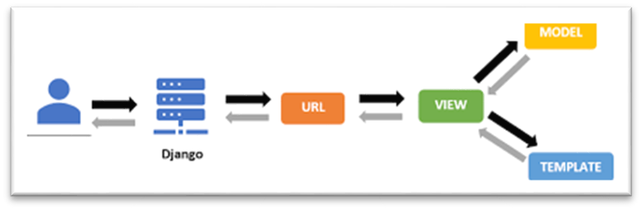

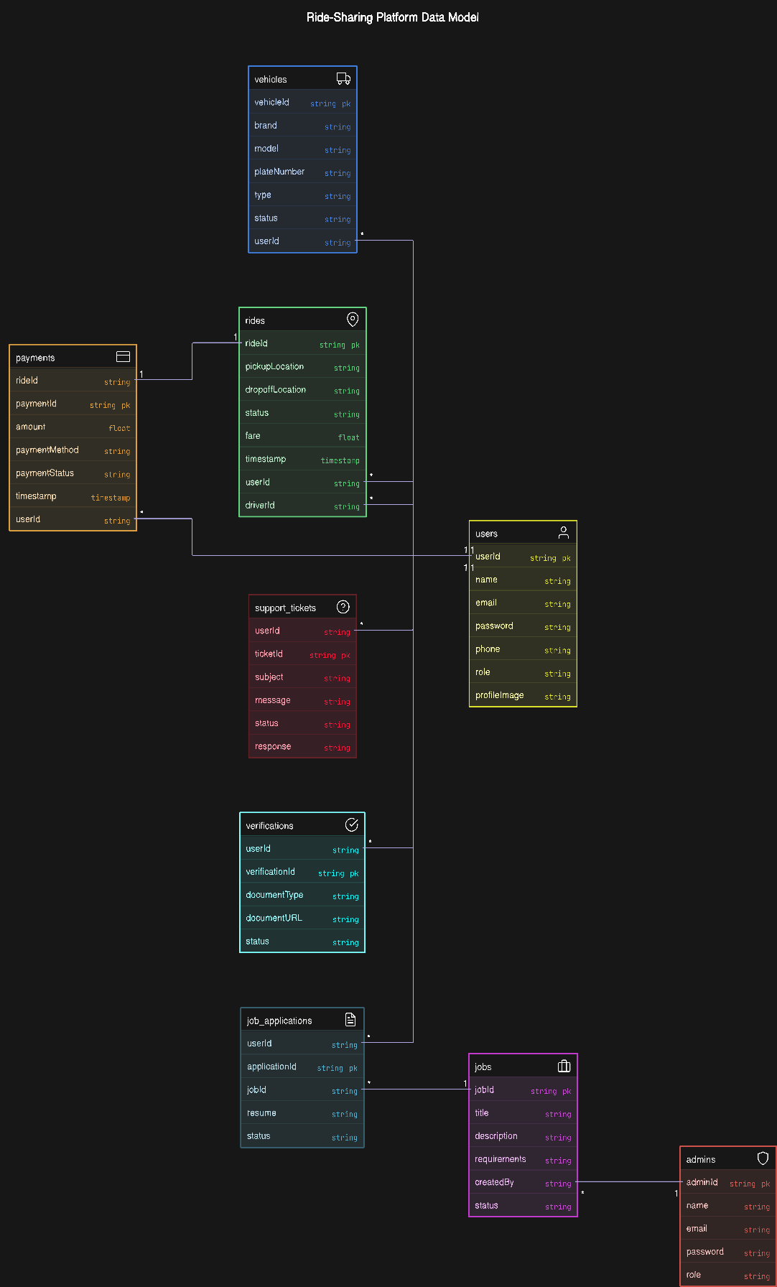 **ER Diagram:**

**Cost Analysis:**

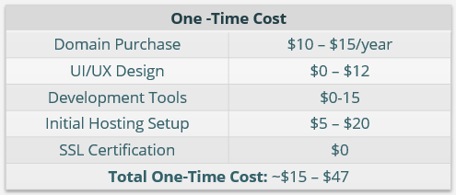

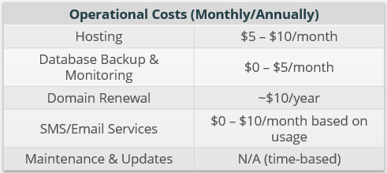

Estimated Monthly Operational Cost: ~$5 – $25

Estimated Annual Operational Cost: ~$60 – $300

## Break-Even Analysis

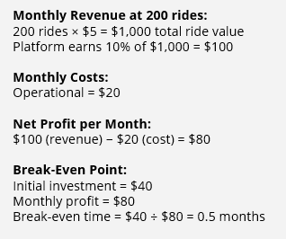

**Project Results:**

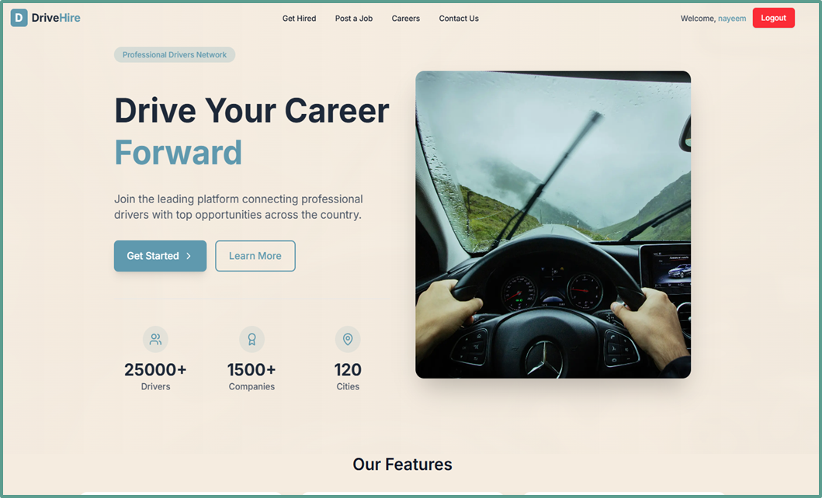

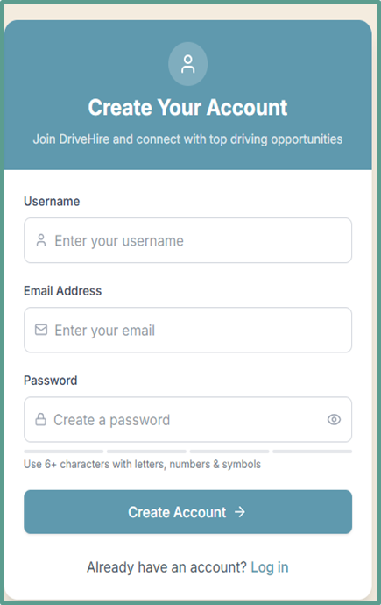

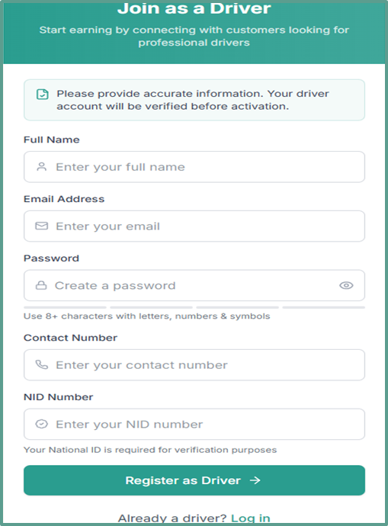

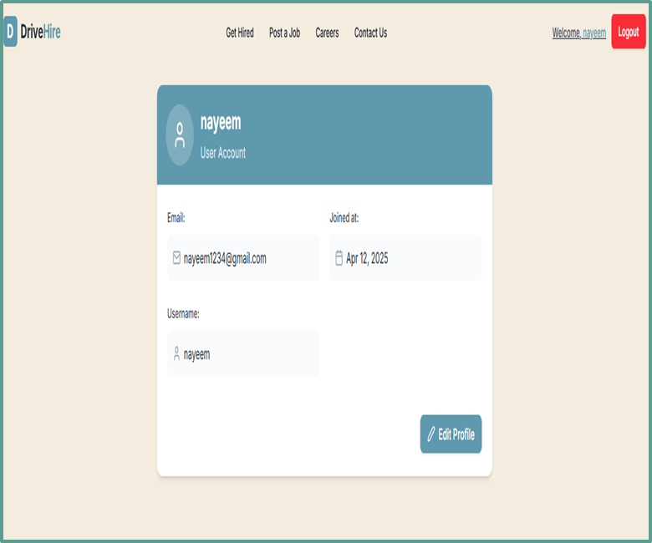

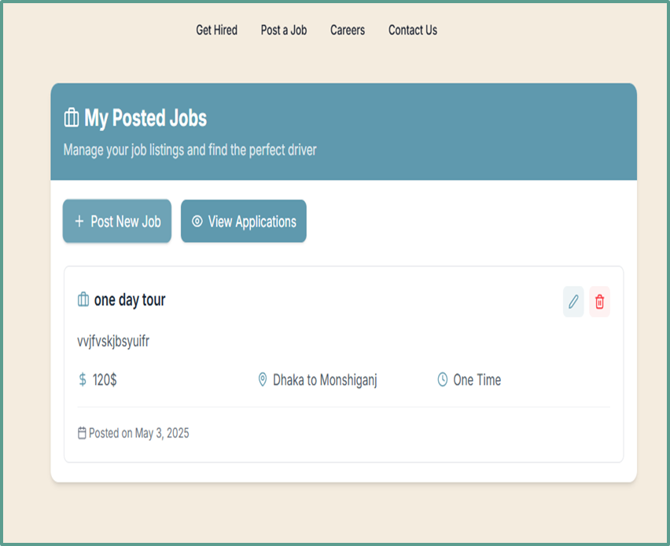

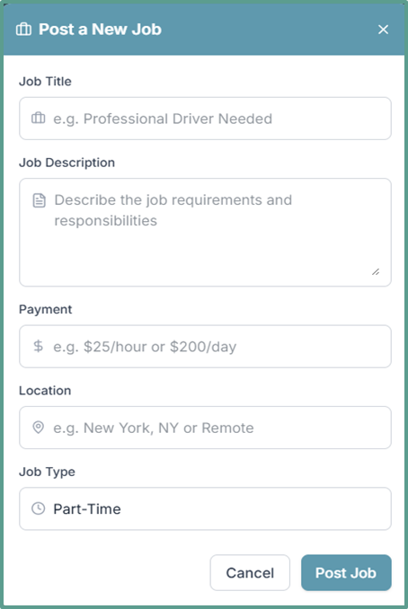

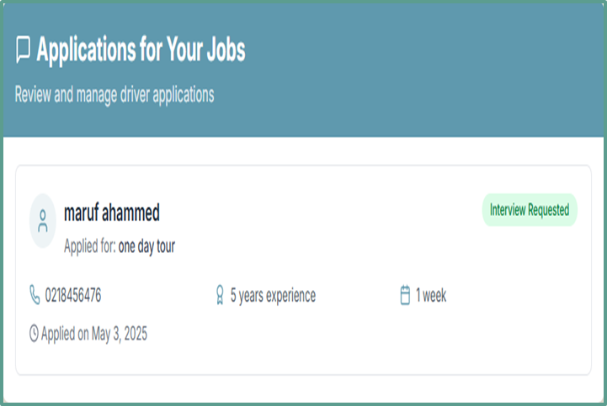

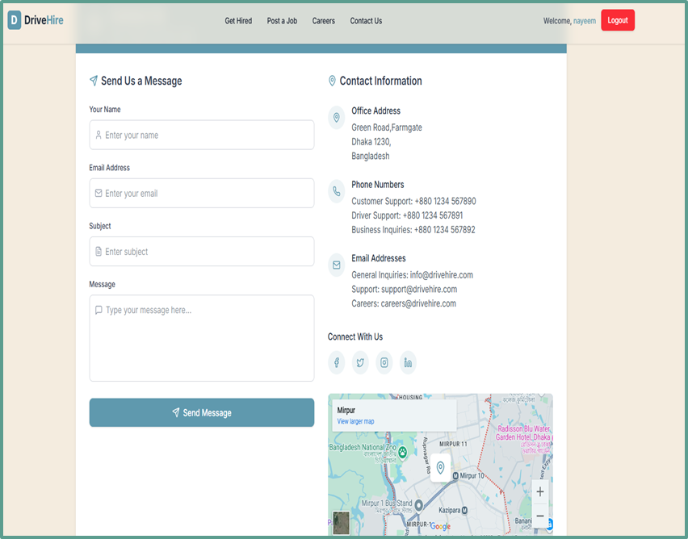

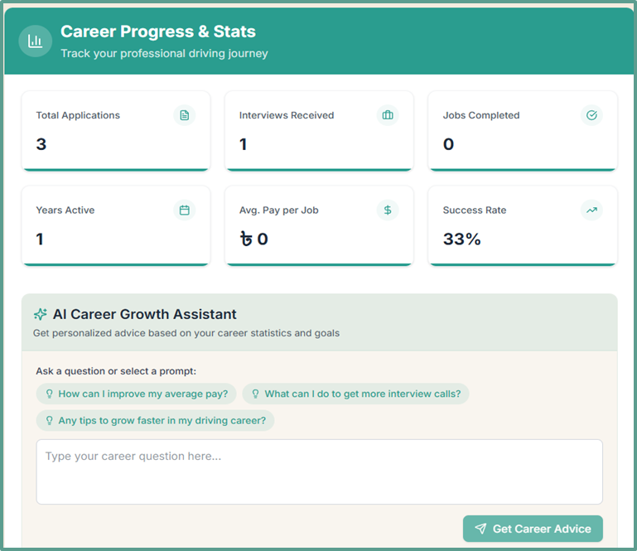



**Conclusion:**

The Driver Hiring Application is a comprehensive platform designed to streamline the process of connecting users with professional drivers. By integrating features such as user and driver management, ride booking, job postings, payment processing, and customer support, the application provides a seamless and efficient experience for all stakeholders. Built with a robust technology stack and adhering to best practices like RESTful API design, MVC architecture, and Agile methodology, the project ensures scalability, maintainability, and security. The use of design patterns like Service Layer and Repository Pattern further enhances the modularity and reusability of the codebase. This project not only simplifies the driver hiring process but also lays a strong foundation for future enhancements, such as real-time tracking and advanced analytics, making it a scalable and user-friendly solution for the transportation industry.

**CEP Mapping**

