UI desiign

About page UI design:

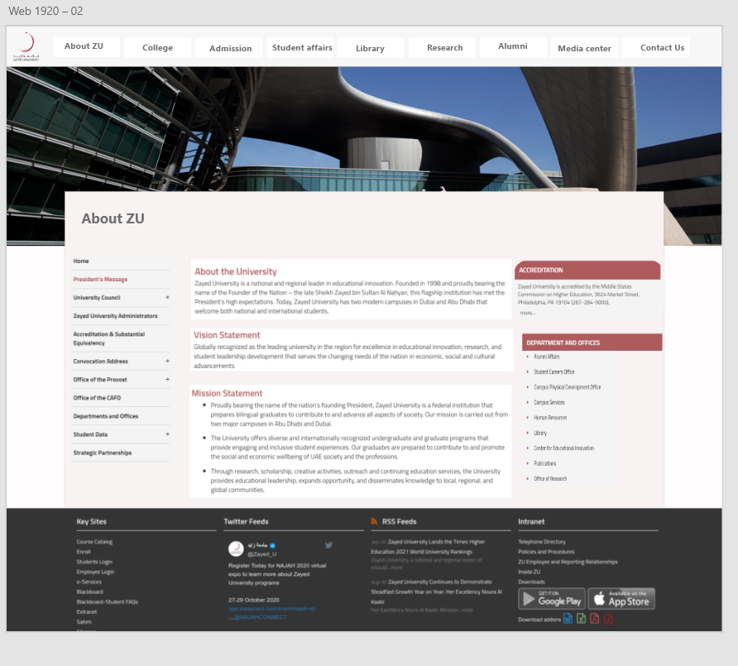

Figure : About page UI design

Course and admission information page UI design:

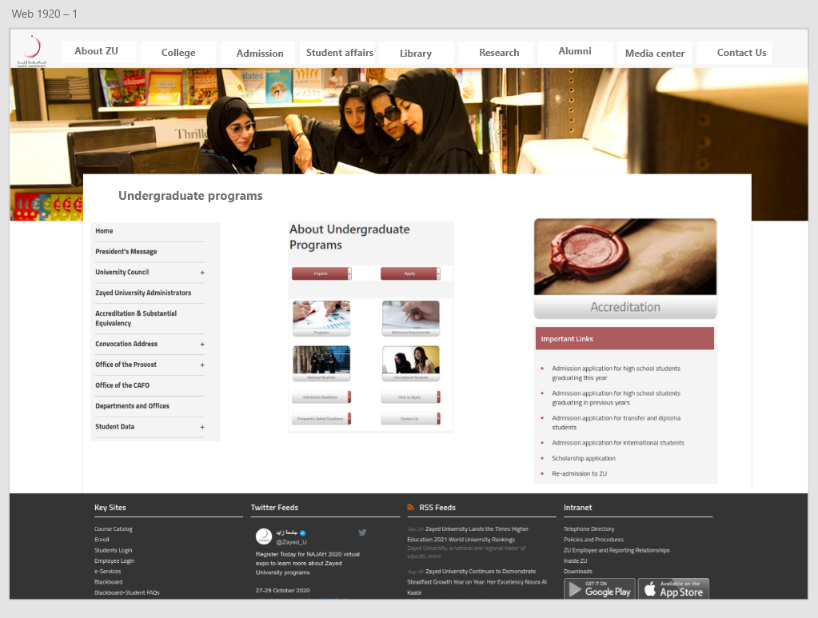

Figure : Course and admission information page UI design

Contact us page UI design:

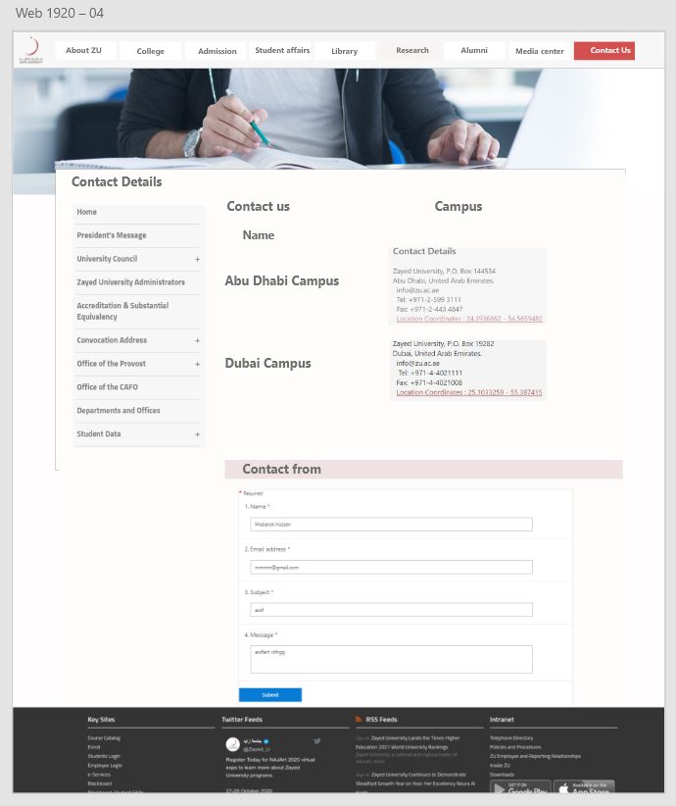

Figure : Contact page UI design

Alumni Success story UI design:

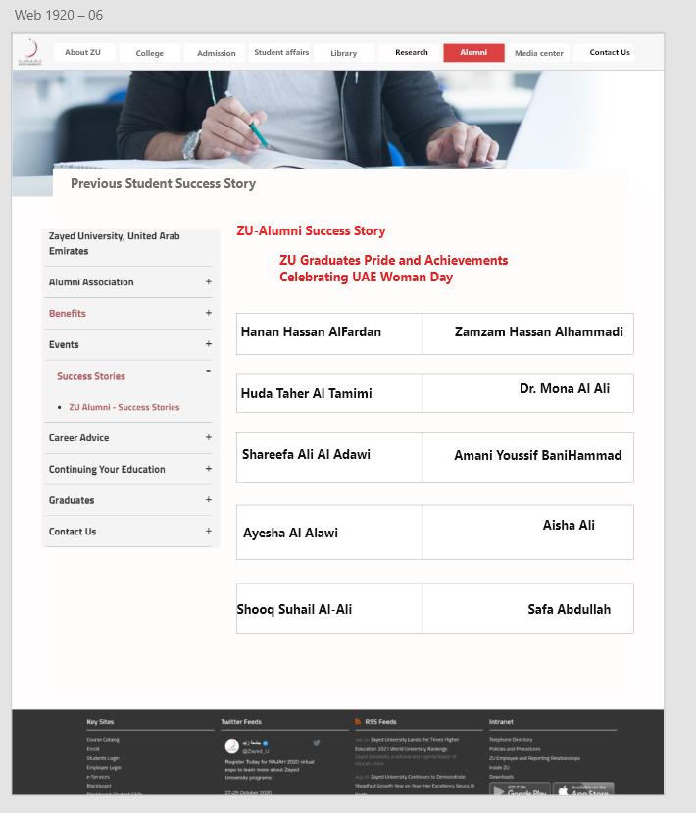

Figure : Alumni UI design

Current News and event page UI design:

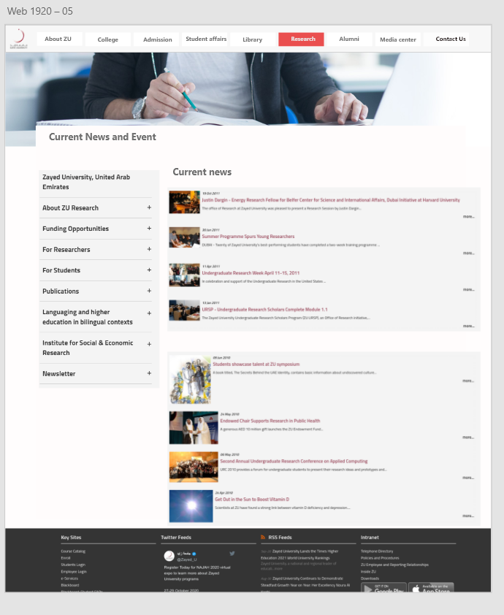

Figure : Current news page UI design.

Research Paper information UI page design:

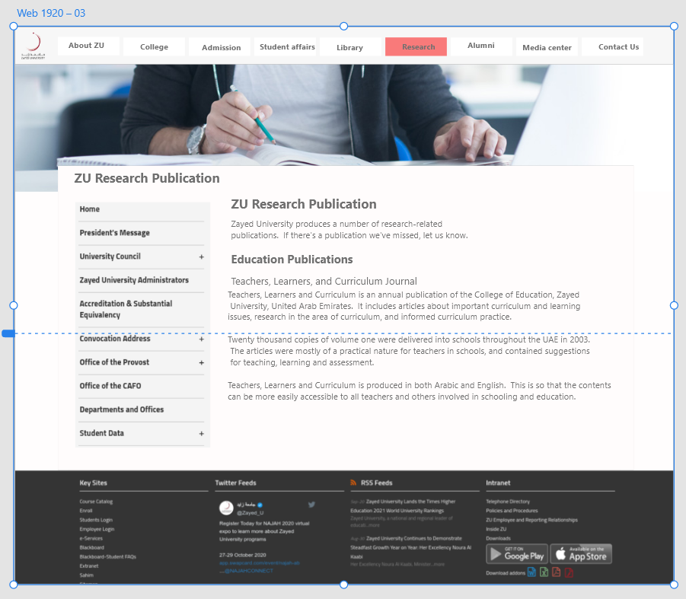

Figure : Research paper information UI design.