**Information Architecture:**

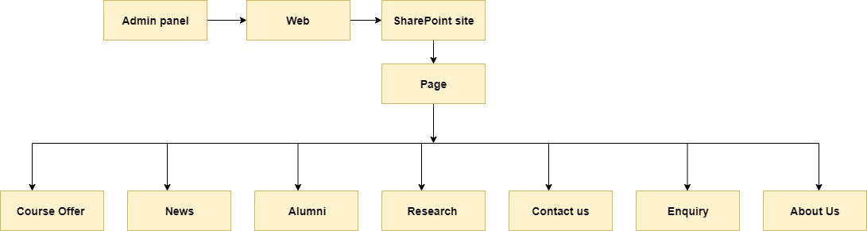

Figure : Information Architecture