

**North South University**

**SDS**

**CSE327**

**SEC: 06, Group: 6  
Due Date: 24th JULY,** 2019

**PROJECT TOPIC: ONLINE HOSPITAL**

**GROUP MEMBERS:**

* **Marufa Tasnime**

**ID:1620287642**

* **Md. Haidaruzzaman**

**ID:1610977042**

* **Aishwaria Roy**

**ID:1610624042**

**ONLINE HOSPITAL**

The purpose of our project is to simplify and automate the process of searching for good doctors in case of emergency. We hope to create a system where individuals can book an appointment with their desired doctor with relative ease. The website would contain the necessary details of all sorts of specialized doctors.

The website would allow the users to find their desired doctors based on their search criteria. The users would be allowed to book appointments only after they have done half of the payment through online banking.

**DESIGN SPECIFICATIONS:**

**Features:**

**Login:**

The system provides security features through username-password matching where only authorized user can access the system.

**Admin Login:**

Admin would have full access to the website and its database (except the confidential information of the users). There would be a default administration account, and with a separate URL. The authority is advised to change the default admin ID for security reasons.

List of activities associated with this type of accounts are:

**>>** View all information

**>>** Modify

**>>** View all number of appointments

**>>** Delete user account

**>>** Retrieve user account by resetting & setting password upon request

**User Login:**

**>>** Create account

**>>** Login

**>>** View specialized doctors for each disease all over the country

**>>** Take appointment

**>>** Know the timing

**>>** Pay fees

**Doctor profile**:

The system will create a profile for each doctor. The records of all doctors are kept in one centralized database and thus reducing duplicate data in the database.

**>>** Section they are specialized in will be given

**>>** Timing

**>>** City & hospital they are available in

**Book Appointments:**

User can book appointments with half of the payment through online banking.

**Surgeons:**

The system will create an extra option where user can find the doctor who also do surgery in their respective fields.

**E-R DIAGRAM:**

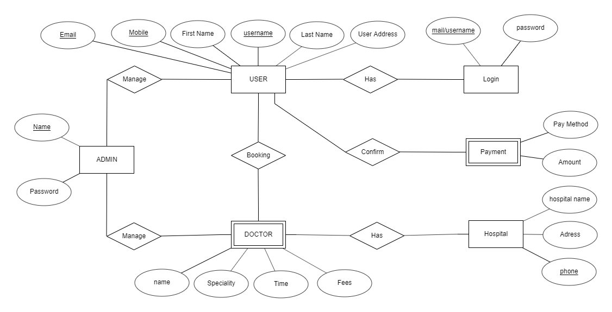

**USE CASE DIAGRAM:**

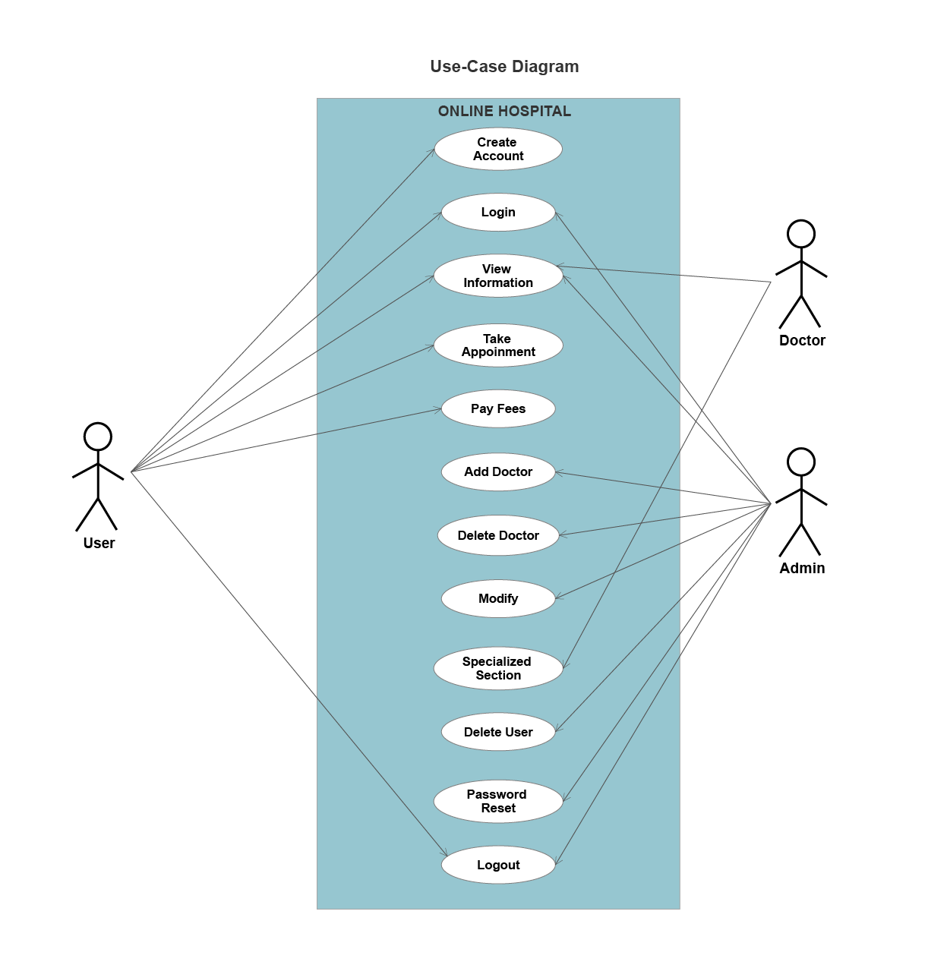

**UML CLASS DIAGRAM:**

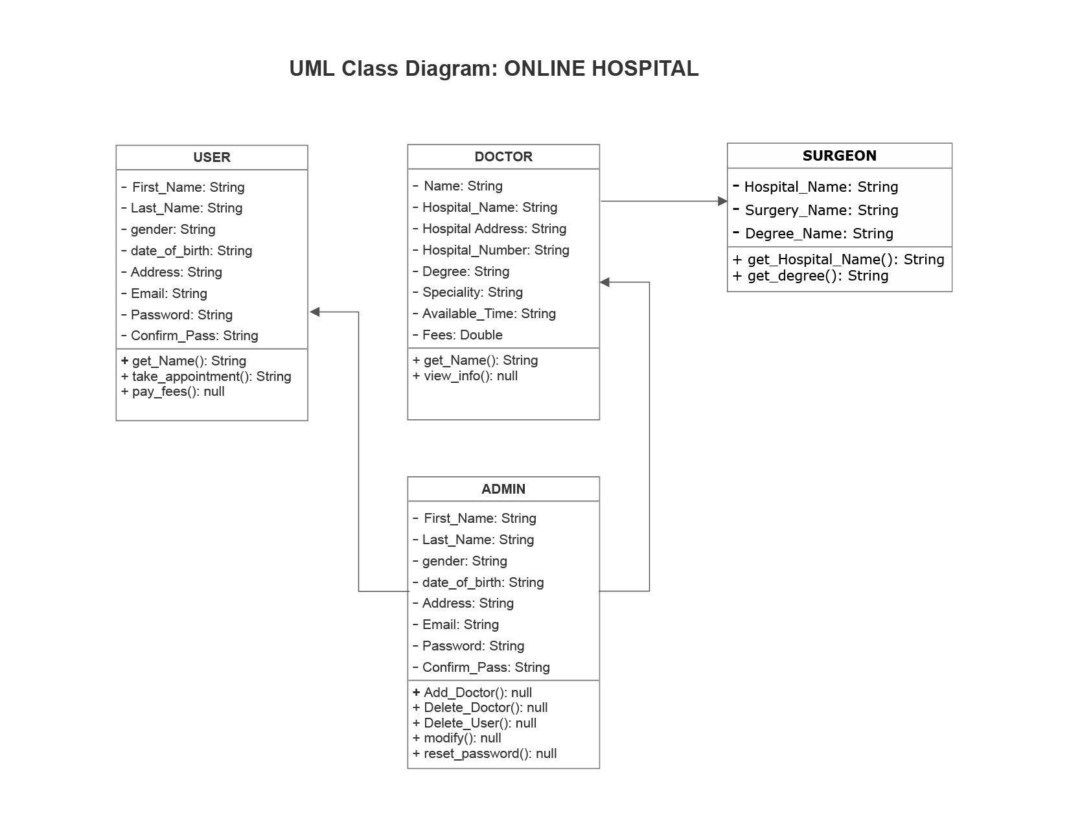

**UML SEQUNCE DIAGRAM:**

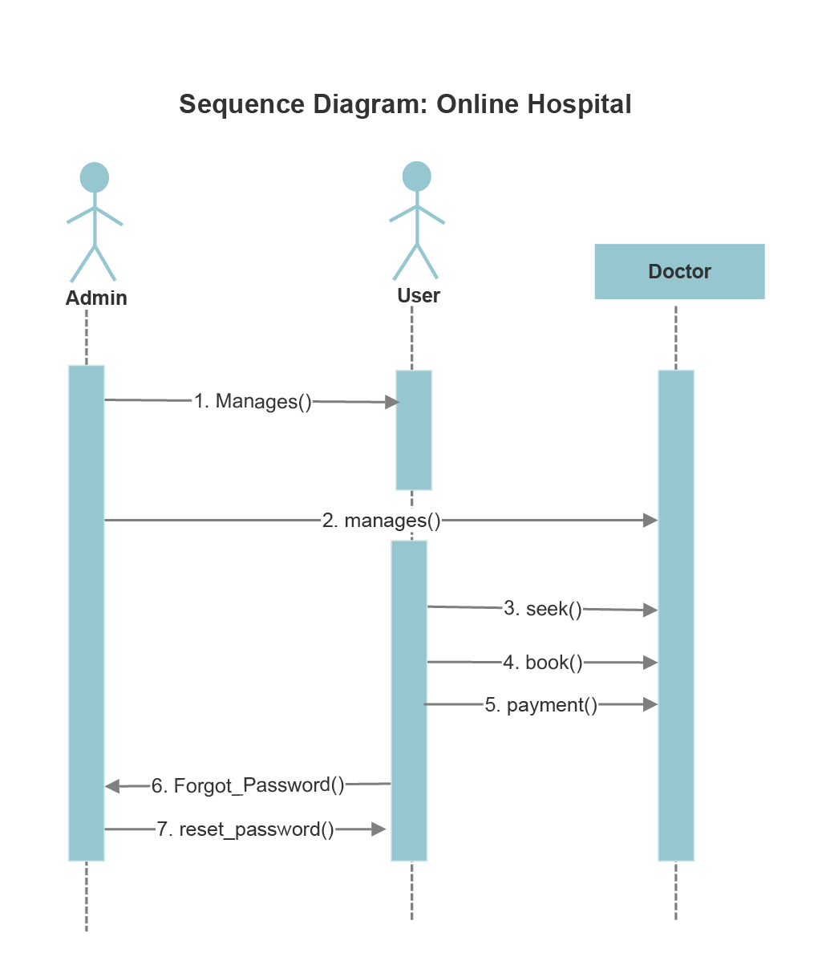

**Banking Partners:** To take the appointment one need to pay the half fees via online banking. The customers have to use the paypal for payment.

The banking partner needs to be aware that the product would have access to this information.

**>>** Transaction ID.

**>>** Transaction time.

**>>** User making the transaction.

**>>** Transaction amount.

**Business Model:** The product would be released as Website into the online world. First 3 months it will be free of cost. After 3 months we will take 5% of the doctor’s fees from the users to take an appointment.

**Real life impact:**

**>>** People can use it while at home or anywhere

**>>** Will be benefited by knowing about the specialized doctors and their timing

**>>** Can take appointment from anywhere

**>>** Can use while emergency

**>>** The lobbing system can be reduced