

**Software Requirements Specification**

**For**

**Tourism Management System**

**SUBMITTED TO**

**Asif Khan Shakir**

**Senior Lecturer, Department of SWE**

**Daffodil International University**

**Submission Date: 10- 12 - 2020**

**Declaration**

**I hereby declare that this Submission is my work and that, to the best of my knowledge and belief, it contains no material previously published or written by another person nor material which to a substantial extent has been accepted for the award of any other degree or diploma of the university or other institute of higher learning, except where due acknowledgment has been made in the text.**

**The declaration Tourism Management System can be considered as most favorite pass time when people get free time. Several travel organizations are available on the web. The people or the tourist selects their own Travel Package according to their personal interest. The travel companies concentrate on the interest associated with tourist making sure to increase their particular market value and supply enormous package deals. So that they can make their travel package more effective. Now-a-days Recommender system is becoming very famous and people are getting attracted to it, as it is helping them to choose the best package in a short time.**

**Sakibul Alam Ador (173-35-2272)**

**Maruf Islam Bhuiyan (173-35-2268)**

**Eshita Akter (173-35-2214)**

**Section: D**

Page-1

**Project in Brief**

**Project Title:** Tourism Management System

**Supervised By:** Asif Khan Shakir

**Date Started:** September 22, 2020

**Date Completed:** December 12, 2020

**Tools Used:**

Hard Disk: 1 TB

Ram: 4 GB

SSD: 128 GB

Processor: Core i5 7th Gen

IDE & Software:

• Sublime Text 3 & Notepad ++

• Core Php

• CSS

• HTML

• Database: MySQL (Php Myadmin)

• Github

• Xampp

**Operating System:** Windows 10 Pro Edition

Page-2

**Abstract**

The recent past showed a greater interest in recommender techniques. Now-day’s there are many travel packages existing from different websites to almost all the places over the world. A customer finds it very difficult to search for the best package as he/she has to browse multiple websites, contact many travel agents and etc. which is a tedious process and is time consuming. There should be a system where the user should find the best package on the Internet with a single click. To address this issue, we adopt Travel Package Recommendation System which offers the best package among all the other packages that are on the web. This project will help tourist to suggest the best Travel Package among all the package deals on the web. On multiple demands of tourist that is, a customer will select a travel package for a particular place based on the recommendations provided by the previous customers who had experience with the package. Therefore, according to the personalized recommendations, he/she will choose the best package that is on the web. Initially, we will evaluate the particular characteristics of the current traveling packages and we mine the data on the tourists rating and the intrinsic features i.e., locations, travel seasons etc. Based on the data collected after mining, we will generate a list for personalized travel package recommendations. Furthermore, we will extract the data based on the tourist's relation with the area and season.

Page-3

**Table of Contents**

Declaration…………………………………………………..………………………………..…...1

Project in Brief.…………………..…………………………..………………………………..…2

Abstract……………………………………..…………………………………………………..……3

1. Introduction…………………………………..…………………………………………….…..6

1.1 About the system…………………………..……..………………………………..…..6

1.2 Purpose……………………………………..…………………………………………….….7

1.3 Scope…………………………………..………………………………………………………7

1.4 Advantages…………………………………..……………………………………………. 8

1.5 Disadvantages……………………………………..…………………………………….. 8

2. System Analysis…………………………………..………………………………….……….9

2.1 Use Case Diagram………………………………………………………………………10

2.1.1 Use Case Diagram for Admin………………………………………………..10

2.1.2 Use Case Diagram for Employee………………………………..………….11

2.1.3 Use Case Diagram for Visitor…………………………………………..……..12

2.1.4 Use Case Diagram for Owner………………………………….……………..13

2.2 Actor Goal List………………………………………………………………………..…..14

2.3 Use Case Description …………………………………………………………………..15

3. System Design………………………………………………………………………………..17

Page-4

3.1 Sequence Diagram …………………………………………………….……………..17

3.1.1 Sequence Diagrams of Sign Up…………………..………………………..17

3.1.2 Sequence Diagrams of Login in……………………..……………………..18

3.2 Class Diagram…………………………………………………………………………....19

3.3 Entity Relationship Diagram…………………………………….………………..20

4. Implementation ……………………………………………………………………..……..21

4.1 Tools & Technologies ………………………………………………………………..21

4.2Project Link ………………………………………………………………………………..21

5. Conclusion……………………………………………………………………………………..22

5.1 Good Features of the System………………………………………..…………..22

5.2 Future enhancement of the system …………………..……………………..22

5.3 Limitation ……….……………………………………………………………….………..23

6. User manuals ………………………………………………………………….……………..24

7. References……………………………………………………………………………………..25

Page-5

**Chapter 1**

**1. Introduction**

Tourism Management is management of all activities related to tourism business. This tutorial introduces you to various types of tourism, geographical milieus, destination awareness, development, and management, market segmentation, tourism products and services, impacts of tourism, and trends in tourism. Tourism was mainly been traditional in its early form. With the evolution of cultures, economies, and knowledge, tourism took a different form called sustainable tourism with the aspect of well-planned tour, well-studied destination, and conservation of destination. It involves the management of multitude of activities such as studying tour destination, planning the tour, making travel arrangements and providing accommodation. It also involves marketing efforts to attract tourists to travel to particular destinations.

**1.1 About the system**

In this Tourist Management System visitors will see the future of different tourism ways. The system is made for consumers to make their tour easier and joyful. The system is mainly about tour places transformation system, fair distance, spot rating, traveller amount, distance fair, user feedback and most important is easier operating and its payment system.

Page-6

**1.2 Purpose**

Tour Management system is a dynamic website for tourism business. It is dynamic and responsive web design. It is also called travel technology solution for agencies & tour operation. Nearly everyone goes on a vacation for this ‘a Tourism management system’ would play a vital role in planning the perfect trip. The tourism management system allows the user of the system access all the details such as location, events, etc. The main purpose is to help tourism companies to manage customer and hotels etc. The system can also be used for both professional and business trips. The proposed system maintains centralized repository to make necessary travel arrangements and to retrieve information easily. Tourists are more attractive for cultural diversity of the world. Bangladesh is one of the most beautiful countries in the south Asia. Rangamati, Cox’s Bazar, Saint-Martin, Sundarban , Sylhet, Moulvibazar are the famous tourist place in Bangladesh as well as in Malaysia, Singapore, Bangkok, Maldives, Nepal, India have attractive tourist places. Our goal is to make a good and healthy tour for our clients.

**1.3 Scope**

The Software product is designed for PC, laptops and all devices which are compatible with java. The users of this product can use the services of the software when they are connected to the web as data is retrieved and stored in SQL database and mined to get the results. The product is compatible with java 1.6 or higher versions and MySQL database.

Page-7

**1.4 Advantages**

1. The Travel Packages will be presented based on the interest of the tourist.

2. By using tourist, area and season as our inputs we can represent our travel data in the best form.

3. By using this recommendation approach the flaws of the existing system will be eliminated as it performs much better than traditional techniques.

4. The algorithms will help the tourist to find the best package in the particular area based on season and theme

**1.5 Disadvantages**

1. Travel data are much fewer and sparser than traditional items.

2. The traditional items for recommendation usually have a long period of stable value, while the values of travel packages can easily depreciate over time.

3. The real world travel recommendation systems are usually very complicated.

4. Every travel package consists of many landscapes (places of interest and attractions), and thus has intrinsic complex spatial temporal relationship.

Page-8

**Chapter 2**

**2. System Analysis**

In this system, there are four types of users. The users are Admin, Employee, Owner, and visitor.

**Admin:** Admin will monitor everything from processing application; check payment status, approved application.

**Employee:** Employee is also an important user. He checks all requested application, payment status, case broken request, renews application.

**Owner:** Owner can enter the system; find their desired information request application, payment by the system easily.

**Visitor:** Visitor is our main user. They will enter to the system search and find their information. Can make payment, get notified by email.

Page-9

**2.1 Use Case Diagram**

**2.1.1 Use Case Diagram for Admin**

**Admin**

Page-10

**2.1.2 Use Case Diagram for Employee**

|  |
| --- |
|  |

**Employee**

Page-11

**2.1.3 Use Case Diagram for Visitor**

Page-12

|  |
| --- |
|  |

**Visitor**

**2.1.4 Use Case Diagram for Owner**

|  |
| --- |
| **Login** |

**Owner**

Page-13

**2.2 Actor Goal List**

In our system, there are four actors. They are admin, employee, owner, and visitor.

Goal List of Admin:

* Maintain the whole system
* processing all application
* Maintain payment system

Goal List of Employee:

* Maintain the application request
* Collect all data from the Owner
* Provide application to admin
* Maintain payment status

Goal List of Owner:

* easily find out desired information
* Solve the problem from home
* Easily request for application
* Easily request for renew application

Goal list of Visitor:

* Easily access to the system
* Easily can make payment
* Easily see the tour spots

Page-14

**2.3 Use Case Description**

|  |  |
| --- | --- |
| Use Case | Find Admin and Processing application |
| Goal | Employee sends applications to Admin for approve the license application by processing the applications very easily by this system |
| Precondition | All the users have to register themselves in the system. |
| Success End Conditions | Admin can maintain all his work within on time and smoothly using this system. Employees communicate with the admin and request applications to be processed and owner easily for making his work easier. |
| Failed End Conditions | Owner may fall in problem if admin reject his application. Admin may face problem in payment system. Employee may find hardness in contacting with Admin. |
| Primary Actors:  Secondary Actors: | Admin, Employee, Visitor, Owner.  Credit card, Banks. |
| Trigger | Doing registration.  Page-15 |
| Description | |  |  | | --- | --- | | Steps | Actions | | 1 | Admin will check update from employee. | | 2 | Employee will maintain and work on the requested application and communicate with consumers. | | 3 | Admin can approve or reject any application. | | 4 | Owner can see all status from employee and admin both. | | 5 | Employee will set the status of all application and add a license to close list after completing the application processing. | |

Page-16

**Chapter3**

**3. System Design**

Design is a process that uses the product of analysis to produce a specification for implementing a system. Design is the logical description of how a system will work. Design emphasizes a conceptual solution that fulfills the requirements, rather than its implementation.

**3.1 Sequence Diagram**

**3.1.1 Sequence Diagrams of Sign Up**

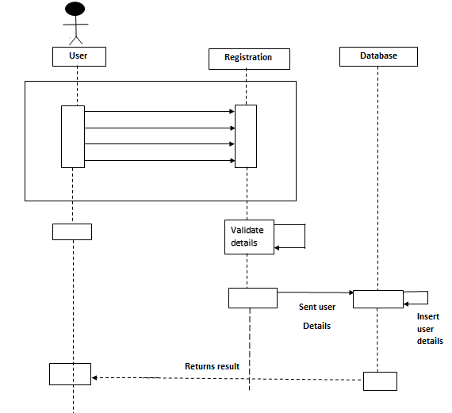

Page-17

**3.1.2 Sequence Diagrams of Login in**

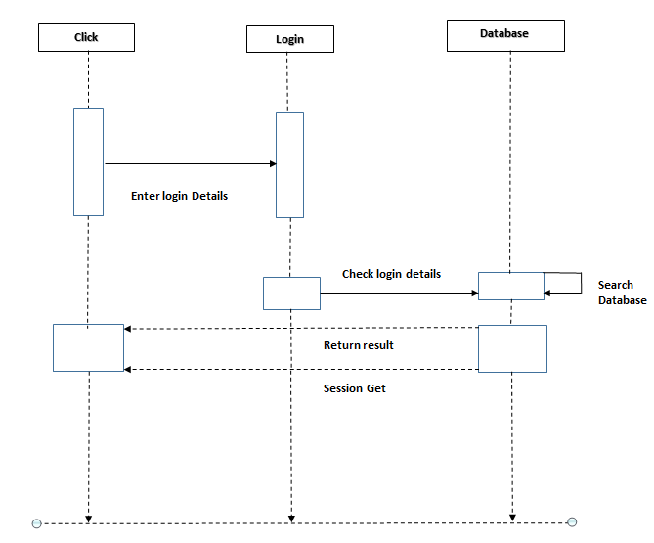

Page-18

**3.2 Class Diagram**

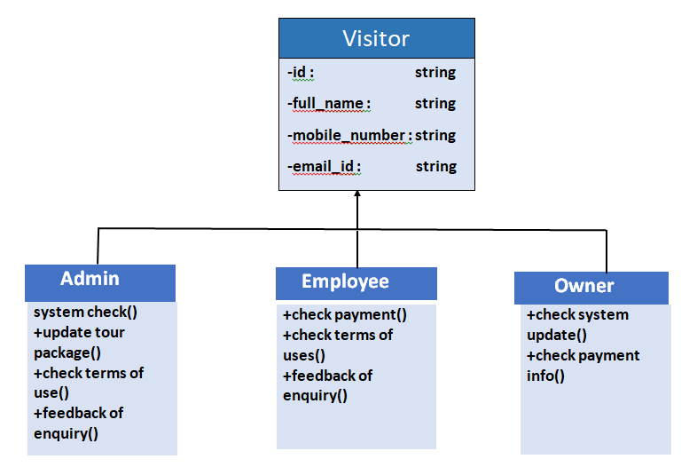

Page-19

**3.3 Entity Relationship Diagram**

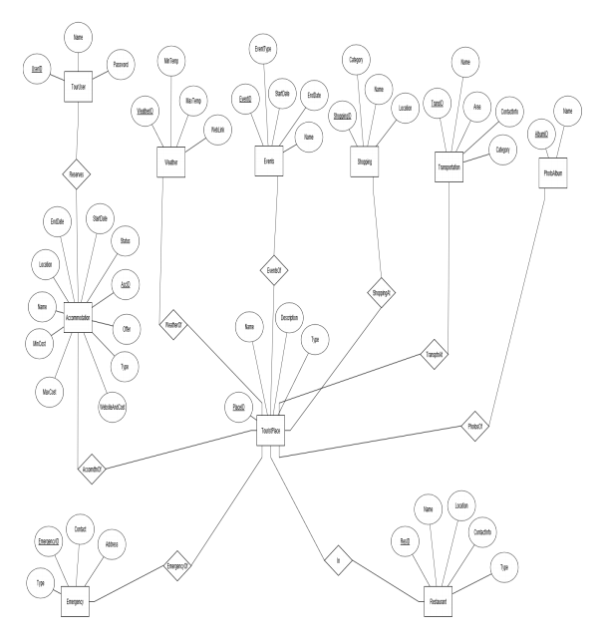

Page-20

**Chapter 4**

**4. Implementation**

**4.1 Tools & Technologies**

Following are the tools and technologies used in development of this project:

• Sublime Text 3

• Core Php

• CSS

• HTML

• Database: MySQL (Php Myadmin)

• Github

* Notepad++

• Xampp

**Operating System:** Windows 10 Pro Edition

**4.2 Project Link**

1. Github Link:

https://github.com/SakibAdor/Project-2

Page-21

**Chapter 5**

**5. Conclusion**

Our application is a web based application that helps in online searching of tour packages. There are many different activities in this system. This tourism management system can be fully customized with integration different API’s. It has friendly environment for customer. This web based application will help your tour related packages effectively & efficiently.

**5.1 Good Features of the System**

* User can search details of the customer, package & booking.
* Tourism management system is an online application, for that user can easily manage package details.
* Admin can track all the information of customer & package.
* Admin can edit delete & update.

5.2 Future enhancement of the system:

It is simplest, maintained & managed easily. Any changes in the future then the changes can be made easily in the system without having any obscurity, & will try to make more faster searching & booking for tourism management system.

Page-22

5.3 Limitation:

* Very high security needed to this system.
* Sometimes very high data interaction so, server is down.
* It is a step by step procedures, all steps are comes after one.
* So every step is needed to be first completed, and then move the other steps.
* No backup database.

Page-23

**Chapter 6**

**6. User manuals**

A user guide or user’s guide, also commonly known as a manual, is a technical communication document intended to give assistance to people using a particular system. It is usually written by a technical writer, although user guides are written by programmers, production project managers, or other technical staff, particularly in smaller companies. User guides are most commonly associated with electronic goods, computer hardware and software. Most user guides contain both a written guide and the associated images. In the case of computer applications, it is usual to include screenshots of the human-machine interface, and hardware manuals often include clear, simplified diagrams. The language used is matched tot he intended audience, with jargon kept to a minimum or explained thoroughly.

**Sign up page:**

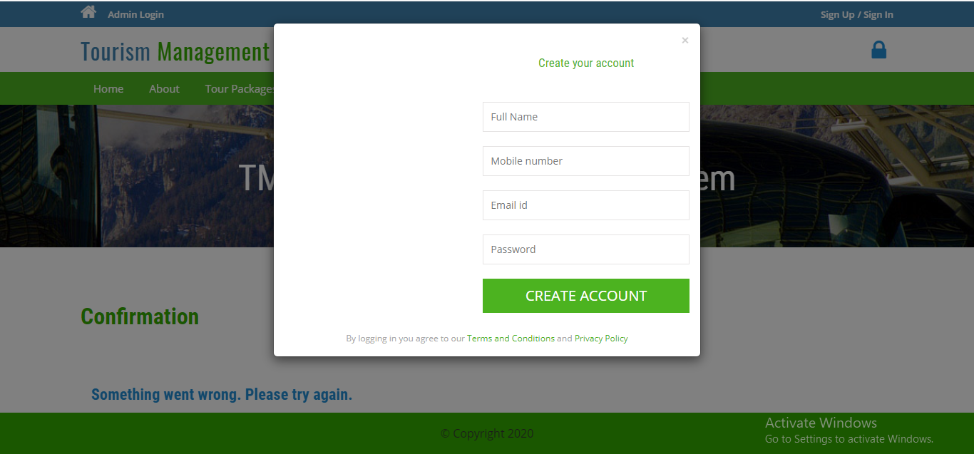

Page-24

**Enquiry page:**

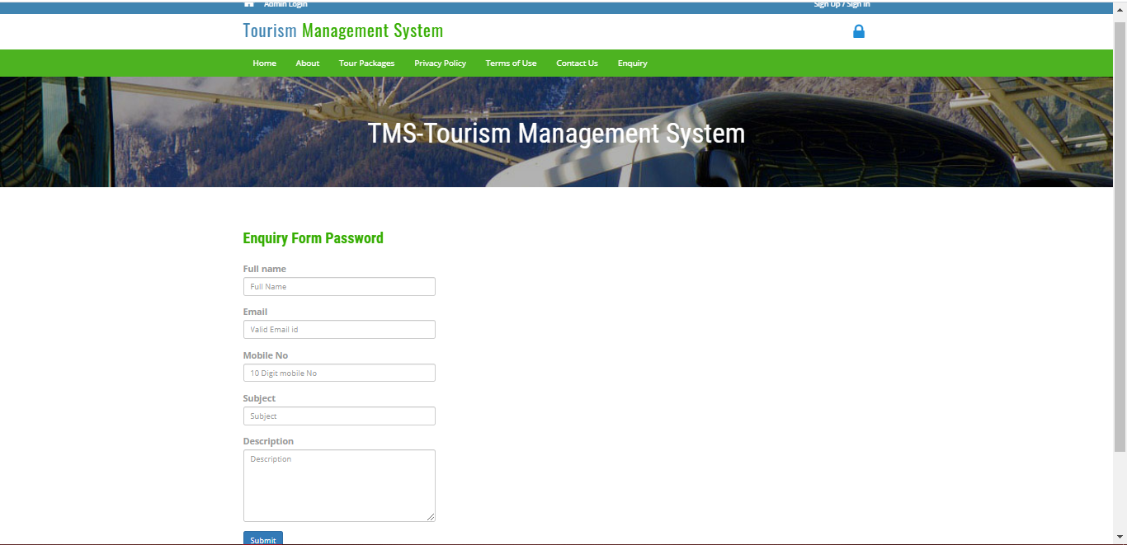

**Chapter 7**

**7. References**

Book: PHP: A Beginner Guide

Author- Vikram Vaswani

Book: The Joy of PHP Programming

Author- Alan Forbes

Page-25