PC GNN Experiment Record
YelpChi and Amazon author-mode checks, validation-only tuning, label-ratio experiments and three-seed results
Prepared for: COMP8851 project team and Dr Venus Haghighi
Updated: 9 September 2026
Status: Final consolidated PC-GNN record: 24 controlled runs verified

Executive summary
Verification result: PASS. PC-GNN is now complete under the current controlled protocol on YelpChi and Amazon. The evidence contains 24 final runs: four nested labelled-training ratios and seeds 2, 42 and 72 on each dataset. Validation and test IDs are fixed within each dataset; training subsets are nested; rho was selected by validation AUROC only; and all 1,812 final epoch timings are present.
• YelpChi mean AUROC moved from 0.8386 ± 0.0056 at TR40 to 0.7960 ± 0.0023 at TR10; mean AUPRC moved from 0.5244 ± 0.0106 to 0.4578 ± 0.0027.
• Amazon mean AUROC moved from 0.9702 ± 0.0007 at TR40 to 0.9413 ± 0.0076 at TR10; mean AUPRC moved from 0.8817 ± 0.0065 to 0.8571 ± 0.0103.
• Ranking performance therefore weakened as labels were removed on both datasets. Threshold-dependent F1 values were less monotonic and should not be used to claim that fewer labels improved the model.
• Mean epoch time fell from 12.563 to 2.754 seconds on YelpChi and from 2.000 to 0.517 seconds on Amazon.
• The datasets have separate persistent split families. Direct model comparisons must stay within the same dataset, ratio, seed set and evaluation condition.

1 Scope evidence and protocol
Paper: Pick and Choose A GNN Based Imbalanced Learning Approach for Fraud Detection
Official code: PonderLY PC GNN
Field | Recorded value
Final datasets | YelpChi and Amazon
Final run design | TR40, TR30, TR20 and TR10 × seeds 2, 42 and 72 for each dataset
Split rule | Persistent split seed 2; fixed validation/test IDs; nested stratified training subsets
Hyperparameter selection | TR40 validation AUROC only; test metrics not used
Optimizer | Adam on both datasets
Hardware | Kaggle Linux; one NVIDIA Tesla T4 on GPU 0
Source identity | Official repository commit 9d7d7fae491081178b6e12e193fb89cfc330f2be
Final timing evidence | YelpChi: 1,200 epoch rows; Amazon: 612 epoch rows; total: 1,812

Amazon evidence archive | Files | CRC | SHA 256 prefix
pcgnn_amazon_final_three_seed_results.zip | 109 | PASS | 2953bc26b6c6dc0009…
pcgnn_amazon_tr40_rho_tuning.zip | 48 | PASS | fb046e705bb3e6b58c…
amazon_shared_splits.zip | 5 | PASS | 517304b22ede42b981…
pcgnn_kaggle_t4_amazon_final_results.zip | 50 | PASS | c9967450fc47184eb5…

The full archive hashes and per-file verification result are retained in the Amazon verification JSON and package manifest.

2 Dataset-specific controlled configurations
Field | YelpChi | Amazon
Feature dimension used | 32 | 25
Eligible labelled nodes | 45,954 | 8,639
Selected rho | 0.4 | 0.2
Learning rate | 0.01 | 0.005
Weight decay | 0.001 | 0.0005
Batch size | 1,024 | 256
Embedding dimension / alpha | 64 / 2 | 64 / 2
Epochs / validation interval | 100 / every 5 | 51 / every 5
Classification threshold | 0.5 | 0.4
Architecture | PC-GNN multi-relation GNN | PC-GNN multi-relation GNN

Model architecture was preserved. Dataset-specific hyperparameters were tuned or retained from the repository workflow; they are not evidence of a single universal configuration.

3 YelpChi controlled results
Field | Recorded value
Graph and labels | 45,954 review nodes; 6,677 fraud/spam labels; three relations
Persistent partitions | TR40 train 18,381; validation 9,099; test 18,474; smaller training sets nested
Selected rho | 0.4; highest recorded TR40 validation AUROC 0.840387 at seed 72
Final evidence | 12 runs; 100 epochs each; 1,200 epoch timing rows

rho | Validation AUROC | Validation Macro F1 | Best epoch | Decision
0.2 | 0.832842 | 0.640469 | 95 | Not selected
0.4 | 0.840387 | 0.641565 | 95 | Selected
0.5 | 0.835192 | 0.625000 | 95 | Not selected
0.6 | 0.826718 | 0.654267 | 95 | Not selected
0.8 | 0.813012 | 0.651748 | 95 | Not selected

YelpChi seed-level test results
Ratio | Seed | Val AUROC | Test AUROC | AUPRC | Macro F1 | Fraud F1 | Fraud recall | G Mean
TR40 | 2 | 0.8283 | 0.8331 | 0.5158 | 0.5746 | 0.4090 | 0.8599 | 0.7192
TR40 | 42 | 0.8321 | 0.8385 | 0.5213 | 0.6587 | 0.4770 | 0.7675 | 0.7604
TR40 | 72 | 0.8404 | 0.8442 | 0.5363 | 0.6483 | 0.4689 | 0.7902 | 0.7602
TR30 | 2 | 0.8326 | 0.8366 | 0.5183 | 0.6447 | 0.4639 | 0.7843 | 0.7559
TR30 | 42 | 0.8266 | 0.8316 | 0.5071 | 0.6281 | 0.4482 | 0.7962 | 0.7473
TR30 | 72 | 0.8276 | 0.8317 | 0.5076 | 0.6458 | 0.4632 | 0.7724 | 0.7532
TR20 | 2 | 0.8080 | 0.8136 | 0.4849 | 0.6422 | 0.4522 | 0.7295 | 0.7375
TR20 | 42 | 0.8023 | 0.8067 | 0.4762 | 0.5639 | 0.3946 | 0.8308 | 0.7033
TR20 | 72 | 0.8180 | 0.8243 | 0.4945 | 0.6612 | 0.4724 | 0.7198 | 0.7466
TR10 | 2 | 0.7921 | 0.7969 | 0.4598 | 0.6749 | 0.4723 | 0.6125 | 0.7144
TR10 | 42 | 0.7879 | 0.7934 | 0.4547 | 0.6015 | 0.4153 | 0.7615 | 0.7175
TR10 | 72 | 0.7941 | 0.7978 | 0.4588 | 0.6791 | 0.4766 | 0.6054 | 0.7136

YelpChi mean and sample standard deviation
Ratio | AUROC | AUPRC | Macro F1 | Fraud F1 | Fraud recall | G Mean
TR40 | 0.8386 ± 0.0056 | 0.5244 ± 0.0106 | 0.6272 ± 0.0459 | 0.4516 ± 0.0371 | 0.8059 ± 0.0481 | 0.7466 ± 0.0238
TR30 | 0.8333 ± 0.0029 | 0.5110 ± 0.0063 | 0.6395 ± 0.0099 | 0.4584 ± 0.0089 | 0.7843 ± 0.0119 | 0.7521 ± 0.0044
TR20 | 0.8149 ± 0.0089 | 0.4852 ± 0.0091 | 0.6224 ± 0.0516 | 0.4397 ± 0.0404 | 0.7601 ± 0.0615 | 0.7291 ± 0.0228
TR10 | 0.7960 ± 0.0023 | 0.4578 ± 0.0027 | 0.6518 ± 0.0437 | 0.4547 ± 0.0342 | 0.6598 ± 0.0882 | 0.7152 ± 0.0021

Ratio | Mean epoch seconds | Fit wall seconds | Inference seconds | Peak GPU memory MB
TR40 | 12.563 ± 0.225 | 1493.9 ± 26.2 | 23.57 ± 0.81 | 269.5 ± 0.6
TR30 | 9.071 ± 0.213 | 1145.4 ± 26.1 | 22.66 ± 0.37 | 266.3 ± 2.3
TR20 | 5.644 ± 0.117 | 794.5 ± 17.0 | 22.57 ± 0.61 | 259.5 ± 2.1
TR10 | 2.754 ± 0.104 | 504.4 ± 19.5 | 22.88 ± 0.92 | 254.1 ± 2.3

• Mean AUROC and AUPRC declined monotonically as labelled training data decreased.
• Mean epoch time was 78.1 percent lower at TR10 than TR40; inference stayed near 22–24 seconds because the test graph was unchanged.
• The YelpChi author-mode run remains an approximate reproduction because the supplied graph uses 32 features rather than the paper's reported 100 features.

4 Amazon reproduction and split protocol
Field | Recorded value
Graph and labels | 11,944 user nodes total; 8,639 labelled eligible users in the official PC-GNN code path
Eligibility rule | The first 3,305 users are excluded as unlabelled by the official Amazon preprocessing path
Relations | Three user relations: shared product, rating/time and review-text similarity
Feature dimension used | 25 in the supplied processed Amazon graph
Persistent split seed | 2
Validation/test isolation | Validation 1,728 and test 3,456 fixed across all ratios and training seeds

Metric | Paper mean ± SD | Saved author-mode seed 72 | Final TR40 mean ± SD
AUROC | 0.9586 ± 0.0014 | 0.9643 | 0.9702 ± 0.0007
AUPRC | Not reported | 0.8513 | 0.8817 ± 0.0065
Macro F1 | 0.8956 ± 0.0077 | 0.8833 | 0.8330 ± 0.0068
G Mean | 0.9030 ± 0.0044 | 0.9052 | 0.9224 ± 0.0050

Reproduction classification. The archive contains 5 saved author-mode executions with identical metrics. They demonstrate a stable runnable path, but this is an approximate reproduction: the run used 25 features and 51 epochs, whereas the paper reports 100 features and 100 epochs. The paper values are contextual and are not used as a claim of exact replication.
Ratio | Train | Train fraud | Train normal | Validation | Test | Unused
TR40 | 3,455 | 328 | 3,127 | 1,728 | 3,456 | 0
TR30 | 2,591 | 246 | 2,345 | 1,728 | 3,456 | 864
TR20 | 1,727 | 164 | 1,563 | 1,728 | 3,456 | 1,728
TR10 | 863 | 82 | 781 | 1,728 | 3,456 | 2,592

• All 8,639 labelled eligible nodes are accounted for in every ratio; all partitions are disjoint and contain no duplicate IDs.
• TR10 is contained in TR20, TR20 in TR30 and TR30 in TR40. Ratio-specific train IDs are identical across seeds.

5 Amazon validation-only rho selection
rho | Validation AUROC | Validation Macro F1 | Best epoch | Decision
0.2 | 0.954576 | 0.819880 | 45 | Selected
0.4 | 0.951395 | 0.854242 | 40 | Not selected
0.5 | 0.951301 | 0.870808 | 40 | Not selected
0.6 | 0.946728 | 0.871429 | 40 | Not selected
0.8 | 0.942759 | 0.871295 | 40 | Not selected

Decision. rho 0.2 achieved the highest recorded validation AUROC, 0.954576, and was frozen for all final ratios and seeds. Test metrics were not used for selection. The completed rho 0.2, TR40, seed 72 tuning run was reused as the corresponding final run and is labelled as reused in the registry.

6 Amazon final results

Amazon seed-level test results
Ratio | Seed | Val AUROC | Test AUROC | AUPRC | Macro F1 | Fraud F1 | Fraud recall | G Mean
TR40 | 2 | 0.9594 | 0.9694 | 0.8870 | 0.8300 | 0.7028 | 0.9271 | 0.9261
TR40 | 42 | 0.9579 | 0.9707 | 0.8836 | 0.8408 | 0.7201 | 0.9149 | 0.9245
TR40 | 72 | 0.9546 | 0.9704 | 0.8745 | 0.8281 | 0.6987 | 0.9058 | 0.9167
TR30 | 2 | 0.9425 | 0.9533 | 0.8676 | 0.8142 | 0.6744 | 0.8784 | 0.9007
TR30 | 42 | 0.9549 | 0.9673 | 0.8767 | 0.8889 | 0.8000 | 0.8389 | 0.9034
TR30 | 72 | 0.9489 | 0.9606 | 0.8582 | 0.8513 | 0.7363 | 0.8784 | 0.9119
TR20 | 2 | 0.9375 | 0.9437 | 0.8613 | 0.8332 | 0.7054 | 0.8663 | 0.9014
TR20 | 42 | 0.9367 | 0.9497 | 0.8640 | 0.7775 | 0.6159 | 0.8845 | 0.8903
TR20 | 72 | 0.9374 | 0.9476 | 0.8610 | 0.8093 | 0.6667 | 0.8815 | 0.9004
TR10 | 2 | 0.9269 | 0.9357 | 0.8497 | 0.8137 | 0.6723 | 0.8511 | 0.8889
TR10 | 42 | 0.9359 | 0.9500 | 0.8688 | 0.8704 | 0.7680 | 0.8450 | 0.9019
TR10 | 72 | 0.9255 | 0.9383 | 0.8526 | 0.8471 | 0.7282 | 0.8511 | 0.8986

Amazon mean and sample standard deviation
Ratio | AUROC | AUPRC | Macro F1 | Fraud F1 | Fraud recall | G Mean
TR40 | 0.9702 ± 0.0007 | 0.8817 ± 0.0065 | 0.8330 ± 0.0068 | 0.7072 ± 0.0114 | 0.9159 ± 0.0107 | 0.9224 ± 0.0050
TR30 | 0.9604 ± 0.0070 | 0.8675 ± 0.0092 | 0.8515 ± 0.0374 | 0.7369 ± 0.0628 | 0.8652 ± 0.0228 | 0.9053 ± 0.0058
TR20 | 0.9470 ± 0.0030 | 0.8621 ± 0.0017 | 0.8067 ± 0.0279 | 0.6627 ± 0.0449 | 0.8774 ± 0.0098 | 0.8974 ± 0.0062
TR10 | 0.9413 ± 0.0076 | 0.8571 ± 0.0103 | 0.8437 ± 0.0285 | 0.7228 ± 0.0481 | 0.8490 ± 0.0035 | 0.8965 ± 0.0068

Values are arithmetic mean ± sample standard deviation across training seeds 2, 42 and 72. n = 3 for each ratio.
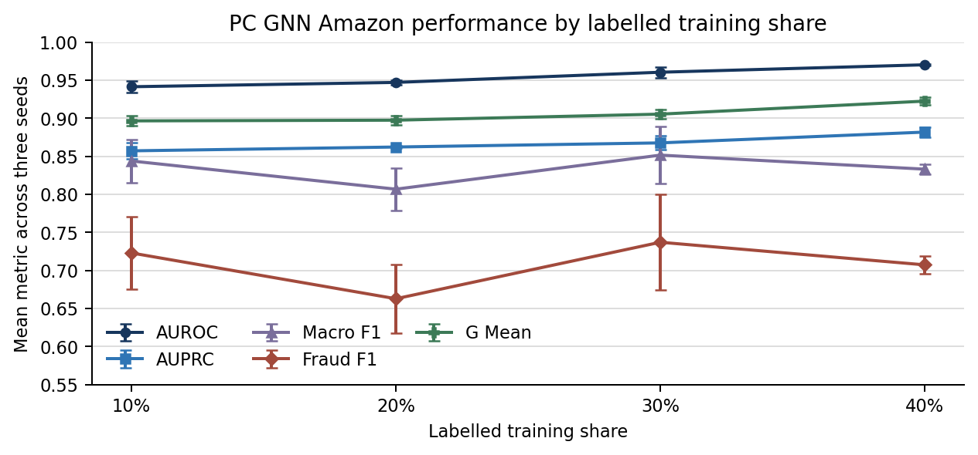
Error bars show sample standard deviation. Checkpoints and rho were selected using validation AUROC only.

7 Amazon timing and resource record
Ratio | Seed | Mean epoch s | Median epoch s | Within-run SD s | Fit wall s | Inference s | Peak MB
TR40 | 2 | 2.041 | 1.990 | 0.198 | 140.8 | 6.57 | 45.2
TR40 | 42 | 2.031 | 1.977 | 0.192 | 140.1 | 6.48 | 45.8
TR40 | 72 | 1.929 | 1.884 | 0.193 | 133.0 | 6.16 | 45.3
TR30 | 2 | 1.513 | 1.475 | 0.171 | 114.3 | 6.61 | 45.0
TR30 | 42 | 1.500 | 1.463 | 0.162 | 113.3 | 6.46 | 45.5
TR30 | 72 | 1.513 | 1.475 | 0.162 | 114.5 | 6.53 | 44.8
TR20 | 2 | 1.044 | 1.034 | 0.084 | 93.2 | 6.72 | 44.6
TR20 | 42 | 1.030 | 1.018 | 0.077 | 91.7 | 6.60 | 45.2
TR20 | 72 | 1.048 | 1.023 | 0.130 | 92.6 | 6.76 | 44.6
TR10 | 2 | 0.526 | 0.499 | 0.130 | 65.1 | 7.61 | 44.5
TR10 | 42 | 0.525 | 0.500 | 0.131 | 65.2 | 7.65 | 44.4
TR10 | 72 | 0.501 | 0.492 | 0.080 | 63.9 | 7.41 | 44.1

Ratio | Mean epoch seconds | Fit wall seconds | Inference seconds | Peak GPU memory MB
TR40 | 2.000 ± 0.062 | 138.0 ± 4.3 | 6.40 ± 0.21 | 45.4 ± 0.3
TR30 | 1.509 ± 0.008 | 114.0 ± 0.7 | 6.53 ± 0.07 | 45.1 ± 0.4
TR20 | 1.041 ± 0.009 | 92.5 ± 0.8 | 6.69 ± 0.08 | 44.8 ± 0.3
TR10 | 0.517 ± 0.014 | 64.8 ± 0.7 | 7.56 ± 0.13 | 44.3 ± 0.2

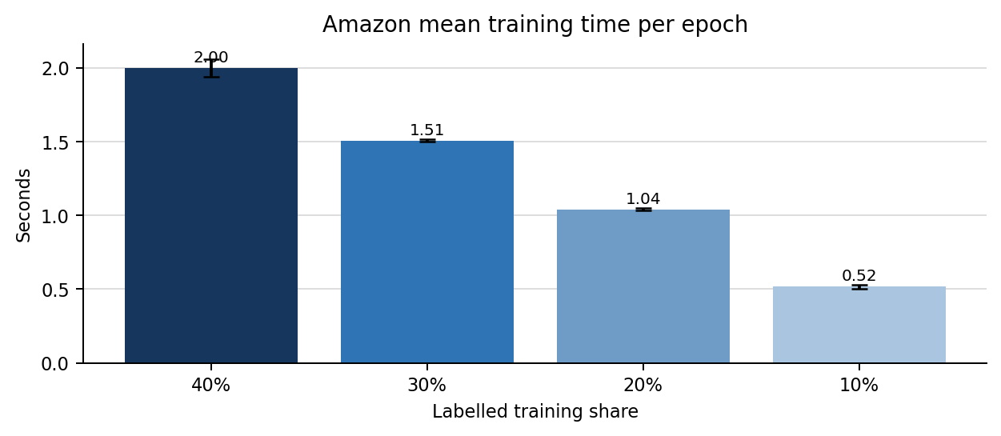
Epoch rows record GPU-synchronised training intervals. Fit wall time includes validation; inference is reported separately.

8 Amazon matched label-scarcity changes
Comparison | AUROC delta | AUPRC delta | Fraud recall delta | Mean epoch-time delta
TR30 - TR40 | -0.0098 ± 0.0063 | -0.0142 ± 0.0065 | -0.0507 ± 0.0244 | -0.492 ± 0.065
TR20 - TR40 | -0.0232 ± 0.0024 | -0.0196 ± 0.0061 | -0.0385 ± 0.0195 | -0.960 ± 0.068
TR10 - TR40 | -0.0288 ± 0.0071 | -0.0246 ± 0.0115 | -0.0669 ± 0.0110 | -1.483 ± 0.048

Differences are paired within the same training seed and then summarised across three seeds. No significance claim is made at n = 3.
• Amazon ranking metrics declined monotonically with label scarcity: mean AUROC 0.9702 to 0.9413 and mean AUPRC 0.8817 to 0.8571 from TR40 to TR10.
• Fraud recall declined overall from 0.9159 at TR40 to 0.8490 at TR10, although TR20 was slightly above TR30.
• Macro F1 and fraud F1 were non-monotonic and more seed-variable because they depend on the fixed 0.4 threshold. They do not show that fewer labels improved ranking performance.
• Mean epoch time fell by about 74.1 percent from TR40 to TR10. Small inference-time differences should not be over-interpreted because the same test graph was used.

9 Cross-dataset interpretation
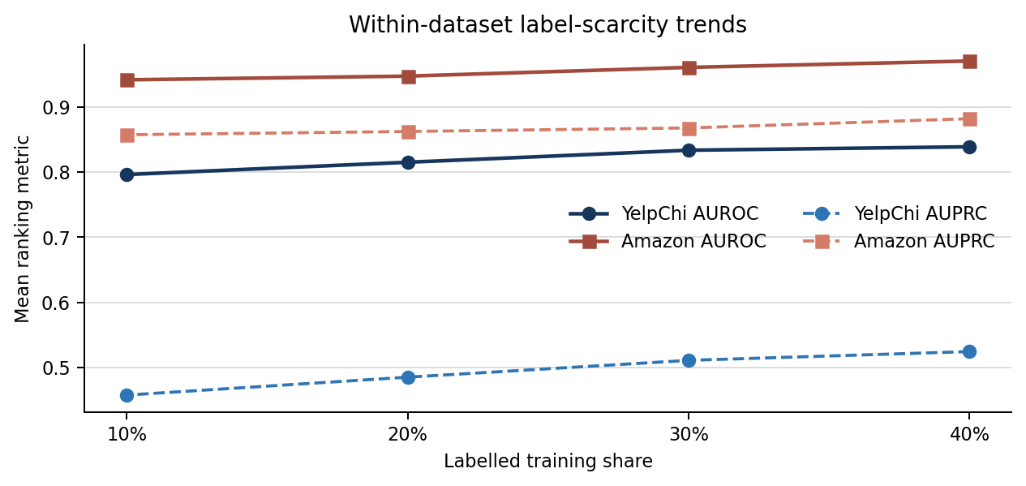
• Both datasets show the same main label-scarcity direction: AUROC and AUPRC decrease as the labelled training share shrinks.
• Absolute Amazon and YelpChi values must not be treated as a direct model ranking because the datasets differ in node population, graph relations, features, thresholds, batch sizes, epoch counts and task difficulty.
• PC-GNN training was much faster per epoch on Amazon than YelpChi under the saved configurations; this is consistent with Amazon's smaller eligible labelled population and smaller batch workload.
• Each dataset remains a separate experimental condition. Future model comparisons should use these exact dataset-specific split files and evaluator rules.

10 Evidence coverage limitations and next action
Field | Recorded value
YelpChi final evidence | 12 runs; 1,200 epoch rows; three seeds; four ratios
Amazon final evidence | 12 runs; 612 epoch rows; three seeds; four ratios
Amazon final-package status | 12 of 12 runs; no failures; one selected tuning run reused transparently
Archive/file verification | CRC, manifest hashes, JSON/CSV agreement, split nesting and leakage checks passed

• Limitation: three seeds support descriptive means and sample standard deviations, but not a reliable statistical-significance claim.
• Limitation: neither author-mode check is an exact paper replication because processed feature dimensions and modern software/hardware differ; Amazon also used 51 rather than 100 epochs.
• Limitation: fixed classification thresholds make F1, precision, recall and accuracy sensitive to the selected operating point. Cross-model comparisons require one common threshold-selection rule.
• The earlier Amazon archive without persistent split paths is retained only as author-mode evidence. The verified 12-run Amazon final archive supersedes it for unified benchmarking.
• Current completion status: PC-GNN is complete on YelpChi and Amazon for the agreed TR40/TR30/TR20/TR10 three-seed protocol. The next step is peer review and repository commit, then the next eligible dataset or assigned model.

References
Liu, Y., Ao, X., Qin, Z., Chi, J., Feng, J., Yang, H., & He, Q. (2021). Pick and choose: A GNN-based imbalanced learning approach for fraud detection. Proceedings of the Web Conference 2021, 3168–3177. https://doi.org/10.1145/3442381.3449989
PonderLY. PC-GNN source repository. https://github.com/PonderLY/PC-GNN

