PC GNN YelpChi Experiment Record
Author reproduction, validation-only tuning, controlled label-ratio experiments and three-seed results
Prepared for: COMP8851 project team and Dr Venus Haghighi
Updated: 9 September 2026
Status: Final PC-GNN YelpChi run record with 12 controlled runs verified

Executive summary
Verification result: PASS. The three final seed archives contain all 12 planned PC-GNN runs: four nested YelpChi training ratios and training seeds 2, 42 and 72. Every run used one Tesla T4, the same persistent validation and test node IDs, rho 0.4, Adam, 100 epochs and unchanged PC-GNN architecture. All 1,200 epoch timing rows are present.
• Mean AUROC fell from 0.8386 +/- 0.0056 at TR40 to 0.7960 +/- 0.0023 at TR10.
• Mean AUPRC fell from 0.5244 +/- 0.0106 at TR40 to 0.4578 +/- 0.0027 at TR10.
• Mean training time per epoch fell from 12.563 +/- 0.225 seconds at TR40 to 2.754 +/- 0.104 seconds at TR10.
• Threshold-dependent scores were not monotonic across ratios. Macro F1, fraud F1, precision and accuracy varied more between seeds than AUROC/AUPRC, so they should not be read as evidence that fewer labels improved ranking quality.
• The selected rho value was chosen using validation AUROC only. No test metric was used for hyperparameter or checkpoint selection.

1 Evidence and provenance
Paper: Pick and Choose A GNN Based Imbalanced Learning Approach for Fraud Detection
Official code: PonderLY PC GNN
Archive | Seed | Files | CRC | SHA 256 prefix
pcgnn_yelpchi_final_seed2_batch.zip | 2 | 48 | PASS | ab0a9ba2da13371d...
pcgnn_yelpchi_final_seed42_batch.zip | 42 | 48 | PASS | cffa141332b4bcad...
pcgnn_yelpchi_final_seed72_batch.zip | 72 | 48 | PASS | 945c7ee865c547da...
pcgnn_tr40_rho_tuning_complete.zip | Tuning | 56 | PASS | f4fe6106449abe4e...

Field | Recorded value
Recorded upstream commit | 9d7d7fae491081178b6e12e193fb89cfc330f2be
Author archive | pcgnn_kaggle_t4_author_100epochs_results.zip
Author archive SHA 256 | 730468192def86f4cd0deca0efeb41d76bad9535ed94c729e1e3990872d581c7
Final controlled runs | 12 of 12 found and verified
Per epoch evidence | 100 rows per run; 1,200 total training epoch rows
Validation events | 20 per run; 240 total validation events
Seed 72 TR40 provenance | The selected rho 0.4 tuning run was reused as the final seed 72 TR40 run; reuse is explicitly recorded and selection used validation AUROC only.

Full archive hashes are retained in the accompanying checksum CSV and verification JSON.

2 Reproduction status and paper comparison
Metric | Paper | Author mode seed 72 | Final TR40 mean +/- SD
AUROC | 0.7987 +/- 0.0014 | 0.8391 | 0.8386 +/- 0.0056
AUPRC | Not reported | 0.5245 | 0.5244 +/- 0.0106
Macro F1 | 0.6300 +/- 0.0230 | 0.6220 | 0.6272 +/- 0.0459
Fraud F1 | Not reported | 0.4461 | 0.4516 +/- 0.0371
G Mean | 0.7160 +/- 0.0130 | 0.7493 | 0.7466 +/- 0.0238

Interpretation limit. The author-mode run is an approximate reproduction, not an exact replication. The supplied YelpChi path uses 32 features whereas the paper reports 100; the paper reports ten runs; and the recorded software and hardware differ. The paper values therefore provide context, not a like-for-like superiority claim.

3 Dataset and persistent split protocol
Field | Recorded value
Dataset | YelpChi processed for the official PC-GNN code path
Task | Binary node classification of fraud or spam reviews versus normal reviews
Graph | Review nodes with three relation adjacency lists; multi relation PC-GNN aggregation enabled
Labelled nodes | 45,954
Fraud nodes | 6,677 or 14.53 percent
Feature dimension used | 32
Split seed | 2, used once to create the persistent nested split family
Isolation rule | Validation and test IDs remain fixed across every ratio and training seed

Ratio | Train | Train fraud | Train normal | Validation | Test | Unused
TR40 | 18,381 | 2,671 | 15,710 | 9,099 | 18,474 | 0
TR30 | 13,786 | 2,003 | 11,783 | 9,099 | 18,474 | 4,595
TR20 | 9,191 | 1,336 | 7,855 | 9,099 | 18,474 | 9,190
TR10 | 4,595 | 668 | 3,927 | 9,099 | 18,474 | 13,786

• TR10 is a subset of TR20, TR20 is a subset of TR30 and TR30 is a subset of TR40.
• All partitions are disjoint, contain no duplicate IDs and account for all 45,954 labelled nodes.
• For a given ratio, the train IDs are byte-identical across seeds 2, 42 and 72; validation and test IDs are identical for all 12 runs.

4 Final controlled configuration
Field | Recorded value
Model | PC-GNN with multi relation GNN aggregator
Architecture status | Original PC-GNN sampling, neighbour selection and aggregation mechanism preserved
Selected rho | 0.4, frozen after TR40 validation-only tuning
Alpha | 2
Embedding dimension | 64
Optimizer | Adam
Learning rate | 0.01
Weight decay | 0.001
Batch size | 1,024
Epochs and validation | 100 epochs; validation every 5 epochs
Checkpoint selection | Highest validation AUROC
Classification threshold | 0.5 fixed
Training seeds | 2, 42 and 72
Hardware | Kaggle Linux; one NVIDIA Tesla T4 on GPU 0; 14.56 GiB VRAM
Software | Python 3.12.13; PyTorch 2.10.0 plus cu128; CUDA 12.8; NumPy 2.0.2

5 Validation only rho tuning
rho | Best validation AUROC | Macro F1 at selected checkpoint | Epoch | Decision
0.2 | 0.832842 | 0.640469 | 95 | Not selected
0.4 | 0.840387 | 0.641565 | 95 | Selected
0.5 | 0.835192 | 0.625000 | 95 | Not selected
0.6 | 0.826718 | 0.654267 | 95 | Not selected
0.8 | 0.813012 | 0.651748 | 95 | Not selected

Decision. rho 0.4 achieved the highest recorded validation AUROC, 0.840387, and was frozen for every final ratio and seed. The test set was not used to choose rho. The tuning seed was 72 and the split seed was 2.

6 Seed level test results
Ratio | Seed | Val AUROC | Test AUROC | AUPRC | Macro F1 | Fraud F1 | G Mean
TR40 | 2 | 0.8283 | 0.8331 | 0.5158 | 0.5746 | 0.4090 | 0.7192
TR40 | 42 | 0.8321 | 0.8385 | 0.5213 | 0.6587 | 0.4770 | 0.7604
TR40 | 72 | 0.8404 | 0.8442 | 0.5363 | 0.6483 | 0.4689 | 0.7602
TR30 | 2 | 0.8326 | 0.8366 | 0.5183 | 0.6447 | 0.4639 | 0.7559
TR30 | 42 | 0.8266 | 0.8316 | 0.5071 | 0.6281 | 0.4482 | 0.7473
TR30 | 72 | 0.8276 | 0.8317 | 0.5076 | 0.6458 | 0.4632 | 0.7532
TR20 | 2 | 0.8080 | 0.8136 | 0.4849 | 0.6422 | 0.4522 | 0.7375
TR20 | 42 | 0.8023 | 0.8067 | 0.4762 | 0.5639 | 0.3946 | 0.7033
TR20 | 72 | 0.8180 | 0.8243 | 0.4945 | 0.6612 | 0.4724 | 0.7466
TR10 | 2 | 0.7921 | 0.7969 | 0.4598 | 0.6749 | 0.4723 | 0.7144
TR10 | 42 | 0.7879 | 0.7934 | 0.4547 | 0.6015 | 0.4153 | 0.7175
TR10 | 72 | 0.7941 | 0.7978 | 0.4588 | 0.6791 | 0.4766 | 0.7136

Ratio | Seed | Fraud precision | Fraud recall | Accuracy | TP | FN | FP | TN
TR40 | 2 | 0.2683 | 0.8599 | 0.6390 | 2308 | 376 | 6293 | 9497
TR40 | 42 | 0.3460 | 0.7675 | 0.7555 | 2060 | 624 | 3893 | 11897
TR40 | 72 | 0.3333 | 0.7902 | 0.7399 | 2121 | 563 | 4242 | 11548
TR30 | 2 | 0.3294 | 0.7843 | 0.7367 | 2105 | 579 | 4286 | 11504
TR30 | 42 | 0.3119 | 0.7962 | 0.7152 | 2137 | 547 | 4715 | 11075
TR30 | 72 | 0.3308 | 0.7724 | 0.7400 | 2073 | 611 | 4193 | 11597
TR20 | 2 | 0.3276 | 0.7295 | 0.7432 | 1958 | 726 | 4018 | 11772
TR20 | 42 | 0.2587 | 0.8308 | 0.6296 | 2230 | 454 | 6389 | 9401
TR20 | 72 | 0.3515 | 0.7198 | 0.7664 | 1932 | 752 | 3564 | 12226
TR10 | 2 | 0.3844 | 0.6125 | 0.8012 | 1644 | 1040 | 2633 | 13157
TR10 | 42 | 0.2855 | 0.7615 | 0.6884 | 2044 | 640 | 5116 | 10674
TR10 | 72 | 0.3930 | 0.6054 | 0.8068 | 1625 | 1059 | 2510 | 13280

All test metrics were evaluated from checkpoints selected by validation AUROC. Threshold-dependent values use the fixed threshold 0.5.

7 Three seed aggregate results
Ratio | AUROC | AUPRC | Macro F1 | Fraud F1 | Fraud recall | G Mean
TR40 | 0.8386 +/- 0.0056 | 0.5244 +/- 0.0106 | 0.6272 +/- 0.0459 | 0.4516 +/- 0.0371 | 0.8059 +/- 0.0481 | 0.7466 +/- 0.0238
TR30 | 0.8333 +/- 0.0029 | 0.5110 +/- 0.0063 | 0.6395 +/- 0.0099 | 0.4584 +/- 0.0089 | 0.7843 +/- 0.0119 | 0.7521 +/- 0.0044
TR20 | 0.8149 +/- 0.0089 | 0.4852 +/- 0.0091 | 0.6224 +/- 0.0516 | 0.4397 +/- 0.0404 | 0.7601 +/- 0.0615 | 0.7291 +/- 0.0228
TR10 | 0.7960 +/- 0.0023 | 0.4578 +/- 0.0027 | 0.6518 +/- 0.0437 | 0.4547 +/- 0.0342 | 0.6598 +/- 0.0882 | 0.7152 +/- 0.0021

Values are arithmetic mean +/- sample standard deviation across training seeds 2, 42 and 72. n equals 3 for every ratio.
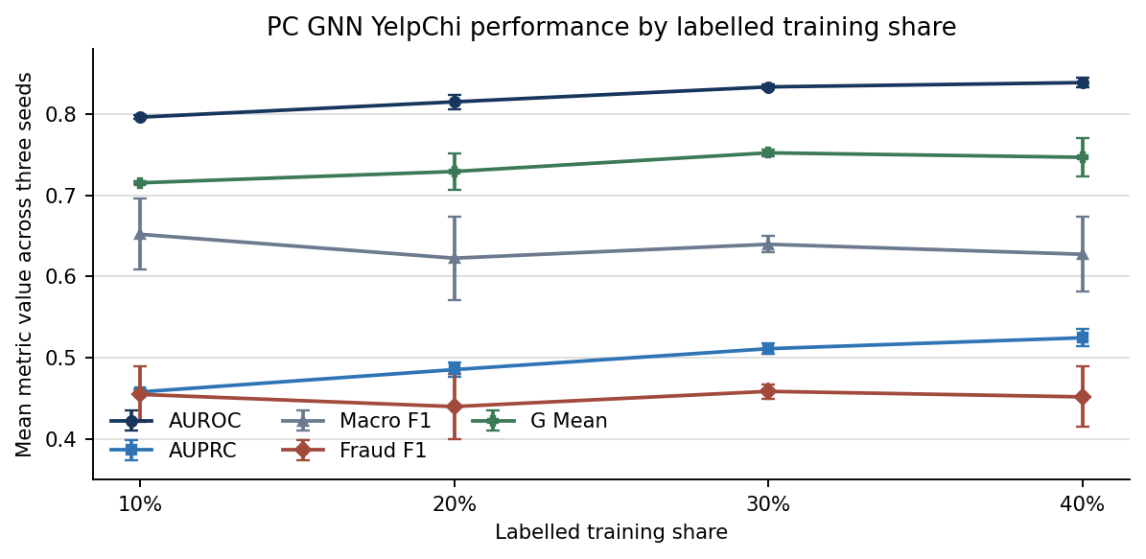
Error bars show sample standard deviation across the three training seeds.

8 Timing and resource results
Ratio | Seed | Mean epoch s | Median epoch s | Within run SD s | Fit wall s | Inference s | Peak MB
TR40 | 2 | 12.823 | 12.827 | 0.426 | 1524.2 | 23.82 | 269.1
TR40 | 42 | 12.428 | 12.433 | 0.499 | 1479.6 | 24.22 | 270.3
TR40 | 72 | 12.437 | 12.436 | 0.316 | 1478.0 | 22.67 | 269.2
TR30 | 2 | 9.282 | 9.217 | 0.277 | 1171.1 | 22.86 | 265.0
TR30 | 42 | 9.075 | 9.036 | 0.374 | 1146.2 | 22.23 | 269.0
TR30 | 72 | 8.856 | 8.722 | 0.249 | 1118.9 | 22.89 | 265.0
TR20 | 2 | 5.686 | 5.579 | 0.255 | 799.9 | 22.73 | 261.9
TR20 | 42 | 5.512 | 5.425 | 0.214 | 775.5 | 21.90 | 257.9
TR20 | 72 | 5.735 | 5.642 | 0.240 | 808.0 | 23.08 | 258.7
TR10 | 2 | 2.859 | 2.791 | 0.190 | 523.8 | 23.82 | 256.7
TR10 | 42 | 2.652 | 2.586 | 0.182 | 484.8 | 21.98 | 252.7
TR10 | 72 | 2.752 | 2.687 | 0.177 | 504.7 | 22.84 | 252.8

Ratio | Mean epoch seconds | Fit wall seconds | Inference seconds | Peak GPU memory MB
TR40 | 12.563 +/- 0.225 | 1493.9 +/- 26.2 | 23.57 +/- 0.81 | 269.5 +/- 0.6
TR30 | 9.071 +/- 0.213 | 1145.4 +/- 26.1 | 22.66 +/- 0.37 | 266.3 +/- 2.3
TR20 | 5.644 +/- 0.117 | 794.5 +/- 17.0 | 22.57 +/- 0.61 | 259.5 +/- 2.1
TR10 | 2.754 +/- 0.104 | 504.4 +/- 19.5 | 22.88 +/- 0.92 | 254.1 +/- 2.3

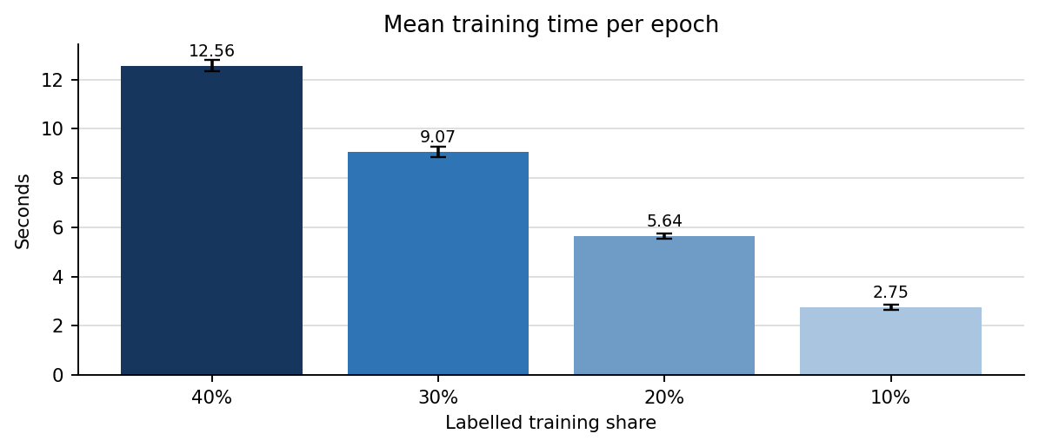
Epoch times are GPU-synchronised training times. Fit wall time includes validation. Inference time is reported separately.

9 Matched changes from TR40
Comparison | AUROC delta | AUPRC delta | Fraud recall delta | Mean epoch seconds delta
TR30 - TR40 | -0.0053 +/- 0.0081 | -0.0134 +/- 0.0156 | -0.0216 +/- 0.0523 | -3.492 +/- 0.121
TR20 - TR40 | -0.0237 +/- 0.0070 | -0.0392 +/- 0.0074 | -0.0458 +/- 0.0992 | -6.919 +/- 0.217
TR10 - TR40 | -0.0426 +/- 0.0056 | -0.0667 +/- 0.0107 | -0.1461 +/- 0.1253 | -9.809 +/- 0.142

Each difference is calculated within the same training seed and then summarised across three seeds. No significance test is reported because n equals 3.

10 Findings and interpretation
• Ranking performance weakened as labelled training data decreased. Mean AUROC and AUPRC declined monotonically from TR40 to TR10.
• TR30 remained closest to TR40: the paired AUROC change was -0.0053 +/- 0.0081 and the AUPRC change was -0.0134 +/- 0.0156.
• TR20 showed a clearer loss: mean AUROC was 0.8149 and mean AUPRC was 0.4852, with paired changes of -0.0237 and -0.0392 from TR40.
• TR10 produced mean AUROC 0.7960 and mean AUPRC 0.4578. Compared with TR40, the paired changes were -0.0426 and -0.0667.
• Training cost responded strongly to the smaller labelled set. Mean epoch time was 27.8 percent lower at TR30, 55.1 percent lower at TR20 and 78.1 percent lower at TR10 relative to TR40.
• Macro F1 and fraud F1 were not monotonic and had larger seed variation. This reflects a changing precision-recall operating point at the fixed 0.5 threshold; it does not overturn the AUROC/AUPRC scarcity trend.
• Inference time stayed near 22 to 24 seconds because the test graph and test node set were fixed; reducing training labels mainly reduced training cost.

11 Per epoch evidence coverage
Ratio | Seed | Epoch rows | Validation rows | Mean epoch s | Within run SD s | Best epoch
TR40 | 2 | 100 | 20 | 12.823 | 0.426 | 95
TR40 | 42 | 100 | 20 | 12.428 | 0.499 | 90
TR40 | 72 | 100 | 20 | 12.437 | 0.316 | 95
TR30 | 2 | 100 | 20 | 9.282 | 0.277 | 95
TR30 | 42 | 100 | 20 | 9.075 | 0.374 | 95
TR30 | 72 | 100 | 20 | 8.856 | 0.249 | 90
TR20 | 2 | 100 | 20 | 5.686 | 0.255 | 95
TR20 | 42 | 100 | 20 | 5.512 | 0.214 | 95
TR20 | 72 | 100 | 20 | 5.735 | 0.240 | 95
TR10 | 2 | 100 | 20 | 2.859 | 0.190 | 90
TR10 | 42 | 100 | 20 | 2.652 | 0.182 | 95
TR10 | 72 | 100 | 20 | 2.752 | 0.177 | 90

Storage rule. The exact 1,200 epoch rows, timestamps, validation records, logs, run configurations, split summaries and test metrics are retained in the accompanying GitHub-ready evidence package. They are indexed here rather than reproducing 1,200 raw rows inside the narrative report.

12 Verification verdict limitations and next action
• PASS: all three final archives passed CRC checks; JSON, CSV and split evidence agree; every final run completed 100 epochs on a Tesla T4.
• PASS: rho 0.4 was selected by maximum validation AUROC; the selection record explicitly states that test metrics were not used.
• PASS: validation and test membership is fixed; nested training membership is identical across model seeds; no overlap or missing labelled nodes was found.
• Limitation: the final estimate uses three seeds. Means and sample SDs are descriptive and do not support a reliable significance claim.
• Limitation: the 32-dimensional YelpChi representation, modern software stack and Tesla T4 prevent exact paper replication.
• Limitation: threshold 0.5 was fixed. Threshold-dependent metrics should only be compared with other models if the same threshold-selection rule is used for all models.
• Cross-model decision required: the team must use the same validation selection metric for every controlled model or document a predefined exception. This PC-GNN block used validation AUROC.
• PC-GNN on YelpChi is complete for the current TR40, TR30, TR20 and TR10 three-seed protocol. The next execution block can move to the second assigned model after these files are committed and peer reviewed.

References
Liu, Y., Ao, X., Qin, Z., Chi, J., Feng, J., Yang, H., & He, Q. (2021). Pick and choose: A GNN-based imbalanced learning approach for fraud detection. Proceedings of the Web Conference 2021, 3168-3177. https://doi.org/10.1145/3442381.3449989
PonderLY. PC GNN source repository. https://github.com/PonderLY/PC-GNN

