BWGNN–T-Finance Experiment Record
Controlled benchmark execution and independent verification
Record field | Verified value
Project | COMP8851 graph fraud detection benchmark
Model and dataset | BWGNN on T-Finance
Execution date | 9 September 2026
Final run matrix | TR40, TR30, TR20 and TR10; seeds 2, 42 and 72
Technical verification | PASS - all 12 final runs and evidence files verified
Benchmark readiness | CONDITIONAL - one dataset-version decision is required

Conclusion. The BWGNN T-Finance execution is technically complete and internally reproducible. The package contains 12 controlled final runs, uses validation-only hyperparameter selection, preserves fixed validation and test IDs, and records every training epoch. Before these results are compared with another model, the team must freeze the exact T-Finance file version because the executed file differs from the earlier dataset-audit file by one fraud label.

1 Verification decision
- Technical run integrity: PASS. No missing or duplicated ratio-seed combinations were found.
- Split integrity: PASS. Training sets are nested, validation and test IDs are fixed, and no leakage was detected.
- Tuning integrity: PASS. Hidden dimension was selected using validation AUROC; test evaluation was disabled for both tuning trials.
- Timing integrity: PASS. The 12 final runs contain 1,135 sequential, positive per-epoch GPU timing records.
- Cross-model readiness: CONDITIONAL. Freeze the raw T-Finance file hash before another model is compared on this dataset.

2 Dataset identity and required version decision
Dataset field | Executed value
Raw-file SHA-256 | b7d853ec4079e9f7137c03f78a044b1c33d0ff5ed6caa297b895542a7c8e3700
Nodes | 39,357
Stored directed edge entries | 42,445,086
Paper edge convention | 21,222,543 transaction connections
Features | 10
Fraud or anomaly nodes | 1,804
Normal nodes | 37,553
Fraud percentage | 4.5837%
Normal to fraud ratio | 20.8165:1

Required action before cross-model comparison. The executed file has SHA-256 b7d853ec4079e9f7137c03f78a044b1c33d0ff5ed6caa297b895542a7c8e3700 and contains 1,804 fraud nodes. The earlier T-Finance investigation used SHA-256 bd8fa6bb279bea1bda0e4891976edd41d67d041821c9f3d2c484c1b19e3a1b8d and reported 1,803 fraud nodes. The current execution otherwise matches the paper's published node, edge, feature and rounded fraud-rate statistics. The recommended decision is to adopt the current executed file, update the dataset report and heterophily calculations using it, and require every later T-Finance model to reuse the split files in this package. If the team instead keeps the earlier file, this BWGNN experiment must be rerun on that file.

3 Computing environment
Component | Recorded environment
Platform | Kaggle Notebook on Linux x86-64
GPU | Tesla T4; GPU 0 only; 14.56 GB
Python | 3.11.16
PyTorch | 2.2.2+cu121
DGL | 1.1.3+cu121
CUDA | 12.1
NumPy | 1.26.4

4 Experimental protocol
Two result tracks were kept separate. The author-setting reference used the supplied BWGNN configuration and random stratified split convention. The controlled track used one persistent split family so every seed and later compatible model can be evaluated on identical node IDs.

4.1 Controlled split family
Ratio | Train | Train fraud | Validation | Test | Unused
TR40 | 15,742 | 722 | 7,871 | 15,744 | 0
TR30 | 11,806 | 541 | 7,871 | 15,744 | 3,936
TR20 | 7,870 | 361 | 7,871 | 15,744 | 7,872
TR10 | 3,935 | 181 | 7,871 | 15,744 | 11,807

Split seed 2 was used once. TR10 is contained in TR20, which is contained in TR30, which is contained in TR40. Validation contains 7,871 nodes and test contains 15,744 nodes in every controlled condition.

4.2 Hyperparameter selection
Hidden size | Epochs | Best epoch | Validation AUROC | Validation Macro F1 | Test evaluated
32 | 45 | 30 | 96.07% | 84.94% | No
64 | 40 | 25 | 94.89% | 87.27% | No

Hidden dimension 32 was selected because its validation AUROC was 96.07%, compared with 94.89% for hidden dimension 64. Although dimension 64 had the higher validation Macro-F1, AUROC was the predeclared selection metric.

4.3 Final controlled configuration
Setting | Controlled value
Architecture | Homogeneous Beta Wavelet Graph Neural Network
Hidden dimension | 32, selected on TR40 seed 72
Beta wavelet order | 2, unchanged from the author setting
Optimizer | Adam
Learning rate and weight decay | 0.01 and 0
Loss | Weighted cross-entropy using the training normal-to-fraud ratio
Maximum epochs | 100
Validation and early stopping | Every 5 epochs; patience 20 epochs
Checkpoint selection | Highest validation AUROC
Classification threshold | Selected on validation Macro-F1 from 0.05 to 0.95
Final seeds | 2, 42 and 72

5 Author setting reference
Measure | Paper T-Finance 40% | Current reference seed 72 | Difference
Macro F1 | 86.87% | 89.31% | +2.44 pp
AUROC | 94.35% | 96.26% | +1.91 pp
Training time | 31.98 s | 29.90 s epoch sum | Timing boundary differs

The current reference achieved 89.31% Macro-F1 and 96.26% AUROC. Its mean epoch time was 0.299 seconds, inference took 0.136 seconds and peak allocated GPU memory was 112.80 MB. The paper reports averages across five seeds for T-Finance, while this reference is one deterministic seed on a newer software environment. Therefore, the close performance supports reproducibility but is not an exact numerical replication.

6 Controlled three seed results
Ratio | AUROC % | AUPRC % | Macro F1 % | Fraud F1 % | Mean epoch s
TR40 | 95.73 ± 0.63 | 80.15 ± 8.89 | 87.59 ± 3.08 | 76.29 ± 5.80 | 0.276
TR30 | 95.88 ± 0.12 | 84.13 ± 1.52 | 88.80 ± 1.12 | 78.58 ± 2.16 | 0.276
TR20 | 95.62 ± 0.29 | 82.94 ± 3.72 | 88.36 ± 2.15 | 77.66 ± 4.12 | 0.274
TR10 | 95.49 ± 0.42 | 82.83 ± 1.81 | 88.03 ± 1.01 | 77.11 ± 1.96 | 0.272

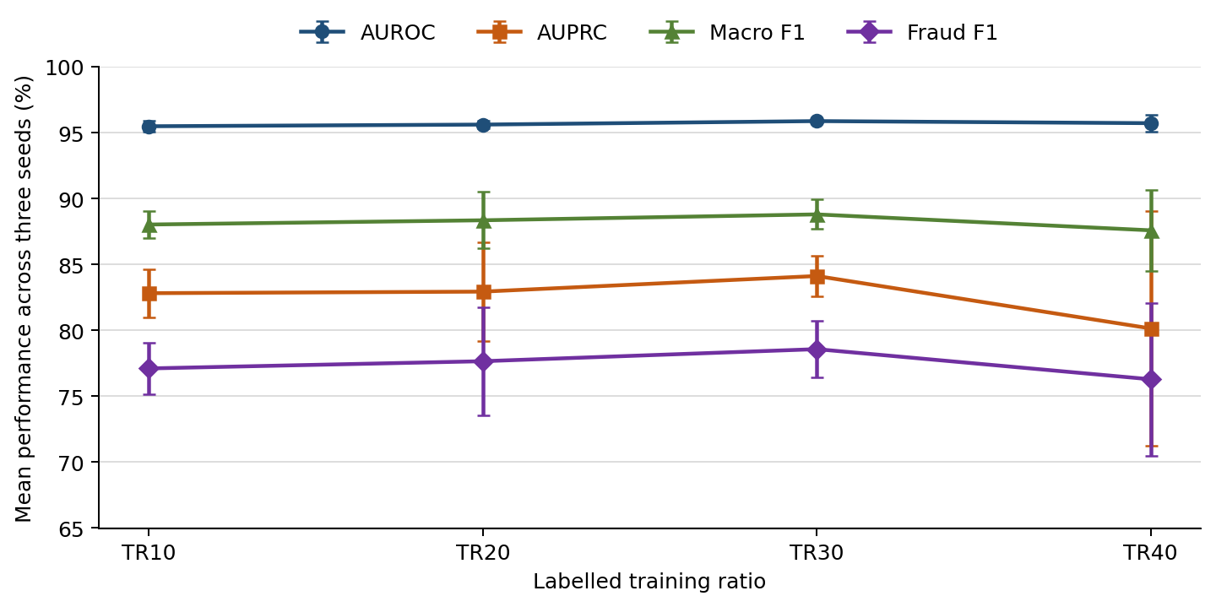
Figure 1 Controlled performance by labelled training ratio
TR30 produced the highest mean AUROC, AUPRC, Macro-F1 and fraud F1, but the differences are small relative to three-seed uncertainty and should not be interpreted as evidence that removing training labels improves the model. Performance remained stable at TR10, suggesting that BWGNN was resilient to the tested reduction in labelled training nodes on this split. TR40 showed the largest AUPRC and fraud-F1 variability because seed 72 was weaker than seeds 2 and 42.

7 Detailed final run results
Ratio | Seed | Epochs | Best val epoch | Val AUROC | Test AUROC | AUPRC
TR40 | 2 | 100 | 100 | 96.39% | 95.98% | 84.85%
TR40 | 42 | 100 | 80 | 96.76% | 96.18% | 85.71%
TR40 | 72 | 50 | 30 | 96.07% | 95.01% | 69.89%
TR30 | 2 | 100 | 95 | 96.79% | 95.90% | 83.80%
TR30 | 42 | 100 | 95 | 96.62% | 95.99% | 85.79%
TR30 | 72 | 100 | 95 | 97.01% | 95.76% | 82.80%
TR20 | 2 | 100 | 100 | 96.03% | 95.32% | 78.73%
TR20 | 42 | 100 | 100 | 96.69% | 95.64% | 85.81%
TR20 | 72 | 85 | 65 | 96.59% | 95.90% | 84.29%
TR10 | 2 | 100 | 85 | 96.63% | 95.29% | 81.27%
TR10 | 42 | 100 | 100 | 97.00% | 95.97% | 84.82%
TR10 | 72 | 100 | 95 | 97.27% | 95.21% | 82.38%

Ratio | Seed | Macro F1 | Fraud F1 | Fraud P | Fraud R | G Mean | Threshold
TR40 | 2 | 88.99% | 78.92% | 85.95% | 72.95% | 85.17% | 0.9
TR40 | 42 | 89.72% | 80.30% | 88.89% | 73.23% | 85.39% | 0.95
TR40 | 72 | 84.06% | 69.65% | 67.10% | 72.40% | 84.36% | 0.7
TR30 | 2 | 88.62% | 78.21% | 84.65% | 72.68% | 84.98% | 0.9
TR30 | 42 | 90.01% | 80.89% | 84.23% | 77.81% | 87.90% | 0.9
TR30 | 72 | 87.79% | 76.63% | 81.21% | 72.54% | 84.83% | 0.9
TR20 | 2 | 85.99% | 73.12% | 83.72% | 64.91% | 80.32% | 0.95
TR20 | 42 | 90.19% | 81.18% | 91.93% | 72.68% | 85.12% | 0.95
TR20 | 72 | 88.89% | 78.68% | 90.45% | 69.63% | 83.29% | 0.9
TR10 | 2 | 87.09% | 75.26% | 82.48% | 69.21% | 82.90% | 0.9
TR10 | 42 | 89.10% | 79.17% | 82.12% | 76.42% | 87.07% | 0.85
TR10 | 72 | 87.91% | 76.91% | 78.58% | 75.31% | 86.35% | 0.85

7.1 Detailed timing and resource use
Ratio | Seed | Mean epoch seconds | Fit wall seconds | Inference seconds | Peak GPU memory MB
TR40 | 2 | 0.281 | 33.21 | 0.128 | 64.35
TR40 | 42 | 0.272 | 32.34 | 0.122 | 64.35
TR40 | 72 | 0.277 | 16.45 | 0.126 | 64.35
TR30 | 2 | 0.278 | 32.97 | 0.126 | 64.32
TR30 | 42 | 0.272 | 32.30 | 0.125 | 64.32
TR30 | 72 | 0.277 | 32.95 | 0.126 | 64.32
TR20 | 2 | 0.272 | 32.30 | 0.124 | 64.29
TR20 | 42 | 0.275 | 32.61 | 0.126 | 64.29
TR20 | 72 | 0.275 | 27.77 | 0.127 | 64.29
TR10 | 2 | 0.273 | 32.34 | 0.126 | 64.26
TR10 | 42 | 0.271 | 32.34 | 0.125 | 64.26
TR10 | 72 | 0.273 | 32.47 | 0.124 | 64.26

8 Independent verification evidence
Check | Status | Evidence
ZIP integrity | PASS | 133 files; CRC check passed
Internal file hashes | PASS | 132 manifest entries independently recomputed
Final run matrix | PASS | 12 of 12 ratio-seed runs present
Persistent split matching | PASS | Every final run matches its master NPZ split exactly
Validation and test isolation | PASS | IDs fixed across ratios; no overlaps
Nested training sets | PASS | TR10 contained in TR20, TR30 and TR40
Tuning test isolation | PASS | No tuning test metrics or test-metrics CSV files
Final metrics | PASS | Registry and confusion-matrix-derived metrics recomputed
Aggregate statistics | PASS | Means and sample standard deviations recomputed
Epoch timing | PASS | 1,135 ordered final-run epoch rows with positive durations
Environment consistency | PASS | All final runs used the same T4 and software versions
Dataset version | ACTION | Freeze raw-file hash before cross-model comparison

9 Interpretation and limitations
- Validated result: BWGNN completed successfully on the executed T-Finance version under every planned training ratio and seed.
- Label scarcity: TR10 retained similar aggregate discrimination to TR40, but only four training-ratio conditions and three seeds were tested.
- Metric emphasis: AUPRC and fraud F1 remain necessary alongside AUROC because only about 4.58% of nodes are anomalous.
- Thresholds: Each final threshold was selected from validation data; test labels were used only for final evaluation.
- Paper comparison: The reference run differs in seed count, environment and exact timing boundary, so its paper comparison is supportive rather than exact.
- Dataset consistency: The earlier heterophily statistics cannot be mixed with this run until they are recalculated or confirmed on the same raw-file hash.
- Model comparison: No claim that BWGNN outperforms another project model should be made until the other model uses the same T-Finance file, split IDs, evaluator and conditions.

10 Files retained for reproduction
The evidence package retains the original and instrumented source code, dependency pins, split-generation code, four persistent split files, the split manifest, smoke-test evidence, the author-setting reference, both validation-only tuning trials, all 12 final runs, terminal logs, per-epoch timing CSV files, per-run configurations and summaries, final registries, aggregate tables, an independent audit and SHA-256 manifests. Raw data and model checkpoints are excluded from GitHub.

References
Tang, J., Li, J., Gao, Z., & Li, J. (2022). Rethinking graph neural networks for anomaly detection. Proceedings of the 39th International Conference on Machine Learning, 162, 21076-21089. https://proceedings.mlr.press/v162/tang22b.html
Tang, J., Li, J., Gao, Z., & Li, J. (2022). Rethinking Anomaly Detection [Source code]. GitHub. https://github.com/squareRoot3/Rethinking-Anomaly-Detection

