ZoroNest

PROJECT PROPOSAL
Smart Automation System
Tittle: Three-Tier Intelligent Automation Framework
Team Name: Team IoT Express
Md Maruf Masrafe — masrafe16-589@diu.edu.bd
Mabia Akonda — jemi22212091022@diu.edu.bd
Jubayer Ahmed — ahmed16-590@diu.edu.bd
Noman Ahmed Bhuyan — noman.bhuyan@gmail.com

🏠 Home · 🏢 Office · 🎓 University

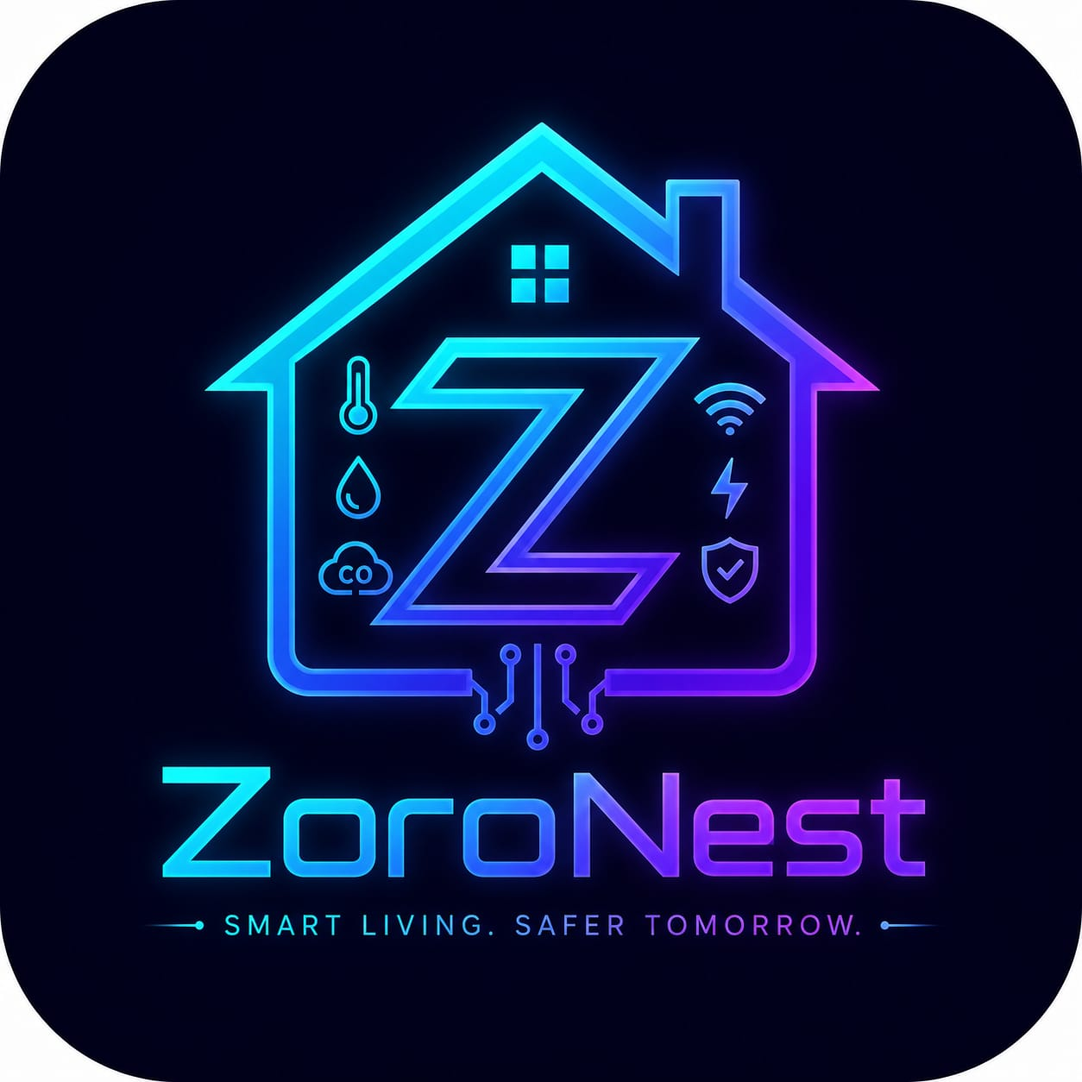

1. Executive Summary
The ZoroNest is a comprehensive, three-tier intelligent automation platform designed for residential homes, corporate offices, and university campuses. Powered by ESP32 microcontrollers and unified through an AI-driven mobile and web dashboard, this system delivers real-time monitoring, intelligent control, and measurable energy savings across all environments.

Key Value Proposition
• Energy savings through occupancy-based auto power management
• Real-time safety monitoring — LPG, smoke, air quality — with instant alerts
• Centralized AI-powered dashboard with voice and text control
• Scalable architecture: add new rooms or buildings without reconfiguration
• Single platform covering Home, Office, and University deployments

2. System Architecture
The platform is structured across three layers — hardware, communication, and application — ensuring reliable, bidirectional, real-time control at every level.

Layer | Component | Technology
Hardware | Sensors, Relays, Actuators | ESP32, Relay Modules, I2C/GPIO Sensors
Communication | Data Transport | Wi-Fi, MQTT Broker, REST API, WebSocket
Application | User Interface & AI | Mobile App, Web Dashboard, AI Agent
Core Hardware: ESP32 Microcontroller
All three modules use the ESP32 as the primary controller node — chosen for its dual-core 240 MHz processor, integrated Wi-Fi, 34 GPIO pins, OTA update capability, and deep sleep power optimization.

3. Product Modules
Module 1 — Home Automation
Transforms any residence into a smart living environment through four integrated subsystems:
- Room Control: 5-relay management of lights, fans, AC, and appliances with AQI monitoring and OLED display
- Kitchen Safety: Automatic LPG/smoke detection with buzzer alarm, exhaust fan activation, and motorized gas valve shut-off
- Washroom Automation: PIR-based occupancy detection for hands-free lighting and fan control
- Smart Plant Watering (optional): Soil moisture sensing with scheduled or automatic pump activation

Module 2 — Office Automation
Enterprise-grade smart control for multi-room office environments:
- 10-channel relay system per room — independently configurable for lights, fans, AC, projectors, and workstations
- AQI monitoring per room with automated ventilation on CO2 threshold breach
- IR proximity door lock — auto-unlocks on approach; all access events logged with timestamps
- Admin dashboard with floor map view, bulk controls, and room-by-room energy and AQI comparison
Module 3 — University Automation
Campus-scale energy management and smart infrastructure:
- 14-relay per classroom — occupancy-based auto power cut-off after 10-minute vacancy
- Real-time power monitoring per classroom using PZEM-004T energy meters (kWh, voltage, current, power factor)
- Centralized energy dashboard with daily/weekly/monthly reports and bill estimation
- Zone-based smart irrigation for campus gardens and playing fields with soil moisture sensing and water usage tracking

4. AI-Powered Dashboard & Agent
All modules are unified under a single cross-platform application (iOS, Android, and Web). The built-in AI Agent Assistant enables natural language interaction with the entire system.

AI Capability | Example Interaction
Voice & Text Control | "Turn off all office lights" → bulk relay command executed
Status Queries | "Is the kitchen safe?" → live LPG/smoke sensor data retrieved
Intelligent Alerts | "Why did the alarm go off?" → sensor history explained in plain language
Energy Insights | "Which classroom used most power today?" → analytics query answered
Scheduling | "Water Zone 3 for 10 minutes at 7 AM" → schedule created automatically
Tech Stack: React Native (mobile) · React.js (web) · Node.js/Express API · PostgreSQL + InfluxDB · MQTT (Mosquitto) · LLM backend (Claude API / GPT-4) · JWT + RBAC authentication

5. Key Differentiators & Scalability
Feature | Benefit
Unified 3-tier platform | One system, one app for home, office, and campus
AI Voice + Chat Agent | No training needed — control everything in plain language
Fail-safe safety design | Gas valve closes on power failure; smoke/LPG response is instant
OTA firmware updates | No physical access required for system upgrades
Plug-and-play scalability | New rooms or buildings added without touching existing nodes
Role-based access control | Granular permissions for owners, admins, faculty, and maintenance
Future Roadmap
- Face recognition and RFID door access for enhanced office security
- ML-based predictive HVAC control from AQI and occupancy patterns
- Weather API integration for predictive irrigation scheduling
- Solar energy monitoring for sustainability reporting
- Smart energy tariff optimization — shift high-load devices to off-peak hours

6. Outcomes
The expected outcomes of this project are significant improvements in energy efficiency, occupant safety, and operational convenience across all three environments. In homes, automated safety responses to gas leaks and smoke, combined with occupancy-driven controls, reduce both risk and wasted energy. In offices, centralized AQI monitoring, proximity-based door access logging, and 10-channel relay scheduling eliminate manual intervention while improving workplace conditions. At the university level, occupancy-based auto power cut-off across classrooms, real-time energy consumption analytics per room, and smart campus irrigation are projected to deliver measurable reductions in electricity and water usage — with all data available for export as reports to support sustainability and cost-management goals.

7. Deployment & Next Steps
The system is currently in the Design & Planning Phase. Deployment follows a structured rollout:

Phase | Milestone | Timeline
Phase 1 | Hardware procurement and ESP32 node assembly | Month 0.5-1
Phase 2 | Firmware development and MQTT infrastructure setup | Month 1-1.5
Phase 3 | Dashboard and AI Agent development | Month 1.5-2
Phase 4 | Pilot deployment (1 home + 1 office room) | Month 2-2.5
Phase 5 | Full campus/office rollout and user training | Month 2.5-3

