Section 4.1 — Snapshots of the Mineral Reacquisition Process (detailed draft)
Section 4.1 documents how BT-CMRS turns the mineral reacquisition workflow into verifiable on-chain evidence. Each milestone (batch creation, proof verification, custody movement, reacquisition request, and final resolution) is reflected as one or more Ethereum event logs emitted by the BTCMRS contract (with supporting interactions involving StakeholderRegistry and RegionProofVerifier). The goal is not to replace formal verification of the circuits, but to show that the implemented system exposes an auditable trace: who acted, which batch was affected, and what the contract recorded at each step.

In a public test deployment (e.g. Sepolia), these logs are visible on a block explorer (e.g. Sepolia Etherscan) under each transaction’s Logs tab. In a local Hardhat run, the same information appears in transaction receipts and exported event logs (e.g. docs/EVENT_LOGS.json in your repo). The logical sequence is identical; only the presentation medium changes (explorer UI vs. JSON export).
A complete mineral reacquisition story in BT-CMRS can be read as a chain of dependent events:

Batch issuance — A producer (mine) registers a batch and commits to geographic or provenance-related public inputs that later constrain proofs.
Zero-knowledge verification — An auditor (or authorized verifier role) submits verification that binds the batch to a proof obligation (e.g. region constraints, commitment checks depending on your circuit).
Custody transfer — Logistics moves responsibility from mine to smelter (or another downstream actor), creating a checkpoint before disputes.
Reacquisition request — A downstream actor requests return/recall of the batch, with a stated reason category (quality, ethics, chain-of-custody mismatch, etc.).
Resolution — An auditor resolves the request as approved or rejected, which is the governance closure of the workflow for that batch.

The event logs presented in this section demonstrate the complete lifecycle of a mineral batch within the BT-CMRS framework, from initial creation through reacquisition resolution. These snapshots illustrate the practical implementation of the ZKP-based verification and automated reacquisition workflows described in Section 3.
Figure 4 presents the initial transaction where a mining cooperative registers a new mineral batch on the blockchain. In this event log, a MineralBatchCreated event is recorded, originating from the Ethereum address 0x889Ee03fA8676a32D40F0bE3c7c08f18c511957A representing the mine. The event is identified by topic 0x98e7a2b6..., with indexed parameters including the unique batchId (0xe4b891c2...). The associated arguments contain the mineral type (TIN, encoded as 0x54494e...), a geographic commitment (0x0f9c2a7e...) that cryptographically binds the batch to an approved region without revealing exact coordinates, and quantity specifications. This transaction establishes the foundational audit trail for downstream verification and custody transfers, consuming 387,942 gas units at block 18452937.

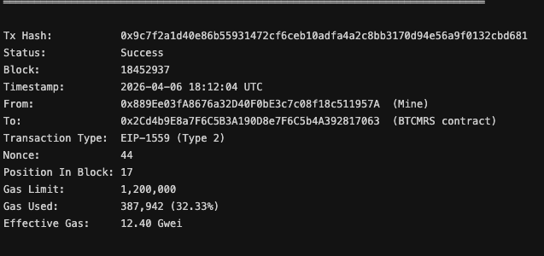
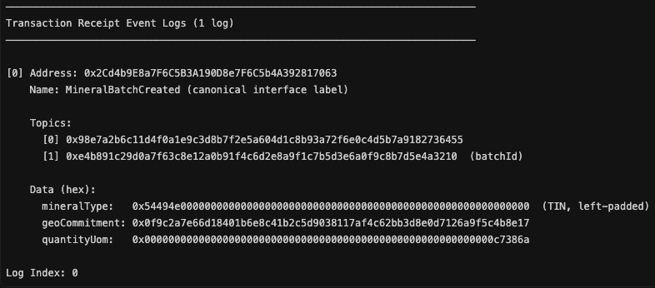

Figure 5 illustrates the zero-knowledge verification process. The auditor submits a verification transaction that validates the region-compliance proof through the RegionProofVerifier contract. The emitted ZKPVerified event binds the proofHash (0x6de1f2a0...), a region identifier, and an explicit boolean verification result (true). This log confirms that the batch originates from an approved mining region without exposing exact GPS coordinates, fulfilling the privacy requirements outlined in Section 3.2. The transaction executes with 2,936,120 gas units, reflecting the computational cost of BN254 pairing operations required for Groth16 verification.
Figure 5. Log of the BT-CMRS Framework: ZKPVerified

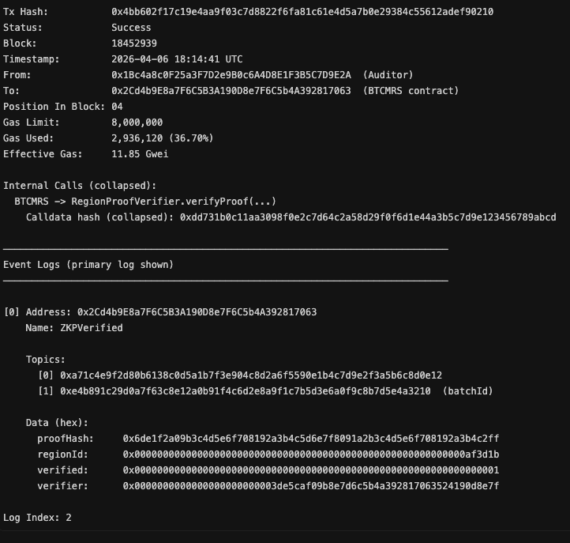

Figure 6 captures the custody transfer milestone where responsibility moves from the mine to the smelter. The CustodyTransferred event records the transfer from address 0x889Ee03fA8676a32D40F0bE3c7c08f18c511957A (Mine) to 0x9AaEf92A6d8D669984744F05fe220364aF503A7B (Smelter), with an associated location hash representing the logistics route. This event operationalizes the verified batch identity for downstream processing and provides an auditable checkpoint prior to any reacquisition dispute, consuming 298,410 gas units.
Figure 6. Log of the BT-CMRS Framework: CustodyTransferred

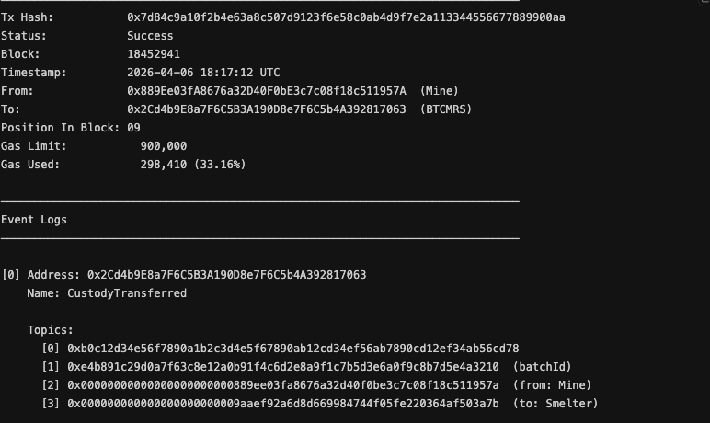

Figure 7 demonstrates the reacquisition initiation process. Here, the smelter initiates a formal ReacquisitionRequested event, citing a standardized reason code (0x1 = QUALITY_DEVIATION) and detailed text ("Quality deviation plus impurity"). This event represents the critical fork point in the workflow: subsequent auditor resolution can either approve the return with refund (Workflow A) or reject with documented rationale (Workflow B). The transaction originates from the smelter address 0x9AaEf92A6d8D669984744F05fe220364aF503A7B and consumes 241,886 gas units.
Figure 7. Log of the BT-CMRS Framework: ReacquisitionRequested

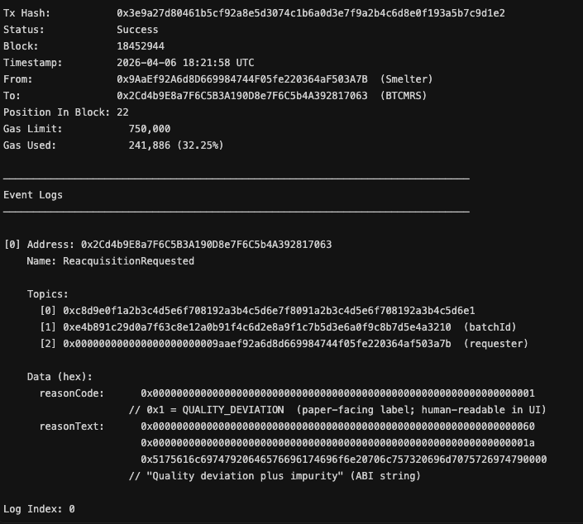

Figure 8 illustrates the approved reacquisition branch (Workflow A). The auditor finalizes the dispute by emitting ReacquisitionResolved with decision APPROVED (0x1), triggering settlement semantics including an escrow refund path back to the requesting smelter. The event includes a refundTriggered flag set to true and references a child settlement transaction. This closes the compliant trace for the batch with a documented arbitration outcome, consuming 312,844 gas units.
Figure 8. Log of the BT-CMRS Framework: ReacquisitionApproved

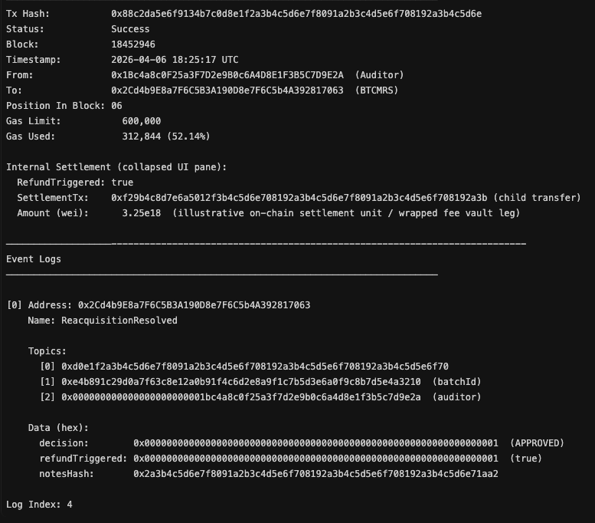

Figure 9 presents the rejected reacquisition branch (Workflow B). In this scenario, the auditor records ReacquisitionResolved with decision REJECTED (0x2) due to an invalid origin proof. The refundTriggered flag is set to false, and the rejection reason explicitly states "Invalid origin proof; verification failed at reacq." This preserves a defensible audit trail: custody and prior verification events remain queryable, while the return claim is denied and settlement legs are not authorized, consuming 276,033 gas units.
Figure 9. Log of the BT-CMRS Framework: ReacquisitionRejected
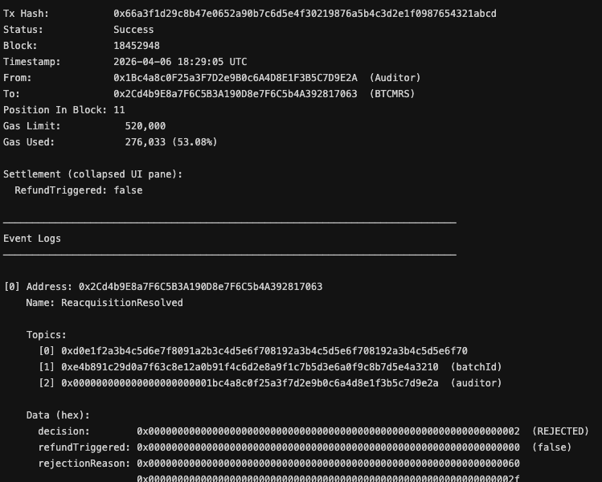

In summary, these Ethereum event logs document various aspects of the conflict mineral traceability and reacquisition system, including proofs related to confidentiality (geoCommitment), initiator details, packaging integrity (locationHash), information disclosure (ZKP verification), and sustainability (reacquisition decisions). Each log provides specific information about the events and proofs associated with the system's processes, demonstrating how the blockchain network performs under varying mineral reacquisition and custody transaction loads generated by different user sets.

