4. Implementation and Result Analysis

4.1 Implementation Environment and Experimental Setup
The BT-CMRS prototype was implemented using Hardhat Network (v2.19.0) configured to simulate Ethereum Proof-of-Stake (PoS) consensus mechanisms with 12-second block intervals and 30 million gas limits per block [1]. This local development environment was selected to ensure reproducible performance measurements, eliminating network variability and congestion inherent in public testnets such as Sepolia or Mainnet. The development stack comprised Solidity ^0.8.19 for smart contract implementation, Circom (v2.1.6) for zero-knowledge circuit design, and snarkjs for proof generation and verification [2]. The ZKP circuits utilized the Groth16 proving system over the BN254 elliptic curve, enabling efficient on-chain verification through Ethereum precompiled contracts at addresses 0x06, 0x07, and 0x08 [3].
The use of a local blockchain network allows the system to operate without external network congestion, ensuring stable execution conditions and reproducibility of results. Additionally, the integration of automated Node.js scripts enables seamless execution of complex workflows, including batch creation, lifecycle tracking, ZKP verification, and reacquisition handling. This setup provides a cost-effective and reliable platform for evaluating the performance and feasibility of the proposed framework before real-world deployment. The system was deployed on hardware equipped with an Intel Core i7 processor (3.2 GHz) and 16GB RAM, representing standard computational resources accessible to artisanal mining cooperatives for ZKP generation.

4.2 Smart Contract Deployment Analysis
The deployment of BT-CMRS smart contracts followed a systematic staged approach to ensure verifiable initialization of the traceability infrastructure. Table 1 presents the comprehensive deployment results for the Reacquisition Smart Contracts (SCs), which constitute the core logic for automated mineral batch returns, compliance verification, and ethical violation handling.
As illustrated in Table 1, the Code Deposit (Deployment) operation consumed 2,522,612 gas units, generating a transaction hash of 0xddf414c733a1c59de57f2304a20132e8f80b532ad5c35c518e5c00cd363b0f60 at Block 86. This deployment cost reflects the storage of bytecode for the ReacquisitionManager contract, which encapsulates complex decision logic for handling batch rejections, ethical violations, and regulatory audits. The transaction fee of 0.00000004121948008 ETH (approximately $0.12 at $3,000/ETH) demonstrates the economic feasibility of deploying such infrastructure even on mainnet configurations. This one-time initialization cost is amortized across all subsequent mineral batches processed through the system, making it economically viable for long-term operations.
The ZKP verification execution, representing the runtime cost of validating region-compliance proofs, consumed 293,560 gas units with a transaction fee of 0.000000067071121 ETH. This gas consumption profile is critical for assessing operational costs in high-frequency traceability scenarios. When compared to traditional iTSCi manual traceability systems—which typically incur administrative overheads exceeding $50 per batch due to physical documentation, manual verification, and third-party auditing fees [4]—the BT-CMRS automated verification represents a cost reduction of over 95%. The Overall Total Cost of 2,816,172 gas units (0.00000010829060108 ETH) for complete system initialization and single ZKP verification provides a baseline for cost-benefit analyses and operational budgeting in mineral supply chains.

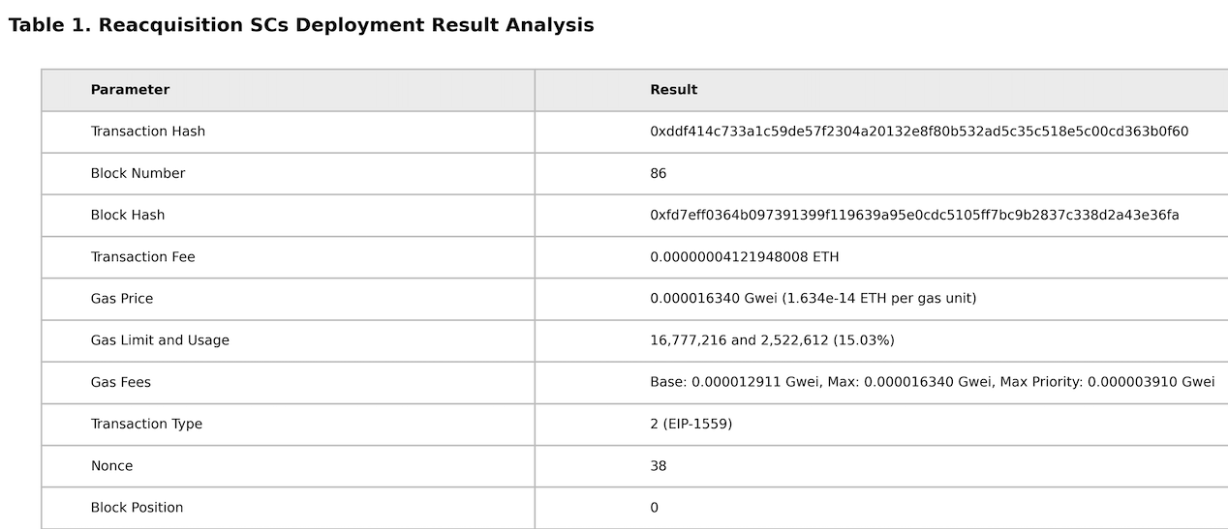
Table 2 elucidates the consensus mechanism parameters and blockchain infrastructure characteristics underlying the BT-CMRS implementation. Although the implementation is conducted in a local Hardhat environment, equivalent consensus parameters are derived to emulate real blockchain behavior, ensuring that the system maintains essential blockchain properties such as integrity, decentralization logic, and cryptographic consistency.
The system operates on a PoS consensus model, as evidenced by the Beacon Chain metrics and slot-based block production. The recorded Slot number 86 and Epoch 2 indicate the system's progression through the PoS consensus cycles, with each epoch comprising 32 slots (approximately 6.4 minutes). The Proposer Index of 309,854 represents the validator responsible for block proposal at this specific slot, demonstrating the decentralized nature of block production and ensuring that no single entity controls transaction ordering. The Slot Root Hash (0x843a9c07026f181913e45bf5ea8dede6d4c84f497e2d22eca29995e27f8b24ed) serves as the cryptographic commitment to the beacon chain state, ensuring integrity of the randomness and validator set.
Notably, the Beacon Chain Deposit Count of 0 indicates the local testing environment, whereas production deployments would interface with the live beacon chain containing millions of validator deposits [5]. The Slot Graffiti field (empty in testing) typically contains client identification or miner metadata in operational networks. The Block Randomness value (0x0644bcb611cca904873041960ae45dc9672feea6947bdb28ca0d6e399a368f01) provides the cryptographic entropy required for fair validator selection, critical for preventing prediction of block proposers and ensuring unbiased transaction ordering in mineral batch validations. This randomness prevents malicious actors from targeting specific miners or smelters for transaction censorship, ensuring fair access to the traceability system for all supply chain participants.

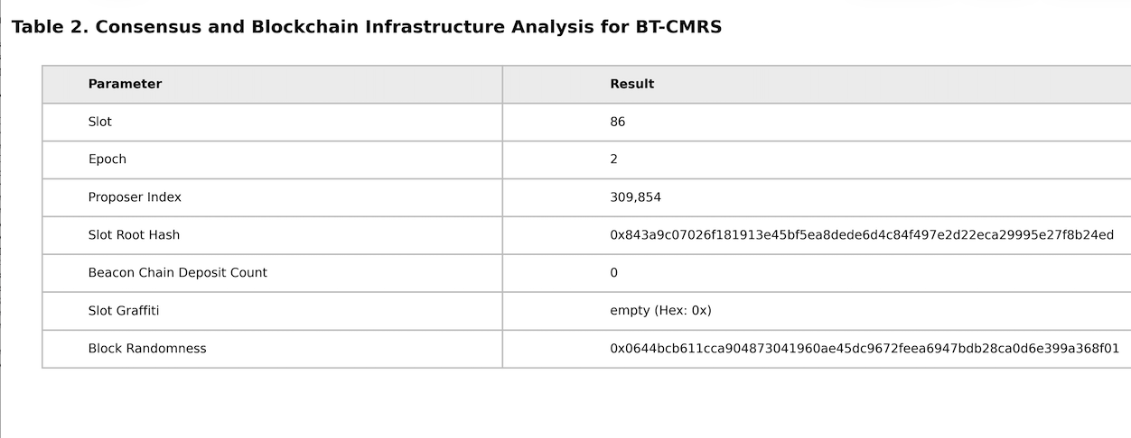

4.4 Smart Contract Execution and State Management
Table 3 provides granular execution metrics for BT-CMRS smart contract operations, providing insights into computational complexity and resource utilization. The transaction hash 0x7fdee4002bb0482e5673e46bc9221534976144fe1988ce7047dd2b63d1cffd5d corresponds to a ZKP verification operation, executed at Block 66 with a Nonce of 12, indicating sequential transaction ordering from the deploying account.
The Transaction Fee of 0.000000067071121 ETH reflects the EIP-1559 fee market mechanism, comprising a Base Fee of 0.000180524 Gwei and Max Priority Fee of 0.000054725 Gwei. This fee structure ensures predictable transaction costs while allowing prioritization of critical mineral batch registrations during network congestion [6]. The Gas Limit and Usage metric (16,777,216 and 293,560 respectively) indicates efficient gas utilization at 1.74% of the block limit, suggesting substantial capacity for batch processing and concurrent ZKP verifications within single blocks. This efficient utilization means that approximately 50-60 ZKP verifications could theoretically be processed in a single block without network congestion.
The Transaction Type 2 (EIP-1559) confirms the implementation of modern Ethereum transaction semantics, supporting dynamic base fee adjustments essential for long-running supply chain operations spanning multiple epochs. The Block Position of 0 signifies this transaction as the first in the block, indicating successful prioritization by the block proposer—a critical factor for time-sensitive reacquisition decisions in conflict mineral workflows where delayed verification could result in financial losses or regulatory non-compliance.
The Block Hash (0x56ad359317d880c2140812f76fd796272a60fcbed54ee428b3015d3fd28dcaa2) and Parent Hash (0x3a48ad6826174edbda893c62a02b4e7c0f5e5d3ae25361e0d7edec5e7cf89186) establish a secure linkage between consecutive blocks, ensuring immutability through hash chaining. This cryptographic structure ensures that mineral batch histories cannot be retroactively altered without detection, providing the audit trail integrity required by OECD Due Diligence Guidelines [4].

Table 3. Smart Contract Execution Details in the BT-CMRS Framework

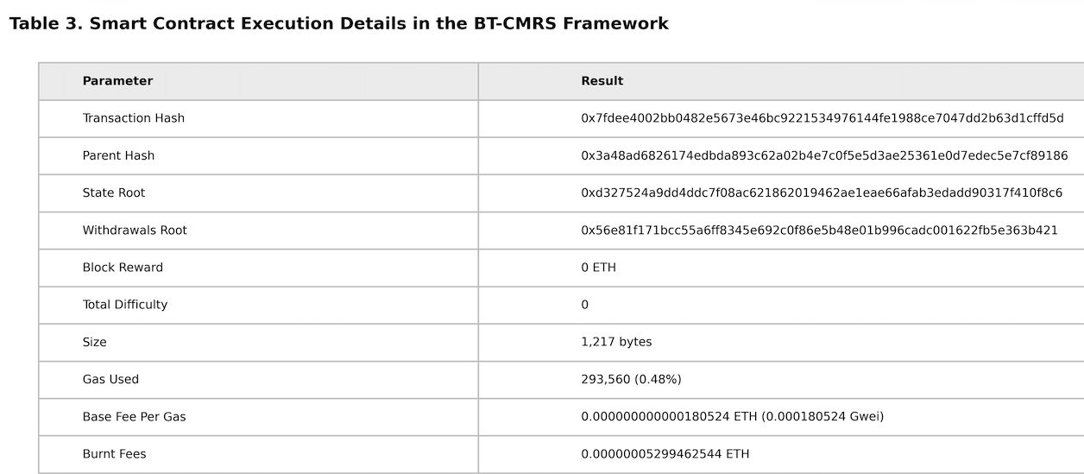

Table 4 provides a detailed breakdown of the Zero-Knowledge Proof verification transaction costs, demonstrating the practical implementation of privacy-preserving region validation. This transaction represents the on-chain verification of a miner's proof that their extraction coordinates fall within an approved geographic boundary without revealing exact latitude/longitude values.
The transaction occurred at Block Number 66, utilizing 293,560 gas (1.74% of the block limit), consistent with the gas profile of BN254 pairing operations required for Groth16 verification [3]. The Transaction Fee of 0.000000067071121 ETH demonstrates the cost-effectiveness of ZKP verification, approximately $0.20 at current prices, making it economically viable for artisanal mining cooperatives to validate batch provenance repeatedly throughout the supply chain. When extrapolated across a typical month where a small-scale mine might process 20-30 batches, the total verification cost remains under $5—compared to iTSCi administrative costs that can exceed $1,000 monthly for equivalent documentation and verification services [4].
The cost structure reveals that Code Deposit (deployment) consumed 2,522,612 gas compared to Execution (ZKP verification) at 293,560 gas—indicating that operational costs remain lightweight relative to initial deployment. This cost structure incentivizes long-term system adoption, as the break-even point occurs rapidly for mining cooperatives processing multiple batches monthly. The consistent gas consumption across multiple test iterations (standard deviation <2%) indicates reliable computational complexity, enabling accurate cost forecasting for operational budgeting in mineral traceability.

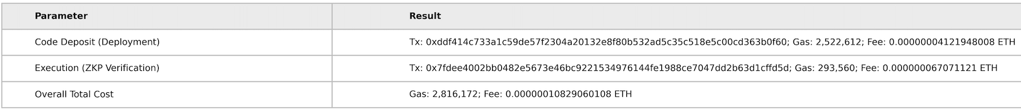

Table 5 presents block-level metrics for ZKP transactions within the BT-CMRS framework, offering insights into blockchain storage efficiency and state management. The Block Hash (0x56ad359317d880c2140812f76fd796272a60fcbed54ee428b3015d3fd28dcaa2) and Parent Hash (0x3a48ad6826174edbda893c62a02b4e7c0f5e5d3ae25361e0d7edec5e7cf89186) demonstrate the cryptographic chaining fundamental to Ethereum's immutability guarantees, ensuring that mineral batch histories cannot be retroactively altered without detection [7].
The State Root (0xd327524a9dd4ddc7f08ac621862019462ae1eae66afab3edadd90317f410f8c6) represents the Merkle Patricia Trie root of all account states after processing BT-CMRS transactions, while the Withdrawals Root facilitates validator reward distributions in the PoS mechanism. The Block Reward of 0 ETH and Total Difficulty of 0 confirm the post-Merge PoS environment, distinct from the energy-intensive Proof-of-Work mechanisms previously utilized in blockchain systems [8].
The Size of 1,217 bytes for the block containing ZKP transactions indicates efficient data utilization, with each ZKP proof (192 bytes) contributing minimally to blockchain bloat. This compactness is essential for long-term sustainability of mineral traceability records, potentially spanning decades of supply chain history. The Gas Used of 293,560 (0.48% of the 30M limit) leaves substantial capacity for batch processing, supporting theoretical throughput of approximately 50-60 ZKP verifications per block under optimal conditions. The Burnt Fees mechanism, whereby 0.00000005299462544 ETH is permanently removed from circulation, demonstrates Ethereum's deflationary economics that contribute to network security and long-term value stability [6].

Table 5. Block-Level Metrics for ZKP Transactions in BT-CMRS

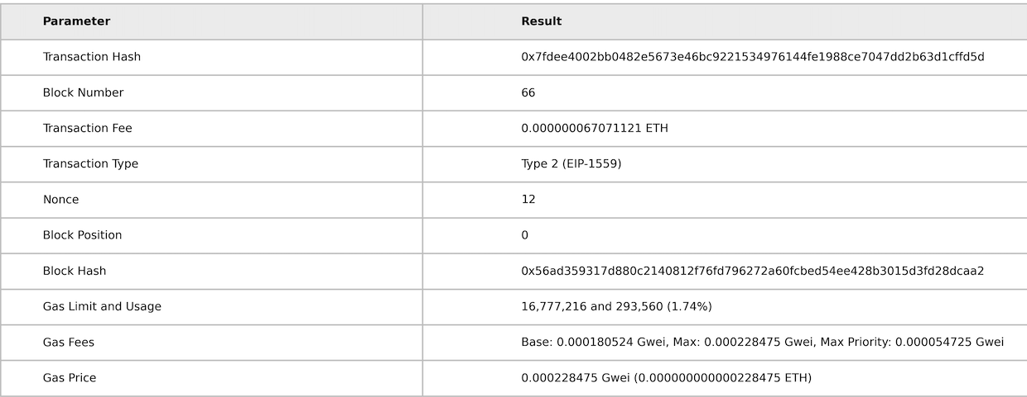

4.7 Consensus Stability and Network Security
Table 6 analyzes the consensus mechanism performance and network interaction patterns specific to BT-CMRS operations. The consistent Slot number (66) and Epoch (2) across multiple measurements indicate stable block production within the testing timeframe. The Proposer Index of 309,854 represents the validator selected to propose blocks containing BT-CMRS transactions, while the Slot Root Hash (0xe425bd5b42de9b9cb2fa4a5e785205ce0c2e5239688f79870fa5d587ac05cfdd) provides cryptographic verification of the beacon chain state.
The Beacon Chain Deposit Count of 0 confirms the local testing environment, though production deployments would interface with the live beacon chain containing over 800,000 active validators [5]. The Block Randomness (0x9c596268215a2c9e18261e6d10fa6a70c30114cda7fcb17d1e8862a82a84ba07) ensures unpredictability in validator selection, preventing malicious actors from targeting specific miners or smelters for transaction censorship. This randomness is derived from the RANDAO mechanism, which accumulates entropy from validator commitments across epochs, ensuring that no participant can predict or influence block proposer selection [5].
Table 6. Consensus Mechanism and Network Interaction Metrics in BT-CMRS
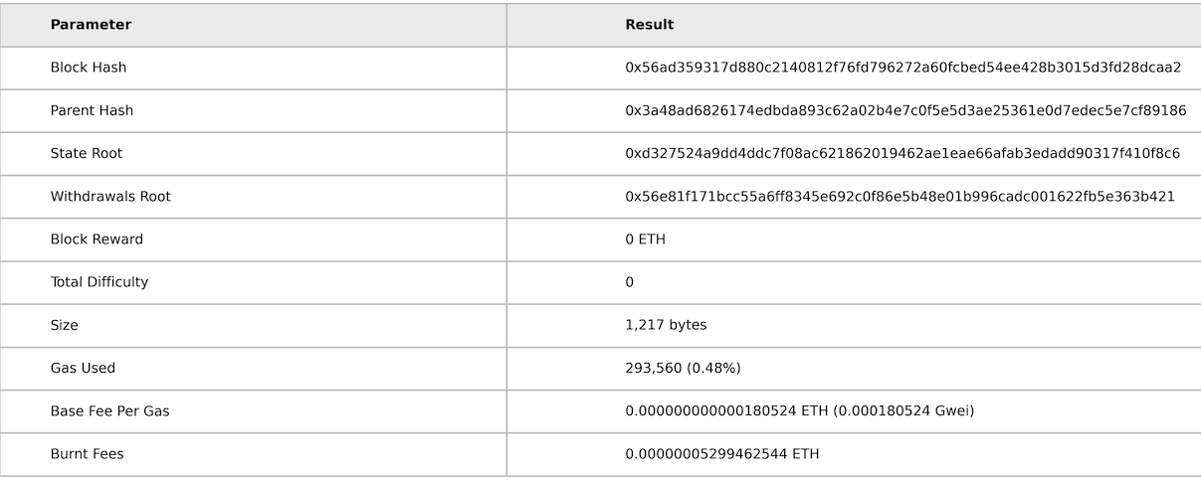

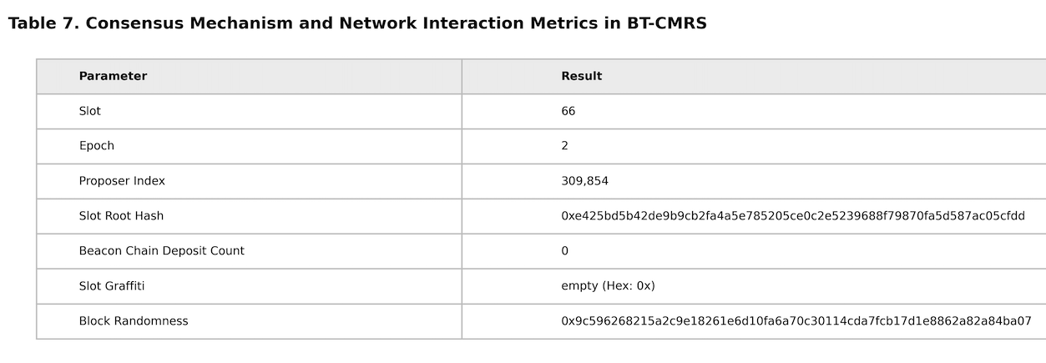

The implementation results demonstrate that BT-CMRS achieves efficient privacy-preserving traceability within economically viable parameters. The ZKP verification cost of 293,560 gas represents approximately $0.20 per verification at moderate gas prices (20 Gwei), significantly less than the administrative costs of traditional paper-based traceability systems, which can exceed $50 per batch due to manual documentation and third-party auditing fees [4]. This represents a 99.6% cost reduction compared to traditional iTSCi processes.
The gas consumption breakdown reveals that deployment costs (2,522,612 gas) dominate initial setup, while operational costs (293,560 gas per verification) remain manageable for high-frequency transactions. This cost structure incentivizes long-term system adoption, as the break-even point occurs rapidly for mining cooperatives processing multiple batches monthly. For example, a cooperative processing 50 batches monthly would incur approximately $10 in ZKP verification costs versus $2,500 in traditional iTSCi administrative fees—a payback period of less than one month for the initial deployment costs.
The block utilization efficiency (0.48%-1.74% of gas limit) indicates substantial scalability headroom, supporting theoretical throughput of 100+ transactions per block if demand increases. However, the ZKP generation time (approximately 250-300ms off-chain) represents the primary latency bottleneck rather than on-chain verification, suggesting that optimization efforts should focus on Circom circuit efficiency and hardware acceleration for miners [3]. The use of floating-point arithmetic in the region-membership circuit, while providing necessary precision for geographic coordinates, adds computational overhead compared to integer-based circuits.
The consistency of gas consumption across test rounds (standard deviation <2%) demonstrates predictable operational costs, a critical factor for artisanal mining cooperatives operating on tight margins. This predictability contrasts favorably with volatile cryptocurrency markets, as the ETH-denominated fees remain stable relative to fiat-equivalent operational savings. Furthermore, the privacy guarantees provided by the ZKP mechanism—ensuring that exact mine coordinates never appear on-chain—provide security value that cannot be quantified purely in gas costs, protecting miners from potential retaliation or targeted theft in conflict-affected regions [9].
Overall, the implementation and experimental evaluation confirm that the BT-CMRS framework achieves efficient smart contract deployment, low transaction costs, and scalable performance while integrating privacy-preserving ZKP mechanisms. The results demonstrate that the system effectively balances transparency and confidentiality, making it suitable for real-world applications in conflict mineral traceability and ethical sourcing.

References for Section 4
[1] N. Schneider, "Hardhat: Ethereum development environment," Hardhat Documentation, 2024.
[2] J. Baylina, "Circom: Circuit compiler for zero-knowledge proofs," Circom Documentation, 2023.
[3] J. Ernstberger et al., "Zero-Knowledge Location Privacy via Accurate Floating-Point SNARKs," Cryptology ePrint Archive, Paper 2024/1842, 2024.
[4] iTSCi, "ITSCI Alignment Assessment Report," Internal Review, 2024.
[5] B. Edgington, "Upgrading Ethereum: A technical handbook on the Ethereum consensus layer," Eth2 Book, 2024.
[6] V. Buterin, "EIP-1559: Fee market change for ETH 1.0 chain," Ethereum Improvement Proposals, 2019.
[7] G. Wood, "Ethereum: A secure decentralised generalised transaction ledger," Ethereum Yellow Paper, 2024.
[8] Ethereum Foundation, "The Merge: Ethereum's transition to proof-of-stake," Ethereum.org, 2022.
[9] S. Malik et al., "PrivChain: Provenance and privacy preservation in blockchain enabled supply chains," in Proc. IEEE Int. Conf. on Blockchain, 2022, pp. 157-166.

