Fbffffffffffffffffffffffffffffffffffffffffffffffffffffffffffffffffff

**How to set up:**

1. Download Git then install it.
2. To check the version, cmd> git –version

**git setup and configuration:**

open project folder right click and open git bash

git config --global user.name marufsagor

git config --global user.name then Enter// to view user name

git config –global user.email [marufsagor10@gmail.com](mailto:marufsagor10@gmail.com)

git config --global user.email then Enter// to view email

git config –list

clear then enter // to clear the screen

**To start GIT**

git init

ls // folder এ কিছু আছে কিনা গিট কে ডেয়া হয়েছে?

Git status

Git add file_name // to add any specific file to staging area

Git add -A // to add all the files to staging area

Git reset // সব গুলা ফাইল untracked হয়ে যাবে।

**Clone/copy code or project .retrieve an entire repository from a hosted location via URL**

git clone [url]

Example:

git clone https://github.com/SyntaxTechnologies/SDETJavaBatch15.git

**How** to push

git remote add [alias] [url]

git push [alias] [branch]

1. **git remote add origin** [**https://github.com/marufsagor/Java1Basic.git**](https://github.com/marufsagor/Java1Basic.git)
2. **git push origin master**

GitHub is a code hosting platform for collaboration and version control.

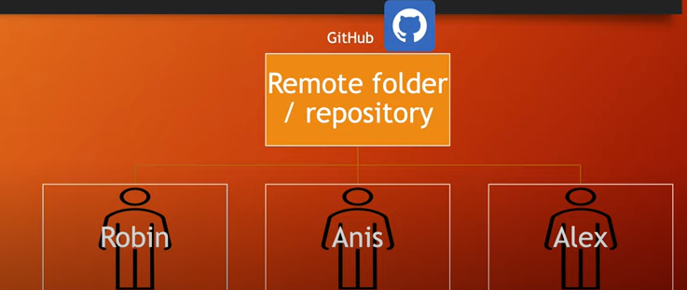

**=> Difference Between Git & GitHub:**

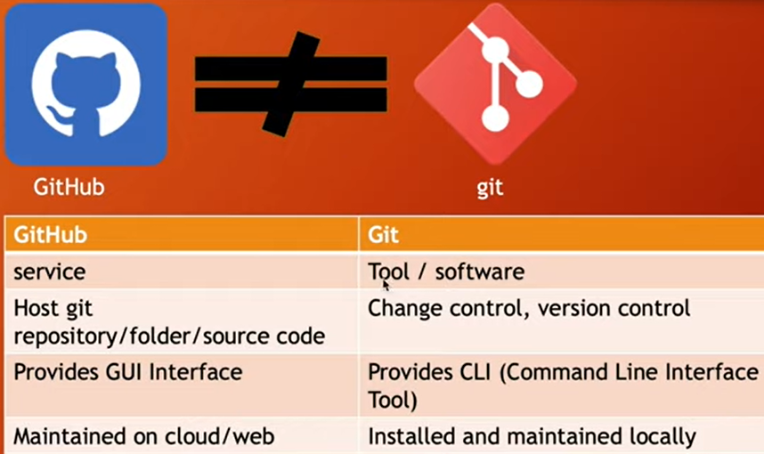

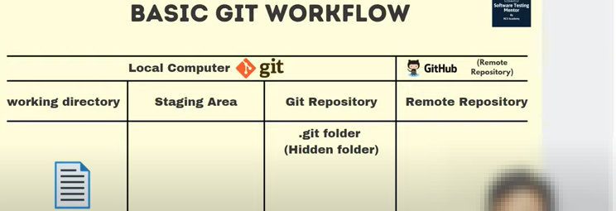

1.Open the project source code folder

2.Right click and open Gitbash

3.Type Git init [.git folder will appear on that project folder]

4.Go to Github>Create new Repository>Code>copy HTTPS url

5.Go to project folder again open Gitbash

6. git commit -m “first comit” // [$ git branch -m master]

7. git remote add origin https://github.com/marufsagor/Java2Basic.git

8.git add -A //To add all the files before push you must have commit

B