Röhrendaten/Tube Data
German | English
Typ | Type |  | QS30-1
Hersteller | Brand |  | 风光 (Fengguang Tube Factory)
Vergleichstypen | Substitutes |  | 10TU26, 122P224, 154-0327-00, 1970-0002, 5031, 50347, 5037, 5092, 5092A, 6770, 6844A, 8037, 8037(B-5031), 8421, 8421(B-5092), 8421/5092, B-5031, B-5031/6844, B-50347, B-5037, B-5092, B-5092/8421, B-5092A, B-6844A, BD-302, CD102, CD18, CD24, CD26, CD32A, CK6844A, CK8037, CK8421, CV5278, CV9316, CV9732, F9057, F9057A, F9057AA, GN-3, GN-4, GN-4A, GN-4D, GN-4E, GN-4P, GNP-4A, GR10M, HB-106, JAN-6844A, JAN-8037, JAN-8421, JAN-CB-6844A, JAN-CZ-6844A, LC-511, LC-513, LC-513A, M2726-102500, M2726-102600, NE-50347, NL-5031, NL-50347, NL-5092, NL-6844, NL-6844A, NL-8037, NL-8421, ST12C, SZ1-1, SZ3-1, SZ-8, Z510M, Z520M, Z5600M, Z560M, ZM1020, ZM1020/01, ZM1022, ZM1022p
Symbole | Displayed symbols |  | 0-9
Symbolhöhe | Symbol height |  | 15 mm (0.591")
Abmessungen | Overall dimensions |  | 30 mm (1.181") dia. X 69 mm (1.358") tall
Pindurchmesser | Pin diameter |  | 1.02mm (0.040")
min. Betriebsspannung | min. supply voltage | V | 170
typ. Brennspannung | typ. maintaining voltage | V | 150
Betriebs-Kathodenstrom | Typical cathode current | mA | 2.25
Sockel | Base |  | B13B, Pin 8 oben/B13B, pin 8 at top
Fassung | Socket |  | B13B oder Einlötbuchsen 1mm/  B13B or pin receptacles 1mm
Outline:
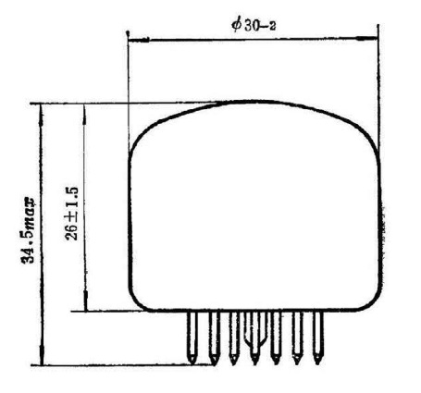
Pinout:
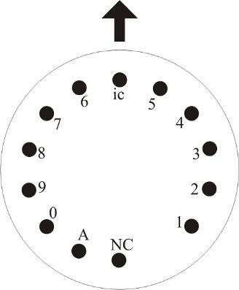
Ansicht von unten/Bottom view
Pfeil zeigt nach oben/Arrow points up

