1. In SolidWorks open the Flow analysis complement and use the following table and figures to configure the study.

|  |  |
| --- | --- |
| Concept | Value |
| Temperature | 294.15 [°K] |
| Atmospheric pressure | 101700 [Pa] |
| Minimum velocity | 0.867 [m/s] |
| Mean velocity | 1.950 [m/s] |
| Maximum velocity | 10.00 [m/s] |

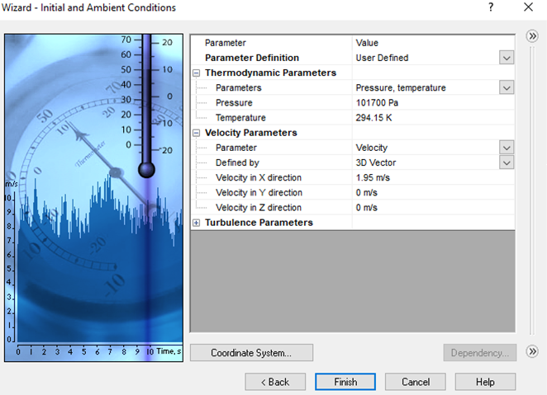

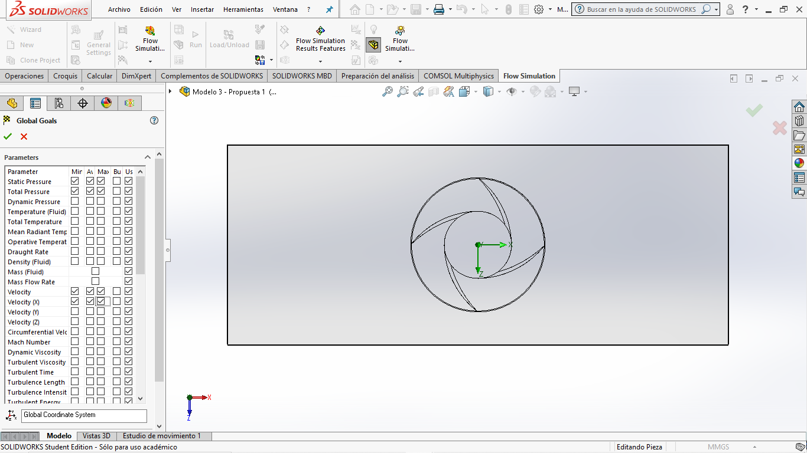

1. Establish the simulation space necessary to cover the Savonius and, when appropriate, the Wind Booster.
2. Execute the simulation.
3. If everything is well set, you will obtain the figures in the paper.