ASSIGNMENT 2

NAME : M SAIKIRAN

ROLL NO : 24MAB0A17

BRANCH : MATHEMATICS AND COMPUTING

1) ls (list of files)
Write a C++ program that lists all files and directories in the current working directory.
Hint: Use opendir(), readdir(), closedir().
CODE:
#include <iostream>
#include <dirent.h>
using namespace std;

int main() {
DIR *dir = opendir(".");
struct dirent *entry;

while ((entry = readdir(dir)) != NULL)
cout << entry->d_name << endl;

closedir(dir);
return 0;
}

OUTPUT:

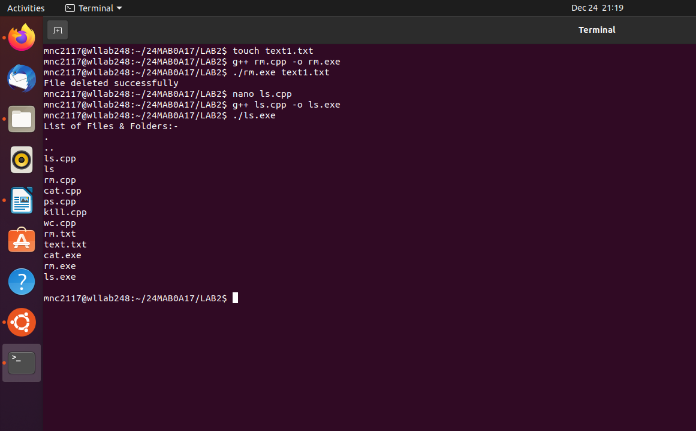

2) rm(remove files):
Write a C++ program that deletes a file specified by the user.
Hint: Use remove() or unlink().
CODE:

#include <iostream>
#include <unistd.h>
using namespace std;

int main() {
string filename;
cout << "Enter filename: ";
cin >> filename;

if (unlink(filename.c_str()) == 0)
cout << "File deleted successfully\n";
else
cout << "Error deleting file\n";

return 0;
}

OUTPUT:

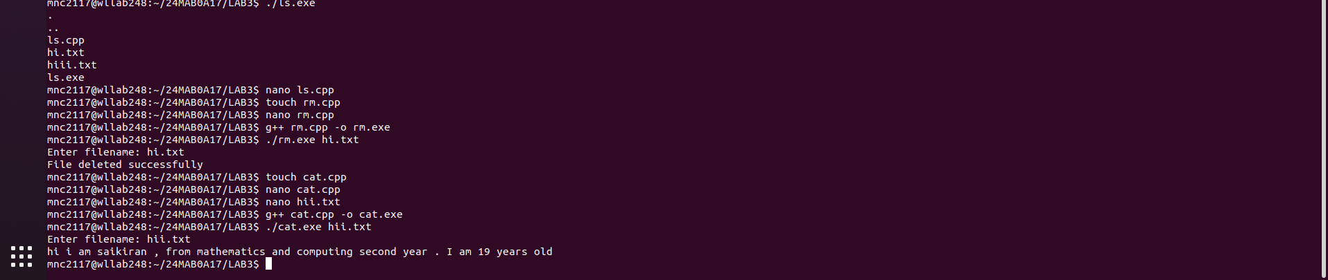

3) cat(file content):
Write a C++ program that displays the contents of a text file.
Hint: Use fopen(), fgetc(), fread().
CODE:
#include <iostream>
#include <cstdio>
using namespace std;

int main() {
char filename[50];
cout << "Enter filename: ";
cin >> filename;

FILE *fp = fopen(filename, "r");
char ch;

while ((ch = fgetc(fp)) != EOF)
cout << ch;

fclose(fp);
return 0;
}

OUTPUT:

4) ps(process status):
Write a C++ program that displays currently running process IDs.
Hint: Read information from the /proc directory.
CODE:
#include <iostream>
#include <dirent.h>
#include <cctype>
using namespace std;

int main() {
DIR *dir = opendir("/proc");
struct dirent *entry;

cout << "PID\n";
while ((entry = readdir(dir)) != NULL)
if (isdigit(entry->d_name[0]))
cout << entry->d_name << endl;

closedir(dir);
return 0;
}

OUTPUT:
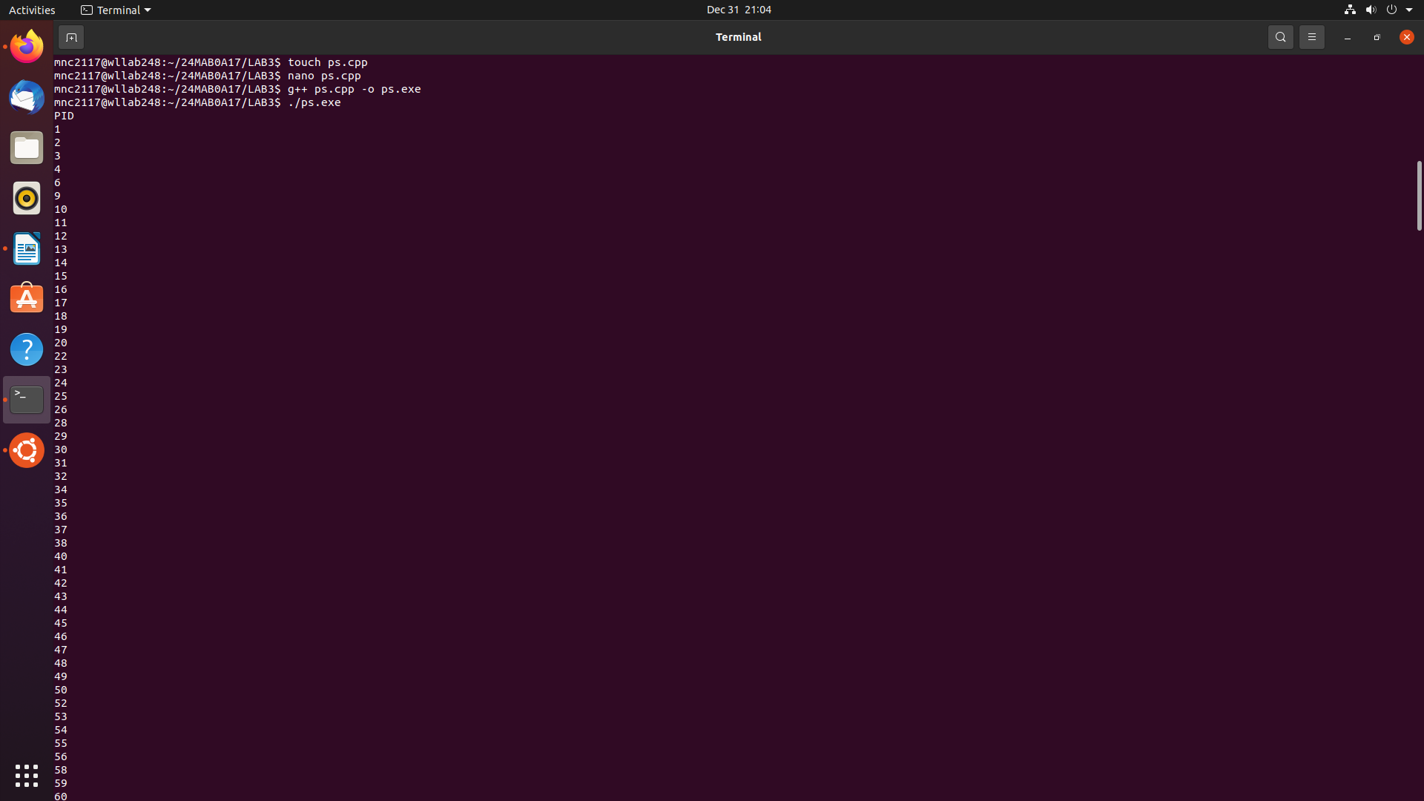

5) kill:
Write a C++ program that terminates a process using its PID.
Hint: Use kill() system call with SIGKILL or SIGTERM.
CODE:
#include <iostream>
#include <signal.h>
using namespace std;

int main() {
int pid;
cout << "Enter PID: ";
cin >> pid;

kill(pid, SIGKILL);
cout << "Process terminated successfully\n";
return 0;
}

OUTPUT:
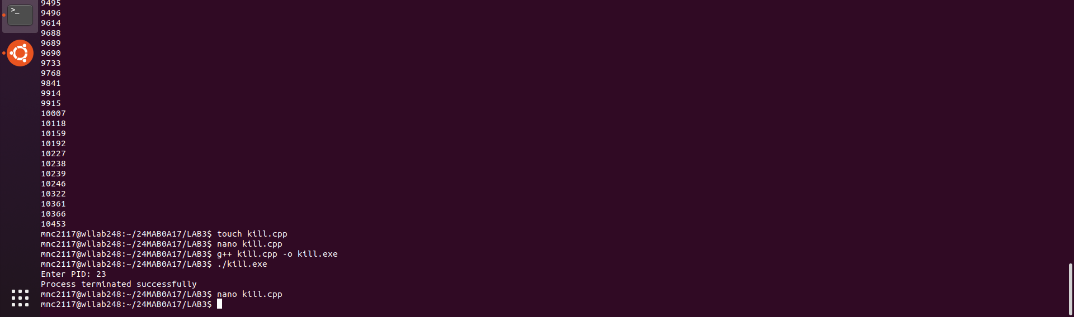

6) wc :

Write a C++ program that counts lines, words, and characters in a file.
CODE:
#include <iostream>
#include <fstream>
#include <sstream>
using namespace std;

int main() {
string filename, line, word;
int lines = 0, words = 0, chars = 0;
cout << "Enter filename: ";
cin >> filename;
ifstream file(filename);
while (getline(file, line)) {
lines++;
chars += line.length();
stringstream ss(line);
while (ss >> word) words++;
}

cout << "Lines: " << lines << endl;
cout << "Words: " << words << endl;
cout << "Characters: " << chars << endl;
return 0;
}

OUTPUT:

