ASSIGNMENT – 3

M.SAIKIRAN
ROLLNO:24MAB0A17

MATHEMATICS &
COMPUTING

PROGRAM : 1

Consider the following C program that uses fork() to create a child process:

#include <sys/types.h>
#include <stdio.h>
#include <unistd.h>
int value = 5;
int main()
{
pid_t pid;
pid = fork();
if (pid == 0) { /* child process */
value += 15;
return 0;
}
else if (pid> 0) { /* parent process */
wait(NULL);
printf("PARENT: value = %d", value); /* LINE A */
return 0;
}
}

What output will be printed at LINE A when the above program is executed?

CPP

#include <iostream>
#include <unistd.h>
#include <sys/wait.h>

int value = 5; // Global variable

int main() {
pid_t pid = fork();

if (pid == 0) { // Child process
value += 15;
return 0;
} else if (pid > 0) { // Parent process
wait(NULL);
std::cout << "PARENT: value = " << value << std::endl; // LINE A [cite: 18]
}
return 0;
}

OUTPUT:

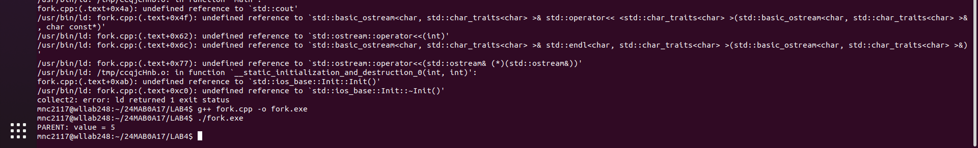

OUTPUT : PARENT: value = 5

EXPLANATION:
When a process calls fork(), the operating system creates a separate copy of the address space for the child. While the child process modifies its own copy of the variable value (changing it to 20), the parent's copy remains unchanged. Because they do not share memory, the parent prints the original value.

PROGRAM:2

Consider the following C program:

#include <stdio.h>
#inclu de <unistd.h>
int main()
{
int i;
for (i = 0; i< 4; i++)
fork();
return 0;
}

How many total processes are created when this program runs?
(Including the initial parent process, how many processes are created by the program)

CPP

#include <iostream>
#inclu de <unistd.h>
using namespace std;
int main() {
for (int i = 0; i < 4; i++)
{
fork();
cout<<"process"<<i<<endl;
}
// Each process will reach this point
return 0;
}

OUTPUT:

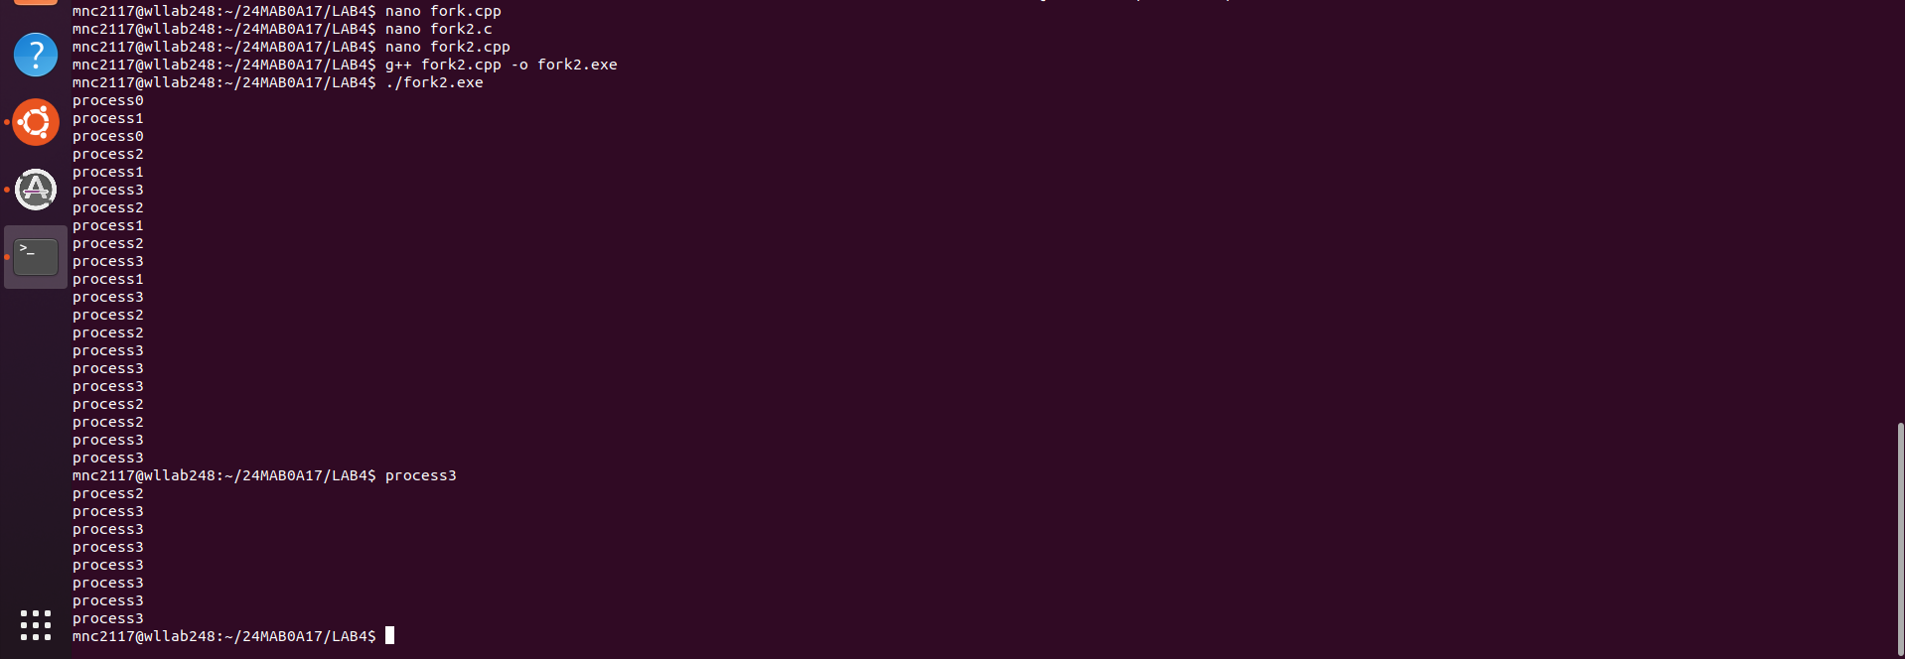

Output: 16 total processes.

EXPLANATION:

Explanation: Each time fork() is called in a loop, the number of processes doubles.

PROGRAM:3
Consider the following C program that uses fork() and execlp():

#include <sys/types.h>
#include <stdio.h>
#include <unistd.h>
int main()
{
pid_t pid;
pid = fork();
if (pid < 0) {
fprintf(stderr, "Fork Failed");
return 1;
}
else if (pid == 0) {
execlp("/bin/ls","ls", NULL);
printf("LINE J");
}
else {
wait(NULL);
printf("Child Complete");
}
return 0;
}

a) Will the line LINE J be printed? Explain your answer based on how execlp() works.
b) Explain the circumstances under which(Conditions) the line of code marked
printf(&quot;LINE J&quot;) will be reached.

CPP

#include <iostream>
#include <unistd.h>
#include <sys/wait.h>

int main() {
pid_t pid = fork();
if (pid == 0) {
execlp("/bin/ls", "ls", NULL);
std::cout << "LINE J" << std::endl; // Only runs if execlp fails
} else if (pid > 0) {
wait(NULL);
std::cout << "Child Complete" << std::endl;
}
return 0;
}

OUTPUT:

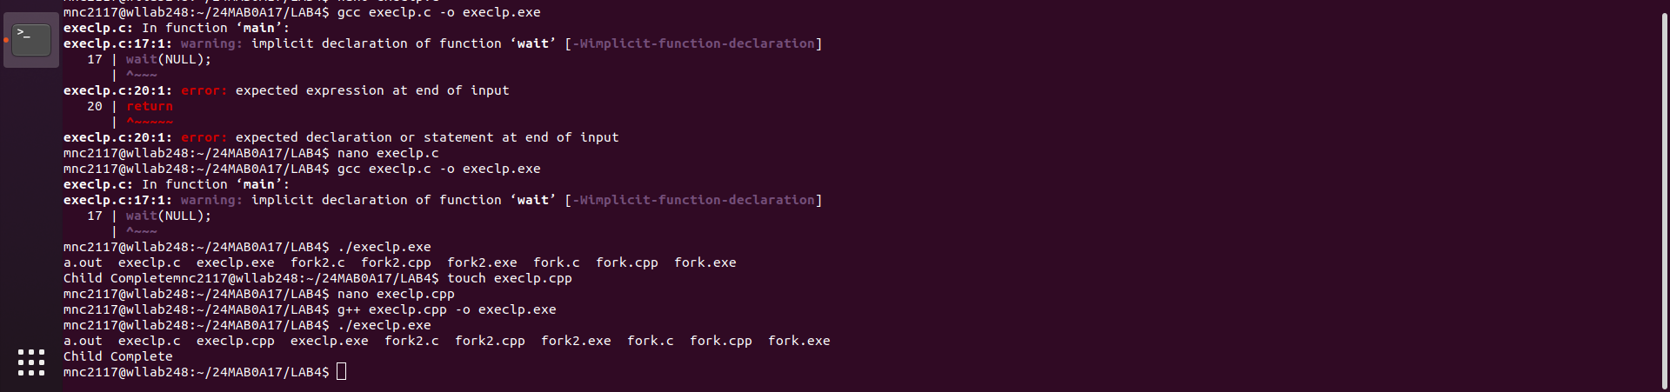

a) Will LINE J be printed? No. Explanation: The execlp() system call replaces the current process image with a new process image (in this case, the ls command). If execlp() is successful, the entire text segment of the child process is overwritten, and the original program code following the execlp() call is "gone." Therefore, the printf at LINE J is never executed.
b) Conditions to reach LINE J: LINE J will only be reached if the execlp() call fails. This could happen if:
- The path to the executable is incorrect.
- The system lacks the resources to load the new image.
- The user does not have permission to execute the file.

PROGRAM:4

Consider the following C program that creates a child process using fork():

#include <sys/types.h>
#include <stdio.h>
#include <unistd.h>
int main()
{

pid_t pid, pid1;
/* fork a child process */
pid = fork();
if (pid < 0) { /* error occurred */
fprintf(stderr, "Fork Failed");
return 1;
}
else if (pid == 0) { /* child process */
pid1 = getpid();
printf("child: pid = %d\n", pid); // LINE A
printf("child: pid1 = %d\n", pid1); // LINE B
}
else { /* parent process */
pid1 = getpid();
printf("parent: pid = %d\n", pid); // LINE C
printf("parent: pid1 = %d\n", pid1); // LINE D
wait(NULL);
}
return 0;}
Assume the parent process has PID 2600 and the child process has PID 2603. What values will
be printed at:
● LINE A
● LINE B
● LINE C
● LINE D

CPP

#include <iostream>
#include <unistd.h>
#include <sys/types.h>
#include <sys/wait.h>

int main() {
pid_t pid, pid1;

/* fork a child process */
pid = fork();

if (pid < 0) {
/* error occurred */

std::cerr << "Fork Failed" << std::endl;
return 1;
}
else if (pid == 0) {
/* child process */
pid1 = getpid();
std::cout << "child: pid = " << pid << std::endl; // LINE A
std::cout << "child: pid1 = " << pid1 << std::endl; // LINE B
}
else {
/* parent process */
pid1 = getpid();
std::cout << "parent: pid = " << pid << std::endl; // LINE C
std::cout << "parent: pid1 = " << pid1 << std::endl; // LINE D
wait(NULL);
}

return 0;
}

OUTPUT:

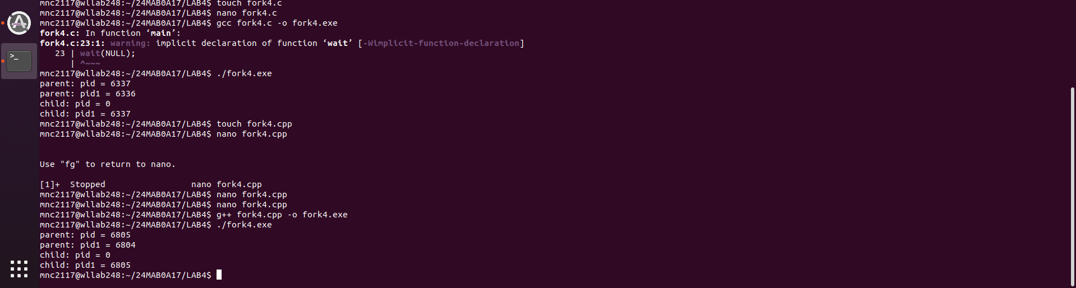

Explanation: getpid() returns the ID of the caller, while fork() returns the child's ID to the parent and 0 to the child .
Assumed: Parent PID = 2600, Child PID = 2603.

Output:
LINE A (child's pid variable): 0
- LINE B (child's pid1 variable): 2603
- LINE C (parent's pid variable): 2603
- LINE D (parent's pid1 variable): 2600

PROGRAM:5
Consider the following C program that creates a child process using fork():

#include <sys/types.h>
#include <stdio.h>
#include <unistd.h>
#define SIZE 5
int nums[SIZE] = {0, 1, 2, 3, 4};
int main()

{
int i;
pid_t pid;
pid = fork();
if (pid == 0) { // Child process
for (i = 0; i< SIZE; i++) {
nums[i] *= -i;
printf("CHILD: %d ", nums[i]); // LINE X
}
}
else if (pid > 0) { // Parent process
wait(NULL);
for (i = 0; i< SIZE; i++)
printf("PARENT: %d ", nums[i]); // LINE Y
}
return 0;
}

What values will be printed at LINE X and LINE Y by the child process? Show the output.

CPP:

#include <iostream>
#include <unistd.h>
#include <sys/wait.h>

int main() {
int nums[5] = {0, 1, 2, 3, 4};
pid_t pid = fork();

if (pid == 0) { // Child
for (int i = 0; i < 5; i++) {
nums[i] *= -i;
std::cout << "CHILD: " << nums[i] << " "; // LINE X
}
} else if (pid > 0) { // Parent
wait(NULL);
for (int i = 0; i < 5; i++)
std::cout << "PARENT: " << nums[i] << " "; // LINE Y
}
return 0;
}

OUTPUT

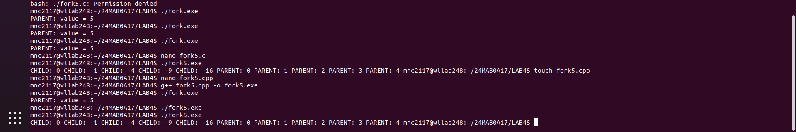

Explanation: Similar to Question 1, the child modifies its own copy of the nums array nums = {0,1,2,3,4}.

Output:
Output at LINE X (Child): 0 -1 -4 -9 -16
Output at LINE Y (Parent): 0 1 2 3 4
Reasoning: Even though the child modifies its array, it is operating on a copy. When the parent resumes after the wait(NULL), its original nums array remains exactly as it was initialized.

