ASSIGNMENT 6

NAME: SAIKIRAN.M

ROLLNO: 24MAB0A17

BRANCH: MATHEMATICS AND COMPUTING

PROGRAM 1 SRJF

CODE :

#include <iostream>
#include <vector>
#include <string>
#include <iomanip>
#include <algorithm>

using namespace std;

struct Process {
string id;
int burstTime;
int arrivalTime;
int remainingTime;
int completionTime;
int turnaroundTime;
int waitingTime;
bool isCompleted = false;
};

int main() {
// Hardcoded Data from User
vector<Process> p = {
{"P1", 10, 0}, {"P2", 5, 2}, {"P3", 8, 4}, {"P4", 6, 6},
{"P5", 10, 10}, {"P6", 13, 1}, {"P7", 7, 9}, {"P8", 9, 7},
{"P9", 2, 3}, {"P10", 8, 12}
};

int n = p.size();
for (int i = 0; i < n; i++) p[i].remainingTime = p[i].burstTime;

int completed = 0, currentTime = 0, prevProcess = -1;
vector<pair<string, int>> ganttChart;

while (completed != n) {
int idx = -1;
int minRemaining = 1e9;

for (int i = 0; i < n; i++) {
if (p[i].arrivalTime <= currentTime && !p[i].isCompleted) {
if (p[i].remainingTime < minRemaining) {
minRemaining = p[i].remainingTime;
idx = i;
}
if (p[i].remainingTime == minRemaining) {
if (idx == -1 || p[i].arrivalTime < p[idx].arrivalTime) {
idx = i;
}
}
}
}

if (idx != -1) {
if (prevProcess != idx) {
ganttChart.push_back({p[idx].id, currentTime});
}
p[idx].remainingTime--;
currentTime++;
prevProcess = idx;

if (p[idx].remainingTime == 0) {
p[idx].completionTime = currentTime;
p[idx].turnaroundTime = p[idx].completionTime - p[idx].arrivalTime;
p[idx].waitingTime = p[idx].turnaroundTime - p[idx].burstTime;
p[idx].isCompleted = true;
completed++;
}
} else {
currentTime++;
}
}
ganttChart.push_back({"END", currentTime});

// 1. Gantt Chart Output
cout << "1. Gantt Chart:\n|";
for (int i = 0; i < ganttChart.size() - 1; i++) cout << " " << ganttChart[i].first << " |";
cout << "\n";
for (int i = 0; i < ganttChart.size(); i++) cout << ganttChart[i].second << " ";
cout << "\n\n";

// 2-4. Process Table
cout << left << setw(8) << "PID" << setw(8) << "CT" << setw(8) << "TAT" << setw(8) << "WT" << endl;
double totalTAT = 0, totalWT = 0;
for (const auto& proc : p) {
cout << left << setw(8) << proc.id << setw(8) << proc.completionTime
<< setw(8) << proc.turnaroundTime << setw(8) << proc.waitingTime << endl;
totalTAT += proc.turnaroundTime;
totalWT += proc.waitingTime;
}

// 5-6. Averages
cout << fixed << setprecision(2);
cout << "\n5. Average Waiting Time: " << totalWT / n << " ms";
cout << "\n6. Average Turnaround Time: " << totalTAT / n << " ms" << endl;

return 0;
}

EXPLANATION:

In SRJF, the execution of a process can be interrupted (preempted) if a new process arrives with a shorter remaining burst time than the one currently running.
- Arrival: When a process enters the ready queue, the scheduler compares its burst time with the remaining time of the current process.
- Preemption: If the new process is shorter, the CPU switches to it immediately.
- Completion: If no shorter process arrives, the current one finishes, and the scheduler picks the next shortest task.
OUTPUT:
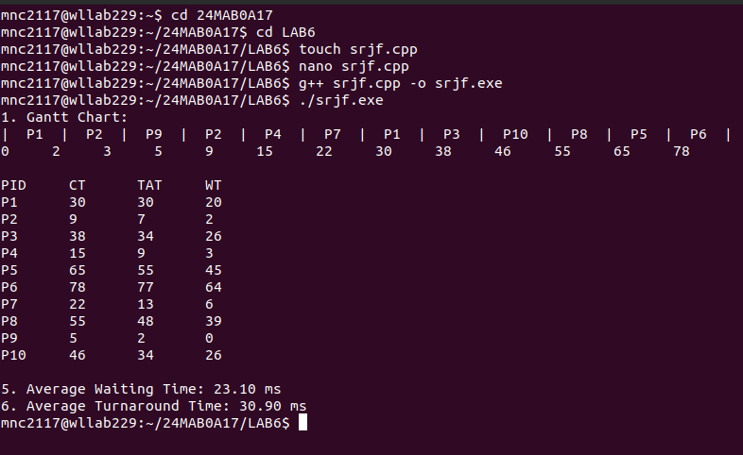
PROGRAM 2 RR(round robin)

CODE :
#include <iostream>
#include <vector>
#include <queue>
#include <iomanip>
#include <algorithm>

using namespace std;

struct Process {
string id;
int burstTime;
int arrivalTime;
int remainingTime;
int completionTime;
int turnaroundTime;
int waitingTime;
};

int main() {
// Hardcoded data matching your previous structure
vector<Process> p = {
{"P1", 10, 0}, {"P2", 5, 2}, {"P3", 8, 4}, {"P4", 6, 6},
{"P5", 10, 10}, {"P6", 13, 1}, {"P7", 7, 9}, {"P8", 9, 7},
{"P9", 2, 3}, {"P10", 8, 12}
};

int n = p.size();
int timeQuantum = 2; // Fixed slice of time for each process

// Sort by arrival time initially
sort(p.begin(), p.end(), [](Process a, Process b) {
return a.arrivalTime < b.arrivalTime;
});

for (int i = 0; i < n; i++) p[i].remainingTime = p[i].burstTime;

int completed = 0, currentTime = 0;
queue<int> readyQueue;
vector<bool> visited(n, false);
vector<pair<string, int>> ganttChart;

// Start with the first process that arrives
readyQueue.push(0);
visited[0] = true;

while (completed != n) {
if (readyQueue.empty()) {
currentTime++;
for (int i = 0; i < n; i++) {
if (p[i].arrivalTime <= currentTime && !visited[i]) {
readyQueue.push(i);
visited[i] = true;
}
}
continue;
}

int idx = readyQueue.front();
readyQueue.pop();

ganttChart.push_back({p[idx].id, currentTime});

// Execute for Time Quantum or remaining time, whichever is smaller
int executeTime = min(p[idx].remainingTime, timeQuantum);
p[idx].remainingTime -= executeTime;
currentTime += executeTime;

// Check for new arrivals while the current process was running
for (int i = 0; i < n; i++) {
if (p[i].arrivalTime <= currentTime && !visited[i]) {
readyQueue.push(i);
visited[i] = true;
}
}

if (p[idx].remainingTime > 0) {
// If not finished, put it back at the end of the queue
readyQueue.push(idx);
} else {
// Process finished
p[idx].completionTime = currentTime;
p[idx].turnaroundTime = p[idx].completionTime - p[idx].arrivalTime;
p[idx].waitingTime = p[idx].turnaroundTime - p[idx].burstTime;
completed++;
}
}
ganttChart.push_back({"END", currentTime});

// Output results
cout << "Round Robin (Time Quantum = " << timeQuantum << ")\n";
cout << "1. Gantt Chart:\n|";
for (int i = 0; i < ganttChart.size() - 1; i++) cout << " " << ganttChart[i].first << " |";
cout << "\n";
for (int i = 0; i < ganttChart.size(); i++) cout << ganttChart[i].second << " ";

cout << "\n\n" << left << setw(8) << "PID" << setw(8) << "CT" << setw(8) << "TAT" << setw(8) << "WT" << endl;
double totalTAT = 0, totalWT = 0;
for (const auto& proc : p) {
cout << left << setw(8) << proc.id << setw(8) << proc.completionTime << setw(8) << proc.turnaroundTime << setw(8) << proc.waitingTime << endl;
totalTAT += proc.turnaroundTime;
totalWT += proc.waitingTime;
}

cout << fixed << setprecision(2) << "\nAvg WT: " << totalWT/n << " ms\nAvg TAT: " << totalTAT/n << " ms" << endl;

return 0;
}

EXPLANATION :

How It Works
- Time Quantum (TQ): The system defines a small unit of time (typically 10–100 milliseconds) called a Time Quantum or Time Slice.
- Ready Queue: All processes are kept in a circular FIFO (First-In-First-Out) queue.
- Execution: The CPU takes the first process from the queue and runs it for a maximum of one Time Quantum.
- Preemption: * If the process finishes within the TQ, it leaves the system.
  - If the process is still running when the TQ expires, the CPU interrupts it and moves it to the back of the queue.
- Cycle: The CPU then picks the next process in the queue and repeats the steps.

OUTPUT:

