ASSIGNMENT 8
NAME : SAI KIRAN
ROLL NO: 24MAB0A17
BRANCH : MATHEMATICS AND COMPUTING

DINING PHILOSOPHERS PROBLEM

EXPLANATION :

### 1. Concept: The Monitor Pattern
In this C++ solution, we implement a "Monitor" to manage synchronization. A Monitor is a thread-safe class that encapsulates shared data and ensures mutual exclusion. Instead of focusing on individual "forks," the monitor tracks the "state" of each philosopher. This prevents the "Hold and Wait" condition, which is a primary requirement for deadlock.

### 2. Shared Data Structures
* **State Array (`state`):** A vector that stores the current condition of each philosopher:
- THINKING: The philosopher is not using any resources.
- HUNGRY: The philosopher wants to eat and is waiting for forks.
- EATING: The philosopher has successfully acquired both adjacent forks.
* **Mutex (`mtx`):** A `std::mutex` used to ensure that only one thread can modify the state array or check conditions at a given time.
* **Condition Variable (`cv`):** Used to block a thread (put it to sleep) if it cannot eat, and wake it up when resources become available.

### 3. Core Logic and Procedures

#### A. The `test(int i)` Method
This is the internal logic used to verify if a philosopher can eat. A philosopher `i` is allowed to change their state to EATING only if:
1. They are currently `HUNGRY`.
2. Their left neighbor `(i + N - 1) % N` is NOT `EATING`.
3. Their right neighbor `(i + 1) % N` is NOT `EATING`.
When these conditions are met, the state is updated and `cv.notify_all()` is called to wake up waiting threads.

#### B. The `pickUp(int id)` Method
1. It acquires a `unique_lock` on the mutex to enter the monitor safely.
2. It sets the philosopher's state to `HUNGRY`.
3. It calls `test(id)` to attempt to acquire forks immediately.
4. If `test` fails, `cv.wait()` is called. This releases the mutex and blocks the thread. It will only wake up when a neighbor finishes eating and signals a state change.

#### C. The `putDown(int id)` Method
1. It acquires the mutex lock.
2. It sets the current philosopher's state back to `THINKING`.
3. It calls `test()` for the left and right neighbors. This is crucial because it "pokes" the neighbors to see if they were waiting for the forks that just became available.

### 4. Problem Resolution
* **Deadlock Prevention:** Since philosophers only change to the EATING state if BOTH forks are available, they never hold a single fork while waiting for another. This breaks the circular wait.
* **Mutual Exclusion:** The `test` function logic ensures that no two adjacent philosophers can ever be in the EATING state simultaneously.
* **Concurrency:** The solution allows the maximum possible number of philosophers to eat at once (e.g., in a group of 5, philosophers 0 and 2 can eat at the same time).

CODE:

#include <iostream>
#include <vector>
#include <thread>
#include <mutex>
#include <condition_variable>
#include <chrono>
#include <random>

using namespace std;

enum State { THINKING, HUNGRY, EATING };

class DiningMonitor {
private:
int N;
vector<State> state;
vector<int> eatCount;
mutex mtx; // The "Monitor" lock
condition_variable cv; // For wait() and notifyAll()

void test(int i) {
// Condition: Hungry AND neighbors are not eating
if (state[i] == HUNGRY &&
state[(i + N - 1) % N] != EATING &&
state[(i + 1) % N] != EATING) {

state[i] = EATING;
cout << "--> Philosopher " << i << " starts EATING." << endl;
// In C++, notifyAll() wakes up everyone to re-check their condition
cv.notify_all();
}
}

public:
DiningMonitor(int numPhilosophers) : N(numPhilosophers) {
state.resize(N, THINKING);
eatCount.resize(N, 0);
}

void pickUp(int id) {
unique_lock<mutex> lock(mtx); // Entry to Monitor

state[id] = HUNGRY;
cout << "Philosopher " << id << " is HUNGRY (Waiting for forks)." << endl;

test(id);

// Wait until the state changes to EATING
cv.wait(lock, [this, id] { return state[id] == EATING; });
}

void putDown(int id) {
unique_lock<mutex> lock(mtx);

state[id] = THINKING;
eatCount[id]++;
cout << "Philosopher " << id << " is THINKING. (Total meals: " << eatCount[id] << ")" << endl;

// Check neighbors
test((id + N - 1) % N);
test((id + 1) % N);
}
};

void philosopher(int id, DiningMonitor& monitor) {
int mealLimit = 3;
// Setup random number generation for sleep
random_device rd;
mt19937 gen(rd());
uniform_int_distribution<> dis(500, 1500);

for (int i = 0; i < mealLimit; ++i) {
// THINKING
cout << "Philosopher " << id << " is thinking..." << endl;
this_thread::sleep_for(chrono::milliseconds(dis(gen)));

// PICK UP
monitor.pickUp(id);

// EATING
this_thread::sleep_for(chrono::milliseconds(dis(gen)));

// PUT DOWN
monitor.putDown(id);
}
cout << "!!! Philosopher " << id << " IS FULL AND LEAVING !!!" << endl;
}

int main() {
int N = 5;
DiningMonitor monitor(N);
vector<thread> philosophers;

cout << "--- Dinner Party Started (C++ Monitor Version) ---" << endl;

for (int i = 0; i < N; ++i) {
philosophers.push_back(thread(philosopher, i, ref(monitor)));
}

for (auto& t : philosophers) {
t.join(); // Wait for all threads to finish
}

return 0;
}

OUTPUT:

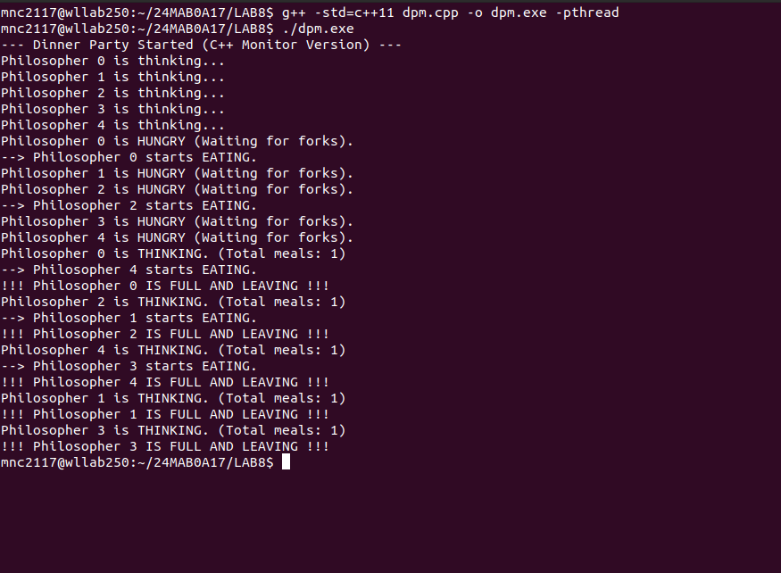

READER WRITER PROBLEM

EXPLANATION :

### 1. Concept: Reader-Writer Problem
The Reader-Writer problem addresses the synchronization of multiple threads accessing a shared data source. The primary constraint is that while multiple "Readers" can safely access data simultaneously, "Writers" require exclusive access to prevent data corruption or inconsistent reads.

### 2. Synchronization Primitives
* **`shared_data`**: The common resource being accessed.
* **`count_mutex`**: A mutex used to ensure that the incrementing/decrementing of the `reader_count` variable is atomic (prevents race conditions between readers).
* **`resource_mutex`**: A mutex that controls access to the actual data. It acts as a gatekeeper against writers.
* **`reader_count`**: An integer tracking how many readers are currently active.

### 3. Core Logic and Procedures

#### A. Reader Logic (First Reader / Last Reader Policy)
The readers use the `reader_count` to coordinate their access:
1. **Entry:** When a reader arrives, it increments `reader_count`. If it is the **first reader** (`reader_count == 1`), it locks the `resource_mutex`. This prevents any writers from entering while readers are active.
2. **Critical Section:** Multiple readers can perform their work here simultaneously.
3. **Exit:** When a reader leaves, it decrements `reader_count`. If it is the **last reader** (`reader_count == 0`), it unlocks the `resource_mutex`, finally allowing waiting writers to enter.

#### B. Writer Logic (Exclusive Access)
Writers have a much simpler, stricter logic:
1. **Entry:** A writer must acquire the `resource_mutex`. If any readers are currently reading, or another writer is writing, the writer will block and wait.
2. **Critical Section:** The writer modifies the shared data.
3. **Exit:** The writer releases the `resource_mutex`, allowing either another writer or a group of readers to enter.

### 4. Analysis of the Solution
* **Mutual Exclusion:** Ensures that a writer and a reader (or two writers) can never access the resource at the same time.
* **Concurrency:** Allows multiple readers to access the resource together, which is more efficient than locking the resource for every individual reader.
* **Reader Preference:** This specific implementation favors readers. If a steady stream of readers arrives, a writer could potentially "starve" (wait indefinitely). To fix this, a "Writer-Preference" or "Fair-Queueing" approach would be required.

CODE:

#include <iostream>
#include <thread>
#include <mutex>
#include <semaphore.h>
#include <vector>
#include <chrono>

using namespace std;

// Shared Resources
int shared_data = 0;
int reader_count = 0;

mutex count_mutex; // Protects the reader_count variable
mutex resource_mutex; // Protects the shared resource (Writer Lock)

void reader(int id) {
for (int i = 0; i < 3; i++) {
// --- Entry Section ---
count_mutex.lock();
reader_count++;
if (reader_count == 1) {
resource_mutex.lock(); // First reader locks the resource for all readers
}
count_mutex.unlock();

// --- Critical Section (Reading) ---
cout << "Reader " << id << " read data: " << shared_data << endl;
this_thread::sleep_for(chrono::milliseconds(1000));

// --- Exit Section ---
count_mutex.lock();
reader_count--;
if (reader_count == 0) {
resource_mutex.unlock(); // Last reader unlocks the resource for writers
}
count_mutex.unlock();

this_thread::sleep_for(chrono::milliseconds(1500));
}
}

void writer(int id) {
for (int i = 0; i < 2; i++) {
// --- Entry Section ---
resource_mutex.lock(); // Writers need exclusive access

// --- Critical Section (Writing) ---
shared_data += 10;
cout << "Writer " << id << " modified data to: " << shared_data << endl;
this_thread::sleep_for(chrono::milliseconds(2000));

// --- Exit Section ---
resource_mutex.unlock();

this_thread::sleep_for(chrono::milliseconds(2500));
}
}

int main() {
vector<thread> threads;

// Create 3 Readers and 2 Writers
for (int i = 1; i <= 3; i++) threads.push_back(thread(reader, i));
for (int i = 1; i <= 2; i++) threads.push_back(thread(writer, i));

for (auto& t : threads) t.join();

cout << "Simulation finished." << endl;
return 0;
}

OUTPUT:

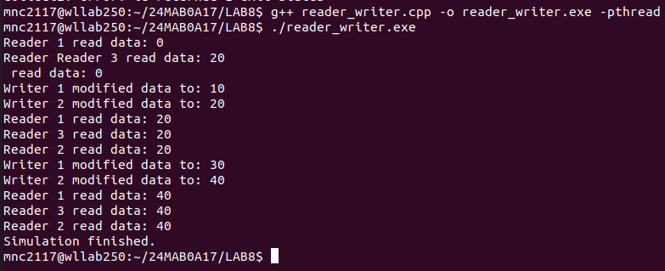

Reader 1 read data: 0
Reader 2 read data: 0
Reader 3 read data: 0
Writer 1 modified data to: 10
Writer 2 modified data to: 20
Reader 1 read data: 20
Reader 3 read data: 20
Reader 2 read data: 20
... and so on ...
Simulation finished.

### Variations of the Reader-Writer Problem

#### 1. First Reader-Writer Problem (Reader Preference)
* **The Rule:** No reader should be kept waiting unless a writer has already obtained permission to use the shared resource.
* **The Logic:** If at least one reader is currently reading, new readers can "skip the line" and join them immediately, even if a writer is already waiting in the queue.
* **Advantage:** Maximizes throughput by allowing the highest possible number of concurrent reads.
* **Risk (Writer Starvation):** If a steady stream of readers arrives, the 'reader_count' never drops to zero, and the waiting writer may never get access to the resource.

#### 2. Second Reader-Writer Problem (Writer Preference)
* **The Rule:** If a writer is ready to write, it should perform its task as soon as possible. No new readers are allowed to start reading once a writer has requested access.
* **The Logic:** When a writer arrives, it "locks the gate." Any current readers are allowed to finish, but all newly arriving readers must wait in a queue until the writer has completed its task.
* **Advantage:** Ensures that the data stays as up-to-date as possible.
* **Risk (Reader Starvation):** If writers arrive frequently, the readers will be blocked indefinitely, even if the resource is currently idle between write operations.

#### 3. Third Reader-Writer Problem (Fair / No Preference)
* **The Rule:** All threads (readers and writers) must be served in the exact order they arrive (First-Come, First-Served).
* **The Logic:** This version introduces an additional "service queue" mutex. If a writer is waiting, a new reader cannot jump ahead of it; the reader must wait behind the writer. This prevents any single group from hogging the resource.
* **Advantage:** Guarantees starvation-free operation. Every thread is eventually guaranteed a turn.
* **Trade-off:** Slightly higher overhead due to the extra locking mechanisms required to maintain the queue order.

🔹 How Synchronization Works (Step-by-Step Example)
Example flow:
- Reader 1 enters → locks resource
- Reader 2 enters → allowed (since first reader already locked resource)
- Reader 3 enters → allowed
- Writer tries to enter → blocked
- Readers finish one by one
- Last reader unlocks resource
- Writer enters

