LAB ASSIGNMENT 9

SAIKIRAN

24MAB0A17

MATHEMATICS AND COMPUTING

Modified bankers algorithm

Modified Banker’s Algorithm – Complete Logic (Single Flow)
The Banker’s Algorithm is a deadlock avoidance algorithm used in operating systems to ensure that resource allocation never leads the system into an unsafe state. It works by simulating resource allocation before actually granting requests.

1. Data Structures Used
The system maintains the following matrices and vectors:
- Max[P][R] → Maximum number of instances of each resource type that a process may request.
- Allocation[P][R] → Number of instances of each resource type currently allocated to each process.
- Available[R] → Number of instances of each resource type currently available in the system.
- Need[P][R] → Remaining resource requirement of each process.
Need is calculated as:
Need[i][j] = Max[i][j] − Allocation[i][j]

2. Resource Request Algorithm (Modified Banker’s Logic)
When a process Pi makes a request Request[i] for resources, the operating system performs the following steps:
Step 1: Check Maximum Claim
If
Request[i] ≤ Need[i]
If this condition is false, the process has requested more than its declared maximum requirement, so the system raises an error.

Step 2: Check Resource Availability
If
Request[i] ≤ Available
If this condition is false, the requested resources are not currently available, so the process must wait.

Step 3: Pretend Allocation (Trial Allocation)
If both conditions are satisfied, the system temporarily allocates the resources to test whether the system remains safe.
Update the system state as follows:
Available = Available − Request[i]
Allocation[i] = Allocation[i] + Request[i]
Need[i] = Need[i] − Request[i]

Step 4: Run Safety Algorithm
The system now runs the Safety Algorithm to determine whether the new state is safe.
If the state is safe, the allocation is permanently granted.
If the state is unsafe, the system rolls back the temporary allocation:
Available = Available + Request[i]
Allocation[i] = Allocation[i] − Request[i]
Need[i] = Need[i] + Request[i]
Then the process Pi waits.

3. Safety Algorithm
The Safety Algorithm determines whether the system is in a safe state by checking if there exists a safe sequence of process execution.
Step 1: Initialization
Work = Available
Finish[i] = false for all processes

Step 2: Find an Executable Process
Find a process Pi such that:
Finish[i] == false
Need[i] ≤ Work
If no such process exists, move to Step 4.

Step 3: Simulate Process Completion
If such a process is found:
Work = Work + Allocation[i]
Finish[i] = true
Repeat Step 2.

Step 4: Check System Safety
If Finish[i] = true for all processes, then the system is in a Safe State and a Safe Sequence exists.
If one or more processes remain unfinished, the system is in an Unsafe State.

4. Final Decision
- If the system remains safe after the trial allocation, the resource request is granted.
- If the system becomes unsafe, the allocation is reverted and the process must wait.

This complete mechanism ensures that the operating system avoids deadlocks by never allowing the system to enter an unsafe state.
Code:
#include <iostream>
#include <vector>

using namespace std;

// Function to calculate the Need Matrix
void calculateNeed(vector<vector<int>>& need, vector<vector<int>>& max, vector<vector<int>>& alloc, int P, int R) {
for (int i = 0; i < P; i++)
for (int j = 0; j < R; j++)
need[i][j] = max[i][j] - alloc[i][j];
}

// Function to check if the current state is safe (Safety Algorithm)
bool isSafe(int P, int R, vector<int> avail, vector<vector<int>> max, vector<vector<int>> alloc) {
vector<vector<int>> need(P, vector<int>(R));
calculateNeed(need, max, alloc, P, R);

vector<bool> finish(P, false);
vector<int> safeSeq(P);
vector<int> work = avail;

int count = 0;
while (count < P) {
bool found = false;
for (int p = 0; p < P; p++) {
if (!finish[p]) {
int j;
for (j = 0; j < R; j++) {
if (need[p][j] > work[j])
break;
}

if (j == R) {
for (int k = 0; k < R; k++)
work[k] += alloc[p][k];
safeSeq[count++] = p;
finish[p] = true;
found = true;
}
}
}
if (!found) return false;
}

cout << "\n[System is in a SAFE state]";
cout << "\nSafe sequence: ";
for (int i = 0; i < P; i++)
cout << "P" << safeSeq[i] << (i == P - 1 ? "" : " -> ");
cout << endl;
return true;
}

// The "Modified" part: Resource-Request Algorithm
void resourceRequest(int P, int R, vector<int>& avail, vector<vector<int>>& max, vector<vector<int>>& alloc) {
int pid;
cout << "\n--- Resource Request Scenario ---";
cout << "\nEnter Process ID making the request (0 to " << P - 1 << "): ";
cin >> pid;

vector<int> request(R);
cout << "Enter request for each resource type: ";
for (int i = 0; i < R; i++) cin >> request[i];

vector<vector<int>> need(P, vector<int>(R));
calculateNeed(need, max, alloc, P, R);

// Step 1: Check if request <= Need
for (int i = 0; i < R; i++) {
if (request[i] > need[pid][i]) {
cout << "Error: Process has exceeded its maximum claim!\n";
return;
}
}

// Step 2: Check if request <= Available
for (int i = 0; i < R; i++) {
if (request[i] > avail[i]) {
cout << "Resources not available. Process P" << pid << " must wait.\n";
return;
}
}

// Step 3: Pretend to allocate (Trial Allocation)
for (int i = 0; i < R; i++) {
avail[i] -= request[i];
alloc[pid][i] += request[i];
}

// Step 4: Check if this new state is safe
if (isSafe(P, R, avail, max, alloc)) {
cout << "SUCCESS: Request granted. Resources allocated to P" << pid << ".\n";
} else {
// Rollback if unsafe
for (int i = 0; i < R; i++) {
avail[i] += request[i];
alloc[pid][i] -= request[i];
}
cout << "FAILURE: Request denied. System would become unsafe.\n";
}
}

int main() {
int P, R;
cout << "Enter number of processes: "; cin >> P;
cout << "Enter number of resource types: "; cin >> R;

vector<int> avail(R);
cout << "Enter Available Resources: ";
for (int i = 0; i < R; i++) cin >> avail[i];

vector<vector<int>> alloc(P, vector<int>(R));
cout << "Enter Allocation Matrix:\n";
for (int i = 0; i < P; i++)
for (int j = 0; j < R; j++) cin >> alloc[i][j];

vector<vector<int>> max(P, vector<int>(R));
cout << "Enter Maximum Matrix:\n";
for (int i = 0; i < P; i++)
for (int j = 0; j < R; j++) cin >> max[i][j];

// Initial safety check
if (isSafe(P, R, avail, max, alloc)) {
// Trigger the modified request algorithm
resourceRequest(P, R, avail, max, alloc);
} else {
cout << "\nInitial system state is already UNSAFE (Deadlock possible).\n";
}

return 0;
}

OUTPUT:
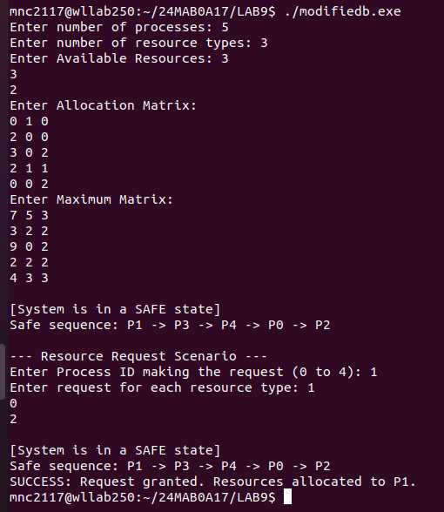

BANKERS ALGORITHM:
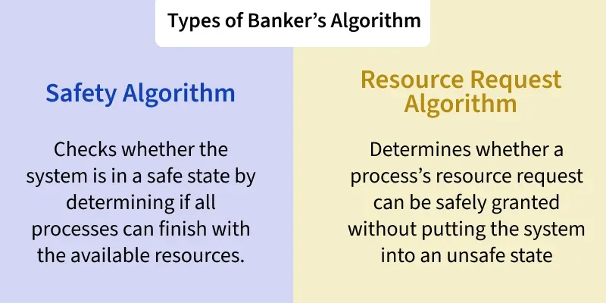
Standard Banker’s Algorithm – Safety Logic

The Standard Banker’s Algorithm is a deadlock avoidance strategy used to
determine if a system is in a "Safe State." It checks if there is at least
one specific sequence (Safe Sequence) in which all processes can eventually
get their maximum resources, finish their execution, and release their
resources back to the system.

1. DATA STRUCTURES USED
The system maintains the following matrices and vectors:

- Max[P][R] : Maximum instances of each resource a process may need.
- Allocation[P][R] : Resources currently held by each process.
- Available[R] : Resources currently free/available in the system.
- Need[P][R] : Remaining resources required by each process.
Calculation: Need[i][j] = Max[i][j] − Allocation[i][j]

2. THE SAFETY ALGORITHM (STEP-BY-STEP)

Step 1: Initialization
- Let Work be a temporary vector equal to Available (Work = Available).
- Let Finish be a boolean vector of size P, where Finish[i] = false for
all processes (i = 0, 1, ..., P-1).

Step 2: Find an Executable Process
- Find an index 'i' such that:
a) Finish[i] == false (The process has not finished yet).
b) Need[i] <= Work (The current available resources can satisfy
this process's remaining requirements).
- If no such 'i' exists, go to Step 4.

Step 3: Simulate Process Completion
- If a process Pi is found:
a) Assume the process finishes and releases all its allocated resources.
b) Update Work: Work = Work + Allocation[i]
c) Mark the process as done: Finish[i] = true.
- Repeat Step 2 to find the next process that can now be satisfied.

Step 4: Determine Safety Status
- If Finish[i] == true for ALL processes (i = 0, 1, ..., P-1), then the
system is in a SAFE STATE.
- The order in which processes were marked 'true' is the SAFE SEQUENCE.
- If any Finish[i] remains false, the system is in an UNSAFE STATE
(Deadlock may occur).

3. FINAL VERDICT
- Safe State : The OS can safely grant resource requests because a
guaranteed path to completion exists for everyone.
- Unsafe State : The OS should be cautious; the system is at risk of
deadlock if processes demand their maximum needs.

CODE:
#include <iostream>
#include <vector>

using namespace std;

void calculateNeed(vector<vector<int>>& need, vector<vector<int>>& max, vector<vector<int>>& alloc, int P, int R) {
for (int i = 0; i < P; i++)
for (int j = 0; j < R; j++)
need[i][j] = max[i][j] - alloc[i][j];
}

bool isSafe(int P, int R, vector<int>& avail, vector<vector<int>>& max, vector<vector<int>>& alloc) {
vector<vector<int>> need(P, vector<int>(R));
calculateNeed(need, max, alloc, P, R);

vector<bool> finish(P, false);
vector<int> safeSeq(P);
vector<int> work = avail;

int count = 0;
while (count < P) {
bool found = false;
for (int p = 0; p < P; p++) {
if (!finish[p]) {
int j;
for (j = 0; j < R; j++)
if (need[p][j] > work[j])
break;

if (j == R) {
for (int k = 0; k < R; k++)
work[k] += alloc[p][k];

safeSeq[count++] = p;
finish[p] = true;
found = true;
}
}
}

if (!found) {
cout << "\nSystem is NOT in a safe state.";
return false;
}
}

cout << "\nSystem is in a safe state.\nSafe sequence: ";
for (int i = 0; i < P; i++)
cout << "P" << safeSeq[i] << (i == P - 1 ? "" : " -> ");
cout << endl;
return true;
}

int main() {
int P, R;
cout << "Enter number of processes: "; cin >> P;
cout << "Enter number of resources: "; cin >> R;

vector<int> avail(R);
cout << "Enter Available Resources: ";
for (int i = 0; i < R; i++) cin >> avail[i];

vector<vector<int>> alloc(P, vector<int>(R));
cout << "Enter Allocation Matrix:\n";
for (int i = 0; i < P; i++)
for (int j = 0; j < R; j++) cin >> alloc[i][j];

vector<vector<int>> max(P, vector<int>(R));
cout << "Enter Maximum Matrix:\n";
for (int i = 0; i < P; i++)
for (int j = 0; j < R; j++) cin >> max[i][j];

isSafe(P, R, avail, max, alloc);

return 0;
}

OUTPUT:
